**THE EFFECT OF HYDROGEN ENHANCEMENT ON THE PERFORMANCE OF SIMPLE PORTED TWO STROKE ENGINE**

**Ahmed Eldeeb1, Moussa Said2, Mostafa Abdel Khalik3, Adham M. Abdelkader**4

1Phd candidate, Automotive department, Ain shams university, Cairo, Egypt.

2,3 Asst. Professor, Automotive department, Ain shams university, Cairo, Egypt.

4 PhD, Automotive department, Ain shams university, Cairo, Egypt.

**ABSTRACT**

**Although the two-stroke gasoline engines have been a mainstay for many Transportation applications, due to their high-power density, they have been austere by high HC emissions and loss of energy which results in poor fuel efficiency. Limited crude oil reserves and increasing concern about pollution norms has pushed us to search for alternative fuel to use in internal combustion engines such as CNG, LPG, HCNG, H2 etc. To improve the poor gas exchange process of a simple ported two-stroke engine, green hydrogen blended with gasoline is considered a good alternative fuel. In this paper, hydrogen-gasoline blends as an alternative fuel are used in a small air-cooled single-cylinder, retrofitted crankcase scavenged two-stroke engine. Engine performance and exhaust emissions have been experimentally compared between gasoline and Hydrogen-gasoline blend fuels in a wide range of engine operating conditions. The results of this work lead to clear insight into Hydrogen enrichment’s impact on the engine performance**.

**Keywords:** Two-Stroke Engine, Green Hydrogen, Engine Performance, Hydrogen Gasoline Blend.

1. **INTRODUCTION**

The distinctive parameter of the two-stroke cycle of operation is that every downward stroke of the piston is an expansion stroke. Such operation is made possible by eliminating the suction and exhaust strokes of the four-stroke cycle. Pumping function is carried out by separate mechanism called the scavenging pump. In this case, charge is slightly compressed in the crankcase, during downward movement of the piston and is transferred to the main cylinder when piston uncovers inlet port. Charge is compressed during upward movement of the piston. Compressed charge is ignited by spark generated through a spark plug. Thereby gases expand by pushing down piston and doing work as soon as piston uncovers exhaust port, gases escape out from the cylinder and next cycle commences [1]. Another interrogation of the two-stroke engine is effective lubrication. Crankcase-scavenged two-stroke engines cannot use conventional four-stroke wet-sump lubrication systems because large quantities of oil would be drawn into the combustion chamber. The mixing of oil and fuel with the incoming air is the method commonly used to lubricate the piston rings and skirt in small carbureted two-stroke spark-ignition engines [2].

Hydrogen is a potential alternative to gasoline in future [3], which is considered a near perfect energy storage medium as it can be created either from fossil or non-fossil sources [4]. Research into hydrogen two-stroke engines was a topic of great interest in the 1970s, notably with the extensive work by [5-6]. Hydrogen is currently a rare commodity compared to hydrocarbon fuels partly due to lack the distribution and infrastructure, so current use of hydrogen is probably limited to the role of a fuel additive. It is suggested that a combination of gasoline and hydrogen could be a superior fuel combining the advantages of both engine itself and hydrogen. An accurate amount of hydrogen that has high flame propagation speed blended with gasoline could provide efficient combustion of fuel/air and oil mixture along the short gas exchange process with little modifications to the fuel system. The main object of this work is to study the impact of hydrogen enriching of crankcase scavenged small two-stroke gasoline engine on its performance especially the emissions.

**2. LITERATURE REVIEW**

Kirby S. Chapman et al. [7] evaluated the feasibility of using blends of hydrogen and natural gas as a fuel for four-stroke, naturally aspirated engines. Performance, efficiency, and emissions along with detailed in-cylinder measurements of key physical parameters were investigated. They reported a modest thermal efficiency gain of about 2% and significant emission reductions of between 18% and 45% when blending hydrogen with natural gas.

Tu Nguyen, et al. [8] highlighted the performance and emissions of large-bore lean-burn two-stroke engines fueled with HCNG mixtures. Hydrogen was blended up to 40% and engine loads varied between 40%-75%. Results showed that blending hydrogen with natural gas reduces emissions and improves thermal efficiency.

C. Mohamed Samath et al. [9] examined the performance and emissions of a hydrogen fueled air cooled single-cylinder two- stroke spark-ignition engine. Slight modifications were made for hydrogen feeding, which do not change the basic characteristics of the original engine. It was concluded that the addition of hydrogen with petrol can result in an increase in the power of the engine. Also, the brake thermal and mechanical efficiencies for hydrogen fuel were higher than gasoline fuel. NOx emissions were about 10 times lower than with gasoline operation.

Katsuhiko Tsuchis et al. [10] discussed the butterfly exhaust valve system installed on the Yamaha Daytona 400cc, two-stroke engine. The structure and principle of valve operation and its effects on engine performance and emissions parameters were studied. They concluded that the improved valve system reduced both short-circuiting and HC emissions in part-throttle operation. It has also successfully reduced fuel consumption and led to an improvement in acceleration by increasing part-throttle power output.

Seralathan S et al. [11] investigated the performance and emissions of a single-cylinder two-stroke carbureted engine set to work on a dual fuel mode operation at which gasoline is used as pilot fuel with hydrogen being used as the inducted fuel. Experimental studies are conducted by running the engine with pure gasoline and in the dual fuel mode with different amounts of hydrogen and gasoline. Results showed an improvement in the brake thermal efficiency. Also, the emission levels of CO and HC are reduced at all loads. Hydrogen, which can be inducted along with air into the combustion chamber, reduces the level of emissions and improves the thermal efficiency of engine.

H. Razali et al. [12] have modified a conventional motorcycle two-stroke gasoline engine to operate on a blend of gasoline and hydrogen generated from hydrochloric acid and aluminum. The study showed that hydrogen can improve the brake thermal efficiency, as well as reduce HC and CO emissions. The average brake thermal efficiency was 23% higher than that for a gasoline engine and is better with the use of hydrogen as a supplemental fuel at the minimum rate of 4%. The total hydrocarbon production for the three loading conditions L0, L1 and L2 of gasoline/hydrogen blend was 34% less than using gasoline only.

Staša et al. [13] investigated the influence of gasoline, ethanol, stabilized hydrogen peroxide, water, and Brown’s gas (oxy-hydrogen or HHO gas) on the performance of a single cylinder two-stroke at constant engine speed. They stated that ethanol enrichment of gasoline leads to a reduction in exhaust emissions of CO, HC, and NOx with the degraded engine's fuel efficiency due to lower calorific value of the blends. It has also been shown that small additions of hydrogen to ethanol and gasoline can lead to decreased NOx emissions.

Nagalingam et al. [14] investigated hydrogen enriched CNG. They noted that the power was reduced due to the lower volumetric heating value of hydrogen compared with methane. However, since the flame speed of hydrogen was significantly higher than that of CNG, less spark advance was required to produce maximum brake torque.

Blarigan and Keller [15] investigated the 100/0, 70/30 and 0/100 CH4/H2 percentages. They studied experimentally and computationally by using three-dimensional CFD code. NOx, thermal efficiency, BTDC and changed equivalence ratios were compared for various CH4 and H2 percentages. They reported that it is possible to build a high efficiency, equivalent zero emissions auxiliary power unit for hybrid vehicles fueled by hydrogen or 30% hydrogen 70% NG blends.

W. B. Santoso et al. [16] investigate the combustion characteristics of H2/diesel fuel to run single cylinder diesel modified research engine at a constant speed of 2000 rpm and 10 Nm load. Stated that, hydrogen induction into the intake manifold reduces the diesel fuel consumption. An increasing hydrogen flow rate at the low load operation results in a higher SEC. It means that more fuel is necessary to produce the same power output. At this low load operation, the efficiency decreases with hydrogen enrichment.

Mohamed F. Al-Dawody et al. [17] investigated theoretically the impact of using HHO gas on single-cylinder diesel engine operation by simulation software diesel-RK model. Diesel oil blended with 10% HHO gas was put into the engine, BTE climbed to 31.5 % and consequently, fuel consumption is reduced by up to 20 %, the maximum reduction in BSN is 25% which is recorded at 3500 rpm.

Charles Lhuillier et al. [18] experimented the engine performance, combustion characteristics and emissions of a recent SI engine fueled with premixed ammonia/hydrogen/air mixtures were assessed. Concluded that blending up to 20% hydrogen in the fuel by volume improves the cyclic stability and avoids misfires, while granting the best work output and indicated efficiencies near stoichiometry. Higher hydrogen fractions result in depleted efficiency, attributed to higher wall heat losses.

Mike Ambler et al. [19] created new modern 50 CC scooter two cycle engine for Aprilia with innovative DITECH technique (fuel metering is performed by an innovative positive displacement, ECU controlled, fuel pump with automotive fuel injector and fuel pressure regulator), a dramatic reduction of oil and fuel consumption and very low emission of exhaust smoke has been possible, without sacrificing “top end” performance and great mid-range torque of a classic two stroke engine.

Pierre Duret et al. [20] evaluated the real potential of IAPAC two stroke engine in comparison to conventional high-efficiency 4-stroke engine by a precise analysis of the remaining part of basis pollutant emissions. They reported that IAPAC engine obtain fuel consumption reductions of more than 20 % in the light-load range, the NOx emissions are 5 to 10 times lower, exceptional low level of NOx emissions, combined with drastic reduction of HC emissions by combustion process optimization.

Yoichi Ishibashi et al. [21] applied the activated radical combustion to a 250 CC motorcycle engine using new exhaust valve targeting to overcome inherent drawbacks of two stoke engine, charge short circuiting and irregular combustion under part load conditions, they analyzed the alternating phases between AR combustion and spark ignition combustion, and proved that the fuel economy was improved by 57% and HC emission was decreased by 65% in the 50 km/h cruising condition at the air to fuel ratio of 15. HC emission was decreased by approximately 60% in the EC 40 emission evaluation mode.

V.Ragavanandham et al. [22] investigated the hybrid fuels. coconut oil, cotton seed oil and sun flower oil is blended with petrol and diethyl ether in order to determine the characteristics and combustion in a spark ignited two stroke petrol engines. They reported that CO and HC emissions from biodiesel blends are significantly less than that of petrol. The mixture of coconut, cotton seed and sun flower oils with petrol oil and diethyl ether can be used as fuel without any modification in spark ignition petrol engine. The mechanical efficiency is found higher for petrol blended with coconut oil as compared to that of other blended fuels and pure petrol. The BTE is found higher for diethyl ether blended with coconut oil as compared to that of other blended fuels and pure petrol. Considering exhaust emissions, the petrol blended with sun flower oil has lower CO emission and diethyl ether blended with cotton seed oil has lower HC emission as compared to that of other blended fuels and pure petrol.

A.Kirthivasan et al. [23] tested usage of petrol blended with different proportions of ethanol by volume (5%, and 10%) for an unmodified and used 100 CC two stroke engine. Tests were performed on the engine, with petrol as the fuel initially and then with ethanol blended petrol with increasing proportion of ethanol.

They concluded suitability of ethanol blended petrol on a two-stroke engine has been tested without any modification. Performance characteristics have been obtained by using varying proportions of ethanol along with gasoline. The experiments have shown that upon usage of ethanol blended petroleum mixtures the BSFC remains fairly constant. Thus, ethanol blended petroleum mixtures can be used as a substitute for regular gasoline fuel, for running two stroke petrol Engines.

Mikiya ARAKI et al. [24] Performance of a CNG a two cylinder, 398 CC, Yamato outboard racing two stroke spark ignition engine using intermittent low pressure fuel injection from scavenging ports is investigated experimentally. Gaseous fuel injectors are attached at the engine block, and a CNG is injected into the scavenging passage through a fuel injection pipe. The fuel injection pressure is set at 0.255 MPa, and the fuel is injected intermittently during the scavenging process. The length and tip geometry of the fuel injection pipe are varied. Scavenging port injection can extend the lean burn limit from 1.2 to 1.46 at most and improves thermal efficiency by 25% at best, scavenging port injection can reduce HCs in the exhaust by 47% at most, which must mean the significant reduction of fuel short-circuiting phenomenon.

A S Anbukarasu et al. [25]described development of (LPG/Gasoline) fuel concept of a single cylinder air cooled 200 CC two stroke engine for three-wheeler application, engine is converted to operate on LPG fuel with electronic ignition system and it is having feature to change the spark ignition timing vs. speed and type of fuel selected, compression ratio, ignition timing, spark plug selection, lubrication oil percentage, Cat - Con, LPG I stage and second stage pressure regulators, mixer Venturi size and power screw were also optimized suitable to LPG operation. They stated that, Accurate control of air/fuel ratio for LPG, major modification in intake system tuning is needed for maintaining air fuel ratio close to unity. Two-stroke will consume about 30 - 35 % more fuel than equivalent four-stroke one. LPG operation gives higher HCs than gasoline due the lighter molecular weight of the fuel, better engine performance was observed with LPG running using advance ignition timing technique.

EL-Kassaby et al. [26] Examined feeding HHO in the intake manifold of a 1.3 [L] GLXi Skoda Felicia gasoline engine, showed that improved thermal efficiency by about 10%, whereas the fuel consumption, HC, CO, and NOx emissions decreased by (34, 18, 14, and 15) %.

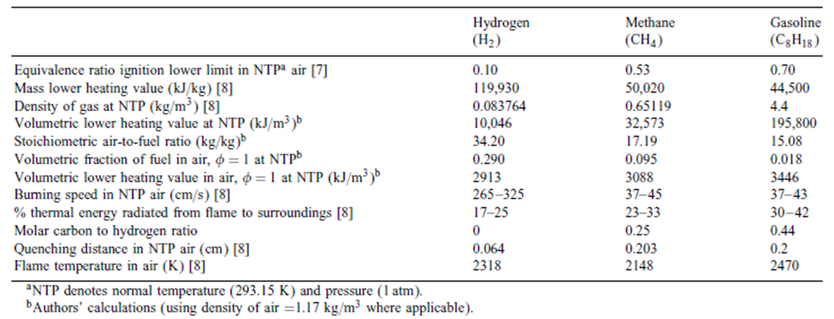

**Table 1**: properties of hydrogen, methane and gasoline [27].

1. **METHODOLOGY**

The experimental setup was constructed in the automotive engine laboratory of Ain shams faculty of Engineering. Experiments are performed on a test rig using a gasoline crankcase scavenged air-cooled single cylinder two-stroke engine.

**3.1 Generation of green Hydrogen:**

An Electrolyzer, powered by PV energy source, is used for production of green hydrogen. Figure (1) shows a schematic drawing of a small station used for generation of the green hydrogen. Through the electrolysis of water, hydrogen gas is generated and then separated from oxygen, providing a clean and versatile fuel source. Since the produced green hydrogen has traces of humidity, another stage, namely silica gel tank, is used to release the hydrogen with no humidity.

**Figure 1:** Schematic drawing of a small station used for generation of green hydrogen by using PV energy [28].

The used station, which can produce hydrogen of about 0.4 [L/min], compresses and stores the generated hydrogen. Compressing the hydrogen is done using an air compressor, which offers a practical solution also for storage. The air compressor tank should be evacuated from the air before compressing the hydrogen. The required temperature and pressure were maintained using suitable control and measuring systems. Figure 1 shows a schematic drawing of the small unit used for generation of green hydrogen using PV energy.

**3.2 Engine and measuring equipment:** The used engine has a volume of 63.3 [cm3]. It is an air-cooled single-cylinder two-stroke gasoline engine, simply retrofitted by a green hydrogen/air mixture at intake duct to ensure premixed fuel induction, specification shown in Table 1. The engine was tested at constant speed of 3000 [rpm] with variable throttle opening ranging from 25% to 100% of engine full throttle opening.

**Table 1.** Engine specifications

|  |  |
| --- | --- |
| Rated Output | 650 [W] @ 3000 [rpm] |
| Cubic Capacity | 63.3 [cm3] |
| Compression Ratio | 6:1 |
| Induction | Carburetor/ reed valve |
| Engine type | Two-stroke, air Cooled, spark- Ignition Engine |
| No. of cylinders | 1 |
| Cylinder Bore | 48 [mm] |
| Stroke | 35 [mm] |
| Lubrication | Fuel oil premix 50:1 |
| Scavenging | Loop Schnurle |
| Ignition system | Flywheel magneto |

● Engine operating temperature is accurately monitored by PT 100 sensor connected to Omron 5EN digital screen in anticipation of engine overheating due to the high combustion temperature of green hydrogen fuel additive.

● Inducted air is measured by U-tube manometer 0.5D/D pressure tapings position configuration is installed on the inlet duct of 6 [L] surge tank at engine air intake, fuel mixtures are measured by calibrated high precession Toledo Mettler weighing machine.

●A DC dynamometer is used for testing the engine. The load applied on the engine by the dynamometer is governed by resistive load bank.

● Green hydrogen vessel is connected to pressure regulator to ensure constant pressure hydrogen fuel line to engine regardless cylinder pressure.

● NDIR calibrated AGS 888 five-gases exhaust gas-analyzer is used to extract oxygen concentration, CO, CO2, HCs, and NOx.

**3.3 Hydrogen concentration setting:** This is achieved by turning throttle screw in the pressure regulator either clockwise or counterclockwise for several trials to keep it in a narrow range.

Figure (2) shows a schematic drawing of the test-rig and measuring equipment used in this work, and Figure (3) shows a photograph of the used Test-R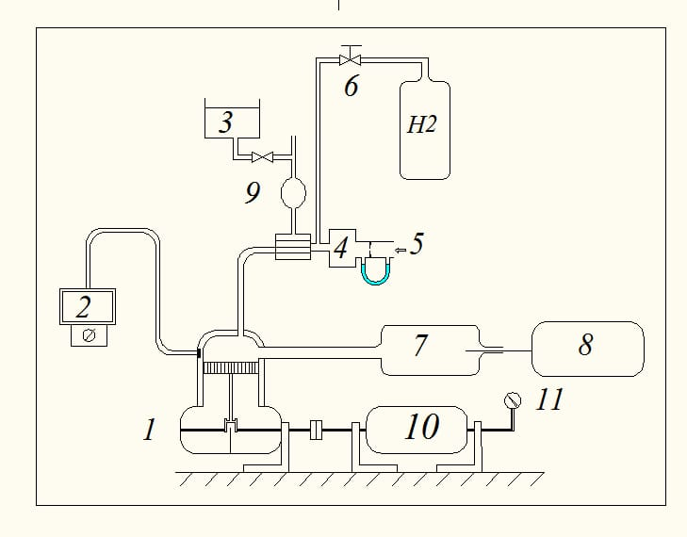

**Figure 2:** A schematic drawing of the Test-Rig and measuring equipment :1- Engine, 2-Temperature display, 3- Fuel Tank, 4-Induced Air measuring device, 5- Intake air, 6- Hydrogen Pressure Regulator, 7- Tailpipe, 8-AGS888 Gas Analyzer, 9- Fuel measuring device, 10- Dynamometer, H2- Hydrogen Vessel.

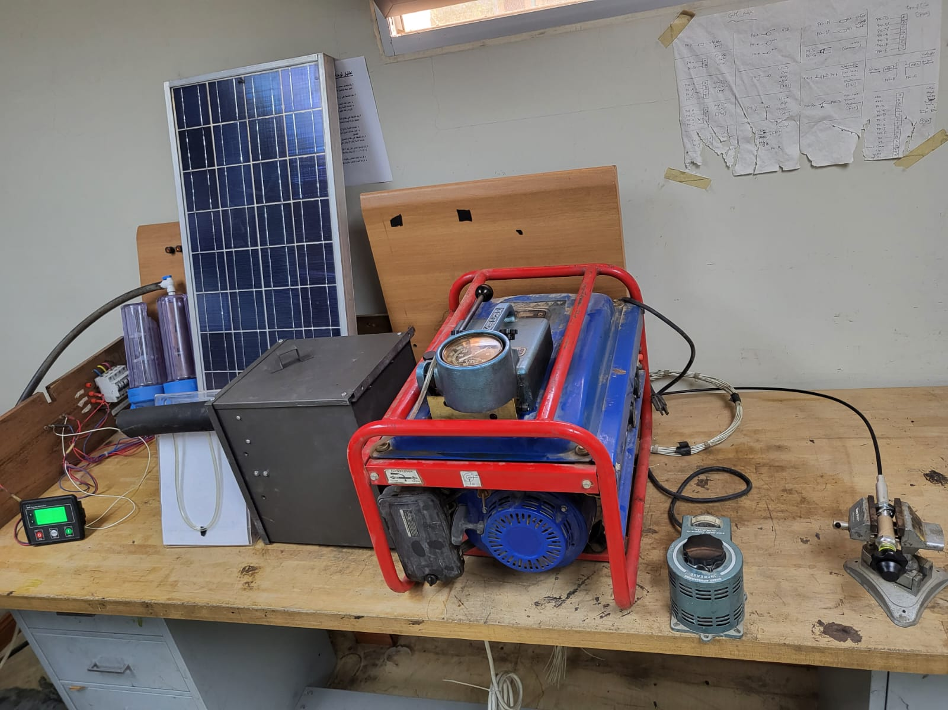

**Fuel Flowmeter**

**Hydrogen Electrolizer**

**PV Module**

**Engine O/P Module**

**Induced Air measuring Kit**

**Two Stroke Engine**

**Resistive Load**

**Throttle Lever**

**Figure 3:** photograph of the Test-Rig and measuring equipment.

**4. RESULTS AND DISCUSSION**

In the present work, performance, and emissions of 63.3 [cm3] tested engine is measured in two different phases of operation, namely, fueled by pure gasoline and then fueled by 1.12 [LPM] H2, enriched gasoline.

**4.1 Engine performance characteristics:** Figure (4) shows excess air ratio versus throttle opening, original manufacturer setting is very rich to ensure stable operation specially at low loads. [1] noted that the maximum laminar burning velocity or speed occurs with slightly richer than stoichiometric mixtures where the temperature of the burned gases produced by combustion is a maximum. Adding green hydrogen at rate of 1.12 [LPM] permits ease dilution of air fuel mixture take advantage from green hydrogen high flame speed and high combustion temperature.

**Figure 4:** Excess air ratio vs. throttle opening percentage at 3000 [rpm] and MBT condition for gasoline and gasoline +1.12 [LPM] H2 fuels.

**Figure 5:** Brake power vs. throttle opening percentage at 3000 [rpm] and MBT condition for gasoline and gasoline +1.12 [LPM] H2 fuels.

Figure (5) shows the effect of hydrogen enrichment on engine power. Drawbacks of hydrogen as a fuel includes lower power density due to a lower heating value per unit volume as compared to gasoline, and susceptibility to pre-ignition and engine knock, due to wide flammability limits and low minimum ignition energy. Blending hydrogen with gasoline, however, overcomes the drawbacks inherent in each fuel type, max power reduction about 9% this investigation shows same trends to that is reported in reference [14].

As illustrated in Figure (6), Brake thermal efficiency (BTE) improves due to higher flame speed which in turns reduced combustion duration. Reduction of the specific fuel consumption is a result of hydrogen higher LHV on mass basis compared to displaced gasoline in mixture and enhanced combustion. Same results are shown in the references [8,9,17].

**Figure 6:** BTE vs. throttle opening percentage at 3000 [rpm] and MBT condition for gasoline and gasoline +1.12 [LPM] H2 fuels.

**4.2 Emissions:** Adding green hydrogen to gasoline increases the H/C ratio of the fuel mixture, which drastically reduces the carbon-based emissions such as CO, CO2, and HC. The production of CO emission is strongly related to excess air ratio [29] so many trials have been performed to increase (EAR) keeping stable operating conditions. As shown in Figure (7), as the gasoline +1.12[LPM] H2 fuel has the lowest average CO emission due to lower carbon atoms in mixture and good premixing of air and fuel. The maximum reduction in CO emissions is 50%, same findings are seen in the investigations of references [11,12,22].

Figure (8) demonstrates that HC production at variable load conditions, the concentration of HCs mainly related to incomplete combustion [30]. As shown the line follows the slope of BTE curve. However, it is reduced by adding H2 due to lesser heat transferred to cylinder walls, the delay of ignition advance angle for MBT achievement contributes the reduction of HC production, these results almost are identical to that of references [10.13,21], best reduction about 19%.

**Figure 7:** CO emissions vs. throttle opening percentage at 3000 [rpm] and MBT condition for gasoline and gasoline +1.12[LPM] H2 fuels.

**Figure 8:** Unburned HCs emissions vs. throttle opening percentage at 3000 [rpm] and MBT condition for gasoline and gasoline +1.12[LPM] H2 fuels.

NOx production mainly depends on the combustion temperature and the presence of oxygen in combustion chamber [32]. As seen in Figure (9) NOx emission of gasoline +1.12 [LPM] H2 operation unexpectedly mitigated, possibly due to leaning of mixture permitted by the high flame-ability limit of hydrogen lowering the combustion temperature, similar outcomes are shown in the study of [13]. Lowered values at full load possibly due to domination of gasoline cooling effect.

CO2 emission is a desired product of combustion as it is a good indication of combustion completeness [31]. According to Figure (10), CO2 emission increases at higher engine load for all the experimented fuels, this is due to improved combustion efficiency. For gasoline +1.12 [LPM]H2 operation CO2 amount increases also due to enhanced combustion. Although increasing hydrogen fraction in mixture increases H/C ratio which in turn should reduce CO2 emission but the effect of hydrogen on combustion completeness is most significant.

**Figure 9:** NOx vs. throttle opening percentage at 3000 [rpm] and MBT condition for gasoline and gasoline +1.12[LPM] H2 fuels.

**Figure 10:** CO2 emissions vs. throttle opening percentage at 3000 [rpm] and MBT condition for gasoline and gasoline +1.12[LPM] H2 fuels.

**5. CONCLUSIONS**

The following can be concluded from the results obtained after experimentations  
performed on 63.3 CC retrofitted two-stroke engine, fueled with gasoline and gasoline +1.12 [LPM] H2% tested at constant speed of 3000 [rpm] and load varied from 25% to 100%.

1. Green Hydrogen addition to gasoline improves BSFC and BTE, the effect of hydrogen gaseous state negatively affects engine power and torque.
2. The effect of green hydrogen addition on engine emissions parameters is superior also for NOX.
3. Ignition advance angle due to high burning rate of hydrogen, green hydrogen enriched fuel shows less advanced angle for MBT.
4. **REFERENCES**

|  |  |  |
| --- | --- | --- |
| [1] | Keswani, H.B., 1982. “Internal Combustion Engines”: For Degree, Diploma and AMIE Students (MKS Units). Standard Book House. | |
| [2]  [3]  [4]  [5]  [6] | Heywood, J., 2017. “Two-Stroke Cycle Engine: Its Development, Operation and Design”. Routledge.  Berry, G.D.; Pasternak, A.D.; Rambach, G.D.; Smith, J.R.; Schock, R.N. “Hydrogen as a future transportation fuel”. Energy 1996, 21, 289–303.  Ho Lung Yip, Aleš Srna, Anthony Chun Yin Yuen, Sanghoon Kook Robert A. Taylor, Guan Heng Yeoh, Paul R. Medwell and Qing Nian Chan A “Review of Hydrogen Direct Injection for Internal Combustion Engines: Towards Carbon-Free Combustion”, Appl. Sci. 2019, 9, 4842; doi:10.3390/app9224842.  Furuhama, S., 1979, “Two-stroke hydrogen injection engine”, International Journal of Hydrogen Energy, 4(6), pp. 571-576.  Furuhama, S.; Kobayashi, Y., 1982, “A Liquid Hydrogen Car with a Two-Stroke Direct Injection Engine and LH2 Pump”, International Journal of Hydrogen Energy, 7(10) pp. 809-820. | |
| [7] | Chapman, K.S. and Patil, A., 2007. “Performance, efficiency, and emissions characterization of reciprocating internal combustion engines fueled with hydrogen/natural gas blends”. Kansas State Univ., Manhattan, KS (United States). | |
| [8] | Nguyen, T., Yousuf, A., Lynch, J.D., Parthasarathy, R.N., Merchan-Merchan, W. and Kazempoor, P. “Impact of Natural Gas-Hydrogen Blended Fuel on Performance and Emissions of Industrial Engines”. Available at SSRN 4541342. | |
| [9] | Samath, C.M. and Aalam, C.S., 2015. “Analysis of hydrogen fueled two stroke petrol engines”. International Journal of Advanced Engineering, Management and Science, 1(2), pp.1-6. | |
| [10] | Tsuchiya, K., Hirano, S., Okamura, M. and Gotoh, T., 1980. “Emission control of two-stroke motorcycle engines by the butterfly exhaust valve”. SAE Transactions, pp.3056-3069. | |
| [11] | S. Seralathan, Nakandhrakumar R S, Sasi Lakshmikhanth. “Performance and emission studies of a Two-stroke SI engine with hydrogen as a dual fuel”. International Journal of Applied Engineering Research, ISSN 0973-4562 Vol. 10 No.2 (2015) pp. 1663-1667. | |
| [12] | Razali, H., Sopian, K., Mat, S., Mansor, M.R.A. and Amon, N., 2016. “Hydrogen mixture with gasoline for conventional motorcycles and effect on mass flow rate, brake thermal efficiency and emissions”. International Journal of Automotive and Mechanical Engineering, 13(3), pp.3681-3695. | |
| [13] | PUŠKARIĆ, S. and Oros, D., 2012. “Effects of Various Fuel Blends on the Performance of a Two-stroke Internal Combustion Engine”. RI Think, 2. | |
| [14] | Nagalingam, B., Duebel, F. and Schmillen, K., 1983. “Performance study using natural gas, hydrogen-supplemented natural gas and hydrogen in AVL research engine”. International Journal of Hydrogen Energy, 8(9), pp.715-720. | |
| [15] | Van Blarigan, P., and Keller, J.O., 1998. “A hydrogen fueled internal combustion engine designed for single speed/power operation”. International Journal of Hydrogen Energy, 23(7), pp.603-609. | |
| [16] | W.B. Santoso, R. A. Bakara and A. Nurb “Combustion characteristics of diesel-hydrogen dual fuel engine at low load”, Energy Procedia 32 (2013) 3 – 10. |
| [17] | M.F. Al-Dawody, K.A. Al-Farhany, S. Allami et al. “Using oxy- hydrogen gas to enhance efficacy and reduce emissions of diesel engine”, Ain Shams Engineering Journal, <https://doi.org/10.1016/j.asej.2023.102217>. |
| [18] | Charles Lhuillier, Pierre Brequigny, Francesco Contino, Christine Mounaïm-Rousselle. “Experimental study on ammonia/hydrogen/air combustion in spark ignition engine conditions”. Fuel, 2020, 269, pp.117448. ‌10.1016/j.fuel.2020.117448‌. ‌hal-02498694.‌ |
| [19] | Mike Ambler, Antonio Zocchi “Development of the Aprilia DITECH 50 engine”. Small Engine Technology Conference and Exhibition Pisa, Italy November 28-30, 200. |
| [20] | Pierre Duret and Jean-Francois Moreau “Reduction of Pollutant Emissions of the IAPAC Two-Stroke Engine with Compressed Air Assisted Fuel Injection” International Congress and Exposition Detroit, Michigan February 26 - March 2,1990. |
| [21] | Ishibashi, Y, and Asai, M., “Improving the Exhaust Emissions of Two-Stroke Engines by Applying the Activated Radical Combustion” SAE Paper 960742, 1996. |
| [22] | V.Ragavanandham, S. Senthil, S.Kanagaraj,T. Shriraman “Experimental Investigation of Usage of Alternative Fuels in Two Stroke Petrol Engine”. International Journal of Applied Engineering Research, ISSN 0973-4562 Vol. 10 No.55 (2015). |
| [23] | A.Kirthivasan, Amitesh Jain , Akhilnandh Ramesh, and D.Ebenezer “Effect of ethanol on the fuel consumption of a two stroke unmodified commercial petrol engine” Applied Mechanics and Materials ISSN: 1662-7482, Vol. 787, pp 756-760. |
| [24] | Mikiya ARAKI, Hideo KISHIMOTO, Kuniaki NAKAJIMA, Mitsuhiro MAEHARA, Seiichi SHIGA, Hisao NAKAMURA and Tomio OBOKATA “A CNG Two Stroke Cycle S.I. Engine Using Intermittent Low Pressure Fuel Injection from Scavenging Ports” 2008-28-0004 SAE International. |
| [25] | A S Anbukarasu, Y R Babu and Vinay Harne, Amit Tyagi, S D Rairikar, K P Kavathekar, S S Thipse and N V Marathe “Development of Two Stroke LPG Three-Wheeler in with BS-III Norms” The Automotive Research Association of India (ARAI), India. 2013 SAE International. |
| [26] | El-Kassaby MM, Eldrainy YA, Khidr ME, Khidr KI. “Effect of hydroxy (HHO) gas addition on gasoline engine performance and emissions”. Alex Eng J 2016;55 (1):243–51. |
| [27] | C.G. Bauer and T.W. Forest, “Effect of hydrogen addition on the performance of methane-fueled vehicles. Part I: effect on S.I. engine performance” International Journal of Hydrogen Energy 26 (2001) 55-70. |
| [28] | Helmut Tributsch, “Photovoltaic hydrogen generation” International Association for Hydrogen Energy. 33(2008)5911–5930. |
| [29] | V. Ganesan, “Internal Combustion Engine”, Third edition, McGraw-Hill Education, 2008. |
| [30] | John B.L Heywood, Internal “Combustion Engine fundamental”, McGraw-Hill, Inc. |
| [31] | Charles Fayette Taylor, “The Internal-Combustion Engine in Theory and Practice” The M.I.T. Press Second edition. revised. 1985. |
| [32] | Macklini Dalla Nora, “Experimental and Numerical Study of a Two-Stroke Poppet Valve Engine Fueled with Gasoline and Ethanol”. A PhD thesis, Brunel University London. |

**LIST OF ABBREVIATIONS**

BTE Brake thermal efficiency.

BSFC Brake specific fuel consumption.

BSNOX  Brake specific production of NOX emissions

Cat – Con Catalytic converter

CO Carbon monoxide.

CO2 Carbon dioxide.

EAR Excess Air Ratio.

HC Hydrocarbon.

HCNG Hydrogen Enriched Compressed Natural Gas.

ICE Internal Combustion Engine.

IAPAC Injection Assistte Par Air Comprime.

ITE Indicated Thermal Efficiency.

LPG Liquefied Petroleum Gas.

LNG Liquefied Natural Gas.

LPM Liter Per Minute.

MBT Minimum advance for best torque.

NG Natural Gas.

NOX Nitrogen Oxides.

ppm Part per million.

SI Spark Ignition.

WOT Wide Open Throttle.

LHV Lower Heating Value.