**Smart Toilet Using Microcontroller**

**Tejas Gajanan Zine1, Rohit Ravindra Muley2, Simita Tukaram Gawai3,**

**Akanksha Jagdish Sonawane4, Hemant S. Ambhore5**

**Department of Electronics and Telecommunication**

**Shreeyash College of Engineering & Technology, Aurangabad,**

**Maharashtra**

**Abstract:** Despite significant technological advancements in the modern world, the issue of cleanliness remains a critical concern in our nation. This paper aims to promote clean and hygienic public toilets, which is a key objective of the government’s “Swachh Bharat” (Clean India) scheme. Maintaining uncontaminated public toilets is crucial to the success of this initiative. Our proposed system not only focuses on identifying dirt but also emphasizes maintaining hygienic at public toilet. This approach can help prevent various health issues and raise public awareness about effective toilet management, contributing significantly to the Clean India project. Our development aims to ensure the use of safe and hygienic toilets by utilizing a controller-based system equipped with various sensors, including IR sensors, switches, batteries, and servo motors. By integrating these sensors, we can create smart toilets that consistently maintain high standards of cleanliness and hygiene.

**Keywords: Smart Toilet, IR sensor, switches, battery, servo motor.**

1. **INTRODUCTION**

The advent of smart technology has revolutionized many aspects of our daily lives, including household amenities. Among these advancements, the smart toilet stands out as a significant innovation in improving hygiene, comfort, and efficiency in restroom facilities. By integrating advanced features such as automated flushing, heated seats, bidet functionality, and health monitoring, smart toilets offer a superior user experience and address various needs of modern households. Smart toilets originated in Japan and have gained popularity worldwide due to their convenience and hygienic benefits. These toilets utilize various technologies such as sensors, microprocessors, and wireless communication to perform multiple functions automatically. Research has shown that smart toilets can significantly reduce water consumption and enhance sanitation standards. The growing interest in smart home technologies and the emphasis on health and wellness further drive the demand for these innovative restroom solutions. Traditional toilets, while functional, often lack the efficiency, comfort, and hygiene offered by smart toilets. Issues such as water wastage, inadequate cleaning, and the absence of health monitoring capabilities present significant drawbacks. Additionally, the manual operation of conventional toilets can be challenging for the elderly and individuals with disabilities. There is a need for an intelligent solution that addresses these issues, providing a more user-friendly and environmentally sustainable alternative. This project aims to design and implement a smart toilet system that integrates various advanced features to enhance user experience and efficiency. The scope includes:

* Developing automated functionalities such as flushing and lid control.
* Incorporating adjustable bidet settings for personalized hygiene.
* Implementing seat heating and air-drying features.
* Integrating health monitoring sensors to provide users with health insights.
* Ensuring water conservation through efficient flush mechanisms.
* Developing a user interface for remote control and customization of settings.
* Conducting user testing to refine features and improve usability.

The primary objectives of this project are to develop a smart toilet system that significantly enhances user experience, hygiene, and efficiency. Firstly, the project aims to design and develop a prototype integrating automated functionalities such as flushing, bidet settings, and lid control, ensuring seamless operation through sensors and actuators. Secondly, it focuses on providing superior hygiene and comfort by incorporating self-cleaning capabilities, heated seats, and adjustable water and air-drying settings. Another key objective is to integrate health monitoring sensors that offer valuable health insights to users through a user-friendly interface. Additionally, the project seeks to promote water conservation by implementing efficient flush mechanisms and evaluating the smart toilet's water-saving efficiency compared to conventional models. Ensuring usability and accessibility for people of all ages and abilities is also a crucial goal, achieved by incorporating voice commands and remote-control options. Finally, the project emphasizes environmental sustainability by using eco-friendly materials and technologies, promoting the adoption of smart toilets as a modern, sustainable solution for improved restroom facilities.

1. **SYSTEM DEVELOPMENT METHODOLOGY**

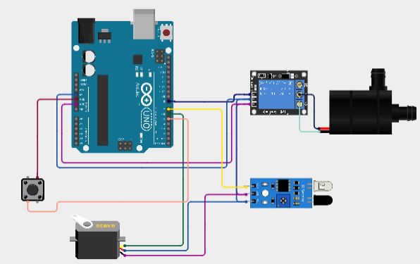

Fig.1: Circuit diagram

The smart toilet system utilizes an IR sensor, switches, a battery, a servo motor, a water pump, and a relay module to automate the flushing process. The IR sensor detects the presence of a user by emitting and receiving infrared light, sending a signal to the microcontroller when a person is detected. The microcontroller processes this signal and, based on programmed logic, activates the relay module. The relay module is responsible for controlling the water pump, which flushes the toilet by delivering water when triggered by the relay. The servo motor may be used to adjust or control a mechanical component such as a lever or gate that facilitates the flushing action. Manual switches are included to allow users or maintenance personnel to manually override the system, enabling direct control of the flushing mechanism if needed. The entire system is powered by a battery, which provides the necessary voltage to the microcontroller, sensors, servo motor, relay module, and water pump, ensuring seamless operation of the smart toilet.

**Technical Specification:**

**Arduino Uno:**  A Microcontroller is used ATmega328P. Its operating voltage is 5V. Digital I/O Pins is 14 (of which 6 provide PWM output) and Analog Input pins: 6. A Flash Memory is32 KB (of which 0.5 KB is used by the bootloader) and Clock Speed is 16 MHz.

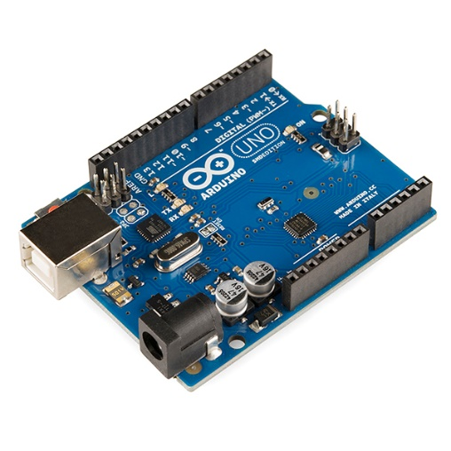

Fig.2: Arduino Uno

**Battery with BMS:** The battery used in the system is either Lithium-Ion with typical voltages of 3.7V depending on the configuration. Its capacity varies, with common options including 2000mAh or 3000mAh. The Battery Management System (BMS) includes crucial protection features such as overcharge protection, over-discharge protection, and short-circuit protection.

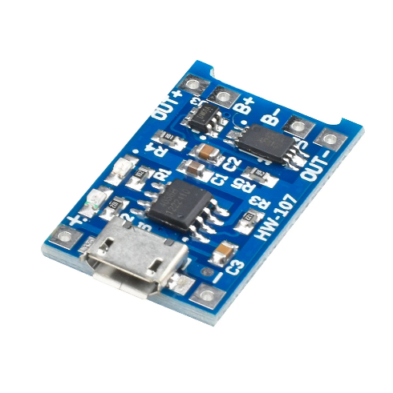

Fig.3: Battery with BMS

**IR sensor:** When selecting and integrating IR sensors into smart toilet systems, understanding their specifications is crucial to ensure optimal performance and compatibility. Typical Range: 850 nm to 950 nm (infrared light). Typical Range: 10 cm to 15 cm (adjustable). Operating voltage is Typical Range: 3.3V to 5V.

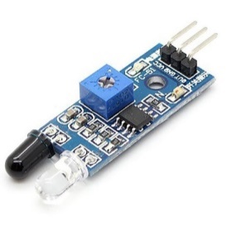

Fig.4: IR sensor

**Servo Motors:** servo motors are used to control the position of objects, rotate objects, move legs, arms or hands of robots, move sensors etc. An Operating Voltage: 4.8V to 7.2V. Servo motors have three wires: power, ground, and signal.



Fig.5: Servo motor

**Limit switch:** Limit switches are used to detect the presence or absence of an object. A limit switch is an electromechanical device operated by a physical force applied to it by an object.



Fig.6: Limit switch

**Water Pump:** A 12V DC water motor is a versatile and compact device designed for low-voltage applications. It typically features a flow rate between 0.5 to 3 liters per minute and can handle pressures up to 3 bar.

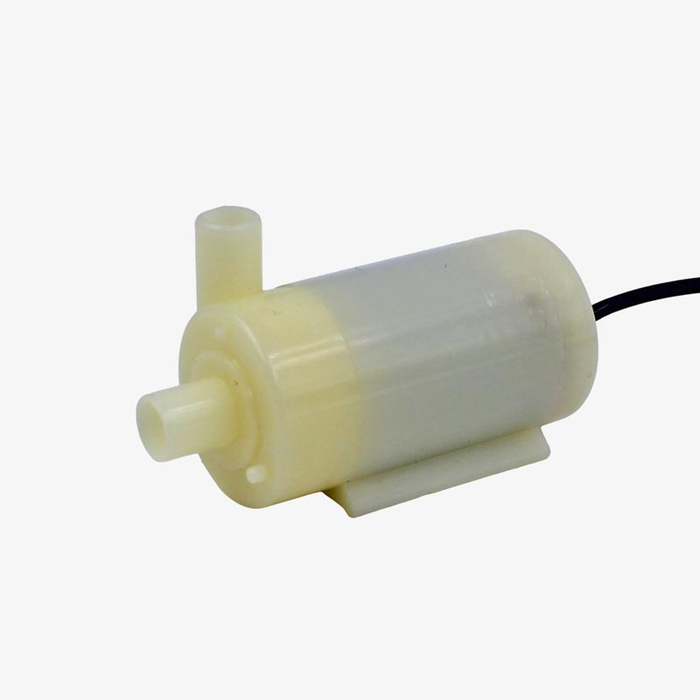

Fig.7: Water pump

**Relay Module**: A 12V relay module is designed to control high-voltage devices using a 12V DC control signal. It features electromechanical relays capable of handling currents up to 10A and voltages up to 250V AC or 30V DC. The module typically comes with multiple relays, ranging from 1 to 8, allowing for versatile switching capabilities. It is often used in automation systems and can be controlled by low-voltage signals from microcontrollers or other digital circuits. Indicator LEDs on the module provide visual feedback on the relay status.



Fig.8: Relay Module

1. **LITERATURE SURVEY**

The intelligent toilet, also known as an "electronic toilet" or "smart toilet," was first invented by Americans in 1964 and later introduced to Japan by Japanese businessmen. After undergoing design optimizations, the product gained popularity in Japan during the 1980s and 1990s. In the early 1990s, Japanese businessmen brought the intelligent toilet to China, marking the beginning of its domestic market. The development of intelligent toilets in China can be roughly divided into three stages. The first stage, known as the birth period, spanned from 1990 to 1995 and marked the initial introduction and adoption of intelligent toilets in China. This period laid the foundation for future growth. The second stage, from 1995 to 2015, was characterized by significant growth as intelligent toilets saw wider acceptance and technological advancements. The third stage began after 2015, a milestone year that marked the maturation of the domestic intelligent toilet industry, with a surge in innovation and adoption. The evolution of intelligent toilets underscores the growing emphasis on hygiene, convenience, and technological integration in restroom facilities, exemplifying how innovation can enhance everyday life.

AINIT 2020

Journal of Physics: Conference Series 1684 (2020) 012038

IOP Publishing

doi:10.1088/1742-6596/1684/1/012038

Elderly people, as well as people with disabilities, face many

mobility problems due to either bone system degradation or various

afflictions they suffer. Therefore, any solution that improves the

quality of life of these people is more than welcome. This paper

aims to present an approach for developing a smart toilet system

for ageing people and persons of all ages with

impairments/disabilities. Toilet4me is one of the most significant

projects that involve smart toilet development especially for senior

population and those with different disabilities who need an

intelligent toilet outside their homes. Unlike the previous solution

developed in iToilet project which led to a prototype for home-use

(including the ability to adjust the height and position of the toilet

and other auxiliary means by using several different technologies,

Toilet4me is now exploring the concept and viability of adapting

these technologies to semi-public spaces

The intelligent toilet, also known as an "electronic toilet" or "smart toilet," was first invented by Americans in 1964 and later introduced to Japan by Japanese businessmen. After undergoing design optimizations, the product gained popularity in Japan during the 1980s and 1990s. In the early 1990s, Japanese businessmen brought the intelligent toilet to China, marking the beginning of its domestic market. The development of intelligent toilets in China can be roughly divided into three stages. The first stage, known as the birth period, spanned from 1990 to 1995 and marked the initial introduction and adoption of intelligent toilets in China. This period laid the foundation for future growth. The second stage, from 1995 to 2015, was characterized by significant growth as intelligent toilets saw wider acceptance and technological advancements. The third stage began after 2015, a milestone year that marked the maturation of the domestic intelligent toilet industry, with a surge in innovation and adoption. The evolution of intelligent toilets underscores the growing emphasis on hygiene, convenience, and technological integration in restroom facilities, exemplifying how innovation can enhance everyday life. [1]

Elderly people and individuals with disabilities often face significant mobility challenges due to bone system degradation or various afflictions. Solutions that improve the quality of life for these individuals are highly valuable. This paper aims to present an approach for developing a smart toilet system specifically designed for aging individuals and persons of all ages with impairments or disabilities. One notable project in this domain is Toilet4me, which focuses on developing smart toilets for the senior population and those with different disabilities who require intelligent toilet facilities outside their homes. Unlike previous solutions that led to prototypes for home use, including adjustable height and position features, Toilet4me is now exploring the concept and viability of adapting these technologies to semi-public spaces. This initiative seeks to extend the benefits of smart toilets beyond the home, enhancing accessibility and convenience for a broader user base. [2]

References

Indian Railways, with its extensive network of 114,500 km of total track, 65,000 km of routes, and 7,500 stations, is a critical mode of transportation for millions of people. However, maintaining a healthy and hygienic environment while traveling is a significant concern, especially due to the waste disposal system currently in place. Train toilets traditionally dispose of human waste directly onto the tracks, causing sanitation issues and creating an unpleasant experience for passengers due to the waste on platforms and the resulting foul smell. This not only affects domestic travelers but also leaves a negative impression on foreign tourists. A proposed solution to this problem is the "Automatic Sewage Disposal System for Train," which aims to address the sanitation issues associated with train travel. This system employs two mechanisms: sewage disposal and track changing. In the sewage disposal mechanism, an ultrasonic sensor and a position sensor are used to manage waste disposal efficiently. The ultrasonic sensor detects the depth of the sewage tank, while the position sensor identifies the appropriate location for sewage disposal. Once the correct location is detected, a solenoid valve is activated, allowing for the controlled disposal of sewage. This innovative approach aims to enhance the hygiene standards of Indian Railways and improve the overall travel experience for passengers. [3]

Smart toilets, integrating advanced technology for enhanced hygiene, comfort, and efficiency, represent a significant innovation in restroom facilities. This paper explores the risks and benefits associated with smart toilets. The benefits include improved hygiene through self-cleaning features, enhanced comfort with adjustable settings, and health monitoring capabilities that can offer early detection of potential health issues. Additionally, smart toilets contribute to water conservation through efficient flush systems and reduce reliance on toilet paper. However, the adoption of smart toilets also presents risks, such as concerns about privacy and data security, high initial and maintenance costs, and potential technical reliability issues. Environmental impacts, including electronic waste and resource consumption, also warrant consideration. This analysis aims to provide a balanced overview of the advantages and challenges of smart toilets, highlighting the need for careful evaluation when integrating these advanced systems into everyday use. [4]

In today's world with the ever-increasing growth in the population of India, the hygiene of our country is endangered. Our Prime Minister Sir Narendra Modi has introduced "Swachh Bharat Abhiyan" Scheme to improve cleanliness in the country. Our project will definitely be a help to improve hygiene condition in India. It will create awareness among people in terms of "Toilet Management". The proposed system "Smart Toilet" is based on IoT, smell sensor, IR sensor, sonic sensor, RFID sensor. The smart toilet will take care of opening and closing of the toilet seat, the IR sensor tracks the dirt present on the toilet seat and raise an alarm, the cleanliness of the toilet will be improved by monitoring the sweeper's activity to maintain the hygiene of the toilet, it also will deal with water conservation. [5]

The paper underscores the importance of smart toilets for elderly and disabled individuals, with projects like Toilet4me extending benefits to semi-public spaces. In Indian Railways, the proposed "Automatic Sewage Disposal System for Train" aims to enhance hygiene through advanced sensors and automated mechanisms. Despite the benefits of smart toilets, such as improved hygiene and health monitoring, challenges like privacy concerns, high costs, and environmental impacts persist. The proposed "Smart Toilet" system, utilizing IoT and various sensors, aims to support India's "Swachh Bharat Abhiyan" scheme by improving hygiene and water conservation.

1. **CONCLUSION**

This paper has explored the development and implementation of smart toilets using microcontroller-based systems, with a focus on promoting hygiene and efficiency in public restrooms. By integrating advanced technologies such as IR sensors, switches, batteries, and servo motors, the proposed smart toilet system aims to support the "Swachh Bharat Abhiyan" scheme and improve cleanliness standards in India. The literature survey highlights the historical evolution of intelligent toilets, originating in the U.S. and gaining popularity in Japan and China. The emphasis on technological integration and innovation in restroom facilities has driven the widespread adoption of smart toilets, underscoring their importance in enhancing everyday life. The proposed system's features, including automated functionalities, personalized hygiene settings, health monitoring sensors, and water conservation mechanisms, offer significant improvements over traditional toilets. These advancements provide a superior user experience, enhance sanitation standards, and promote environmental sustainability.

The development of smart toilets using microcontroller-based systems has the potential to revolutionize public restroom facilities by promoting hygiene, accessibility, and efficiency. Continued innovation and thoughtful adoption of these advanced systems can significantly contribute to nationwide cleanliness initiatives and enhance the overall user experience in restroom facilities.

**Advantages of Smart Toilets**

* Self-Cleaning: Smart toilets often come with self-cleaning capabilities for the bowl, seat, and bidet nozzles, reducing the need for manual cleaning and ensuring a consistently sanitary environment.
* Touchless Operation: Features such as automatic flushing and touchless lid operation minimize contact with surfaces, reducing the spread of germs and bacteria.
* Integrated Sensors: Health monitoring sensors can track various health parameters such as weight, body temperature, and even urine analysis, providing valuable health insights.
* Early Detection: Continuous health monitoring can help in early detection of potential health issues.
* Efficient Flush Systems: Smart toilets often use dual-flush systems and precise water usage mechanisms, significantly reducing water consumption compared to traditional toilets.
* Leak Detection: Advanced sensors can detect leaks and notify users, preventing water wastage.

**Applications of Smart Toilets**

* Residential Use
* Public and Commercial Facilities
* Healthcare Settings
* Transportation
* Smart Cities

**REFERENCES**

[1] F Zakaria, J Ćurko, A Muratbegovic et al. (2018) Evaluation of a smart toilet in an emergency camp. International Journal of Disaster Risk Reduction.vol. 27, pp. 512-523.

[2] H Katano, K Yokoyama, Y Takei, H Matsuki et al. (2011) The study of the bacterial contamination in the spray water of electronic toilets and in the gluteal and inguinal regions due to splashing following spray water. Microbial Ecology in Health and Disease. vol. 25, pp. 8-14.

[3] Ying Huang et al. (2019) A novel multidimensional analysis of writing styles of editorials from China Daily and The New York Times. Lingua. vol. 235, pp. 87-96.

[4] Andreas Schumacher et al. (2016) A maturity model for assessing Industry 4.0 readiness and maturity of manufacturing enterprises. Elsevier B.V.Vol 52,pp. 161-166.

[5] KorhanKo et al. (2020) Is Support Vector Regression method suitable for predicting rate of penetration. Journal of Petroleum Science and Engineering.Vol 194,pp. 19-24.