**WATER SUSTAINABILITY & MANAGEMENT IN INDIA:**

**AN OVERVIEW OF CURRENT PRACTICES**

**Ms.Sreelakshmi A**

**Mr.Adith Pavi B**

**Ms.Arathi S Prasanth**

**Aslam K M**

**Ms.Ahalya H**

**Ms.Fathima Haneena C P**

(Dept .of Economics Holy Cross College, Kozhikode, Kerala)

**Dr.Vineeth Mathew**

(Assit.Professor, Dept .of Economics Holy Cross College, Kozhikode, Kerala)

**Abstract**

India, the world’s largest populated country faces great water sustainability issues like scarcity, inadequate clean drinking water, and mismanagement. This study on Water sustainability management systems discusses some of the current water management systems in India. Through the detailed review of literature, identified India’s water management strategies and the analysis reveals there must be a shift towards more sustainable approaches, including water harvesting, and wastewater reuse. The water sustainability is rooted in the understanding that the availability of water resources must meet the current needs of society without compromising the ability of future generations to meet their own needs. Achieving water sustainability requires a multifaceted approach that addresses issues of quantity, quality, and accessibility. This involves not only optimizing water use efficiency but also safeguarding water ecosystems, preventing pollution, and promoting equitable access to clean water. In conclusion water sustainability and management is a global issue, particularly in developing countries like India, where improper waste water management pose major threat to the society and local environment.

**Keywords:** Water sustainability, management systems, climate change, water governance, policy frameworks.

**Introduction**

Water sustainability and management constitute pivotal aspects of our global responsibility as custodians of the planet. It is crucial to underscore the significance of water in sustaining life and the urgent need for responsible management practices. Effective water management systems play a pivotal role in ensuring the sustainable use of water resources. These systems encompass a spectrum of strategies and technologies aimed at efficiently allocating, distributing, and utilizing water. From advanced irrigation techniques in agriculture to innovative wastewater treatment processes, the quest for sustainable water management involves harnessing technological advancements alongside adopting prudent policies and fostering community engagement. It is evident that, India’s journey towards water sustainability and effective management is ongoing. The commitment to this cause requires continuous innovation, education, and advocacy. Governments, businesses, communities, and individuals all play pivotal roles in shaping a water- secure future. Water conservation plays a pivotal role in preserving natural ecosystems. Aquatic habitats, from rivers to wetlands, are intricately linked to the availability and quality of water. Excessive withdrawals for human activities can disrupt these ecosystems, leading to habitat degradation and loss of biodiversity. Conservation measures, such as maintaining minimum flow levels in rivers and protecting wetlands, are crucial to safeguarding these delicate ecosystems. In urban areas, where water demand is particularly high, conservation measures can lead to significant benefits. Simple actions such as fixing leaks, using water-efficient appliances, and promoting public awareness about responsible water use contribute to reducing the strain on municipal water supplies. Water conservation in urban settings not only ensures a reliable water supply but also alleviates the energy and financial costs associated with water treatment and distribution.

India has adopted numerous approaches towards the sustainability and management of water, ranging from policy frameworks and institutional innovations to community-based initiatives and technological interventions. This study aims to critically examine India's approaches towards water sustainability and management.

**Objective**

To understand the methods and approaches in India for the effective water management to attain the sustainability.

## Methodology

This study is mainly based on secondary data and this information is used to describe the concept of sustainable and water management system India. Secondary data collected from published sources like books, journals articles, websites etc.

# Water Management Systems in India

Water management systems in India are a critical aspect of the nation's development and sustainability efforts. With a population exceeding 1.3 billion and diverse geographic conditions, India faces significant challenges in ensuring equitable access to water resources while mitigating the risks of water scarcity, pollution, and natural disasters. Through technology and policy, India strives for holistic water management to meet its diverse demands.

Following are the three major water management systems in India:

**1. Drip irrigation**

Drip irrigation is an efficient irrigation method that delivers water directly to the root zone of plants, minimizing water wastage through evaporation or runoff. In India, drip irrigation systems are increasingly adopted in agriculture, particularly for water-intensive crops like fruits, vegetables, and cash crops. This method helps conserve water resources, improve crop yield, and reduce the pressure on groundwater supplies.

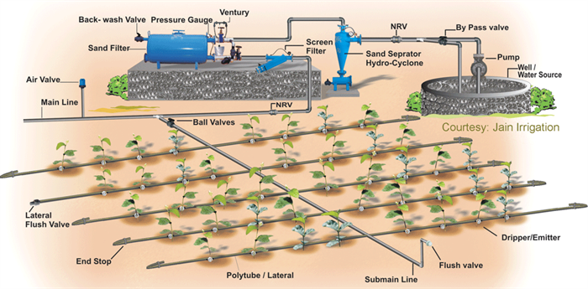

Drip irrigation systems circulate water across crop fields using a network of tubes or pipes, allowing water to slowly trickle out closer to the roots of each plant. This system is more efficient & effective means of water management by minimal water usage, waste and evaporation, when compared to other irrigation systems. Drip irrigation systems can also receive water additions such as fertilizers and this procedure also improves fertilizer efficiency by delivering nutrients near to the root system.

**2. Water reuse and Recycling**

Increasing water scarcity and pollution concerns, water reuse and recycling have become crucial for sustainable water management in India. Municipalities and industries are implementing wastewater treatment plants to treat sewage and industrial effluents, producing reclaimed water suitable for non- potable uses such as irrigation, industrial processes, and groundwater recharge. This practice reduces freshwater demand, minimizes pollution, and conserves valuable water resources.

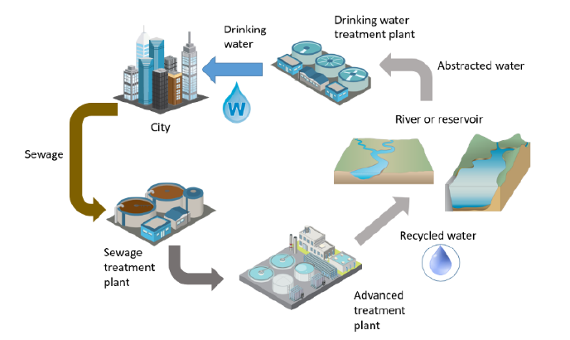

In India, water and wastewater sec- tor, especially wastewater reuse, has recently started getting attention due to growing water problems especially in water scarce cities. Urban local bodies and municipalities have implemented reclaimed water reuse projects in many water sensitive cities in the country. However, the challenges such as lack of planning and feasibility studies, incentives, social acceptance, regulatory guidelines and poor institutional framework have made it difficult to sustain such projects.

**3. Community-based water management**

Community-based water management initiatives empower local communities to actively participate in water resource management and conservation efforts. Through decentralized governance structures, community members collaborate to implement water-saving techniques, maintain water infrastructure, and resolve water-related conflicts. These initiatives promote social equity, build resilience to climate change impacts, and ensure the sustainable utilization of water resources at the grassroots level.

**Waste water Treatment Methods**

India's wastewater treatment landscape is a complex and multifaceted endeavour, encompassing a range of conventional and advanced technologies to purify wastewater for safe disposal or reuse. The country's treatment infrastructure is constantly evolving to address the growing concerns of urbanization and industrialization, which have led to increased pollution and environmental degradation. To mitigate these concerns, India is focusing on upgrading its treatment infrastructure through a combination of physical, chemical, and biological processes. These techniques aim to remove pollutants, contaminants, and pathogens from wastewater, thereby safeguarding public health and the environment. India is also exploring advanced technologies to improve wastewater treatment efficiency and effectiveness.

**1. Membrane Bioreactors**

This method use membranes to separate biological solids from wastewater, providing a more efficient and effective treatment process. Membrane Bioreactors (MBRs) - a fascinating technology that combines the benefits of biological treatment and membrane filtration to produce high-quality effluent. A Membrane Bioreactor is a hybrid treatment process that combines biological treatment with membrane filtration. It consists of a bioreactor, where microorganisms break down organic matter, and a membrane module, where the treated water is filtered through a semipermeable membrane.

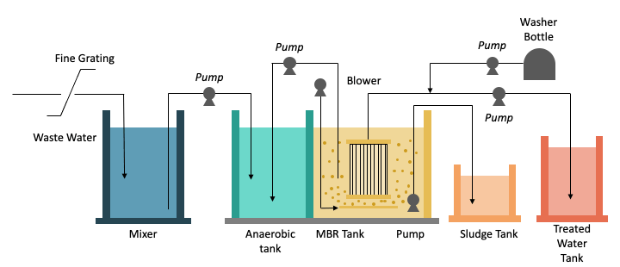

Firstly, Wastewater enters the bioreactor, where microorganisms break down organic matter. Then the treated water passes through the membrane, which filters out suspended solids and bacteria. The filtered water enters the clarifier, where any remaining solids settle to the bottom. The clarified water is pumped out of the system, ready for reuse or discharge. The microorganisms in the bioreactor consume organic matter and produce carbon dioxide, biomass, and water. The membrane acts as a filter, separating the treated water from the biomass and other solids.The air supply helps maintain optimal conditions for microbial growth and activity.The clarified water is free of suspended solids and bacteria, making it suitable for reuse or discharge.

**2. Activated sludge process**

The activated sludge process is a widely used biological method for treating wastewater in India. In this process, wastewater is mixed with a culture of microorganisms in an aerated tank. These microorganisms, primarily aerobic bacteria, feed on organic pollutants present in the wastewater, breaking them down into simpler, less harmful substances. The aeration ensures sufficient oxygen supply for the bacteria to thrive and efficiently degrade organic matter.

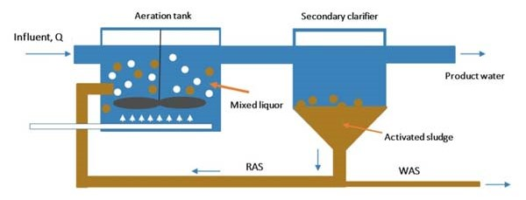

Microorganisms in the aeration tank consume organic pollutants and produce biomass, carbon dioxide, and water. The activated sludge is made up of these microorganisms, which are suspended in water. The activated sludge is returned to the aeration tank to maintain the optimal balance of microorganisms. The treated wastewater is clarified, and the suspended solids are removed.

**3. ADVANCED OXIDATION PROCESSES** Advanced Oxidation Processes represent an innovative approach to wastewater treatment, offering a complementary solution to conventional methods. Advanced Oxidation Processes utilize powerful oxidants, such as hydrogen peroxide, ozone, or ultraviolet (UV) radiation, to degrade organic pollutants and harmful contaminants in wastewater.

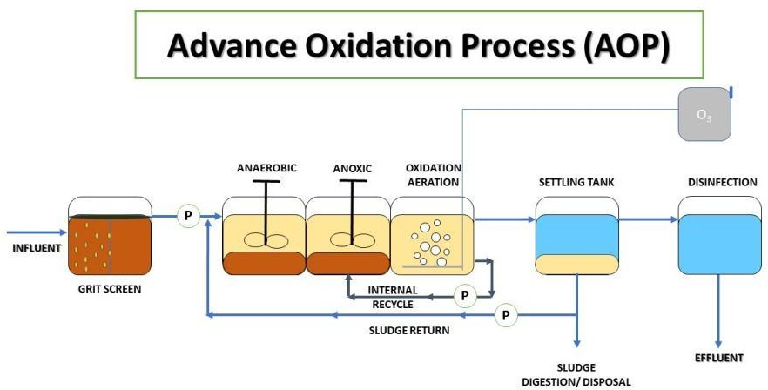The implementation of Advanced Oxidation Processes begins with the addition of the selected oxidant to the wastewater stream, either directly or through injection points within the treatment system. Once introduced, the oxidants undergo chemical reactions that generate highly reactive hydroxyl radicals (·OH), which are capable of oxidizing and breaking down a wide range of organic compounds.

**RESULTS**

By the adaptation of various advanced methods for water sustainability and its management, India has made notable advancements in improving its water sustainability and management.

**1. Water Conservation**

* Water conservation efforts have helped to reduce water consumption by 15% between 2010 and 2015. (Source: Ministry of Water Resources).
* India's per capita water availability has increased from 1,342 cubic meters in 1990 to 2,000 cubic meters in 2019. (Source: Ministry of Water Resources).

**2. Water infrastructure Development**

* The total length of irrigation canals in India has increased from 2.5 million kilometers in 2000 to 3.5 million kilometers in 2019 (Source: Ministry of Water Resources).
* The total installed capacity of water treatment plants in India has increased from 10,000 million liters per day (MLD) in 2000 to 20,000 MLD in 2019 (Source: Ministry of Water Resources).

**Water Supply and Sanitation**

* The percentage of rural population with access to improved water sources has increased from 42% in 2000 to 65% in 2019 (Source: World Bank).
* The percentage of urban population with access to improved sanitation facilities has increased from 65% in 2000 to 82% in 2019 (Source: World Bank).

**Water Harvesting and Recharge**

* India's water harvesting and recharge capacity has increased by 30% between 2010 and 2015 (Source: Ministry of Water Resources).
* The total area under water harvesting and recharge schemes has increased from 1.5 million hectares in 2000 to 3.5 million hectares in 2019 (Source: Ministry of Water Resources).

**Water Efficiency and Leak Reduction**

* India's water distribution losses have reduced by 15% between 2010 and 2015 (Source: Ministry of Water Resources).
* The country's water efficiency has improved by 10% between 2010 and 2015 (Source: Ministry of Water Resources).

**Climate Resilience and Adaptation**

* India's climate-resilient water infrastructure development has increased by 20% between 2010 and 2015 (Source: Ministry of Water Resources).
* The country's adaptation efforts to climate change impacts on water resources have increased by 15% between 2010 and 2015 (Source: Ministry of Water Resources).

**Conclusion**

India's water sustainability and management systems have undergone significant transformations over the years. While there is still much work to be done to address the country's ongoing water challenges, the progress made is notable. India's water conservation efforts have helped to reduce water consumption and increase per capita water availability. The country has made significant investments in water infrastructure development, including the construction of new dams, canals, and treatment plants. Water harvesting and recharge schemes have been implemented to improve water availability and reduce the reliance on groundwater. Efforts have been made to improve water efficiency and reduce leakages in the distribution system. Climate resilience and adaptation efforts have been undertaken to address the impacts of climate change on water resources. International cooperation and funding have played a crucial role in supporting India's water sustainability and management efforts.

**References**

1. Ashok Gulati, Bharat Sharma, Pritha Banerjee, Gayathri Mohan (2019): Getting More from Less, Story of India’s Shrinking Water Resource. (ICRIER)
2. Mukta Sapkota, Meenakshi Arora (2014): An Overview of Hybrid Water Supply Systems in the Context of Urban Water Management: Challenges and Opportunities.
3. Sakshi Gupta (2024): Sustainable Water Management in India.
4. Ministry of Jal Shakti (2022): Sustainable Development & Efficient Management of Water Resources.
5. **Ekansha Khanduja, Upasana Negi, Kartikey Chaturvedi, Saiba Gupta, Nitin Bassi (2023) :** Ripples: India’s Sustainable Water Management Story
6. https://jalshakti-dowr.gov.in/