**DISTRIBUTED RAY TRACING WITH ARTIFICIAL INTELLIGENCE**

**Saad Malick *1, Prince Mishra*2, Dr. Shalini Lamba *3**

*1,2 Student, Computer Science, National P.G. College, Lucknow, Uttar Pradesh, India

*3 Head of Department, Computer Science, National P.G. College, Lucknow, Uttar Pradesh, India

**ABSTRACT**

Combining Artificial Intelligence (AI) with ray tracing in distributed systems represents a major leap forward in computer graphics and computing efficiency. This paper explores how merging AI techniques with ray tracing algorithms, when used in distributed systems, can improve both rendering performance and image quality. We discuss the challenges, methodologies, and potential applications of this integration, offering a detailed guide for future research and development in this exciting area. Combining AI with ray tracing, especially within distributed systems, has the potential to revolutionize industries such as gaming, film production, and scientific visualization by making high-quality rendering more feasible and efficient.

**INTRODUCTION**

Ray tracing is a powerful technique for creating highly realistic images by simulating the way light interacts with objects. However, its computational demands make real-time rendering challenging. By integrating AI, particularly machine learning, with ray tracing, we can enhance both the speed and quality of rendering. Distributed systems, which allow for parallel processing across multiple computers, further amplify these benefits. Recent advancements in AI and distributed systems have opened new possibilities in various fields, including computer graphics. Integrating AI with ray tracing addresses the significant computational demands of producing realistic images. Distributed systems, which have long been a cornerstone of modern computing, enable efficient processing by distributing tasks across multiple machines. With the rise of AI, these systems have become even more crucial, supporting complex machine learning algorithms and real-time data processing.

Ray tracing simulates how light travels through a scene, interacting with objects to create lifelike images. Despite its ability to produce stunning visuals, it requires considerable computational resources.

**LITERATURE REVIEW**

Recent studies have shown that integrating AI with ray tracing can significantly enhance the performance and accuracy of distributed systems. For example, the Ray framework developed at UC Berkeley employs a dynamic task graph model to improve the handling of computational tasks, especially in reinforcement learning scenarios [1].

Further research has explored the use of AI in various contexts, including real-time rendering and scientific simulations. Innovative algorithms that leverage AI to optimize ray tracing have emerged, reducing computational overhead and improving rendering speeds. These advancements have implications for industries that rely on high-quality visualizations, such as film and virtual reality. [2]

**TRUSTWORTHY DISTRIBUTED AI SYSTEMS**

Recent research has focused on making distributed AI systems more robust, private, and fair. As these systems transform big data computing, they also introduce new security and fairness challenges. Studies emphasize the importance of developing defenses against attacks like evasion and poisoning, while also ensuring privacy and fairness in AI models.[1] Addressing these issues is essential for the widespread adoption and trustworthiness of distributed AI systems.

**DISTRIBUTED DEEP LEARNING**

Distributed deep learning has gained attention for its ability to manage large datasets and complex computations efficiently. This approach distributes data and algorithms across multiple machines, improving both performance and accuracy. Research has categorized distributed machine learning algorithms into traditional, deep learning, and deep reinforcement learning, outlining their limitations and future research directions [2]. These insights are crucial for advancing distributed deep learning and its applications in AI-enhanced ray tracing.

Ray: A Distributed Framework for AI Applications

Ray is a distributed framework designed to meet the high demands of next-generation AI applications. These applications often involve continuous interaction with their environment, requiring high performance and flexibility. Ray addresses these needs by providing a scalable and efficient framework for distributed AI.[1][6] Its design makes it an excellent platform for integrating AI with ray tracing and developing advanced rendering techniques. This framework can be utilised to make the following graphical computation and with the help of POV Raytracer it is evident that single user systems’ tracing is limited and can create bottlenecks in the imagery being forged.

|  |  |  |  |  |  |  |  |  |
| --- | --- | --- | --- | --- | --- | --- | --- | --- |
| **Sno.** | **Image handle** | **Pixels** | **Rays** | **Rays Type** | **Shadow Ray Tests** | **Success** | **Time, Threads** | **Image Resolution** |
| **1** | **Sphere.pov** | **480K** | **503770** | **S.I.** | **188577** | **1290** | **0.408, 2** | **800 X 600** |
| **2** | **Fbuf2.pov** | **480K** | **480K** | **S.I.** | **90K** | **0** | **0.266, 2** | **800 X 600** |
| **3** | **adap_samp.pov** | **480K** | **494123 (~500k)** | **S.I.** | **294891** | **6291** | **0.466, 2** | **800 X 600** |

***Samples:***

***1. Sphere.pov ->***

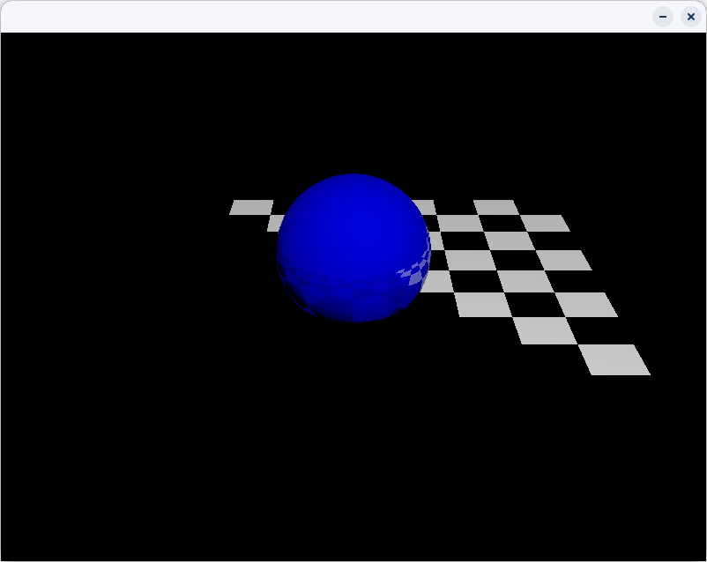

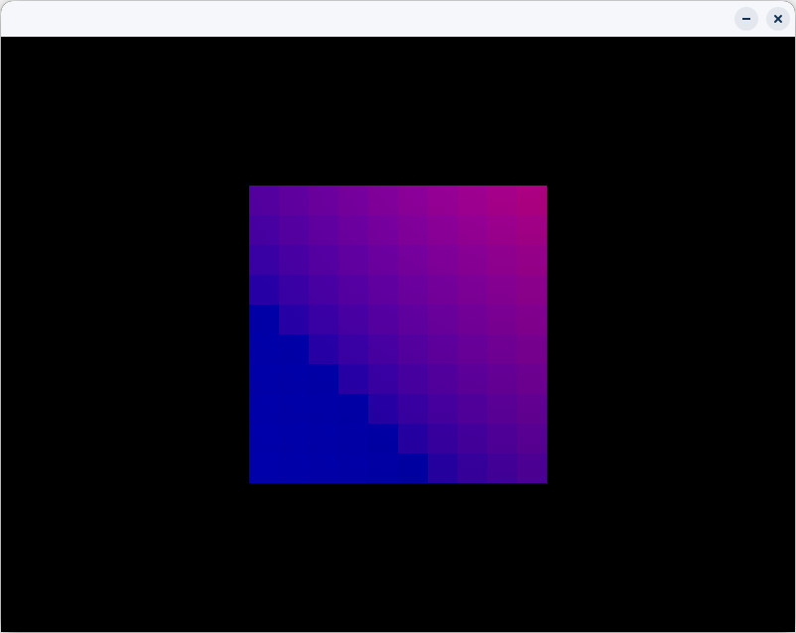***2****.* ***Fbuf2 ->***

***3. Adap_samp.pov***

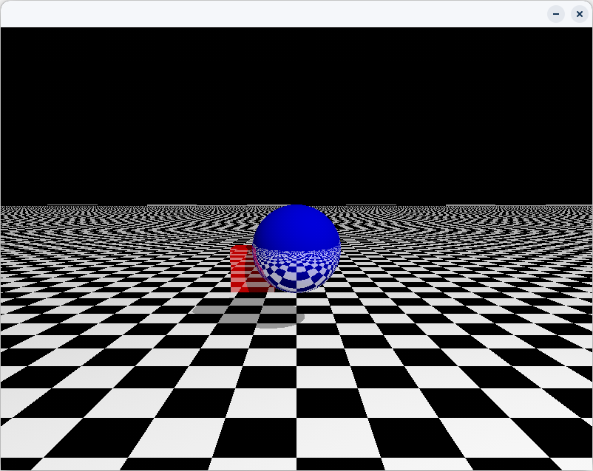

The above analysis was done on a single user system, with the help of POV Raytracer (version 3.71) the below findings tell us something about the performance input has a role in:

***Processing Time:***

- The frame buffer technique (Fbuf2.pov) achieved the quickest processing time at 0.266 seconds, likely due to its handling of just one ray per pixel and the absence of recorded successes.

- On the other hand, adaptive sampling (adap_samp.pov) took 0.466 seconds to process, as it carried out the highest number of shadow ray tests and recorded the most successes.[3]

***Ray and Shadow Ray Tests:***

- Adaptive sampling performed the most shadow ray tests (294,891) and had the highest success rate (6,291), indicating a more thorough approach in producing accurate images.

- In contrast, the frame buffer technique, although faster, conducted fewer shadow ray tests and had no recorded successes, suggesting it may be less accurate but more efficient in simpler scenes or when speed is a priority. [4]

***Effectiveness:***

- Adaptive Sampling proves to be the most effective for scenarios requiring high precision, given its high success rate and extensive shadow ray testing, despite the slightly longer processing time.

- The Frame Buffer technique, while advantageous for quick rendering, may sacrifice accuracy for speed, making it ideal for scenarios where rapid processing is essential. [5][7]

**PROBLEM STATEMENTS**

The primary challenge with AI-integrated ray tracing lies in the significant computational power needed to simulate realistic lighting effects.[7] Traditional ray tracing methods, although capable of producing high-quality visuals, can be extremely slow and resource-intensive, particularly when rendering complex scenes with intricate light interactions. This makes real-time applications, such as video games and virtual reality, difficult to achieve at the desired level of quality.[8] Additionally, ray tracing algorithms often struggle with efficiently managing memory and processing power, leading to performance bottlenecks. Distributed systems offer a potential solution by distributing the workload across multiple nodes.[9][12] However, this introduces its own set of problems, such as ensuring data consistency across the nodes, handling synchronization issues between tasks, and managing network latency, which can impact performance.[10][11] Moreover, the dynamic allocation of resources, especially in heterogeneous environments, poses another layer of complexity, requiring careful management to prevent underutilization or overloading of computational nodes. Balancing accuracy and speed, especially in real-time rendering, remains a significant challenge that must be addressed for practical AI-driven ray tracing systems.

**DISCUSSIONS AND SOLUTION**

**Distributed Systems for Load Balancing:** By distributing the computational tasks across multiple nodes in a distributed system, the immense processing load required for ray tracing can be spread out. This allows the system to handle complex scenes more efficiently, improving rendering times without compromising visual quality. Task partitioning ensures that each node focuses on a specific part of the image or scene, leading to faster and more scalable rendering. Proper synchronization and load balancing techniques can mitigate issues related to data consistency and synchronization, while latency-sensitive algorithms can manage network delays effectively.

**Adaptive Resource Allocation:** One solution is to adaptively allocate resources based on the scene's complexity. For simpler scenes, techniques like the frame buffer method can be used, which require fewer resources and render quickly. For more intricate scenes, adaptive sampling, which produces more precise visuals, can be employed with greater computational power. By dynamically adjusting the resource allocation, the system can strike a balance between speed and accuracy, optimizing performance based on the scene being rendered.

**Efficient AI Algorithms:** Leveraging AI-based optimization algorithms can significantly reduce the computational load of ray tracing. For instance, machine learning techniques can be used to predict light behavior in a scene, allowing the ray tracing engine to focus only on relevant rays, thereby reducing unnecessary calculations. AI can also improve memory management by predicting which parts of the scene need more processing power and focusing resources accordingly.

**Hybrid Rendering Techniques:** A hybrid approach, combining traditional rasterization with ray tracing, can also be implemented to reduce the computational burden. While rasterization can handle simpler parts of the scene like textures and shading, ray tracing can focus on more complex aspects such as reflections and refractions, optimizing performance while maintaining high visual fidelity.

**Asynchronous Task Management:** By implementing asynchronous task management, the distributed system can continue processing without waiting for slower tasks to complete. This ensures that bottlenecks are minimized, and tasks are processed in parallel as much as possible. Techniques like pipeline parallelism can be introduced, where one stage of rendering is processed while another is being computed.

**Cloud and Edge Computing:** Cloud-based solutions, leveraging the power of edge computing, can offload heavy computations from local systems to remote, powerful servers. By distributing the ray tracing tasks across geographically distributed servers, latency can be minimized, and computational power can be maximized. Cloud environments allow for scalability, where more resources can be added as needed based on the complexity of the scene.

**Improved Synchronization Protocols:** Advanced synchronization protocols can ensure that tasks distributed across multiple nodes are processed in harmony without introducing delays. Techniques like task pipelining and checkpointing can help manage node failures and ensure consistent progress in rendering without data loss.

In essence, distributed systems and AI can work together to optimize ray tracing performance, ensuring high-quality visuals without the excessive computational delays typically associated with traditional methods. These solutions can make AI-enhanced ray tracing feasible for real-time applications, such as gaming, virtual reality, and cinematic rendering, while improving scalability and efficiency.

**CONCLUSION:**

Distributed ray tracing enables the parallel handling of complex rendering tasks, which helps eliminate bottlenecks and accelerate processing times. When integrated with AI, this method can further enhance resource allocation, predictive analysis, and error correction, making the rendering process both smarter and more efficient. AI can automatically adjust ray tracing settings according to the complexity of the scene, ensuring that computational resources are used in the most effective way. In the case of adaptive sampling, AI can identify regions of the image that require more detailed rendering, allowing computational power to be concentrated where it’s most needed. This results in quicker, more precise rendering with minimal waste of resources.

**FUTURE SCOPE:**

The synergy between AI and distributed ray tracing offers transformative potential for advancing graphics technology. As AI tools evolve, they promise to significantly enhance the performance and capabilities of distributed ray tracing systems.

In fields such as gaming and virtual reality, AI-enhanced distributed ray tracing could enable the creation of highly realistic and interactive environments with real-time rendering. AI could also customize graphics to fit individual user preferences and system capabilities.

In summary, integrating AI with distributed ray tracing is expected to bring about substantial improvements in rendering efficiency, image clarity, and system scalability, offering new possibilities for engaging and visually stunning applications across various industries.

**REFERENCES**

[1] Moritz, P., Nishihara, R., Wang, S., et al. (2018). Ray: A Distributed Framework for Emerging AI Applications. arXiv. This framework helps us understand how distributed systems can improve computational tasks.

[2] Usher, W., Wald, I., Amstutz, J., et al. (2023). Scalable Ray Tracing Using the Distributed Frame Buffer. arXiv. This paper offers insights into how scalable algorithms enhance ray tracing efficiency.

[3] Shirley, P., & Morley, R. K. (2003), Realistic ray tracing, *AK Peters/CRC Press.*

[4] Pharr, M., Jakob, W., & Humphreys, G. (2016), Physically based rendering: From theory to implementation, *Morgan Kaufmann.*

[5] Veach, E. (1997), Robust Monte Carlo methods for light transport simulation, *Stanford University.*

[6] Nishihara, R., Moritz, P., Wang, S., Tumanov, A., Liaw, R., Liang, E., Elibol, M., Yang, Z., Paul, W., Jordan, M. I., & Stoica, I. (2017), Ray: A Distributed Framework for Emerging AI Applications, *arXiv*.

[7] Kajiya, J. T. (1986), The rendering equation, *ACM SIGGRAPH Computer Graphics*, 20(4), 143-150.

[8] Wald, I., Woop, S., Benthin, C., Johnson, G. S., & Ernst, M. (2014), Embree: A kernel framework for efficient CPU ray tracing, *ACM Transactions on Graphics (TOG)*, 33(4), 1-8

[9] Gribel, C. J., Doggett, M., & Akenine-Möller, T. (2011), Analytical motion blur rasterization with compression, *High-Performance Graphics*, 163-172.

[10] Beyer, J., Hadwiger, M., & Pfister, H. (2014), A survey of GPU-based large-scale volume visualization..

[11] Wald, I., Friedrich, H., Knoll, A., & Hansen, C. D. (2009), Interactive isosurface ray tracing of time-varying tetrahedral volumes, *IEEE Transactions on Visualization and Computer Graphics*, 15(3), 386-399.

[12] Benthin, C., Wald, I., Woop, S., Ernst, M., & Mark, W. R. (2012), Combining single and packet-ray tracing for arbitrary ray distributions on the Intel MIC architecture, *IEEE Transactions on Visualization and Computer Graphics*, 18(9), 1438-1448.