**DETECTION OF STRESS IN MENTAL ILLNESS USING MACHINE LEARNING**

**Raja Packiam P1, Thulasimani K2**

1(P. G. Student, Department of Computer Science and Engineering, GCE,Tirunelveli)

2(Professor, Department of Computer Science and Engineering, GCE, Tirunelveli)

**ABSTRACT**

The major goal of this study is to use vivid Machine Learning and Image Processing methods to identify stress in the human body. Human facial expressions convey a lot of information visually rather than articulately. Facial expression being a important mode of communicating human emotions. Expressions and emotions go hand in hand; special combinations of face muscular actions reflect a particular type of emotion. If further prediction is needed, then the computationally slower Haar cascade feature extraction is performed and a class prediction is made with a trained Densenet algorithm. Face recognition technology has many applications, but they are generally limited to the understanding of human behavior, the detection of mental disorders, and synthesizing human expressions. Haar Cascade is a feature- based face (object) detection algorithm to detect face (object) from images. A cascade function is trained on lots of positive and negative images for detection. The emotion expression of a song and even more importantly its emotional impression on the listener is often underestimated in the domain of music preferences. People tend to listen to music based on their mood and interests. It is widely known that humans make use of facial expressions to express themselves.

**Keywords:** Stress, Facial Expression,Stress prediction, Haar Cascade , Denset Algorithm.

**…**…………………………..****************************……………………………

1. **INTRODUCTION**

Stress management systems are necessary for detecting stress levels that affect our socio-economic situation. According to the World Health Organization, stress is a mental health disorder that affects one out of every four people (WHO). Mental and financial troubles, as well as a lack of clarity at work, bad working relationships, despair, and, in extreme situations, death, are all symptoms of human stress. This necessitates the provision of therapy to help stressed people manage their stress. While it is impossible to totally eliminate stress, taking preventative measures may help you cope. Only medical and physiological peoples can now determine whether or not someone is depressor (stressed). Interpersonal interaction is oftentimes intricate and nuanced, and its success is often predicated upon a variety of factors. These factors range widely and can include the context, mood, and timing of the interaction, as well as the expectations of the participants. This technique relies primarily on individual responses; people will be hesitant to communicate whether or not they are worried. Automatically detecting stress lowers the likelihood of health problems and improves society's well-being. This involves the creation of a scientific approach for assessing stress levels in people using physiological markers. Since stress is such a significant societal contribution, a variety of approaches for detecting it have been investigated. It enhances people's quality of life, according to Ghaderi Tal. Stress was assessed using data from respiration, heart rate (HR), face electromyography (EMG), Galvanic skin response (GSR) foot, and GSR hand, with the finding that parameters related to the respiratory process are critical in stress detection. MariaViqueira et al. present a method for anticipating mental stress that relies only on GSR as a physiological sensor and uses a standalone stress detecting device. Electrocardiograms alone were utilized by David Liu and colleagues to predict stress levels (ECG). The effectiveness of multimodal sensors in detecting stress in working individuals is investigated experimentally. Sensor data from pressure distribution, heart rate, blood volume pulse (BVP), and electro dermal activity is used in this investigation(EDA). In addition, an eye tracker sensor is used, which analyses eye movements in connection with stressors such as the Stroop word test and information regarding pick-up tasks.

Humans can quickly and even subconsciously assess a multitude of indicators such as word choices, voice inflections, and body language to discern the sentiments of others. This analytical ability likely stems from the fact that humans share a universal set of fundamental stress like emotions.The input image is given to the system, emotions are detected.The results are evaluated using various metrics at the macro and micro levels and indicate that the trained model detects the status of emotions based on social interactions.The main goal of the system is to analyze the mental stress through physiological data using machine learning in different positions and moods. Different pre-processing techniques can be used for stress detection.

**2.LITERATURE REVIEW**

**2.1.Natural Language Processing (NLP) for Stress Detection**

**2.1.1.Sentiment Analysis**

De Choudhury et al. (2013) used sentiment analysis on social media posts to detect stress and depression. Techniques such as bag-of-words, TF-IDF(Term Frequency-Inverse Document Frequency) Term Frequency - Inverse Document Frequency (TF-IDF) is a widely used statistical method in natural language processing and information retrieval. It measures how important a term is within a document relative to a collection of documents, and word embeddings were utilized.Traditional approaches (e.g., bag-of-words, TF-IDF) and advanced methods (e.g., word embeddings, BERT).Advanced NLP models can detect subtle emotional nuances in text, aiding in early stress detection.

**2.1.2. Emotion Detection**

Calvo and D'Mello (2010) reviewed affect detection models, highlighting the use of SVMs (Support Vector Machine)and RNNs(Recurrent Neural Network) for emotion classification. SVMs, RNNs, and transformer-based models. A support vector machine (SVM) is a type of supervised learning algorithm used in machine learning to solve classification and regression tasks; SVMs are particularly good at solving binary classification problems, which require classifying the elements of a data set into two groups. A recurrent neural network (RNN) is a deep learning model that is trained to process and convert a sequential data input into a specific sequential data output. Emotion detection in text provides insights into an individual's stress levels, with RNNs and transformers showing high accuracy.

**2.2.Multimodal Approaches to Stress Detection**

**2.2.1.Audio and Video Analysis**

Jaiswal et al. (2019) used CNNs and LSTMs to analyze speech and facial expressions for stress detection. Speech analysis, facial expression recognition, CNNs(Convolutional Neural Network), LSTMs(Long Short Term Memory) A convolutional neural network (CNN) is a type of artificial neural network used primarily for image recognition and processing, due to its ability to recognize patterns in images. Long short-term memory (LSTM) is a type of recurrent neural network (RNN) aimed at dealing with the vanishing gradient problem present in traditional RNNs. Its relative insensitivity to gap length is its advantage over other RNNs, hidden Markov models and other sequence learning methods.. Audio and video data provide additional layers of information, enhancing the reliability of stress detection models.

**3.METHODOLOGY**

**3.1. Block Diagram**

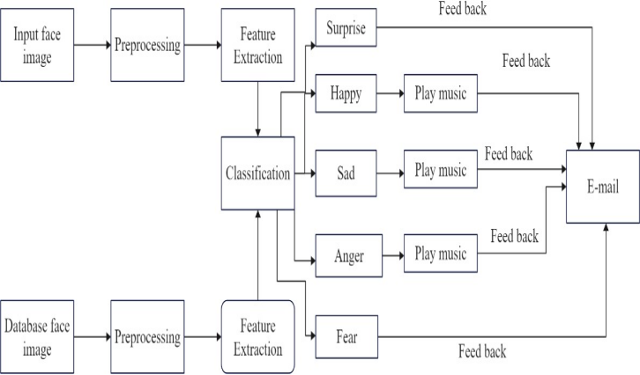

The input face image will show infront of the camera and next it will the image will preprocessing and the feature extraction is done and after the classification is occurred and the classification is follows as human facial expressions as surprise,happy,sad,anger and fear of the expression will be detected and if its sad means it will play the music and atlast it will give the feedback to the e-mail.

**3.2. Data acquisition**

Data acquisition refers to the process of collecting and gathering information from various sources, including camera.In the context of detecting mental stress through face recognition using machine learning, data acquisition invovles capturing images of individual’s faces.

**3.3. Frame pre-processing**

In the context of image or video processing, frame pre-processing refers to a set of techniquesapplied to individuals frames of a video or image before any further analysis or processing is done. The purpose of frame. -preprocessing is to enchance the quality of the image or video, remove distortions that may be present, and make the data more suitable for analysis or further processing.

# **3.4. Face detection**

Face detection is the process of identifying and locating human faces in an image or video stream. It is crucial step in many computer vision application including stress detection in mental illness using machine learning. The haar cascade algorithm is the popular method for face dection that utilises machine learning techniques.

**3.5. Emotion determination**

Emotion determination using a CNN(convoluational neural network) structure can be useful in detecting stress in mental illness using machine learning. To begin, a dataset of emotions and stress levels in individuals with mental illness would need to be collected.this dataset would be used to train the cnn to recognize patterns in the data that are associated with different emotions and levels of stress. Once the CNN has been trained, it can be used to classify new datbase on its emotional content and level of stress**.**

**3.6. Disorder classification and prediction**

Here the positive ant the negative emotions are determine through face recoginition.The positive emotions such as Happy, Surprise and the negative emotions such as Sad, Angry, Disgust, Fear are detected.

**4. PROPOSED SYSTEM**

A proposed system for detecting stress in mental illness using machine learning would involve collecting data from various sources like clinical assessments, self-reports, and physiological sensors. This data would undergo preprocessing and feature engineering to extract relevant features indicative of stress. Machine learning models, such as decision trees or neural networks, would then be trained on this data to predict stress levels. The trained model would be deployed for real-time inference, with mechanisms in place for model validation, result interpretation, and continuous monitoring to ensure accuracy and reliability in stress detection, facilitating personalized interventions and support for individuals with mental illness.

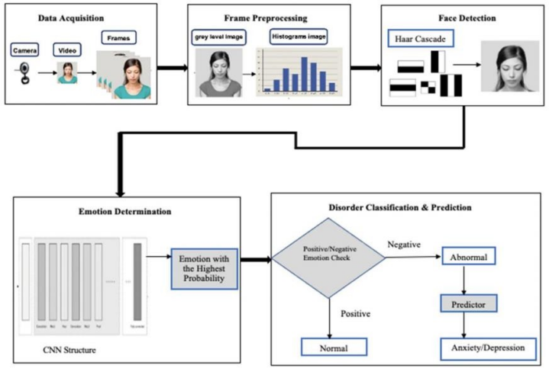

**4.1. HAAR CASCADE ALGORITHM**

Haar Cascade is a feature-based object detection algorithm to detect objects from images. A cascade function is trained on lots of positive and negative images for detection. The algorithm does not require extensive computation and can run in real-time.

Euclidean Distance = sqrt{(x_2 - x_1)^2 + (y_2 - y_1)^2}

Haar-like feature = sum of pixels in white region - sum of pixels in black region.

**4.2. DENSENET ALGORITHM**

Dense Net was developed specifically to improve the declined accuracy caused by the vanishing gradient in high-level neural networks. In simpler terms, due to the longer path between the input layer and the output layer, the information vanishes before reaching its destination.

**5.EXPECTED OUTCOME**

•An image processing and classification method has been implemented in which face images are used to train a dual classifier predictor that predicts the seven basic human emotions given a test image.

•The predictor is relatively successful at predicting test data from the same dataset used to train the classifiers.

•However, the predictor is consistently poor at detecting the expression associated with contempt.

•This is likely due to a combination of lacking training and test images that clearly exhibit contempt, poor pretraining labelling of data, and the intrinsic difficulty at identifying contempt.

**6. IMPLEMENTATAION**

**6.1. Data Collection**

Gather data sources such as physiological signals (heart rate, skin conductance), behavioral patterns (sleep patterns, activity levels), and self-reported information (surveys, mood logs) from individuals.

**6.2. Feature Extraction**

Extract relevant features from the collected data sources that can be used to detect stress. These features could include heart rate variability, sleep duration, physical activity levels, and self-reported stress levels.

**6.3. Data Preprocessing**

Clean and preprocess the data to handle missing values, normalize the features, and remove any outliers that could affect the performance of the machine learning model.

**6.4. Model Selection**

Choose an appropriate machine learning algorithm for stress detection, such as support vector machines, random forests, or neural networks. Consider the nature of the data and the complexity of the problem when selecting the model.

**6.5. Model Evaluation**

Evaluate the trained model on the testing data to assess its performance in detecting stress accurately. Metrics such as accuracy, precision, recall, and F1 score can be used to evaluate the model's performance.

**6.6. Deployment**

Once the model has been trained and evaluated successfully, deploy it in a real-world setting to detect stress in individuals based on the collected data sources.

T. Mohana Priya, Dr. M. Punithavalli & Dr. R. Rajesh Kanna, Machine Learning Algorithm for Development of Enhanced Support Vector Machine Technique to Predict Stress, Global Journal of Computer Science and Technology: C Software & Data Engineering, Volume 20, Issue 2, No. 2020, pp 12-20

**7. CONCLUSION**

The stress detection of an image processing and classification method has been implemented in which face images are used to train a dual classifier predictor that predicts the seven basic human emotions given a test image. The predictor is relatively successful at predicting test data from the same dataset used to train the classifiers. However, the predictor is consistently poor at detecting the expression associated with contempt. This is likely due to a combination of lacking training and test images that clearly exhibit contempt, poor pre-training labelling of data, and the intrinsic difficulty at identifying contempt. The classifier is also not successful at predicting emotions for test data that have expressions that do not clearly belong exclusively to one of the seven basic expressions, as it has not been trained for other expressions.

**8. REFERENCES**

[1] W. Swinkels, L. Claesen, F. Xiao and H. Shen, "SVM point-based real-time emotion detection," 2017 IEEE Conference on Dependable and Secure Computing, Taipei, 2017.

[2] Neerja and E. Walia, "Face Recognition Using Improved Fast PCA Algorithm," 2008 Congress on Image and Signal Processing, Sanya, Hainan, 2008

[3] H. Ebine, Y. Shiga, M. Ikeda and O. Nakamura, "The recognition of facial expressions with automatic detection of the reference face," 2000 Canadian Conference on Electrical and Computer Engineering. Conference Proceedings. Navigating to a New

[4] Wajid Mumtaz, Machine learning frame work for the detection of mental stress at mulitple levels, 2019

[5] Vaishnavi, Predicting Mental Health Illness using Machine Learning Algorithms, 2020

[6] Akshada Kene, Shubhada Thakare “Mental Stress Level Prediction and Classification based on Machine Learning”, 2021 IEEE.

[7] Uma Rani.K, Dr. K. Latha “Early Depression Prediction and Estimation with EEG Signals using Machine Learning Algorithm”,2022 IEEE.

[8] Sara Taylor, Natasha Jaques, EhimwenmaNosakhare,Akane Sano, and Rosalind Picard “Personalized Multitask Learning for Predicting Tomorrow’s Mood, Stress, and Health”, 2020 IEEE.

[9] MS.Purude Vaishali Narayanrao, Dr. P. Lalitha Surya Kumari “Analysis of Machine Learning Algorithms for Predicting Depression”, 2019 IEEE.

[10] Rahul Katarya, Saurav Maan.” Predicting Mental health disorders using Machine Learning for employees in technical and non-technical companies”, 2020 IEEE.

[11] Rajdeep Kumar Nath, Himanshu Thapliyal, Allison Caban-Holt, Saraju P. Mohanty.” Machine Learning Based Solutions for Real-Time Stress Monitoring”,2020 IEEE.

[12] Chung-Yen Liao, Rung-Ching Chen, Shao-Kuo Tai,” Emotion Stress Detection using EEG Signal and Deep Learning Technologies”, 2018 IEEE.48

[13] Ahmad Rauf Subhani, Wajid Mumtaz, Mohamed Naufal Bin Mohamed Saad, NidalKamel, Aamir Saeed Malik,” Machine Learning Framework for the Detection of Mental Stress at Multiple Levels”,2018 IEEE.

[14] Bharath Kumar Chowdary Pokuri, Satya Sree Annamneedi, Anudeep Chowdary Kamani, Sai Tharun Thalluri, Sarayu Kurra,” Mental Illness Detection with Facial Movement as Using Neural Networks”,2022 IEEE.

[15] Manivannan Karunakaran, Jeevanantham Balusamy, Krishnakumar Selvaraj,” Machine Learning Models based Mental Health Detection”,2022 IEEE.