**Artificial Intelligence and Machine Learning**

1Mithun Shanataram Jadhav,2Mr. Ajay Bhaegele,3Sujata Tirpude, 4Payal Chavan 5Shivani Shivade

1Head of Department,2 Lecturer, 3Lecturer, 4Lecturer, 5 Lecturer

1Artificial Intelligence and Machine Learning,

1Dilkap Institute of Engineering and Management studies, Neral-Karjat, India

**ABSTRACT**

Artificial Intelligence is concerned with the design of intelligence in an artificial device. The term was coined by John McCarthy in 1956. AI is unique, sharing borders with Mathematics, Computer Science, Philosophy, Psychology, Biology, Cognitive Science and many others. Intelligence is the ability to acquire, understand and apply the knowledge to achieve goals in the world. It is the science and engineering of making intelligent machines, especially intelligent computer programs. It is related to the similar task of using computers to understand human intelligence, but AI does not have to confine itself to methods that are biologically observable. While no consensual definition of Artificial Intelligence (AI) exists, AI is broadly characterized as the study of computations that allow for perception, reason and action.

**KEYWORDS**

machine learning,deep learning,neural networks,Natural Language Processing and Knowledge Base System, Thyroid, Disease, Psychological tests, Comparative Analysis, Chatgpt, Deepbrain, canva etc.

**INTRODUCTION**

As per Winston AI is the study of the computations that make it possible to perceive, reason, and act. As per Bellman AI is the automation of activities that we associate with human thinking, activities such as decision-making, problem solving, learning. Artificial Intelligence ( AI ) is the branch of computer science which deals with intelligence of machines where an intelligent agent is a system that takes actions which maximize its chances of success. It is the study of ideas which enable computers to do the things that make people seem intelligent. The central principles of AI include such as reasoning, knowledge, planning, learning, communication, perception and the ability to move and manipulate objects. It is the science and engineering of making intelligent machines, especially intelligent computer programs. As per Winston AI is the study of the computations that make it possible to perceive, reason, and act.

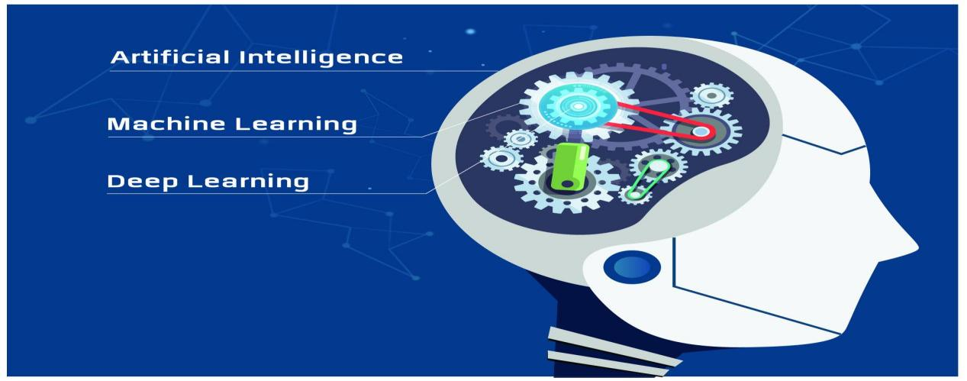

**ARTIFICIAL INTELLIGENCE METHODS:**

Machine Learning- It is a subset of AI that allows machines to learn from data without being explicitly programmed. This is done by using algorithms that identify patterns in data and then use those patterns to make predictions or decisions.

Natural Language Processing(NLP) is a field of AI that deals with the interaction between computers and human language. NLP application. NLP application inlclude machine translation, speech recognition, and text analysis.

Automation & Robotics- The purpose of Automation is to get the monotonous and repetitive tasks done by machines which also improve productivity and in receiving cost-effective and more efficient results.

Machine Vision- Machines can capture visual information and then analyze it. Here cameras are used to capture the visual information, the analogue to digital conversion is used to convert the image to digital data, and digital signal processing is employed to process the data. Then the resulting data is fed to a computer.

Knowledge-Based Systems(KBS): A KBS can be defined as a computer system capable of giving advice in a particular domain, utilizing knowledge provided by a human expert.

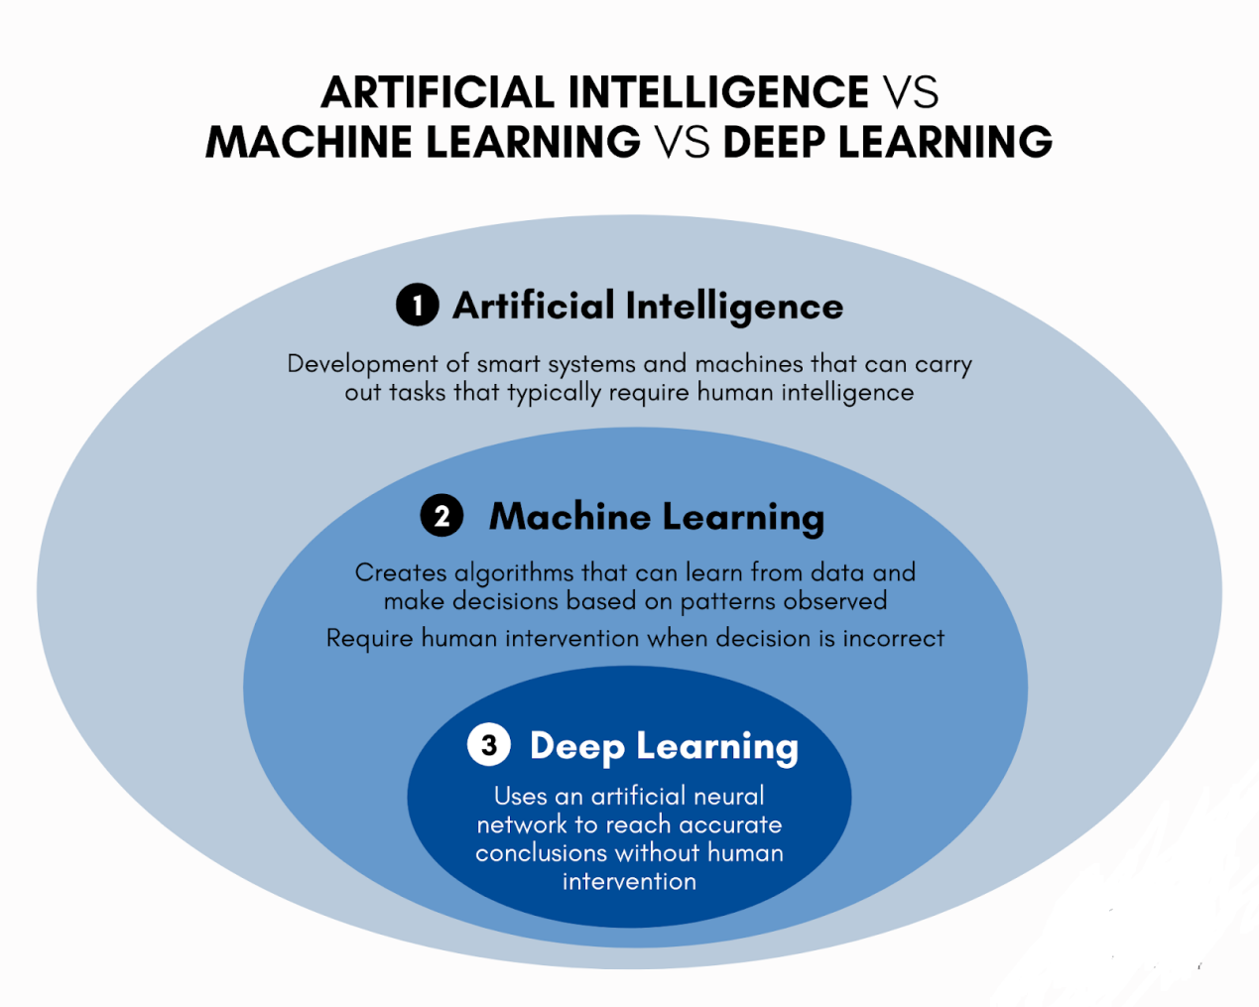

**Applications of AI:** AI algorithms have attracted close attention of researchers and have also been applied successfully to solve problems in engineering. Nevertheless, for large and complex problems, AI algorithms consume considerable computation time due to stochastic feature of the search approaches

1. **AI in Astronomy**

Artificial Intelligence can be very useful to solve complex universe problems. AI technology can be helpful for understanding the universe such as how it works, origin, etc.

1. **AI in Healthcare**

In the last, five to ten years, AI becoming more advantageous for the healthcare industry and going to have a significant impact on this industry. o Healthcare Industries are applying AI to make a better and faster diagnosis than humans. AI can help doctors with diagnoses and can inform when patients are worsening so that medical help can reach to the patient before hospitalization.

1. **AI in Gaming**

AI can be used for gaming purpose. The AI machines can play strategic games like chess, where the machine needs to think of a large number of possible places.

1. **AI in Finance**

AI and finance industries are the best matches for each other. The finance industry is implementing automation, chatbot, adaptive intelligence, algorithm trading, and machine learning into financial processes.

1. **AI in Data Security**

The security of data is crucial for every company and cyber-attacks are growing very rapidly in the digital world. AI can be used to make your data more safe and secure. Some examples such as AEG bot, AI2 Platform,are used to determine software bug and cyber-attacks in a better way.

1. AI in Social Media

Social Media sites such as Facebook, Twitter, and Snapchat contain billions of user profiles, which need to be stored and managed in a very efficient way. AI can organize and manage massive amounts of data. AI can analyze lots of data to identify the latest trends, hashtag, and requirement of different users.

1. **AI in Travel & Transport**

AI is becoming highly demanding for travel industries. AI is capable of doing various travel related works such as from making travel arrangement to suggesting the hotels, flights, and best routes to the customers. Travel industries are using AI-powered chatbots which can make human-like interaction with customers for better and fast response.

1. **AI in Automotive Industry**

Some Automotive industries are using AI to provide virtual assistant to their user for better performance. Such as Tesla has introduced TeslaBot, an intelligent virtual assistant.Various Industries are currently working for developing self-driven cars which can make your journey more safe and secure.

1. **AI in Robotics**

Artificial Intelligence has a remarkable role in Robotics. Usually, general robots are programmed such that they can perform some repetitive task, but with the help of AI, we can create intelligent robots which can perform tasks with their own experiences without pre-programmed. Humanoid Robots are best examples for AI in robotics, recently the intelligent Humanoid robot named as Erica and Sophia has been developed which can talk and behave like humans.

1. **AI in Entertainment**
2. **AI in Agriculture**

Agriculture is an area which requires various resources, labor, money, and time for best result. Now a day's agriculture is becoming digital, and AI is emerging in this field. Agriculture is applying AI as agriculture robotics, solid and crop monitoring, predictive analysis. AI in agriculture can be very helpful for farmers.

1. **AI in E-commerce**

AI is providing a competitive edge to the e-commerce industry, and it is becoming more demanding in the e-commerce business. AI is helping shoppers to discover associated products with recommended size, color, or even brand.

1. **AI in education**

AI can automate grading so that the tutor can have more time to teach. AI chatbot can communicate with students as a teaching assistant. AI in the future can be work as a personal virtual tutor for students, which will be accessible easily at any time and any place.

**Current development in Artificial Intelligence and Machine Learning**

1. Teachbot (Teaching Robot) using Artificial Intelligence and Machine learning.
2. Machine Learning Fusion using for Forecasting Thyroid Disease.
3. Decision tree for predicting student performance based on Psychological tests.
4. Fake review detection using Machine learning,
5. Comparative Analysis of Stock Price prediction by ANN and RF Model.
6. Ontology Based Semantics Search System in Ayurvedic Medicine.
7. Thwart the capturing of Videos and images in unauthorized place through camblocker.

**Tools in AI**

## ****1. ChatGPT****4

[ChatGPT 4](https://openai.com/index/gpt-4/), created by OpenAI, is a powerful chatbot. It’s the next generation of ChatGPT and is renowned for its capability to produce high-quality text in response to various prompts and questions, making it a valuable conversational AI. It is also capable of translating languages, writing different kinds of creative content, and answering your questions in an informative way. Furthermore, ChatGPT 4 introduces a distinctive aspect called [ChatGPT plugins](https://intellipaat.com/blog/chatgpt-plugins/), which are add-on tools that enhance the chatbot’s core functionality. These plugins enable ChatGPT 4 to access updated information, utilize external services, and perform computations, expanding its range of functions.



## ****2. Google Bard****

ChatGPT’s main competitor is Google Bard, often called a conversational [generative artificial intelligence](https://intellipaat.com/blog/what-is-generative-ai/) chatbot and was developed by Google. Google Bard can chat with people and hold interactive conversations. It uses advanced AI technologies like LaMDA, PaLM, Imagen, and MusicLM. These technologies are used to invent new ways of engaging with different types of information, like text, images, videos, and audio., This enhances the tool’s capabilities

## ****3. Chatsonic****

ChatSonic is a smart AI tool made by Writesonic. It uses AI to help companies make their conversations with customers more special. It uses fancy computer learning and has pre-written conversations to sound like a human. ChatSonic can also make text and pictures, and it looks up useful stuff from Google to give even better answers.

## ****4. Midjourney****

Midjourney is the most popular [AI art generator tool](https://intellipaat.com/blog/ai-art-generator-tools/) that uses AI (Artificial Intelligence) to generate art. It’s like having a virtual artist create artwork for you. It uses sophisticated AI algorithms, particularly deep learning neural networks, to create art. These algorithms can analyze and understand patterns, styles, and artistic elements from existing artworks.



## ****5. DALL-E****3

[DALL-E 3](https://openai.com/index/dall-e-3/) is the latest iteration of OpenAI’s groundbreaking AI model, specializing in image generation based on textual descriptions. It expands the AI’s creative abilities by producing a wide range of images based on detailed descriptions, covering everything from basic objects to intricate scenes and abstract ideas. DALL-E 3 leads the way in AI-powered visual creativity. It understands text better and generates images to produce a variety of contextually relevant visual content.

## ****6. SlidesAI****

SlidesAI referred to as a top [AI PowerPoint generator tool](https://intellipaat.com/blog/ai-powerpoint-generator-tools/), is a software or platform designed to assist users in creating and enhancing presentations using artificial intelligence (AI) capabilities. SlidesAI uses AI algorithms to automatically generate content for PowerPoint presentations. This content can include text, images, charts, and even layout suggestions. Users can input their presentation topic or key points, and the AI generates slides accordingly.

## ****7. Alli AI****

Alli AI stands out as a top-notch [AI tool for SEO](https://intellipaat.com/blog/ai-tools-for-seo/) as it makes [SEO](https://intellipaat.com/blog/what-is-seo/) tasks easier for companies. For busy marketers, finding tools that simplify their work is crucial. With this tool, you can also test different keywords on your pages and automatically keep the one that works best after the testing is done. With this tool, tracking and reporting can easily be done by accurately measuring the effectiveness of your SEO efforts and making informed decisions.

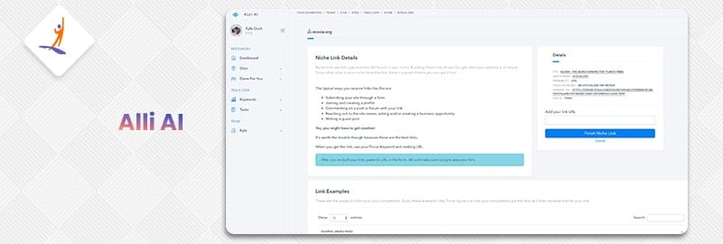

## ****8. Synthesia****

To create videos from written information, Synthesia stands out as a top [artificial intelligence (AI) video generator tool](https://intellipaat.com/blog/ai-video-generator-tools/). This tool offers a rapid and user-friendly approach to crafting high-quality videos. It caters to businesses seeking training or marketing materials, educational institutions producing instructional content, and individuals creating videos for personal or professional use.

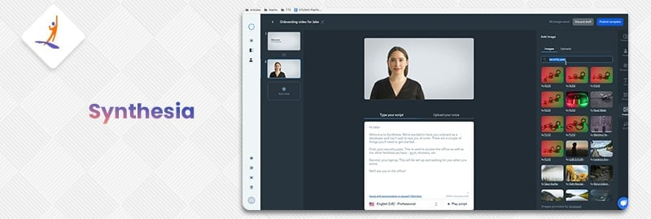

## ****9. DeepBrain AI****

DeepBrain AI has proven its world-class conversational artificial intelligence technology to be highly utilized in many areas, including broadcasting, education, and in service industry. The main goal of DeepBrain AI is to build a connection with your viewers by elevating your training videos using hyper-realistic AI avatars offered by DeepBrain to infuse them with a lifelike quality.



## ****10. Canva: AI Slide Creator****

Canvas AI Slide Creator offers a user-friendly and efficient solution for creating presentations by utilizing artificial intelligence. It simplifies the process by suggesting design elements, layouts, and content placement, allowing users to craft visually appealing slides with ease. Through smart suggestions and automated design assistance, Canvas AI Slide Creator simplifies the presentation-making experience, empowering users to produce professional and engaging slides effortlessly.

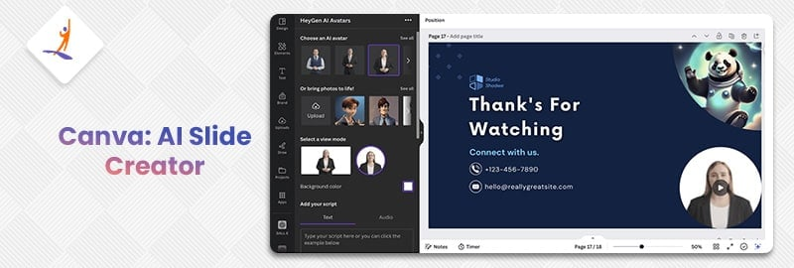

Future of AI

Looking at the features and its wide application we may definitely stick to artificial intelligence. Seeing at the development of AI, is it that the future world is becoming artificial. Biological intelligence is fixed, because it is an old, mature paradigm, but the new paradigm of non-biological computation and intelligence is growing exponentially. The memory capacity of the human brain is probably of the order of ten thousand million binary digits. But most of this is probably used in remembering visual impressions, and other comparatively wasteful ways . Hence we can say that as natural intelligence is limited and volatile too world may now depend upon computers for smooth working. Artificial intelligence (AI) is truly a revolutionary feat of computer science, set to become a core component of all modern software over the coming years and decades. This presents a threat but also an opportunity. AI will be deployed to augment both defensive and offensive cyber operations. Additionally, new means of cyber attack will be invented to take advantage of the particular weaknesses of AI technology. Finally, the importance of data will be amplified by AI’s appetite for large amounts of training data, redefining how we must think about data protection. Prudent governance at the global level will be essential to ensure that this era-defining technology will bring about broadly shared safety and prosperity.

**Conclusion**

Till now we have discussed in brief about Artificial Intelligence. We have discussed some of its principles, its applications, its achievements etc.The ultimate goal of institutions and scientists working on AI is to solve majority of the problems or to achieve the tasks which we humans directly can’t accomplish. It is for sure that development in this field of computer science will change the complete scenario of the world Now it is the responsibility of creamy layer of engineers to develop this field.

References

1. http://en.wikibooks.org/wiki/Computer_Science:Artificial_Intelligence 2.http://www.howstuffworks.com/arificialintelligence

3.http://www.google.co.in

4.http://www.library.thinkquest.org

5.https://www.javatpoint.com/application-of-ai

6.https://www.educba.com/artificial-intelligence-techniques/ 7.https://www.cigionline.orgw/articles/cybersecuritybattlefield/?utm_source=google_ads&utm_medium=grant&gclid=EAIaIQobChMIsdz9qLSF_AIVzQ0rCh1bNQylEAA YAiAAEgI40_D_BwE