**ENHANCING PERMANENT MAGNET SYNCHRONOUS MOTORS PERFORMANCE CHARACTERS USING THE COMBINATION OF VECTOR CONTROL AND MODEL PREDICTIVE CONTROL**

**Otor, Emmanuel1, Uju, I.U.1, Nwosu, A. W.1, Imo, F. U.2**

1Department of Electrical and Electronics Engineering, Chukwuemeka Odumegwu Ojukwu University, Uli, Anambra, Nigeria

2Nigeria Institute of Leather and Science Technology, Abuja, Nigeria

**ABSTRACT**

This paper is aimed at enhancing PMSM performance characteristics using the combination of vector control and model predictive control. The methods involves simulation of PMSM system in a Simulink/Matlab environment, using the system to analyze the effect of vector controller on PMSM performance characteristics based on the equivalent circuit, using the system to analyze the effect of model predictive controller on PMSM performance characteristics, using the system to analyze the effect of the combination of vector controller and MPC on PMSM performance characteristic and validation of the enhanced PMSM performance characteristics with other conventional control method. The analysis involves verifying torque production, response to speed tracking, transient current control capabilities at time intervals of 0.5s at reference speed of 1000RPM and 1500RPM. The analysis when vector controller was implemented, at reference speed of 1000 RPM, shows that vector controller has fast dynamic response as it tracks the targeted velocity but has an overshoot from 1000RPM to 1,180RPM, 18% of the reference speed. With the load disturbance of 1N to the torque at 0.5s, the velocity went down to 510 RPM which is 49% of the reference speed, the transient current amplitude control capability was 10A, and there was torque production but with ripples. When the reference speed was adjusted to 1500RPM, it tracked the targeted velocity but has an overshoot from 1500RPM to 1700RPM, 13. 3% of the reference speed, the transient current control capability was 10A, and there was torque production but with ripples. In the analysis with Model Predictive Controller using a reference speed of 1000RPM, the system tracks the reference speed faster but has an overshoot from 1000 RPM to 1020 RPM, 2% of the reference speed, there was torque production with less ripple. With the load disturbance of 1N to the torque at 0.5s, the velocity went down to 602RPM, 3.9.8% of the reference speed. The transient current amplitude control capability was 10A. When the reference speed was adjusted to 1500RPM, it did not track the targeted velocity but went down from 1500RPM to 1480RPM 1.33% less the reference speed. With the load disturbance of 1N the velocity went down to 300RPM, 80% less the reference speed. There was torque production, and the transient current control capability was 10A.The analysis when a combined vector control and MPC method were implemented, with the reference speed set at 1000 RPM shows that the PMSM has been enhanced; there was fast tracking of reference speed, and torque producing current $i_{q}$ was achieved. $i_{q}$ is the quadrature axis current responsible for torque production and adjustment of motor torque which directly affect the motor speed and acceleration. When $i_{d}$ current (direct axis) is set to zero, maximum efficiency and torque production is achieved, hence the main source of torque production will be by the interaction between the $i_{q}$ and the rotor’s magnetic field created by permanent magnets. The actual speed does not have overshoot, and it tracks closely to the reference speed. With a disturbance of 1N load torque at t=0.5s, the speed remains constant. When the speed was adjusted to 1500RPM the information remains the same as it was when the speed was 1000RPM, hence the combination of vector control and MPC have being used to enhance PMSM performance characteristics. The comparison shows that when reference speed was 1000 RPM; vector controller has an overshoot of 180 RPM (18% of referenced speed), MPC has an overshoot of 20 RPM (2% of referenced speed), and the enhanced PMSM maintained the reference speed (1000 RPM). When the reference speed was adjusted to 1500 RPM: vector controller has an overshoot of 200 RPM which is 13.3% of referenced speed, MPC has an overshoot of 20 RPM (1.33% of the reference speed), while the enhanced method maintained 1500 RPM.. Also, the transient behavior of current control capability showed that at ${0.05}_{s}$ and ${0.06}_{s}$, the current amplitude for vector control and MPC each was ±10A, while the enhanced scheme has ±8A.The research contributed in finding a faster dynamic velocity response of PMSM that solves the problem of ripple torque and helps the motor to run very close to its reference speed not minding load disturbance. Hence the enhanced PMSM is more suitable for industrial automations and robotics.

**Keywords:** Control, Synchronous motor, PMSM, Model predictive controller (MPC).

1. **INTRODUCTION**

Permanent Magnet Synchronous Motor (PMSM) is an AC synchronous motor whose field excitation is provided by permanent magnets. The permanent magnets are used as the rotor to create constant magnetic flux that operates and locks at synchronous speed. A rotating magnetic field is created in the air-gap when the three-phase winding of the stator is energized by the three-phase power source. At synchronous speed, the rotor field magnetically locks with the stator poles, producing torque and allowing the rotor to continue rotating. Also permanent magnet synchronous motor (PMSM) is a motor that uses permanent magnets to produce the air gap magnetic field rather than using electromagnets. These motors have significant advantages that attract the interest of researchers and industry for use in many applications. The properties of the permanent magnet material affect directly the performance of the motor therefore proper knowledge is required for the selection of the materials and for understanding Permanent Magnet synchronous motors. Permanent magnet synchronous motors are widely used in low and mid power applications such as computer peripheral equipment, robotics, adjustable speed drives and electric vehicles.

Many control algorithms have been implemented to address challenges associated with the operation of PMSM such as torque current reference tracking, speed reference tracking, and torque by ampere optimization, and current magnitude limitation. Conventional control systems such as proportional-integral-derivative (PID) controller, which has been used in many industrial process control due to its simple design [1,2], have not been able to address these challenges. The Proportional term responds to the current error, the Integral term accounts for past errors over time, and the Derivative term anticipates future errors. These actions are performed simultaneously to bring about correctional control command [3]. Yet PMSM suffer three significant deficiencies, which include, ripple torque, accurate motion control and load disturbance compensation. They create deficiency in speed reference tracking. Another factor affecting Permanent magnet synchronous motors has been the type of controllers used in their controls.

The torque ripples problem of the Permanent Magnet Synchronous Motors, Accurate motion control and load disturbance compensation are so complicated and influenced by multiple factors and not easy to overcome. Many researchers have employed many strategies in other to minimize these challenges by using several control schemes, but the real solution which is the ability to track the targeted velocity or reference speed and bring needed improvement on the torque ripple has not been seen. But with the advantages of the combination of vector controller and model predictive controller, these inefficiencies of PMSM can be minimized, for example, vector controller has the advantage of controlling the magnitude and frequency of the supply voltage and phase. Vector control separates the magnetic flux and the torque component of the current and controls them independently. Vector control can compensate for non linarites and losses of the motor and can provide fast and accurate speed and torque control, even at low speeds. In the other hand, model predictive controller has the advantages of Torque current reference tracking, Speed reference tracking, Torque by ampere optimization and Current magnitude limitation. Therefore using the advantages of vector controller and MPC, the goal of fast tracking of reference speed and torque producing is achieved and the performance characteristics of PMSM is enhanced.

MPC and vector control is a new algorithm that combines the advantages of model predictive control and vector control. Being different from other control methods, MPC based scheme evaluates the influence of control variables on the system and has faster dynamic performance compared to the conventional vector control scheme. Thus, this paper aims at enhancing permanent magnet synchronous motor (PMSM) performance characteristics using vector control and Model predictive control (MPC).

1. **LITERATURE REVIEW**

This section focused on providing insight on some of the strategies that have been used to improve the performance of PMSM operation. For instance, [4] presented passivity-based control for rocket launcher position servo system based on improved active disturbance rejection technology. The authors stated that the application environment is generally complex and often has various disturbances because PMSM is a nonlinear, multivariable, and strongly coupled system. Hence, these control methods cannot easily perform fast and high-precision control. For example, PID control is sensitive to changes in the parameters of the controlled object model, and only the deviations of the given feedback are adjusted. PID is a single-degree-of-freedom control, and balancing the tracking performance and immunity of the system is difficult. Dastjerdi [5] used a new deadbeat-direct current controller to improve the performance of permanent-magnet synchronous motor. It showed that sliding mode control (SMC) belongs to the bang-bang control, (a type of control system that turns something on or off either mechanically or electrically when a desired target or set point has been reached, e.g. on, when the measurement is below the set point and off, otherwise) and the control volume is a non-continuous quantity. Therefore, the problem of “flicker” inevitably arises. (i.e. unsteady or irregular current). Zhou [6] confirmed that vector controlled of PMSM drive provides better dynamic response and lesser torque ripples, and necessitates only at constant switching frequency. The Outer speed loop in vector control system has low control accuracy, and satisfying the control requirements is difficult. Nagesh [7] presented modeling and analysis of switched reluctance motor with PI controller, and showed that several control schemes have been proposed for the control of power converters and PMSM drives. Among these are hysteresis control and linear PI control, and they are the most common methods presented in literature. The efficiency enhancement of switched reluctance generator employing optimized control associated with tracking technique was presented in [8]. Energies combined the traditional Proportional-Integral-Derivative (PID) controller and a tracking technique, the result was an improvement in the efficiency of the PMSM output voltage. Khan [9] used new speed estimation technique for vector-controlled switched reluctance motor drive reluctance motor drive and said that Vector control, also known as Field-Oriented Control (FOC), is a technique used to control AC machines. FOC provides good control capability over the full torque and speed ranges. The implementation of this type of control scheme requires transformation of stator currents from the stationary reference frame to the rotor flux reference frame. Nicola [10] presented the FOC control strategy for the control of a PMSM by emphasizing very good control performance on the condition that implementation in an embedded system proves to be easy. In this study, the use of switched systems theory is proposed as a study option, given the fact that these types of systems are suitable both for the study of systems with variable structure and for systems with significant parametric variation under conditions of lower complexity of the control algorithms. The study begins by linearizing a PMSM model at a static operating point and continues with a systematic presentation of the basic elements and concepts concerning the stability of switched systems, by applying these concepts to the control system of a PMSM based on field-oriented control (FOC) strategy, which usually changes the value of its parameters during operation. The numerical simulations performed in Simulink validate the fact that, for parametric variations of the PMSM structure, the PMSM control switched systems preserves qualitative performance in terms of its control. Kangping [11] presented vector control of PMSM sensors and transducers, proposed the implementation of the CLARK transformation, the PARK transformation, the inverse PARK transformation and the SVPWM in the MATLAB / SIMULINK environment. The control system is then implemented with tri-cyclic nested loops, i.e., the current loop, the speed loop and the position loop. Simulation results show that the system has fast response, with small overshoot and high accuracy. Xiao [12] confirmed that recent advancement in motor drives and control such as permanent magnet synchronous motors comes from their use in the transportation sector, where applications such as aerospace and electric vehicles that require drive systems with higher performance, power density, efficiency and reliability. In [13], harmonic current cancellation method for PMSM drive system using resonant controllers was presented. It stated that in many applications, PMSMs is predominantly used due to their comparative advantages over other electrical drives. Xiong [14] stated that the control algorithms for PMSM are mainly divided into three categories, namely vector control, direct torque control (DTC), and model predictive control (MPC). Among them, MPC can handle multi-input and Multi-output nonlinear systems with complex constraints and has superior dynamic performance and parameter robustness. Liu [15] stated that vector control, also known as Field-Oriented Control (FOC), is a technique used to control PMSM and AC induction motors (ACIM). Field Oriented Control provides good control capability over the full torque and speed ranges. The implementation of this type of control scheme requires transformation of stator currents from the stationary reference frame to the rotor flux reference frame also known as d-q reference frame. From the analysis of Karamanakos [16], vector control strategy was formulated in the synchronously rotating reference frame. Zhang and Wang [17] stated that are permanent-magnet synchronous motors widely used in various applications due to their simple control, high efficiency, good torque characteristics, and low loss.

1. **MODELING AND ANALYSIS**

This section presents the mathematical modelling of PMSM, vector control technique and MPC. The block diagram of the proposed system is shown in Fig. 1.

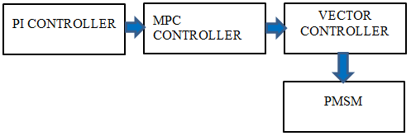

Figure 1 Block diagram of system architecture

.

**3.1 Modelling PMSM in d-q Rotating Reference Frame**

The dynamic equations of a PMSM in the d-q reference frame are given by:

${{V_{d}=R_{s}i_{d}+L_{d}\frac{di_{d}}{dt}}^{}}_{}^{}ω_{e}L_{q}i_{q}$ (1)

Where: ${(V_{d}}^{}) and \left(V_{q}\right)are the d axis and q axis stator voltages.$

$$\left(I_{d}\right)and \left(I_{q}\right)are the d axis and q axis stator currents$$

$$(R_{s}) is the stator resistance.$$

$${(L}_{d}) and \left(L_{q}\right)are the d-axis and q- axis inductances.$$

$$(ω_{e}) is the electrical angular velocity.$$

$${(φ}_{m}) is the permanent magnet flux linkage.$$

**Park and Clarke Transformations**

To transform the three-phase stator currents to the d-q frame, the Clarke and Park transformations are used.

Clarke Transformation (abc to αβ):

$\left(\begin{matrix}i_{α} \\ i_{β}\end{matrix}\right)= \left(\begin{matrix}1 \\ 0\end{matrix}-\begin{matrix}\begin{matrix}1 \\ 2\end{matrix}- \\ \sqrt{\begin{matrix}3 \\ 2\end{matrix}}-\end{matrix}\begin{matrix}1 \\ \begin{matrix}2 \\ \sqrt{\begin{matrix}3 \\ 2\end{matrix}}\end{matrix}\end{matrix}\right) \left(\begin{matrix}i_{α} \\ i_{b} \\ i_{c}\end{matrix}\right)$ (2)

Park Transformation $\left(αβ\right)to dq:$

$\left(\begin{matrix}i_{α} \\ i_{β}\end{matrix}\right)= \left(\begin{matrix}\cos{θ} \\ -\sin{θ}\end{matrix}\begin{matrix}\sin{θ} \\ \cos{θ}\end{matrix}\right)\left(\begin{matrix}i_{α} \\ i_{β}\end{matrix}\right)$ (3)

Where ($θ$) is the rotor position

**Control Strategy**

a. Current Control Loop

The objective is to control the d-axis and q-axis currents. Typically, the d-axis current ($i_{d}$) is controlled to regulate the torque

b. PI Controllers for Current Regulation

PI controllers are used for regulating $(I_{d})$ and $I_{q}$):

$v_{d^{}}= K_{pd} \left(i_{d}- i_{q}\right)+ K_{id} \int{\left(i_{d^{}}^{}-i_{q}\right)}dt$ (4)

Where:

${( {V_{{d^{}}_{}}}_{}}_{} and V_{q^{})}$ are the reference voltages for the d and q axis

$〖\left(I_{d} \right) and {(I}_{q}) are the$ reference currents for the d and q axis (typically ($I_{q}=0$)).

K {$p_{d}$} $\left(K_{\left\{id\right\}}\right), \left(K_{\left\{pq\right\}}\right), and (K \left\{iq\right\})$ are the PI controller gains.

**Inverse Park and Clarke Transformations**

The references voltages $V_{d} and \left(V_{q}\right)$ are transformed back to the three-phase system using the inverse park and Clarke transformations.

Inverse park transformation (dq to $αβ to abc$)

$\left(\begin{matrix}V_{α} \\ V_{β}\end{matrix}\right)= \left(\begin{matrix}\cos{(θ}) \\ -\sin{(θ)}\end{matrix}\begin{matrix}\sin{(θ)} \\ \cos{(θ})\end{matrix}\right) \left(\begin{matrix}V_{d}^{*} \\ V_{a}^{*}\end{matrix}\right)$ (5)

Inverse Clarke transformation $αβ to abc$):

$\left(\begin{matrix}V_{α} \\ \begin{matrix}V_{β} \\ V_{c}\end{matrix}\end{matrix}\right)= \left(\begin{matrix}1 \\ - \begin{matrix}1 \\ 2\end{matrix} \\ - \begin{matrix}1 \\ 2\end{matrix}\end{matrix} \begin{matrix}0 \\ \sqrt{\frac{3}{2}} \\ - \sqrt{\frac{3}{2}}\end{matrix}\right) \left(\begin{matrix}V_{α} \\ V_{β}\end{matrix}\right)$ (6)

**Space Vector Pulse Width Modulation (SVPPWM)**

The final step is to apply the calculated three-phase Voltages ($V_{a}$), ($V_{b}$), ($V_{c}$) to the inverter using a technique such as Space Vector Pulse Width Modulation (SVPWM) to control the PMSM.

These steps encapsulate the mathematical formulations involved in the vector control of PMSMs. The core idea is to decouple the torque and flux control by transforming the stator currents and voltages into a rotating reference frame aligned with the rotor flux.

**3.2 Vector Control Model of PMSM in MATLAB**

On the MATLAB/Simulink platform, a model of the Vector controlled PMSM is fed from DC supply via an inverter, developed and simulated based on the appropriate equations derived previously. A simulation diagram of the Vector control strategy is shown in Figure 2, in which the Vector control block, inverter block, power supply module, PMSM module, Clark transformation and Park transformation modules to obtain feedback currents of the d and q-axis current are included. Figures 2 to 4 are the Simulink model of the Vector control strategy, Subsystem model of current and speed controllers respectively. The parameters of PMSM, which includes inverter, current and velocity used in the simulation are given below:

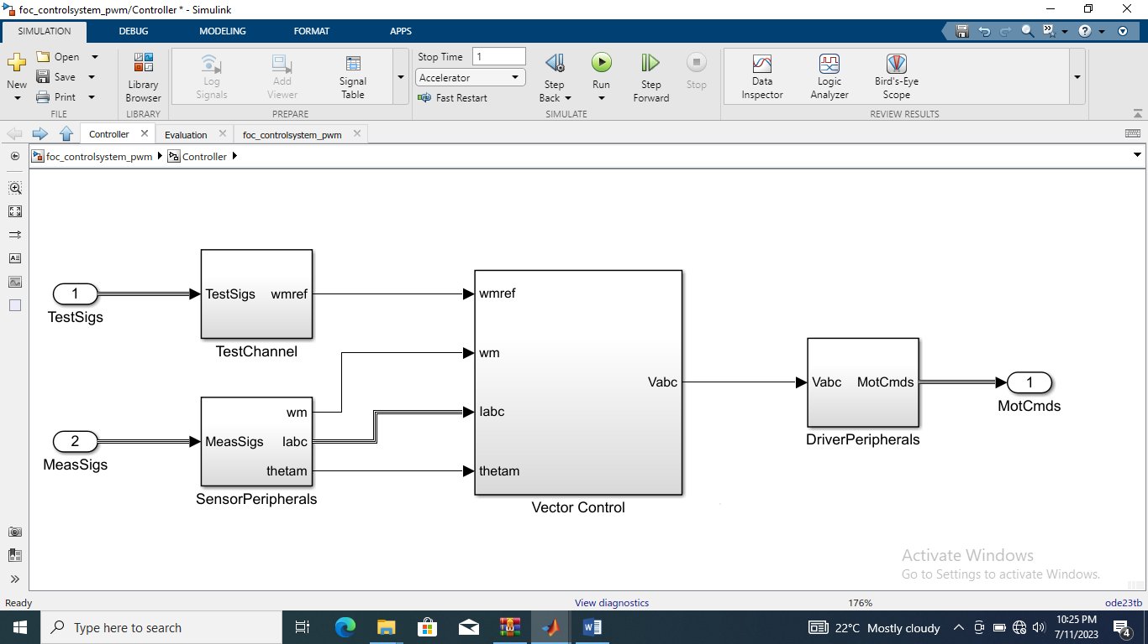

Figure 2 Simulink model of the Vector control strategy

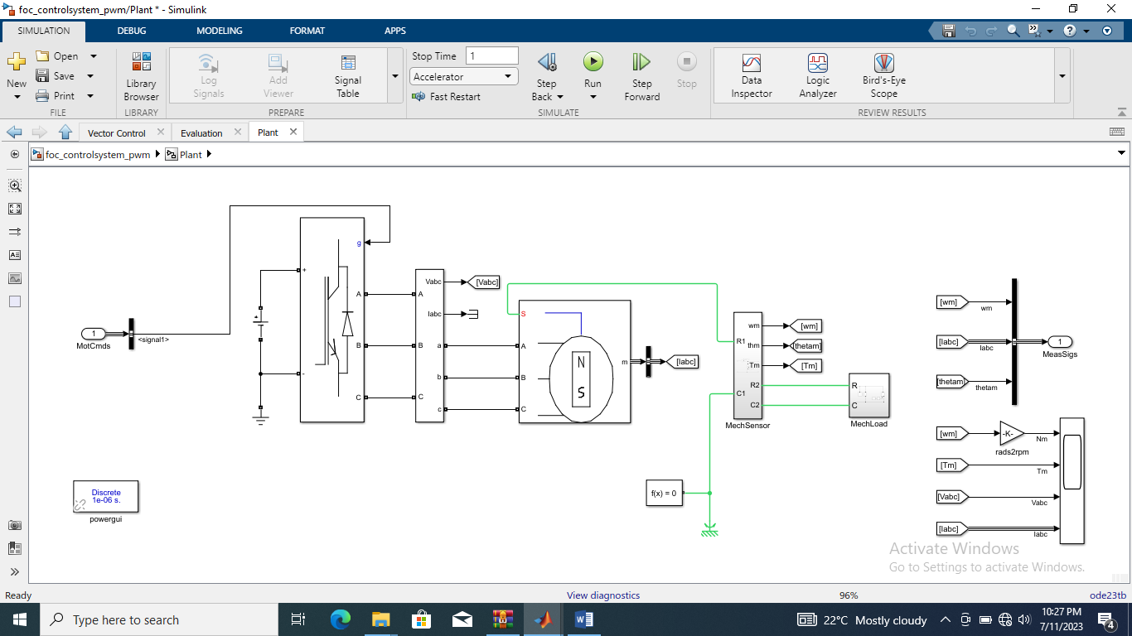

Figure 3 Subsystem model of the PMSM

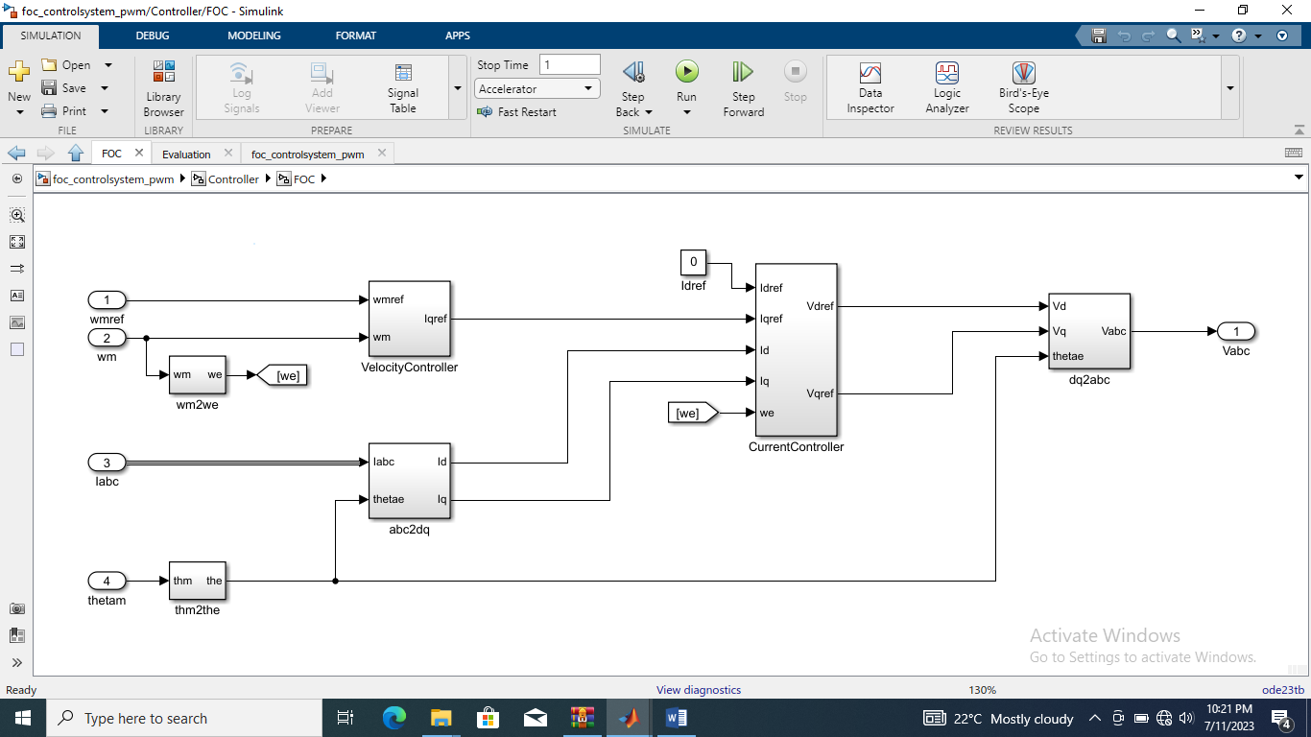

Figure 4 Subsystem model of current and velocity controllers

**PMSM Parameters**

$θ$ = 0.1; % Permanent magnet flux linkage [$φ_{b}$]

$L_{d}$ = 0.01; % Stator d-axis inductance [H]

$L_{q}$ = 0.02; % Stator q-axis inductance [H]

$R_{s}$ = 0.38; % Stator resistance per phase

p = 2; % Number of pole pairs

$J_{m}$ = 0.1e-3; % Rotor inertia [kg $m^{2}]$

$D_{m}$ = 1e-3; % Rotor damping [ ${N^{2}}_{m}$ {rad/s]

**Inverter Parameters**

$V_{dc}$ = 100; % DC voltage [V]

$f_{c}$ = 10e3; % Carrier Frequency [Hz]

$T_{s}$ = 1/fc/100; % Sampling time [sec]

Current controllers of dq-axis (PI controller)

$\%$ $L_{d}$/ $R_{s}$ $= 0.0263[sec];$

$$\% {L_{q}}/{R_{s}} = 0.0526[sec];$$

$\%$ Target response time constant: 1e-3[sec]

$W_{c} \underline{c}$ = ${1e}^{3};$ $\% Target response frequency [rad/s]$

${〖Kp}_{id}$ = $w_{c}c^{2} L_{d}$; % d-axis proportional gain

${Kp}_{id}$ = $w_{c}$ c $c^{2}R_{s}$; % d-axis integral gain

${Kp}_{iq}$ = $w_{c}c^{2}c^{2}L_{c}$ q; % q-axis proportional gain

${Ki}_{iq}$ = $w_{c}c^{2}R_{s}$; % q-axis integral gain

% ${cc}^{2}$ = 100e-6; % Sample time of current control [sec]

Velocity controller (PI controller)

% $J_{m}$/ $D_{m}$ = 0.1[sec];

% Target response time constant: 0.02[sec]

$W_{c}$ s = 50; % Target response frequency [rad/s]

K $p$ s = 0.0014; % Velocity proportional gain

${Ki}_{s}^{}$ = 0.041; % Velocity integral gain

% ${KP}_{s}$ = $w_{c}s^{2}J_{m}$; % Velocity proportional gain

% ${Ki}_{s}$ = $w_{c}s^{2}D_{m}$; % Velocity integral gain

% $T_{sc}$ = 1e-3; % Sample time of velocity control [sec]

**3.3 Modeling of MPC Based PMSM**

The PMSM dynamics can be represented in the d-q reference frame (rotating frame) as follows:

$\begin{matrix}, \\ ,\end{matrix}\left\{\begin{matrix}\frac{d}{dt}i_{d}= \\ \frac{d}{dt}i_{q}= \\ \frac{d}{dt}w=\end{matrix}\begin{matrix}-\frac{R_{s}}{L_{d}}i_{d}+ \\ \frac{R_{s}}{L_{q}}i_{q}- \\ \begin{matrix}\begin{matrix}3 \\ 2\end{matrix} & \begin{matrix}p \\ J\end{matrix}\end{matrix}\left(λfi_{q}\right.\end{matrix}\begin{matrix}\frac{L_{a }}{L_{d}} \\ \frac{L_{d}}{L_{q}} \\ +\end{matrix}\begin{matrix}wi_{q} + \\ wi_{q}- \\ \left(Ld-\right)\end{matrix}\begin{matrix}\frac{I}{L} \\ \frac{λ}{L} \\ L\end{matrix}\right\}$ (7)

where: $(i_{d}, i_{q}) are the dq axis currents$,

$(V_{d}, V_{q}) are the d-q axis voltages.$,

$(R_{s}) is the stator resistance$,

$(L_{d}, L_{q}) are the dq axis inductances.$,

$(φ) is the flux linkage$

($ω$) is the rotor angular spee

(P) is the number of pole pairs

(J) is the moment of inertia

(T $L_{T}$) is the load torque

**Discrete-Time Model**

Discretize the continuous-time model for implementation in MPC.

Using a sampling time ($T_{s}$):

$\begin{matrix}, \\ ,\end{matrix}\left\{\begin{matrix}i_{d} \\ i_{q} \\ w\end{matrix}\begin{matrix}\left[k+1\right] \\ \left[k+1\right] \\ \left[k+1\right]\end{matrix}\right\}\begin{matrix}= \\ = \\ =\end{matrix} \begin{matrix}i_{d} \\ i_{q} \\ w\end{matrix} \begin{matrix}\left[k\right] \\ \left[k\right] \\ \left[k\right]\end{matrix}\begin{matrix}+ \\ + \\ +\end{matrix}\begin{matrix}T_{s} \\ T_{s} \\ T_{s}\end{matrix}\begin{matrix}\left(-\frac{i}{L}\right) \\ \left(-\frac{i}{L}\right) \\ \left(\begin{matrix}3 \\ 2\end{matrix}P_{j}\right)\end{matrix}$ (8)

**Cost Function:** The objective is to minimize a cost function over a prediction horizon ( Np ). A common cost function is:

$J= \sum_{k=0}^{N_{p}-1}{\left(Q_{i}\right)}{\left(i_{d}^{*} \left[k\right]-i_{d}\left[k\right]\right)}^{2}$ (9)

where: $, \left(i_{q}\left[k\right]\right), i_{q}$ are the reference values for the d-q currents and speed, ($Q_{i}$, $Q_{w}$) are the weighting factors for the current and speed tracking errors, ($R_{v}$) is the weighting factor for the control effort (voltages).

**Optimization Problem**

The MPC optimization problem can be formulated as:

$v_{d}\left[0\right],…,v_{d} \left[N_{p}-1\right],v_{d}\left[0\right], …, v_{q} \left[N_{p}-1\right]$ (10)

**Solving the Optimization Problem**

The optimization problem is typically solved using numerical solvers such as Quadratic Programming (QP) solvers for linear MPC or more advanced nonlinear programming (NLP) solvers for nonlinear MPC.

**. Control Implementation**

At each sampling instant:

1. Measure or estimate the current state $( \{i_{d}[k], i_{d}[k], ω[k]\} ).$
2. Solve the optimization problem to obtain the optimal control inputs $(\{v_{d}[k], v_{q}[k]\} ).$
3. Apply the first control input $( \{v_{d}[0], v_{q}[0]\} )$ to the PMSM.
4. Repeat the process at the next sampling instant.

This completes the mathematical formulation for model predictive control of a PMSM. The implementation involves iteratively solving the optimization problem at each time step to generate the control inputs that drive the system towards the desired references while respecting all constraints.

**3.4 MATLAB Simulation of PMSM Using MPC**

Simulations were carried out to investigate the steady state performance of the system under different control methods. In order to improve the performance of the PMSM, the PI controller of the speed loop is changed to MPC. Figure 5 shows the simulink block diagram of the PMSM system based on MPC which includes a voltage source, an MPC block with its different peripherals, a voltage source IGBT-based drives and measurement circuits, 3-ph PMSM with an incremental encoder that used as motor feedback. MPC control algorithm has been implemented with a sampling time of Tp = 100 μ, and tested with a reference speed of 1000rpm. The DC link voltage is set to 400V. The speed, torque and current performances are experimentally investigated for different loading conditions.

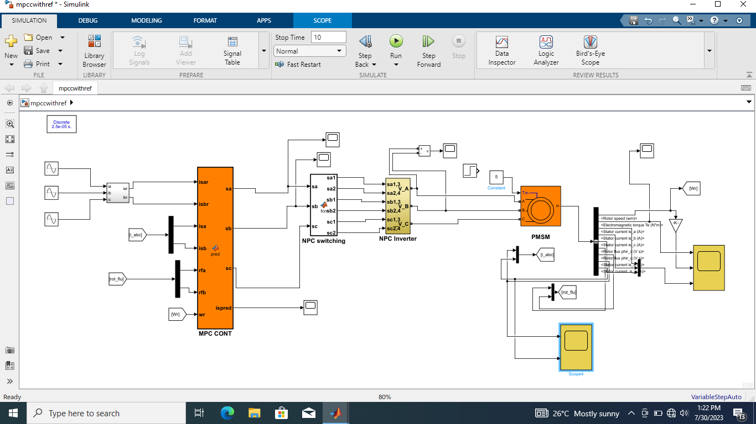

Figure 5 Simulink model of the MPC scheme

The MPC scheme and drive control scheme are presented here and they are considered as a reference for comparison to the Vector control scheme presented previously and the enhanced PMSM using vector control and MPC.

The Model Predictive Control (MPC) strategy is based on the fact that only a finite number of possible switching states can be generated by a static power converter and that models of the system can be used to predict the behavior of the variables for each switching state. For the selection of the appropriate switching state to be applied, a selection criterion must be defined. This criterion consists of a cost function that will be evaluated for the predicted values of the variables to be controlled. Prediction of the future value of these variables is calculated for each possible switching state and then the state that minimizes the cost function is selected.

**Predictive Control Algorithm**

The value of the reference parameter (k) is obtained (from an outer control loop), and the output I (k) is measured.

The model of the system is used to predict the value of the output parameter in the next sampling interval I (k + 1) for each of the different voltage vectors.

The cost function g evaluates the error between the reference and predicted currents in the next sampling interval for each voltage vector.

The voltage that minimizes the current error is selected and the corresponding switching state signals are generated.

**Discrete-Time Model**

By using the Euler approximation for the stator current derivatives for a sampling time Ts , that is,

$\frac{di}{dt}≈\frac{i(k+1)-i(k)}{T_{s}}$ (11)

The following expressions for the predicted stator currents in the dq reference frame are obtained from the machine equation derived earlier:

${i_{sd}}^{p}\left(k+1\right)=\left(1-\frac{R_{s}T_{s}}{L_{s}}\right)i_{sd}\left(k\right)+T_{s}ω_{r}i_{sq}(k)+\frac{T_{s}}{L_{s}}v_{sd}$ (12)

${i_{sq}}^{p}\left(k+1\right)=\left(1-\frac{R_{s}T_{s}}{L_{s}}\right)i_{sq}\left(k\right)-T_{s}ω_{r}i_{sd}(k)-ψ_{m}ω_{r}T_{s}+\frac{T_{s}}{L_{s}}v_{sq}$ (13)

These equations allow predictions of the stator currents to be calculated for each one of the seven voltage vectors generated by the inverter. The voltage vectors generated by the inverter are fixed in the stationary reference frame, but they are rotating vectors in the dq reference frame, calculated as:

${V_{s}}^{r}={V_{s}e}^{{-jθ}_{r}}$ (14)

**Control Scheme**

Siami [19] in his paper titled “Simplified finite control set-model predictive control for matrix converters-fed PMSM drives predicted that Current control is aimed at minimizing the error between reference current and actual current while keeping stator current below the maximum amplitude of current. These objectives can be expressed as the following cost function:

$g={[{i_{d}}^{p}\left(k+1\right)]}^{2}+{[{i_{q}}^{*}(k)-{i_{q}}^{p}(k+1)]}^{2}+f\left({i_{d}}^{p}\left(k+1\right), {i_{q}}^{p}(k+1)\right)$ (15)

Liu [20] in his paper Speed control for permanent magnet synchronous motor based on an improved extended state observer supported that where the first item denotes the minimization of the reactive power, the second item is for precision tracking of the torque producing current, and the last item is a nonlinear function for limiting the amplitude of the stator current. This function can be expressed as

$f\left({i_{d}}^{p},{i_{q}}^{p}\right)=\left\{\begin{aligned}0 \left|{i_{d}}^{p}\right|≤i_{d}max⁡and\left|{i_{q}}^{p}\right|≤i_{q}max \\ ∞ \left|{i_{d}}^{p}\right|>i_{d} max or\left|{i_{q}}^{p}\right|>i_{q}max \end{aligned}\right.$ (16)

Where $i_{d}$ max and $i_{d}$ max are the maxima allowed for the amplitudes of 𝑑, 𝑞 axis currents, respectively. On the one hand, if the predictive stator currents are below the limits, the cost function comprises only the first two items and the voltage vector that minimizes the current error will be selected. On the other hand, if a given voltage vector generates predictive currents with magnitudes higher than $i_{d}$ max or $i_{q}$ max, the cost function will be infinitely great, and in turn the voltage vector will not be selected.

Given that the change of the high frequency switching states of an inverter will harm the steady-state performance of system, another constraint is imposed on the cost function to reduce the number of commutations of the power switches and minimize the switching losses. Therefore, the cost function should include an item that covers the number of switches that change (Logofet, 2000) when the switching state (𝑘) is applied, with respect to the previously applied switching state (𝑘 1); that is,

$g={[{i_{d}}^{p}\left(k+1\right)]}^{2}+{[{i_{q}}^{*}(k)-{i_{q}}^{p}(k+1)]}^{2}+f\left({i_{d}}^{p}\left(k+1\right), {i_{q}}^{p}(k+1)\right)+λ_{n}$ (17)

where 𝜆 is the weighting factor and 𝑛 is the number of switches that change when switching state (𝑘) is applied. The switching state vector 𝑆 is defined as:

$S=\left(S_{1},S_{2},S_{3}\right)$ (18)

Where ${ S}_{1}$, $S_{2}$, $S_{3}$ represent the states of a switch and only have two values, one or zero; then the number of switches that change from 𝑆 (𝑘 1) to 𝑆(𝑘) is:

$n=\sum_{x=1}^{N}{\left|S_{x}(k)-S_{x}\left(k-1\right)\right|}$

$=S_{1}(K)-S_{1}\left(k-1\right)+S_{2}\left(k\right)-S_{2}\left(k-1\right)+S_{3}\left(k\right)-S_{3}\left(k-1\right)$ (19)

Different switching states will generate different configurations of the three-phase load connected to the DC source of the converter. Considering all the possible combinations of the gating signals S1, S2, and S3, eight switching states and consequently eight voltage vectors are obtained.

It is worthy of mention that the values of the weighting factor 𝜆 has influence on the switching frequency of the converter. Hence, current ripples when 𝜆 improves.

**3.5 Vector Control and MPC Based PMSM**

The objectives of the model of vector control and predictive control of the PMSM scheme are summarized as follows:

Torque current reference tracking

Speed reference tracking

Torque by ampere optimization

Current magnitude limitation.

These objectives can be expressed as the following cost function:

$g={({i_{sd}}^{p}\left(k+1\right))}^{2}+{({i_{sq}}^{*}\left(k\right)-{i_{sq}}^{p}\left(k+1\right))}^{2}+\hat{f}\left({i_{sd}}^{p}\left(k+1\right), {i_{sq}}^{p}(k+1)\right)$ (20)

where the first term represents the minimization of the reactive power, allowing the torque

by ampere optimization, the second term is defined for tracking the torque-producing current,

then the third one is the speed reference tracking and the last term is a nonlinear function for limiting the amplitude of the stator currents. This function is defined as:

$\hat{f}\left({i_{sd}}^{p}\left(k+1\right), {i_{sq}}^{p}(k+1)\right)=\left\{\begin{aligned}∞ if \left|{i_{sd}}^{p}\right|>i_{max}{or}\left|{i_{sd}}^{p}\right|>i_{max} \\ 0 if \left|{i_{sd}}^{p}\right|≤i_{max} and \left|{i_{sd}}^{p}\right|≤i_{max} \end{aligned}\right.$ (21)

where imax is the value of the maximum allowed stator current magnitude. In this way, if a given voltage vector generates predicted currents with a magnitude higher than imax then the cost function will be g =∞, and, in consequence, this voltage vector will not be selected. On the other hand, if the predicted stator currents are below the limits, the cost function will be composed of the first two terms only and the voltage vector that minimizes the current error will be selected.

**3.6 Vector Control and MPC Based PMSM**

A MATLAB / Simulink simulation model is developed to verify the proposed enhanced PMSM using vector control and MPC. The PMSM motor model and the IGBT model come from the SimPower Systems library of SIMULINK. Six separate IGBTs with fly-wheeling diode are used as switches, driven by DC link voltage of 400 V. A three-phase AC permanent magnet synchronous motor is used, which is made by nominal torque of 2.4 Nm. The simulation model is shown in Figure 6.

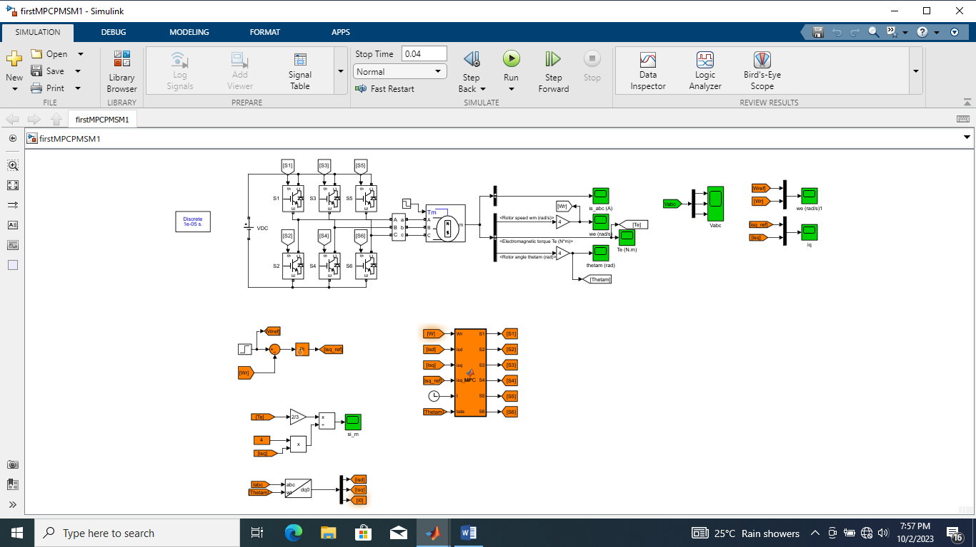Figure 6 Simulink model of the proposed control scheme

**4. RESULTS AND DISCUSSION**

Results obtained when vector control and MPC was used together to control PMSM scheme are shown in Figure. 3. In these figures speed reference step change is performed at time t = 0.05 s, and finally a load step is applied at time 0.5 s. It can be seen from these results that all the objectives of the control are achieved during the tests. Fast tracking of the reference speed and torque-producing current isq is achieved while the isd current is near zero. During transients the magnitude of the currents is limited and both components are decoupled.



**Figure 4.1:** Graphs of Speed, Torque, Voltage and Current with Proposed Method

In Figure. 4 the actual speed does not have overshoot, and it tracks perfectly to the reference velocity. And, when the disturbance of the load torque at t = 0.5 sec was caused, and shows the speed performance when it was referenced at 1000 RPM. It can be noticed that with the proposed method, the speed matches its reference very fast more than that of conventional vector control method and MPC independently.

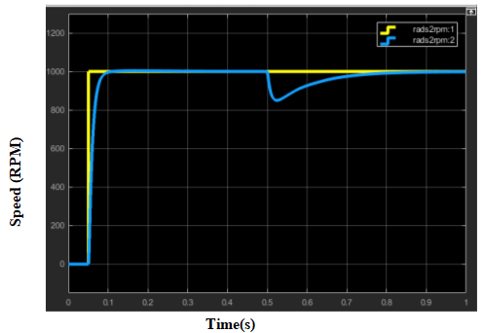

**Figure 4.2**: Waveforms of Reference speed vs actual speed with the enhanced method

The phase voltage waveforms are shown in Fig. 6. It can be seen from the graph that the frequency is constant.

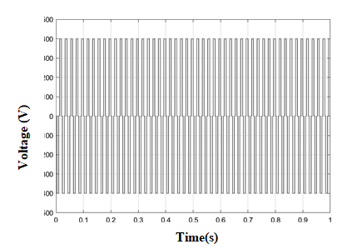

**Figure 4.3:** Waveform of output voltage with the enhanced method

The current waveforms at steady state with nominal parameters are shown in Fig. 7. The three methods show good results, even in the case of vector control where a small increment in the current ripple is noticed, compared to the other two methods. From the current simulation results shown, the current fluctuation amplitude of the vector control algorithm at start-up time was significantly higher than that of MPC and improved PMSM. The application of load at 0.05 s resulted in change in the amplitude of the three-phase current as shown in Fig. 7. At 0.065 and 0.066 s, the current waveforms of MPC and improved PMSM control were stable, however, that of the vector control is still in transition state.

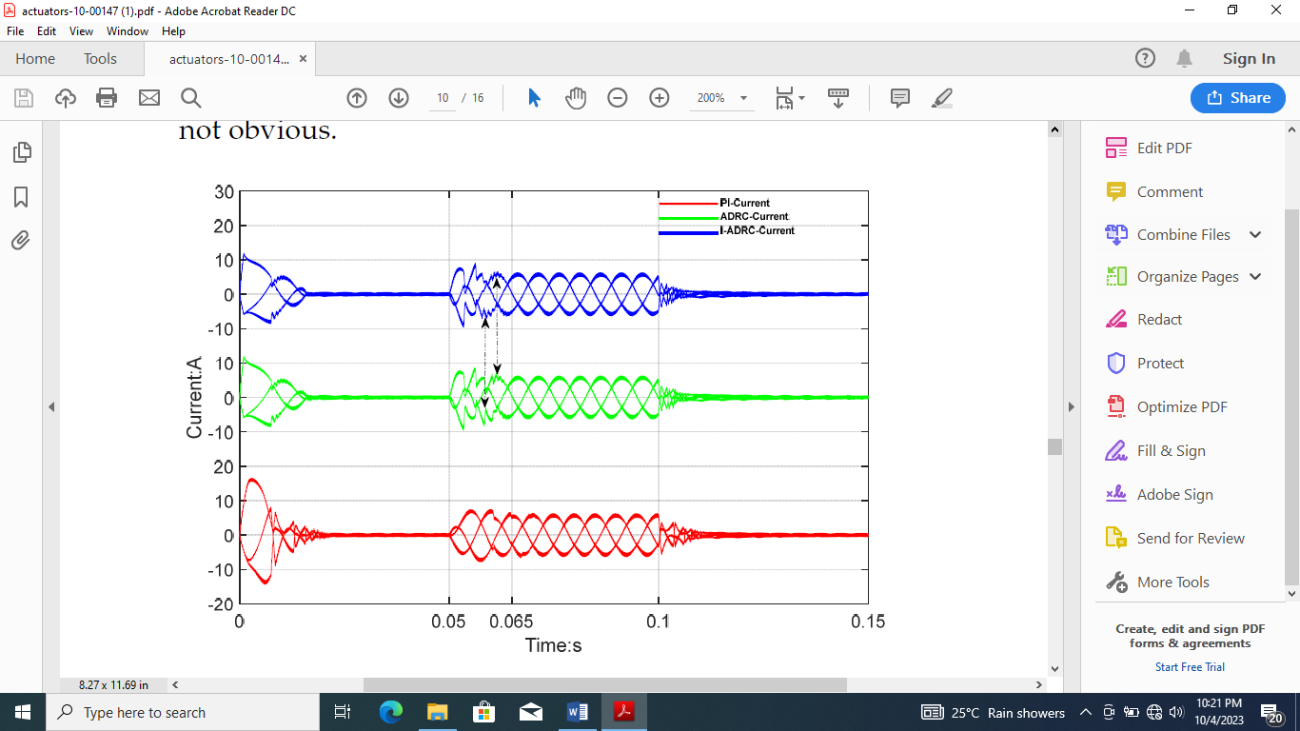

**Figure 4.4**: Comparison of current waveforms for the 3 controllers

**Performance validation of the Enhanced PMSM using Vector Control, Model Predictive Control and Conventional controller**

In order to evaluate the dynamic response of the enhanced PMSM, the same test as explained before was replicated. Table 1 shows the effects when speed values are changed respectively. It can be seen that the dynamic performance of the vector controller is slightly affected by load parameter variations, presenting a slower response in some cases. However, the fast dynamic response of the proposed method is almost unchanged.

**Table 1:** Comparison of current waveforms for the 3 controllers

|  |  |  |  |
| --- | --- | --- | --- |
| **S/NO** | **CONTROLLER** | **REFERENCE SPEED CHANGE** | |
| 1000 RPM | 1500 RPM |
| 1 | Vector control | 1,180 RPM | 1,700 RPM |
| 2 | MPC | 1020 RPM | 1,480 RPM |
| 3 | Enhanced Method | 1000 RPM | 1500 RPM |
|  |  |  |  |

Table 1 presents the performance metrics obtained by three control methods for various levels of reference speed. It is clear that with increase in reference speed, the vector control method overshoots and the actual speed values increases. The MPC method show an improved performance when compared to classical vector control. Hence the enhance method (which is the combination of vector control and MPC) seems to be the better suitable method for tracking reference speed.

The performance of vector control is very good in the ideal case but is greatly affected by variations in the load parameters as shown in Table 2. The transient behavior of the current control capability of the three control methods with nominal parameters is presented. It can be seen that the enhanced method presents a faster dynamic response when a step in the amplitude of the reference current is applied, compared to the other two control methods.

**Table 2:** Load change comparison

|  |  |  |  |
| --- | --- | --- | --- |
| **S/NO** | **CONTROLLER** | **CURRENT AMPLITUDE** | |
| 0.05 s | 0.065s |
| 1 | Vector control | ±10A | ±10A |
| 2 | MPC | ±10A | ±10A |
| 4 | Proposed Method | ±8A | ±8A |

The effectiveness of the enhanced scheme is measured by comparing the result with that of active disturbance rejection control (ADRC) proposed by [18] as shown in Fig. 8.

As can be seen, in terms of speed reference tracking capability, the enhanced PMSM using vector control and MPC outsmarts the ADRC method.

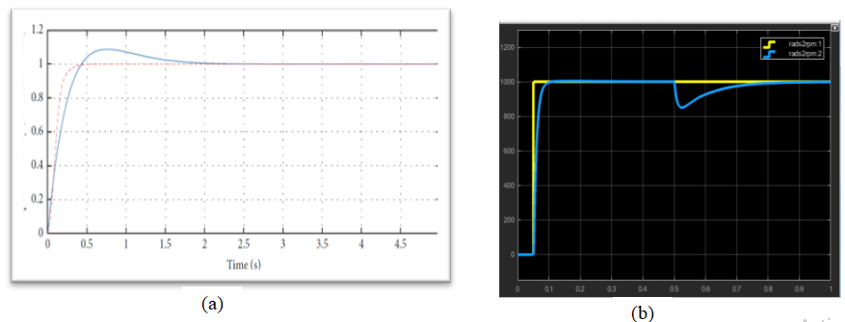

**Figure 4.5**: Speed reference tracking with ADRC (b) with enhanced Method

It has been shown via simulation that an achievement has been made for the enhancement of permanent magnet synchronous motor performance characteristics using vector control and model predictive control. Verification of various controls like vector control, model predictive control and the combination of vector and model predictive control were carried out in other to ascertain which of them that will best enhance the performance of permanent magnet synchronous motors. Also various simulations of PMSM were done using each individual controls and the combination of vector control and predictive control. From the result obtained it can be clearly seen that the result obtained using the combination of vector control and predictive control enhances PMSM performance characteristics better than the result obtained when vector control and model predictive control were used independently. From example the experimental result obtained when vector control was used independently shows that vector control has fast dynamic response, however, the torque fluctuation as can be seen is greater than that of MPC and the enhanced permanent magnet synchronous motor.

Validation was done using three controllers; vector controller and MPC, [17] to compare reference speed changes and current amplitude. it can be seen from tables 1 and 2,that when reference to 1000 RPM vector controller has 1,180 RPM, overshoot of 180 RPM,18% of referenced speed. MPC has 1,020 RPM. Overshoot of 20 RPM, 2% of referenced speed. The enhanced PMSM, maintains 1000 RPM. When it was referenced to1500 RPM, vector controller has 1,700 RPM, overshoot of 700 RPM, 13.33% of referenced speed. While the enhanced method still maintained 1500 RPM. Results obtained from transient (temporal state or behavior of motor during changes in operation such as stopping, starting or sudden load changes) behavior of current control capability shows that at 0.05s and 0.06s, the current amplitude for vector control and MPC each was ±10A, while the enhanced scheme has ±8A. In all it can be seen that the enhanced method presents a faster dynamic response when a step in the amplitude of the reference current is applied, compared to the other two control methods. Hence the enhance method (which is the combination of vector control and MPC) seems to be the better suitable method for tracking reference speed in PMSM, and therefore is recommended for PMSM controls.

1. **CONCLUSION**

A MATLAB / Simulink simulation model is developed to verify the enhancement of PMSM using vector control technique and MPC. The PMSM motor model and the IGBT model come from the SimPower Systems library of SIMULINK. Six separate IGBTs with fly-wheeling diode are used as switches, driven by DC link voltage of 400 V. A three-phase AC permanent magnet synchronous motor is used, which is made by nominal torque of 2.4 Nm. The performance of the enhanced PMSM using vector control and MPC are compared in terms of speed overshoot, torque ripple and current waveforms stability. Simulation results shows that the torque response of the MPC was faster than that of the classical vector control, and torque fluctuation was effectively reduced. But the torque, speed and current fluctuations were corrected when the enhanced method was introduced.

**REFERENCES**

1. Okoye, U. P., Eze, P. C. & Oyiogu, D. C. (2021) Enhancing the Performance of AVR System with Prefilter aided PID Controller. Access International Journal of Research & Development, Vol. 1, Issue 1, pp. 19-32.
2. Eze, P. C., Jonathan, A. E., Agwah, B. C. & Okoronkwo, E. A. (2020) Improving the performance response of mobile satellite dish antenna network within Nigeria. Journal of Electrical Engineering, Electronics, Control and Computer Science, Vol. 6, Issue 21, 2020, pp. 25-30
3. Eze, P. C., Ekengwu, B. O., Asiegbu, N. C. & Ozue, T. I. (2021) Adjustable Gain Enhanced Fuzzy Logic Controller for Optimal Wheel Slip Ratio Tracking in Hard Braking Control System. Advances in Electrical and Electronic Engineering, Vol. 19, No. 3, Sept. 2021, 231-242.
4. Wang, R. L. Lu, B. C Hou, Y. L. and Gao, Q. (2018) “Passivity-based control for rocket launcher position servo system based on improved active disturbance rejection technology,” Advances in Mechanical Engineering, vol. 10, no. 3, pp. 121–131.
5. Dastjerdi R. S., Abbasian, M. A Saghafi, H. and Vafaie, M. H. (2018) Performance improvement of permanent-magnet synchronous motor using a new deadbeat-direct current controller, IEEE Transactions on Power Electronics, vol. 34, no. 4, pp. 3530–3543.
6. Zhou, J.; Hassan, M.A.; Zhang, J.; Hou, M.; Wu, S.; Xing, G. and Chi, S. (2021) Stabilization of Constant Power Loads in DC Microgrid Systems Using an Adaptive Continuous Control Set Model Predictive Control Symmetry.
7. Nagesh, K., Lenine, D., Sujatha, P. (2020). Modeling and analysis of 8/6 switched reluctance motor with PI controller. Journal of Mechanics of Continua and Mathematical Sciences, 5: 357-370.
8. Araujo, W.R.; Reis, M.R.; Wainer, G.A.; Calixto, W.P. Efficiency Enhancement of Switched Reluctance Generator Employing Optimized Control Associated with Tracking Technique. Energies 2021, 14, 8388.
9. Khan, Y.A., Verma, V. (2019). Novel speed estimation technique for vector-controlled switched reluctance motor drive. IET Electric Power Applications, 13(8): 1193-1203. <https://doi.org/10.1049/ietepa.2018.5572>
10. Nicola, M.; Nicola, C.-I.; Selis, teanu, D.; Ionete, C. Control of PMSM Based on Switched Systems and Field-Oriented Control Strategy. Automation 2022, 3, 646–673. https:// doi.org/10.3390/automation3040033.
11. Kangping Xu, 1 Wenjia Chen, 1 Yushan Xu, 2 Mingyu Gao, 2 Zhiwei He (2014) Vector Control for PMSM. Sensors and Transducers, Vol. 170, Issue 5, May 2014, pp. 227-233 IFSA publishing, S.L.s
12. Xiao D. (2020) “Universal full-speed sensorless control scheme for interior permanent magnet synchronous motors,” IEEE Trans. Power Electron., vol. 36, no. 4, pp. 4723–4737.
13. Li D, Iwaji Y, Notohara Y, Kishita K. (2018) Harmonic Current Cancellation Method for PMSM Drive System using Resonant Controllers. In: International Power Electronics Conference Niigata, IPEC-Niigata 2018 -ECCE Asia, 1301-1307.
14. Xiong, C.; Xu, H.; Guan, T.; Zhou, (2019) P. A Constant Switching Frequency Multiple-Vector-Based Model Predictive Current Control of Five-Phase PMSMWith Non--sinusoidal Back EMF. IEEE Trans. Ind. Electron., 67, 1695–1707.
15. Liu, B. (2018) Speed control for permanent magnet synchronous motor based on an improved extended state observer, Advances in Mechanical Engineering, vol. 10, no. 1, pp. 21–31
16. Karamanakos, P.; Geyer, T. (2020) Guidelines for the Design of Finite Control Set Model Predictive Controllers. IEEE Trans. Power Electron.
17. Zhang X., Wang C. (2018) Permanent magnet synchronous motor (PMSM) current trajectory control based on single Q axis current regulator. Journal of electrical technology, 33(24):5779-5788.
18. YiBo Meng , BingYou Liu and LiChaoWang (2019) Speed Control of PMSM Based on an Optimized ADRC Controller Mathematical Problems in Engineering Volume 2019, Article ID 1074702, 18 pages <https://doi.org/10.1155/2019/1074702>
19. Siami, M., Khaburi, D. A., and Rodriguez, J. (2017) Simplified finite control set-model predictive control for matrix converters-fed pmsm drives, IEEE Transactions on Power Electronics, pp. 2438–2446.
20. Liu, B. (2018) Speed control for permanent magnet synchronous motor based on an improved extended state observer, Advances in Mechanical Engineering, vol. 10, no. 1, pp. 21–31.