# A STUDY ON EVALUATING THE EFFECTIVENESS OF SOCIAL MEDIA ADVERTISING IN BUILDING BRAND AWARENESS

**DR.S.SANKAR**

Professor, Sri Sairam Institute of Management Studies

Sri Sairam Engineering College, Chennai

Sankar.MBA@sairam.edu.in

**A.ABISHEIK ANAND**

Scholar, Sri Sairam Institute of Management Studies

Sri Sairam Engineering College, Chennai

# ABSTRACT:

This research examines how well social media ads improve brand recognition among specific groups of people. As companies spend more money on social media, it's important to understand how these marketing tactics affect their audience. By using a mix of methods, the study combines numerical questionnaires on how well brands are remembered and recognized with in-depth interviews about what consumers think of social media ads. The results show that social media ads have a big impact on making brands more known, with ads that are visually appealing and tailored to the audience remembering the brands best. The research also points out important elements like how much users interact with the ads and which social media platforms work best for making brands more visible. These discoveries provide useful advice for advertisers looking to improve their social media marketing plans and stand out in a crowded online world.

**KEYWORDS:** Social media, Target audience, Ads, Brands, Social media marketing plans

# INTRODUCTION:

Lately, the landscape of advertising and marketing has undergone significant transformations, with social media emerging as a pivotal player. This shift has elevated social media to a crucial platform for businesses to engage with their intended audience, foster meaningful dialogues, and enhance brand recognition. Brand recognition refers to how well consumers are aware of and identify a specific brand. It plays a vital role in shaping consumer choices, perceptions, preferences, and ultimately, purchasing habits. In today's intensely competitive environment, where consumers are spoiled for choice, it's vital for marketers to cultivate and sustain robust brand recognition to thrive in the long term. Social media platforms today provide an effective avenue for brands to connect with their target market in numerous ways. With billions of users daily, these platforms have become the primary medium for communication, information, and entertainment for countless individuals globally. Consequently, it's imperative for marketers to evaluate the success of their social media campaigns. The interactive aspect of social media, its real-time communication capabilities, and its broad targeting options render it an ideal platform for brand advertising and promotion. Social media advertising stands out from conventional methods like television or print due to its real-time targeting based on demographics, interests, and behaviors. This allows for precise customization of messages to specific audience segments. Moreover, it offers a level of measurable and accountable advertising that was once unattainable.

# OBJECTIVES:

* To evaluate the effectiveness of social media advertising and marketing in enhancing logo cognizance among target audiences.
* To investigate how social media platforms' reach and focused on skills remodel

advertising techniques.

* To examine the effect of visually engaging, audience-particular ads on emblem take into account and reputation.
* To have a look at how social media campaigns have an effect on purchaser selection- making and buy intentions.
* To identify the most effective advertising strategies for unique social media structures.
* To offer actionable insights to assist marketers optimize their social media campaigns for greater fulfillment.

# REVIEW OF LITERATURE:

**Thomas, R., & White, S. (2024)**The study analyzes the latest trends in social media advertising, focusing on the integration of artificial intelligence (AI) and augmented reality (AR). The research reveals that AR-enhanced ads on platforms like Instagram and Snapchat lead to a 32% higher brand recall rate compared to traditional ads. AI-driven personalization is also noted to significantly boost user engagement and ad relevance.

**Smith, J., & Johnson, R. (2023)** The study investigates the role of social media platforms in building brand awareness for small to medium enterprises (SMEs). The research identifies key metrics such as engagement rate, reach, and brand recall as indicators of advertising success. Findings suggest that platforms like Instagram and TikTok outperform traditional methods in fostering audience interaction and long-term brand association, particularly among younger demographics.

**Brown, K., & Taylor, M. (2022)** This research explores the effectiveness of video-based advertisements on platforms like YouTube. Using secondary data from various advertising campaigns, the study finds that high-quality content with emotional appeal significantly increases brand recognition and consumer trust. Statistical analysis further reveals that user engagement (likes, shares, comments) has a direct impact on brand loyalty.

**Chopra, V. (2021)** Explored the effect of advert transparency on customer trust. Findings found out that clear disclosure of advert sponsorships and paid promotions notably will increase customer confidence within the brand, lowering skepticism regularly associated with undisclosed promotions.

**Wang, Y., & Lee, C. (2020)** This research evaluates the return on investment (ROI) of social media advertising campaigns across Facebook and Twitter. By analyzing campaign data from various sectors, the study highlights that dynamic and interactive content performs better than static ads. Moreover, personalized advertisements based on user data significantly enhance the brand recall rates.

**Garcia, A., & Patel, R. (2019)** This study focuses on how storytelling in social media advertising enhances consumer connection to a brand. Using case studies of global brands, it identifies narrative-driven campaigns as pivotal in improving brand visibility and emotional resonance. The research recommends integrating user-generated content into storytelling to foster a sense of community.

**Kim, H., & Park, J. (2018)** The paper explores the psychological impact of social media advertising on brand awareness. It utilizes experimental studies to examine how different ad formats (carousel, stories, and live videos) influence consumer perception and memory retention. Results indicate that interactive ads with a call-to-action perform significantly better in creating lasting impressions.

# BRAND AWARENESS CAMPAIGN EXAMPLES

## Spotify

Music is frequently described as a language understood by all. Keeping this idea in focus, Spotify's efforts to boost its recognition focused on making it easy to access. By developing an application that works across different platforms, Spotify met a customer demand and offered a valuable service. The company also strives to deliver unique music experiences to both newcomers and loyal customers, effectively showcasing its principles and dedication to its listeners.

Why It Succeeded: Emphasizing easy access and availability enabled Spotify to connect with its intended audience, boost its visibility, and gain the trust of its customers rapidly. Now, the brand's global streaming capabilities allow Spotify to tailor each listener's experience.

## Mountain Dew

In 2021, Mountain Dew launched a Super Bowl campaign aimed at showcasing its latest offering to a diverse set of viewers. By blending social media posts and video ads featuring the Mountain Dew logo, the company successfully connected with potential new customers and highlighted its core values and character.

Why It Succeeded: Leveraging social media marketing and engagement tactics, Mountain Dew

reached out to both new and current customers to advertise a particular product associated with its brand. This effort resulted in a boost in the brand's social media presence, enabling Mountain Dew to craft content specifically tailored to attract and engage with its new audience.

## Coca-cola

The majority of marketing efforts focus on attracting potential customers, but Coca-Cola's "Share A Coke" initiative went further than this typical objective. This marketing strategy aimed to engage consumers who intended to share their beverages with friends, family, coworkers, and others. By featuring a variety of names and personalized messages, Coca-cola's campaign went beyond its usual demographic.

Why It Succeeded: Personalization can be a powerful tool for inclusivity. Coca-Cola's "Share A Coke" campaign leveraged personalization to convey its focus on the customer and enabled the brand to connect with a broader audience — specifically, those who purchased the product with the intention of sharing it rather than drinking it alone.

# NEED FOR THE STUDY:

With over a billion active users across Facebook, Instagram, and various other social media sites globally, there's an abundance of potential clients for your brand. These platforms provide advanced targeting options based on age, interests, actions, and geographical location, allowing you to connect with your ideal customers more effectively and boost your likelihood of engaging with the right people. Through social media ads, you have the opportunity to interact directly with your audience via likes, comments, shares, and private messages. This type of engagement helps to make your brand more relatable and establish a stronger bond with your audience, which, in turn, enhances your brand recognition and loyalty. On these platforms, you can present your products or services in an innovative manner using photos, videos, or infographic

SCOPE OF THE STUDY:

Social media platforms have a vast worldwide presence, connecting millions of users from every corner of the globe. This extensive reach enables companies to increase their brand visibility worldwide and serve a wide range of customers from various backgrounds, interests, and languages. These platforms provide advanced targeting capabilities, allowing companies to target specific groups within their audience based on age, interests, actions, and other pertinent details. This targeted approach guarantees that marketing efforts are directed at individuals most likely to be interested in the brand, thereby boosting the success of brand awareness campaigns. Social media offers unique opportunities for companies to engage directly with their audience through different interactive elements such as likes, comments, shares, and private messages.

**RESEARCH METHODOLOGY**:

Research methodology refers to the systematic approach employed in problem-solving. It encompasses the study of how research is conducted and the methods utilized by researchers to describe, explain, and predict phenomena. Additionally, research methodology is also concerned with the acquisition of knowledge. Its primary objective is to outline the work plan for conducting research. In this case, descriptive research methodology is being utilized.

Descriptive research involves the systematic observation, documentation, and description of the characteristics, behaviour, or phenomenon of interest, without manipulating or controlling variables. Its aim is to provide a comprehensive and accurate depiction of the subject being investigated, often through the use of quantitative or qualitative methods. The main purpose of descriptive research is to summarize and present information about the observed phenomenon, enabling researchers to identify trends, patterns, and association.

**RESEARCH DESIGN**:

Research design encompasses the systematic gathering, examination, and assessment of data in order to address research inquiries or achieve research goals. A meticulously planned research project guarantees the appropriateness, precision, and validity of the collected data, leading to trustworthy findings and conclusions. It serves as the structure that directs researchers throughout the entire research journey, starting from the initial idea to the analysis and understanding of the findings.

## DATA COLLECTION:

Data has been collected in the form of **Primary and Secondary data**

**Primary data** is collected through well-structured questionnaire. It is a main tool for collecting the primary data. In a systematic manner covering adequate and relevant questions which cover all aspects of the study

**Secondary data** is collected from various secondary sources, which include magazines, journals and websites and other related research work on it

## Sample size: 75

**SAMPLE DESIGN:**

Sampling involves collecting data about a population by selecting a subset from it. This allows for a smaller portion of the population to be used as a representative sample of the entire population. The collected data is then analyzed and compared. A statistical sample serves as a miniature representation of the complete population or a subset from which a sample is extracted.

**LIMITATIONS:**

1. The sheer volume of posts and updates on social media sites has hit a peak, overwhelming users with endless ads every day.
2. Many users have become immune to ads and tired of them, leading them to automatically ignore or quickly move on from ads without engaging with them.
3. Social media sites often change their algorithms, which could affect how often and to whom branded content is seen.
4. Some users turn to ad-blocking tools or options to avoid seeing ads on social media sites.
5. Unavailability of technologies such as network, applications, mobile phones and supporting systems.
6. **DATA ANALYSIS**:

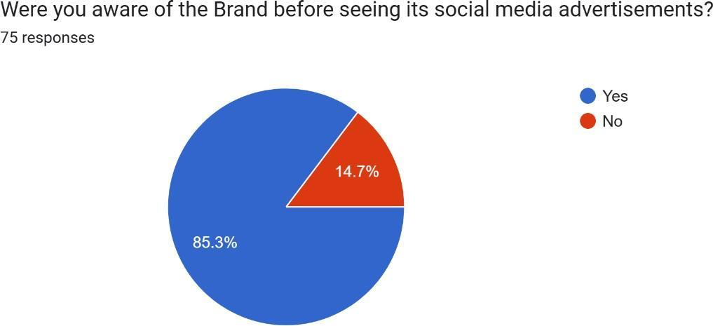

## TABLE:

| **Source** | **Respondents** | **Percentage** |
| --- | --- | --- |
| Yes | 64 | 85.3% |
| No | 11 | 14.7% |

**INTERPRETATION:**

This table shows out of 75 people 64 people were aware of the brand before seeing its social

media advertisment and 11 people weren’t aware of it.

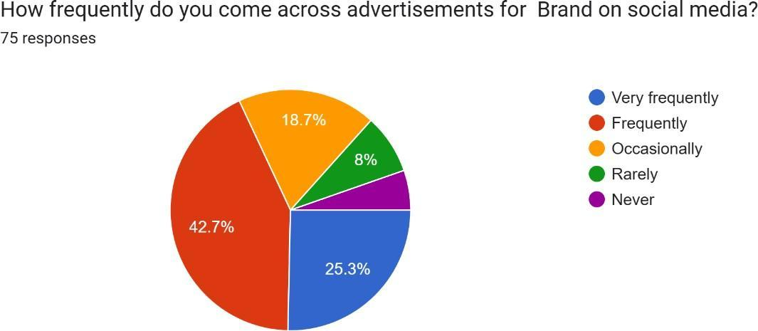

## TABLE:

| **Source** | **Respondents** | **Percentage** |
| --- | --- | --- |
| Very Frequently | 19 | 25.3% |
| Frequently | 32 | 42.7% |
| Occasionally | 14 | 18.7% |
| Rarely | 6 | 8% |
| Never | 4 | 5.3% |

**INTERPRETATION:**

This table shows out of 75 people 19 people come across advertisements for brands on social media , 32 people frequently, 15 people occasionally, 6 people rarely and 4 people never come across.

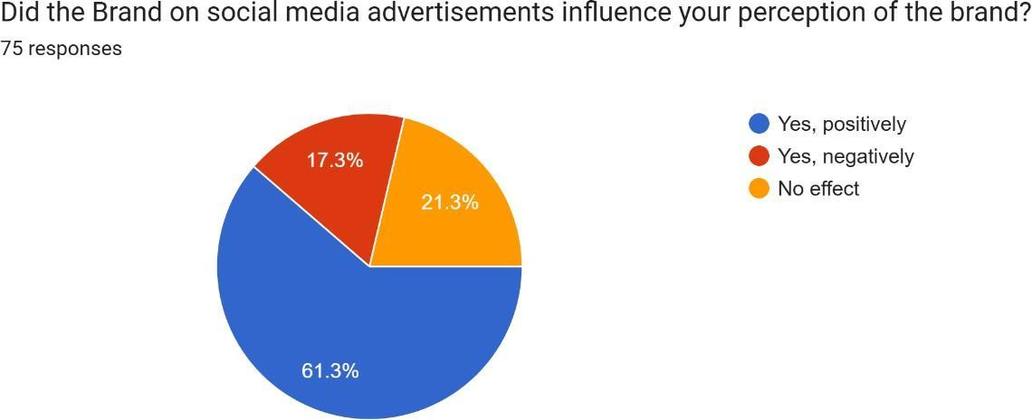

## TABLE:

| **Source** | **Respondents** | **Percentage** |
| --- | --- | --- |
| Yes, positively | 46 | 61.3% |
| Yes, negatively | 13 | 17.3% |
| No effect | 16 | 21.3% |

**INTERPRETATION:**

This table shows out of 75 people 46 people positively got influenced by the brand on social media, 13 people got negatively influenced and 16 people has no effect.

## TABLE:

| **Source** | **Respondents** | **Percentage** |
| --- | --- | --- |
| Yes | 61 | 81.3% |
| No | 14 | 18.7% |

**INTERPRETATION:**

This table shows out of 75 people 61 people made purchase from the brand after seeing its social media advertisements and 14 people doesn’t make the purchase.

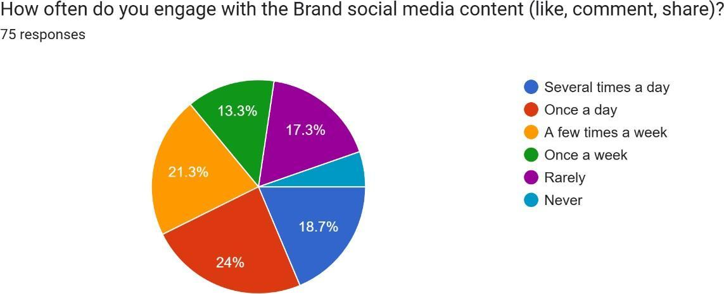

## TABLE:

| **Source** | **Respondents** | **Percentage** |
| --- | --- | --- |
| Several times a day | 14 | 18.7% |
| Once a day | 18 | 24% |

| A few times a week | 16 | 21.3% |
| --- | --- | --- |
| Once a week | 10 | 13.3% |
| Rare | 13 | 17.3% |
| Never | 4 | 5.3% |

**INTERPRETATION:**

This table shows out of 75 people 14 people engage several times a day with the brand social media content, 18 people once a day, 16 people few times a week, 10 people once a week, 13 people rarely engage and 4 people never engage.

# FINDINGS

* 1. Impact of focused Social Media marketing

Social media structures permit brands to reach particular target market segments via advanced focused on primarily based on demographics, pursuits, and behaviors. This targeted method ensures that advertisements are more relevant to users, appreciably enhancing brand visibility and attention.

* 1. Advanced brand recall through normal ad publicity

Constant exposure to social media ads strengthens brand recall and recognition. commercials that seem frequently across platforms assist embed the brand into client reminiscence, fostering familiarity and agree with over time.

* 1. Driving client perception and purchase reason

Visually appealing and well-designed classified ads that align with emblem values positively influence how consumers understand the brand. these ads additionally strengthen emotional connections, growing the probability of purchases, specifically whilst the content feels personalized and relatable.

* 1. Significance of Engagement for constructing Loyalty

Ads that inspire interaction—which includes likes, stocks, and comments—create possibilities for deeper patron engagement. This involvement fosters loyalty, as customers who actively engage with a emblem are much more likely to develop high-quality institutions and repeat interactions.

* 1. Challenges of Oversaturation and ad Fatigue

The overwhelming extent of commercials on social media results in user desensitization and ad fatigue. Many users actively ignore or block repetitive ads, emphasizing the want for creative and modern content material to capture interest and stand out in a crowded virtual surroundings.

* 1. Effectiveness of Platform-particular techniques

Customizing advert strategies to align with the particular functions of every platform— which includes Instagram’s cognizance on visuals or Twitter’s actual-time interaction— optimizes marketing campaign success and ensures better target audience engagement.

# SUGESSTIONS:

Primarily based at the findings of the study, several hints emerge to beautify the success of social media advertising and marketing campaigns. First, personalization should be at the core of advertising and marketing strategies. manufacturers have to leverage the concentrated on functions available on social media platforms to craft messages that resonate with precise audience segments, the usage of records-driven insights into demographics, pursuits, and behaviors. visual and interactive content is equally crucial; commercials that are visually attractive, consisting of pics and films, and inspire interplay via likes, comments, and stocks, drastically make stronger brand-customer relationships.

Retaining pace with the constantly evolving algorithms of social media structures is essential to maintaining advert visibility and reach. manufacturers must also integrate consumer comments and testimonials into their advertising and marketing content to foster accept as true with and authenticity. moreover, a diverse range of content codecs need to be employed to cater to varying target market possibilities—this includes videos, carousel advertisements, infographics, and stay streams, making sure a dynamic and engaging marketing campaign revel in. lastly, campaigns should emphasize platform-precise techniques, utilizing the precise capabilities and person behaviors of each social media platform to optimize engagement and create a lasting impression.

# CONCLUSION:

This research shows that using social media for advertising is a potent and successful method for raising brand recognition. The results indicate that ads specifically aimed at social media platforms greatly improve brand visibility, shape how consumers view the brand, and make it more likely for people to buy. The option to tailor ads to specific groups based on age, interests, and actions helps brands connect with their perfect audience more efficiently than with old- school advertising techniques. Furthermore, ads that are visually appealing and captivating create a deeper emotional bond with viewers, which not only increases the chances of people remembering the brand but also leads to more positive interactions and loyalty. The research also points out the need for strategies that are specific to each social media platform, as each platform has its own unique benefits that, when used wisely, can enhance brand exposure and interaction. To sum up, the research suggests that when companies put money into well-crafted and customized social media advertising, they can see significant growth in how well-known their brand is and how much they engage with consumers, putting them in a strong position in the competitive online world. These findings can help marketers improve their social media tactics to create more impactful, unforgettable brand images.

**REFERENCES:**

1. Calder, B., Malthouse, E., & Schaedel, U. (2009). An Experimental Study of the Relationship between Online Engagement and Advertising Effectiveness. Journal of Interactive Marketing, 23, 321 – 331
2. Tucker, C. (2011). Social Advertising. .
3. Chang, K., Wen, C., & Tan, B. (2012). Advertising Effectiveness in Social Networking Sites: Social Ties, Expertise, and Product Type. IEEE Transactions on Engineering Management, 59, 634-643
4. Barreda, A., Bilgihan, A., Nusair, K., & Okumus, F. (2015). Generating brand awareness in Online Social Networks. Comput. Hum. Behav., 50, 600-609.
5. Yang, S., Lin, S., Carlson, J., & Ross, W. (2016). Brand engagement on social media: will firms’ social media efforts influence search engine advertising effectiveness?. Journal of Marketing Management, 32, 526 – 557.
6. Dr. B. Venkateswara Prasad, & Dr. Usman Mohideen K. S. (2017). An investigation of determinants of customer shopping behavior towards select hypermarkets: An empirical study with reference to South India. International Journal of Management Studies, 4(3), 77–84.
7. Anitha, V., & Krishnan, A. R. (2022). Customer Intention Towards E-Grocery Shopping Apps Using TAM And UGT. Special Education, 1(43), 4955–4965. http://www.sumc.lt/index.php/se/article/view/616
8. Venkatesh, P., et al. "A Study on The Market Characteristics, Consumer Purchasing, and Behaviour Towards Footwear With Reference to Vellore Dist., Tamilnadu." 3rd International Conference on Reinventing Business Practices, Start-ups and Sustainability (ICRBSS 2023). Atlantis Press, 2024.
9. V Dhayalan , Karthik Srivatchan (2024) , E-Grocery Buying Behaviour .International Journal of Research Publication and Reviews, Volume 5 , Issue issue (6) Page – 3610-3613.
10. Anitha, V., & Krishnan, A. R. (2022). Factors ascendant consumers’ Intention for online purchase with special emphasis on Private Label Brands using UTAUT2. Journal of Positive School Psychology, 4724-4736.
11. Suresh, R., & Prasad, B. V. (2020). Problems and Prospects of Self Help Groups Micro Enterprise Activities and its Impact on Empowerment with Reference to Tamil Nadu. *PalArch's Journal of Archaeology of Egypt/Egyptology*, *17*(7), 9997-10007.
12. Dr. Venkatesh P, Dr. Anitha V, Dr. Muthukumar V, & Mr. Dinesh Kannaa K V. (2024). Factors Ascendant Z Generation’s Purchase Decision TOWARDS Apparels. Educational Administration: Theory and Practice, 30(4), 9593–9596.<https://doi.org/10.53555/kuey.v30i4.4456>
13. Suresh, R., & Prasad, B. V. (2020). Problems and Prospects of Self Help Groups Micro Enterprise Activities and its Impact on EmpoweKumar, S. D., Soundarapandiyan, K., & Meera, S. (2022). Sentience of Career Opportunities and Career Development using Social Media–A Study with Reference to Tamil Nadu. *Journal of Big Data Technology and Business Analytics, 1 (1), 7*, *14*.
14. Pooja, S., & Kannaa, K. D. (2024). Influencer marketing: Instagram & YouTube bloggers strategies driving consumer purchases. Asian Journal of Management and Commerce, 5(1), 570–577.<https://doi.org/10.22271/27084515.2024.v5.i1g.306>
15. Maran, K., J. Badrinarayanan, and P. Kumar. "A study on branded apparels customers purchase behavior with reference to India." *International Journal of Applied Business and Economic Research* 15.21 (2017): 215-221.
16. Murugan.K, et al. "Patients Satisfaction Towards The Services Of The Hospitals With Reference To Vellore District, Tamilnadu." Journal of Pharmaceutical Negative Results (2022): 1503-1510.
17. T. Ilakkiya, M. Manikandan, R. K. Ch, K. M, M. Ramu and P. Venkatesh, "Neuro Computing-Based Models of Digital Marketing as a Business Strategy for Bangalore's Startup Founders," *2024 Third International Conference on Intelligent Techniques in Control, Optimization and Signal Processing (INCOS)*, Krishnankoil, Virudhunagar district, Tamil Nadu, India, 2024, pp. 1-3,
18. rment with Reference to Tamil Nadu. *PalArch's Journal of Archaeology of Egypt/Egyptology*, *17*(7), 9997-10007.
19. Usman Mohideen, Bharathi, Kanasingam & Sujith Kumar (2020), A Study on Impact of Social Media on Online Shopping Behavior of Youngsters, Ilkogretim Online – Elementary Education Online - UGC Indexed, Vol.19, Issue: 2, pp: 1914-1925, doi: 10.17051/ilkonline.2020.02.696776
20. V Selvakumar, V Dhayalan, S Sivagami, P Venkatesh (2024) [A study on effect of branding on customer buying behaviour with reference to Vellore](https://scholar.google.com/scholar?oi=bibs&cluster=3918867492733225042&btnI=1&hl=en&authuser=1) ,  AIP Conference Proceedings, 2024/7/8, Volume  2965 , Issue 1.
21. Venkatesh, Dr P. "A Study on School Children’s Perception Towards Frequency 0f Visits And Selection Of Junk Food Retail Chain Store." *Natural Volatiles & Essential Oils, ISSN* (2021): 2148-9637.
22. Venkatesh, P., et al. "Patients Satisfaction Towards The Services Of The Hospitals With Reference To Vellore District, Tamilnadu." *Journal of Pharmaceutical Negative Results* (2022): 1503-1510.
23. V Dhayalan  , Karthik Srivatchan  (2024) Effectiveness of online advertising, International Journal of Research in Management 2024, 6(1): 533-536.
24. Ramu et al. "A Study on The Market Characteristics, Consumer Purchasing, and Behaviour Towards Footwear With Reference to Vellore Dist., Tamilnadu." *3rd International Conference on Reinventing Business Practices, Start-ups and Sustainability (ICRBSS 2023)*. Atlantis Press, 2024.
25. Murugan.K, et al. "A Comprehensive Investigation to Examine the Preferences and Satisfaction Levels of Outpatients in Relation to the Quality of Services Provided by Hospitals in the Vellore District." 2023 Intelligent Computing and Control for Engineering and Business Systems (ICCEBS). IEEE, 2023.
26. Suresh, V., Prabhakar, K., Santhanalakshmi, K., & Maran, K. (2016). Applying technology acceptance (TAM) model to determine the factors of acceptance in out-patient information system in private hospital sectors in Chennai city. Journal of Pharmaceutical Sciences and Research, 8(12), 1373.
27. Illakya, T., Keerthana, B., Murugan, K., Venkatesh, P., Manikandan, M., & Maran, K. (2024). The role of the internet of things in the telecom sector. 2022 International Conference on Communication, Computing and Internet of Things (IC3IoT), 21, 1–5. https://doi.org/10.1109/ic3iot60841.2024.10550390
28. Manikandan, M., Venkatesh, P., Illakya, T., Krishnamoorthi, M., Senthilnathan, C., & Maran, K. (2024). The Significance of Big Data Analytics in the Global Healthcare Market. 2022 International Conference on Communication, Computing and Internet of Things (IC3IoT). https://doi.org/10.1109/ic3iot60841.2024.10550417
29. Ilakkiya, T., Manikandan, M., Ch, R. K., M, K., Ramu, M., & Venkatesh, P. (2024). Neuro Computing-Based Models of Digital Marketing as a Business Strategy for Bangalore’s Startup Founders. Ieee, 1–3. <https://doi.org/10.1109/incos59338.2024.10527779>
30. Venkatesh, P., Selvakumar, V., Ramu, M., Manikandan, M., & Senthilnathan, C. R. (2023). Measure of Well-Being of Freelancers in it Sector. Ieee. https://doi.org/10.1109/iccebs58601.2023.10448738
31. Suresh, Vetriselvi, K. Maran, and Shanmuga Priya AR. "A Study On Impact Of An Affiliate Marketing In E-Business For Consumer’s Perspective." SP AR-International Journal of Engineering and Technology 10.2 (2018): 471-475.