DESIGN FABRICATION AND TESTING OF WIRELESS CONTROLLED RIVER WASTE CLEANING VEHICLE

1Suresh Premil Kumar R, 2Rajkumar S R, 3Jein Sam Dhas R, 4Ajin D, 5Ajithkumar A, 6Benitline Geno E

1Professor, 2,3Assistant Professor, 4,5,6UG Student,

1,2,3,4,5,6Department of Mechanical Engineering

Stella Mary’s College of Engineering

Aruthenganvilai, Azhikal Post, Kanya Kumari District,

Tamil Nadu, India

Corresponding email: [jein@stellamaryscoe.edu.in](mailto:jein@stellamaryscoe.edu.in) 3

# ABSTRACT - River bodies have been polluted indiscriminately by being subjected to waste generated by industries as well as human being and apart from the soluble waste there is a lot of insoluble waste which creates a layer on the river body which not only affects the quality of water but also prevents the sunrays to move down the bed of the river seriously affecting the aquatic life within the river. This huge amount of sewage loaded with pollutants, toxic material and debris has also led to shortage of potable water to be used by humans and poses health hazard to the flora and fauna as well as humans. The government of India has taken efforts toward cleaning of river bodies by investing huge capital on projects like “Namami Gange”, ‘’Narmada Bachoo’’ and various other major and medium projects in various cities like Ahmadabad, Varanasi etc. Considering the above factor we have designed and fabricated a machine which is able to flush out the floating waste from the river bodies. The machine is automated with the help of an RF module. This RF module controls the dc motors fabricated on the machine and helps the machine to move ahead and make various movements on the river to collect the floating garbage. The machine is supplemented by a garbage bin which accumulates the garbage collected. The machine is able to collect floating garbage and thus can be supplemented to be used to clean various small water bodies which otherwise may not be cleaned due to want of funds.

# Keywords: Waste Management System, Small Water Bodies, Waste Accumulation, Environmental Conservation

# I. INTRODUCTION

The “River cleanup machine” has been utilized in that places where there's waste debris within the water body which are to be removed. This machine is consisting of waterwheel driven conveyer mechanism which collect & remove the wastage, garbage & plastic wastages from water bodies. This also reduce the difficulties which we face when collection of debris is done. A machine will lift the waste surface debris from the water bodies, this may ultimately end in reduction of pollution and lastly the aquatic animal's death to those problems will be reduced. It consists of Belt drive mechanism which lifts the debris from the water.

The use of this project is going to be made in rivers, ponds, lakes and other water bodies for to wash the surface water debris from bodies. Similarly, they are lots of problems of water pollution under Godavari River, Nasik which affect the acoustic, human life & beauty of Godavari River. Some photo graphs are showing the pollution near Godavari River Nasik. Waste water is defined because the flow of used water from homes, business industries, commercial activities and institutions which are subjected to the treatment plants by a carefully designed and engineered network of pipes. The biggest impact of cleaning the chemical wastes can cause respiratory diseases and it plays a challenging issue for the municipality officers Water damage is classified as three types of contaminated water. They are clean water, gray water and black water. Clean water is from a broken water system line or leaking faucet. If not treated quickly, this water can become black water or gray water, counting on length of your time, temperature, and get in touch with surrounding contaminants. A ditch may be a narrow channel that's dug at the side of a road or field to hold away the water. Nowadays, albeit automation plays important role altogether industrial applications within the proper disposal of sewages from industries and sewage cleaning remains a challenging task. Drainage pipes are used for the disposal of sewage and unfortunately sometimes there could also be loss of human life while cleaning the blockages within the drainage pipes. The municipality workers are only responsible to ensure that the sewage is clean or not. Though they clean

The ditches at the side of buildings, they can’t clean in very wide sewages. The municipality workers need to get down into the sewage sludge to clean the wide sewage. It affects their health badly and also causes skin allergy.

# CONSTRUCTIONAL DETAILS

Solar Lake Cleaner system consists of

* Solar power generation system
* Energy storage system
* Vehicle power system
* Transmission system
* Body of the system

Solar power generation system consists of panels, cell and solar panel, which is fixed on the top of the vehicle. A generator is coupled with the solar panel. Energy storage system consists of two batteries, one is for online charging and the other is for motor power. Vehicle power system consists of one electrical motor which gets power from the energy storage system. Transmission system consists of gear box wheel axles and the four wheels. The above all the four systems are provided on the body of the vehicle.

**1.2 Basic Components of a Solar Lake Cleaner**

DC motor

A DC motor is an electric motor that runs on direct current (DC) electricity. DC motors were used to run machinery, often eliminating the need for a local steam engine or internal combustion engine. DC motors can operate directly from rechargeable batteries, providing the motive power for the first electric vehicles. Modern DC motors are nearly always operated in conjunction with power electronic devices.

Brushed DC electric motor

This is a brushed DC electric motor generating torque directly from DC power supplied to the motor by using internal commutation, stationary permanent magnets. Torque is produced by the principle of Lorentz force, which states that any current- carrying conductor placed within an external magnetic field experiences a force known as Lorentz force. The commutator consists of a split ring 80 degree shows the effects of having a split ring. The brushed DC electric motor generates torque directly from DC power supplied to the motor by using internal commutation, stationary magnets (permanent or electromagnets), and rotating electrical magnets. Like all electric motors or generators, torque is produced by the principle of Lorentz force, which states that any current-carrying conductor placed within an external magnetic field experiences a torque or force known as Lorentz force. Advantages of a brushed DC motor include low initial cost, high reliability, and simple control of motor speed. Disadvantages are high maintenance and low life-span for high intensity uses. Maintenance involves regularly replacing the brushes and springs which carry the electric current, as well as cleaning or replacing the commutator. These components are necessary for transferring electrical power from outside the motor to the spinning wire windings of the cell inside the motor. Brushless

Brushless DC motors use a rotating permanent magnet or soft magnetic core in the cell, and stationary electrical magnets on the motor housing. A motor controller converts DC to AC. This design is simpler than that of brushed motors because it eliminates the complication of transferring power from outside the motor to the spinning cell. Advantages of brushless motors include long life span, little or no maintenance, and high efficiency. Disadvantages include high initial cost, and more complicated motor speed controllers. Some such brushless motors are sometimes referred to as "synchronous motors" although they have no external power supply to be synchronized with, as would be the case with normal AC synchronous motors.

Uncommuted

Other types of DC motors require no commutation. Homopolar motor – A homopolar motor has a magnetic field along the axis of rotation and an electric current that at some point is not parallel to the magnetic field. The name homopolar refers to the absence of polarity change. Homopolar motors necessarily have a single-turn coil, which limits them to very low voltages. This has restricted the practical application of this type of motor. Ball bearing motor – A ball bearing motor is an unusual electric motor that consists of two ball bearing-type bearings, with the inner races mounted on a common conductive shaft, and the outer races connected to a high current, low voltage power supply. An alternative construction fits the outer races inside a metal tube, while the inner races are mounted on a shaft with a nonconductive section (e.g. two sleeves on an insulating rod). This method has the advantage that the tube will act as a flywheel. The direction of rotation is determined by the initial spin which is usually required to get it going.

Connection types

There are three types of connections used for DC electric motors: series, shunt and compound. These types of connections configure how the motor's field and armature windings are connected together. The type of connection is significant because it determines the characteristics of the motor and is selected for speed/torque requirements of the load.

# II. LITERATURE REVIEW

Ankita B Padwal [1] Automatic voidance water cleansing and system victimization motorcar mechanism planned to beat the important time issues. Our planned technique is to filter and management the voidance level victimization motorcar mechanism technique. motorcar mechanism is major dominant unit. The voidance level a monitor by the municipal. The system used chain, driver, bucket, frame etc.

Arman Shaikh [2] the general public washrooms stay constantly dirty as a result of the users don’t flush water once victimization the bathroom. during this project they're implementing the automated lavatory cleansing system, this can be supported natural philosophy also as software package programs with completely different algorithms for the automated system. once the general public bathrooms stay constantly dirty then the system clean the bathrooms mechanically with facilitate of assorted sensors and Arduino controller.

Nitin Sall [3] Explained regarding the flow of used water from homes, business industries, industrial activities is named waste water. 200L and 500L wastage water area unit generated all and sundry on a daily basis. therefore, by victimization waste water technology that removes, instead of destroys a waste material in an exceedingly system.

Dr .Narendra Bawane [4] The watercourse finish off machine has been used in this places wherever there is waste rubbish inside the water body that area unit to be removed. This machine is consists of waterwheel driven conveyer mechanism that collect and take away the wastage, garbage and plastic wastages from water bodies. This conjointly cut back the difficulties that we tend to face once assortment of rubbish is finished . A machine can raise the waste surface rubbish from the water bodies, this might ultimately finish in reduction of pollution and in conclusion the aquatic animal's death to those issues are reduced. It contain of Belt drive mechanism that lifts the rubbish from the water.

Gaurav S Gajare [5] The analysis paper focuses on replacement the manual technique of cleansing the system with semiautomated mechanical voidance cleaner. the tactic followed today is proving to be the hazard for the employee enterprise the method of cleansing the drainages. at the side of voidance water some solid waste travels through the voidance line and at the junction points of system these solid waste gets accumulated over time and so causes the blockage of system. This urges the requirement of cleansing of the voidance line on time. therefore, this technique can facilitate to resolve such downside and can so assist you to confirm timely cleansing of the system by segregating the solid waste.

N. Yashaswini [6] designed and analyzed for conveyancing granular materials to the peak of 15m at the speed of 10tones/hr. output. They explained regarding the fundamental style calculations for the event of the bucket elevator in 3D surroundings of NX software package. They conjointly administrated static and vibration analysis on the bucket elevator. They explained dynamic behavior of the bucket and kit shaft assembly**.**

Vivek Cuon alpines [7] because of the difficulties baby-faced to keep the beach clean manually, we've to come back up with instrumentality that not solely collect the waste and conjointly separates. this can be straightforward for waste disposal. The machine principally consists of associate degree engine and it runs through a fossile that driven the entrie method. The waste is collected by conveyor balde and at the side of the sand that falls of through the perforations done on the conveyor back to the sand bed materials come about through principle of density distinction. It consists of 2 hoppers wherever the various waste area unit collected that facilitate straightforward disposal of waste.

Reshav Bisen [8] Once Mahatma Gandhi aforementioned that sanitation has a lot of values and importance than independence. Normally, we tend to seen that dirt on the road causes unclean. numerous studies shows that thirty third of pollution is creates by dirt on road in Republic of India which can cause health and accident downside for folks’ motion on road. Hence, it's necessary to stay clean road from dirt and dirt. during this project a trial has done to style and development of dirt cleansing machine for cleansing of dirt beside the road divider by sterilization manual method with economical technique. This machine carries with it scrubber brush which offer sweeping action at constant time vacuum dirt collector is provided which can clean the dirt. Also, by introducing this project our aims to meet the goals of Swachh.

India Mission. Praveen H [9] cleansing is that the main basic would like for all citizenry and it's necessary for daily routine method. the standard road and floor cleansing machine is most generally employed in several applications like example roads, railway stations, airports, hospitals, Bus stands, in multi buildings, faculties etc. conjointly this machine uses human energy for its operating operation. it's a user friendly also as eco-friendly. In our project we tend to area unit aimed to use simply obtainable materials with low price and it is simply fancied and simple to use and management. it's the higher various for standard machine.

MS Deepika [10] outlined the water watching systems like Tank pollution watching and water pipeline leak sensing watching. They avoided Brobdingnagian quantity of water wasted by uncontrolled use of huge residences. They used the PID primarily based water level watching to point the amount of water for our generation

2.1 OBJECTIVES

* To design and fabricate unmanned solar operated lake cleaning boat to clean lake.
* To use UV sensor technology to identify the nearby obstacles in the lake
* To Improve the water quality in the lake.
* To make public aware of lake cleaning by creating website and to publishing lake cleaned data in the website
* To Reduce the Pollution of Water Surface
* To Increase the Uses of Renewable Energy
* To Maintain Automation During Working towards Cleaning River
* To Reduce the man power and Time Consumption
* To Record the Amount of Garbage, Remove from Waterway and Give Solution and Provide Better Environment

1. **Methodology & System Modeling**
   1. Research Design

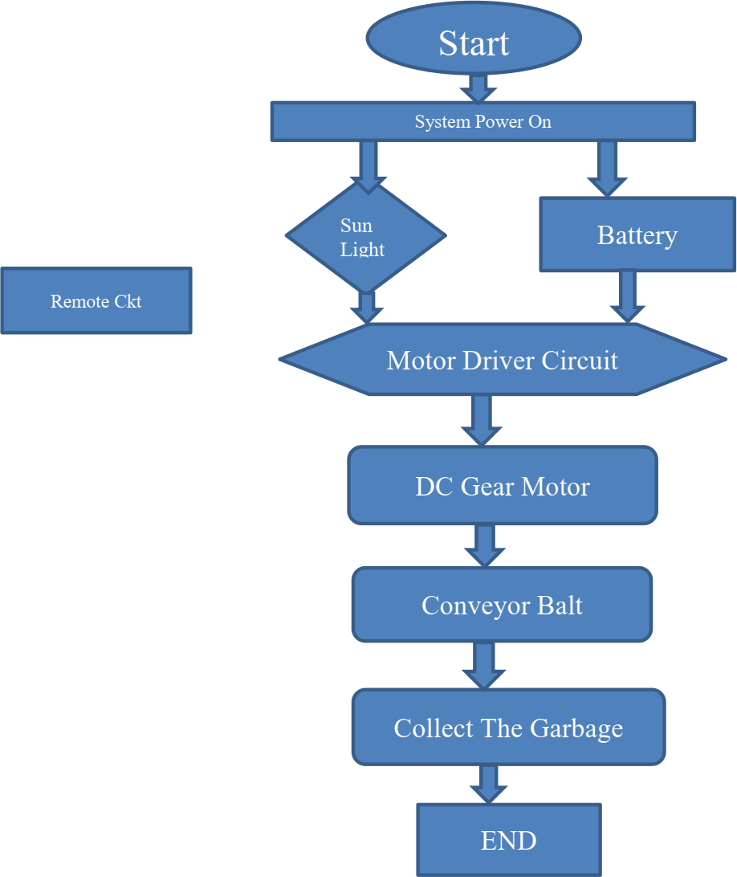The Research design is based on a simplified model proposed by Borg & Gall having 10 step which have been modified into four basic steps as given below development of Borg & Gall the authors simplified them into 4 steps. In line with the model, the stages taken in developing CBOT were:

Figure 1: Flow of work

1. Analyzing the system requirement,
2. Mechanical Design,
3. Electronic Design
4. Development and Testing

# SYSTEM REQUIREMENT

C-BOT developed can be included in the category of rotor mobile robot with navigation system. The System requirement is as given below:

The main driver of C-BOT is rotor, so it takes mechanical wheel and wheel driver.

1. Power Supply to develop the required torque to drive the wheel.
2. Battery of 12 volts
3. Appropriate motion controller.
4. Wireless RF remote as robot controller.
5. DC Motor used to drive the robot rotor.
6. DC Motor which serves to move the lever if the garbage receptacle is full.
7. Motor Driver circuit.
8. Base Frame
9. Collecting Mechanism
10. Chain
11. Carrying Belt
12. Water Wheel

# Mechanical Design

# The drive source of our project is an electrical motor having 12V and seven .6 ampere current which is employed to drive gear train, water wheel and collecting mechanism. We have used 4 motors. One motor is mounted on garbage collector, one motor each is mounted on left and right water wheel and one motor is mounted on carrying belt with the help of gear train and chain drive mechanism. Collecting Mechanism is employed in our project to beat real time issue as thanks to water tension garbage is difficult to gather. By using this four-bar mechanism, it rotates at a specific angle intended to gather the rubbish for the model. It has two window which can be opened and closed as per the requirement with the help of an RF remote. Water wheel is bolted on shaft which is placed aboard frame. The purpose of water wheel is to maneuver the machine forward or backward on water. Motor is employed to rotate the water wheel with the assistance of chain drive mechanism.

# 

Figure 2. Exploded View of River Cleaning Machine

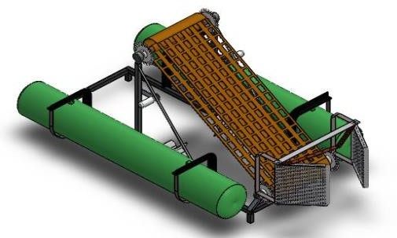

Figure 3. Assembled View of River Cleaning Machine

## 3.4 Chain Drive

Chain drive may be a way of transmitting mechanical power from one place to a different. It is often wont to convey power to the wheels of a vehicle, particularly bicycles and Motorcycles. It is also utilized in a good sort of machines besides vehicles. The power is conveyed by a roller chain, referred to as the drive chain, passing over a sprocket gear, with the teeth of the gear meshing with the holes in the links of the chain. The gear is turned, and this pulls the chain putting mechanical force.

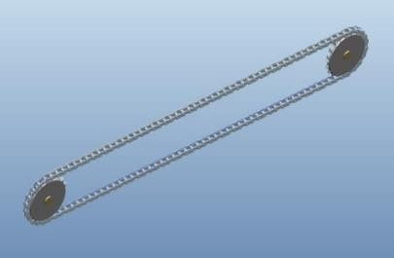

Figure 4. Chain Drive

## 3.5 Propeller

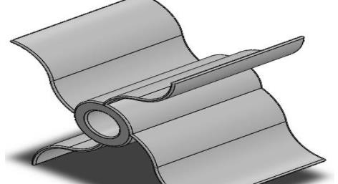Propeller may be a sort of fan that transmits power by converting rotational motion into thrust. A pressure difference is produced between the forward and rear surfaces of the airfoil-shaped blade, and a fluid (such as air or water) is accelerated behind the blade. Propeller dynamics, like those of aircraft wings, are often modelled by either or both Bernoulli's principle and Newton's third law.

Figure 5. CAD Model of Propeller

# Electronic Design

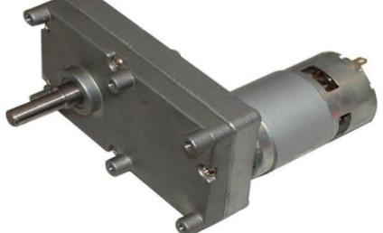In any motor, operation is predicated on simple electromagnetism. A current- carrying conductor generates a magnetic flux; when this is often then placed in an external magnetic field, it'll experience a force proportional to the present within the conductor, and to the strength of the external magnetic flux. The internal configuration of a DC motor is meant to harness the magnetic interaction between a current-carrying conductor and an external magnetic flux to get rotational motion.

Figure 6. Actual DC Motor

## RF Transmitter and Receiver

This circuit is designed to control the DC motor in the forward and reverse direction. It consists of two relays named as relay1, relay2. The relay ON and OFF is controlled by the pair of switching transistors. A Relay is nothing but electromagnetic switching device which consists of three pins. They are Common, normally close (NC) and normally open (NO). The common pin of two relay is connected to positive and negative terminal of DC motor through snubber circuit respectively. The relays are connected in the collector terminal of the transistors Q2 and Q4. When high (5 Volt) pulse signal is given to either base of the Q1 or Q3 transistors, the transistor is conducting and shorts the collector and emitter terminal and zero (Zero volt) signals given to base of the Q2 or Q4 transistor. So, the relay is turned OFF state. When low pulse is given to either base of transistor Q1 or Q3 transistor, the transistor is turned OFF. Now 12v is given to base of Q2 or Q4 transistor so the transistor is conducting and relay is turn ON. The NO and NC pins of two relays are interconnected so just one relay are often operated at a time. The series combination of resistor and capacitor is named as snubber circuit. When the relay is activated and switch OFF continuously, the rear EMF may fault the circuit. So, the back EMF is grounded through the snubber circuit. When relay 1 is in the ON state and relay 2 is in the OFF state, the motor is running in the forward direction. When relay 2 is in the ON state and relay 1 is in the OFF state, the motor is running in the reverse 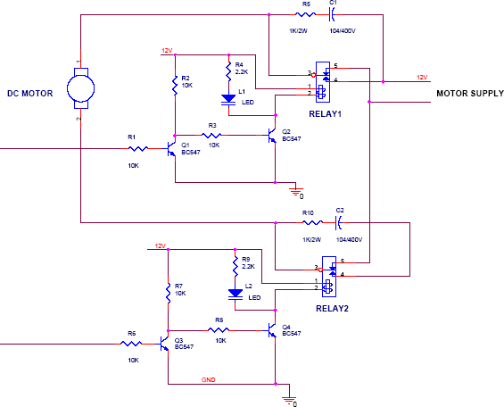direction.

Figure 7. Dc Motor Forward - Reverse Control

## Relay

Relay is an electrically operated switch. Current flowing through the coil of the relay creates a magnetic flux which attracts a lever and changes the switch contacts. The coil current is often on or off so relays have two switch positions and that they are double throw (changeover) switches. Relays allow one circuit to modify a second circuit which may be completely break away the primary. For example, a coffee voltage battery circuit can use a relay to modify a 230V AC mains circuit. There is no electrical connection inside the relay between the 2 circuits; the link is magnetic and mechanical. The coil of a relay passes a comparatively large current, typically 30mA for a 12V relay, but it is often the maximum amount as 100mA for relays designed to work from lower voltages. Most ICs (chips) cannot provide this current and a transistor is typically wont to amplify the tiny IC current to the larger value required for the relay coil.

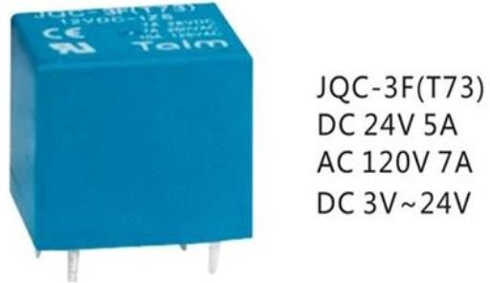Figure 8. Relay

## Decoder with RF Receiver

This circuit utilizes the RF module (Tx/Rx) for creating a wireless remote, which might be wont to drive an output from a foreign place. RF module, because the name suggests, uses frequency to send signals. These signals are transmitted at a specific frequency and a baud. A receiver can receive these signals as long as it's configured for that frequency. A four-channel encoder/decoder pair has also been utilized in this technique. The input signals, at the transmitter side, are taken through four switches while the outputs are monitored on a group of 4 LEDs like each input switch. The circuit are often used for designing Remote Appliance system. The outputs from the receiver can drive corresponding relays connected to any home appliance.

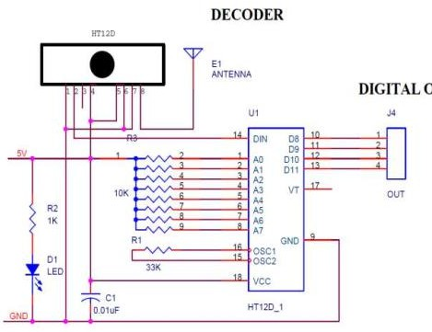This frequency (RF) transmission employs Amplitude Shift Keying (ASK) with transmitter/receiver (Tx/Rx) pair operating at 434 MHz The transmitter module takes serial input and transmits these signals through RF. The transmitted signals are received by the receiver module placed far away from the source of transmission. The system allows a method communication between two nodes, namely, transmission and reception. The RF module has been utilized in conjunction with a group of 4 channel encoder/decoder ICs.

Figure 9. Decoder with RF Receiver

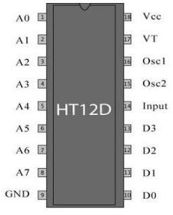

Figure 10. HT12D Decoder

Here HT12E & HT12D have been used as encoder and decoder respectively. The encoder converts the parallel inputs (from the remote switches) into serial set of signals. These signals are serially transferred through RF to the reception point. The decoder is used after the RF receiver to decode the serial format and retrieve the original signals as outputs. These outputs can be observed on corresponding LEDs. Encoder IC (HT12E) receives parallel data in the form of address bits and control bits. The control signals from remote switches along with 8 address bits constitute a set of 12 parallel signals. The encoder HT12E encodes these parallel signals into serial bits. Transmission is enabled by providing ground to pin14 which is active low.

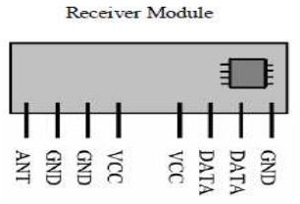

Figure 11. Receiver Module

## Encoder with RF Transmitter

Figure 12. Encoder with RF Transmitter

This circuit utilizes the RF module (Tx/Rx) for creating a wireless remote, which might be wont to drive an output from a foreign place. RF module, because the name suggests, uses frequency to send signals. These signals are transmitted at a specific frequency and a baud . A receiver can receive these signals as long as it's configured for that frequency. A four-channel encoder/decoder pair has also been utilized in this technique. The input signals, at the transmitter side, are taken through four switches 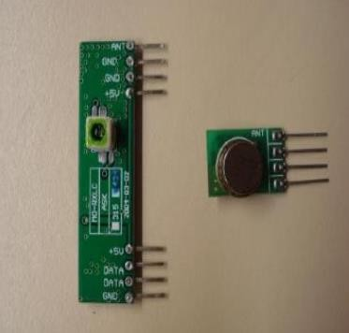 while the outputs are monitored on a group of 4 LEDs like each input switch. The RF module, because the name suggests, operates at frequency. The corresponding frequency range varies between 30 kHz & 300 GHz. In this RF system, the digital data is represented as variations within the amplitude of carrier. This kind of modulation is known as Amplitude Shift Keying (ASK). Transmission through RF is best than IR (infrared) due to many reasons. Firstly, signals through RF can travel through larger distances making it suitable for long range applications

Figure 13. RF Module

Also, while IR mostly operates in line-of-sight mode, RF signals can travel even when there's an obstruction between transmitter & receiver. Next, RF transmission is stronger and more reliable than IR transmission. RF communication uses a selected frequency unlike IR signals which are suffering from other IR emitting sources. This RF module comprises of an RF Transmitter and an RF Receiver. The transmitter/receiver (Tx/Rx) pair operates at a frequency of 434 MHz An RF transmitter receives serial data and transmits it wirelessly through RF through its antenna connected at pin4. The transmission occurs at the speed of 1Kbps - 10Kbps.The transmitted data is received by an RF receiver operating at an equivalent frequency as that of the transmitter.

# Battery

A battery is a device consisting of one or more electrochemical cells with external connections for powering electrical devices such as flashlights, mobile phones, and electric cars. When a battery is supplying electric power, its positive terminal is the cathode and its negative terminal is the anode. The terminal marked negative is the source of electrons that will flow through an external electric circuit to the positive terminal. When a battery is connected to an external electric load, a redox reaction converts high-energy reactants to lower-energy products, and the free-energy difference is delivered to the external circuit as electrical energy. Historically the term "battery" specifically referred to a device composed of multiple cells, however the usage has evolved to include devices composed of a single cell.

Primary (single-use or "disposable") batteries are used once and discarded, as the electrode materials are irreversibly changed during discharge; a common example is the alkaline battery used for flashlights and a multitude of portable electronic devices. Secondary (rechargeable) batteries can be discharged and recharged multiple times using an applied electric current; the original composition of the electrodes can be restored by reverse current. Examples include the lead-acid batteries used in vehicles and lithium-ion batteries used for portable electronics such as laptops and mobile phones.

Batteries come in many shapes and sizes, from miniature cells used to power hearing aids and wristwatches to small, thin cells used in smartphones, to large lead acid batteries or lithium-ion batteries in vehicles, and at the largest extreme, huge battery banks the size of rooms that provide standby or emergency power for telephone exchanges and computer data centers.

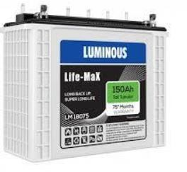Batteries have much lower specific energy (energy per unit mass) than common fuels such as gasoline. In automobiles, this is somewhat offset by the higher efficiency of electric motors in converting chemical energy to mechanical work, compared to combustion engines

Figure 14. Lithium Ion Batterie

**Solar Panel**

A PV module is an assembly of photo-voltaic cells mounted in a framework for installation. Photo-voltaic cells use sunlight as a source of energy and generate direct current electricity. A collection of PV modules is called a PV Panel, and a system of Panels is an Array. Arrays of a photovoltaic system supply solar electricity to electrical equipment. The most common application of solar energy collection outside agriculture is solar water heating systems. Photovoltaic modules use light energy (photons) from the Sun to generate electricity through the photovoltaic effect. Most modules use wafer-based crystalline silicon cells or thin-film cells. The structural (load carrying) member of a module can be either the top layer or the back layer. Cells must be protected from mechanical damage and moisture. Most modules are rigid, but semi-flexible ones based on thin-film cells are also available. The cells are connected electrically in series, one to another to the desired voltage, and then in parallel to increase amperage. The wattage of the module is the mathematical product of the voltage and the amperage of the module. The manufacture specifications on solar panels are obtained under standard condition which is not the real operating condition the solar panels are exposed to on the installation 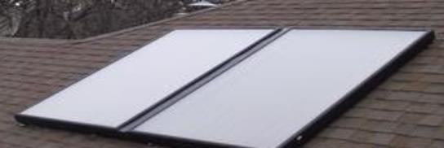site.

Figure 15. PV Solar panel

A PV junction box is attached to the back of the solar panel and functions as its output interface. External connections for most photovoltaic modules use MC4 connectors to facilitate easy weatherproof connections to the rest of the system. A USB power interface can also be used. Module electrical connections are made in series to achieve a desired output voltage or in parallel to provide a desired current capability (amperes) of the solar panel or the PV system. The conducting wires that take the current off the modules are sized according to the ampacity and may contain silver, copper or other non-magnetic conductive transition metals. Bypass diodes may be incorporated or used externally, in case of partial module shading, to maximize the output of module sections still illuminated.

Some special solar PV modules include concentrators in which light is focused by lenses or mirrors onto smaller cells. This enables the use of cells with a high cost per unit area (such as gallium arsenide) in a cost-effective way. Solar panels also use metal frames consisting of racking components, brackets, reflector shapes, and troughs to better support the panel structure

# WORKING PRINCIPLE

Fabrication is done into various stages. At initial stage the conveyer frame was made using mild steel sheet metal of 16 gauge i.e. 1.29 mm thickness. It was precisely cut by Shearing machine. Holes were drilled for inserting shafts. The frame was bended into the rectangular form by Hand press machine. The sheet metal is bend into ‘L’ shaped flappers, so that the waste can congest on flappers. The flappers are welded on thin metal bar which is attached through welding on chain. Sprocket chain mechanism is used as a conveyer bed to clog waste into the bin. This is powered by motor which runs at 15 rpm. Floating frame is made up of PVC pipes of diameter 100 mm. 4 elbows are used to get it into curved rectangular form.

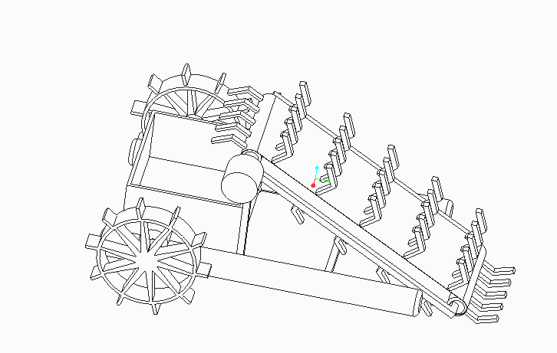Figure 16. 3D model of river waste cleaning machine

This rectangular frame is 1200 mm × 800 mm of frame area. Additional 2 PVC pipes are installed inside the frame for better floating, having length of 915 mm and one below the conveyer frame of same length. With mild steel 2 impellers are made. Its circumferential diameter of 350 mm is achieved by cutting it meticulously by Roller machine. Impellers will be adjacent to the frame and will be responsible for the back and forth as well as side movements and shall also act as aerator Impellers have their own independent motors. Impeller and motor are connected with V belt pulleys to transmit power between both shafts. Motor has power of 30 W and runs at 100 rpm, this is connected to pulley via shaft having 75 mm diameter. Another pulley of 50mm diameter is mounted on impeller shaft and are bind by V belt to motor shaft pulley. The battery which is power house of this system is of 6 V, 4 Amp. It will be charged by solar panel.

1. **Development and Analysis** 
   1. **Design Development**

The design for trash collector boat for small area application was completed using Autodesk Inventor 2019 software, and a 3D model had been generated for the purpose of visualizing the requirements and specification that had been determined throughout the analysis. Four drawings are previewed with different angles of view; isometric view, front view, top view and side view as illustrated in Fig. 2. The basic design of the trash collector boat is based on the catamaran boat with two hulls positioned at both sides of the trash collector boat. The unique feature of Catamaran hull was selected to reduce the water resistance and improve the stability of the trash collector boat. Several modifications have been made to equip the boat with an additional system for the collection of floating solids off the surface water including conveyor system and temporary storage. In this design, a rotating conveyor belt is positioned in between of the catamaran hulls along the center line. The rotating conveyor is mounted at the front of the boat and tilted at a certain angle for an efficient trash collection system. A few of wire mesh are attached to the conveyor system to act as the main trap to collect and capture the floating solids and carried them to the storage container or dustbin that is located at the back of the trash collector boat. The dustbin is made of wire mesh web to remove any trapped water within the trash. When the dustbin is fully loaded, the boat is taken to a discharge position where the trash is manually removed into a truck or other facilities.

## Body Fabrication

The body of the trash collector boat is divided into five main parts including frame, dustbin electronic board, hull and motor cover. Each part is built using different methods and types of materials. Every part of the trash collector boat can be easily assembled and disassembled, except for the frame and the electronic board. Several criteria were considered in the selection of materials to fulfil the objectives of the construction of a lighter collector boat. Proper selection of materials is very important to determine the right method of construction. In addition, the durability and strength of the boat are also influenced by the type of material used in the fabrication of the trash collector boat. The main body of the trash collector boat which is the frame, dustbin and conveyor system were constructed using square hollow mild steel and stainless-steel net. Stainless steel was chosen since it is durable and lightweight material. On top of that, it does not corrode when in contact with water allowing their usage in the surface water. The Catamaran hull was fabricated using fiberglass material. Fiberglass is a lightweight material that is mostly used in boat fabrication. It is durable and high in strength which makes it a suitable material for the hull. An electro-galvanized sheet was used in the fabrication of electronic box to store all the electronic components of the trash collector boat due to the high level of thickness which will prevent from water intrusion to the electric and electronic components of the trash collector boat. The motor cover was made using PVC material since it is durable and lightweight.

## System Fabrication

Boat system composes of three main components including boat, remote control and adjustable step-down power supply module. It uses two motors to drive and operate the boat within 30 m distance control with 27 MHz frequency. An adjustable step-down module was used to reduce the power supply from 12 V to 7.2 V to suit the requirement of the boat system. A rechargeable sealed lead battery is used to supply power to the system. Conveyor system the conveyor system is the main feature for the trash collector boat to collect floating solids and debris from surface water. The conveyor system has been featured in most trash collector boat design since it can effectively collect trash and floating solid off the water surface. The conveyor was fabricated using aluminum, gasket rubber and PVC pipe. Wire mesh was attached to the conveyor for trash collecting purpose. The system is equipped with a DC motor speed that enables the user to control the speed of the conveyor according to the collection area. In addition, a relay wireless remote control was installed into the conveyor system to allow the control of the forward and backward movement of the conveyor. The relay wireless controller can be operated within a distance of 300 m. Monitoring System Monitoring system consists of a camera with android application SYMA FPV and battery indicator. This system was incorporated to facilitate the operation of the prototype in terms of movement control. It allows the user to monitor the condition of the river or the direction of the boat

# ASSEMBLING PROCEDURE OF WASTE CLEANING MACHINE

The basic step is to assemble base frame of the project by using hand cutting machine and electric welding machine to withstand the model and its operation. The base frame is made of M.S angle.

* Hollow pipe is assembled at the base frame with the help of L- section through nut and bolt. It is made of tin sheet by using rolling and tapping operation. The purpose of this pipe is to float on water, carrying the project weight as compressed air is placed in pipe creating a differential pressure head, causing the machine to float on water.
* L- Section is welded in base frame which is used to hold the hollow pipe with the help of nut and bolt.
* Inclined section is welded on base frame to support the bearing and shaft.
* T- Section is assembled on base frame by welding. It is used to support the larger chain drive with the help of bearing and shaft.
* Shaft is used to transmit the torque from motor to chain drive. There is two shafts assembled in machine. Shaft 1 is mounted at the front chain drive of machine and shaft 2 is mounted at the rear chain drive with the help of inclined selection and T- section respectively.
* The drive source of our project is an electric motor having 12V and 7.6 ampere current which is used to drive gear train, water wheel and collecting mechanism. Here we are used 4 motors. 1 motor is mounted on garbage collector, 2 and 3 motor is mounted on left and right water wheel and 4 motor is mounted on carrying belt with the help of gear train and chain drive mechanism.
* Gear drive is welded on shaft with the help of connecting link and T- section. Gear drive is power transmission drive used to transmit the power from motor to chain drive as required to carry a load as desirable to complete the project objective.
* There are 8 sprockets used in the project in which 1,2,3,4 are of same dimension is mounted on shaft of carrying belt with the help of chain and Remaining 5,6,7,8 are used to drive the water wheel which is used to float the machine in water.
* Chain drive is a way of transmitting mechanical power from one place to another. It is often used to convey power to the wheels of a vehicle, particularly bicycles and Motorcycles. It is also used in a wide variety of machines besides vehicles. The power is conveyed by a roller chain, known as the drive chain, passing over a sprocket gear, with the teeth of the gear meshing with the holes in the links of the chain. The gear is turned, and this pulls the chain putting mechanical force.
* Collecting Mechanism is used in our project to overcome real time issue as due to water tension garbage is difficult to collect. By using this four-bar mechanism, it rotates at a particular angle intended to collect the garbage for the model. It has two window open and close as user wishes using remote to ON and OFF the mechanism.
* Water wheel is bolted on shaft which is placed on base frame. The purpose of water wheel is to move the machine forward or backward on water. Motor is used to rotate the water wheel with the help of chain drive mechanism.

Figure 17. River Waste Cleaning Machine

# Prototype Evaluation

System Performance, the boat system works well with the movements and speed corresponding to the collecting process of floating solids. However, the radio connection is not stable that will result in connection loss for a few times during the testing. For the conveyor system, it was found that that the rotational power is capable to hold a maximum capacity of 8 kg per rotation. It is limited due to the strength of wire mesh attached to the conveyor belt. Nevertheless, the speed controller and the relay of the conveyor system is working efficiently. Monitoring Performance The monitoring system of the trash collector boat consists of a camera, LED light and battery indicator. The camera works properly during product testing however the display quality is quite low due to the low-resolution camera (2 MP). Further improvement should be considered to improve the quality of the image for better monitoring of the trash collector boat. On the other hand, the LED light attached to the collector boat works properly. The brightness of the LED light is sufficiently illuminating the front area of the boat during the trash collection process. Battery indicator works properly by showing the digital numbers and displaying the amount of battery left. The battery indicator is visible on android application from the camera because it located in front of the camera.

## Loading Capacity

The loading capacity of the trash collector boat prototype was investigated by inspection of water displacement level during operation. shows the water displacement level of trash collector boat during the product testing in the university Lake the water displacement level is quite low indicating that the hulls are capable to accommodate the weight of trash collector in water. the water displacement level after full loading of trash in the dustbin. The trash collector boat can achieve a maximum loading capacity of 4 kg in a single operation. From observation, there is a slight increment in the water displacement level when compared to before loading. The hulls are capable to hold the weight of both collector boat and trash without being sunk. This shows the good performance of trash collector boat in full load mode.

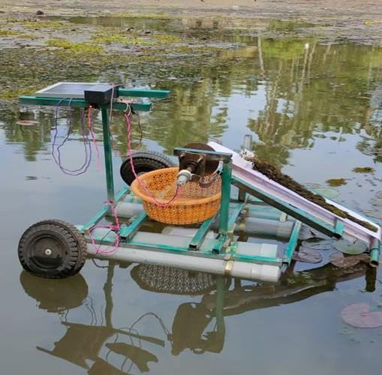

Figure 18. collecting waste in field operation

# WASTE COLLECTION ANALYSIS

The waste collection is varied from the type of materials example the plastic waste (PET), plant waste, organic waste the collection speed of the river waste collector it depend on the material.

The below table 1 show the collection amount of the materials in hours

Table 1. Collection amount of the materials in hours

|  |  |  |  |  |
| --- | --- | --- | --- | --- |
| **S. No.** | **Materials** | **Collection amount of material/ hr.**  **1** | **Collection amount of material/ hr.**  **2** | **Collection amount of material/ hr.**  **3** |
| 1 | Plastic waste bottle | 5kg | 5kg | 6kg |
| 2 | Flower waste | 6kg | 5kg | 6kg |
| 3 | Algae waste | 8kg | 9kg | 8kg |
| 4 | Coconut coir waste | 8kg | 7kg | 9kg |
| 5 | Plastic cover | 2kg | 3kg | 4kg |

Figure 19. Graphical Presentation of material collection

The speed of the river can fluctuate depending on various factors such as rainfall, snowmelt, or dam releases. When the river flow rate is high, it can affect the efficiency of the waste collection machine, making it more challenging to collect a significant amount of waste in a short time. The type and density of waste present in the river can influence the collection process. Lighter materials like plastic bags may be easier to collect quickly, while heavier items like debris or logs might slow down the collection process. Different waste collection machines have varying designs and capacities. Some machines may have larger holding capacities, allowing them to collect more waste before needing to unload. Others may be designed for faster collection but have smaller capacities, requiring more frequent unloading. Environmental factors such as wind, waves, and currents can impact the operation of the waste collection machine. Strong winds or turbulent waters can make it difficult for the machine to maneuver effectively, affecting both its speed and the amount of waste it can collect.

# V. CONCLUSIONS

In the present scenario of climate change and Global warming, the pollution caused by floating bodies on the river and other water bodies cannot be left unseen. The mass dumping of toxic waste into these water bodies creates a question of both pollution and unhygienic surroundings. The Government is spending more money on cleaning these unwanted objects as they cut the oxygen supply for both marine flora and fauna. As the life of flora and fauna is disturbed it creates disturbances in the circle of aquatic life chain. The most prominent methods present today for the removal of these wastes are the traditional ones. Removal and collection of these wastes from a water body are labor-intensive in India and thus can substitute labor work. Technology has to be incorporated in such a way that cleaning the water is done efficiently and effectively, here comes the scope of our project as our prime objective is to collect the floating waste and to reduce human labor for such works. Here a trash-collecting boat is deployed to clean the lake water. The boat comes with control and power units along with conveyors attached to it. In the future, the project can be improved to sort more categories of waste using various automated techniques and it can be made remote controlled. In this system, an advanced conveyor system and conveyor materials can be used for increasing the efficiency of collecting garbage. Also, solar power can be utilized to drive the boat instead of battery operation and can completely work on solar energy thus saving the power. To modify the size of the boat and to implement different boats that can communicate with each other’s help increase the efficiency and to clean the whole are more efficiently. Only smaller water bodies are considered presently and larger water bodies can be cleaned by making some modifications to its size and capacity.

# References

1. Houssam Albitar, Anani Ananiev, Ivan Kalaykov, “In-Water Surface Cleaning Robot: Concept, Locomotion and Stability”, “International Journal of Mechatronics and Automation”, Volume 4, Number 2, 2014, pp 104-114.
2. Asst. Prof. R. Raghavi, Varshini, L. Kemba Devi, "Water Surface Cleaning Robot", "International Journal of Advanced Research in Electrical , Electronics and Instrumentation Engineering", Volume 8, Issue 3, March-2019, pp. 831-837.
3. Prof. Kean V. Dhande,"Design and Fabrication of river cleaning system", " International Journal of Modern trends in Engineering and Research", Volume 4, Issue 2, February-2017, pp. 8-18.
4. Prof. H. M Preeti, M.Tech scholar Soumya, research guide and Prof. Baswaraj Gadgay, "Pond Cleaning Robot", "International Research Journal of Engineering and Technology", Volume 5, Issue 10, October2018, pp. 1136-1139.
5. Prof. Khunt Sagar P, "Wireless DC Motor Speed and Directional Control using RF", " International Journal of Novel Research and Development", Volume 2, Issue 4, April-2017, pp. 1-8.
6. Harsha Gopinath, Indu .V, Meher Madhu Dharmana, "Autonomous Underwater Inspection Robot under Disturbances", "International Conference on circuits Power and Computing Technologies", 2017.
7. Prof. Ajay Dumal, "Study of River Harvesting and trash cleaning machine", "International Journal of Innovation Research in Science and Engineering", Volume 2, Issue 3, March -2016, pp. 884-894 Prof. N.G. Jogi. "Efficient Lake Garbage Collector by using Pedal Operated Boat", International Journal of Modern Trends in Engineering and Research”, Volume 2, Issue 4, April-2016, pp. 327- 340..
8. M. Mohamed Idhris, M.Elamparthi, C. Manoj Kumar, Dr.N.Nithyavathy,Mr.K. Suganeswaran, Mr. S. Arunkumar, "Design and fabrication of remote-controlled sewage cleaning machine", IJETT - Volume-45 Number2 -March -2017, pp. 63-65..
9. Mr. P. M.Sirsat, Dr. I. A. Khan, Mr. P.V. Jadhav, Mr. P.T. Date, "Design and fabrication of River Waste Cleaning Machine", IJCMES 2017, pp. 1-4.
10. Zhongli Wang, Yunhui Liu, Hoi Wu Yip, Biao Peng, Shuyuan Qiao, and Shi He, "Design and Hydrodynamics Modeling of A Lake Surface Cleaning Robot", "International Conference on Advanced Intelligent Mechatronics", July-2008.
11. Tomoyasu Ichimura and Shin-ichi Nakajima, "Performance Evaluation of a Beach Cleaning Robot "Hirottaro 3" in an Actual Working Environment", "International Conference on Control, Automation and Systems", October-2018, pp. 825-828..
12. Associate Prof. Suraya Muben, M. Kumar Yadav , B. Sirisha Reddy, T. Sowmya Reddy, B.Praneetha, "Wireless Electrical Apparatus Controlling System with Speed Control of AC motor using RF communication" , "Global Journal for Research Analysis", Volume 6, Issue 4, April 2017.
13. Harsha Gopinath, Indu. V, Meher Madhu Dharmana, "Development of Autonomous Underwater Inspection Robot under disturbances", "IEEE International Conference on Technological Advancements in Power annd Energy", 2017, pp. 724- 727.
14. Jayasree P.R, Jayasree K.R, Vivek A, "Dynamic Target Tracking using a 4- Wheeled Mobile Robot with optimal path planning technique", "International Conference on Circuits Power and Computing Technologies", 2017.