**UNHEARD VOICES OF GARBAGE COLLECTOR ON GARBAGE COLLECTION: A NARRATOLOGY APPROACH**

**Alonzo, K.H1, Otero Y.J2, Saldua, K.3**

1Graduate School of Development Management University of Southeastern Philippines Davao City, Philippines

**ABSTRACT**

This study delves into the often-overlooked accounts of garbage collectors in Davao City, Philippines, focusing on their indispensable, yet underappreciated, roles in urban sanitation and environmental sustainability. Using a narratological approach and qualitative methodologies, this research looks into the challenges and lived experiences of these individuals. Based on the study results, five themes were generated: Orientation and Training, which reveals a lack of formal training, leading to reliance on experiential learning; Challenges with Non-compliance of Residents, highlighting frustration due to residents' failure to adhere to waste segregation rules; Support from the Agency, which shows that although workers receive some support, issues like low wages and job insecurity remain; Health and Safety Concerns, emphasizing the discomfort of PPE, especially face masks, which hinder effective work, and underscores the critical issue that garbage collectors do not undergo annual physical examinations, leaving their health status unmonitored despite frequent exposure to hazardous conditions; and Challenges in Wearing PPE and Behavioral Gaps in PPE Usage, pointing to inconsistent usage due to discomfort and physical challenges. Despite all the hardships their job carries, garbage collectors take an identity in this occupation; their work is somehow thwarted due to a lack of resources and insufficient community engagement. Studies have shown that training, additional resources, and higher community involvement can help build worker welfare as well as enhance efficiency in managing waste. This will include just wages, stronger support systems, and stricter compliance to waste separation guidelines. The authors should amplify the voices of waste collectors for effective sustainable urban waste management.

**Keywords:** Waste Collectors, Inadequate Working Conditions, Community Participation, Public Health Contribution, Waste Management Policy, Training and Resources, Equitable Salaries, Davao City

1. **INTRODUCTION**

Waste is defined as anything that has lost its usefulness after being used; as a result, it is no longer valuable to an individual or a community. When an item loses its worth, it must be taken out of homes, offices, shops, marketplaces, etc. Waste collectors pick up trash that has been left on the streets and dispose of it properly. (Magalhaes et Al, 2021). Davao is a highly urbanized city in the Davao Region, Philippines. Davao City generates around 700 metric tons of trash per day, a significant fraction of this is made up of reusable materials. The often-overlooked work of waste collectors is essential to the well-being of our communities. Waste collectors in Davao City play a crucial role in maintaining the city's cleanliness and environmental sustainability. Despite their painstaking efforts, managing the garbage generated is a challenging undertaking. Due to inadequate working conditions, inadequate facilities for health and hygiene, a lack of appropriate protective gear, and little to no understanding of appropriate waste management practices, waste collectors face numerous occupational dangers (Gowda et.al, 2023). This study draws on the lived experiences of waste collectors in Davao City, highlighting their aspirations and challenges. It emphasizes their important contributions in the city’s environmental initiatives while addressing their struggles such as working conditions, health risk and income insecurity. The evaluation of existing social and support services in the study aims at providing effective responses in terms of improving their accessibility to healthcare, working environment and general welfare. To fill the gaps of research, it evaluates policies of social protection and of its accessibility and proposes measures that are aimed at addressing the waste collectors in all their diversity and resiliency. Using a narrative approach, it highlights their resilience and aspirations, offering insights to inform meaningful interventions (Creswell, 2013; Wilson et al., 2006).

**Scopes and Limitations:**

This study explores the lived experiences of garbage collectors working under the City Environment and Natural Resources Office (CENRO) in Davao City. Using a narratology approach, it aims to highlight their often-overlooked voices. It aims to understand their goals, challenges, and contributions to waste management, emphasizing the human aspect of their work in preserving environmental sustainability and urban cleanliness.

**Scope:**

1. **Geographic Focus:** The study is conducted in Davao City, a highly urbanized area generating approximately 700 metric tons of waste daily, emphasizing the role of CENRO-affiliated garbage collectors (Magalhaes et al., 2021).
2. **Participants:** The study includes garbage collectors directly engaged in waste collection under CENRO in Davao City, providing insights into their working conditions, occupational risks, and perspectives on their societal roles (Gowda et al., 2023).
3. **Themes Covered:** Key focus areas include working conditions, health risks, income security, access to social services, and the availability of safety measures. It also highlights the garbage collectors’ resilience and aspirations.
4. **Methodology:** Using a narratology approach, the study collects qualitative data from personal narratives, enabling an in-depth understanding of the individual and collective experiences of garbage collectors (Creswell, 2013).
5. **Policy Analysis:** The study evaluates the accessibility and adequacy of social protection programs and waste management policies, recommending measures to improve garbage collectors' welfare and work environment (Wilson et al., 2006).

**Limitations:**

1. **Geographic Scope:** The study focuses exclusively on CENRO-affiliated garbage collectors in Davao City, excluding private or independent waste collectors, which may limit the generalizability of findings.
2. **Narrative Bias:** The reliance on self-reported narratives introduces potential biases, as participants’ recollections and perspectives may vary.
3. **Temporal Scope**: The research examines current conditions and does not provide a longitudinal analysis of changes in policies or practices over time.
4. **External Influences:** Broader economic, social, or political factors affecting waste management may not be comprehensively addressed due to the study's narratology-centered design.
5. **Policy Implementation:** While the study evaluates existing policies, it does not extend to the actual implementation or enforcement of these policies.
6. **METHODOLOGY**

The study utilized a qualitative narrative-based approach, using a survey questionnaire adapted from the World Health Organization (2015) and Safe Management of Wastes from Healthcare Activities. Geneva: WHO Press. Approval of the letter of permission was secured from the office of the CENRO’s Department Head to survey the garbage collectors-respondents of the study. After the initial protocols were complied with, the face-to-face interview was conducted.

This study focuses on in-depth interviews with 10 garbage collectors from the City Environment and Natural Resources Office (CENRO) of Davao City. Purposive sampling ensured participants had diverse experiences regarding age and years of service. Data collection involved in-depth, structured questionnaires, and open-ended interviews were conducted in the participants' preferred language, allowing participants to share their stories freely. Interviews lasted between 11 minutes to 30 minutes and were recorded with consent. Thematic narrative analysis was used to identify recurring themes and unique insights from the collected stories (Riessman, 2008).

Ethical considerations, including informed consent and confidentiality, were strictly observed throughout the study.

1. **RESULTS AND DISCUSSION**

This section aims to thoroughly explore the themes that emerged from the one-on-one interviews conducted with the garbage collector. The themes were analyzed in terms of the knowledge, attitude, and practices of waste collectors in Davao City in relation to managing solid waste, including collecting, segregating, and disposing. A discussion was also made on challenges they face, such as non-compliance by residents, income insecurity, job security, and health concerns.

Garbage collectors mentioned below, expressed thoughts that were echoed by several other garbage collectors during the interviews. Most respondents shared common complaints regarding inadequate orientation or training, noncooperation from residents on waste segregation practices, and challenges of working under resource-constrained environments, such as a lack of appropriate protective gear. These recurrent feelings mirror the universal plight facing waste collectors and indicate some deeper systemic issues associated with waste management and an opportunity for targeted interventions on the same.

Figure 1. Framework of Component and Themes

**Garbage Collectors’ Knowledge on their work**

***Themes 1: Orientation and Training***

Orientation before the beginning of work, accompanied by hands-on experience, allows a garbage collector to acquire necessary knowledge and skills gradually. Through the orientation process, they are initiated into the basics of the job, including safety procedures, handling equipment properly, and learning routes and schedules.

***Experiential Learning***

Garbage Collector A shared that “*wala mi orientation ug training...diretso ra man mi uy…” “through experience rajud mi ug sa mga kauban sa trabaho” (“We did not receive any formal orientation or training prior to starting our job and began working immediately”...We just learned through experience and learned from our co-workers).*

Garbage Collector B also shared that*“anaa mi orientation ug training bago mi nanarbaho…” (“We underwent orientation and training before we started working”).* Some other garbage collectors expressed similar thoughts, highlighting that proper orientation or training was either lacking or insufficient.

Frederick Taylor’s Scientific Management Theory (1880s) explained that the optimization of work translates to productivity and efficiency, and not the fact that how the workers were made to work hard. Through the orientation process, they are able to do their job by acquiring the basics and knowledge that are deemed necessary to their work. Kolb’s Experiential Learning Theory (1984), states that “Experiential learning, as the term suggests, is the process of converting experiences into meaningful learning. Kolb's theory of experiential learning emphasizes the role of our experiences—such as our thoughts, emotions, and surroundings—in shaping how we learn”

**Garbage Collectors' Attitudes Toward Their Work**

The attitude of the garbage collectors toward their jobs reflects a mix of pride in the vital role in keeping cleanliness and public health with the challenges of low wages, public stigma, and lack of recognition.

***Themes 2: Challenges with Non-compliance of Residents***

Garbage Collector C (Indigenous People - from Brgy. Tapak, Paquibato District) shared that, *“Permanente naman ang mga empleyado sa barangay mamadlong didto…pero usahay lagi pud anaay mag supak-supak” (“The barangay personnel consistently reminds and reproaches residents regarding their responsibility for waste segregation.…Occasionally, however, some residents disregard the policy”).*

Garbage Collector G shared that, *“wala na namo gina segregate…labay na diretso sa truck…ang plastic lang ginasako kay mao among patimbangon…” (“We no longer segregate...everything is dumped straight into the garbage truck...we only collect plastic items and put them into a sack to be weighed and sold to make extra income”)*. They no longer segregate waste from the residents because it is their responsibility.

***Themes 3: Support from the Agency***

Garbage Collector E shared that, *“wala na siguro…okay raman ang among panginabuhi…makakaon gyapon ug lami-lami…kay katong wala pami sa CENRO perting paita gyud…” (“perhaps not any more... our lives are going well... we can still eat delicious food...when we weren't in CENRO yet, it was quite difficult”). He added also, “pananglitan maglain ang lawas anaa may nurse…isyuhan man mi ug boots, gloves, masks ug unta madungagan sweldo gamay…” (“for instance, there's a nurse available if I get sick…we were provided with boots, gloves, masks, and we are hoping for a small pay raise”).*

***Themes 4: Health and Safety Concerns***

Garbage Collector C also expresses that, *“hangak magsuot ug facemask…pero ga suot gihapon mig botas ug gloves…ug pirme jud maghugas ug kamot” (“wearing a facemask makes breathing more difficult… however, we still wear boots and gloves… and frequently wash our hands”).*

Ajzen's theory of planned behavior (1985) (Zhang, 2015), a person's action is dependent on his or her willingness to do that action (i.e., intention). Intention depends upon three elements: (1) attitude (A), Personal beliefs and perceptions garbage collectors have about their role in waste management are a large factor in their actions; (2) subjective norm (SN), Subjective norms are the perceived social influences toward or against performing a behavior. If residents habitually fail to separate waste, garbage collectors may not feel as burdened to separate waste as well, especially when society does not take it seriously, though barangay policies and expectations can still compel them to enforce proper practices; and (3) perceived behavioral control (PCB), which aspect focuses on an individual's belief in his or her capability to perform a behavior based on internal and external factors. Perceived control would influence the garbage collectors' behavior because, if a system is organized with appropriate tools and support policies, it empowers them to effectively manage waste while maintaining segregation practices, while a lack of resources or limited support or resistance from residents would make them feel they cannot enforce policies, thereby making them less proactive.

**Garbage Collectors’ Perspective on their work**

Garbage collectors form an important part of a city's public health and sanitation management. Their work practices, experiences, and challenges throw significant light on their profession.

***Themes 5:*** ***Challenges in Wearing PPE and Behavioral Gaps in PPE Usage***

All Garbage Collectors shared that they don’t completely wear the PPEs as it gives difficulties on carrying on their work. Garbage Collector H shared his experience *“botas…oo… ang mask man gud magsingot, magbasa…di ka kaginhawa ba..anaay gwantes, botas pirme…” (“boots…yes… the mask becomes sweaty and damp… You can barely breathe…I always wear gloves and boots, though”).*

Garbage collector I also shared that *“talagsa ra ko mugamit ug gloves, kay maglisod ko ug hawid sa mga basura…” (“I rarely used gloves because I find it difficult to grasp the garbage…”)*

Nearly all garbage collectors possess strong knowledge of personal protective equipment (PPE), with only a small percentage showing limited understanding (Hasanah et.al, 2023). Wearing personal protective equipment (PPE) is essential to safeguard against hazards, and a full understanding of these risks reinforces the importance of consistently using PPE (Ngwira et. al, 2024). Furthermore, recognizing that many workers exhibit inadequate behavior in using PPE, it is essential for relevant agencies to provide guidance and counseling on occupational safety and health for garbage collectors, supported by educational institutions through community service initiatives (Hasanah et.al, 2023).

1. **CONCLUSION**

The study on the garbage collectors in Davao City indicates that the issues and concerns related to their functions in solid waste management are complicated and interrelated. Based on the findings of the study, five themes came out to encapsulate the experiences of garbage collectors. Orientation and training are now an area of emphasis since this reflects the lack of formal educational opportunities, forcing employees to rely on experiential learning. The case of non-compliance by residents illustrates the frustration of workers, as they fail to adhere to the waste segregation rules. A pattern of agency support emerged; the implication is that some help is being offered, but problems like low wages and lack of security at work remain. Health and safety concerns were mentioned, including the discomfort with the PPE, such as face masks, that hinder proper work, and inadequate health monitoring systems. Notably, garbage collectors do not undergo mandatory annual physical examinations, leaving them vulnerable to undetected health risks despite their frequent exposure to hazardous environments. Lastly, challenges in wearing PPE and behavioral gaps in PPE usage. Workers report using PPE inconsistently, claiming discomfort.

In conclusion, the study emphasizes the need for a comprehensive approach to address the various challenges facing waste management workers in Davao City. The results indicate that improvements in personnel orientation and training, greater public compliance with waste segregation regulations, enhanced support from relevant agencies, better health and safety measures, and more comfortable and functional personal protective equipment are critical for improving both the working conditions and efficiency of the waste management system. Since these improvements would, on one hand, have significant effects on protecting the health and safety of the waste collection staff and, on the other hand, significantly contribute to a more effective and sustainable waste management program in the city, a comprehensive approach becomes necessary for raising the operational effectiveness of the waste collection teams and for improving the quality of waste management practices in Davao City.

1. **REFERENCES**
2. Agwu, M. O. (2012). Issues and challenges of solid waste management practices in Port Harcourt City, Nigeria. Journal of Environmental Management, 3(1), 1–8.
3. Chikarmane, P., & Narayan, L. (2009). Informal waste workers in India. WIEGO Policy Brief, 7.
4. Creswell, J. W. (2013). Qualitative inquiry and research design: Choosing among five approaches (3rd ed.). SAGE Publications.
5. Dave, S. (2023, July 29). What is the experiential learning theory of David Kolb? Practera. https://practera.com/what-is-the-experiential-learning-theory-of-david-kolb/
6. Gowda, A., Sharma, N., & Kumar, S. (2023). Challenges faced by waste workers: A review of occupational health hazards. International Journal of Environmental Health, 25(3), 45–56.
7. Gowda, M., et al. (2023). Occupational hazards in informal waste management. Journal of Environmental Health Research.
8. Gutberlet, J., & Uddin, S. M. N. (2017). Household waste and health risks affecting waste pickers and the environment in low- and middle-income countries. International Journal of Occupational and Environmental Health, 23(2), 163–170.
9. Hasanah, N., Ambarwati, R., & Indriatie, N. (2023). Knowledge and behavior of using personal protective equipment on garbage collectors. In Advances in Health Sciences Research (pp. 252–262). https://doi.org/10.2991/978-94-6463-324-5_27.
10. Hasanah, N., Santoso, D., & Pratiwi, E. (2023). Understanding PPE usage among garbage collectors in urban areas. Journal of Occupational Safety and Health, 15(2), 134–142.
11. Hennink, M., Hutter, I., & Bailey, A. (2020). Qualitative research methods. SAGE Publications.
12. Kolb, D.A. (1984). Experiential Learning: Experience as the Source of Learning and Development. Prentice Hall.
13. Magalhaes, R., Costa, L., & Mendes, P. (2021). Waste management in urban centers: The role and plight of garbage collectors. Journal of Urban Studies and Environmental Sustainability, 9(1), 23–31.
14. Magalhaes, R., et al. (2021). Waste and its societal impacts. Environmental Sustainability Review.
15. Medina, M. (2000). Scavenger cooperatives in Asia and Latin America. Resources, Conservation and Recycling, 31(1), 51–69.
16. MindTools | Home. (n.d.-b). https://www.mindtools.com/anx8725/frederick-taylor-and-scientific-management.
17. Ngwira, M., Chitete, M. M., Sibande, M., Ngwira, Y., & Damazio, C. (2024). Understanding solid waste collectors’ awareness of occupational hazards and personal protective equipment practices in northern Malawi. Environmental Health Insights, 18. https://doi.org/10.1177/11786302241303688
18. Ngwira, T., Banda, L., & Malumbe, C. (2024). Enhancing occupational safety for waste workers in tropical climates. Environmental Health Review, 18(1), 22–36.
19. Riessman, C. K. (2008). Narrative methods for the human sciences. Sage Publications.
20. Wilson, D. C., Velis, C., & Cheeseman, C. (2006). Role of informal sector recycling in waste management in developing countries. Habitat International, 30(4), 797–808.
21. Wilson, D. C., Velis, C., & Cheeseman, C. (2012). Role of informal sector recycling in waste management in developing countries. Habitat International, 30(4), 797–808.
22. World Health Organization (WHO). (2017). Health, safety, and dignity of sanitation workers: An initial assessment. WHO Publications.
23. Zhang, D., Huang, G., Yin, X., & Gong, Q. (2015). Residents’ waste separation behaviors at the source: Using SEM with the Theory of Planned Behavior in Guangzhou, China. International Journal of Environmental Research and Public Health, 12(8), 9475–9491. https://doi.org/10.3390/ijerph120809475
24. Administrator. (2023, December 15). Barangays urged to strengthen waste segregation - City Government of Davao. City Government of Davao. https://www.davaocity.gov.ph/solid-waste-management/barangays-urged-to-strengthen-waste-segregation/
25. Exploring the challenges of reintegrating ex-offenders into society. (n.d.). Interdisciplinary Studies in Society, Law, and Politics. Retrieved from https://journalisslp.com/index.php/isslp/article/view/58

**APPENDIX**

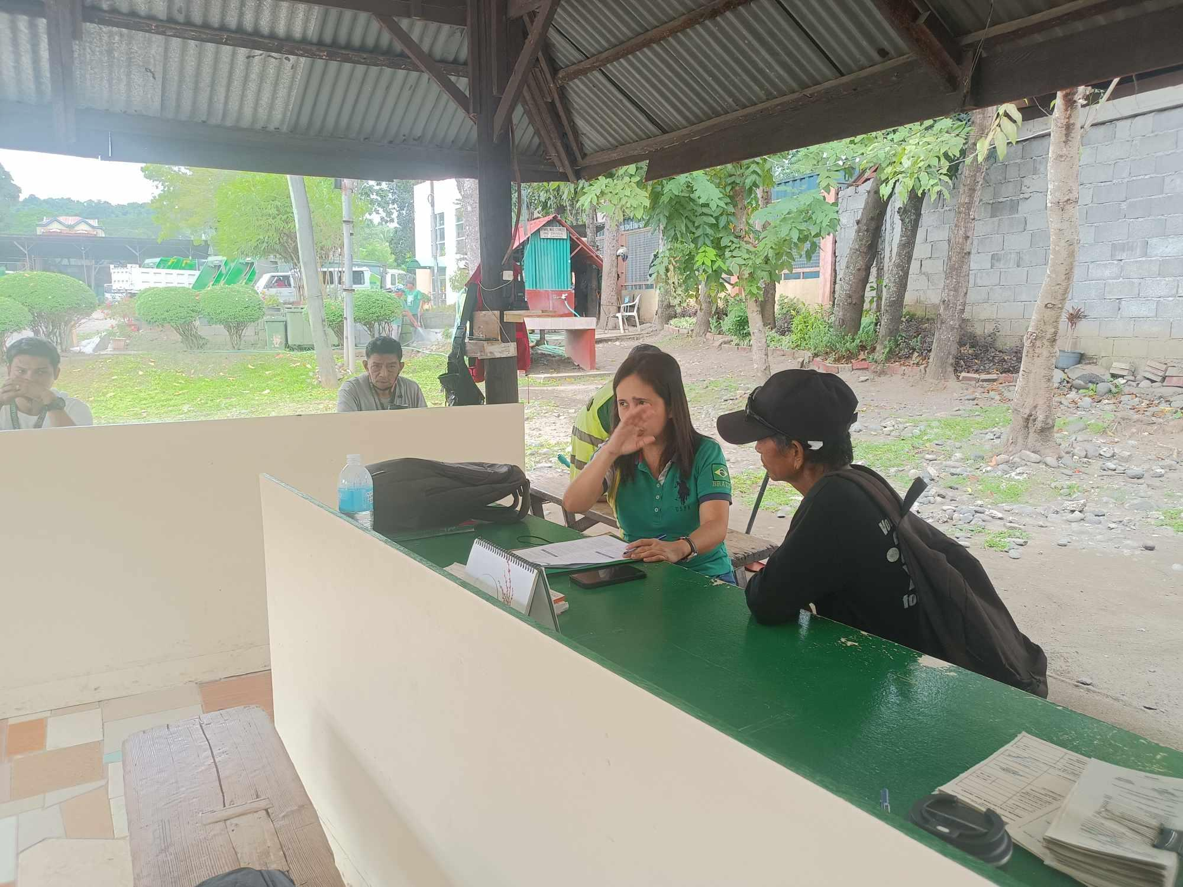

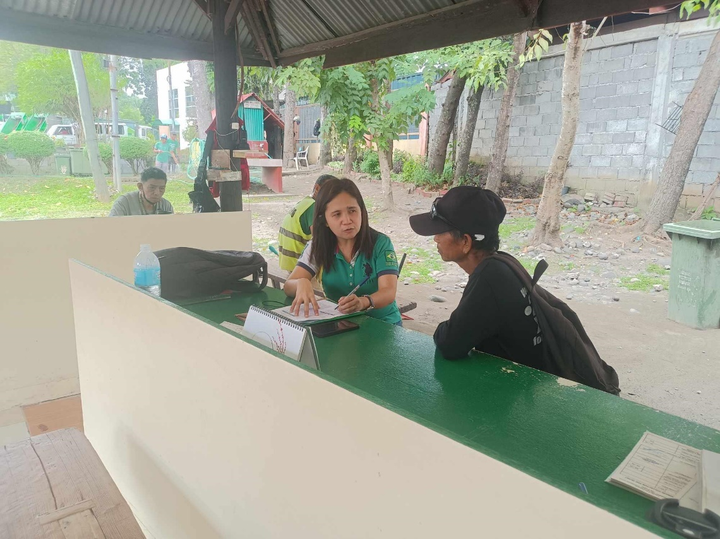

Figure 2. Documentation during the actual interview of the respondents

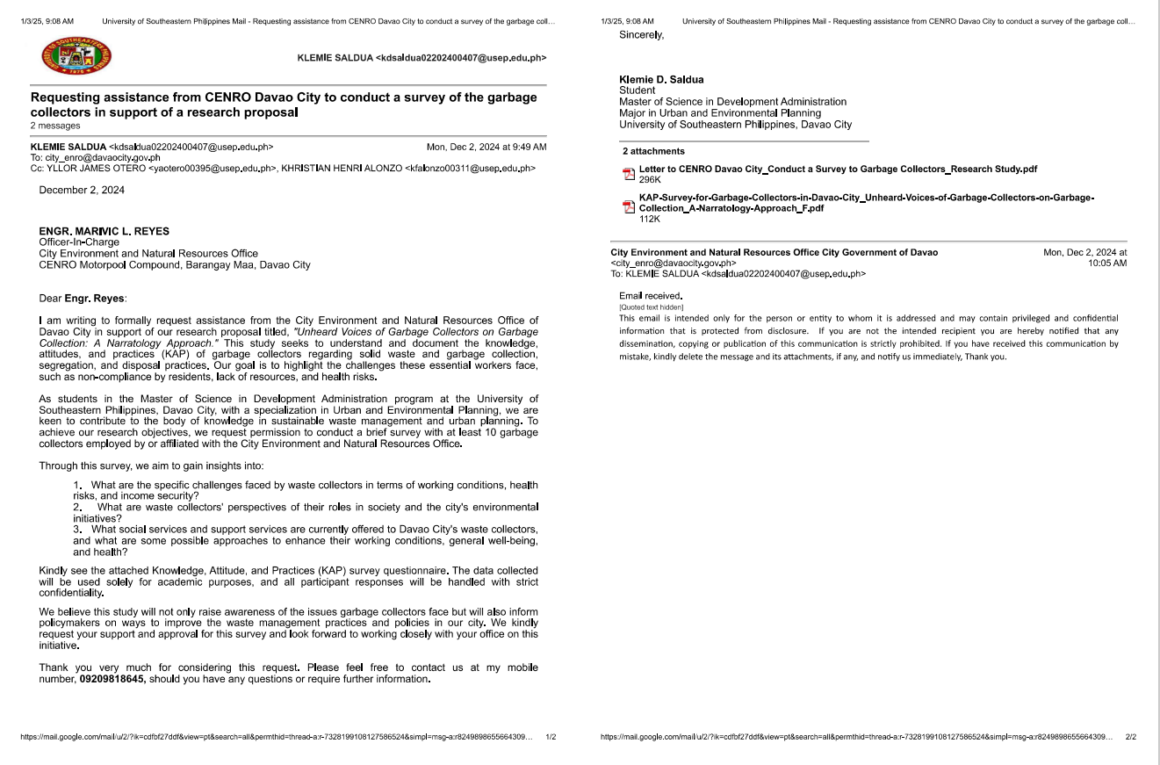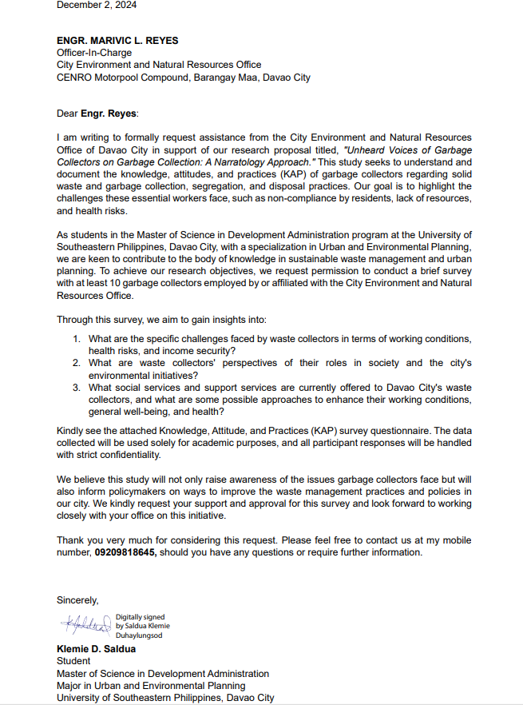

Figure 3. Sample of email and request letter to conduct interviews with the respondents

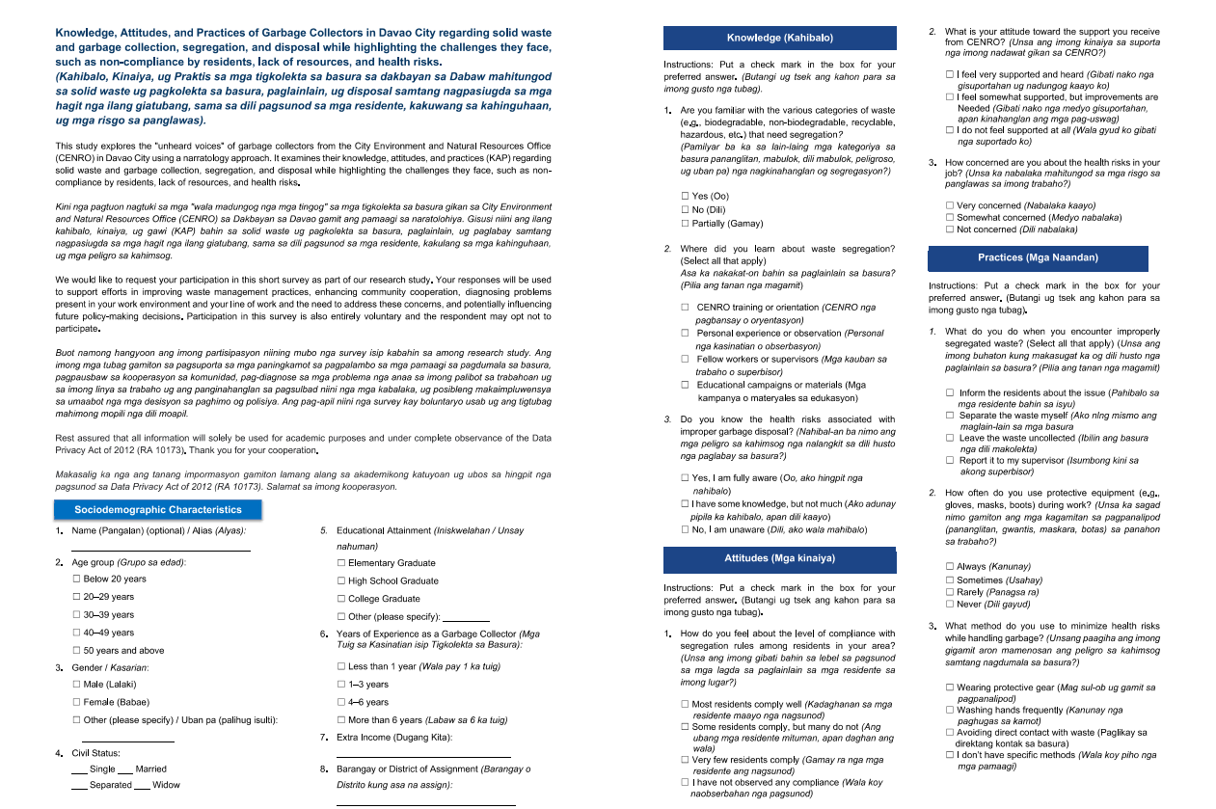

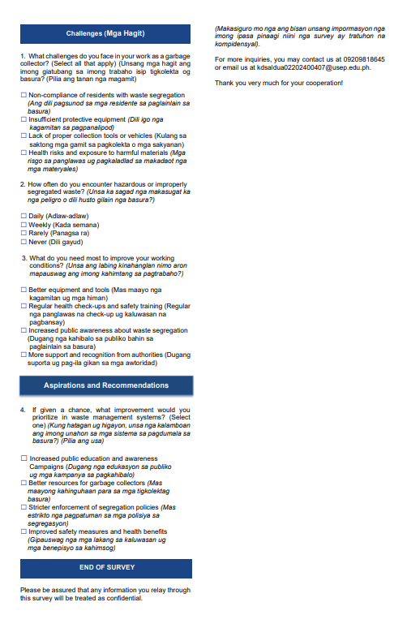

Figure 4. Sample of Knowledge, Attitude, and Practices (KAP) survey guide questions

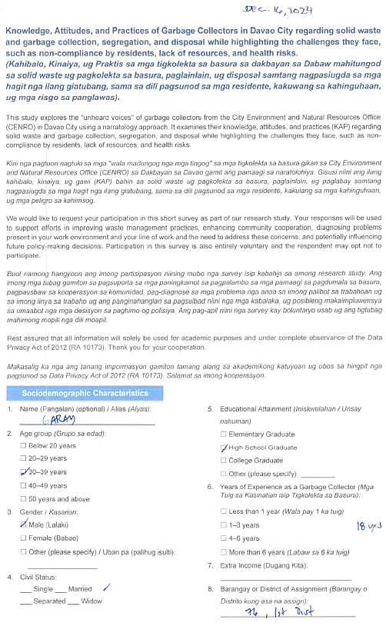

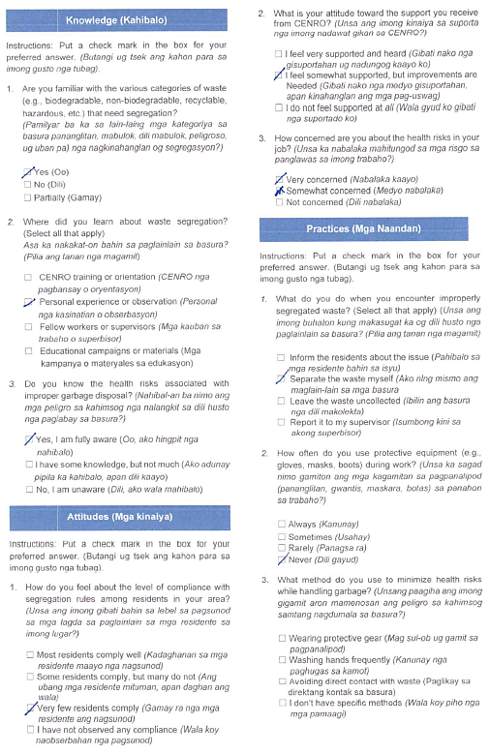

Figure 5. Sample of accomplished Knowledge, Attitude, and Practices (KAP) survey

