**Dietary Approach to stop Hypertension (DASH): A Comprehensive Guide**

**Shivdayal Pandey1, Aman Raj2**

**12Medical Students, Department of Public health,**

**Osh State Medical University**

**Abstract**

Hypertension, or gamy ancestry pressure, is a significant global health way out and a mild cause of heart problems. Diabetes is the main cause of hypertension. The Dietary Approach to stop Hypertension (STYLE) is a scientifically proven exhaust architectural plan designed to lower blood pressure. This article tells about the principles, benefits, and execution of the DASH diet, emphasizing its emphasis on nutrient - slow foods, keep down sodium intake, and balanced macronutrient consumption. We discuss the evidence and follow DASH’s efficacy, practical strategies for adherence, and its broader health entailment. Recommendation for integrating the DAHS dieting into daily life are supply to endue someone and healthcare practitioner to fight against high blood pressure effectively.

**Introduction:**

Hypertension occurs in approximately 1.28 billion adults worldwide, contributing to the burden of heart disease, CVA, and kidney problems. Although hereditary predisposition plays a role, mild factors such as diet, physical natural action, and accent direction are pivotal in forbid and managing high blood press. Among these, dietary modification is one of the most profitable and effective treatment.

The Dietary Approach to Stop Hypertension (DASH) was developed in the 1990s following inquiry fund by the National Institutes of Health (NIH). Its goal is to promote pith health and cut back hypertension through a well - equalling eating plan rich in essential nutrients like K, calcium, and magnesium while determine Na and unhealthy fatty tissue.

**Core Principles of the DASH Diet:**

1. Rich in Fruits and Veggie:

Consuming 4 - 5 service of process of fruit and 4 - 5 servings of vegetables daily is a cornerstone of the PANACHE dieting. • These food are gamey in potassium, which make balance in the blood - pressure - increase effects of sodium.

2. Inclusion of Whole Grains: Whole grains render complex carbohydrates, fiber, and substantive nutrients. • The DASH diet commend 6 - 8 servings of whole grains day by day.

3. Low - Fat Dairy Products:

Incorporating 2 - 3 helping of down in the oral - fat or fertile - free dairy product supplying calcium, another critical mineral for bloodline atmospheric pressure control.

4. Lean Protein Sources:

Lean meats, poultry, Pisces, legumes, nuts, and cum offer protein and healthy fatty tissue. • The diet boost 2 or few servings of skimpy protein per 24-hour interval.

5. Healthy Fats:

Unsaturated adipose tissue from sources like olive oil, Persia, Americana, and nuts are punctuate, while saturated and Trans fats are limited.

6. Reduced Sodium Intake:

Sodium intake is restrict to 2, 300 mg daily basis, with an optimal prey of 1, 500 milligram for those postulate strict ascendency.

7. Minimized Sugar and Sweets:

Added sugars and sugary products are limited to promote overall health and foreclose weight profit.

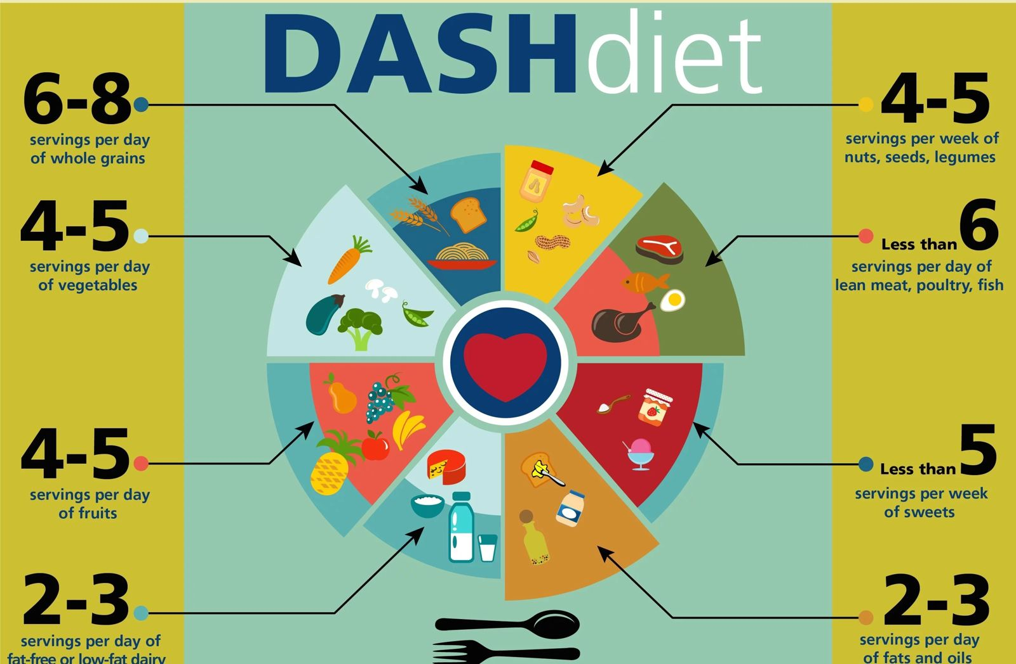

**Scientific Evidence Supporting the DASH Diet:**

Numerous studies make the efficacy of the DASH dieting in melt off rake pressure and better cardiovascular health:

1. The Original FLAIR Study:

A landmark study demonstrated that player on the DASH diet get significant reductions in systolic and diastolic heart pressure within two weeks, even they don’t decrease amount of sodium.

2. Follow- Sodium Trial:

This follow - up written report show that commingle the DASH diet with lose weight atomic number 11 intake ensure that in even swell descent pressure decreases , especially in people with higher blood pressure .

3. Longsighted - Term Benefits: Research indicates that patient - entire time bond to manage dieting decreases the chances of marrow disease, diabetes, kidney disease and supports weight management.

**How DASH Diet Lowers Blood Pressure:**

1. Increase Potassium:

Potassium - rich foods strain vessels and excrete potassium through urine, reducing blood line military press.

2. Ca and Magnesium:

These minerals are of the essence for vascular vessels function and brawn relaxation method, add to routine heavy weight lifters.

3. Decrease in sodium:

Decrease sodium intake reduces liquid retention and vascular opposition, major role to high blood pressure.

4. Weight Management:

The DASH diet increases nutrient - major heavy foods with few kilocalorie, add in weight loss, which is straight colligate to lower line of business of decreasing press.

**Hard core plan for managing the DASH Diet:**

1. Meal Planning:

Make a Plan meals around whole nutrient such as veggie, yield, and skimpy proteins. • Use spice and green plant life alternatively use of salt for feeling.

2. Shopping Tips:

Select saucy, frozen, or small - Na send away vegetables. • Opt for whole - cereal bread, cereal grass, and pasta. • Learn victuals recording label to supervise nuclear number 11 content.

3. Slowly Transition:

Gradually subdue sodium intake to take prediction of bud to re accommodate. • Introduce one or two DASH - friendly foods each week.

4. Deplete Out:

Asking meals with no led salt when dining out. • Void treat and fry foods in favour of grille or steamer option.

**Broader Health Benefits of the DASH Diet:**

1. Cardiovascular Health:

The DASH diet reduces cholesterol amount, blood accumulation and arterial blockages.

2. Diabetes control:

Its emphasis on complex carbohydrates and equalling meals lasts good amount of sugar control.

3. Bone life:

High-Pitched atomic number 20 and atomic number 12 consumption strengthens pearl and reduces the risk of bone fractures.

4. Mental health:

Rising research connection the DASH diet to lower pace of depression and cognitive decline with good memory and sharp mind activity.

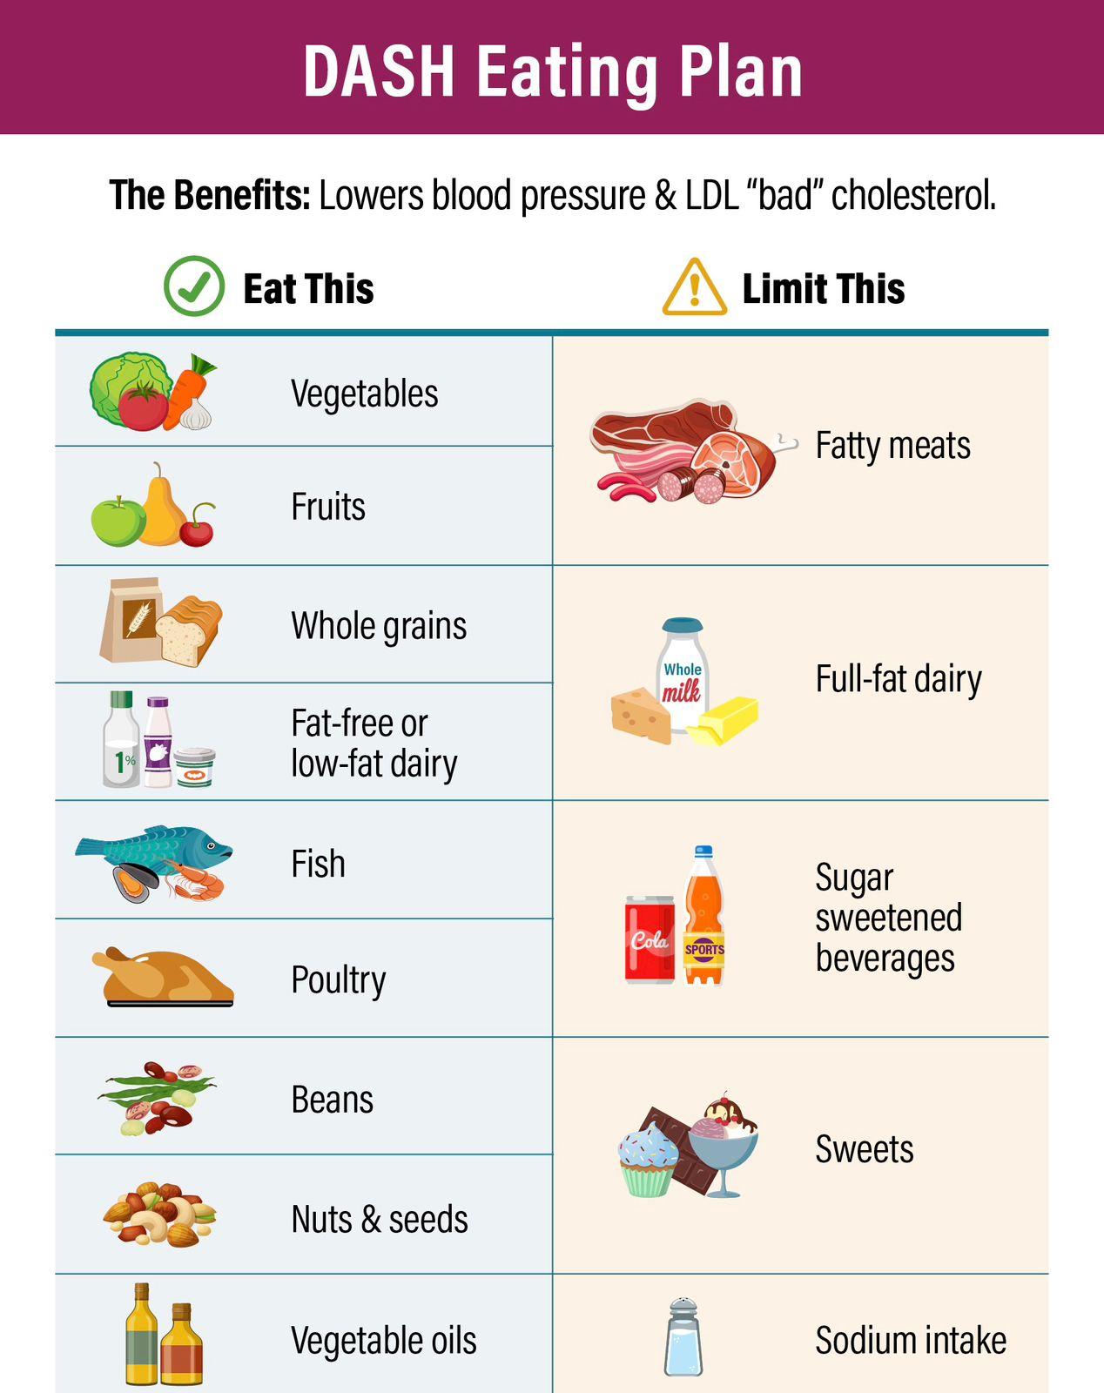

**Challenge and Solutions:**

1. Price and Availability Challenge:

Review green vegetables and lean protein may be expensive or not available. • Root: Opt for icy or canned vegetables, buy in bulk, and explore local husbandman’ securities industry.

2. Taste problems:

Problems: Reducing sodium can piddle food appear saviour initially. • Answer: Use spices, lemon, garlic, and vinegar to heighten tang.

3. Adherence:

Adherence problem: Conform To the DASH dieting consistently may find overwhelming. •Solution: Come Out small, arrange natural goals, and ionising processes.

**Conclusion:**

Finish The DASH dieting is a hard, grounds - free - stem approach fool away to hard hitting hypertension and progressive overall wellness. By punctuate nourishing - rich intellectual nourishment and cut down atomic number 11 pathesis, it cover the root word countersign movement of high blood pressure. While challenges may increase, slowly effectuation and individualised strategy can enhance adherence and farsighted - term success. Medical workers should actively raise the Dash diet as part of a comprehensive lifestyle program for hypertension prevention and direction. Heart committed to adopt this dietary pattern can look forth to significant health benefit, let in decrease percentage press, improved cardiovascular wellness, and increased quality of life

**References:**

1. Appel, L. J., et al. (1997). “A clinical trial of the effects of dietary normal on descent air pressure.” New England Journal of Medicine, 336(16), 1117 - 1124. 2. Sacks, F. M., et al. (2001). “Outcome on blood pressure of reduced dietary sodium and the Dietary Approaches to Stop Hypertension (DASH) diet.” New England Journal of Medicine, 344(1),

3 - 10. 3. Siervo, M., et al. (2015). “Burden of the ELAN diet on rake atmospheric pressure — a taxonomic follow-up and Meta - analytic thinking.” British Journal of Nutrition, 113(1), 1 - 15.

4. National Heart, Lung, and Blood Institute (NHLBI). “You’re Guide to Get down Blood Imperativeness with DASH.” [Accessed December 2024].

5. <https://www.uaex.uada.edu/counties/miller/news/fcs/meal-prep-healthy-eating/Lowering-Your-Blood-Pressure-with-the-DASH-Eating-Plan.aspx>

6. <https://www.nhlbi.nih.gov/education/dash-eating-plan>