**The Synthesis of Azelnidipine in the treatment of Hypertension.**

Prof.Tandale L.D,Mr.Domale Sagar N.

Department of Pharmaceutical Chemistry

Shri Swami Samarth Institute of Pharmacy Malwadi, (Bota).

India-422602

Email id: sagardomale74089@gmail.com

* **ABSTRACT**

Azelnidipine is chemically 3-(1-diphenymethylazetudin3-yl) 5- isopropyl 12-amino- 1, 4 -dihydro -6 methyl -4(3 nitrophenyl) 3,5 pyridinedicarboxylate . In the work presented here, the degradation behavior of the azelnidipine under diverse forced degradation conditions was studied.The prevalence of hypertension and comorBidities such as metabolic syndrome, diabetes,Mellitus, and chronic kidney disease in India is Alarmingly high.The peculiar Three-dimensional structure of the active enantiomer of AZEL may be Related to its unique pharmacological features that are not shared byOther DHPs such as long lasting reduction in blood pressure, decreased heart rate and Antiatherosclerotic effect.Therefore, an effective antihyper-Tensive agent that does not cause these adverseEffects and provides end-organ protection isRequired for the holistic management ofHypertension in the country.Further, chemical kinetics under acidic and alkaline conditions were studied, and validation studies were performed.

* **Keyword**

Azelnidipine, hypertension,RP-HPLC, methods validation, stability indications , calcium channel blockers, diabetes Mellitu

* **Introduction**

Hypertension is a condition where blood pressure is the elevated to an extent that clinical benefit Is obtained from BP lowering. Azelnidipine was synthesized by Ube Industries, Ltd. And the developed by Sankyo Co., Ltd. (currently known as Daiichi Sankyo Co., Ltd., Tokyo, Japan) and was the launched into the market as CALBLOCK in Japan in 2003.According to Guidelines from the European Society of Cardi-Ology and European Society of Hypertension,Hypertension is defined as a systolic BP (SBP) Level of at least 140 mmHg and/or a diastolic BP (DBP) level of at least 90 mmHg Moreover, many patients With hypertension are unaware that they have This condition .AZD is a third-generation calcium channel antagonist and an Effective antihypertensive agent used in patients suffering from Hypertension.5 It specifically suppresses the L-type calcium Channels of smooth muscle cells, and prevents the influx of Transmembrane calcium.A literature review found numerous analytical methods Stated for the estimation of AZD, including AZD estimation In pharmaceutical formulations by high performance liquid Chromatography (HPLC),7-10 ultraviolet (UV) spectroscopy11 in Biological fluids by hyphenated LC-mass spectrometry (MS) Techniques,12,13 enantiomeric separation and estimation of AZD By HPLC14 and LC-tandem MS.15 Hence, the effective control ofHypertension is necessary to reduce large-scalePremature morbidity and mortality in India.The Indian guidelines for BP control recom-Mend targets of 130/80 mmHg in individualsAged less than 60 years and 130–140/80–- 90 mmHg in those aged more than 60 years

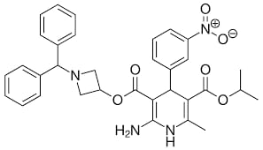  
   
 **Chemical structure of AZEL**

* **Synthesis**

1. a preparation method for Azelnidipine, is characterised in that,

2-is prepared in the first step 3-nitrobenzaldehyde and ISOPROPYL ACETOACETATE effect, and (3-nitrobenzal and ISOPROPYL ACETOACETATE, make solvent with Virahol;

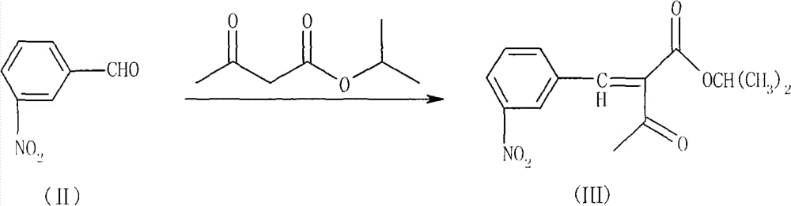

Second step is under alkaline condition, and benzhydrylamine and epoxy chloropropane effect, prepare 1-diphenyl-methyl-3-hydroxy azetidine;

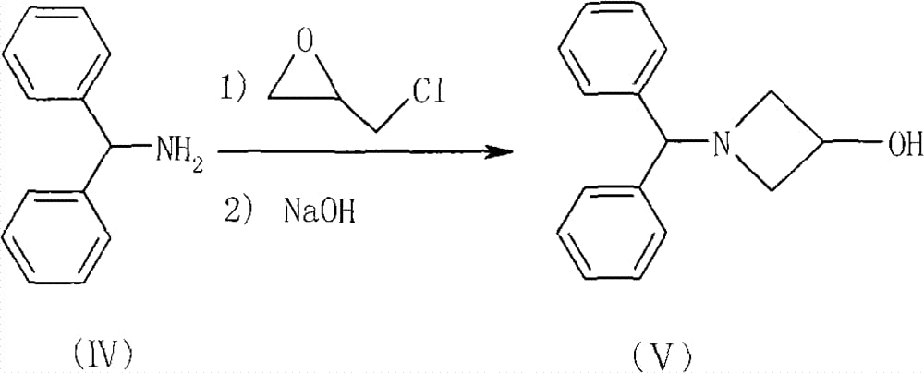

The 3rd step 1-diphenyl-methyl-3-hydroxy azetidine, at N, with cyanoacetic acid effect, is prepared cyanoacetic acid (1-dibenzo-p-methyl-aza-cyclobutane-3-yl) ester under the effect of N '-dicyclohexyl diimine;

The 4th step cyanoacetic acid (1-dibenzo-p-methyl-aza-cyclobutane-3-yl) ester and hydrogenchloride effect, prepare amidino groups acetic acid (1-dibenzo-p-methyl-aza-cyclobutane-3-yl) ester acetate, with methylene dichloride, makees solvent;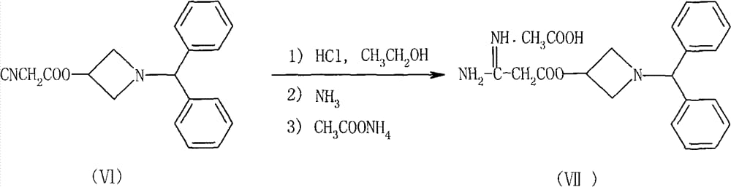

The 5th step

Condensation Product + Acetic anhydride + EtOH → Azelnidipine

* **MOA**

Azelnidipine selectively blocks L-type calcium channels, reducing calcium influx and vascular smooth muscle contraction.

Steps involved in MOA:

1. Binding to L-type calcium channels

2. Blocking calcium influx

3. Reducing calcium-calmodulin complex formation

4. Inhibiting vascular smooth muscle contraction

5. Decreasing the blood pressure

* **Pharmacokinetics [ADME]**

**Absorption:**

- Oral bioavailability: 10-20%

- Peak plasma concentration 2-4 hours

- Food effect: No significant impact

Distribution:

- Volume of distribution 2.5 L/kg

- Protein binding: 95-98%

- Blood-to-plasma ratio: 0.8-1.0

Metabolism:

- Primary metabolic pathway: CYP3A4/5

- Metabolites: Azelnidipine-3-glucuronide, azelnidipine-N-glucuronide

- Metabolic half-life: 10-15 hours

Excretion:

- Renal excretion: 60-70%

- Fecal excretion: 30-40%

- Elimination half-life 24-30 hours

* **Azelnidipine Development**

Research and Development Phase (1990s-2000s)

1. Discovery: Fujisawa Pharmaceutical Co. (now Astellas Pharma)

2. Synthesis: Modified dihydropyridine structure

3. Preclinical studies: Pharmacology, toxicology, pharmacokinetics

Clinical Trials (2000-2005)

1. Phase I: Single-dose, multiple-dose studies

2. Phase II: Dose-finding, efficacy, and safety evaluation

3. Phase III: Multicenter, randomized, double-blind studies

Regulatory Approval (2006)

1. Japan: Approved for hypertension treatment

2. Later approved in China, Korea, India, and other countries

Key Development Milestones

1. 1995: Patent application filed

2. 2001: Phase I clinical trials initiated

3. 2006: Regulatory approval in Japan

4. 2010: Global sales exceeded $1 billion

Development Challenges

1. Optimizing synthesis and formulation

2. Addressing pharmacokinetic variability

3. Demonstrating efficacy and safety in diverse patient populations

Lessons Learned

1. Innovative synthesis and optimization

2. Rigorous preclinical and clinical evaluation

3. Collaborative research and development

Development Team

1. Researchers: Fujisawa Pharmaceutical Co.

2. Clinical investigators: Multicenter trials

3. Regulatory experts: Astellas Pharma

Development Cost

Estimated $500 million - $1 billion

Development Time

Approximately 15-20 years

* **Scale-Up Azelnidipine:**

Laboratory Scale (100 mg - 1 g)

1. Reaction conditions: Optimized for yield and purity

2. Purification methods: Chromatography, crystallization

3. Equipment: Round-bottom flasks, magnetic stirrers

Pilot Scale (100 g - 1 kg)

1. Scale-up factors: 10-100x

2. Equipment: Reactors (10-50 L), filters, dryers

3. Process optimization: Yield, purity, cost

Commercial Scale (100 kg - 1 ton)

1. Large-scale production: Continuous flow, batch processing

2. Equipment: Reactors (100-500 L), centrifuges, dryers

3. Quality control: In-process testing, release testing

Scale-Up Parameters

1. Reaction temperature

2. Reaction time

3. Pressure

4. Agitation speed

5. Feed rate

6. Solvent ratio

Scale-Up Challenges

1. Maintaining yield and purity

2. Ensuring process consistency

3. Managing impurities and by-products

4. Meeting regulatory requirements

Scale-Up Strategies

1. Process intensification

2. Debottlenecking

3. Equipment optimization

4. Quality by Design (QbD) approach

Regulatory Considerations

1. FDA guidelines: Process validation, GMP compliance

2. ICH guidelines: Quality risk management, QbD

3. Regulatory submissions: DMF, NDA, ANDA

Azelnidipine Scale-Up Data

1. Yield: 80-90%

2. Purity: 99.5-100.5%

3. Particle size: 100-200 μm

4. Bulk density: 0.5-0.7 g/mL

Equipment Requirements

1. Reactors: 100-500 L

2. Filters: 10-50 μm

3. Dryers: 10-50 kg/h

4. Centrifuges: 10-50 L

* **Azelnidipine Uses:**

1. Hypertension (high blood pressure)

2. Angina pectoris (chest pain)

3. Coronary artery disease

4. Cardiovascular disease

5. Cerebrovascular disease (stroke prevention)

6. Treatment of essential hypertension

7. Management of angina pectoris

8. Prevention of cardiovascular events (e.g., heart attack, stroke)

9. Treatment of peripheral vascular disease

10. Management of cardiac arrhythmias

* **Azelnidipine Side Effects:**

1. Headache

2. Dizziness

3. Edema (peripheral,

4. Fatigue

5. Nausea

6. Abdominal pain

7. Muscle cramps

8. Flushing

9. Palpitations

10. Cough

* **Azelnidipine Adverse Drug Reactions**

1. Angioedema

2. Anaphylaxis

3. Stevens-Johnson syndrome

4. Toxic epidermal necrolysis

5. Atrial fibrillation

6. Ventricular arrhythmias

7. Hypersensitivity reactions

* **Azelnidipine Toxicity:**

1. LD50 (oral): 200-300 mg/kg (rat and mouse)

2. LD50 (IV): 10-20 mg/kg (dog)

3. Hepatotoxicity: Elevated liver enzymes, centrilobular necrosis

4. Nephrotoxicity: Increased creatinine, renal tubular damage

5. Cardiotoxicity: Decreased cardiac output, arrhythmias

* **Conclusion: Azelnidipine**

Azelnidipine is the potent and effective calcium channel blocker, providing significant benefits in the treatment of hypertension and cardiovascular diseases

Azelnidipine is a valuable treatment option for patients with hypertension and cardiovascular disease, offering effective blood pressure control and the improved cardiovascular outcomes.

1. High efficacy in blood pressure control

2. Long-acting and once-daily dosing

3. Improved cardiovascular outcomes

4. Reduced risk of stroke and myocardial infarction

5. Well-tolerated with minimal side effect

* **References:**

1.Walker R and Whittlesea C. Clinical Pharmacy and Therapeutics; 5th Edn; Elsevier, 2007; 295-307.

2.Tamargo J and Ruilope LM.,Investigational calcium channel blockers for the treatment of hypertension, Expert Opinion on Investigational Drug, 2016; 1-51.

3.O’Neil MJ, ed. The Merck Index An Encyclopedia of Chemicals, Drugs,

and Biological. 14th ed. New Jersy USA,: Merck research laboratories

Division of Merck and Co. Inc.; 2006:153.

4.Catterall WA, Perez-Reyes E, Snutch TP, Striessnig J. International

Union of Pharmacology. XLVIII. Nomenclature and structure-function

relationships of voltage-gated calcium channels. Pharmacol Rev.

2005;57:411-425.

5.Gore MG, Dabhade PS. RP-HPLC method development and validation of

azelnidipine. Int J Pharm Sci Res. 2016;7:5111.

6.Williams B, Mancia G, Spiering W, et al. 2018 ESC/

ESH Guidelines for the management of arterial

hypertension: The Task Force for the management

of arterial hypertension of the European Society of

Cardiology and the European Society of Hyperten-

sion: The Task Force for the management of arterial

hypertension of the European Society of Cardiology

and the European Society of Hypertension.

J Hypertens. 2018;36:1953–2041

7.Ramakrishnan S, Zachariah G, Gupta K, et al.

Prevalence of hypertension among Indian adults:

results from the great India blood pressure survey.

Indian Heart J. 2019;71:309–13.

8.Gupta R, Xavier D. Hypertension: the most impor-

tant non communicable disease risk factor in India.

Indian Heart J. 2018;70:565–72.

9.Abe M, Soma M. Multifunctional L/N- and L/T-type

calcium channel blockers for kidney protection.

Hypertens Res. 2015;38:804–6.

10.Oizumi K, Nishino H, Koike H, Sada T, Miyamoto

M, Kimura T. Antihypertensive effects of CS-905, a

novel dihydropyridine Ca?? channel blocker. Jpn J

Pharmacol. 1989;51:57–64.

11.Jian – jun zou, Hong-jian ji, Xiao-Hua Zhou, Yu-Bin Zhu, Hong –wei Fan, Da-Wei Xiao,

Qin Hu, Determination of azelnidipine by LC-ESI-MS and its application to a

pharmacokinetic study in healthy Chinese volunteers, Pharmazie, 2008; 63(8): 568-70.

13.Jenisha M, Shivangi P, Namrata P, Shreya S, Prasanna P and U. M. Upadhyay, stability

indicating analytical method development and validation for estimation of azelnidipine,

World Journal of Pharmaceutical Research, 2016; 5(2): 831-847.

14.Rele RV, Spectrophotometric Estimation of Azelnidipine in Bulk drug and

Pharmaceutical Dosage form by First Order Derivative and Area Under Curve Methods,

American Journal of PharmTech Research, 2014; 4(2): 126-135.

15.Amin AA,Saad M and Ahmed M, Simultaneous Determination of Azelnidipine and

Olmesartan Medoxomil in Pharmaceutical Dosage Forms by UFLC Method, Journal of

Pharma SciTech, 2016; 69-74.

16.Gore MG and Dabhade PS, RP-HPLC Method Development and Validation of

Azelnidipine, IJPSR, 2016; 5111-5114.

17.Kawabata K, Samata N, Urasaki Y, Fukazawa I, Uchida N, Uchida E,

Yasuhara H. Enantioselective determination of azelnidipine in human

plasma using liquid chromatography-tandem mass spectrometry. J

Chromatogr B Anal Technol Biomed Life Sci. 2007;852:389-397.

18.Rele RV, Sawant SA. Development and validation of stability indicating

reverse phase liquid chromatographic method for the assay of

azelnidipine in bulk and pharmaceutical formulations. Int J Pharma

Biosci. 2016;7:376-380

19.Ganduri R, Peddapapireddigari J, Vurimindi H, Ramprakash. Stability

indicating liquid chromatographic method for the simultaneous

determination of olmesartan medoxomil and azelnidipine in combined

tablet dosage form. Int J Pharma Sci Res. 2014;5:275-282.

20.Sada T, Saito H. [Pharmacological profiles and

clinical effects of azelnidipine, a long-acting cal-

cium channel blocker]. Nihon Yakurigaku Zasshi.

2003;122:539–47.

21.Inomata J, Murai H, Kaneko S, et al. Differential

effects of azelnidipine and amlodipine on sympa-

thetic nerve activity in patients with primary

hypertension. J Hypertens. 2014;32:1898–904.

22.Isaka T, Yahashi T, Sakamoto M, Sakamoto N, Ikeda

K, Tojo K. Azelnidipine decreased plasma aldos-

terone and plasminogen activator inhibitor type 1

levels in the hypertensive patients with type 2 dia-

betes mellitus-the Jikei Azelnidipine study in the

patients with Hypertension and Diabete

23. Org. Process Res. Dev. 2007, 11(2), 239-246

24. J. Pharm. Sci. 2010, 99(11), 4141-4153.