Development and validation of Novel drug RP-HPLC method for quantification of Tolvaptan bulk and Pharmaceutical dosage form.

M. Ashok babu

Associate Professor, Dept. Pharmaceutical Analysis & QA, SSJ College of Pharmacy, Hyderabad, India

**ABSTRACT**

A method was set up for synchronous estimation of a Tolvaptan by RP-HPLC. This was simple, rapid, effective and efficient technique for the validation of Tolvaptan in bulk and Pharmaceutical dosage form by RP-HPLC. A Thermosil C18 Column (100mm x 4.6mm) 5μm in isocratic mode, with mobile phase was Phosphate buffer: Methanol pH 2.5 (35:65 v/v) were used. The flow rate was 1ml/min. UV recognition at 254 nm. The correlation coefficient is 0. 999.The method was validated for system suitability, Linearity, precision, accuracy, ruggedness, robustness, LOD & LOQ. The recovery studies were found to be in the range 99.1-100.11% and showing linearity in the range of 20-60µg/ml. Proposed method can be successfully applied for the quantitative determination for Tolvaptan in Bulk and Pharmaceutical dosage form.

**Keywords:** Tolvaptan, RP-HPLC, Method validation

**1. INTRODUCTION**

**Tolvaptan** is a selective vasopressin V2-receptor antagonist to slow kidney function decline in patients at risk for rapidly progressing autosomal dominant polycystic kidney disease (ADPKD).   
Tolvaptan is used to treat low blood sodium levels (hyponatremia) associated with various conditions like congestive heart failure, cirrhosis, and syndrome of inappropriate antidiuretic hormones (SIADH). Tolvaptan is a selective and competitive arginine vasopressin receptor 2 antagonist. Vasopressin acts on the V2 receptors found in the walls of the vasculature and luminal membranes of renal collecting ducts. By blocking V2 receptors in the renal collecting ducts, aquaporins do not insert themselves into the walls thus preventing water absorption. This action ultimately results in an increase in urine volume, decrease urine osmolality, and increase electrolyte-free water clearance to reduce intravascular volume and an increase serum sodium levels. Chemically (±)-4'-[(7-chloro-2, 3, 4, 5-tetrahydro-5-hydroxy-1H-1-benzazepin-1-yl) carbonyl]-o tolu-mtoluidide

**2. DRUG PROFILE**

**TOLVAPTAN**

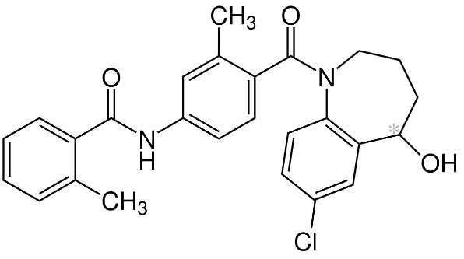

**IUPAC Name:** N-{4-[(5R)-7-chloro-5-hydroxy-2,3,4,5-tetrahydro-1H-1-benzazepine-1-carbonyl]-3-methylphenyl}-2-methylbenzamide

**Chemical formula:** C26H25ClN2O3

**Molecular weight:** 448.941

**Solubility:** Soluble in methanol and Chloroform

**3. MATERIALS & METHOD**

The strategy improvement and approval of Tolvaptan require a more prominent goal. Consequently, extraordinary dissolvable frameworks were attempted.

The path is utilizing UV 3000+ hardware with a PDA locator and isocratic siphon. The framework is constrained by LC arrangement programming. The portable stage comprises of water: methanol HPLC grade were used.

**4. METHOD DEVELOPMENT**

**Choice of stream rate:**

The streaming pace of Tolvaptan was attempted from 0.8 ml to 1.5ml.

**Preliminary 1**

**Cushion readiness:**

About 7.0g of potassium dihydrogen orthophosphate was broken up in 1000ml of HPLC grade water and PH 2.5 was changed with ortho-phosphoric corrosive. It was sifted through a 0.45μm nylon film channel and degassed with a sonicator. It was utilized like a diluent for the arrangement of test and standard arrangement.

**Arrangement of portable stage:**

The portable stage comprises of water: methanol HPLC of PH 2.5 (30:70) was taken sonicated and degassed for 10 min and sifted through 0.45μm nylon layer channel.

**Standard Preparation:**

Weigh precisely 10mg Tolvaptan working Reference Standard and 15mg of Tolvaptan working reference standard is taken into 100ml volumetric flask and afterwards, it was disintegrated and weakened to volume with portable stage sufficient. After that 50ml of the above arrangement was taken into a 100ml standard carafe and made up with a versatile stage. (Stock arrangement)

Further pipette 0.5ml of the above stock arrangement into a 10ml volumetric jar and weaken sufficiently with diluent.

**Chromatographic conditions:**

Column : Thermosil C18 Column (100mm x 4.6mm) 5μg.

Mobile phase : Phosphate buffer: Methanol PH 2.5 (35:65 v/v)

Flow rate : 1ml/ min

Detector wavelength : 254 nm

Injection mode : Auto injector (vial)

Injection volume : 20μl

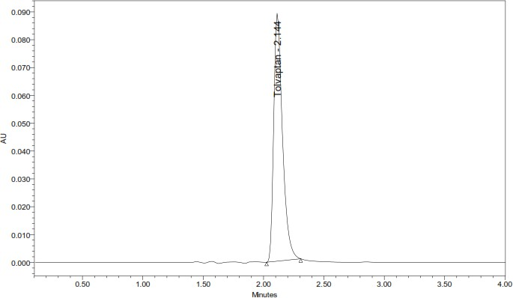

Figure:01 Optimised Chromatogram

|  |  |  |  |  |  |  |
| --- | --- | --- | --- | --- | --- | --- |
| **S.No** | **Peak Name** | **Rt** | **Area** | **Height** | **USP Plate Count** | **USP**  **Tailing** |
| 1 | Tolvaptan | 2.605 | 2233704 | 365596 | 4456 | 1.4 |

**5. METHOD VALIDATION**

**Specificity:** A measure of 352.6 mg of the container powder was taken into a 100ml standard jar. A volume of 70ml of the portable stage was added and sonicated for 30min. Then the arrangement was cooled and weakened to volume with versatile stage and sifted through 0.45µm layer channel. Further pipette out 0.25ml of Tolvaptan of the above stock solution into a 10ml Volumetric flask.

**Standard Arrangement**

Weigh precisely 10mg Tolvaptan Working Reference Standard is taken into 100ml volumetric cup and afterwards, it was broken down and weakened to volume with versatile stage sufficient. After that 50ml of the above arrangement was taken into a 100ml standard jar and made up with a versatile stage. Further pipette out 0.5ml of Tolvaptan of the above stock solution into a 10ml Volumetric flask.

**Test Arrangement**

A measure of 352.6 mg of the tablet powder was taken into a 100ml standard jar. A volume of 70ml of the versatile stage was added and sonicated for 30min. Then the arrangement was cooled and weakened to volume with a portable stage and sifted through 0.45µm film channel. Further pipette out 0.25ml of Tolvaptan of the above stock solution into a 10ml Volumetric flask.

**Linearity and Range**

**Arrangement of stock arrangement**

Weigh precisely 10mg Tolvaptan Working Reference Standard is taken into 100ml volumetric flagon and afterwards it was disintegrated and weakened to volume with portable stage sufficient. After that 50ml of the above arrangement was taken into a 100ml standard jar and made up with a versatile stage.

|  |  |
| --- | --- |
| **Tolvaptan** | |
| **Concentration** (µg/ml) | **Area** |
| 20 | 1224140 |
| 30 | 1595681 |
| 40 | 1992966 |
| 50 | 2356546 |
| 60 | 2797214 |

Table:02 Data for Linearity Results

Figure:02 Linearity curve for Tolvaptan

**Accuracy Studies**

|  |  |  |  |  |  |  |
| --- | --- | --- | --- | --- | --- | --- |
| Recovery level | **Accuracy of Tolvaptan** | | | | | Average  %  Recovery |
| Amount taken  (mcg/ml) | Area | Average area | Amount recovered  (mcg/ml) | Percentage Recovery |
| 50% | 5.05 | 1011326 | 1017498.5 | 101.3927 | 101.3927 | 100.599% |
| 5.05 | 1015029 |
| 5.05 | 1026141 |
| 100% | 10 | 1986534 | 1987384.8 | 100.0106 | 100.0106 |
| 10 | 1987425 |
| 10 | 1988195 |
| 150% | 15 | 2989367 | 2992493.4 | 100.3936 | 100.3936 |
| 15 | 2991556 |
| 15 | 2996557 |

Table-14: Accuracy for Tolvaptan

**Precision:**

|  |  |  |  |  |  |
| --- | --- | --- | --- | --- | --- |
| **S.No** | **Injection** | **Peak Name** | **Rt** | **Area** | **Height** |
| 1 | Injection-1 | Tolvaptan | 2.112 | 2010800 | 92856 |
| 2 | Injection-2 | Tolvaptan | 2.122 | 2002956 | 95705 |
| 3 | Injection-3 | Tolvaptan | 2.113 | 2012800 | 90602 |
| 4 | Injection-4 | Tolvaptan | 2.115 | 2005243 | 91610 |
| 5 | Injection-5 | Tolvaptan | 2.136 | 2011092 | 89754 |
| 6. | Injection-6 | Tolvaptan | 2.124 | 2011054 | 94584 |
| **Average** | | | | 2008991 | |
| **Standard Deviation** | | | | 3922.241 | |
| **%RSD** | | | | 0.195234 | |

**Ruggedness**

|  |  |
| --- | --- |
| **Injection** | **Area** |
| Injection-1 | 2005053 |
| Injection-2 | 2007362 |
| Injection-3 | 2007473 |
| Injection-4 | 2009153 |
| Injection-5 | 2012800 |
| **Average** | 2008368.1 |
| **Standard Deviation** | 2874.8 |
| **%RSD** | 0.10 |

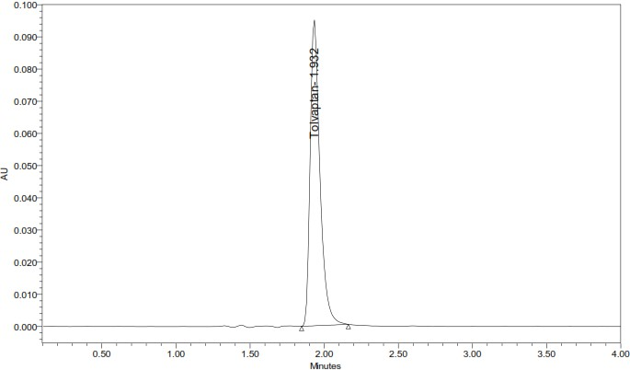**Robustness: more flow rate 1.2 ml/min**

|  |  |  |  |  |  |  |
| --- | --- | --- | --- | --- | --- | --- |
| **S.No** | **Peak Name** | **Rt** | **Area** | **Height** | **USP**  **Plate Count** | **USP**  **Tailing** |
| 1 | Tolvaptan | 2.168 | 1676589 | 321224 | 4207 | 1.3 |

**less flow rate 0.8ml/min**

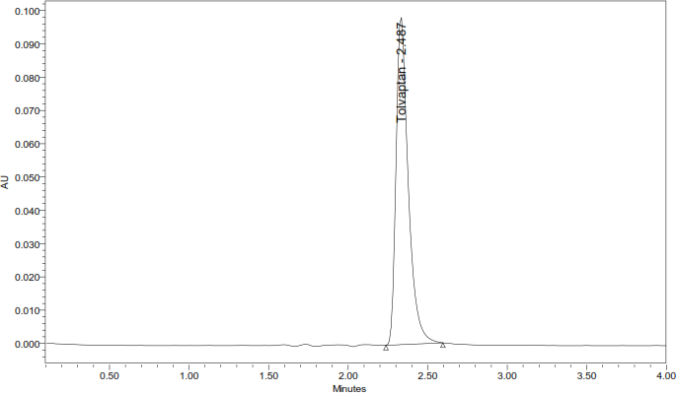

Figure:04 Chromatogram of Tolvaptan Flowrate

|  |  |  |  |  |  |  |
| --- | --- | --- | --- | --- | --- | --- |
| **S.No** | **Peak Name** | **Rt** | **Area** | **Height** | **USP**  **Plate Count** | **USP**  **Tailing** |
| 1 | Tolvaptan | 3.215 | 2492492 | 372153 | 5752 | 1.4 |

**Flow rate results for Tolvaptan:**

|  |  |  |  |
| --- | --- | --- | --- |
| **S.No** | **Flow Rate (ml/min)** | **System Suitability Results** | |
| **USP Plate Count** | **USP Tailing** |
| 1 | 0.8 | 5752 | 1.4 |
| 2 | 1.0 | 5026.5 | 1.3 |
| 3 | 1.2 | 4476 |  |

**Organic phase results for Tolvaptan**

|  |  |  |  |
| --- | --- | --- | --- |
| **S. No** | **Change in organic composition in the mobile phase** | **System suitability results** | |
| **USP Plate Count** | **USP Tailing** |
| 1 | 5 % less | 6498 | 1.2 |
| 2 | *Actual | 5026.5 | 1.3 |
| 3 | 5 % more | 6471 | 1.2 |

**LIMIT OF DETECTION:**

|  |  |  |  |
| --- | --- | --- | --- |
| **Drug name** | **Standard deviation(σ)** | **Slope(s)** | **LOD(µg)** |
| Tolvaptan | 618048 | 39092 | 0.001 |

The LOD was performed for Tolvaptan was found to be 0.001.

**QUANTITATION LIMIT**

|  |  |  |  |
| --- | --- | --- | --- |
| **Drug name** | **Standard deviation(σ)** | **Slope(s)** | **LOQ(µg)** |
| Tolvaptan | 618048 | 39092 | 0.004 |

The LOQ was performed for Tolvaptan was found to be 0.004

**Assay**

The results show that the %purity was found to be 99.7% which indicates that the value was within the specified range and hence meets the necessary criteria.

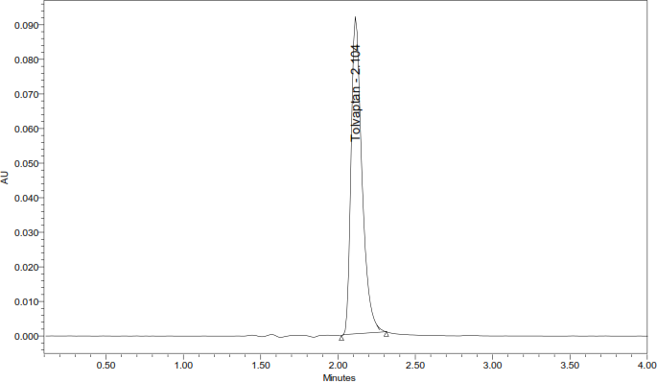

Figure:05 Assay Chromatogram for Tolvaptan

**Calculation: (For Tolvaptan)**

2005829 15 0.5 100 10 99.89 694.2

----------- x ----------x ----------- x----------- x----------- x----------- x ----------- x 100

2008408 10 10 694.2 0.25 100 200

= 99.77%

**6. CONCLUSION**

In this research, we have effectively established and thoroughly validated a high-performance liquid chromatography with ultraviolet detection (RP-HPLC) UV- technique for the accurate quantification of Tolvaptan in biological samples. The method exhibited outstanding performance across multiple validation criteria, such as linearity, precision, accuracy, recovery, stability, specificity, and robustness. The established method demonstrated a broad linear range from 20 to 60 μg/ml, rendering it appropriate for the quantification of Tolvaptan in pharmaceutical formulations. The method's precision, assessed through both intraday and interday evaluations, fell within acceptable parameters, thereby ensuring dependable and reproducible outcomes Recovery studies revealed consistent and reproducible recovery rates, further affirming the method's reliability in drug quantification.

**7. REFERENCES**

[1] Skoog, West, Holler. “*Fundamental of Analytical chemistry”*. 7th eds. USA: Saunders college publishing, 1992; 3-4.

[2] Furniss BS, Nash RA. “*Vogel’s Textbook of practical organic chemistry”*. 5th eds.London: Longman group LTD, 1989; 165-169.

[3] Kealey D, Haines PJ. Instant Notes “*Analytical chemistry”,* UK: BIOS Scientific Publishers LTD, 2002; 1-2.

[4] Kealey D, Haines PJ. Instant Notes Analytical Chemistry, UK: BIOS Scientific Publishers LTD, 2002: pp. 3-4.

[5] Remington. The Science & Practice of a pharmacy Vol. I, 20TH Edn.B.I.publication PVT. Ltd. pp. 587-613.

[6] Synder L.R., Kirkland, J.L.Glajch, “*practical HPLC Method Development”*. John Wiley and Sons, INC; 2ND Edn. 1997: 98-102.

[7] Ahuja S, Dong MW, editors. “*Handbook of Pharmaceutical Analysis by HPLC”.*

[8] Dong MW. “*Modern HPLC for practising Scientists”*. John Wiley& Sons, New Jersey; 2006: 17-27.

[9] Marvin C.McMaster. “*HPLC-A Practical User’s Guide*”. 2nd eds. New Jersey: John Wiley & sons. Inc. Hoboken-2007.

[10] V. Kalyana Chakravarthy* and D.Gowri Shankar, Development And Validation Of Rp-Hplc Method For Estimation Of Tolvaptan In Bulk And Its Pharmaceutical Formulation, *Rasayan Journal of Chem* -Vol.4, No.1 (2011), 165-171.

[11] K. Vijaya Sri, S. Sruthi, M.A. Madhuri. Rapid RP-HPLC Method Development and Validation of Tolvaptan in Bulk and Pharmaceutical Dosage Form for an Internal Standard. Asian J. Pharm. Ana. 2017; 7(1): 36-40. DOI: 10.5958/2231- 5675.2017.00007.2.

[12] Sk. Chandmalin and CH. M. M. Prasada Rao. Analytical method development and validation of Tolvaptan and its related substances in drug product by RP- HPLC method, Asian Journal of Pharmaceutical Analysis and Medicinal Chemistry, 4(4), 2016, 194-200

[13]  Ranga BG, Sankepally R, Sollu S, Pragada VR, Haque MA, Boggul N, et. al. Analytical method development and validation of Tolvaptan in bulk and its tablet dosage form by UV- Spectrophotometry. IAJPS. 2022; 09 (02):186-193.

[14] Ahmed A, Khan GJ. An eco-friendly RP-HPLC and UV-method development and validation for an estimation of Tolvaptan in bulk and tablet dosage form followed by forced degradation studies. JPRI. 2021; 33(42B):271-86.

[15] Chakravarthy VK, Shankar DG. Development and validation of RP-HPLC method for estimation of Tolvaptan in bulk and its pharmaceutical formulation. Rasayan J. Chem. 2011; 4(1):1165-71.

[16] Gandhi BM, Rao AL, Rao JV. A New Stability Indicating and Validated RP-HPLC Method for the Estimation of Tolvaptan in Pharmaceutical Dosage Forms. Asian J. Research Chem. 2014; 7(7): 628-633.