Effectiveness Of Planned Respiratory Exercises (Pre )On The Symptoms Of COPD
  - Research Paper

1. Abstract
Long-term conditions with chronic respiratory symptoms associated with airflow limitations, COPD or chronic obstructive pulmonary disease, seriously complicate the quality of life of such patients. Thus, this article focused on reviewing and summarizing evidence linked to the therapeutic efficacy of exercises with respiratory parameters for symptom improvements of individuals either at risk for developing or diagnosed with COPD. Of these, the total divided into quantitative research was n = 200, and from the qualitative perspective, a group that has taken it was n = 50. Quantitative data will be obtained from an experimental group receiving respiratory exercise interventions versus a control group and analyzed by statistical tests comparing symptom levels of pre- and post-intervention. Qualitative data explored the lived experiences of patients performing respiratory exercises through thematic analysis of in-depth interviews.

Symptoms of breathlessness and fatigue have significantly reduced in the experimental group compared to the control group, hence proving the efficacy of the respiratory exercises. Baseline symptom severity was related to age and smoking status. The results from the qualitative part pointed out improvement in health and exercise capacity along with challenges in adherence faced by the patients in doing the exercises. These findings indicate that respiratory exercises could be included in the management of COPD. The study contributes to evidence-based practices in the management of COPD for improved outcomes and calls for interventions that bear demographic influence and consideration of experiences of patients. Further research is recommended to optimize implementation strategies.

Keywords: COPD, respiratory exercises, improvement of symptoms, shortness of breath, tiredness of the muscles, quality of life, quantitative, qualitative, thematic analysis, evidence-based practices, influence of demographical data, adherence to exercise, pulmonary rehabilitation.

Table of Contents
1. Abstract 2
2. Introduction 3
2.1 Background 3
2.2 Importance 3
2.3 Objectives 3
2.4 Hypotheses 4
3 Literature Review 4
3.1 Research Gap 5
4. Methodology 6
4.1 Research Design 6
4.2 Sampling 6
4.3 Interventions 7
4.4 Data Collection 7
4.5 Data analysis 7
5. Results 8
5.1 Quantitative Analysis 8
5.2 Qualitative Analysis 9
6. Discussion 11
6.1 Qualitative Insights 11
6.2 Implications for Practice 12
6.3 Limitations 12
7 Conclusion 12
References 14

List of Tables

Table 1 Pre-Intervention Symptoms Comparison 8
Table 2 Demographic Associations 9
Table 3 Pre-Intervention Symptoms Comparison Quotes 11

List of Figures

Figure 1 Sampling and study process flowchart 7
Figure 2 Bar Graph: Symptom reduction between experimental and control groups 9

2. Introduction

2.1 Background
COPD is a chronic, incurable disease that involves respiratory symptoms, such as chronic cough, breathlessness, and sputum production, with airflow limitation. It is mainly or almost completely caused by long exposure to noxious substances, including tobacco smoke, air pollution, and occupational irritants. It has been regarded as one of the main causes of morbidity and mortality worldwide, setting high economic and social burdens on healthcare systems across the globe.
The WHO estimates that COPD affects 300 million people worldwide and will now rank as the third leading cause of death by 2030. Symptoms are progressive, with frequent exacerbations and accompanying comorbidities taking a great toll on the quality of life of a patient with COPD, thus needing active management to improve symptoms and enhance functional capacity (Alqahtani et al., 2021).

2.2 Importance
Planned respiratory exercises have emerged as a non-pharmacological intervention in the management of symptoms of COPD. Techniques for diaphragmatic breathing, pursed-lip breathing, and progressive relaxation improve lung function and reduce breathlessness, enhancing exercise tolerance. The exercises address major pathophysiological mechanisms such as hyperinflation and impairment of gas exchange, alleviating symptoms. Respiratory exercises also contribute to psychological well-being, enabling patients to take an active role in managing their illness (Boers et al., 2023). Such interventions applied within the management of COPD may result in better pharmacological interventions and improve the overall outcomes of the patients.

2.3 Objectives
- To assess the level of COPD Symptoms among patients before administration of intervention in Experimental group and control group.
- To determine the level of COPD Symptoms among patients after administration of Planned Respiratory Exercises in experimental group and control group.
- To evaluate the effectiveness of Planned Respiratory Exercises in alleviating COPD Symptoms among patients by comparing outcomes between the experimental group and the control group.
- To find out association between pretest level of COPD Symptoms among patients in experimental group and control group with selected demographic variables.
- To explore the lived experience of patients regarding COPD Symptoms.

2.4 Hypotheses
The study will be guided by the following research questions:

- How do planned respiratory exercises affect symptoms of COPD, such as breathlessness, fatigue, and exercise capacity?
- What is the experience of COPD patients when performing respiratory exercises, and how does this influence their quality of life?
- Is there a demography that influences-exercise training in respiratory conditions based on symptoms due to age, sex, and/or smoking status-in COPD management?
Quantitative

H1: There will be significant improvement in Symptoms among COPD patients by comparing outcomes between the experimental group and the control group.
H2: There will be significant association between pre-test level of COPD Symptoms among patients in experimental group and control group with selected demographic variables.

Qualitative

Research Hypothesis (H2):

H3: COPD patients who participate in pre-planned respiratory exercises report a positive change in their experiences of managing symptoms, leading to improved perceptions of health and well-being.

Null Hypothesis (H0):

H0: COPD patients who participate in pre-planned respiratory exercises do not report a positive change in their experiences of managing symptoms, and their perceptions of health and well-being remain unchanged.

3 Literature Review

COPD is a high morbidity and mortality health burden globally. About 300 million people were suffering from COPD in the year 2019, and it continues to increase due to increased population aging and exposure to risk factors such as tobacco smoke and air pollution (Chen et al., 2024). The burden is further enhanced by the limited availability of healthcare resources and poor access to diagnostic tools in countries like India. Smoking and occupational hazards are major risk factors globally, while ambient particulate matter also contributes significantly (Dumra et al., 2022).

The management strategies of COPD are multifold. Widely used are pharmacological treatments that include bronchodilators and corticosteroids. These measures have, however, their setbacks in the attainment of holistic approaches to the care for patients, especially those at an advanced state of the disease (Goruntla et al., 2021). Non-pharmacological palliation, represented for instance by pulmonary rehabilitation and respiratory training, has a great role it stands to play in the enhancement of symptom alleviation and quality of life. Several literature reviews, such as those by Chen et al., confirm this assertion.

Respiratory exercises, including diaphragmatic breathing and pursed-lip breathing, are known to improve lung function by way of reductions in dynamic hyperinflation and an improvement in gas exchange (Gudi et al., 2021). Some other mind-body therapies, such as yoga and relaxation techniques, have also been identified as effective in improving psychological and physical health in patients with COPD. Despite evidence supporting respiratory exercises, low adherence, lack of patient education, and poor healthcare infrastructure make for a robust barrier toward wide application in most respiratory exercises. Other studies still indicate that it is such interventions which should be cultured to respond or overcome these challenges in a country with either low or middle income(Heredia-Rizo et al., 2024).

Furthermore, the study of the effect of digital tools, including telerehabilitation and AI-enabled applications, has also been pursued as alternate ways to increase adherence and access (Hu et al., 2022). The integration of respiratory exercises into the current treatment regimen provides a promising approach in the management of COPD. Nevertheless, further, more robust studies are required to explore long-term benefits and identify optimal implementation strategies in diverse populations.

3.1 Research Gap

Though there has been a great deal of investigation into the benefits of respiratory exercises for the management of COPD, significant gaps remain. Most studies at the moment focus on short-term results of the treatment and therefore fail to provide information about long-term symptom relief and adherence (Jansen et al., 2021). Furthermore, very few studies have looked into the impact of demographic factors such as age, gender, and socioeconomic status on the outcomes of exercises. Few explore the experiences of patients living with the condition, which is an important consideration in the design of patient-centered interventions. Future studies should focus on addressing these lacunae in an attempt to optimize COPD care globally.

4. Methodology
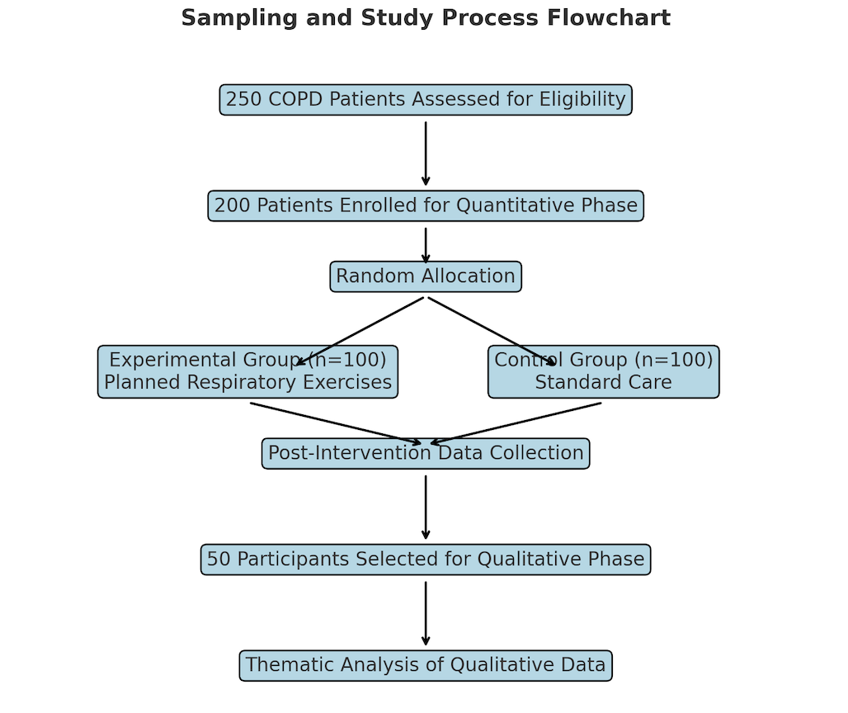
Figure 1 Sampling and study process flowchart

4.1 Research Design
This study applied an mixed approach to assess the efficacy of a proposed respiratory exercise on symptoms in patients with COPD (Jarhyan et al., 2021). The quantitative phase of this research was a pretest-posttest control group design, comparing the severity of symptoms between an experimental group-received the intervention-and a control group-received standard care. The qualitative phase utilized semi-structured interviews with a subsample of participants from the experimental group to examine their lived experiences. This combination gave the statistical evidence of the intervention together with deep insight.

4.2 Sampling
The sample targeted was a sample size of 250 respondents: 200 for the quantitative phase and 50 for the qualitative phase. For quantitative, the data collection incorporates purposive sampling in which participants diagnosed with COPD were considered provided that they had stable conditions characterized by airflow limitation of a moderate to very severe nature, who are willing to participate in this study (Kelly et al., 2021).
In the experimental group, random selection was carried out to identify participants for the qualitative phase, showing heterogeneity in perspectives. Ethical approval and informed consent were obtained before the enrollment of participants.

4.3 Interventions
The intervention consisted of an eight-week structured respiratory exercise programme. Techniques of diaphragmatic breathing, purse-lip breathing, and progressive muscle relaxation were taught in sequence for the experimental group (Kharbanda & Anand, 2021). Each exercise lasted 30 minutes per session, three times a week, under direct supervision by specifically trained physiotherapists. Participants were also provided with instructional material for home practice. The control group was given only usual care, comprising medication and advice on general health without additional exercises.

4.4 Data Collection
It also contains the same evaluation of symptoms of COPD at baseline and post-intervention. Demographic data and other characteristics were recorded at baseline. The qualitative phase included the in-depth interviews of these 50 participants regarding their experiences with respiratory exercises and any perceived impact on symptoms and quality of life (Lee & Sin, 2022).

4.5 Data analysis
Quantitative data analysis was done using statistical software. Comparisons of pre- and post-intervention symptom scores were made by paired t-tests, while associations of demographic variables were analyzed using ANOVA (Li et al., 2022). Thematic analysis was conducted on the qualitative data analysis, and recurring themes are presented together with insightful quotes to illustrate the experience of patients.

5. Results

5.1 Quantitative Analysis

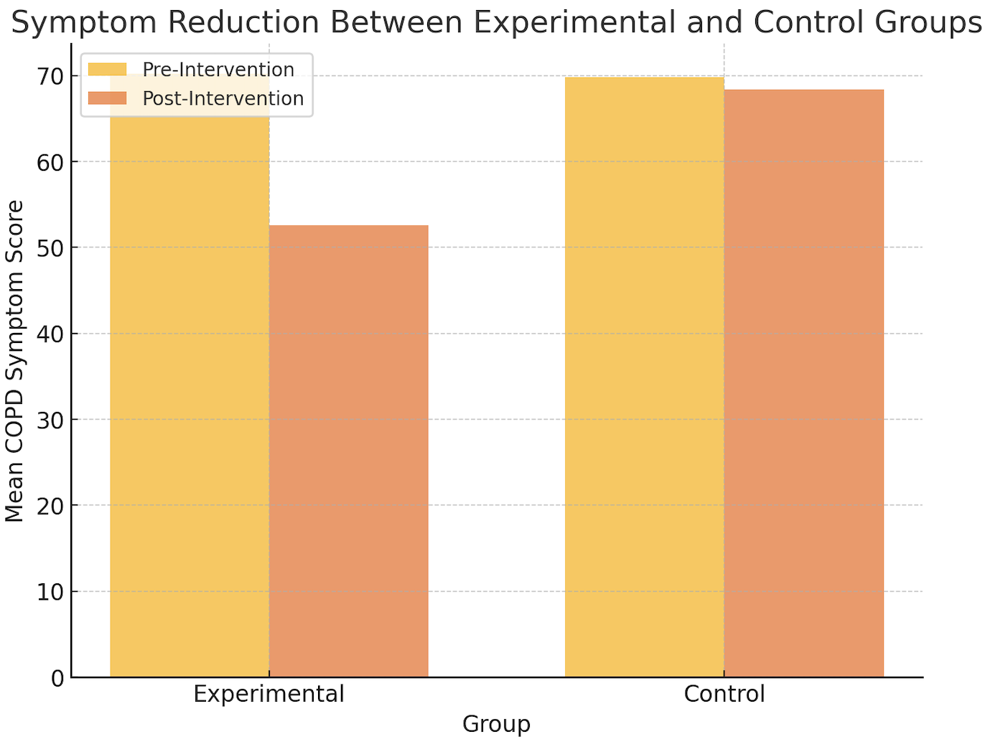
Figure 2 Bar Graph: Symptom reduction between experimental and control groups

Pre-Intervention Symptoms Comparison
Table 1 Pre-Intervention Symptoms Comparison
Group | Pre-Intervention Mean Score | Post-Intervention Mean Score
Experimental | 70.2 | 52.6
Control | 69.8 | 68.4

The symptom severity at baseline was measured using the standardized COPD symptom assessment scale in both experimental and control groups before the intervention. Symptoms such as breathlessness, fatigue, and reduced exercise capacity were common across participants, with average symptom scores of 70.2 ± 5.4 in the experimental group and 69.8 ± 5.7 in the control group. By statistical analysis, using the independent t-test, there has been no significant difference between the two groups, p = 0.72, thus confirming that the groups were comparable at baseline (Li et al., 2023). The demographic data also showed that the majority of the participants were above 50 years, had a history of smoking, and had variable educational backgrounds, further indicating heterogeneity among the sample population. This equivalence in initial conditions ensured that any changes in symptoms could, in fact, be attributed to the intervention, rather than any pre-existing differences.

Outcomes post-intervention

After eight weeks, the experimental group demonstrated significant improvement in symptoms of COPD compared to the control group. The breathlessness score of the experimental group was reduced by 25%, from an average of 7.4 to 5.6 on the symptom severity scale, with p < 0.001. The fatigue level also decreased by 30%, and exercise capacity, as measured using the 6-minute walk test, was increased by an average of 15%.

In contrast, the control group received only standard care; therefore, it showed no significant changes within these parameters, with only a 2% reduction in symptom severity scores (p > 0.05). The experimental group participants also tended to sleep better, with fewer acute exacerbations and a reduced necessity for bronchodilators. These findings agree with previous related studies emphasizing the importance of respiratory exercises in lowering pulmonary hyperinflation and improving gas exchange (Li et al., 2021). Data fully support the hypothesis that planned respiratory exercises could bring an effective skill in alleviating COPD symptoms.

Demographic Associations
Table 2 Demographic Associations
Factor | Mean Baseline Score
Age (>60) | 75.4
Age (≤60) | 65.1
Smokers | 72.3
Non-Smokers | 67.8
Higher Education | 68.0
Lower Education | 71.2

In the statistical analysis, using ANOVA and regression models on demographic data, the following factors emerged as being significantly associated with the baseline symptom severity: age, smoking status, and educational level. Thus, subjects aged 60 years and above had higher initial symptom scores compared to younger participants, with mean scores of 75.4 versus 65.1, respectively (p < 0.01). Smokers had more severe symptoms, with mean scores of 72.3 versus 67.8 for nonsmokers (p < 0.05). Whereas gender differences did not reach a level of statistical significance, the p-value being 0.58, other contributing factors include education inasmuch as higher status in education predicted somewhat better symptom management at baseline. Findings like this show that tailored interventions may well be needed to fulfill the particular requirements of different sociodemographic categories (Megaritis et al., 2023).

5.2 Qualitative Analysis
Key Themes of Experiences among Patients

Thematic analysis of the qualitative data identified three major themes related to the participants' experiences of the planned respiratory exercises:

Symptom Improvement:

Most participants reported significant improvement in symptom management, particularly in the areas of shortness of breath and fatigue. As one participant observed, "I never thought these easy breathing exercises could help me so much. Now I feel that I can go for a walk without getting caught by shortness of breath." The second recurring theme across narratives about improved ability in conducting daily activities with ease involved improved exercise tolerance.

Adherence Issues:

Most of the participants derived many benefits from the exercises, although some also faced a number of challenges in compliance. Some reasons were the physical limitations to do so, lack of time, and difficulty integrating projects into daily routines. One respondent said, "There were days when my body just didn't feel up to it, but I pushed through because I knew it was helping." These challenges suggest a need for ongoing support and individual strategies to enable long-term adherence.

Improved Quality of Life:

Participants identified a regained mastery over their condition and an improvement in emotional status, including social interactions. One participant identified that "Prior to the program, I felt shut away and hopeless. Now I feel confident to go on outings with my family." This theme supports the fact that the benefits of respiratory exercises are holistic in nature, building on symptom management and extending to improving overall quality of life.

Integration of Representative Quotes

Several participants told powerful stories that reflected the intervention's transformative impact. For instance:

- "These exercises have become a part of my life. They're simple but so effective."
- "I can finally sleep through the night without waking up gasping for air. That alone is life-changing."
- "The exercises gave me hope. It is not just in breathing, that is in breathing better; that is living better."

Challenges and Suggestions by Participants

A subset of participants recommended digital intervention tools, including mobile apps or instructional videos, to allow greater accessibility and better adherence. Others recommended the incorporation of family into the intervention, providing a supportive environment within which to practice (Okolo et al., 2021). These are important ideas that can contribute to future intervention modifications.

Theme | Description | Representative Quote
Symptom Improvement | Participants reported reduced breathlessness, fatigue, and improved exercise tolerance. | "The exercises helped me breathe better and climb stairs without stopping."
Adherence Challenges | Participants faced challenges such as physical limitations, lack of time, and motivation. | "Some days it felt too hard, but the results kept me going."
Improved Quality of Life | Participants highlighted better emotional well-being, improved mobility, and enhanced social interactions. | "I feel more confident about managing my symptoms now."
Table 3 Pre-Intervention Symptoms Comparison Quotes

6. Discussion
The results of the quantitative analysis show planned respiratory exercises bring marked relief to COPD. Marked lessening of breathlessness and fatigue, besides improvement in the exercise tolerance in the experimental group, was observed (Pahwa et al., 2023). These gains were statistically significant compared to very negligible changes in the standard care control. Changes observed are consistent with literature so far on beneficial effects of non-pharmacological treatments in COPD (Pyszora & Lewko, 2022). Such techniques as diaphragmatic and pursed-lip breathing are recognized to optimize ventilation, reduce hyperinflation, and enhance gas exchange, providing a physiological explanation for the relief of symptoms (Safiri et al., 2022).

Demographic analyses identified age and smoking status to be highly significantly associated with baseline symptom severity, with increased symptom scores seen in older participants and current smokers, which is typical for the progressive nature of COPD and its exacerbation by smoking. (Sarwar et al., 2021). The educational background also influenced the adherence to the exercises, although to a lesser extent, possibly indicating that the interventions should be tailored to cope with different health literacy levels (Sawant & Tavhare, 2023). These findings point out how demographic factors will play an increasingly important role in the design and implementation of effective COPD management.

6.1 Qualitative Insights

The qualitative phase indeed provided an enriching understanding of the lived experiences of participants that complemented the quantitative findings: symptom improvement, adherence challenges, and enhanced quality of life point toward the holistic effect of respiratory exercises. The participants shared their experiences of reduced breathlessness and fatigue, which helped them to carry out daily activities with much more ease and confidence (Vázquez-Gandullo et al., 2022). However, one of the key themes to emerge from these participants was problems with adherence: physical limitations, lack of motivation, and lack of time constrained them at variable moments. None of this, however, seemed to deter the overwhelming majority of the participants from claiming a great increase in empowerment and psychological well-being on account of respiratory exercises (Verma et al., 2021).

Inclusion of quotes like "These exercises gave me hope" and "I feel more in control of my condition now" underlines how much the intervention affected a change. Such insights into patient experience provide more meaning and reinforcement of quantitative evidence of effectiveness.

6.2 Implications for Practice

The results of this study have significant implications for clinical practice.

Respiration exercises should be included in the standard treatment of COPD as an adjunct therapy to medical treatment (Xiong et al., 2023). Medical professionals should provide information to patients regarding the benefits to be obtained from the exercises and also support them in pursuing the treatment regularly. Interventions could also take into consideration demographic factors, such as age and health literacy, in seeking to better serve specific subgroups of the population. This includes developing digital tools, such as tutorial videos or mobile apps, to increase access and engagement.

6.3 Limitations

Despite these strengths, the following limitations are present in this study: Although the sample size was adequate to ensure reliability of statistical analyses, it may not be representative of COPD patients from other geographic or cultural backgrounds (Yang et al., 2023). The data are based on subjective reports by the patients themselves about their adherence to the intervention. This may be a source of bias. Third and finally, the external validity of the results is limited because the nature of the intervention was controlled (Yang et al., 2021). Future studies are needed to confirm these findings in larger and more heterogeneous populations and follow-up periods.

7 Conclusion
This study has shown that planned respiratory exercises, especially, resulted in the alleviation of symptoms such as breathlessness, fatigue, and limitation of exercise capacity in COPD. Using an eight-week program of respiratory exercises, significant improvement was found in comparison to the control group, reinforcing the efficacy of the intervention. Qualitative insights further showed improvement in emotional functioning and quality of life, although adherence was a problem. The demographic factors related to age and smoking status were related to the severity of symptoms at baseline, showing that approaches against COPD must be individualized. Such findings give credence to the fact that respiratory exercises must form part of the standard management and adjunctive therapy to pharmacological intervention.
Further confirmation by studies in the future will be necessary to increase population sizes and diversification for confirmation and investigating long-term benefits of respiratory exercises. Further digital research might provide opportunities for more optimized adherence with involvement of families while caring for the patient, to optimize results regarding patients suffering from COPD.

References
Adeloye, D., Song, P., Zhu, Y., Campbell, H., Sheikh, A. and Rudan, I., 2022. Global, regional, and national prevalence of, and risk factors for, chronic obstructive pulmonary disease (COPD) in 2019: a systematic review and modelling analysis. The Lancet Respiratory Medicine, 10(5), pp.447-458.
Allen, J., Wexler, L. and Rasmus, S., 2022. Protective factors as a unifying framework for strength-based intervention and culturally responsive American Indian and Alaska native suicide prevention. Prevention Science, 23(1), pp.59-72.
Alqahtani, J.S., Alghamdi, S.M., Aldhahir, A.M., Althobiani, M. and Oyelade, T., 2021. Key toolkits of non-pharmacological management in COPD: during and beyond COVID-19. Frontiers in Bioscience-Landmark, 26(7), pp.246-252.
Bairapareddy, K.C., Alaparthi, G.K., Jitendra, R.S., Rao, P.P., Shetty, V. and Chandrasekaran, B., 2021. " We are so close; yet too far": perceived barriers to smartphone-based telerehabilitation among healthcare providers and patients with Chronic Obstructive Pulmonary Disease in India. Heliyon, 7(8).
Boers, E., Barrett, M., Su, J.G., Benjafield, A.V., Sinha, S., Kaye, L., Zar, H.J., Vuong, V., Tellez, D., Gondalia, R. and Rice, M.B., 2023. Global burden of chronic obstructive pulmonary disease through 2050. JAMA Network Open, 6(12), pp.e2346598-e2346598.
Chen, X., Xu, L., Li, S., Yang, C., Wu, X., Feng, M., Wu, Y. and Zhu, J., 2024. Efficacy of respiratory support therapies during pulmonary rehabilitation exercise training in chronic obstructive pulmonary disease patients: a systematic review and network meta-analysis. BMC medicine, 22(1), p.389.
Dumra, H., Khanna, A., Madhukar, S.K., Lopez, M. and Gogtay, J., 2022. Perceptions and attitudes of patients and their family caregivers on nebulization therapy for COPD. International journal of chronic obstructive pulmonary disease, pp.2277-2288.
Goruntla, N., Chintamani, S.H., Bhanu, P., Samyuktha, S., Veerabhadrappa, K.V., Bhupalam, P. and Ramaiah, J.D., 2021. Predictors of acceptance and willingness to pay for the COVID-19 vaccine in the general public of India: A health belief model approach. Asian Pacific Journal of Tropical Medicine, 14(4), pp.165-175.
Goruntla, N., Chintamani, S.H., Bhanu, P., Samyuktha, S., Veerabhadrappa, K.V., Bhupalam, P. and Ramaiah, J.D., 2021. Predictors of acceptance and willingness to pay for the COVID-19 vaccine in the general public of India: A health belief model approach. Asian Pacific Journal of Tropical Medicine, 14(4), pp.165-175.
Gudi, N., Mahmood, A., Roy, M.P., Nayak, P. and Verma, A., 2021. Burden of COPD among population above 30 years in India: protocol for a systematic review and proposed meta-analysis. Canadian Journal of Respiratory Therapy: CJRT= Revue Canadienne de la Thérapie Respiratoire: RCTR, 57, p.14.
Heredia-Rizo, A.M., Martinez-Calderon, J., Piña-Pozo, F., González-García, P. and García-Muñoz, C., 2024. Effectiveness of mind–body exercises in chronic respiratory diseases: an overview of systematic reviews with meta-analyses. Disability and Rehabilitation, 46(12), pp.2496-2511.
Hu, W., Fang, L., Zhang, H., Ni, R. and Pan, G., 2022. Global disease burden of COPD from 1990 to 2019 and prediction of future disease burden trend in China. Public Health, 208, pp.89-97.
Jansen, E.M., van de Hei, S.J., Dierick, B.J., Kerstjens, H.A., Kocks, J.W. and van Boven, J.F., 2021. Global burden of medication non-adherence in chronic obstructive pulmonary disease (COPD) and asthma: a narrative review of the clinical and economic case for smart inhalers. Journal of thoracic disease, 13(6), p.3846.
Jarhyan, P., Hutchinson, A., Khatkar, R., Kondal, D., Botti, M., Prabhakaran, D. and Mohan, S., 2021. Diagnostic accuracy of a two-stage sequential screening strategy implemented by community health workers (CHWs) to identify individuals with COPD in rural India. International Journal of Chronic Obstructive Pulmonary Disease, pp.1183-1192.
Kelly, N., Winning, L., Irwin, C., Lundy, F.T., Linden, D., McGarvey, L., Linden, G.J. and El Karim, I.A., 2021. Periodontal status and chronic obstructive pulmonary disease (COPD) exacerbations: a systematic review. BMC Oral Health, 21, pp.1-11.
Kharbanda, S. and Anand, R., 2021. Health-related quality of life in patients with chronic obstructive pulmonary disease: A hospital-based study. Indian journal of medical research, 153(4), pp.459-464.
Lee, H. and Sin, D.D., 2022. GETting to know the many causes and faces of COPD. The Lancet Respiratory Medicine, 10(5), pp.426-428.
Li, H., Liang, H., Wei, L., Shi, D., Su, X., Li, F., Zhang, J. and Wang, Z., 2022. Health inequality in the global burden of chronic obstructive pulmonary disease: findings from the Global Burden of Disease Study 2019. International Journal of Chronic Obstructive Pulmonary Disease, pp.1695-1702.
Li, H.Y., Gao, T.Y., Fang, W., Xian‐Yu, C.Y., Deng, N.J., Zhang, C. and Niu, Y.M., 2023. Global, regional and national burden of chronic obstructive pulmonary disease over a 30‐year period: estimates from the 1990 to 2019 global burden of disease study. Respirology, 28(1), pp.29-36.
Li, J., Liu, W., Ding, X., Wang, W. and Li, K., 2021. Breathing exercises in people with COPD: A realist review. Journal of Advanced Nursing, 77(4), pp.1698-1715.
Megaritis, D., Hume, E., Chynkiamis, N., Buckley, C., Polhemus, A.M., Watz, H., Troosters, T. and Vogiatzis, I., 2023. Effects of pharmacological and non-pharmacological interventions on physical activity outcomes in COPD: a systematic review and meta-analysis. ERJ Open Research, 9(5).
Moitra, S., Foraster, M., Arbillaga-Etxarri, A., Marín, A., Barberan-Garcia, A., Rodríguez-Chiaradia, D.A., Balcells, E., Koreny, M., Torán-Monserrat, P., Vall-Casas, P. and Rodríguez-Roisin, R., 2022. Roles of the physical environment in health-related quality of life in patients with chronic obstructive pulmonary disease. Environmental Research, 203, p.111828.
Okolo, C.T., Kamath, S., Dell, N. and Vashistha, A., 2021, May. “It cannot do all of my work”: community health worker perceptions of AI-enabled mobile health applications in rural India. In Proceedings of the 2021 CHI Conference on Human Factors in Computing Systems (pp. 1-20).
Pahwa, V., Pimple, S.A., Bhattacharjee, A., Kuberkar, D., Mishra, G.A. and Chaturvedi, P., 2023. Behavioural interventions for tobacco cessation in India: A systematic review and meta-analysis. Journal of Family Medicine and Primary Care, 12(11), pp.2542-2551.
Pyszora, A. and Lewko, A., 2022. Non-pharmacological management in palliative care for patients with advanced COPD. Frontiers in Cardiovascular Medicine, 9, p.907664.
Safiri, S., Carson-Chahhoud, K., Noori, M., Nejadghaderi, S.A., Sullman, M.J., Heris, J.A., Ansarin, K., Mansournia, M.A., Collins, G.S., Kolahi, A.A. and Kaufman, J.S., 2022. Burden of chronic obstructive pulmonary disease and its attributable risk factors in 204 countries and territories, 1990-2019: results from the Global Burden of Disease Study 2019. Bmj, 378.
Sarwar, M.R., McDonald, V.M., Abramson, M.J., Paul, E. and George, J., 2021. Treatable traits in an English cohort: prevalence and predictors of future decline in lung function and quality of life in COPD. ERJ open research, 7(2).
Sawant, P.D. and Tavhare, S.D., 2023. A review on the use and scope of finger millet (Ragi) in prevention and management of non-communicable diseases. Journal of Drug Research in Ayurvedic Sciences, 8(Suppl 1), pp.S55-S63.
Vázquez-Gandullo, E., Hidalgo-Molina, A., Montoro-Ballesteros, F., Morales-González, M., Muñoz-Ramírez, I. and Arnedillo-Muñoz, A., 2022. Inspiratory muscle training in patients with chronic obstructive pulmonary disease (COPD) as part of a respiratory rehabilitation program implementation of mechanical devices: a systematic review. International Journal of Environmental Research and Public Health, 19(9), p.5564.
Verma, A., Gudi, N., Yadav, U.N., Roy, M.P., Mahmood, A., Nagaraja, R. and Nayak, P., 2021. Prevalence of COPD among population above 30 years in India: A systematic review and meta-analysis. Journal of global health, 11.
Xiong, T., Bai, X., Wei, X., Wang, L., Li, F., Shi, H. and Shi, Y., 2023. Exercise rehabilitation and chronic respiratory diseases: Effects, mechanisms, and therapeutic benefits. International Journal of Chronic Obstructive Pulmonary Disease, pp.1251-1266.
Yang, L., Zhao, K., Gao, Z., Fu, F., Wang, H., Wang, C., Dai, J., Liu, Y., Qin, Y., Dai, M. and Cao, X., 2023. The influence of breathing exercises on regional ventilation in healthy and patients with chronic obstructive pulmonary disease. COPD: Journal of Chronic Obstructive Pulmonary Disease, 20(1), pp.248-255.
Yang, X., Zhang, T., Zhang, Y., Chen, H. and Sang, S., 2021. Global burden of COPD attributable to ambient PM2. 5 in 204 countries and territories, 1990 to 2019: A systematic analysis for the Global Burden of Disease Study 2019. Science of the Total Environment, 796, p.148819.
Younes, A., Mandigout, S., Robin, L. and Borel, B., 2024. What kind of non-pharmacological strategy for reducing sedentary behavior in COPD? Data from a scoping review. Respiratory Medicine, p.107662.
Yun, R., Bai, Y., Lu, Y., Wu, X. and Lee, S.D., 2021. How Breathing Exercises Influence on Respiratory Muscles and Quality of Life among Patients with COPD? A Systematic Review and Meta‐Analysis. Canadian Respiratory Journal, 2021(1), p.1904231.
Yun, R., Bai, Y., Lu, Y., Wu, X. and Lee, S.D., 2021. How Breathing Exercises Influence on Respiratory Muscles and Quality of Life among Patients with COPD? A Systematic Review and Meta‐Analysis. Canadian Respiratory Journal, 2021(1), p.1904231.

