INTERACTIVE HEALTHCARE CHATBOT

Mr. V. Chandra Sekhar Reddy1 Deepali Tekam2 Solleti Gayani3

G.Nikhil Reddy4 P.Premchand5

**Department of Computer Science & Engineering**

1 Assoc. Professor, HoS(CSE-C), ACE Engineering College Hyderabad, India

2Student,ACE Engineering College Hyderabad, India

3Student, ACE Engineering College Hyderabad, India

4Student, ACE Engineering College Hyderabad, India

5Student, ACE Engineering College Hyderabad, India

Email [vcsreddy@aceec.ac.in](mailto:vcsreddy@aceec.ac.in) [deepalitekam59@gmail.com](mailto:deepalitekam59@gmail.com) [gayanisolleti03@gmail.com](mailto:gayanisolleti03@gmail.com)

[nnikhilreddygobburi@gmail.com](mailto:nnikhilreddygobburi@gmail.com) [Premnani146@gmail.com](mailto:Premnani146@gmail.com)

**ABSTRACT:**

A chatbot is a computer program that has the capability of chatting with humans in messaging platforms. Currently most users communicate with the systems using chatbots. Whenever the chatbot receives any input from the user, it saves both the input and the response which enables a chatbot with minimal initial knowledge to evolve using learned responses. This chatbot perform all routine works and it can also answer the symptoms and other health-related questions, and recommend solutions. So, the people who are experiencing a crisis in the middle of the night when "human help" is not available, this chatbot can help them out. Bot will provide the type of disease according to the usersymptoms the user is showing, and provides doctor also gives the food suggestion that means which type of food you have to take. Thus, people will get an idea about their health condition and have all necessary protection. It is a user-friendly chatbot related to health-care for better communication. Recent years have witnessed increasing interest in exploiting NLP technologies to advance healthcare. In the advent of digitalization, the convenience of health services requires an innovative platform that ensures people can obtain necessary health solutions from anywhere with convenience. With these considerations in mind, developing an advance level chatbot will offer personalized interactive healthcare assistance.

I. INTRODUCTION:

With the increasing integration of artificial intelligence into various domains, healthcare has been identifies as one of the critical areas where intelligent systems can bring about considerable benefits. This project introduces an interactive healthcare chatbot that will help users by providing health-related information, symptom-based disease prediction, and recommendations for doctors and proper dietary suggestions.

The chatbot uses NLP to enable users to interact with the system in a very natural and seamless way, thus making healthcare assistance more accessible and convenient. It continuously learns from user interactions to improve its responses and provide personalizes and reliable assistance.

This solution addresses the need for round-the-clock medical guidance, especially during emergencies when human assistance is not available. It is in the form of virtual assistant where the chatbot provide recommendations for symptoms, medicines, and lifestyle changes, thus empowering users with much needed health insights.

II. OBJECTIVES:

The primary objective of this project is to develop an AI-powered healthcare chatbot that provides interactive and personalized assistance to users by leveraging Natural Language Processing (NLP). The key objectives include:

1.Symptom-Based Disease Prediction – The chatbotwill analyze user-provided symptoms and suggest possible health conditions, helping users gain preliminary insights into their health.

2. 24/7 Medical Assistance – To offer round-the-clock healthcare guidance, especially during emergencies when human professionals are unavailable.

3. Recommendations based on specific health conditions __ The chatbot will recommend medicines, changes in lifestyle, and food intake according to the symptoms and the health conditions of the user.

4. Improved Accessibility to Healthcare Information – To make essential healthcare knowledge readily available to users without requiring immediate consultation with a doctor.

5. Enhanced User Experience with NLP – By using NLP, the chatbot ensures seamless and natural interaction, making it user-friendly and efficient.

6. Integration with Medical Professionals – The system can suggest appropriate doctors or healthcare facilities based on the user's condition, enhancing the scope of medical assistance.

7. Continuous Learning and Improvement – The chatbot will evolve over time by gathering user responses, improving accuracy, and delivering more relevant healthcare insights.

III. PROBLEM STATEMENT:

## This project aims to develop an AI-powered interactive healthcare chatbot that provides real-time, accurate, and personalized health assistance. The chatbot will leverage, Natural Language Processing (NLP) to facilitate human-like interactions, offering symptom-based disease predictions, medicine recommendations, and dietary guidance. This solution will enhance healthcare accessibility, reduce dependency on immediate doctor consultations for minor concerns, and improve overall user experience in managing personal health.

IV. PROPOSED SYSTEM:

## The proposed system aims to create a more comprehensive healthcare chatbot that not only offers health support but also predicts diseases based on user symptoms, also suggests doctors, recommends medications, and provides food recommendations. This system leverages artificial intelligence and NLP to offer a more holistic approach to healthcare, reducing time and cost for users while providing personalized, real-time assistance. These chatbots can perform various healthcare tasks, such as answering questions about symptoms, recommending solutions, and providing guidance during critical situations when human assistance is unavailable, especially at odd hours. For example, by analyzing user-reported symptoms, the chatbot can predict potential diseases, recommend medications, suggest appropriate food options, and connect users with healthcare professionals. This enables individuals to gain a better understanding of their health and take timely preventive or corrective their health and take timely preventive or corrective measures.

V.SOFTWARE REQUIREMENTS:

VI. Platform: Visual Studio code

Frontend Technologies: HTML, CSS,

JavaScript, React.js, Bootstrap/Tailwind

CSS

Backend Technologies: Node.js, Express.js,

MySQL, Flask (Python).

VII.TECHNOLOGY DESCRIPTION:

**Python:**

Python is a general-purpose interpreted, interactive, object-oriented, and high-level programming language. An interpreted language, Python has a design philosophy that emphasizes code readability (notably using whitespace indentation to delimit code blocks rather than curly brackets or keywords), and a syntax that allows programmers to express concepts in fewer lines of code than might be used in languages such as C++or Java. It provides constructs that enable clear programming on both small and large scales. Python interpreters are available for many operating systems. CPython, the reference implementation of Python, is open- source software and has a community-based development model, as do nearly all of its variant implementations. CPython is managed by the non-profit Python Software Foundation. Python features a dynamic type system and automatic memory management implementation. It supports multiple programming paradigms, including object-oriented, imperative, functional and procedural, and has a large and comprehensive standard library.

PACKAGES USED: A few packages have been used in order to build this project. The packages include pandas, NumPy, Scikit-learn, flask, matplotlib. pyplot, sklearn, seaborn etc. Which are used in the data visualization, data cleaning, data preprocessing and the overall data analysis process. There are many libraries available within these packages which we import and utilize.

## VIII. ALGORITHM:

The Healthcare Interactive Chatbot applies NLP,ML and a Rule-Based Approach to interactively assist with healthcare service and provide the appropriate and correct solution. The hybrid approach follows pre-defines rule-based responses combined with machine learning based symptom analysis.

**User Input Processing**

The input captured by the chatbot undergoes preprocessing via NLP techniques to extract the relevant health related keywords.

**Symptom Analysis & Disease Prediction**

The extracted symptoms are matched against a medical knowledge database. A decision Tree or Machine Learning classifier is used to predict possible diseases based on the given symptoms.

**Response Generation**

If a matching disease is found, the chatbot provides disease information potential causes and severity recommended medications and treatment options. Dietary and lifestyle suggestion. If the chatbot is uncertain or lacks the data it advices the user to consult a human doctor nearby.

**Personalized Recommendations**

The chatbot uses collaborative filtering or recommendation algorithms to suggest medicines Doctors & hospitals diet plans & health tips.

**Machine Learning & Continuous Learning**

Reinforcement learning is used to improve responses based on user feedback. User interactions are stored and analysed to refine predictions and enhance chatbot accuracy over time.

IX. METHODS:

**Frontend:**

It accepts user input and process chatbot queries. Display chatbot responses dynamically and send API requests to the backend.

**Backend:**

It handles user queries using REST API and manage the database and store patient queries then it integrates the backend with the AI model.

**Model Training:**

It collects the various data from user input and

preprocess the data. Features engineering and model training then model evaluation, optimization and deployment is done.

X. OUTPUT SCREENS:

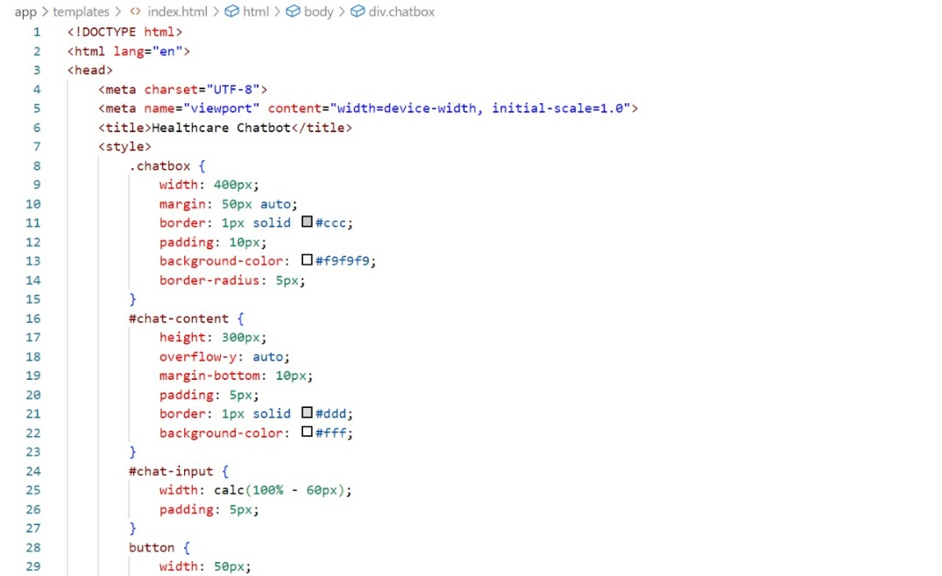

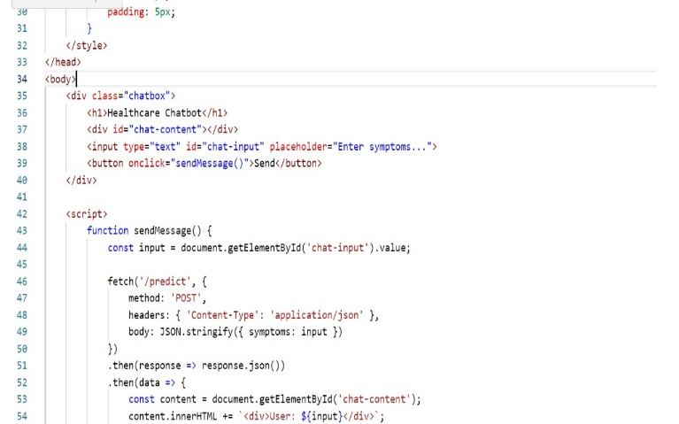

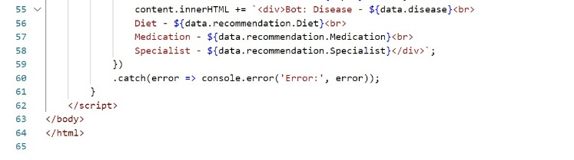

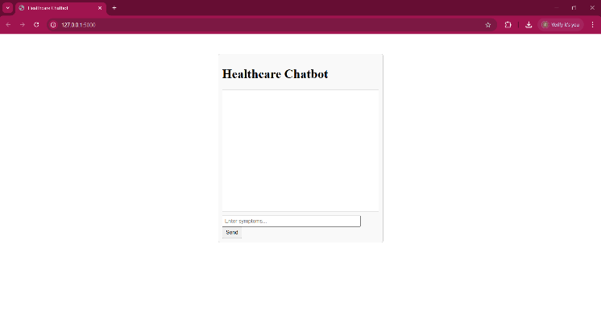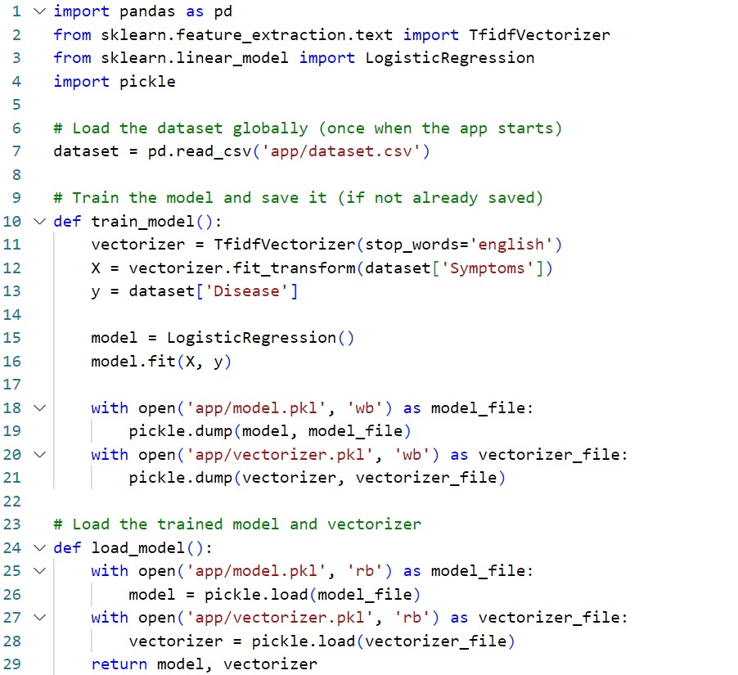

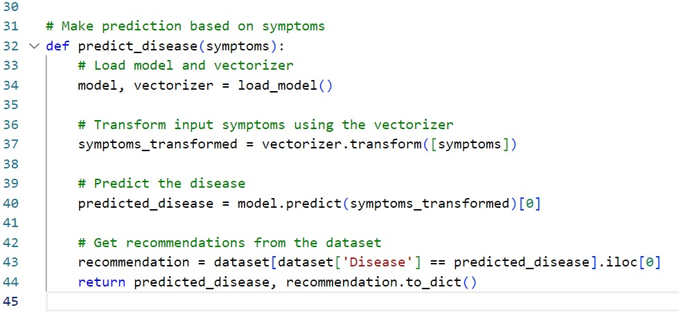

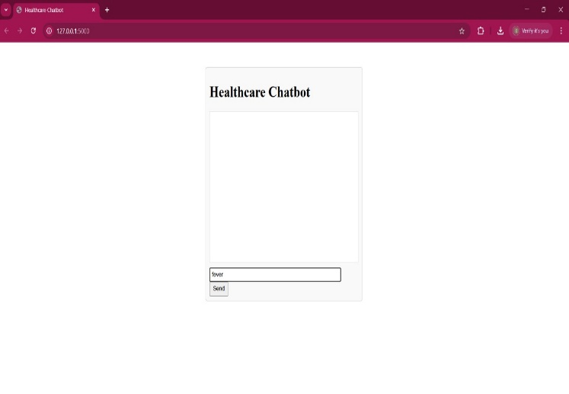

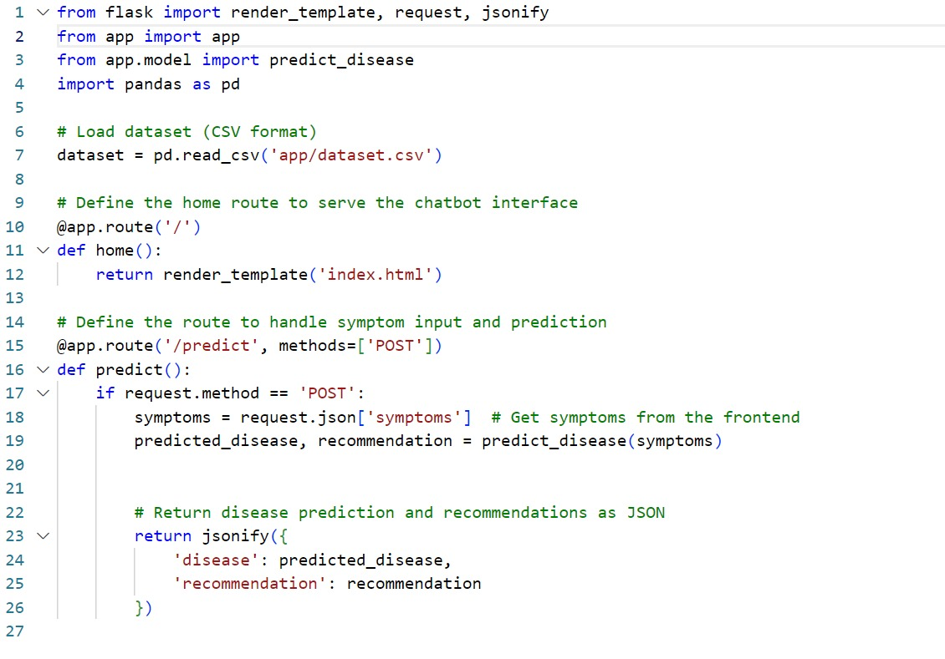

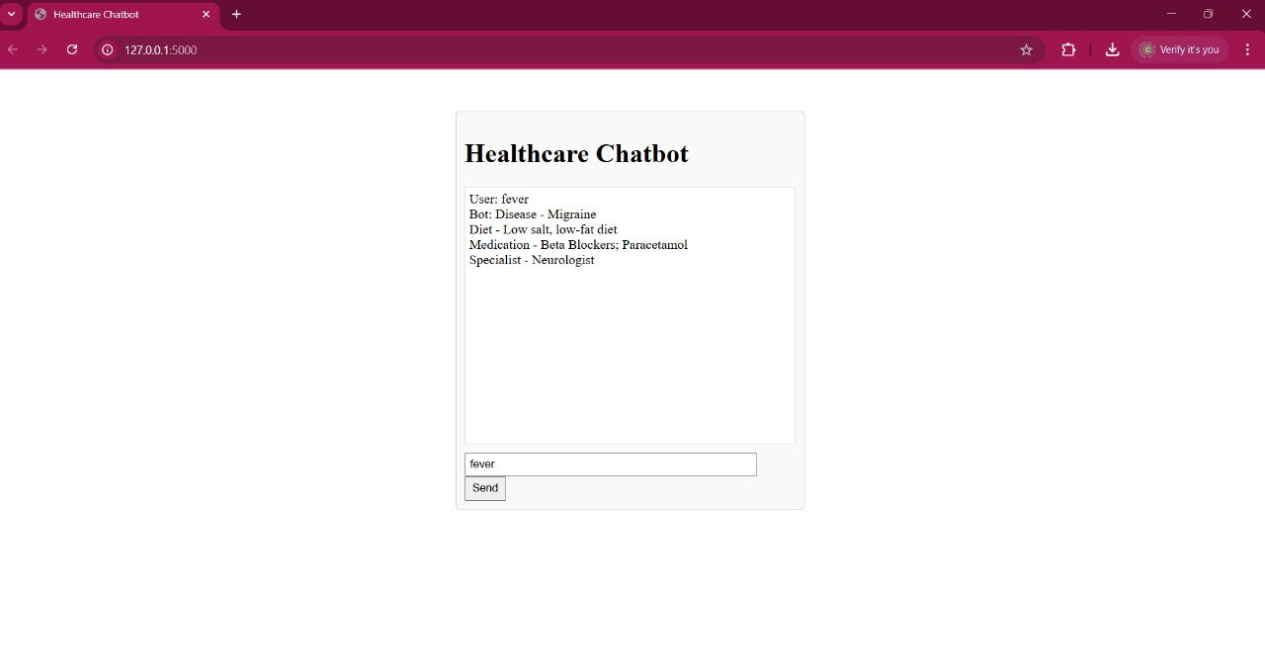

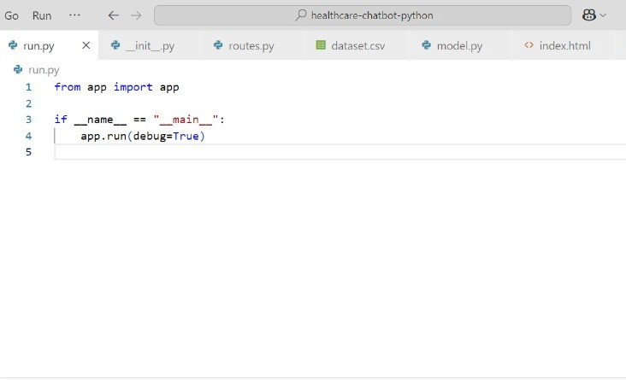

XII. CONCLUSION:

The Healthcare Interactive Chatbot is a smart, AI-driven system designed to provide real-time, personalized, and accessible medical assistance to users. By leveraging Natural Language Processing (NLP) and Machine Learning (ML) algorithms like Logistic Regression, the chatbot effectively analyzes user symptoms, predicts potential diseases, and recommends appropriate treatments, medicines, and dietary suggestions.

This chatbot serves as a 24/7 virtual health assistant, offering symptom-based diagnosis, doctor recommendations, and self-care tips, especially for individuals who lack immediate access to healthcare professionals. It reduces dependency on human doctors for minor medical queries and enhances the efficiency of digital healthcare services.

XIII. REFERENCE:

1. Ashish Zagade, Vedant Killedar, Onkar Mane, Ganesh Nitalikar, Smita Bhosale (2024). <https://ijisrt.com/assets/upload/files/IJISRT24MAR804.pdf>

2. Luke Balcombe (2023). AI Chatbots in Digital Mental Health.

<https://www.mdpi.com/2227-9709/10/4/82>

3. Riddhi Shetty, [Ankita Bhosale](https://papers.ssrn.com/sol3/cf_dev/AbsByAuth.cfm?per_id=5242018), [Pankaj Verma](https://papers.ssrn.com/sol3/cf_dev/AbsByAuth.cfm?per_id=5242019), [Ashwini Phalke](https://papers.ssrn.com/sol3/cf_dev/AbsByAuth.cfm?per_id=5242020) (2022). AI Based Healthcare Chatbot.

<https://papers.ssrn.com/sol3/papers.cfm?abstract_id=4109100>

4. Soufyane Ayanouz, Boudhir Anouar Abdelhakim, Mohammed Benhmed (2020). A Smart Chatbot Architecture based NLP and Machine Learning for Health Care Assistance

<https://www.researchgate.net/publication/340678278_A_Smart_Chatbot_Architecture_based_NLP_and_Machine_Learning_for_Health_Care_Assistance>

5. [Batyrkhan Omarov](https://www.researchgate.net/profile/Batyrkhan-Omarov?_tp=eyJjb250ZXh0Ijp7ImZpcnN0UGFnZSI6InB1YmxpY2F0aW9uIiwicGFnZSI6InB1YmxpY2F0aW9uIn19), [Sergazi Narynov](https://www.researchgate.net/scientific-contributions/Sergazi-Narynov-2218653206?_tp=eyJjb250ZXh0Ijp7ImZpcnN0UGFnZSI6InB1YmxpY2F0aW9uIiwicGFnZSI6InB1YmxpY2F0aW9uIn19), [Zhandos Zhumanov](https://www.researchgate.net/scientific-contributions/Zhandos-Zhumanov-2202198223?_tp=eyJjb250ZXh0Ijp7ImZpcnN0UGFnZSI6InB1YmxpY2F0aW9uIiwicGFnZSI6InB1YmxpY2F0aW9uIn19) (2022).Artificial Intelligence-Enabled Chatbots in Mental Health: A Systematic Review.

<https://www.researchgate.net/publication/366774382_Artificial_Intelligence-Enabled_Chatbots_in_Mental_Health_A_Systematic_Review>

6. M.V. Patil, Subhawna, Priya Shree, Puneet Singh (2021). AI based healthcare chat bot system.

<https://www.researchgate.net/publication/362491736_AI_based_healthcare_chat_bot_system>

7. Mrs. Rashmi Dharwadkar, Dr.Mrs. Neeta A. Deshpande (2018). A Medical Chatbot.

<https://www.ncerpune.in/NAAC/CR-3/3.3/3.3.1/125%20Journal%20Papers/2018-19_5.pdf>