**ANALYSIS OF LIQUEFACTION POTENTIAL OF SOIL BY FIELD TEST DATA AND NOVOLIQ SOFTWARE**

Sandipan Saha1, Deepak Mathur2

1M.tech Scholar, Kautilya Institute of Technology &Engineering, Jaipur

2Associate Professor, Kautilya Institute of Technology &Engineering, Jaipur

*Department of Civil Engineering (Transportation),*

[*Kautilya*](mailto:Anshul@ccepl.co.in) *Institute of Technology & Engineering, Jaipur*

1[sandipan.saha.1992@gmail.com](mailto:sandipan.saha.1992@gmail.com), 2 [mathurdeepak1507@gmail.com](mailto:mathurdeepak1507@gmail.com)

……………………………………………………………………………………………………

ABSTRACT: Liquefaction takes place when loosely packed saturated granular soil near ground surface loose its strength in response to strong ground shaking. Such phenomenon leads to collapse of existing structures resulting in loss of lives and properties. Hence awareness regarding zone of liquefaction at a particular site is very important before highway design. With this in view a site at Sonarpur area of Kolkata, with sand deposit, has been identified for the present research. In the present study an attempt has been made to evaluate liquefaction potential of soil (at Sonarpur near Kolkata) firstly by SPT method. Evaluation of liquefaction resistance of soils, which is expressed in terms of cyclic resistance ratio (CRR) has been done with two DMT parameters, horizontal stress index (KD) and dilatometer modulus (ED), are then used as an index for assessing liquefaction resistance of soils. Specifically, CRR–KD and CRR–ED boundary curves are established based on the data obtained from DMT tests. Further attempt has been made to study the assessment of liquefaction potential using Finite element software (NovoLIQ) and compare the results obtained from above in-situ tests i.e, SPT and DMT tests. The paper highlights the site-specific liquefaction zone which may be considered for geotechnical design of foundation at the site.

**Keywords:** Liquefaction potential; SPT; DMT; NovoLIQ Software,

1. Introduction:

Liquefaction takes place when loosely packed saturated granular soil near ground surface loose its strength in response to strong ground shaking. During earthquake cyclic loading is induced and passes through the sub-soil. Therefore, rise of pore water pressures takes place through sub-soil in addition to the vertical stress and it results in loss of shear strength of the soil and the soil is said to have undergone liquefaction during earthquake. This phenomenon leads to collapse of existing structures resulting in loss of lives and properties.

Damages by Liquefaction in past earthquakes has led to consequential economic losses. Damage during the 1964 Niigata Earthquake in Japan was linked to liquefaction of the soil. More than 250 bridges were damaged by this phenomenon during the 1964 Alaskan earthquake. Along with this, billions of dollars in damage, due to liquefaction, was caused to port facilities in the 1995 Kobe Earthquake (Gallagher, Pamuk and Abdoun, 2007). Liquefaction has caused extensive structural damage and economic losses in urban areas and ports during (Díaz-Rodríguez, et al., 2008). Recently there has been significant damage caused by liquefaction in the 2011 Tohoku Earthquake in Japan (Bhattacharya et al., 2011) and on 2011 Christchurch Earthquake in New Zealand.

The simplified procedure proposed by [Seed and Idriss 1971] was the first standard procedure to evaluate liquefaction using standard penetration test (SPT). Subsequently, many researchers provided correlations based on cone penetration test (CPT), notable ones being [Robertson and Campanella 1985], [Robertson and Wride 1998]. Shear velocity (Vs) based correlations for liquefaction assessment was developed by [Andrus and Stokoe 2000]. [Youd et al. 2001] presented a procedure with updates based upon consensus by various experts in the field of liquefaction assessment. Recent study done by [Paola Monaco, Silvano Marchetti and Glafranco Totani 2005] translate CRR-CPT and CRR-SPT correlations into CRR-KD correlations. Furthermore [Tsai PH, Lee DH, Kung GTC, Juang CH, 2009] established CRR-KD and CRR-ED boundary curves.

However, estimation of liquefaction susceptibility of soil is important prior to any construction of structures for avoiding the future vulnerability to such calamity with respect to the study area.

* 1. **Liquefaction Susceptibility Criteria of Sonarpur site:**

Excessive pore water pressure generation is the cause of liquefaction. It is directly connected to the compositional characteristics of the soil i.e., fine content, gradation, plasticity index etc. Generally, cohesion less soils (sand, silty sand or sandy silt) undergo liquefaction but this phenomenon may be also occurred on plastic & cohesive silty clay and sensitive clay (Updike et al., 1988; Kramer, 1996). Wang (1979) suggested Chinese Criteria to evaluate liquefaction susceptibility based on the earthquake observations in China. There are four criteria which might be considered to evaluate liquefaction susceptibility for the fine-grained sediments (Wang, 1979; Kramer, 1996). These criteria are given below

1) Fraction finer than 0.005 mm ≤ 15%

2) Liquid limit, LL ≤ 35%

3) Natural Water Content ≥ 0.9LL

4) Liquidity Index ≤ 0.75

However, many researchers have followed some varying criteria on estimating the liquefaction susceptbility which unless if properly addressed, may cause the extensive damage when silty or clayey soils cotaining more than 15% clay size particles are found (Bray et al., 2004; Bray and Sancio, 2006).

On the other hand, based on water content (wc), liquid limit (LL) and plasticity index (PI), Bray and Sancio (2006) had proposed a new compositional criteria ob- tained from the results of cyclic tri axial test to deter- mine liquefaction susceptibility:

1) Highly Susceptible towards liquefaction: PI <12 and (wc/LL) ≥0.85.

2) Moderately Susceptible towards liquefaction: 12< PI <18 and 0.85> (wc/LL) ≥0.8.

3) Non-Susceptible towards liquefaction: PI >18 and (wc/LL) < 0.8.

The subsurface condition of Kolkata, Sonarpur site specify that the sedimentary deposits underlying the city involve predominantly of grain size favorable for liquefaction and this area is formed on coarse grained artificial non engineered fill. So the site may be susceptible to soil liquefaction. [Nath et al., 2018]. Earthquake zone III has been considered for the Sonarpur site as per IS 1893-2016

1. Methodology

The methodology adopted for the present study has been adopted as illustrated below**:**

* 1. **Estimation of Soil property by soil test at site:**

The bore log data are shown in Fig 1

The Standard Penetration Test (SPT) is a common in situ dynamic testing method used to determine the geotechnical engineering properties of subsurface soils. It is a simple and inexpensive test to estimate the relative density of soils and approximate shear strength parameters. The SPT test is carried out within a borehole.

Two numbers of DMT tests i.e., DMT1 and DMT2 (aligned to the straight line with the SPT points), were carried out by giving 1000mm spacing between the respective SPT tests points. The Flat Dilatometer Test (DMT) is used to evaluate the compressibility characteristics along with shear strength parameters of the soils in very short time with accuracy. The flat dilatometer consists of a steel blade with size of 240 mm length, 95 mm width and 15 mm thickness, having one side consisting of an expandable steel membrane. The gas (nitrogen gas) pressure is required to expand the membrane. When the, membrane is expanded by allowing gas pressure, the soil is compressed. Two numbers of pressure readings (A and B) are then taken from pressure gauges fitted to the control unit, for a particular test depth. After completion of B reading, further the blade is pushed to the next depth. This control unit is connected to the DMT blade and the gas tank through pneumatic-electrical cable (p-e cable).

The main purpose of the DMT test was to evaluate the geotechnical parameters of the soil instantaneously in the field. The SPT and DMT test locations are plotted in the Fig. 2 and Fig.3 below.

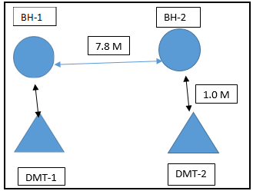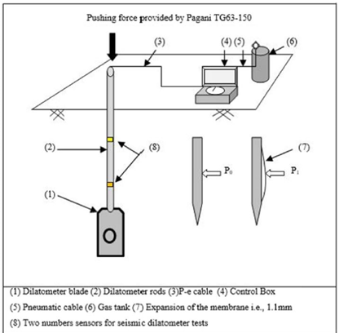

Figure 2. Field Test Locations Figure 3. Details of DMT.

* 1. **Determination of earthquake magnitude from peer ground motion database and earthquake zone.**

Authentic ground motion database is needed as an important parameter of earthquakes that is likely to occur in Sonarpur area of Kolkata. To get the data history of earthquake, it was collected from the website of the peer ground motion database. It was observed that the earthquake magnitude in the study area is 7.0 in Richter Scale which was used as earthquake magnitude for liquefaction susceptibility analysis of the study area.

As per Indian standard (IS 1893 (Part-1) 2016, peak ground acceleration is obtained for the study. According to the code Sonarpur is classified into the zone III having PGA of 0.3g and seismic zone factor (Z) is considered as 0.16

* 1. **Determination of CSR (Seed and Idriss 1971).**

The "simplified procedure" requires the calculation of two variables: (1) the seismic demand on a soil layer generated by the earthquake, or cyclic stress ratio CSR, and (2) the capacity of the soil to resist liquefaction, or cyclic resistance ratio CRR. If CSR is greater than CRR, liquefaction can occur. The cyclic stress ratio CSR is calculated by the following equation (Seed & Idriss 1971):

CSR = *av* / σ′vo= 0.65 (*amax* /*g*) (σvo / σ′vo) *rd* (1)

Where *av=* average cyclic shear stress, *amax* = peak horizontal acceleration on the surface of soil caused by earthquake, g = gravitational acceleration, σv = vertical overburden stress, σ′vo = effective vertical overburden stress, rd = coefficient of stress reduction.

* 1. **Determination of CRR from SPT test data**

Seed and idris (1985) proposed CRR7.5 equation as mentioned below

CRR7.5=+ (2)

Where ${(N1)}_{60CS}$ is the clean-sand equivalence of the corrected SPT blow count as per Youd et al. (2001).As per IS 1893 part (1) 2016,

${(N1)}_{60CS}$ =α+β ${(N1)}_{60}$ (3)

${(N1)}_{60}$ = $C_{N}N_{60}$ (4)

Where, CN= $\sqrt{\frac{Pa}{σ'vo }}$,

σ′vo = effective vertical overburden stress and Pa=atmospheric pressure.

The subscript 7.5 in the CRR7.5 term indicates that this cyclic liquefaction resistance is evaluated at a magnitude of 7.5. Note that Eq. (1) is valid only for ${(N1)}_{60CS}$ <30, while the sandy soil is considered un liquefiable when ${(N1)}_{60CS}$ is greater than 30

Idriss and Boulanger (2006) noted that the trend of the CRR curve proposed by Youd et al. (2001) would sharply increase as the ${(N1)}_{60CS}$ approaches 30, which may be irrational and would cause the unreasonable results when conducting the probabilistic analysis. They proposed a new model as follows (Idriss and Boulanger, 2006).

CRR7.5= (5)

* 1. **Determination of CRR from DMT tests data.**

The DMT-based methods for evaluating CRR include those by [Marchetti (1982)], [Robertson and Campanella (1986)], [Reyna and Chameau (1991)], [Monaco et al. (2005)], [Grasso and Maugeri (2006)], and [Monaco and Marchetti (2007)]. The more recent development by [Monaco et al. (2005)], and [Monaco and Marchetti (2007)] are brieﬂy reviewed herein. [Monaco et al. (2005)] proposed a new CRR curve based on a study of the correlations between cone tip resistance (*q*c) and relative density (Dr), between SPT blow count (*N1)60* and (Dr) and between DMT horizontal stress index (*K*D) and Dr. Their DMT-based model is expressed as follows

CRR=.0107KD3-0.0741KD2 +.2169KD-.1306 (6)

A tentative conservative average CRR-KD curve is proposed below

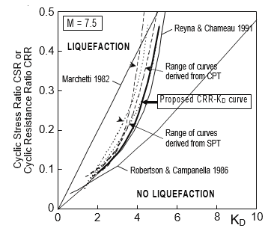

Figure 4**.** CRR-KD curves for estimating liquefaction resistance from DMT (Monaco et al. (2005).

Again, based on the transformed SPT and CPT-based CRR–ED curves along with the transformed data points of the SPT- and CPT based liquefaction case histories, New DMT-based CRR–ED curve is proposed by [Tsai ,Lee, Chin Kung Jumg (2009)] and expressed by

CRR7.5= (7)

A tentative conservative average CRR-ED curve is proposed by [Tsai, Lee, Chin Kung Jumg (2009)] below

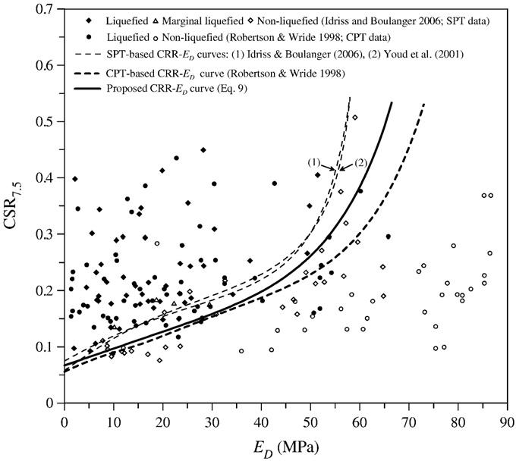

Figure 5**.** CRR-ED curves for estimating liquefaction resistance from DMT [Tsai, Lee, Chin Kung Jumg (2009)]

1. **Computation of Factor of safety (FOS) from SPT and DMT tests data and NovoLiq Software.**

Further, CRR value computed from SPT as well as from DMT test is compared with respect to depth for two bore hole locations and is given below. Factor of safety (FOS) against liquefaction is calculated using the following equations

FOS**=**  (8)

* 1. **Computation of Factor of safety (FOS) from SPT and DMT tests data.**

Variation of FOS calculated from SPT as well as DMT tests is plotted against depth in fig nos. respectively

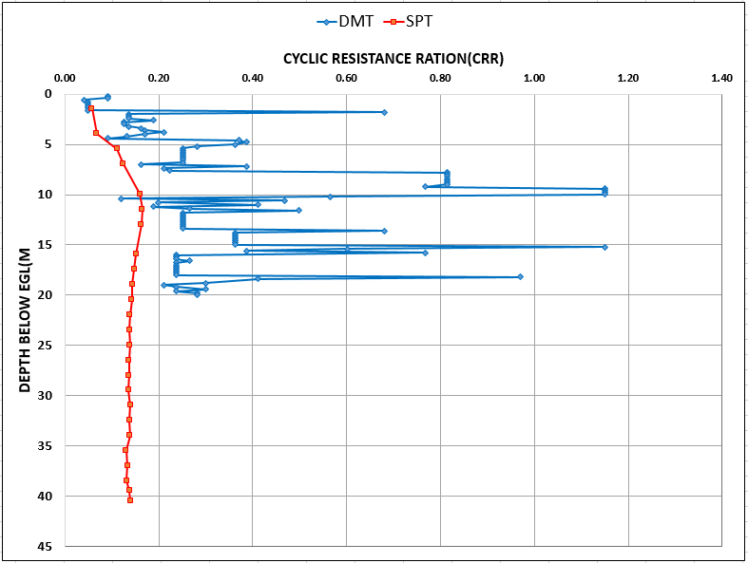

Figure 6. Comparison of CRR with depth for DMT-1 and SPT -1

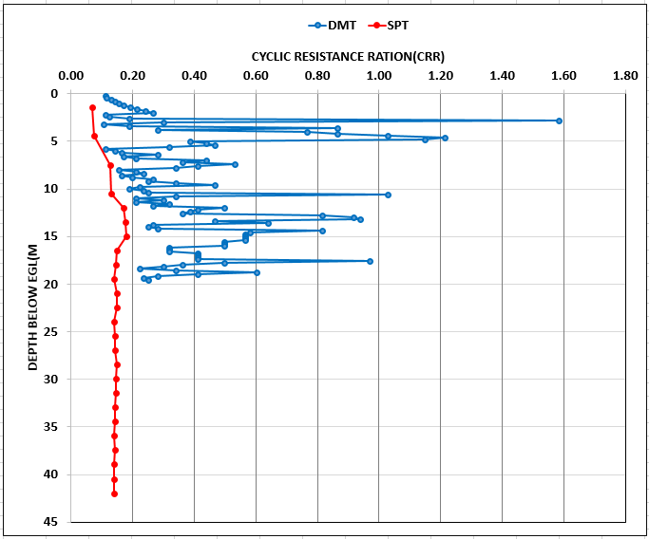

Figure 7. Comparison of CRR with depth for DMT-2 and SPT -2

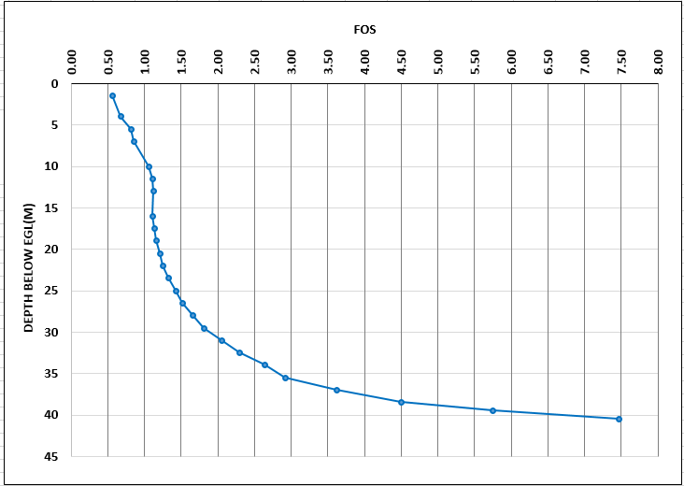

Figure 8. FOS Vs depth from SPT Data (Borehole-1)

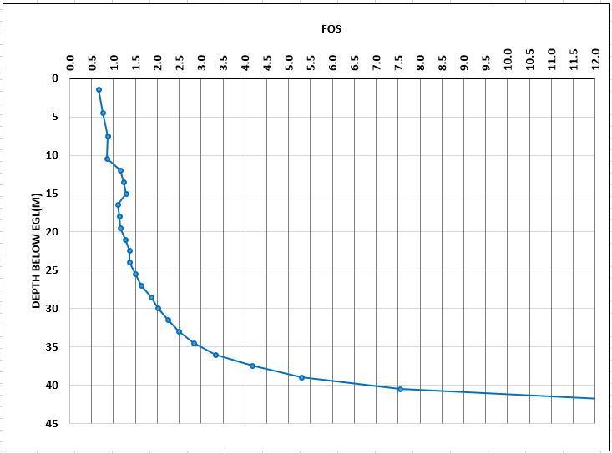

Figure 9. FOS Vs depth from SPT Data (Borehole-2)

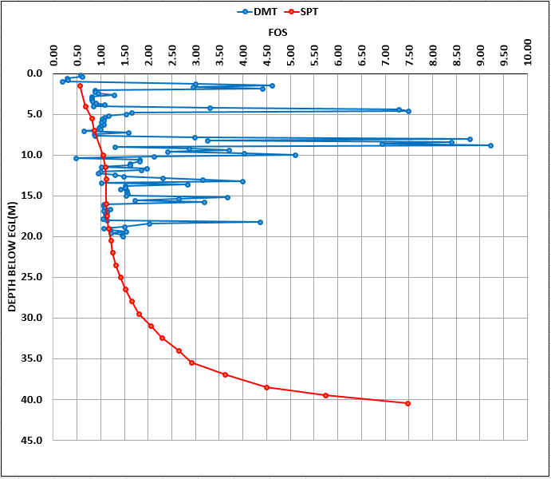

Figure 10. Variation of FOS with depth for DMT-1 and SPT-1

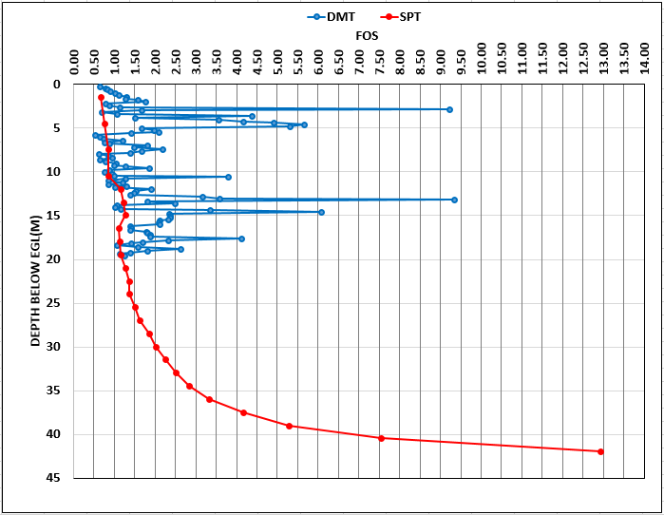

Figure 11. Variation of FOS with depth for DMT-2 and SPT-2

* 1. **NovoLIQ software**.

NovoLiq software was selected for analysis which is designed for soil liquefaction analysis during earthquake and supports multilayer as well as single layer stratigraphy. A wide variety of methods from well-respected researchers and practitioners have been implemented in NovoLiq to carry out the soil liquefaction analysis. It gives options for choosing the analysis methods among all available recommended formulas. NovoLiq supports the following field tests for soil liquefaction triggering: Standard Penetration Test (SPT), Becker Denseness Test (BDT), Shear Wave Velocity (Vs). For this analysis SPT N value according to depth; soil type, unit weight, fineness content, D50, ground water table etc. values were given input in the software. Also, some values like peak ground acceleration of the area, damping of soil etc. were given as input.

Figure 12 shows a view of graphical interface of NovoLiq for input parameters. Then among different analysis method: [Seed et al. (1983)] was selected. Figure 13 shows the graphical interface of selection of the methods for calculating CRR.

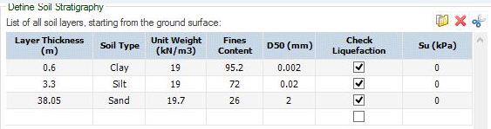

***Figure 12.*** *Different input parameters in NovoLiq software*

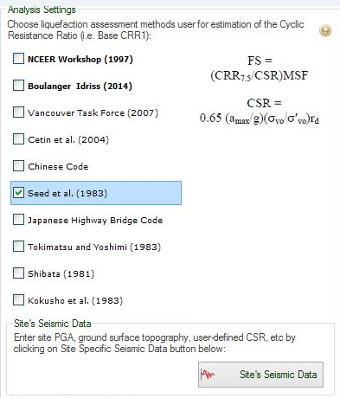

Figure 13. Different input parameters in NovoLiq software

On the basis of results obtained from NOVOLIQ software an attempt has been made to obtain different parameters and variation of these parameters has been studied with respect to depth. Fig 14 and Fig 15 furnishes depth vs CSR, Fig. 16 and Fig.17 furnishes depth vs CRR, Fig. 18 and Fig.19 furnishes depth vs Factor of safety (FOS) along with these Fig. 20 and Fig.21 also demonstrate the Probability of liquefaction with respect to change in depth respectively for SPT-1 and SPT-2.

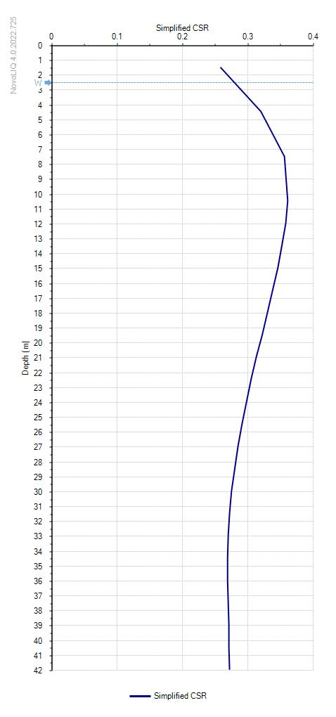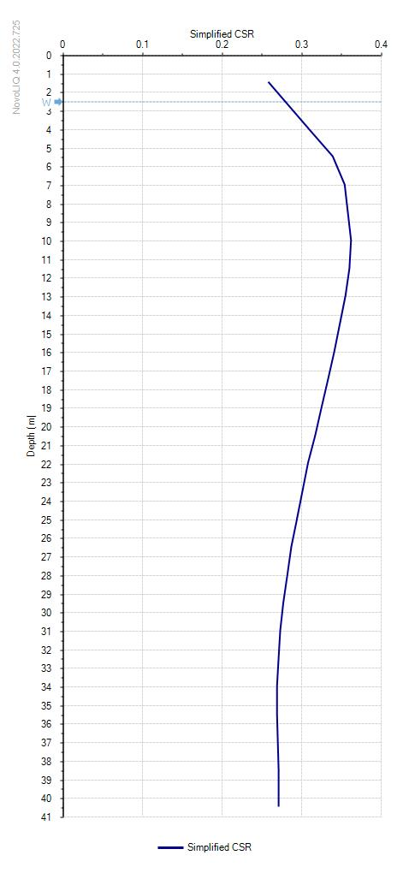

***Figure 14*** *Depth vs CSR for SPT-1 from NovoLiq*

***Figure 15*** *Depth vs CSR for SPT-2 from NovoLiq*

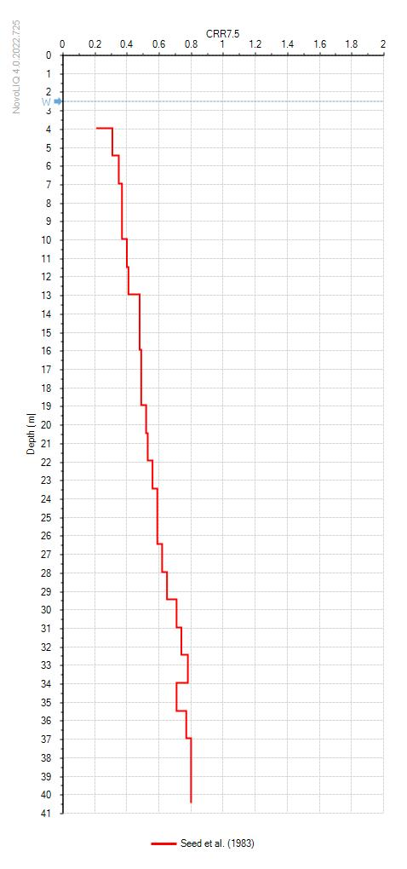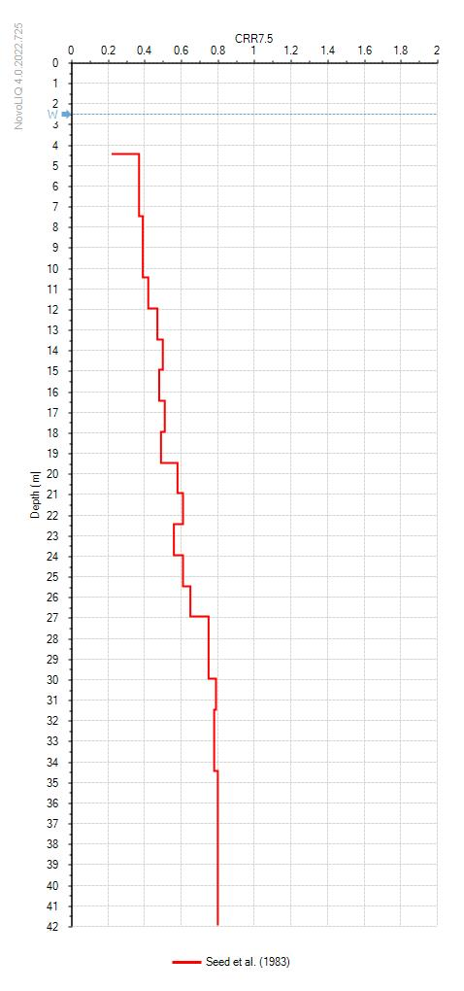

***Figure 16*** *Depth vs CRR for SPT-1 from NovoLiq*

*software* ***Figure 17*** *Depth vs CRR for SPT-2 from NovoLiq software*

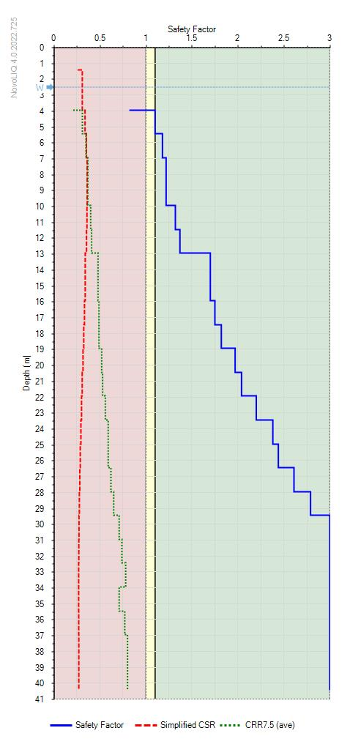

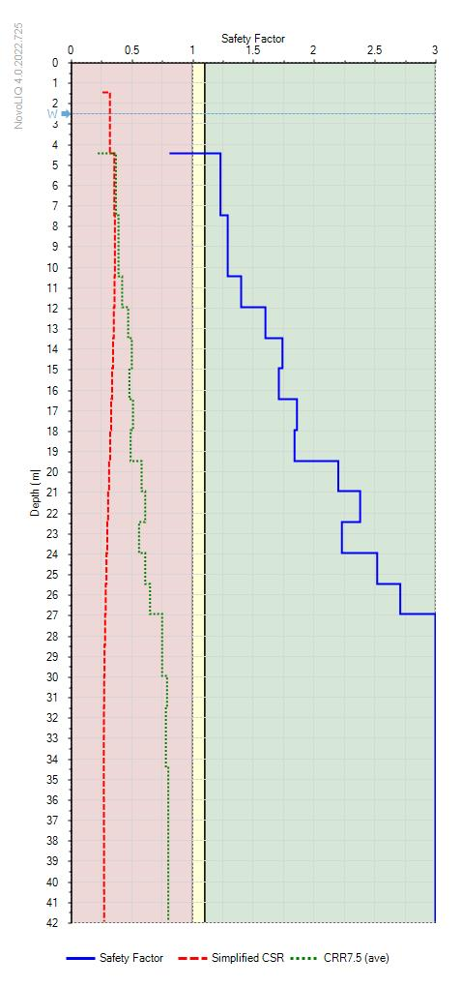

***Figure 18*** *Depth vs FOS for SPT-1 from NovoLiq software* ***Figure 19*** *Depth vs FOS for SPT-2 from NovoLiq software*

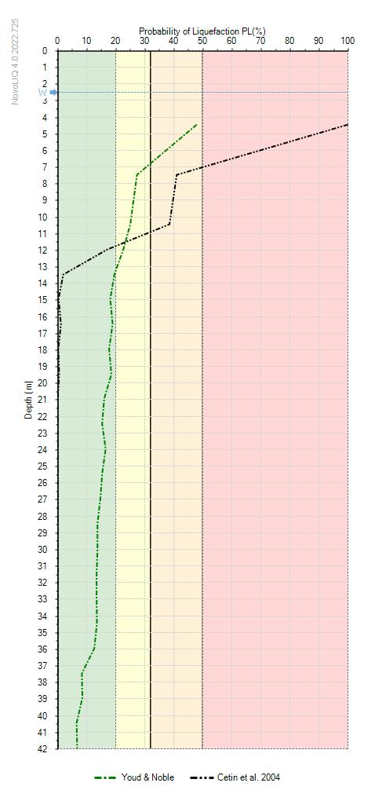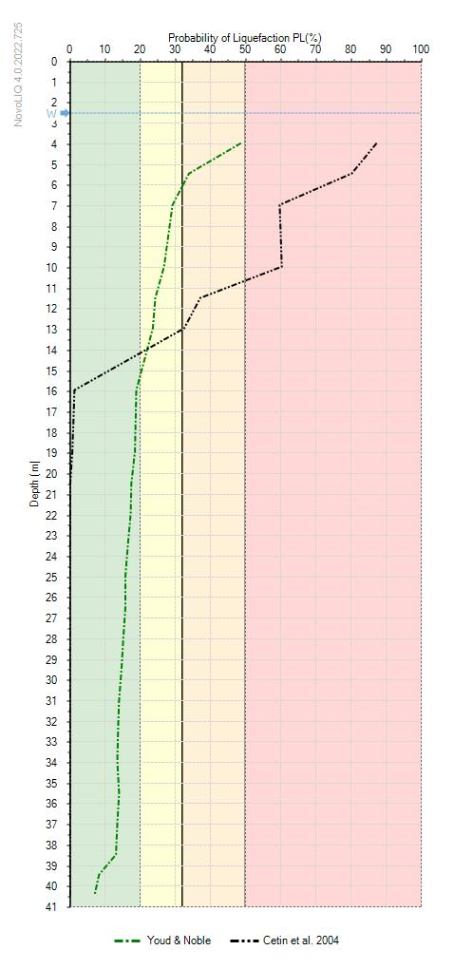

**Figure 21.** Depth vs Probability of liquefaction for SPT-2 from NovoLiq software

**Figure 20.** Depth vs Probability of liquefaction for SPT-1 from NovoLiq software

So, from the analysis we can summarized that around up-to 10 m depth for Bh-1 and 8m for BH-2, liquefaction probability is visible in sites.

1. **Discussion:**

An attempt has been made to obtain depth of liquified zone, minimum FOS and probability of liquefaction from SPT, DMT and NovoLiq so that they can be compared to understand behavior of soil encountered with approach through different approaches such as

* Depth of Liquefied zone
* Minimum Factor of Safety
* Probability of liquefaction

1. **Conclusions:**

**The following conclusions may be drawn from the present study**

* The liquefaction Analysis done by the finite element software ‘NovoLIQ’ based on SPT data shows the soil will be liquefiable Upto a depth of 7 m whether with conventional approach the soil will be liquefiable upto a depth of 10 m. But when liquefaction analysis is done based on DMT data, it shows that the soil is liquefiable Upto a depth of 12.0m.
* The minimum factor of safety against liquefaction is 0.81 and 0.83 for SPT-1 and SPT-2 respectively.
* Probability of liquefaction with respect to depth had been computed by the finite element software ‘NovoLIQ’ and also shown in graphically. By Youd & Noble method, 25% probability of liquefaction upto a depth of 10m and by Cetin et al. 2004,38% probability of liquefaction found for the site.

1. **References**

1. Pradnya Singbal, Santiram Chatterjee Deepankar Choudhury on “Assessment of Seismic Liquefaction of Soil Site at Mundra Port, India, Using CPT and DMT Field Tests”.

2. K Das, S Nandi, S Chattaraj, A Halder, and W Sadhukhan (2022) “Estimation of subsoil parameters and settlement of foundation for a project in Kolkata based on CPT, DMT”.

3. Figen ORHUN ÖNAL, Gülçin ÖZMEN studied (2016) on” Using Combination of SPT, DMT and CPT to Estimate Geotechnical Model for a Special Project in Turkey”.

4. Gordon Tung-Chin KUNG1, Der-Her LEE Pai-Hsiang TSAI (2021) “Examination of DMT-based methods for evaluating the liquefaction potential of soils”

5. Onal, F. O., & Özmen, G. “Using Combination of SPT, DMT and CPT to Estimate Geotechnical Model for a Special Project in Turkey”

6. Pradeep Muley, D. K. Paul, B.K. Maheshwari researched on” Assessment of Liquefaction Potential Index for Roorkee Region

7. Francesca Buselli “Use of DMT to predict settlements of shallow foundations” in 2013

8. Kyle Rollins, Sara Amoroso, Roman Hryciw (2015) investigate on “Comparison of DMT, CPT, SPT, and V S based Liquefaction Assessment on Treasure Island during the Loma Prieta Earthquake”.

9. Yelvi, Handi Sudardja, Shany Elizabeth (2020) researched on” Liquefaction Resistance of Sand Mixed with Fines-Grained for Reclaimed Land”.

10. M.K. Gupta “Liquefaction during 1988 earthquake and a case study” international conference on case histories in geotechnical engineering.7. (1993)

11. Prabin Acharya a, Indra Prasad Acharya on 2016 work on” Liquefaction Potential Assessment of selective sites inside Kathmandu Valley considering different Earthquake Scenarios and comparison with existing Liquefaction Susceptibility Map”.

12. Jasna Smolar, Matej Maček and Ana Petkovšek (2019)” Liquefaction potential of sands at the Krško-Brežice field, Slovenia”.

13. Marchetti, S. (1980). In situ tests by flat dilatometer. Journal of the geotechnical engineering division, 106(3), 299-321.

14. Report of the ISSMGE Technica1 Committee 16, “The Flat Dilatometer Test (DMT) in Soil Investigations”, (2001).

15. Tsai PH, Lee DH, Kung GTC, Juang CH (2009) Simplified DMT—based methods for evaluation liquefaction resistance of soils. Eng Geol 103:13–22. <https://doi.org/10.1016/j.enggeo.2008.07.008>

16. Paola Monaco, Silvano Marchetti and Glafranco Totani (2005) “Sand liquifiability assessment by Flat Dilatometer Test (DMT)

17. Monaco P, Marchetti S (2007) Evaluating liquefaction potential by seismic dilatometer (SDMT) accounting for aging/stress his- tory. In: Proceedings of 4th international conference on earth- quake geotechnical engineering, Thessaloniki, Paper No. 1626

18. ASM Fahad Hossain and Shahana Akter Esha (2017) “Soil Liquefaction Analysis of Banasree Residential Area, Dhaka using NovoLIQ software

19. Indian Standard (2002) ‘‘Method of standard penetration tests for soils’’, IS 2131–1981

20. IS 1893 (Part 1) : 2016- Criteria for Earthquake Resistant Design of Structure Part 1 General Provisions and Buildings ( Sixth Revision )

21. characteristics of Minna City Centre development site using Plaxis 2D software and empirical formulations. Niger J Technol 36(3):663–670. https://doi.org/10.4314/njt.v36i3

22. Marchetti DMT home page, https://www.marchetti-dmt.it/

23. Plaxis Reference Manual V84-3.

24. Marchetti Dilatometer™ “Setup DMT Settlements (v1.0.1.16)”, [computer programme] Available at: http://www.marchetti-dmt.it/software-download/ [Accessed: (6/10/2020)]

25. Buselli, F. (2013). Use of DMT to predict settlement of shallow foundations. Geotechnics for Sustainable Development; Phung, DL, Ed.; Construction Publishing House: Hanoi, Vietnam, 531- 536.

26. A Report by the ISSMGE Committee TC16. “The Flat Dilatometer Test (DMT) in Soil Investigations”