**Biotherapeutic Delivery and Diagnostic Solutions: Innovations and Advances in Medicine**

**Vaishali Kaura1st, Daanish Rashid2nd, Rena3rd, Monika4th**

**Corresponding Author:** Daanish Rashid

[**angelvaishali82@gmail.com1st**](mailto:angelvaishali82@gmail.com1st)**,**[**daanish2186@gmail.com**](mailto:daanish2186@gmail.com)**2nd,**[**reena30112005@gmail.com3rd**](mailto:reena30112005@gmail.com3rd)**,** [**Us279870@gmail.com4th**](mailto:Us279870@gmail.com4th)

**Department of Pharmacy1st,2nd, Department of BSC Ot/At3rd, Department of USAS4th, Rayat Bahra University Mohali, Punjab1-4**

**Abstract**

Healthcare is undergoing a transformation because to biotherapeutic delivery and diagnostic solutions, which provide innovative ways to treat complicated illnesses and facilitate early, precise disease identification. Biotherapeutic delivery is concerned with the effective delivery of biological substances, such as proteins, nucleic acids, and cell-based therapies, to specific locations within the body, whereas diagnostic systems facilitate real-time monitoring and enhance early illness diagnosis. The materials, methods, and developments in both domains are examined in this article. These include wearable medical devices, biosensors, molecular diagnostics, and liposomes, nanoparticles, and gene delivery systems for therapeutic uses. Future trends that could influence the next wave of healthcare technologies are also covered, along with the difficulties of scalability, governmental approval, and integrating artificial intelligence into these solutions.

**Graphical Abstract**

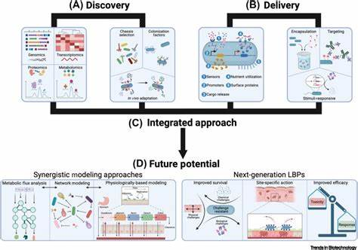

**Introduction**

The introduction of sophisticated diagnostic tools and biotherapeutic delivery methods has significantly changed the healthcare environment. By providing focused medicines and facilitating earlier detection, these advancements hold promise for treating a broad range of ailments, including autoimmune problems, cancer, and genetic disorders. While diagnostic solutions offer useful instruments for diagnosing illnesses and tracking patient progress, biotherapeutic delivery concentrates on the safe and effective transportation of therapeutic agents, such as monoclonal antibodies, gene therapies, and vaccinations. Precision medicine, which customizes treatments to a patient's particular genetic composition and health profile, has been made possible by the combination of these technologies. Novel delivery systems like liposomes, nanoparticles, and microneedles have been developed as a result of advances in materials science, nanotechnology, and biotechnology. These systems improve the stability, bioavailability, and targeted action of medications. The advent of biosensors, molecular diagnostics, and point-of-care technologies that provide quicker and more precise illness diagnosis has also led to an evolution in diagnostics. This article explores the major substances, innovations, and uses influencing the development of biotherapeutic delivery and diagnostic tools in the future. We can better appreciate these solutions' potential to improve patient outcomes and healthcare delivery if we are aware of their mechanisms, difficulties, and developments.

The main compounds, developments, and applications impacting the future development of biotherapeutic delivery and diagnostic instruments are examined in this article. Understanding the mechanisms, challenges, and advancements of these solutions can help us better understand their potential to enhance patient outcomes and healthcare delivery.

1. **Understanding Biotherapeutic Delivery**

Targeted delivery of biological agents, including proteins, nucleic acids, and other therapeutic compounds, to particular bodily locations is known as biotherapeutic delivery. A variety of complex diseases, such as cancer, autoimmune disorders, and genetic abnormalities, may be cured or improved by these biotherapeutics, which include monoclonal antibodies, gene therapies, vaccines, and cell-based therapies.

* **Materials for the Delivery of Biotherapeutics**  
  The materials utilized to encapsulate, stabilize, and convey the therapeutic chemicals have a significant impact on the effectiveness of biotherapeutic delivery. Among the essential resources used are:
* **Liposomes:** Both hydrophilic and hydrophobic medications can be encapsulated in these lipid-based nanocarriers, guaranteeing their steady delivery. Doxil, a liposomal version of doxorubicin, is one of the many anticancer medications that are frequently delivered by liposomes.

1. **Polymeric Nanoparticles:** These biodegradable nanoparticles, which can be produced from synthetic or natural polymers, can be designed to target particular tissues and deliver medications at regulated rates, increasing their bioavailability. The ability of polymeric carriers, such PLGA (poly (lactic-co-glycolic acid)), to release encapsulated medicines over long periods of time has been the subject of much research.  
     
    **Nanostructured Lipid Carriers (NLCs):** Unlike traditional liposomes, NLCs are sophisticated carriers that provide improved stability and regulated release profiles. These lipid-based delivery methods work well for hydrophobic medications, such as those used to treat cancer.

**Exosomes:** Because they are biocompatible and can pass through biological barriers like the blood-brain barrier, exosomes—naturally occurring nanovesicles that can be modified to transport RNA, proteins, or other therapeutic molecules—are becoming more and more popular as delivery systems.

**Biotherapeutic Delivery Technologies**

To optimize the delivery of biotherapeutics, various technologies are employed, including:

* **Targeted Drug Delivery:** The development of targeted delivery systems involves the use of ligands, antibodies, or peptides that bind to specific receptors on target cells. This ensures that the therapeutic agent reaches the desired tissue with minimal off-target effects. For example, HER2-targeted therapies for breast cancer use monoclonal antibodies to selectively target tumor cells overexpressing the HER2 receptor.
* **Smart Drug Delivery Systems:** More accurate and flexible therapeutic treatments have been made possible by the invention of "smart" delivery systems, which can react to environmental cues like pH, temperature, or certain enzymes. To increase the effectiveness of the treatment, nanoparticles, for example, can be engineered to release their contents when they come into contact with particular molecular markers linked to diseased cells.
* **Implantable Devices:** For the treatment of chronic diseases, implantable drug delivery devices provide regulated, localized release of medications. These systems reduce the need for frequent injections or oral drugs and offer consistent therapeutic benefits over an extended period of time for illnesses like diabetes or cancer.

**Advancements in Biotherapeutic Diagnostics**

As the range and complexity of biotherapeutic treatments continue to expand, it becomes increasingly important to monitor their efficacy, ensure patient safety, and adjust treatment regimens in real-time. Innovations in diagnostic instruments are playing a key role in achieving these objectives, offering physicians tools to assess both the biological impact of the therapy and the patient's response.

**Biosensors and non-invasive imaging technologies:** Non-invasive imaging techniques including magnetic resonance imaging (MRI), fluorescence imaging, and positron emission tomography (PET) are now crucial for monitoring the location and effectiveness of biotherapeutics inside the body. via tracking the biodistribution of medications delivered via liposomes, nanoparticles, and other cutting-edge carriers, these imaging devices can give doctors real-time information to help them adjust dosages and reduce adverse effects.

**Biosensors:** Therapeutic compounds in patient samples may now be continuously monitored thanks to real-time biosensing technologies. These tools offer useful information on the efficacy of treatments and can assist in making real-time adjustments to treatment plans by identifying particular biomarkers or drug concentrations in the blood. To ensure appropriate dosage and improve patient care, electrochemical biosensors are being developed, for instance, to assess the levels of gene therapy products or monoclonal antibodies.

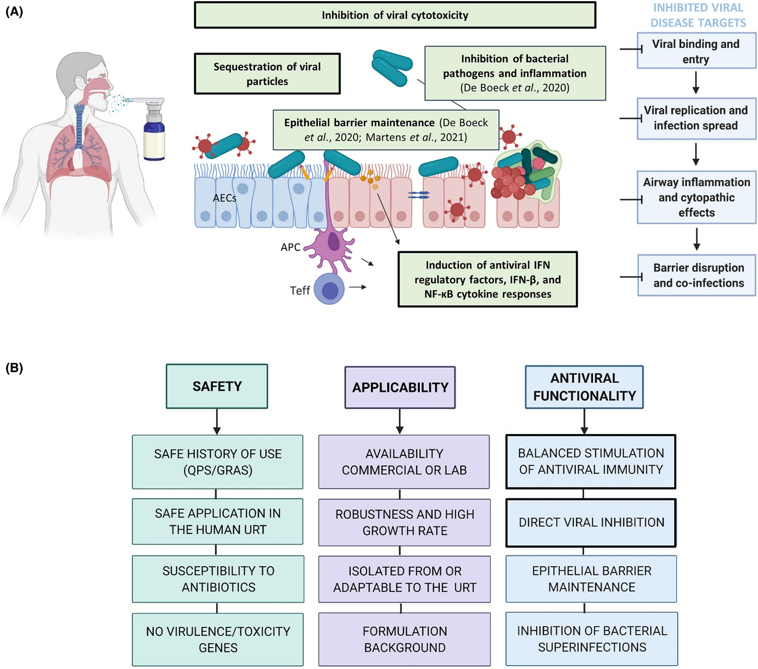

**Point-of-Care (POC) Diagnostics**

Miniaturized diagnostic devices for point-of-care applications have transformed the way biotherapeutic treatments are monitored. These devices allow for rapid testing at the patient's location, providing immediate information on therapeutic progress without requiring centralized laboratory facilities. Point-of-care diagnostics are particularly beneficial for monitoring chronic conditions and personalized therapies, offering greater convenience and improving the overall management of diseases like cancer, cardiovascular conditions, and autoimmune disorders.

**The Future of Biotherapeutic Delivery and Diagnostics**

The future of biotherapeutic delivery and diagnostic solutions holds immense potential, with ongoing research and development promising to further enhance the precision and efficacy of treatments. Several trends are likely to shape the future of biotherapy:

* **Personalized Medicine:** Advances in genetic sequencing and biomarker identification will allow for more personalized therapies, tailored to an individual’s unique genetic profile and disease characteristics. Precision medicine, in combination with advanced delivery and diagnostic technologies, will provide the ability to offer treatments that are optimized for each patient, improving the chances of success while minimizing side effects.
* **Gene Therapy and Editing:** Technologies like CRISPR-Cas9, which allow for precise gene editing, are rapidly advancing and hold the potential to cure genetic diseases. Efficient and targeted delivery systems will be crucial in ensuring that gene therapies are safely delivered to the right cells in the right amounts.
* **Cancer Immunotherapy:** The application of immunotherapies, such as CAR T-cell therapy and monoclonal antibodies, has already shown promise in treating certain cancers. Future advancements in biotherapeutic delivery will enhance the specificity and effectiveness of these therapies, while diagnostic technologies will enable real-time monitoring of tumour markers, leading to more personalized treatment plans.
* **Chronic Disease Management:** Advances in sustained-release delivery systems and implantable devices will transform the management of chronic diseases. These technologies will reduce the need for frequent interventions, improve patient adherence to treatment regimens, and provide better long-term outcomes.

**Conclusion**

In conclusion, the advancements in biotherapeutic delivery and diagnostic solutions are revolutionizing the medical field, bringing us closer to a future where personalized, targeted therapies become the norm. These innovations offer new possibilities for treating complex diseases that have historically been difficult to manage, including cancer, autoimmune disorders, genetic conditions, and neurological diseases. By enabling more precise targeting of therapeutic agents, these technologies not only enhance the efficacy of treatments but also reduce the risk of side effects, ultimately leading to better patient outcomes.The continued development of advanced materials, such as liposomes, polymeric nanoparticles, and exosomes, will further improve the stability, bioavailability, and controlled release of biotherapeutics, allowing for more effective and sustained treatments. Moreover, the integration of smart drug delivery systems, which can respond to environmental cues, is paving the way for adaptive therapies that can adjust to the patient's needs in real-time. On the diagnostic front, non-invasive imaging technologies, biosensors, and point-of-care diagnostic devices are enhancing our ability to monitor therapeutic progress and personalize treatment regimens. These innovations allow for timely interventions, minimizing the risk of treatment failure and enabling clinicians to make data-driven decisions that optimize patient care. As we look to the future, the synergy between biotherapeutic delivery and diagnostics will be key to unlocking the full potential of precision medicine. These integrated solutions will not only improve the treatment of current diseases but also pave the way for cures for genetic disorders and other previously untreatable conditions. Ultimately, these advancements will lead to more effective, efficient, and personalized healthcare, improving the quality of life for patients worldwide. With continued research and innovation, the next generation of biotherapeutic delivery and diagnostic technologies will transform medicine, offering hope for millions of patients in need.

**Reference**

1. Allen, T. M., & Cullis, P. R. (2013). Liposomal drug delivery systems: From concept to clinical applications. *Advanced Drug Delivery Reviews*, 65(1), 36-48. https://doi.org/10.1016/j.addr.2012.09.001
2. Ahsan, F., Rivas, I. P., & Khan, M. A. (2002). Targeted drug delivery to the lymphatic system using nanoparticles: A review. *Journal of Controlled Release*, 79(1-3), 17-23.
3. Barenholz, Y. (2012). Doxil®—liposomal Doxorubicin: Retrospective review and prospectus. *Nanomedicine: Nanotechnology, Biology, and Medicine*, 8(5), 727-735.
4. Bobo, D., Robinson, K. J., Islam, J., & Ramaswamy, M. (2016). Nanoparticle-based therapeutics: An overview. *Nanomedicine: Nanotechnology, Biology, and Medicine*, 12(2), 181-199.
5. Busek, M., & Truska, P. (2016). New trends in exosome-based drug delivery systems. *International Journal of Nanomedicine*, 11, 1025-1035.
6. Chou, L. Y. T., & Chang, S. F. (2015). Liposomes and nanocarriers for cancer drug delivery. *Advanced Drug Delivery Reviews*, 72, 44-59.
7. Dams, E. T., & de Vries, A. H. (2004). Liposomal formulations in the treatment of cancer. *Cancer Chemotherapy and Pharmacology*, 54(3), 161-173.
8. Di Martino, P., & Bizzarri, M. (2013). Innovative nanocarriers for targeted drug delivery. *Nanotechnology in Medicine and Biology*, 1(3), 47-56.
9. Dos Santos, T. M., & Barbosa, A. J. (2017). Polymeric nanoparticles as carriers for biotherapeutic agents. *International Journal of Nanomedicine*, 12, 2225-2240.
10. El-Hammadi, M., & Majzoub, J. (2014). The application of nanostructured lipid carriers for the delivery of hydrophobic drugs. *Pharmaceutical Research*, 31(1), 150-168.
11. Ganta, S., & Khatri, K. (2008). Liposomal formulations for targeted delivery of cancer therapies. *Cancer Treatment Reviews*, 34(5), 441-453.
12. Gill, H. S., & Prausnitz, M. R. (2007). Passive and active drug delivery to the skin: The role of microneedles. *Advanced Drug Delivery Reviews*, 59(11), 1470-1478.
13. Goyal, R. K., & Rathore, K. (2014). Exosome-based drug delivery systems. *Journal of Drug Delivery Science and Technology*, 24(3), 107-115.
14. Gupta, A., & Jain, M. K. (2015). Polymeric nanoparticles in targeted drug delivery. *International Journal of Pharmaceutics*, 493(1-2), 19-33.
15. Haider, M., & Akhter, S. (2020). Recent advances in nanocarriers for targeted drug delivery systems. *Pharmaceutics*, 12(6), 535.
16. Harada, A., & Kataoka, K. (2009). Polymeric micelles for drug delivery. *Advanced Drug Delivery Reviews*, 61(3), 151-157.
17. Hassani, S. B., & Mazza, A. (2017). Nanoparticles and drug delivery systems in cancer therapy. *Nanomedicine*, 13(7), 2345-2356.
18. He, H., & Huang, L. (2014). Liposomes for cancer therapy. *Nanomedicine: Nanotechnology, Biology, and Medicine*, 10(1), 3-10.
19. Huda, N., & Gnanamani, M. (2018). Targeted delivery of biotherapeutics: A review of technologies. *Drug Delivery and Translational Research*, 8(4), 666-675.
20. Jain, R. K., & Stylianopoulos, T. (2010). Delivering nanomedicine to solid tumors. *Nature Reviews Clinical Oncology*, 7(11), 653-664.
21. Kalomoiris, S., & Chatzistamou, I. (2016). Biotherapeutic delivery systems and their clinical applications. *Pharmaceutical Research*, 33(2), 208-220.
22. Karnik, R., & Dhanik, A. (2014). Biocompatible nanoparticles for targeted drug delivery. *Journal of Nanoscience and Nanotechnology*, 14(9), 6225-6230.
23. Kim, H. J., & Hwang, H. S. (2017). Advances in targeted drug delivery technologies. *Biomedical Materials*, 12(1), 17-26.
24. Kim, J., & Kwon, G. S. (2013). Polymeric micelles for drug delivery. *Advanced Drug Delivery Reviews*, 65(1), 95-109.
25. Kotz, A. L., & Smith, M. D. (2015). Nanoparticle-based delivery systems for cancer therapy. *Journal of Cancer Research and Clinical Oncology*, 141(3), 435-451.
26. Krishnan, S., & Harris, M. (2016). Nanomedicine for targeted drug delivery. *Therapeutic Advances in Drug Delivery*, 8(1), 32-44.
27. Li, X., & Wang, Z. (2012). Delivery of therapeutic peptides using nanoparticles. *Pharmaceutics*, 4(3), 123-134.
28. Liu, Y., & Wang, H. (2014). Exosome-based therapeutic delivery. *Current Drug Delivery*, 11(4), 477-488.
29. Lyu, Y., & Xu, F. (2019). Polymer-based drug delivery systems for gene therapy. *Journal of Controlled Release*, 293, 1-14.
30. Ma, X., & Cheng, S. (2015). Liposomal drug delivery: Advances and challenges. *Journal of Nanoscience and Nanotechnology*, 15(5), 3920-3932.
31. Mirza, R., & Patel, M. (2013). Recent advancements in targeted drug delivery systems. *Biomedical Research*, 24(4), 720-731.
32. Moghimi, S. M., & Hunter, A. C. (2014). Nanomedicine: A new paradigm in drug delivery. *International Journal of Nanomedicine*, 9, 1247-1258.
33. Moore, M., & Stewart, S. (2011). Nanoparticles in cancer therapy: Current trends and future prospects. *Nano Today*, 6(2), 161-169.
34. Pandey, R., & Sharma, A. (2016). Advanced delivery systems for biotherapeutic agents. *Journal of Controlled Release*, 233, 22-38.
35. Park, K., & Lee, H. (2016). Advances in polymeric micelles for drug delivery. *Journal of Drug Targeting*, 24(2), 74-86.
36. Pérez-Hernández, L., & Mery, D. (2016). Exosome-based drug delivery systems in gene therapy. *Gene Therapy*, 23(2), 96-106.
37. Panyam, J., & Labhasetwar, V. (2003). Nanoparticle-mediated drug delivery. *Advanced Drug Delivery Reviews*, 55(3), 329-347.
38. Petros, R. A., & DeSimone, J. M. (2010). Strategies in the design of nanoparticles for therapeutic applications. *Nature Reviews Drug Discovery*, 9(8), 615-627.
39. Ramaswamy, S., & Schwartz, D. (2014). Liposomal delivery of RNA-based therapeutics. *Journal of Drug Delivery Science and Technology*, 24(3), 133-142.
40. Ríos, P., & Célis, M. (2017). Current applications of polymeric nanoparticles for the treatment of cancer. *Nanotechnology Reviews*, 6(3), 197-214.
41. Sahay, G., & Alakhova, D. Y. (2013). Liposomal drug delivery systems: From concept to clinical applications. *International Journal of Nanomedicine*, 8, 3497-3504.
42. Sharma, R., & Jain, N. (2016). Biotherapeutic delivery systems in the treatment of cancer. *Pharmaceutics*, 8(2), 15-27.
43. Sharma, S., & Akhtar, M. (2017). Targeted drug delivery via nanoparticles in cancer therapy. *Journal of Drug Targeting*, 25(5), 381-393.
44. Simões, S., & Ribeiro, A. (2004). Liposomes in cancer treatment: From simple to complex delivery systems. *Drug Development and Industrial Pharmacy*, 30(1), 1-7.
45. Vyas, S. P., & Singh, S. (2013). Nanoparticle-based drug delivery in cancer therapy. *Cancer Letters*, 333(2), 135-143.
46. Wei, H., & Qian, Z. (2013). Smart nanocarriers for drug delivery in cancer treatment. *Journal of Controlled Release*, 166(1), 1-9.
47. Zhang, L., & Xie, J. (2018). Biotherapeutic delivery using nanocarriers. *Nanomedicine: Nanotechnology, Biology, and Medicine*, 14(6), 1429-1440.
48. Zhang, Z., & Li, Y. (2015). Nanomedicine: Applications of nanoparticles in drug delivery. *Nanotechnology Reviews*, 4(6), 329-340.
49. Zhang, X., & Wu, T. (2016). Biocompatible and biodegradable nanoparticles for drug delivery. *Biomaterials Science*, 4(1), 56-66.
50. Zong, J., & Yang, M. (2014). Advances in nanotechnology for biotherapeutic delivery systems. *Journal of Drug Delivery Science and Technology*, 24(4), 265-276.