Phytochemical Analysis of *Hibiscus sabdariffa* L.

*Eremrena, P.O. andIsiofia, D. N.

Department of Plant Science and Biotechnology, Faculty of Science, University of Port Harcourt, P.M.B.5323, Choba, Port Harcourt, Rivers State, Nigeria.

*Corresponding author***:*** [***peter.eremrena@uniport.edu.ng***](mailto:peter.eremrena@uniport.edu.ng)

**ABSTRACT**

This study aimed to investigate the phytochemical profile of *Hibiscus sabdariffa* to provide scientific evidence for its purported health benefits. The existence of key Phytochemical group were examined in the plant *Hibiscus sabdariffa*. The phytochemicals analyzed included Alkaloids, Tannins, Flavonoid, Total phenol and Oxalate. The alkaline precipitation gravimetric method were used to determine for alkaloid. Flavonoid were determined using the Harborne method while tannins were determined by Folin Denis calorimetric method. From the results obtained, *Hibiscus sabdariffa* contains more flavonoids (17.80%) and oxalates (12.28%) than alkaloids (4.50%), tannins (3.77%), saponins (1.60%), phenols (1.40%) and cynogenic glycosides (0.13%). The plant antioxidant properties may contribute to reduced oxidative stress and inflammation. However, more rigorous clinical trials are needed to establish definitive conclusion on its safety and dosage.

**Key words:** Phytochemical**,** Analysis,*Hibiscus sabdariffa*

1. **INTRODUCTION**

*Hibiscu*s *sabdariffa* is a species of hibiscus, native to the old-world tropics, used for the production of bast fiber and as an infusion (herbal tea). *Hibiscus sabdariffa* is known as “Roselle” in Australia, and “Zobo’ in Nigeria (Chau *et al*, 2000). *Hibiscus sabdariffa* belongs to the family of Malvaceae. It is an annual or perennial herb or woody-based sub-shrub, growing to 2–2.5m tall. The leaves are deeply 3-5 palmately lobed and 8–15 cm long, arranged alternately on the smooth, cylindrical red stems. The plant is widely cultivated for its strong fibers and it is well known for its edibility and medicinal properties, though the calyx is the most frequently used portion of the plant, the leaves and seeds are often made into salads, curries and potherbs (Adegunloye *et al*, 1996).

The economic uses of the plant are as garden ornamentals and potherbs, used locally in Africa as source of dye, drink and as medicinal plant (Onyenekwe *et al,* 1999). In Africa, the water extract of *Hibiscus* *sabdariffa* is taken as hot or cold drink. The leaves and calyces are used as vegetables in various local dishes (Obiefuna *et al,* 1994). *Hibiscus* *sabdariffa* plant is antiseptic, diuretic, purgative, sedative and emollient. The leaves in combination with ginger are used to suppress high blood pressure and in treatment of hypertension (Haji, 1999). It can be used in making jams, jellies, ice cream, flavor and colorants in many drinks, a decoction of the leaves is taken as juice which helps in the improvement of health and immune system thus in the prevention of diseases in a research carried in Nigeria (UNICEF, 2006).

1. **MATERIALS AND METHODS**

**2.1 Plant Collection**

The samples of *Hibiscus sabdariffa* calyces were sourced from Choba market, Port Harcourt, Rivesr State of Nigeria. The plant were analysed at the physiology unit of the Department of Plant Science and Biotechnology, University of Port Harcourt.

**2.2 Extract Preparation**

Reasonable quantity of the plant *Hibiscus sabdariffa* calyces were collected and after it’s identification, the leaves were thoroughly dried and smashed using mortal and piston. The dried powder samples were however used for the various analyses. The extraction of *Hibiscus sabdariffa* calyces was done using 20g of the grinded calyces sample in Soxhlet.

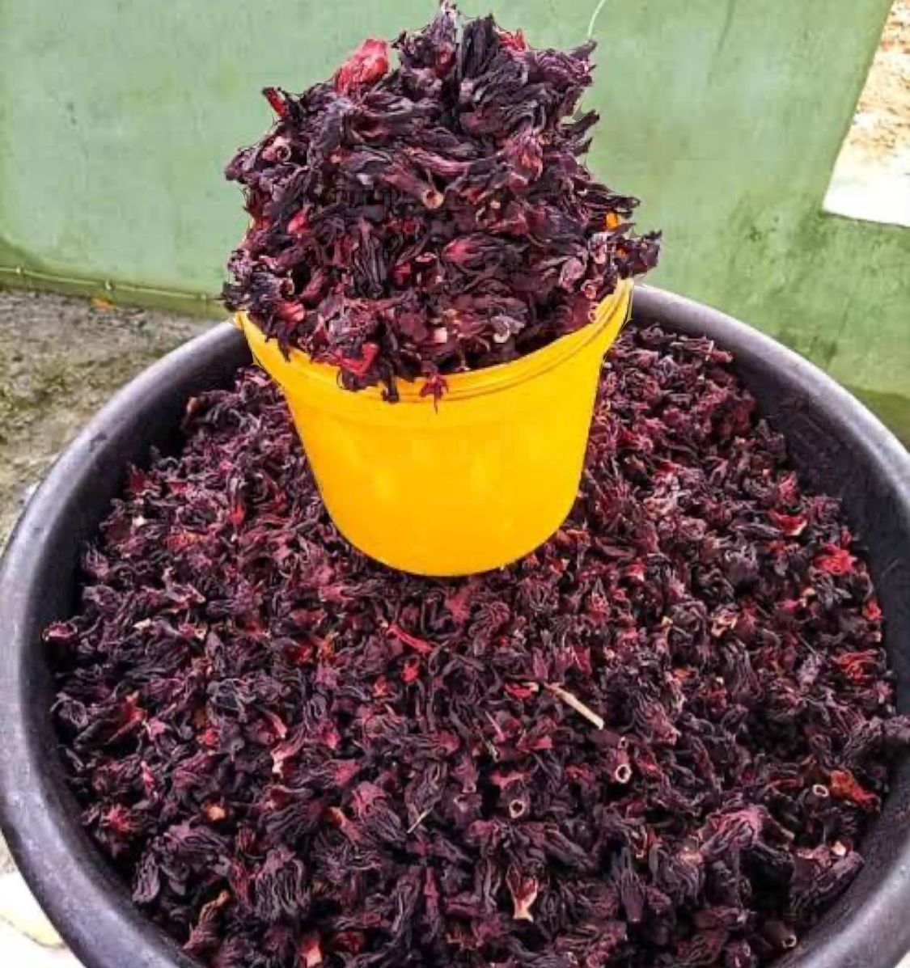

Plate 1: Calyces of *Hibiscus sabdariffa*

**2.3 PHYTOCHEMICAL ANALYSIS**

**2.3.1 Determination of Alkaloid**

The alkaline precipitation gravimetric method (Inuwa *et al.,* 2011). A measured weight of 1kg of the processed sample were dispersed in 30ml of 10% acetic acid in ethanol solution. The mixture was shaken well and allowed to stand for 4hours at room temperature. The mixture was shaken periodically at 30mins interval. At the end of this period, the mixture was filtered using Whatman No. 42 grade of filter paper.

The filtrate (extract) was concentrated by evaporation to a quarter of the original volume, the extract were treated with dropwise addition of concentrated NH solution to precipitate the alkaloid. The dilution was done until the NH is in excess.

The alkaloid precipitate was removed by filtration using a weighed Whatman No.42 filter paper. After washing with 1% NH, OH solution, the precipitate in the filter paper was dried at 60°C in an oven and then weighed after cooling in a desiccator.

The alkaloid content was calculated as shown below:

Where:

Wl = Weight of empty filter paper

W2 = Weight of filter paper + alkaloid precipitate.

**2.3.2 Determination of Flavonoid**

Flavonoid was determined using the method described by Harborne (1973)

A measured weight of the processed sample 1g was boiled in 100ml of 2M HCL solution under reflux for 40mins. It is allowed to cool before being filtered. The filtrate was treated with equal volume of ethyl acetate and the mixture were transferred to a separation funnel. The flavonoid extract (contained in the ethylacetate portion) were received by filtration using weighed filter paper. The weight was obtained after drying in the oven and cooling in desiccator. The weight was expressed as percentage of the weight analyzed. It is calculated as shown below:

Where:

W1 = Weight of empty filter paper

W2 = Weight of filter paper + flavonoid precipitate.

**2.3.3 Saponin Determination**

The method used was that of Obadoni and Ochuko (2001). 20g of the samples Powder was put into a conical flask and 100ml of 20% aqueous ethanal was added.

The samples were heated over a hot water bath for 4hrs with continuous stirring at about 55°C. the mixture was filtered and the residue reextracted with another 200ml of 20% ethanol. The combined extract was reduced to 40ml over water bath at about 90°C. the concentrate was transferred into a 250 ml separating funnel and 20ml diethyl ether was added and shaken vigorously, the aqueous layer was recovered while the ether layer was discarded. The purification process was repeated. 60ml of n-butanol was added. The combined n-butanol extracts were washed twice with 10ml of 5% aqueous sodium chloride. The remaining solution was heated in a water bath. After evaporation, the samples were dried in the oven to a constant weight and the saponin content is calculated as percentage.

Where:

W1 = Weight of empty filter paper

W2 = Weight of filter paper + saponin extract.

W= Weight of Sample

**2.3.4 Determination of Tannins**

Tannin content of the sample was determined by Folin Denis calorimetric method (Kirk and Sawyer 1998). A measured weight of 1g of the processed sample was mixed with distilled water in the ratio of 1:10 (w/v). the mixture was agitated for Omni at room temperature and filtered to obtain the extract. A standard tannic acid solution was prepared, 2 ml of the standard solution and equal volume of the distilled water were dispersed into a separate 50ml volumetric flask to serve as standard and reagent black, respectively. Then 2ml of each of the sample extract were put in their respective labelled flask.

The content of each flask was mixed with 35ml distilled water and 1ml of the foli denis reagent were added to each. This was followed by 2.5ml of saturated Na2CO3 solution. Thereafter each flask was diluted to 50ml mark with distilled water and incubated for 90mins at room temperature. Their absorbance was measured at 710mm in a calorimeter with the reagent blank at zero. The Tannin content was calculated below.

Where:

W= Weight of Sample used

au = Absorbance of test sample

as = absorbance of Standard Tannin solution

C= concentration of Standard Tannin solution

vt = Total volume of extract

va = Volume of extract analysed

D= dilution factor (if any)

**2.3.5 Determination of Total Phenol using Spectrophotometric method**

This was determined by the folin-ciocateau spectrophotometric method (AAC,

1990). The total phenols were extracted in 0.2g of the Sample with 10ml concentrated methanol. The mixture was shaken for 30min at room temperature.

The mixture was centrifuged at 500pm for 15min, and the supernatant (extract) was used for the analysis. Iml portion of the extract from each sample was treated with equal volume of folin-ciocalteau reagent followed by the addition of 2ml of 2% Na2CO3 solution. The Standard Phenol solution was prepared and diluted to a desired concentration. Iml of the standard solution also treated with the folin-ciocalteau reagent and Na2CO3 solution. The intensity of the resulting blue coloration was measured in the spectrophotometer at 540m wavelength.

Measurement was made with a reagent blank at zero. The phenol content is

calculated using the formula below:

Where:

W= Weight of Sample used

aul = Absorbance of test sample

as = absorbance of Standard Phenol solution

C= concentration of Standard Phenol solution

Vt = Total volume of extract

va = Volume of extract analysed

D= dilution factor (if any)

**2.3.6 Oxalate Determination**

Two grams (2g) of each sample was boiled in 40ml of water for 30mins in a reflux condenser. 10ml of 20% Na2CO3 was added and boiled for another 30mins. The liquid extract was filtered and washed with hot water until the water did not show any alkaline reaction and concentrated and filtered into a small volume and cooled.

With constant stirring, HCl (1:1 molar ration) was added in drops until the final acid concentration after neutralization is about 4% at which stage, a heavy precipitate appeared (which was allowed to flocculate). The extract was carefully fitred into a 250ml flask and made up to mark. It was kept overnight, and then supernatant liquid was filtered through a dry filter paper in a dry beaker.

An aliquot of this filtration was put in a beaker and diluted with water to 100ml and made to ammonic acid and then acidified with laconic acid. In the cold media, 10ml of Calcium chloride solution was added and stirred well for calcium oxalate precipitate to appear and allowed to settle overnight. The clean supernatant liquid was carefully decanted off through Whatman No. 42 filter paper, without disturbing the precipitate. The precipitate was dissolved in HCI (1:1) acid and precipitated by adjusting the pH with ammonium hydroxide solution. the content was boiled and allowed to settle overnight. Oxalic acid was determined by titrating against 0.05N KMnO4 solution.

Calculations:

Iml of KMn04 = 0.00225 anhydrous Oxalic acid

=% Oxalic acid -titre value x 0.00225 × 100 2 1 = titre value x 0.1125

1 ml 0.02N AgNO3, = 1.08 mg HCN (Ag equiv. to 2 CN)

**2.3.7 Determination for glycosides using** **Borntrager’s test**

2ml of filtrate, 3ml of chloroform is added and shaken. The chloroform layer is separated and 10% ammonia solution was added. The pink colour indicates the presence of glycosides 2.5ml of extract was hydrolysed with 5ml of conc. HCl boiled for few hours in a boiling water bath, small amount of alcoholic extract were dissolved in 2ml of water and 10% of aqueous 10% NaOH was

added the presence of yellow colour was a positive result for the glycosides.

3.2ml of extract is mixed swith about 0.4 ml of glacial acetic acid containing traces of ferric chloride and 0.5 of conc. H2SO4 was added the production of blue colour is positive for glycosides.

1. **RESULTS** 
   1. Phytochemical Analysis of ***Hibiscus sabdariffa***

Table 1.1. Summary of phytochemical results

|  |  |  |
| --- | --- | --- |
| S/N | PHYTOCHEMICALS | PERCENTAGE (%) |
| 1 | Tannins | 3.77 |
| 2 | Flavonoids | 17.80 |
| 3 | Alkaloids | 4.50 |
| 4 | Saponins | 1.60 |
| 5 | Cynogenic Glycosides | 0.13 |
| 6 | Phenols | 1.40 |
| 7 | Oxalates | 12.28 |

The result shows the presence of tannins, flavonoids, alkaloids, saponins, cynogenic glycosides, phenols and oxalates in *hibiscus sabdariffa*. From the result above *hibiscus sabdariffa* contains more flavonoids (17.80%) and oxalates (12.28%) than alkaloids (4.5%), tannins (3.77%), saponins (1.60%), phenols (1.40%) and cynogenic glycosides (0.13%).

1. **DISCUSSION**

The extracts of *Hibiscus sabdariffa* revealed the presence of plants secondary metabolites in the form of phytochemicals. The biologically active chemical substances have curative properties. These phytochemicals include: tannins, saponins, glycosides, phenols, and flavonoids extracted quantitatively. Table 3.1 shows the result of their presence quantitatively in high percentages.

Flavonoids were found to be the most abundant phytochemical in *H. sabdriffa* followed by oxalate, while Cynogenic Glycoside were the least abundant (Table 3.1). The flavonoid constituents of *H. sabdariffa* have been reported to show good effect on peroxidase and protease activity in human blood which confirmed the benefit of Roselle as an antioxidant and anti-aging plant, in addition to indications through *in vitro* and *in vivo* studies that flavonoids hold great potential as anticancer substances (Nhung *et al*., 1998). Antioxidant is a substance that slows or inhibits oxidation reaction, especially in biological materials or within cells, thereby reducing spoilage or preventing damage. The main function of antioxidant is trapping the free radical particularly reactive oxygen species and reactive nitrogen species which are involved in the pathogenesis of several chronic and degenerative diseases such as cardiovascular diseases, inflammation, neurodegenerative diseases, aging-related disorders, and cancer. The calyx of Roselle provides higher levels of antioxidants than traditional sources such as blueberries and raspberries (Juliani *et al.,* 2009).

Numerous scientific research has revealed that Roselle calyces are rich in flavonoids and polyphenols, which have enhanced the nutritional value of Roselle, as their antioxidant properties distinguish these compounds. Polyphenols of the flavanol found in Roselle are in the form of a simple or polymer form. The most flavonoids isolated from the Roselle extracts were, hibiscetin-3-glucoside (hibiscitrin), gossypitrin, gossytrin, sabdaritrin and other gossypetin glucosides, quercetin and luteolin; also, chlorogenic acid, protocatechuic acid, pelargonidic acid, eugenol, quercetin, luteolin, and the sterols b-sitosterol and ergosterol (McKay, 2009; Williamson *et al*, 2009).

The juice from the Roselle was found to have the potential of an excellent transporter in the development of functional beverages with gibberellic acid acting as a prebiotic source. Food products from the Roselle are classified as functional foods, thus provide consumers with the required health benefits by counting on the significant contribution of their phytochemicals.

1. **CONCLUSION**

This study reveals the rich profile of bioactive compounds. These compounds contribute to the medicinal properties, making it a promising source for natural remedies, which have been documented in traditional medicine and supported by scientific research. This study also confirmed that roselle consumption is safe at low doses without any adverse effect on liver or kidney. It is essential to approach *Hibiscus sabdariffa* as potential supplement rather than a cure all, replacing a balanced diet and regular exercise.

1. **RECOMMENDATION**

Further research should still go on to establish a potential strategy that can balance the pharmacological and toxic effects of roselle. The bioavailability and dosage of the extract of roselle is yet another concern that has to be focused on. Hence there is a need for the standardized fingerprint of *Hibiscus sabdariffa* internationally for quality control. The medical, pharmacological and therapeutic uses should still be done with other parts of the roselle plant.

1. **REFERENCES**

[1] Adanlawo, I. G., Ajibade, V. A. (2006). Nutritive value of the two varieties of

Roselle (*Hibiscus sabdariffa*) calyces soaked with wood ash. *Pakistan Journal of Nutrition*.

5:555-557.

[2] Adegunloye B. J, Omoniyi J. O, Ajabonna O. P. (1996). Mechanism of blood

pressure lowering effects of the calyx extract of *Hibiscus sabdariffa* in rats. *Journal of*

*science*, 9(8):235-238.

[3] Ali, B. H., Wabel, N. A., Blunden, G. (2005). Phytochemical, pharmacological and

toxicological aspects of *Hibiscus sabdariffa L*.: A review. *Phytotherapy Research: An*

*International Journal Devoted to Pharmacological and Toxicological Evaluation of Natural*

*Product Derivatives*. 19(5):369-375.

[4] Balasundram N, Sundram K, Saman S. (2006). Phenolic Compounds in Plants and Agri

industrial by- Products: Antioxidant Activity, Occurrence, and Potential Uses. *Food*

*Chemistry*. 99(4):191-203.

[5] Benson, Dukuje (2015). Anthocyanins of rosella (*Hibiscus sabdariffa*, L.). *Advances*

*in Food Science and Technology*. 3(5):318-320.

[6] Bohlmann J, Meyer-Gauen G, Croteau R. (1998). Plant terpenoid synthases:

Molecular biology and phylogenetic analysis. *National Academic Science*. 95(4):4126-4133

[7] Chau J. W, Jin M. W, Wea L. L, Chia Y. C, Fen P. C, Tsui H. T. (2000). Protective

effect of Hibiscusanthocyannins against tertbutylhydroperoxide-induced hepatic toxicity in

rats. *Food and chemical toxicology*. 38 (15):412-417.

[8] Costa M. A, Zia Z. Q, Davin L. B, Lewis N. G. (1999). Toward Engineering the

Metabolic Pathways of Cancer-Preventing Lignans in Cereal Grains and Other Crops. In

Recent Advances in Phytochemistry. *Phytochemicals in Human Health Protection,*

*Nutrition, and Plant Defense*. 33(4):67-87.

[9] Dai J, Mumper R. (2010). Plant phenolics: extraction, analysis and their antioxidant

and anticancer properties. *Journal of science.* 15(9):7313-7352.

[10] Gomaa, R. B. A., Rashed, N. M. (2016). Post-harvest studies on reducing losses and

maintaining quality of packaging Roselle calyxes. *Journal of Sustainable Agricultural*

*Sciences*. 42(4):68-86.

[11] Harborne J. B, Baxter H. (1999). The handbook of natural flavonoids. *John Wiley*

*and Sons*.

[12] Hahn N. I. (1998). Is Phytoestrogens Nature’s Cure for What Ails Us? A Look at the

Research. Journal of the American Dietetic Association, 98(8):974-976.

[13] Haji F. M, Haji T. A. (1999). Production and quality evaluation of wine produced

from zobo extract (*Hibiscus sabdariffa*) and the effect of the extract on hypertensive wistar

rats. *Nigeria food science Technology*. 12(5):26-27.

[14] Hossain, M. F., Akhtar, S., & Anwar, M. (2015). Nutritional value and medicinal

benefits of pineapple*. International Journal of Nutrition and Food Sciences*. 4(1):84-88.

[15] Ismail, A., Ikram, E. H. K., Nazri, H. S. M. (2008). Roselle (*Hibiscus sabdariffa* L.)

seeds nutritional composition protein quality and health benefits. *Nutritional Food*,

2(1):1-16.

[16] Jabeur, I., Pereira, E., Barros, L., Calhelha, R. C., Sokovi´c, M., Oliveira, M. B. P.

P. Ferreira, I. C. F. R. (2017). Hibiscus sabdariffa L. as a source of nutrients, bioactive

compounds and colouring agents. *Food Research International*. 100(21):717-723.

[17] Kek, T. Z., Sakimin, S. Z., Nazrin, M., Juraimi, A. S., Alam, M. A., & Aslani, F.

(2017). Regulation of fruit colour development, quality and storage life of *Hibiscus*

*sabdariffa* L. As influenced by plant growth regulators. *Bangladesh Journal of Botany*.

46(9):419-426.

[18] Krishnan R, Chandravadana M. V, Ramachander P. R, Bharathkumar H. (1983).

Inter relationships between growth and alkaloid production in *Catharanthus roseus*. *Herba*

*Hungarica*. 22(3):47-54.

[19] Lacaille-Dubois M. A, Wagner H. (2000). Bioactive saponins from plants: An

update in Studies in Natural Products Chemistry. *Elsevier Science*. 21(8):633-687.

[20] Lasztity R, Hidvegi M, Bata A. (1998). Saponins in food. Food Review

International. 14(3):371-390.

[21] Mahadevan, N, Kamboj, S. P. (2009). *Hibiscus sabdariffa* Linn. An overview.

*Natural Product Radiance*. 8(1):77-83.

[22] Mcclintock, N. C., Tahir, E. (2004). Vegetables. *Plant resources of tropical Africa*.

2(2):321-326.

[23] McKay, D. (2009). Can hibiscus tea lower blood pressure. *AfroFood Industry Hi-*

*Tech*. 20(6):40-42.

[24] Mohamed R, Fernandez, J, Pineda, N, Augilar, M. (2007) Roselle (*Hibiscus*

*sabdariffa*) seed oil is a rich source of gamma-tocopherol, *Journal of Food Science*.

72(3):207–210.

[25] Moussa, N., Ndeye, S. F., Joseph, B., Mady, C. (2018). Stability of concentrated

extracts of *Hibiscus sabdarifa L*. calyx during storage at different temperatures. *African*

*Journal of Food Science*, 12(12):347-352.

[26] Obiefuna P. C. M, Owolabi A. O, Adegunloye B. J. (1994). The petal extract of

*Hibiscus sabdariffa* produces relaxation of the isolated rat’s aorta. *Pharmacology*.

32(7):69-74

[27] Ochoa-Velasco, C. E., Salazar-Gonza´lez, C., Cid-Ortega, S., Guerrero-Beltra´n, J.

A. (2017). Antioxidant characteristics of extracts of Hibiscus sabdariffa calyces encapsulated

with mesquite gum. *Journal of Food Science and Technology*, 54(7):1747-1756.

[28] Odigie I. P, Ettah R. R, Adigun F. (2003). Chronic administrative of aqueous

*Hibiscus sabdariffa* attenuates hypertension and reverses cardiac hypertrophy in hypertensive

rats. *Ethnopharmcci*. 86(4):181-187.

[29] Onyenekwe P. C, Ajani E. O, Ameh D. A, Gamanniel K. S., (1999). Antihypertensive effect

of *Hibiscus sabdariffa* calyx infusion in spontaneously hypertensive rats and a comparison

of its toxicity with that of wistar rats. *Cell Biochemistry functions*. 7(3):198-207.

[30] Plotto, A., Mazaud, F., Rottger, A., Steffel, K. (2004). Hibiscus: Post-production

management for improved market access organization. *Food and Agriculture Organization*

*of the United Nations*.

[31] Pretorius J. C. (2003). Flavonoids: A Review of Its Commercial Application

Potential as Anti-Infective Agents. *Current Medicinal Chemistry- Anti Infective Agents*.

2(2):335-353.

[32] Schofield P, Mbugua D. M, Pell A. N. (2001). Analysis of condensed tannins: a

review. *Animal Feed Science Technology*. 91(5):21-40.

[33] Shruthi, V. H., Ramachandra, C. T., Kurubar, A. R. (2016). Hibiscus sabdariffa extract

inhibits the development of atherosclerosis in cholesterol-fed rabbits. *Plant*

*Archives*. 16 (22):515-522.

[34] Tindal, H. D. (1983). Vegetables in the tropics. *Macmillan Press.*

[35] UNICEF (2006). Changes in the quality of zobo beverages produced from the plant

food, *Hibiscus sabdariffa* and the effects on human immune system. *Nigeria National Science*

*Journal*. 5(2):1-10.

[36] Walton N. J, Mayer M. J, Narbad A. (2003). Molecules of Interest: Vanillin.

*Phytochemistry*.63(4):505-515.

[37] Williamson, E. M., Driver, S., Baxter, K. (2009). Stockley’s herbal medicines

interactions: a guide to the interactions of herbal medicines, dietary supplements and

nutraceuticals with conventional medicines/editors. *Pharmaceutical Press*. 7(2):21-24.