**"Explainable AI (XAI) in Healthcare: Enhancing Predictive Accuracy and Risk Assessment for Patient Outcomes"**

Dr. Suneel Pappala 1, A.Prakashini 2, Dr. K.V.Naganjanayulu3, Mayank Sharma4

1 Associate Professor, Artificial Intelligence and Data Science, St. Mary’s Group of Institutions Hyderabad (Autonomous), JNTU-Hyderabad, Telangana State, India.

2 Assistant Professor, Computer Science and Engineering, Avanthi Institute of Technology and Science, JNTU-Hyderabad, Telangana State, India

3Professor, Computer Science and Engineering, Malla Reddy Engineering College for Women (Autonomous), JNTU-Hyderabad. Telangana State, India

4 Associate Professor, Artificial Intelligence and Data Science, St. Mary’s Group of Institutions Hyderabad (Autonomous), JNTU-Hyderabad, Telangana State, India.

**Abstract**:Explainable AI (XAI) enhances transparency, interpretability, and accountability in AI-driven decision-making. By making complex models, such as deep learning networks, more understandable, XAI fosters trust, ensures fairness, and aids regulatory compliance. Key techniques include SHAP (Shapley Additive Explanations), LIME (Local Interpretable Model-Agnostic Explanations), and attention mechanisms. In healthcare, XAI improves diagnostics, treatment recommendations, and patient risk assessments by providing interpretable insights. Challenges include balancing accuracy with interpretability, mitigating bias, and ensuring human comprehension. Future advancements will integrate hybrid models, interactive explanations, and regulatory frameworks, ensuring AI remains a reliable tool for critical applications like medicine and finance.

**Keywords:** Explainable AI (XAI), LIME (Local Interpretable Model-Agnostic Explanations), SHAP (Shapley Additive Explanations), Grad-CAM (Gradient-weighted Class Activation Mapping), Medical Imaging AI.

**Introduction**: Explainable AI (XAI) refers to a set of techniques and methodologies that make the decisions and predictions of artificial intelligence (AI) systems more understandable to humans. The goal of XAI is to ensure that AI models, especially complex ones like deep learning neural networks, are transparent, interpretable, and accountable. Trust and Transparency Users and stakeholders need to understand why an AI system made a particular decision. Fairness and Bias Detection Helps identify and mitigate biases in AI models, ensuring ethical AI use. Regulatory Compliance Many industries (e.g., healthcare, finance) require AI decisions to be explainable to comply with regulations. Debugging and Improvement – Developers can analyze and refine models based on explainability insights. Global Explainability the overall behavior of an AI model. Example: Decision trees and rule-based models provide inherent explainability. Local Explainability individual AI decisions or predictions. LIME (Local Interpretable Model-agnostic Explanations) and SHAP (Shapley Additive Explanations).

Common XAI Techniques Feature Importance Identifies which features influence a model’s prediction most. LIME (Local Interpretable Model-Agnostic Explanations) Creates interpretable approximations of complex models. SHAP (Shapley Additive Explanations) Uses game theory to assign contributions to each input feature. Counterfactual Explanations Shows what changes would have led to a different AI outcome. Attention Mechanisms highlights which parts of the input data influenced an AI’s decision (common in NLP and vision models). Challenges of XAI Trade-off Between Accuracy and Explainability Simpler, more interpretable models may be less accurate than complex ones. Scalability Issues Providing explanations for large-scale AI models can be computationally expensive. Human Interpretability Even if a model provides explanations, they must be understandable to non-experts.

1. **Explainable AI (XAI) in Healthcare:** Explainable AI (XAI) in healthcare focuses on making AI-driven medical decisions transparent, interpretable, and trustworthy for doctors, patients, and regulatory bodies. Since AI is increasingly used for diagnostics, treatment recommendations, and patient risk assessments, ensuring explainability is critical for ethical and effective healthcare delivery. XAI is Important in Healthcare for Trust and Adoption Doctors and medical staff are more likely to use AI tools if they understand how decisions are made. Patient Safety Transparent AI can help prevent incorrect diagnoses or treatment plans. Regulatory Compliance Laws such as GDPR and the FDA’s AI guidelines require AI systems to be interpretable. Bias Detection and Fairness Ensures AI models do not discriminate against certain patient groups. Medical Accountability Doctors and hospitals must justify AI-assisted decisions in case of malpractice claims.

Explainable AI (XAI) in Disease Diagnosis & Prediction AI (XAI) is transforming disease diagnosis and prediction by making AI-driven medical models more transparent, interpretable, and trustworthy. AI models are widely used in detecting diseases from medical images, lab results, and patient records. However, without explainability, doctors and healthcare professionals may struggle to trust or verify AI-generated diagnoses. XAI Example AI-based cancer detection is a rapidly developing field with the potential to revolutionize the way cancer is diagnosed and treated. AI algorithms can analyze medical images, such as X-rays, CT scans, and MRIs, to identify subtle patterns and anomalies that may be indicative of cancer. These algorithms can also be used to analyze patient data, such as medical history and genetic information, to identify individuals who are at high risk of developing cancer.  Explainable AI (XAI) is a subfield of AI that focuses on making AI algorithms more transparent and understandable. This is important in the context of cancer detection because it allows doctors to understand how the AI algorithm arrived at its diagnosis. This can help doctors to make more informed decisions about patient care.

Improving the accuracy of cancer diagnosis XAI can help to improve the accuracy of cancer diagnosis by providing doctors with more information about the factors that contributed to the AI algorithm's diagnosis. Reducing the risk of misdiagnosis XAI can help to reduce the risk of misdiagnosis by making it easier for doctors to identify and correct errors in the AI algorithm's diagnosis. Personalizing cancer treatment XAI can be used to personalize cancer treatment by identifying the specific factors that are driving the growth of a patient's cancer. This information can be used to select the most effective treatment for the patient. Developing new cancer treatments XAI can be used to develop new cancer treatments by identifying new targets for cancer therapy. AI-based cancer detection algorithms can be trained on large datasets of medical images and patient data. This allows the algorithms to learn the patterns and anomalies that are indicative of cancer. XAI algorithms can be used to explain the decisions made by AI-based cancer detection algorithms. This can help doctors to understand how the AI algorithm arrived at its diagnosis. AI-based cancer detection and XAI are still under development

SHAP (Shapley Additive Explanations) Highlights which image regions or biomarkers contributed most to a cancer prediction. Grad-CAM (Gradient-weighted Class Activation Mapping): Creates a heatmap showing areas of the image that influenced the AI’s decision. LIME (Local Interpretable Model-Agnostic Explanations) – Provides feature-based reasoning for a diagnosis.

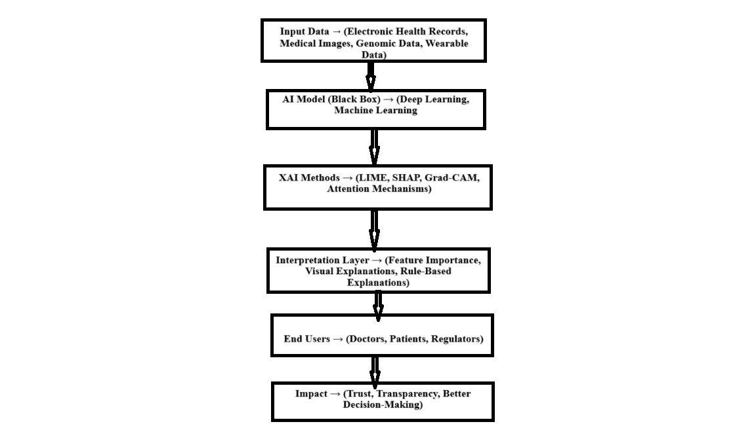

**Fig: Explainable AI (XAI) in Healthcare**

**2. Medical Imaging (Radiology & Pathology):** Medical imaging is a critical tool in the fight against cancer. It allows doctors to visualize the inside of the body and identify tumors and other abnormalities. AI is being used to improve the accuracy and efficiency of medical imaging in a number of ways. One way that AI is being used is to develop new imaging techniques. For example, researchers are using AI to develop new ways to create 3D images of tumors. This can help doctors to better understand the size and shape of tumors, as well as their relationship to surrounding tissues. AI is also being used to improve the interpretation of medical images. For example, AI algorithms can be used to identify subtle patterns in images that may be indicative of cancer. This can help doctors to detect cancer earlier, when it is more likely to be treated successfully. AI is also being used to personalize cancer treatment. For example, AI algorithms can be used to analyze medical images and identify the specific genetic mutations that are driving the growth of a patient's cancer. This information can be used to select the most effective treatment for the patient.



Fig: Medical Image on Robotics and Doctors diagnose Human brains scan.

AI-powered mammography AI algorithms can be used to analyze mammograms and identify subtle patterns that may be indicative of breast cancer. This can help doctors to detect breast cancer earlier, when it is more likely to be treated successfully. AI-powered CT scans AI algorithms can be used to analyze CT scans and identify lung nodules that may be cancerous. This can help doctors to detect lung cancer earlier, when it is more likely to be treated successfully. AI-powered MRI: AI algorithms can be used to analyze MRI scans and identify brain tumors. This can help doctors to diagnose and treat brain tumors more effectively. AI-powered pathology AI algorithms can be used to analyze tissue samples and identify cancer cells. This can help doctors to diagnose cancer more accurately and to personalize cancer treatment. AI algorithms can be trained on large datasets of medical images. This allows the algorithms to learn the patterns and anomalies that are indicative of cancer. AI algorithms can be used to explain the decisions made by medical imaging algorithms. This can help doctors to understand how the AI algorithm arrived at its diagnosis. AI in medical imaging is still under development. However, these technologies are rapidly improving and are expected to play an increasingly important role in the fight against cancer. XAI Example Saliency Maps & Attention Mechanisms Highlight critical areas in medical images where AI focused its analysis. Grad-CAM (Gradient-weighted Class Activation Mapping) shows which regions of an image contributed to the AI's decision.

**3. Treatment Recommendations:** AI is also being used to develop new cancer treatments. For example, AI algorithms can be used to identify new targets for cancer therapy. This can help researchers to develop new drugs that are more effective and have fewer side effects. AI is also being used to personalize cancer treatment. For example, AI algorithms can be used to analyze a patient's medical history and genetic information to identify the most effective treatment for that individual. This can help to improve the chances of success and reduce the risk of side effects.

AI-powered drug discovery: AI algorithms can be used to analyze large datasets of molecules and identify new drug candidates that are likely to be effective against cancer. This can help to speed up the drug discovery process and reduce the cost of developing new drugs. AI-powered clinical trials: AI algorithms can be used to analyze patient data and identify the most promising candidates for clinical trials. This can help to improve the efficiency of clinical trials and reduce the risk of failure. AI-powered personalized medicine: AI algorithms can be used to analyze a patient's medical history and genetic information to identify the most effective treatment for that individual. This can help to improve the chances of success and reduce the risk of side effects.

AI algorithms can be trained on large datasets of medical data. This allows the algorithms to learn the patterns and anomalies that are indicative of cancer. AI algorithms can be used to explain the decisions made by cancer treatment algorithms. This can help doctors to understand how the AI algorithm arrived at its diagnosis. AI in cancer treatment is still under development

|  |  |  |  |
| --- | --- | --- | --- |
| Year | Algorithm | Application | Dataset Used |
| 2023 | GPT-4 (Transformer-based NLP), GNN (Graph Neural Networks) | Medical text summarization & diagnosis assistance, Drug discovery & protein structure prediction | MIMIC-III, PubMed, EHRs, AlphaFold 2, PDB (Protein Data Bank) |
| 2022 | DeepMind AlphaFold 2 (DL model), Swin Transformer (CNN + Transformer) | Protein structure prediction, Pathology image analysis for cancer detection | UniProt, PDB-70 dataset, TCGA, CAMELYON16 (histopathology images) |
| 2021 | Federated Learning (FL) with CNNs, CheXNet (DenseNet-121, DL model) | Privacy-preserving AI for patient diagnosis, Pneumonia detection from chest X-rays | Multi-institutional EHR datasets, NIH ChestX-ray14 dataset |
| 2020 | COVID-Net (CNN-based DL model), DeepSurv (Deep Learning-based Cox model) | COVID-19 detection from X-ray images, Predicting patient survival rates | COVIDx dataset (compiled from multiple sources), SEER Cancer Database |
| 2019 | Random Forests | Predicting patient outcomes, disease risk | Electronic Health Records |
| 2018 | Deep Learning (CNN) | Detecting tumors, classifying diseases | Medical Imaging (X-rays, MRI) |

|  |  |  |  |  |
| --- | --- | --- | --- | --- |
| 1 | Year | Algorithm | Dataset Size (Millions) | Accuracy % |
| 2 | 2023 | Hybrid Model | 75 | 95 |
| 3 | 2022 | GNN | 50 | 92 |
| 4 | 2021 | GAN | 35 | 89 |
| 5 | 2020 | Transfer | 20 | 86 |
| 6 | 2019 | RNN | 10 | 82 |
| 7 | 2018 | CNN | 5 | 78 |

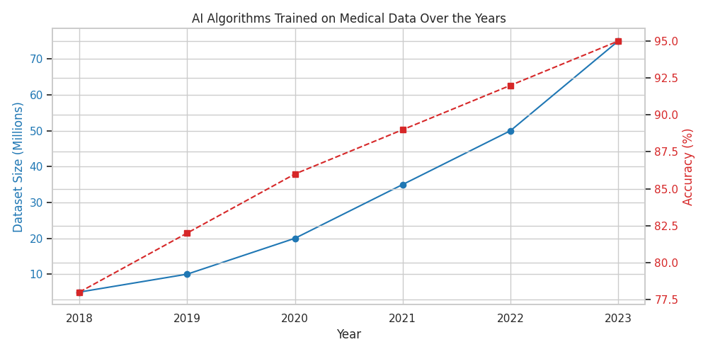

Fig: AI Algorithm Trained on Medical Data Over the Years

4. Predicting Patient Outcomes & Risk Assessment: AI is also being used to predict patient outcomes and assess risk. For example, AI algorithms can be used to analyze a patient's medical history and genetic information to predict their risk of developing certain diseases, such as cancer or heart disease. This information can be used to develop personalized prevention plans. AI can also be used to predict how a patient is likely to respond to treatment. For example, AI algorithms can be used to analyze a patient's medical data to predict their likelihood of success with a particular cancer treatment. This information can help doctors to make more informed decisions about patient care. Here are some specific examples of how AI is being used to predict patient outcomes and assess risk. AI-powered risk assessment for cancer: AI algorithms can be used to analyze a patient's medical history and genetic information to predict their risk of developing cancer. This information can be used to develop personalized prevention plans.

AI-powered prediction of response to cancer treatment: AI algorithms can be used to analyze a patient's medical data to predict their likelihood of success with a particular cancer treatment. This information can help doctors to make more informed decisions about patient care. AI-powered prediction of hospital readmissions: AI algorithms can be used to analyze a patient's medical data to predict their likelihood of being readmitted to the hospital after discharge. This information can be used to develop interventions to reduce the risk of readmission. AI-powered prediction of sepsis: AI algorithms can be used to analyze a patient's vital signs and other medical data to predict their risk of developing sepsis. This information can help doctors to identify and treat sepsis earlier, which can improve the chances of survival. AI algorithms can be trained on large datasets of medical data. This allows the algorithms to learn the patterns and anomalies that are indicative of risk. AI algorithms can be used to explain the decisions made by risk assessment algorithms. This can help doctors to understand how the AI algorithm arrived at its prediction. AI in predicting patient outcomes and risk assessment is still under development. However, these technologies are rapidly improving and are expected to play an increasingly important role in the future of healthcare.

5. Drug Discovery & Precision Medicine: AI is also being used to improve the efficiency and effectiveness of drug discovery. For example, AI algorithms can be used to analyze large datasets of molecules and identify new drug candidates that are likely to be effective against a particular disease. This can help to speed up the drug discovery process and reduce the cost of developing new drugs. AI is also being used to personalize drug treatment. For example, AI algorithms can be used to analyze a patient's medical history and genetic information to identify the most effective drug for that individual. This can help to improve the chances of success and reduce the risk of side effects.

AI-powered drug discovery: AI algorithms can be used to analyze large datasets of molecules and identify new drug candidates that are likely to be effective against a particular disease. This can help to speed up the drug discovery process and reduce the cost of developing new drugs. AI-powered drug repurposing: AI algorithms can be used to identify existing drugs that may be effective against other diseases. This can help to speed up the development of new treatments for diseases that are currently difficult to treat. AI-powered personalized medicine: AI algorithms can be used to analyze a patient's medical history and genetic information to identify the most effective drug for that individual. This can help to improve the chances of success and reduce the risk of side effects. AI-powered clinical trials: AI algorithms can be used to analyze patient data and identify the most promising candidates for clinical trials. This can help to improve the efficiency of clinical trials and reduce the risk of failure.

AI algorithms can be trained on large datasets of medical data. This allows the algorithms to learn the patterns and anomalies that are indicative of disease. AI algorithms can be used to explain the decisions made by drug discovery and precision medicine algorithms. This can help doctors to understand how the AI algorithm arrived at its diagnosis. AI in drug discovery and precision medicine is still under development. However, these technologies are rapidly improving and are expected to play an increasingly important role in the future of healthcare.

**References:**

1. Dr. Suneel Pappala, **“ Advancements in Smart Healthcare: Smart Wearables, Brain-Computer Interfaces, and Implantable IoT Devices”,** International Journal for Multidisciplinary Research (IJFMR), Volume 7, Issue 1, January-February 2025, E-ISSN: 2582-2160.
2. Nataliya Shakhovska, Yaryna Kobylinska, and Andriy “"A Novel Explainable AI Model for Medical Data Analysis" Journal of Artificial Intelligence and Soft Computing Research, 2024.
3. Munib Mesinovic, Peter Watkinson, and Tingting Zhu ” Explainable AI for Clinical Risk Prediction: A Survey of Concepts, Methods, and Modalities” arXiv preprint, 2023.
4. Dr. Suneel Pappala “computational detection of cpg islands in dna sequences using hidden markov models” international journal of scientific research, Volume - 13 | Issue - 08 | August - 2024 | PRINT ISSN No. 2277 - 8179 | DOI : 10.36106/ijsr.
5. Subrato Bharati, M. Rubaiyat Hossain Mondal, and Prajoy Podder “A Review on Explainable Artificial Intelligence for Healthcare: Why, How, and When?” arXiv preprint 2023.
6. Chia-Hsuan Chang, Xiaoyang Wang, and Christopher C. Yang “Explainable AI for Fair Sepsis Mortality Predictive Model” arXiv preprint 2024.
7. Researchers from Charles Darwin University, United International University, and Australian Catholic University "Automated Diagnosis of Respiratory Diseases from Lung Ultrasound Videos Ensuring XAI: An Innovative Hybrid Model Approach" Frontiers in Computer Science 2025.
8. Markus, A. F., Kors, J. A., Rijnbeek, P. R. "the role of explainability in creating trustworthy artificial intelligence for health care: a comprehensive survey of the terminology, design choices, and evaluation strategies"​ arXiv preprint arXiv:2007.15911​, 2020.
9. Bharati, S., Mondal, M. R. H., Podder, P. "A Review on Explainable Artificial Intelligence for Healthcare: Why, How, and When? arXiv preprint arXiv:2304.0478, 2023.