The Human Microbiome: "Impact of the Gut Microbiome on Human Immunity and Metabolism"

**KOTTE LAVANYA**

Student, B. Tech. (1st year), Christ (Deemed to be University), Bangalore, India.

**ABSTRACT**

The human microbiome is a vast and complex community consisting of trillions of tiny microorganisms, including bacteria, fungi, archaea, viruses and other microbes, that live in and on the human body. Most of the microbes are found in different parts of the body including skin, mouth, lungs, reproductive organs and guts (also known as the intestines). Among these the gut microbes play a crucial role in regulating the human immune system and metabolism, influencing various processes such as immune response, nutrient absorption and especially digestion. Understanding the structure and the function of the microbiome is essential for developing new medical treatments, including microbiome-targeted therapies. This paper explores the impact of the gut microbiome on human immunity and metabolism and highlights its significance in maintaining overall health. This study explores the human microbiome and assesses the impact of the gut microbiome on human immunity and metabolism by analysing peer-reviewed journal research papers published in the last 10 years on microbiome, immune system and gut microbes. The results indicate that imbalances in gut microbiota (dysbiosis) are linked to various metabolic disorders such as obesity, diabetes, inflammatory bowel diseases (IBD). These gut microbes influence the production of vitamins (e.g., vitamin A, D, E) and neurotransmitters (e.g., serotonin, dopamine and acetylcholine).

**Keywords:** Human microbiome, Gut microbes, Immune system, Metabolism, Microbiome-targeted therapies, Dysbiosis.

**1.INTRODUCTION**

Did you know that your body is home to trillions of tiny microscopic organisms that play a crucial role in your health?

These tiny organisms, known as microbes, together known as the human microbiome, that live in and on the human body. Most microbes are found in different parts of the body including the skin, mouth, lungs, reproductive organs, and gut (also known as the intestines).

**2.METHODOLOGY**

This study is conducted as a journal research paper to analyse the human microbiome and the impact of the gut microbiome on human immunity and metabolism. The selection criteria focused on the peer-reviewed journals published in the last 10 years on microbiome, immune system interactions and gut microbes.

Data Collection:

The data was gathered by identifying and selecting peer- reviewed journals related to microbiome and gut microbes.

**3.MODELING AND ANALYSIS**

A Unique Microbiome in Every Part of the Body:

Each part of the body contains a unique microbiome with important functions.

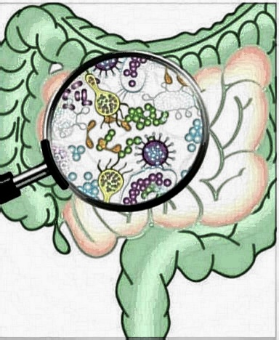

1.Skin: The skin helps to protect against infections.

2.Mouth: The mouth impacts digestion and oral health.

3.Lungs: The lungs play a role in immune system modulation and pathogen defense.

4.Reproductive organs: The reproductive organs help to maintain the vaginal microbiome, which supports vaginal health and prevents infections.

5.Guts: Guts plays a crucial role in digestion, nutrient absorption, immune function, and overall health. 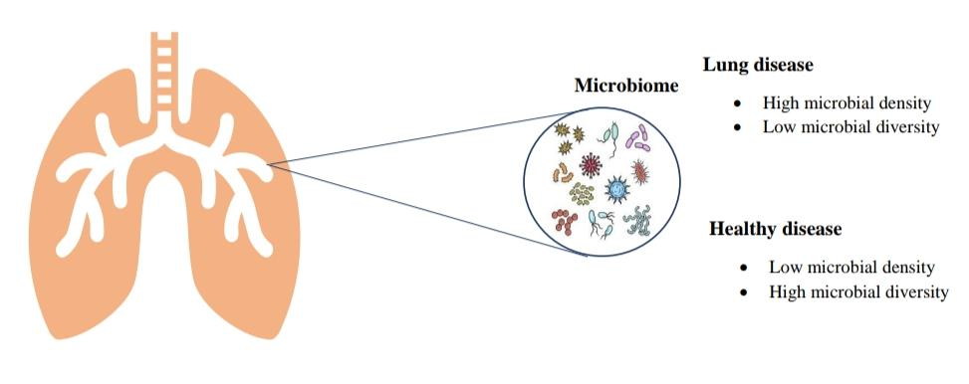

How the microbiome contributes health

The microbiome helps the body with digestion by breaking down food and aiding in nutrient absorption. Vitamin biosynthesis allows these microbes to naturally produce essential nutrients, contributing to overall health. The immune system support provided by the microbiome helps protect against harmful microbes. Finally, the microbiome plays a role in metabolism, influencing weight regulation and energy levels.

Maintenance of a healthy microbiome:

For a healthy microbiome, we should consume fibre-rich foods like vegetables, fruits, and whole grains. Including fermented foods such as yogurt and kimchi is also beneficial. Additionally, getting enough sleep and managing stress are essential for maintaining a healthy and balanced microbiome.

**4.RESULTS AND DISCUSSION**

In the presence of microbes, the analysis of human microbiome distribution across different parts of the body

indicates significant variations. 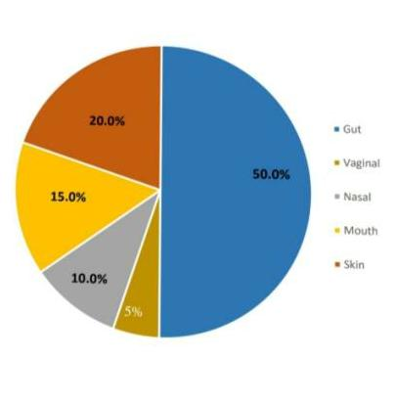

The gut microbiome constitutes the largest portion, emphasizing its crucial role in digestion, immune system regulation, and metabolism. While the skin microbiome plays an essential role in protecting against pathogens and maintaining skin health, the oral microbiome contributes to systemic health through interactions with the immune system, regulating and aiding digestion. The nasal microbiome plays a key role in respiratory health by preventing pathogenic colonization. Meanwhile, the vaginal microbiome, which constitutes a smaller portion of the human microbiome, is crucial for maintaining reproductive health and preventing infections.

**5.CONCLUSION**

The human microbiome plays a crucial role in maintaining overall health by influencing digestion, metabolism and the regulation of the immune system. The skin, oral, nasal, and vaginal microbiomes contribute to particular biological functions, such as pathogen defense and systemic health regulation. Imbalance in gut microbiota, known as dysbiosis, is linked to various metabolic disorders such as obesity, diabetes, inflammatory bowel diseases (IBD).

**6.REFERENCES**

[1] Pray, Leslie., Pillsbury, Laura., Tomayko, Emily. The Human Microbiome, Diet, and Health: Workshop Summary. United States: National Academies Press, 2013.

[2] Marchesi, Julian R., ed. The Human Microbiota and Microbiome. Illustrated ed. Vol. 25 of Advances in Molecular and Cellular Microbiology. Wallingford, UK: CABI, 2014.