**ENTERPRISE RESOURCE PLANNING**

**S.Lokesh,S.Malini**

Student,Master of Computer Application,Adhiyamaan College Of Engineering,Hosur,Tamil Nadu,India

professor,Master of Computer Application,Adhiyamaan College Of Engineering,Hosur,Tamil Nadu,India

**ABSTRACT**

The ERP Invoice, Payment, Quote, and Customer Management System is an integrated solution designed to streamline financial and customer-related processes within an enterprise. This system enhances business efficiency by automating key operations, ensuring accuracy, and improving decision-making.The Invoice Management Module facilitates the generation, tracking, and management of invoices, reducing manual effort and ensuring timely payments. The Payment Management Module enables secure transaction processing, tracking of pending payments, and financial reconciliation. The Quote Management Module assists in generating and managing quotations, helping businesses provide accurate pricing and improve client communication. Lastly, the Customer Management Module centralizes customer data, maintains communication history, and enhances customer relationship management (CRM).

**Keywords:** ERP System,Invoice Management,Payment Processing,Quote Management,Customer Relationship Management (CRM).

1. **INTRODUCTION**

In today's competitive business landscape, efficient management of financial transactions and customer relationships is essential for operational success. The **ERP Invoice, Payment, Quote, and Customer Management System** is designed to streamline these core processes by integrating automated solutions for invoicing, payment processing, quotation management, and customer relationship management (CRM). By reducing manual effort, minimizing errors, and improving financial accuracy, the system enhances decision-making and business productivity. It enables seamless invoice tracking, secure payment handling, accurate quote generation, and centralized customer data management, fostering better client interactions and financial transparency. This comprehensive solution empowers businesses to optimize workflows, enhance efficiency, and drive sustainable growth..

1. **METHODOLOGY**
   1. **Invoice Management**

The **Invoice Management Module** is designed to simplify the creation, tracking, and management of invoices, reducing manual effort and ensuring timely payments. This module allows businesses to generate detailed invoices, send them to clients, and track their status in real time. It also facilitates automated reminders for overdue payments, improving cash flow and minimizing delays in revenue collection.

* 1. **Payment Management**

The **Payment Management Module** enables secure transaction processing and efficient monitoring of payments. It supports multiple payment methods, tracks pending and completed transactions, and ensures seamless financial reconciliation. By providing real-time payment status updates and generating financial reports, this module helps businesses maintain accuracy in financial records and enhances transparency in payment processing.

* 1. **Quote Management**

The **Quote Management Module** assists businesses in generating and managing service quotations. It allows enterprises to create detailed and customizable quotes, ensuring accurate pricing and professional presentation to clients. This module streamlines the process of converting quotes into invoices once approved, reducing redundancy and improving efficiency. Additionally, it enhances client communication by maintaining a structured record of pricing discussions and approvals

..

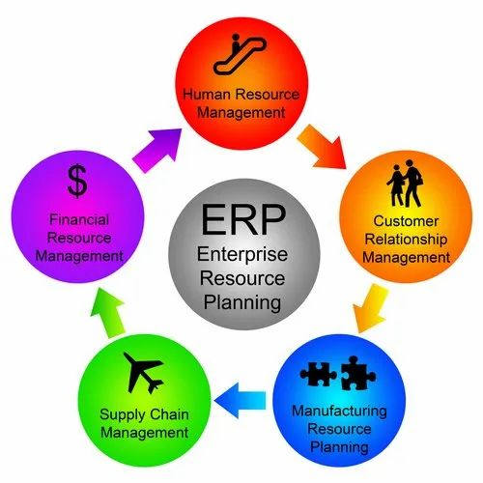

**Figure1:**ERP Flow

1. **RESULT**

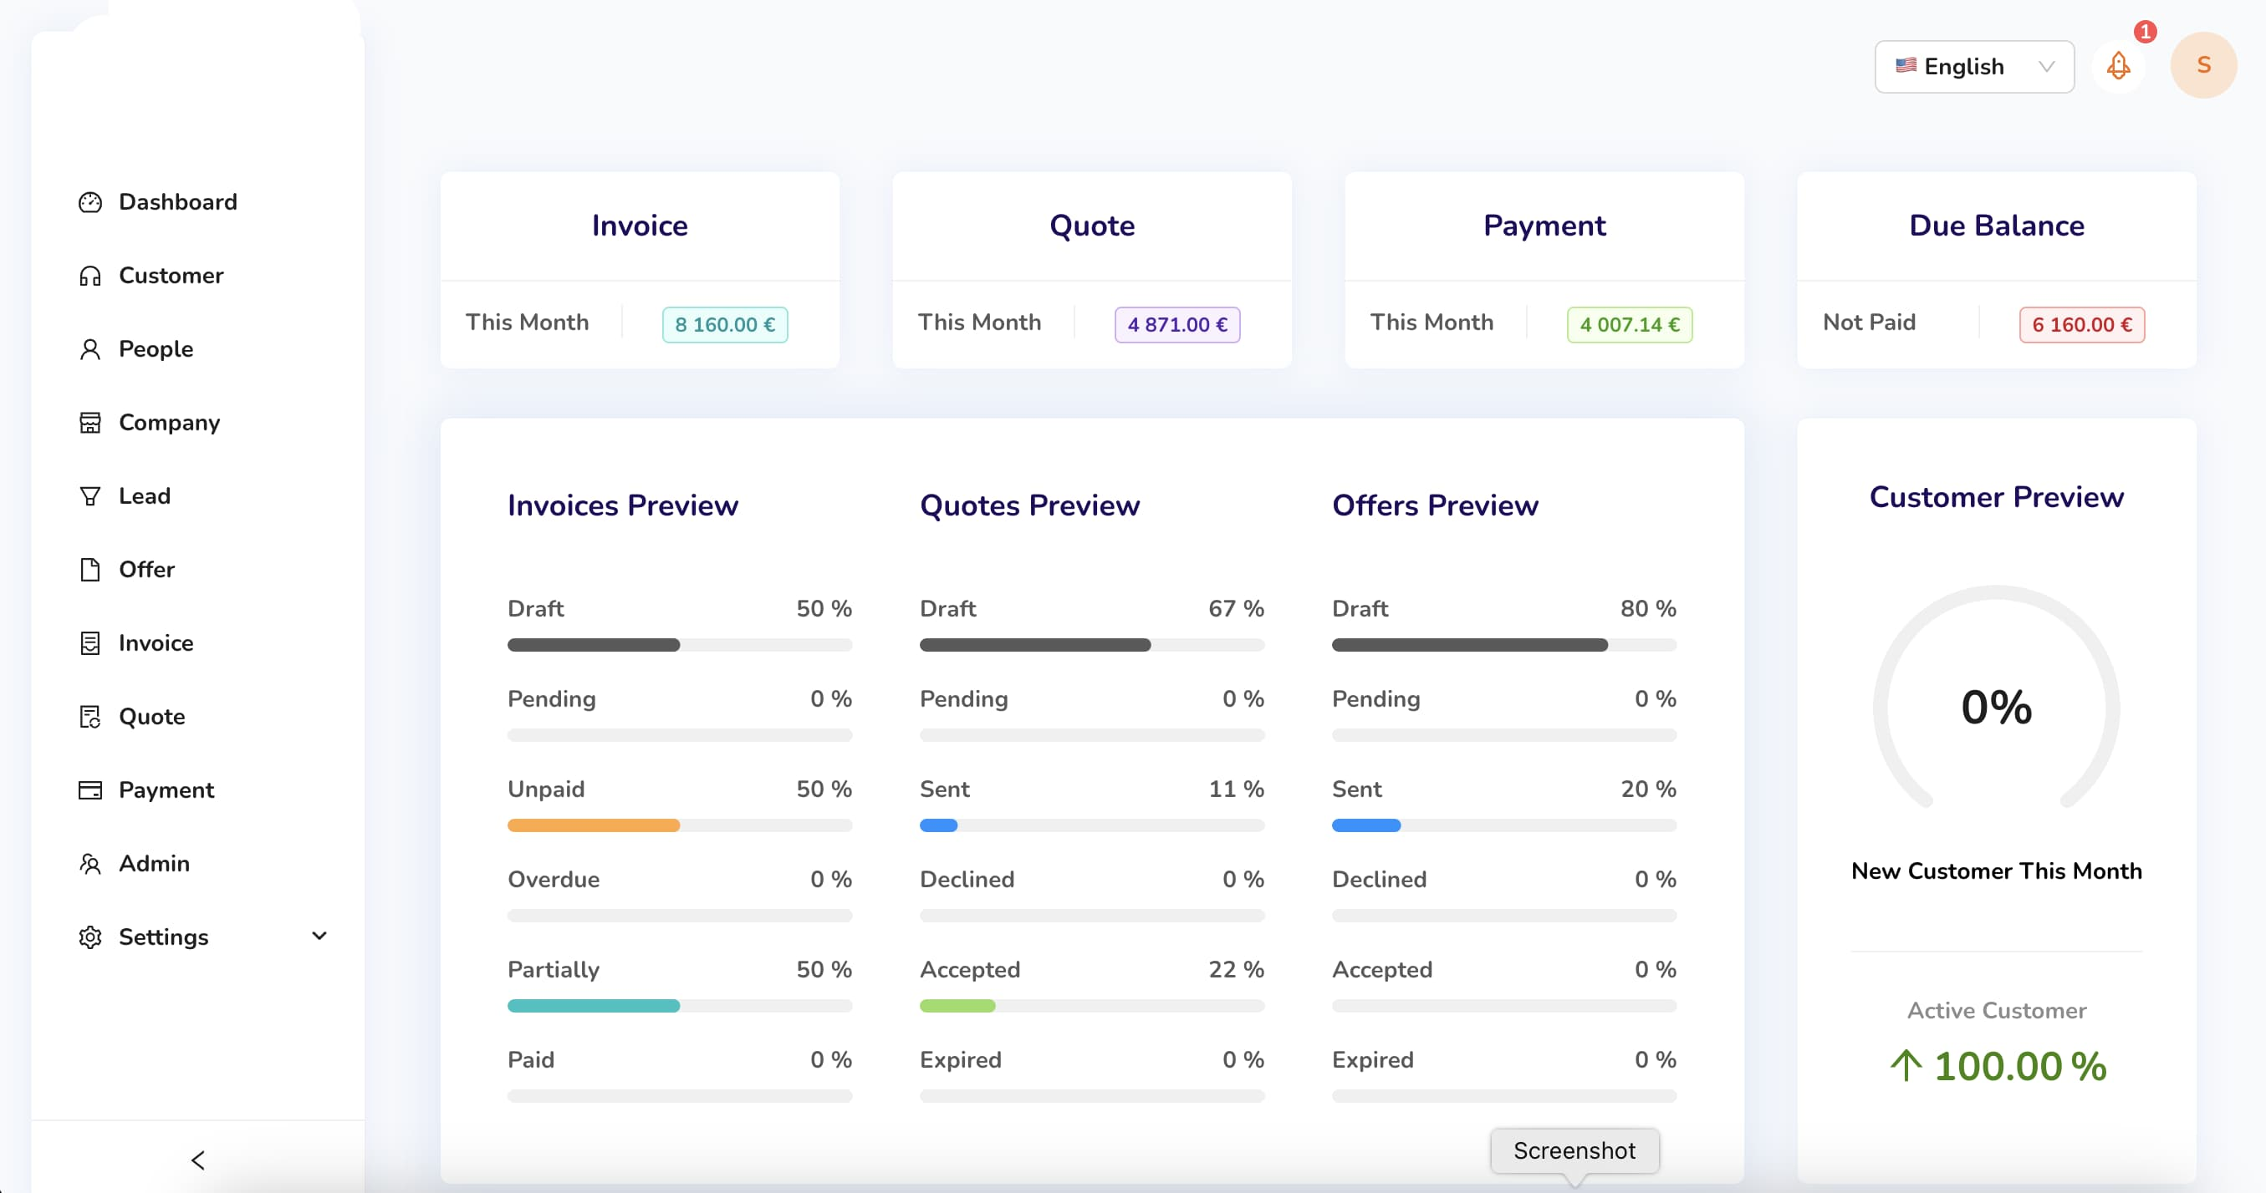

1. **CONCLUSION**

In conclusion, the **ERP Invoice, Payment, Quote, and Customer Management System** provides a comprehensive and automated solution for managing key financial and customer-related processes within an enterprise. By integrating invoice generation, secure payment processing, quote management, and customer relationship management into a single platform, the system enhances operational efficiency, reduces manual workload, and ensures accuracy in financial transactions. The automation of these modules not only streamlines workflow but also improves decision-making by providing real-time insights into financial and customer data. With its ability to centralize and organize critical business information, this system helps enterprises improve cash flow, maintain strong client relationships, and drive overall business growth. Ultimately,the implementation of this ERP system leads to better resource management, increased productivity, and a more structured approach to financial and customer operations.

1. **ACKNOWLEDGEMENTS**

This journal paper was truly prepared by my itself I agree the terms and conditions.

1. **REFERENCES**
2. Daniel E.O’Leary, Enterprise Resource Planning Systems, Cambridge University Press, 2002.
3. Ellen Monk, Bret Wagner, Concepts in Enterprise resource planning, Cengage learning, Third edition, 2009.
4. R. Addo-Tenkorang and P. Helo, “Enterprise Resource Planning (ERP): A Review Literature Report”, Proceedings of the World Congress on Engineering and Computer Science 2011 Vol II, WCECS 2011, October 19-21, 2011, San Francisco, USA.
5. The Impact of Enterprise Systems on Corporate Performance: A study of ERP, SCM, and CRM System Implementations [An article from: Journal of Operations Management] by K.B. Hendricks; V.R. Singhal; and J.K. Stratman, Publisher: Elsevier.