**AURA – “Advanced Utility and Response Assistant”**

**Asst. Prof. P. B. Jaipurkar1, Himanshu P. Maski2, Shreyash P. Suryawanshi3**

1Assistant Professor, Computer Engineering Department, SRPCE, Nagpure, Maharashtra, India

2UG Student, Computer Engineering Department, SRPCE, Nagpure, Maharashtra, India

3UG Student, Computer Engineering Department, SRPCE, Nagpure, Maharashtra, India

**ABSTRACT**

The Advanced Utility and Response Assistant (AURA) represents a paradigm shift in intelligent systems, offering a multi-faceted platform to enhance human productivity, decision-making, and creativity. By leveraging cutting-edge advancements in natural language processing,and contextual understanding, AURA delivers adaptive, personalized, and real-time assistance across diverse domains, including research, education, healthcare, and business. This paper examines AURA's architecture, capabilities, and potential applications while addressing the ethical considerations and challenges inherent in developing such systems. The research emphasizes AURA's ability to harmonize with human goals, not only augmenting cognitive capacities but also fostering innovation and inclusivity. By exploring the nexus of technology and human potential, this study contributes to the evolving narrative of AI as a collaborative force for societal progress.

**Keywords:** Artificial Intelligence, Realtime Feedback, Task Execution, Automation, Robot Adaptation

1. **INTRODUCTION**

In today’s digital landscape, voice assistants have become increasingly popular by offering a convenient way to interact with technology through spoken commands. However, while these systems simplify our daily interactions, they also raise significant privacy concerns—especially on desktops, where users often handle sensitive information. This is because many voice assistants rely on collecting and processing user audio data for speech recognition and other functionalities.This survey paper explores the concept of privacy-preserving, multifunctional desktop voice assistants. It provides a comprehensive overview of current desktop voice assistants, focusing on their capabilities as well as on the privacy risks associated with their data collection practices. The main goal of this research is to address and resolve the privacy issues inherent in these systems.We delve into the vibrant field of privacy-preserving desktop voice assistants powered by AI. By examining the challenges and advances in on-device speech recognition, natural language understanding, and the generation of speech responses, we aim to offer valuable insights into methods designed to safeguard user privacy. Our study reviews current research and cutting-edge strategies, including technologies such as federated learning and differential privacy. Furthermore, this article discusses unresolved research questions and outlines promising future directions for developing desktop voice assistants that prioritize privacy. By tackling these challenges, we envision a future where users can engage in secure and personalized voice interactions on their desktops—without compromising the confidentiality of their data. Ultimately, our goal is to contribute meaningfully to the conversation around privacy-enhancing technologies and to inspire innovative solutions that empower users while protecting their sensitive information.

1. **METHODOLOGY**

**Brains and Brawn:** The Raspberry Pi acts as the brain of the robot. It handles all the smart thinking—like listening to your voice commands, figuring out what you're saying with speech recognition, and making decisions based on that input. Meanwhile, the Arduino works like the robot’s muscles, controlling movement, sensors, and other hardware functions such as motors.**Listening and Speaking:** The robot has a microphone that lets it hear your commands. Once it processes what you say, it responds using a speaker so that it’s not just sitting there silently. Imagine having a conversation where you ask, "What's the weather?" and the robot answers out loud.**Visual Touch:** A display on the robot serves as its face or dashboard, showing important information—like the results of voice commands, sensor readings, or even animated expressions. This visual interface makes the interaction more engaging and user-friendly.**How They Connect:** The Raspberry Pi and Arduino need to work together. They can be connected using methods like Serial (UART) or I2C. The idea is simple: let the Pi handle the high-level processing (like voice recognition and AI) while the Arduino focuses on controlling the hardware (like motors for moving around). **Programming and Libraries:** The Raspberry Pi is usually programmed in Python, which is great for handling data, speech-to-text conversion (using tools like Google Speech-to-Text), and even image processing (with libraries like OpenCV). The Arduino, on the other hand, is typically programmed in C++, which gives you precise control over hardware functions and timing.**Mobility and Power:** If you want your robot to move, motors come into play. These motors could be driven using components like the L298N motor driver which works with the Arduino. To keep everything running smoothly, a rechargeable battery with correct voltage regulation is essential, ensuring that the robot has enough power for all its tasks without any hiccups.This project blends creativity with practical electronics, combining voice interaction, movement, and a visual display to create a lively, interactive machine. It’s like giving life to a piece of hardware, allowing it to understand your commands and respond in its own unique way.

**SYSTEM ARCHITECTURE:**

The system architecture of AURA consists of various elements and they are as following

Microprocessor Connected (Raspberry Pi/ Arduino)

3D Printed Body

LCD Display

Stereo Audio Amplifier Module

Speech Recognition

(Calculation, News etc.)

Voice Input Using Mic

Mini Robot

AURA

(Advance Learning and Friendly Assistant)

Voice Recognition

(Switch Window Command Prompt etc.)

Arm/ Hand Movement

Displaying Output through LCD Display

Fig. 2.1 System Architecture

1. **MODELING AND ANALYSIS**

**1. Hardware Testing**

Make sure all the physical parts of the robot are working correctly:

Component Check: Verify that everything—from the Arduino Uno and Raspberry Pi to the microphone, speaker, and display—is operating as expected.

Power Supply Testing: Confirm that the robot is receiving the correct voltage and that its power consumption is within safe limits.

Sensor & Actuator Testing: Ensure that sensors (for example, those detecting the environment) are giving accurate readings and that the motors (or any moving parts) respond correctly and on time.

Communication Testing: Check that data is being seamlessly exchanged between the Raspberry Pi and Arduino using interfaces like UART or I2C. This step is crucial for the overall coordination of tasks.

**2. Software Testing**

Check the efficiency and correctness of the software running on the robot:

Unit Testing: Test individual pieces of code separately. For instance, write tests for the Python modules running on the Raspberry Pi and the C++ code on the Arduino.

Integration Testing: Make sure that different parts of the system (such as voice recognition, motor control, and display functions) work well together when combined.

Latency Testing: Measure the time it takes for the robot to process a command and then act on it. The goal is to keep delays as short as possible.

**3. Learning Capability Testing**

If the robot is designed to learn and improve over time, its machine learning features also need to be evaluated:

AI Model Training Validation: Check that the training datasets are solid and that the AI models learn effectively.

Speech Recognition Accuracy: Test the system’s ability to understand different voices and accents. It’s important that the robot accurately captures and interprets spoken commands.

Task Adaptability: Evaluate whether the robot can improve its performance based on past experiences—essentially, whether it learns from its mistakes and successes.

**4. Task Execution Testing**

Confirm that the robot performs its designated tasks correctly:

Success Rate Analysis: Measure how often the robot completes its assigned tasks without any errors.

Multi-Task Handling: Test the robot’s ability to manage multiple tasks at the same time, ensuring it doesn’t get overwhelmed or fail to prioritize.

Error Recovery Testing: Check that the robot can detect when something goes wrong and recover from errors automatically, keeping interruptions to a minimum.

**5. User Interaction Testing**

Since the robot interacts with people, it’s important to verify that these interactions are smooth and effective:

Voice Command Recognition: Test the robot’s ability to understand spoken commands in various environments (quiet rooms, noisy places, etc.).

Display & UI Testing: Ensure that the display shows clear, useful information and that the overall user interface is both intuitive and user-friendly.

**6. Real-World Testing**

Finally, deploy the robot in an actual environment to observe its performance outside of controlled tests:

Field Deployment: See how the robot handles real-world scenarios. This is the ultimate check to ensure that all the components, software, learning abilities, and interaction methods work harmoniously together when the robot is “on the job.”

1. **RELATED WORK**

**“Robot Learning from Demonstration: A Task-level Planning Approach” (2019):** Thia study discusses a task learning system where a robot learning by demonstration scenario is integrated with a task level planning system. The current system requires that all objects are visible at the planning stage [1].

**“Guanwen Ding, Yubin Liu, Xizhe Zang, Xuehe Zhang, Gangfeng Liu, Jie Zhao "A Task-Learning Strategy for Robotic Assembly Tasks from Human Demonstrations" - National Library of Medicine - 25 Sept 2020:** This paper presents a novel task-learning strategy that integrates goal configurations learning and trajectory learning. the robot is not equipped with the ability for real-time obstacle avoidance during task execution, nor the ability to increase the task success rate by self-learning [2].

**“Chao Zeng, Jing GUO, Qiang Li, Chenguang Yang "Advanced Learning Control in Physical Interaction Tasks" – 24 Feb 2023:** This paper summarizes the state-of-the-art research on robotic tool usage, which is of great importance in physical interaction tasks. In this survey, they first give the definition of robot tool usage that is necessary to understand the uniqueness of tool use. It also presents a taxonomy of robot tool usage inspired by animal tool use. Subsequently, the skills required for robot tool usage are summarized [3].

**“Dingkun Guo "Learning Multi-Step Manipulation Tasks from A Single Human Demonstration" - 04 Jan 2024**: This paper presents a system that learns multi-step manipulation tasks from a single human demonstration. We show that a key is the identification and replication of hand-object and object-object contact relationships [4].

**RESULTS AND DISCUSSION**

* **Voice Recognition Module:** Voice Recognition module enables a computer or device to identify, capture, and interpret spoken words and convert them into text or commands that the system can understand. It takes the commanded speech and converts it into text as well can they interpret those spoken commands and execute certain actions. There are many sub-modules like switching window, search in Wikipedia, take screenshot etc., For example:
* When we command **“search Wikipedia”** the output generated will be as shown below:

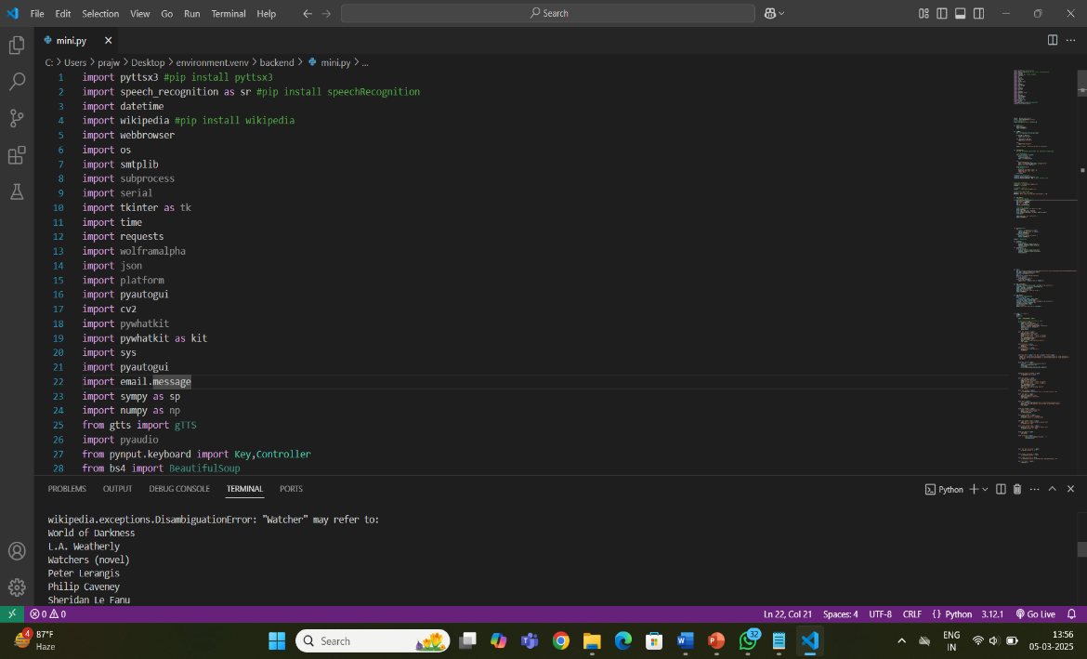

# Fig. 1.2: **Search Wikipedia**

* When we command **“Search YouTube”** the output generated will be as shown below:

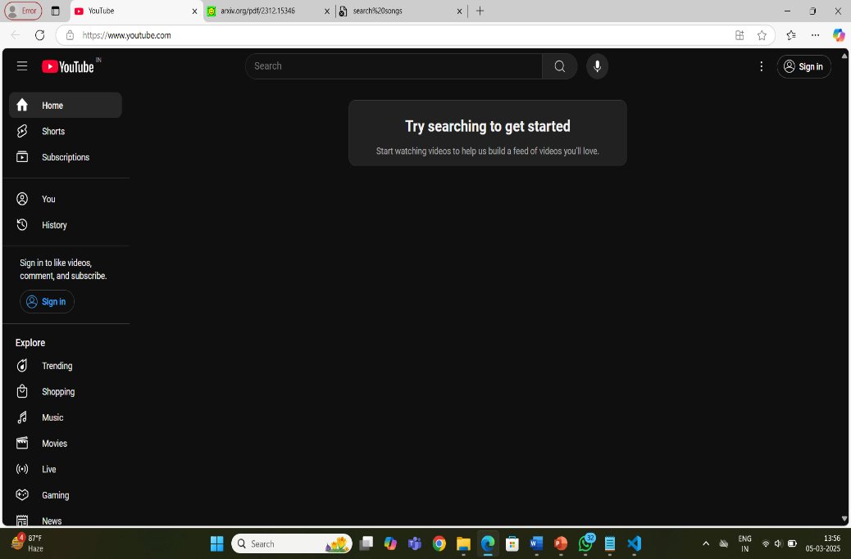

Fig. 1.3 Search You-tube

* **Speech Recognition Module:** Speech recognition is the technology that allows a computer or device to recognize spoken language and convert it into text. Essentially, its "listens" to spoke words, analyzes the sound waves, and then processes these sounds to understand and transcribe the spoken words accurately. In this module there are many sub-modules like play music, who are you, etc., For example:
* When you say **"open notepad"** the software recognizes this as a command to open notepad :
* 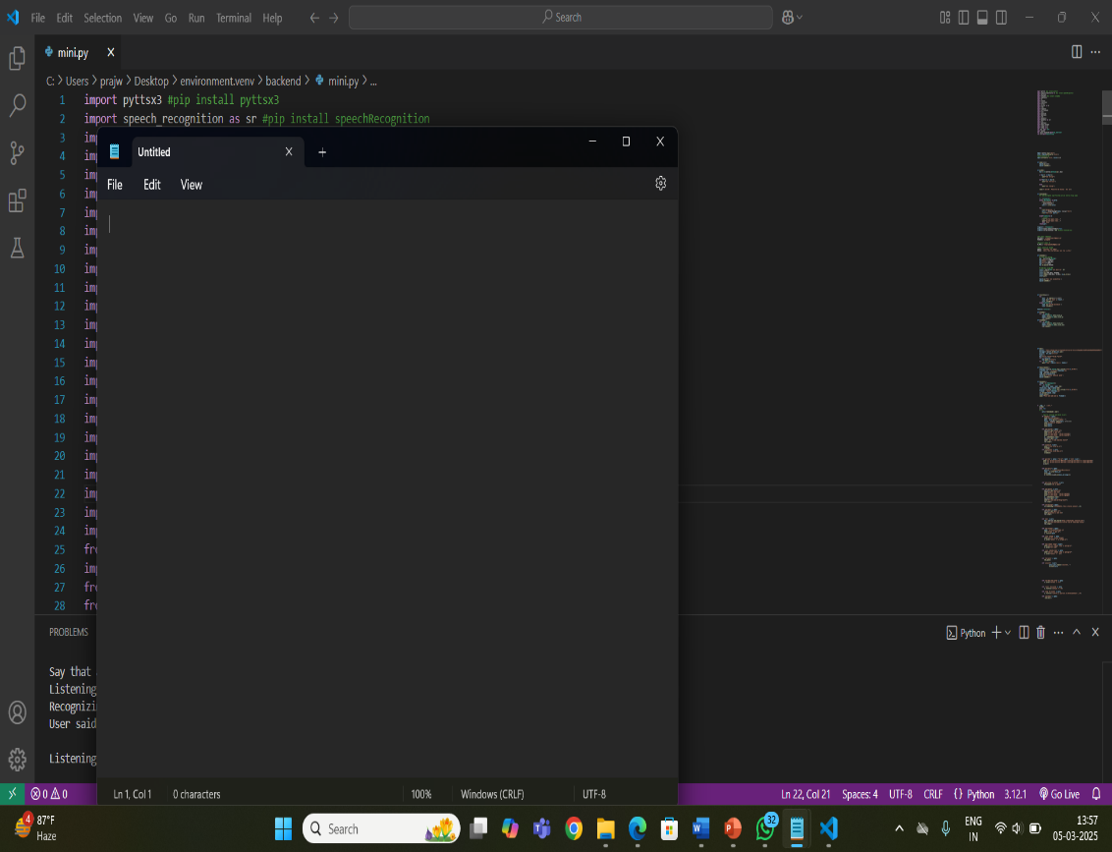

Fig. 1.4: Open Notepad

* When you say **" take screenshot “**th**e** following output is generated**:**

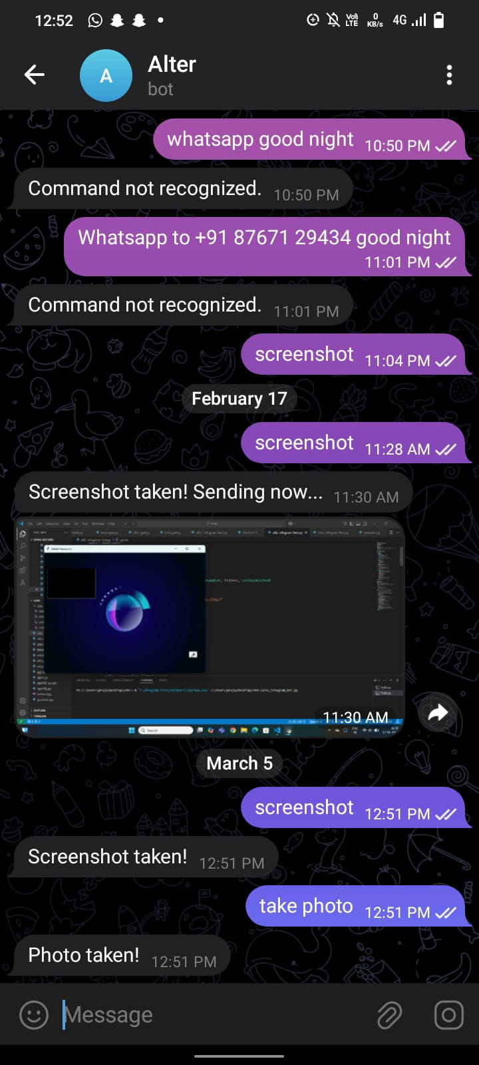

Fig: 1.5 Take screenshot

* **Display Module**: 2.4 Inch Touch Screen TFT Display Shield adds a touch up to your Arduino project with a beautiful large touchscreen display shield with built-in microSD card connection. This TFT display is big (2.2″ diagonal) bright and colorful! 240×320 pixels with individual pixel control. It has way more resolution than a black and white 128×64disply.

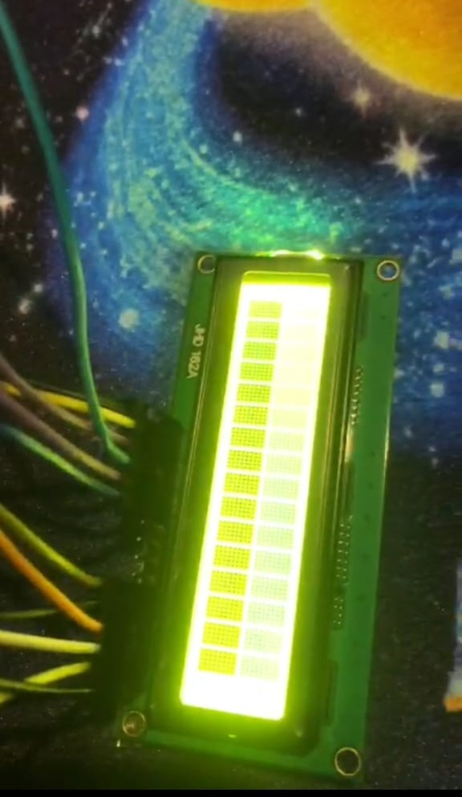

Fig. 1.6: Display Device

* **Microphone:** A microphone is a device that translates sound vibrations in the air into electronic signals and scribes the voices. Microphones enable many types of audio recording devices for purposes including communications of many kinds, as well as music vocals, speech and sound recording.

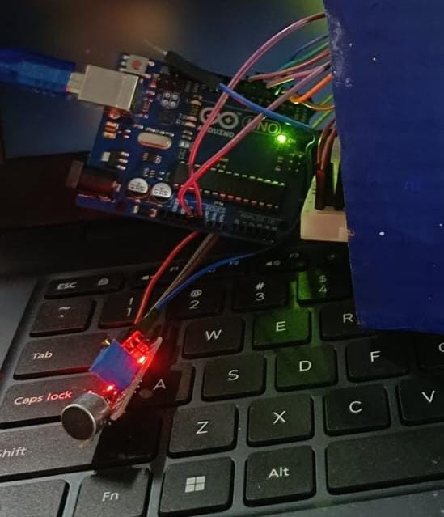

Fig. 1.7: Microphone

1. **CONCLUSION**

The paper explored the development and enhancement of an Advanced Learning and Friendly Assistant. Through improved learning algorithms and task execution strategies, the robot demonstrated increased efficiency, adaptability, and accuracy in performing complex tasks. The presented paper finds and highlight the potential of such systems in real-world applications from automation to human-robot collaboration.

Future search can focus on refining the robot's decision-making capabilities, real-time adaptability and interaction with humans to enhance its effectiveness further. By integrating more advanced AI techniques and expanding its dataset, we can push the boundaries of what such robots can achieve in various domains.

1. **REFERENCES**

1. Staffan Ekvall and Danica Kragic "Robot Learning from Demonstration: A Task-level Planning Approach" – 2019. [journals.sagepub.com](https://journals.sagepub.com)

2. Guanwen Ding, Yubin Liu, Xizhe Zang, Xuehe Zhang, Gangfeng Liu, Jie Zhao "A Task-Learning Strategy for Robotic Assembly Tasks from Human Demonstrations" - National Library of Medicine - 25 Sept 2020. [pmc.ncbi.nlm.nih.gov](https://www.ncbi.nlm.nih.gov)

3. Kazuhiro Sasabuchi, Daichi Saito, Atsushi Kanehira, Naoki Wake, Jun Takamatsu, Katsushi Ikeuchi "Task-sequencing Simulator: Integrated Machine Learning to Execution Simulation for Robot Manipulation" - 03 Jan 2023. [arxiv.org](https://arxiv.org)

4. Chao Zeng, Jing GUO, Qiang Li, Chenguang Yang "Advanced Learning Control in Physical Interaction Tasks" – 24 Feb 2023. [frontiersin.org](https://www.frontiersin.org)

5. Dingkun Guo "Learning Multi-Step Manipulation Tasks from A Single Human Demonstration" - 04 Jan 2024. [arxiv.org](https://arxiv.org)

6. Zhirong Luan, Yujun Lai, Rundong Huang Shuanghao Bai, Yuedi Zhang, Haoran Zhang, Qian Wang "Enhancing Robot Task Planning and Execution through Multi-Layer Large Language Models" - Multidisciplinary Digital Publishing Institute - 06 March 2024. [mdpi.com](https://www.mdpi.com)

7. Asst. Prof. P.B.Jaipurkar, Himanshu P. Maski, Shreyash P. Suryawanshi “N.I.V.A [NEXT-LEVEL INTELLIGENCE VIRTUAL ASSISTANT]” International Research Journal of Engineering and Technology - 09 Sept 2024. [irjmets.com](https://www.irjmets.com)

8. Asst. Prof. P.B.Jaipurkar, Shraddha M. Rangari, Kshitija C. Wanjare "ALFA [Advanced Learning and Task Execution Robot]" - International Research Journal of Engineering and Technology - 09 Sept 2024. [rjmets.com](http://www.rjmets.com)

9. Hengxu Yan, Haoshu Fang, Cewu Lu “Dexterous Manipulation Based on Prior Dexterous Grasp Pose Knowledge “ - 12/2024. [researchgate.net](https://www.researchgate.net)