Review Paper on Three Phase Transmission line fault detection and analysis using GSM module

Department of Electrical Engineering,

Padm. Dr. V. B. Kolte college of Engineering, Malkapur.

**1Roshan Ingale, 2Swapnil Tayade, 3Manish Patil, 4Sakshi Hirole, 5Rohini Ingale, 6Assit.Prof. Nilesh Budukhale**

1,2,3,4,5, Students, 6Asst. Professor

**ABSTRACT**

Transmission line is the most crucial device of the power system. The power and commitment requirement had developed up to an exponential scale with regard to the recent system, and the most crucial operation of a transmission line is to transfer electric power from the source point to the distribution system. The explode between limited production, and a colossal claim has enhanced the priority of reducing power losses. Losses such as transmission loss and also the supposed factors as much as possible nearest to the physical losses other than technical losses, another parameter is the foremost factor it possess the reactive power and voltage deviation are significant for long-distance power line transmission. Fault analysis is a critical focusing problem in power system engineering in virtual to remove fault in short time and return to normal power system as early as possible with nearly no interruption. Fault detection, however, line breaking the transmission line is also challenging task to study fault as well as to enhance the reliability of the system. The GSM module served to transmit information to the relevant authorities.

**Keywords:** GSM Module, Arduino uno, Relay, 16*2 CH LED, LL, LG, LLL, Transmission line, etc.

1 **INTRODUCTION:**

Transmission line is the most critical part of the power system. The power demand and commitment have grown exponentially compared to the recent system, and the most critical function of a transmission line is to transmit electric power from the source point to the distribution system. The explode between limited production, and a tremendous claim has raised the focus of minimizing power losses. A smart GSM based fault detection and location system was utilized to sufficiently and precisely signal and pinpoint where fault had occurred. The system utilizes a Arduino, LCD, Sensors and a GSM modem. Losses like transmission loss and also presume factors as alike as physical losses to other technical losses, another factor is the major factor it has a reactive power and voltage deviation are crucial in the long-distance transmission power line. Fault analysis is a highly focused problem in power system engineering in virtually to eliminate fault within short time and restore power system as soon as possible with minimum interruption. The detection of fault, however, breaking the transmission line is also tough task to study fault as well as to improve the reliability of the system.

**2 LITERATURE REVIEW:**

1. D. B. “Transmission Line Fault Detection Using Wavelet Transform”.
2. International Journal on Recent and Innovation Trends in Computing and Communication, vol. 2, no. 10, Oct. 2014, pp. 3138-42, doi:10.17762/ijritcc. v2i10.3364.
3. Fault Detection and Classification in Three Phase Transmission Line Using Signal Processing (Dr.D.Kavitha, May 2018)
4. GuruprasadP. Sail, Mohini J. Deshmukh, Mrunalini S. Wankhede, Bipasa B. Patra, "Smart GSM MODULE Automation for Advanced Home Security”, International Journal of Engineering Research in Electrical and Electronic Engineering (IJEREEE), Vol 6, Issue 4, IFERP, April 2020, ISSN (Online) - 2395-2717, pp.1-6, doi: 01.1617/vol7/iss4/pid45820
5. .Dhawale, Vishvadeep J., Vishal Dake, and Prafulla A. Desale. "Blocking the Distance Relay 3rd Zone Operation during Power Swings by DTLR Enhancement in MATLAB/Simulink." International Journal of Electronic and Electrical Engineering. Vol. 7. No. 7. International Research Publication House, 2014. 757-765.
6. Transmission and fault detection and classification (Manohar singh, Dr.B.k panigrahi, Dr.R.P Maheshwari, Member I EEE)
7. Transmission line fault detection using wavelet transform (Anurag.D.Borkhade, Assistant Professor)
8. Aurdino based autorecloser for three phase AC system (Rajeev valunjkr 2017)
9. Bipasa Bimalendu Patra “Necessity for future smarter nation with Sustainable Trend- Smart Grid”, PRATIBHA: International Journal of Science, Spirituality, Business and Technology (IJSSBT), Vol. 6, No. 2, September 2018, pp. 35- 41, ISSN (Print) 2277-7261

**3 FAULT CATEGORIZATION:**

Symmetric faults in a three-phase system, if the fault is equally affecting all three phases, then it is referred to as a symmetric or a balanced fault. faults an unbalanced fault or asymmetric fault causes unequal impact of fault on each of the three phases. Symmetric faults typically account for around 5% of the total faults. Asymmetric Asymmetric faults are also categorized as LL or Line to Line fault, LG or Line to Ground fault and LLG or Double Line to Ground fault.

•Fault of Line to Line is a short circuit between two lines, due to ionization of air, or when lines make physical contact with each other, for instance, due to broken insulator.

• LG Fault is a one-line to ground short circuit resulting from physical contact through lightning or storm.

• LLG fault is developed when two lines are in contact with the ground and with each other. Storm damage is responsible for this predominantly. Transient faults in a circuit, when a fault decreases with the power disconnection for some short interval and then connected back, the fault is called a transient fault.

**4 MAJOR COMPONENTS USED:**

**Arduino Uno Controller:** Arduino Uno controller is a central part of the mission. All the sensors are attached to the Arduino and it regulates all sensors by providing instructions. using the use of Arduino, we can accomplish all things at low cost. Arduino contains analogy and virtual pins through which we will handle the challenge in terms of providing inputs in analogy as well as digital form. Current Sensor: On this task we have utilized.

**GSM Module**: A GSM module is a device that allows electronic devices to communicate with each other over the GSM network. GSM is a standard for digital cellular communications, which means that it provides a platform for mobile devices to communicate with each other wirelessly.

**5 PROPOSE METHODOLOGY:**

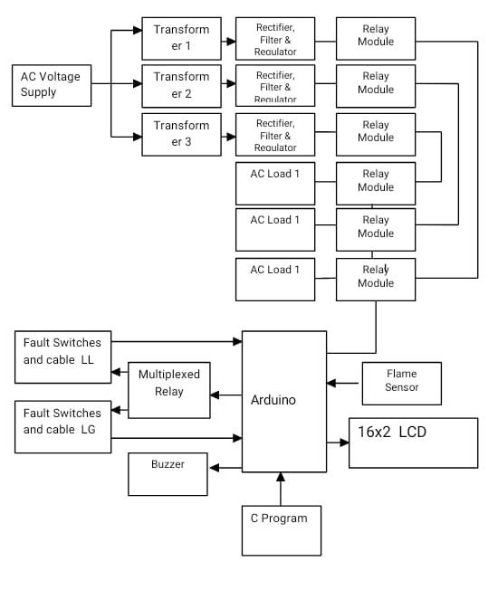

**1.Arduino:**

A dialect of components from the programming languages C and C++ are normally used to programme microcontrollers. The Arduino project features an integrated development environment (IDE) built on top of the Processing language project as well as working with standard compiler toolchains. A manufacturer of single-board microcontrollers and microcontroller kits for building digital devices and interactive objects that can sense and be controlled physically as well as digitally, Arduino is an open-source software and hardware company, project, and community of users. Because of its products' GNU Lesser General Public License (LGPL) or GNU General Public License (GPL) licensure, anyone may manufacture Arduino boards and redistribute software. Commercially, Arduino boards are available as assembled or as kits for assembly by the user. Various microprocessors and controllers are employed in the designs of Arduino boards. A range of expansion boards, breadboards (shields), and other circuits may be connected to the boards' sets of digital and analogue input/output (I/O) pins. The boards include serial communications interfaces that allow for loading software from personal computers, such as on some models, Universal Serial Bus (USB).

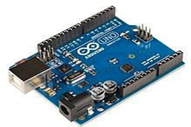

Fig. 1

**2. GSM Module:**

GSM, or Global System for Mobile communications, is the prevalent (major) world's most popular cell phone technology. Cell phones use a cell phone service carrier's GSM network by searching for cell phone towers nearby. Global system for mobile communication (GSM) is a globally used standard for digital cellular communication. A GSM compresses and digitizes the data and then sends it down in a channel with two client data streams, each of which is allocated to a unique time slot. The digital system is capable of transporting 120 Mbps to 64 kbps of data rates. There are several cell sizes in a GSM network such as macro, micro, pico, and umbrella cells. All cells vary based on the region. There are five different cell sizes in a GSM network macro, micro, pico, and umbrella cells

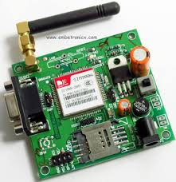

Fig. 2

**3. Relay Module:**

Relay modules serve as interface devices that enable the transfer of signals and information between different devices or systems. They act as a bridge, allowing low-powered digital electronics, such as microcontrollers like Arduino or Raspberry Pi, to control high-powered devices like motors or lighting circuits.

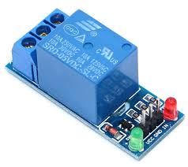

Fig.3

**4 Buzzer:**

A buzzer or beeper is a sound-signal device that is either mechanical, electromechanical, or piezoelectric (and more commonly just "piezo"). Common applications for buzzers and beepers include alarm units, timers, trains and user-input confirmation of, for instance, a click on a mouse or a press on a keyboard.

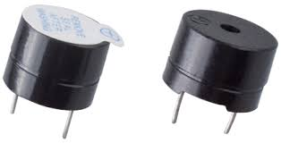

Fig. 4

**6 WORKING PRINCIPLE:**

We have established the connection as per the circuit diagram, here we have employed three 12volt step down transformer as one for one phase indication. Output of the transformers is given to the rectifier and filter circuit. The LCD connected to indicate the distance of faults in km. The circuit includes the power supply, 16x2 display, microcontroller and resistance measurement circuit. Fault switches are employed to induce faults manually in the kit. Approximately 12 fault switches are employed that are placed in three rows each with 4 switches. The open circuit faults can also be anticipated by depressing the switches which are located close to tower, after depressing each switch the corresponding phase load will be switched off. The flame sensor connected to Arduino to sense the fire, if fire catches by short circuit condition, then the controller will instruct to switch off all loads.

**7 ADVANTAGES**:

* Detect a exact fault location and actual fault
* Reduce a Human efforts
* Improve the system quality

**8 PROPOSE CONCLUSION:**

This research indicates approximately the earth fault conducted for different points along the overhead transmission line for different types of the faults. In this overhead transmission are categorized line four types of faults i.e. L-G, 2L-G, 3L-G and three phase faults have been Distance considered at 12 km into this work and here four fault namely as single line ground fault, Double line to ground faults, Triple line to ground faults and LL-L faults are comparison and detection has been indicating by this study with their proposed work.

**9 REFERENCES:**

1. D. B. “Transmission Line Fault Detection Using Wavelet
2. Transform”. International Journal on Recent and Innovation Trends in Computing and Communication, vol. 2, no. 10, Oct. 2014, pp. 3138-42, doi:10.17762/ijritcc.v2i10.3364.
3. Fault Detection and Classification in Three Phase Transmission Line Using Signal Processing (Dr.D.Kavitha, May 2018)
4. Guruprasad. Sail, Mohini J. Deshmukh, Mrunalini S. Wankhede, Bipasa B. Patra, "Smart GSM MODULE Automation for Advanced Home Security”, International Journal of Engineering Research in Electrical and Electronic Engineering (IJEREEE), Vol 6, Issue 4, IFERP, April 2020, ISSN (Online) - 2395-2717, pp.1-6, doi: 01.1617/vol7/iss4/pid45820
5. Dhawale, Vishvadeep J., Vishal Dake, and Prafulla A. Desale. "Blocking the Distance Relay 3rd Zone Operation during Power Swings by DTLR Enhancement in MATLAB/Simulink." International Journal of Electronic and Electrical Engineering. Vol. 7. No. 7. International Research Publication House, 2014. 757-765.
6. Transmission and fault detection and classification (Manohar singh, Dr.B.k panigrahi, Dr.R.P