“WhatsApp Clone”

Arpita Dongale¹, Sou. Venutai Chavan Polytechnic, Pune, India.
Samruddhi Navghane², Sou. Venutai Chavan Polytechnic, Pune, India.
Pallavi Dalvi³, Sou. Venutai Chavan Polytechnic, Pune, India.
Prof. S. S. Vellapure⁴, Sou. Venutai Chavan Polytechnic, Pune, India.

Abstract: This project focuses on developing a WhatsApp Clone application, a real-time messaging platform that mimics the core features and functionalities of WhatsApp, but serves as an academic project for understanding mobile application development, networking, and cloud technologies. The application aims to provide instant messaging, voice and video calls, group chats, media sharing (such as images, videos, and documents) and status updates. The new feature in this project is Image Steganography & Video call filters. Image Steganography is like in personal chats, we will take an image and create a password in it and send it. A code like password will be sent then your secret chat will start.
The project leverages technologies such as React Native, JavaScript, XML Sheet for the mobile app's user interface (UI), Node.js and Express.js for the backend server, and Socket.IO for real-time communication. The data is stored in a MongoDB database, ensuring scalability and efficiency in managing user data, messages, and media. There will be End-to-End Encryption. Only the sender and recipient will be able to read the message. In this WhatsApp Clone you will get new feature i.e. Image Stegnography which will help to secure your important documents. And Video Call where you can get exciting filters.

Introduction

Instant messaging apps have become an integral part of modern communication providing a convenient and efficient way to stay in touch with friends family and colleagues. Whatsapp a popular instant messaging app owned by Facebook, has dominated the market for several years with over 2 billion monthly active users worldwide. Its success can be attributed to its wide range of features, including End-To-End encryption, voice and video calls, group chats, and location sharing. However, in recent years, several clones of Whatsapp, such as Telegram, signal, and Wechat, have emerged and are gaining popularity due to their unique features and focus on security and privacy. One of the key Features that sets Whatsapp apart from its clones is its end-to-end encryption, which ensures that only the sender and receiver of a message can read it. Telegram and signal also offer end-to-end encryption, but we chat does not offer this level of security.

In addition, Telegram offers the ability to create large groups of up to 200,000 members while signal focuses on privacy and security, offering features such as disappearing messages and the ability to blur faces in photos. Another factor that distinguishes WhatsApp from its clones is its massive user base. With over 2 billion monthly active users, WhatsApp has dominated the messaging app industry for several years. However, Telegram and signal have significantly smaller user bases, but are gaining popularity due to their emphasis on privacy and security. Furthermore, WhatsApp and its clones differ in terms of their monetization strategies.

WhatsApp is free to use and does not display ads, but is owned by Facebook, which uses data from WhatsApp for advertising purposes. Telegram is also free to use and does not display ads, but offers premium features for a fee. Signal, on the other hand, is a non-profit organization and relies on donations from its users. Given the increasing importance of instant messaging apps in modern communication, it is important to understand the similarities and differences between WhatsApp and its clones. This research paper aims to provide a comprehensive analysis of WhatsApp and its clones, focusing on their features, security and privacy measures, user base, and monetization strategies. By comparing and contrasting these messaging apps, this study aims to provide insights into their impact on the market and their implications for users.

Problem Statement:

In today's digital world, effective communication is vital for personal, professional, and social interactions. While popular messaging platforms like WhatsApp dominate the market, many organizations and businesses require customized solutions tailored to specific needs such as enhanced privacy, unique features, or integrations with their existing systems.

The problem lies in the inability of mainstream messaging platforms to offer the flexibility and control that certain organizations need, whether for privacy-focused communication, secure enterprise collaboration, or niche community management. This leads to a demand for a scalable, customizable, and secure messaging application that can provide similar functionality to WhatsApp but allows for customization in terms of features, user interface, and data management.

Literature Survey:

Prof.S.S.Kadam, Amruta Dongare, Jyoti Ekad, Sakshi Rudrakanthwar, Priti More, Madhuri Dongare, “An Eminent Model of WhatsApp Clone using Android Cloud”, Volume 3, Issue 8, May 2023, ISSN (Online) 2581-9429.

The paper presents a model for developing a WhatsApp clone using Android cloud infrastructure. It aims to replicate WhatsApp's key features, like real-time messaging, multimedia sharing, and secure communication, while leveraging cloud technology for scalability, flexibility, and enhanced user experience. The model integrates robust encryption for security, supports cross-device synchronization, and includes cloud-based storage for media and messages. The paper also emphasizes the importance of performance evaluation and scalability, showcasing cloud computing’s role in handling large user bases. Future research could enhance this model by incorporating advanced cloud features, cross-platform compatibility, and AI-driven functionalities.

Azhar Ashraf, “WhatsApp Clone for Cross-Platform”, Volume 10, Issue 4, April 2023, ISSN-2349-5162

The paper compares the features, security, and usability of popular messaging apps such as WhatsApp, WeChat, Telegram, and Signal. It highlights the growing importance of instant messaging in personal and business communication, with a focus on privacy and user base differences. While WhatsApp leads with its large user base and end-to-end encryption, Telegram offers larger groups, and Signal emphasizes privacy with disappearing messages. The paper also

discusses the role of APIs and third-party tools in analyzing communication patterns while stressing ethical concerns regarding data privacy and security in such analysis. in China, with over 1 billion active users. In a study by Shi et al. (2018), the authors analysed WeChat data to identify important dates, such as birthdays and anniversaries. The study used machine learning algorithms to classify messages based on their content, and the results showed that the analysis of WeChat data can be used to infer social relationships and understand user behaviour.

Problem Solution:

In today's digital world, effective communication is vital for personal, professional, and social interactions. While popular messaging platforms like WhatsApp dominate the market, many organizations and businesses require customized solutions tailored to specific needs such as enhanced privacy, unique features, or integrations with their existing systems.

VI. Scope of Project:

The WhatsApp clone project has a strong foundation with its core features, but there are several areas for future improvement and expansion. The following are some potential future enhancements and developments:

1. AI Integration 5. Business Solutions

2. Multi-Platform Support

3. Personalization Options

4. Integration with Other Apps

VII. System Architecture:

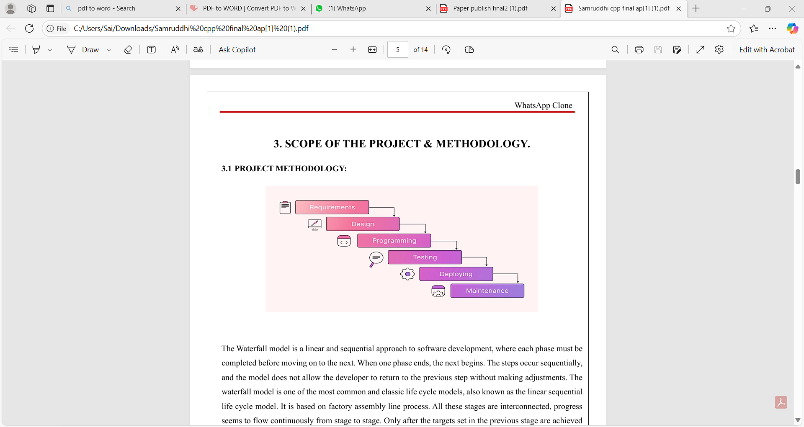

VIII. Conclusion:

The development of the WhatsApp clone project has been a valuable learning experience that allowed us to explore the complexities involved in creating a real-time messaging platform. Through this project, we successfully implemented core features such as user authentication, one-on-one and group messaging, multimedia sharing, and real-time notifications. The project helped us enhance our skills in various technologies, including WebSockets for real-time communication, Firebase/MongoDB for database management, and JWT for secure user authentication. It also exposed us to cloud services and mobile development frameworks, highlighting the importance of performance optimization, scalability, and security in app development.

Despite facing challenges in ensuring real-time performance, handling large media files, and implementing secure data management, we were

able to find effective solutions that allowed us to meet the core objectives of the project. We also identified potential areas for future enhancement, such as integrating end-to-end encryption for message security and adding support for voice and video calling. The WhatsApp clone project provided an in-depth understanding of how modern messaging applications work and equipped us with practical knowledge in full-stack development, making it a rewarding endeavor.

IX. References:

A. Krizhevsky, I. Sutskever, and G. E. Hinton, "ImageNet Classification with Deep Convolutional Neural Networks," Communications of the ACM, vol. 60, no. 6, pp. 84-90, Jun. 2012.

Y. LeCun, Y. Bengio, and G. Hinton, "Deep learning," Nature, vol. 521, no. 7553, pp. 436-444, May 2015.

A. Zisserman, A. Vedaldi, and A. Farhadi, "Deep image retrieval: Learning global representations for image search," Proceedings of the IEEE Conference on Computer Vision and Pattern Recognition (CVPR), pp. 1-8, 2015.

S. Hochreiter and J. Schmidhuber, "Long Short-Term Memory," Neural Computation, vol. 9, no. 8, pp.

