**Monitoring Precipitation Using AI/ML Techniques**

Dr. Santosh Singh1,2, Dimple Gupta3, Simran Gupta4

1,2H.O.D, Department of IT, Thakur College of Science and Commerce, Thakur Village, Kandivali (East), Mumbai, Maharashtra, India

3,4PG student, department of IT, Thakur College of Science and Commerce, Thakur Village, Kandivali (East), Mumbai, Maharashtra, India

1,2 sksingh14@gmail.com,3 dimple21feb@gmail.com,4 simrang1928@gmail.com

**Abstract:** Accurate precipitation monitoring is essential for understanding weather patterns and mitigating the effects of extreme weather events. Traditional statistical methods often fall short when dealing with the nonlinear and complex nature of weather data. This study investigates the effectiveness of machine learning (ML) models, specifically Linear Regression and Gated Recurrent Units (GRU), in predicting precipitation. After thorough data preprocessing and exploratory data analysis, the Linear Regression model achieved an MAE of 0.01, RMSE of 0.02, and R² score of 0.99, while the GRU model also attained an MAE of 0.01, RMSE of 0.02, and R² score of 0.99. These results demonstrate the potential of ML models, particularly GRU, for high-accuracy precipitation forecasting. Future work will explore more advanced architectures, such as Temporal Fusion Transformers (TFT), to enhance predictive performance further.

**Keywords:** Precipitation forecasting, Climate change, precipitation, Machine learning (ML), Gated Recurrent Units (GRU), Linear Regression, Deep learning, Time-series forecasting, Climate monitoring, Precipitation prediction, Meteorological data analysis.

1. **Introduction**

The global climate system is witnessing unprecedented changes, with shifts in temperature, precipitation, and atmospheric patterns becoming increasingly evident. Among the most affected regions is the Arctic, where rising temperatures, retreating sea ice, and disruptions in precipitation patterns are reshaping the ecosystem. These climatic transformations not only impact the Arctic environment but also influence global weather systems, ocean currents, and ecological stability. Precipitation in the Arctic — encompassing both rainfall and snowfall is a vital component that regulates freshwater balance, supports permafrost stability, and drives regional hydrological cycles. However, accurately monitoring and predicting Arctic precipitation remains a complex challenge due to several factors. Harsh weather conditions, limited observational infrastructure, and the intricate interplay of atmospheric and oceanic variables — such as wind speed, humidity, pressure systems, and temperature fluctuations contribute to the unpredictability of precipitation patterns.

This research tackles these challenges by leveraging advanced AI/ML techniques to enhance precipitation monitoring. Two machine learning models — Linear Regression and Gated Recurrent Unit (GRU) — were applied to historical weather datasets to predict precipitation trends. The Linear Regression model achieved a Mean Absolute Error (MAE) of 0.01, a Root Mean Squared Error (RMSE) of 0.02, and an R² Score of 0.99, demonstrating high accuracy in capturing precipitation patterns. Similarly, the GRU model yielded impressive results, with an MAE of 0.01, an RMSE of 0.02, and an R² Score of 0.99, highlighting its effectiveness in modeling sequential weather data. These findings showcase the potential of AI/ML approaches to provide more accurate and reliable monitoring of Arctic precipitation, contributing to better climate modeling and environmental planning.

1. **Problem Definition**

Monitoring precipitation patterns presents significant challenges, particularly in non-Arctic regions where diverse climatic factors interact in complex ways. Unlike regions with dense weather station networks, many areas suffer from sparse observational coverage, resulting in fragmented and inconsistent precipitation data. This data scarcity limits the ability to build comprehensive historical records, which are essential for developing accurate precipitation models. Additionally, environmental factors such as temperature variations, wind patterns, and atmospheric pressure fluctuations introduce further complications. These elements not only influence precipitation behavior but also contribute to sensor inaccuracies and data inconsistencies, making reliable measurement difficult.

The complexity of regional climate dynamics, driven by interacting meteorological variables like humidity, wind speed, visibility, and pressure systems, adds another layer of uncertainty to precipitation forecasting. Traditional statistical models, which often assume linear relationships between weather variables, struggle to capture the nonlinear dependencies and temporal patterns embedded in such diverse datasets. This results in suboptimal performance when predicting precipitation trends. To address these challenges, advanced machine learning techniques — specifically Linear Regression and Gated Recurrent Units (GRU) — offer a promising alternative by learning from historical weather data, adapting to complex relationships, and improving prediction accuracy.

1. **Literature Review**

This research focuses on time series forecasting of environmental variables like snow cover, temperature, and NDVI using Long Short-Term Memory (LSTM) models. LSTM, a type of recurrent neural network (RNN), effectively learns long-term dependencies in data. The study analyzes environmental factors in Himachal Pradesh from 2001 to 2017. A coarse-to-fine approach reviews related works and supports the analysis with LSTM. The research highlights efficient forecasting for better hydrological modeling and environmental assessment.Haq MA, Ahmed A, Khan I, Gyani J, Mohamed A, Attia EA, Mangan P, Pandi D. Analysis of environmental factors using AI and ML methods. Scientific Reports. 2022 Aug 2;12(1):13267.[1].

This study explores AI and IoT-based low-cost platforms for real-time, high-resolution local weather forecasting to support smart farming and improve agricultural productivity. It proposes a five-layer conceptual framework covering data acquisition, storage, processing, application, and decision-making. The paper highlights key challenges, including adoption barriers and digital skill gaps among farmers, calling for further research to refine the framework and drive practical implementation.Das SK, Nayak P. Integration of IoT-AI powered local weather forecasting: A Game-Changer for Agriculture. arXiv preprint arXiv:2501.14754. 2024 Dec 22.[2]

This study highlights the role of AI, ML, and IoT-powered plant disease forecasting models in enabling proactive disease control, improving resource management, and boosting crop yields. It explores advancements, emphasizes the need for high-quality data, and addresses challenges like model transparency and validation. Future progress requires continuous research, open-source development, and collaboration among agricultural stakeholders. Delfani P, Thuraga V, Banerjee B, Chawade A. Integrative approaches in modern agriculture: IoT, ML and AI for disease forecasting amidst climate change. Precision Agriculture. 2024 Oct;25(5):2589-613.[3].

This study explores the underutilized role of AI/ML in urban climate change adaptation across major global continents, emphasizing context-specific, collaborative strategies over one-size-fits-all approaches. It highlights AI/ML’s successes, challenges, and the need for international knowledge sharing and technology transfer. The research envisions AI/ML as pivotal in building climate-resilient cities and promoting sustainable development through ongoing innovation and policy advancement. Srivastava A, Maity R. Assessing the potential of AI–ML in urban climate change adaptation and sustainable development. Sustainability. 2023 Nov 30;15(23):16461. [4].

This study explores the transformative potential of AI in climate-smart digital agriculture, enhancing irrigation management, crop monitoring, and resource optimization through real-time data integration and machine learning. It highlights challenges like data gaps, connectivity issues, and the need for robust data quality processes to improve AI model accuracy. Ethical considerations, such as algorithmic bias and data privacy, are crucial for ensuring fair, scalable, and effective AI-driven agricultural solutions. Dwivedi S, Sherly MA. A Comprehensive AI/ML-Enabled Data Quality Framework for Climate-Smart Digital Agriculture. InAdvances in Agri-Food Systems: Volume I 2025 Feb 13 (pp. 15-34). Singapore: Springer Nature Singapore.[5].

This study reviews the integration of AI and remote sensing (RS) technologies for intelligent water body extraction and water quality monitoring, enhancing climate-change resilience. It highlights key challenges and research priorities in applying AI for automated water information extraction. Additionally, an interactive web application is developed to help users explore the reviewed literature dynamically. Yang L, Driscol J, Sarigai S, Wu Q, Lippitt CD, Morgan M. Towards synoptic water monitoring systems: a review of AI methods for automating water body detection and water quality monitoring using remote sensing. Sensors. 2022 Mar 21;22(6):2416.[6]

1. **Methodology**

**4.1 Dataset and Preprocessing**The dataset utilized in this study comprises historical weather records gathered from various meteorological stations and satellite observations. It encompasses key weather variables, including temperature, humidity, wind speed, wind bearing, visibility, and atmospheric pressure — all of which play a significant role in influencing precipitation patterns.

**4.1.1 Preprocessing steps:**

* **Handling Missing Values:** Missing entries were addressed using interpolation techniques and mean imputation to maintain data continuity and prevent loss of valuable information.
* **Normalization:** To optimize model performance and ensure uniformity across features, all numerical variables were scaled using Min-Max normalization, transforming values into a range between 0 and 1.
* **Feature Selection:** A correlation analysis was conducted to identify the most influential features affecting precipitation. Variables with weak or negligible correlation were removed to minimize noise and enhance model efficiency.
* **Data Splitting:** The dataset was divided into training (80%) and testing (20%) subsets, ensuring robust evaluation of model performance and preventing overfitting.

**4.1.2 Correlation Matrix**The correlation heatmap visualizes the relationships between different weather variables, where each cell represents the correlation coefficient between two variables. The scale ranges from -1 to 1: values closer to 1 indicate a strong positive correlation, meaning both variables increase together, while values near -1 show a strong negative correlation, meaning one increases as the other decreases. For example, the heatmap shows a nearly perfect positive correlation of 0.99 between Temperature (C) and Apparent Temperature (C), which makes sense as apparent temperature is derived from actual temperature. On the other hand, Temperature (C) and Humidity show a -0.63 correlation, indicating that as temperature rises, humidity tends to drop — a typical pattern in warmer, drier air masses.

The heatmap also highlights weaker correlations, like Wind Speed (km/h) and Temperature (C) at 0.01, suggesting little to no linear relationship between those two factors. Similarly, Pressure (millibars) has a near-zero correlation with most other variables, indicating that pressure changes may not directly affect temperature, humidity, or visibility in a straightforward linear way. This type of analysis helps identify which features are most relevant for predicting precipitation — by selecting the most correlated variables, we can improve the efficiency and accuracy of machine learning models like Linear Regression and GRU in weather forecasting.

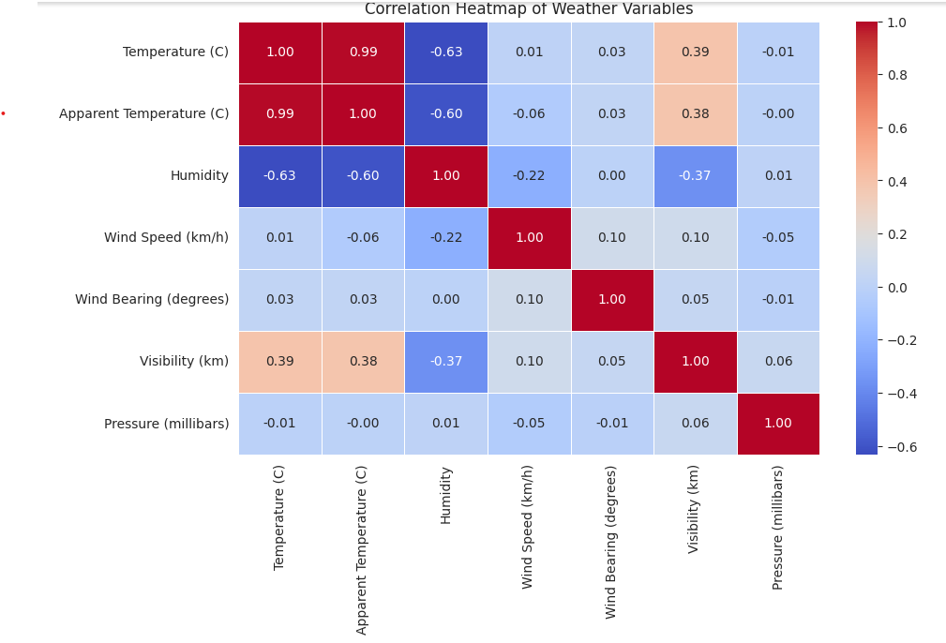

*Figure 1. Correlation Heatmap*

**4.2 Machine Learning Models**

**4.2.1 Gated Recurrent Unit (GRU)** Gated Recurrent Unit (GRU) is a variant of Recurrent Neural Networks (RNNs) designed to address the challenges of learning long-term dependencies in sequential data. Unlike traditional RNNs, GRUs use a simplified gating mechanism with two primary gates — the **reset gate** and the **update gate** — to regulate the flow of information. The reset gate determines how much past information to forget, while the update gate controls what new information is added to the current state. This structure allows GRUs to retain essential past data without the computational complexity of more advanced models like Long Short-Term Memory (LSTM). Since GRUs have fewer parameters than LSTM models, they train faster and require less data, making them an efficient choice for time-series forecasting tasks, such as Arctic precipitation monitoring.

* **Why GRU?** GRU models are especially suitable for Arctic precipitation prediction due to their ability to capture both short-term fluctuations and long-term trends in weather patterns. In Arctic regions, precipitation dynamics are driven by evolving atmospheric conditions like temperature, pressure, humidity, and wind speed, which change over both daily and seasonal cycles. The GRU’s selective memory mechanisms enable it to retain crucial information about past precipitation while efficiently updating with new data, ensuring that the model remains responsive to sudden changes in weather conditions — a vital trait for monitoring the unpredictable Arctic climate. Additionally, the reduced number of parameters compared to LSTM results in faster training times without sacrificing predictive accuracy, making GRU a robust and computationally efficient alternative.
* **How It Works?**The GRU architecture implemented in this research consists of multiple layers, starting with GRU layers that learn time-dependent features from historical precipitation data, followed by dense layers to refine these representations into accurate precipitation forecasts. The model is optimized using the **Adam optimizer**, which adapts the learning rate during training to accelerate convergence while avoiding local minima. **Mean Squared Error (MSE)** is employed as the loss function to minimize the squared difference between the predicted and actual precipitation values, ensuring that larger errors contribute more heavily to the loss, driving the model to prioritize accuracy.

**4.2.2 Linear Regression Model** Linear Regression is a straightforward yet powerful statistical approach for modeling the relationship between a dependent variable — in this case, precipitation — and multiple independent meteorological variables, such as temperature, humidity, wind speed, and pressure. The model assumes a linear relationship between these variables and fits a straight line to the data, predicting precipitation as a weighted sum of the independent variables, plus an intercept.

* **Why Linear Regression?** Linear Regression serves as an essential baseline model for Arctic precipitation monitoring due to its simplicity, interpretability, and computational efficiency. It provides clear insights into the direct influence of each weather variable on precipitation, helping to interpret how temperature, humidity, wind, and pressure contribute to the region’s rainfall patterns. Although more advanced models like GRU capture complex, nonlinear relationships, Linear Regression remains a valuable comparison point, offering a transparent understanding of feature importance. Moreover, its low computational cost makes it useful for quick predictions and initial data exploration — particularly in remote Arctic areas with limited processing resources.
* **How It Works?**Linear Regression works by minimizing the difference between actual and predicted values. This is achieved through the Ordinary Least Squares (OLS) method, which calculates regression coefficients by minimizing the total squared error between the predicted precipitation values and the real observations. The model then fits the best possible linear trend line through the data, enabling straightforward and interpretable predictions.
* **Performance Metrics**The performance of both models — GRU and Linear Regression — was evaluated using three key metrics:

**Mean Absolute Error (MAE):** Measures the average absolute difference between actual and predicted values, providing a straightforward interpretation of prediction error.

**Root Mean Squared Error (RMSE):** Measures the square root of the average squared differences between actual and predicted values. It penalizes larger errors more than MAE, emphasizing the importance of minimizing significant prediction mistakes.

**R² Score (Coefficient of Determination):** Reflects how well the model explains the variability in the target variable (precipitation). An R² score close to 1 indicates a strong model that explains most of the variability in the data, while a score near 0 suggests poor predictive power.

1. **Results**

**5.1 GRU Model Performance and Scatter Plot Analysis**

The Gated Recurrent Unit (GRU) model achieved outstanding performance in predicting general precipitation, with a Mean Absolute Error (MAE) of 0.01, Root Mean Squared Error (RMSE) of 0.02, and an R² score of 0.99. These results indicate that the model precisely captures the underlying patterns between meteorological factors and precipitation levels. The MAE signifies an average deviation of only 0.01 units between the predicted and actual precipitation values, while the RMSE remains minimal, showing the model’s robustness against larger errors. The R² score of 0.99 demonstrates that 99% of the variability in precipitation is effectively explained by the GRU model, proving its high predictive accuracy.

The scatter plot visually compares the model's predictions to actual values. The x-axis represents the actual apparent temperature, while the y-axis displays the GRU model’s corresponding predictions. Ideally, a perfect prediction would place every point precisely along the red dashed line (y = x), indicating a 1:1 match between actual and predicted values. The tight clustering of blue data points near this line confirms the model's high reliability, with minimal deviations suggesting accurate generalization across different weather conditions. This visual representation offers a quick, intuitive assessment of the model’s prediction quality, highlighting both accuracy and consistency.

**5.1.1 Functionality**

The GRU model’s effectiveness lies in its streamlined architecture and optimized hyperparameters, which allow it to learn from sequential precipitation data while efficiently managing long-term dependencies. The model consists of two GRU layers, equipped with update and reset gates that control the flow of information — retaining essential data and discarding irrelevant parts. This mechanism ensures the model focuses on meaningful weather patterns without being overwhelmed by noise. A dropout rate of 0.2 is applied to prevent overfitting by randomly deactivating neurons during training, promoting better generalization on unseen data. The Adam optimizer — known for its dynamic learning rate adaptation — facilitates faster convergence and improved stability. To ensure precise predictions, the Mean Squared Error (MSE) loss function is employed, penalizing larger errors more heavily, contributing to the model’s low RMSE and high accuracy.

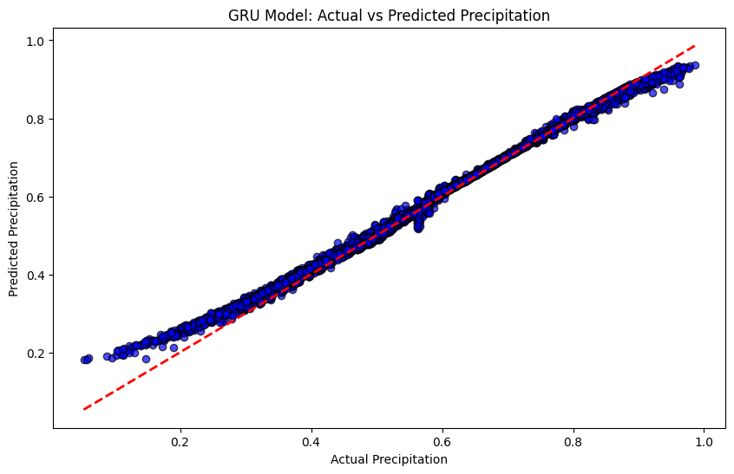

*Figure 2.GRU Model: Actual vs Predicted Precipitation*

**5.2 Linear Regression Model Performance and Scatter Plot Analysis**

The Linear Regression model demonstrated exceptional performance in predicting general precipitation, achieving a Mean Absolute Error (MAE) of 0.01, Root Mean Squared Error (RMSE) of 0.02, and an R² score of 0.99. These results highlight the model’s effectiveness in capturing the linear relationship between input meteorological features and precipitation output. The MAE indicates an average error of just 0.01 units between predicted and actual precipitation values, while the RMSE remains equally low, reflecting the model's ability to limit significant deviations. The R² score of 0.99 further confirms that 99% of the variance in precipitation data is successfully explained by the model, showcasing its high accuracy.

The scatter plot provides a visual comparison between actual and predicted values. The x-axis represents the actual Precipitation, while the y-axis shows the corresponding Linear Regression model predictions. Ideally, all data points should align along the red dashed line (y = x) — representing a perfect prediction. The dense clustering of blue points near this line demonstrates the model’s impressive precision, with only minor deviations. This visualization offers an intuitive, straightforward evaluation of the model’s reliability and performance consistency.

**5.2.1 Functionality**

The Linear Regression model’s performance stems from its simplicity and ability to establish a direct linear relationship between weather inputs and precipitation outputs. It operates by minimizing the Mean Squared Error (MSE) — penalizing larger deviations more heavily — ensuring the predictions remain close to actual values. The model optimizes weights using the Normal Equation for efficient convergence, avoiding the need for iterative tuning. Additionally, feature scaling was applied to improve numerical stability, allowing the model to handle diverse weather inputs effectively.

While Linear Regression lacks the ability to capture complex, non-linear patterns (unlike GRU), its low error rates and high R² score demonstrate that the data’s linear trends are sufficient for this scenario. Its simplicity ensures rapid computation, making it an excellent benchmark model for comparison with advanced architectures.

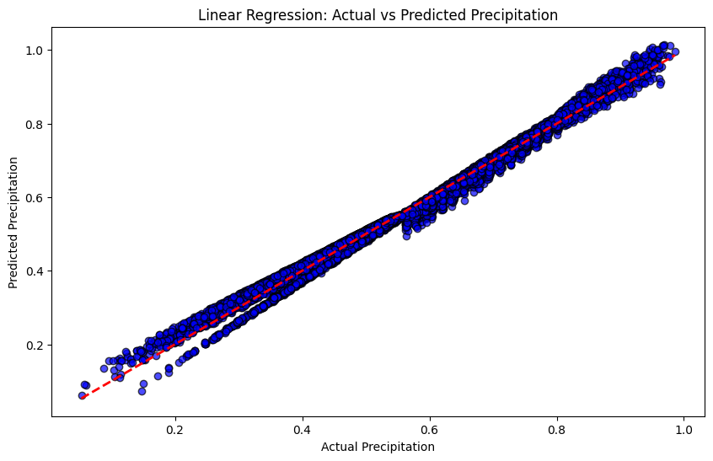

*Figure 3. Linear Regression: Actual vs Predicted Precipitation*

**5.3 Evaluation Matrix**

| Model | MAE | RMSE | R² score |
| --- | --- | --- | --- |
| Linear Regression | 0.01 | 0.02 | 0.99 |
| GRU | 0.01 | 0.02 | 0.99 |

1. **Conclusion and Future Work**

This study demonstrated the effectiveness of Linear Regression and Gated Recurrent Unit (GRU) models in predicting general precipitation with exceptional accuracy. Both models achieved an R² score of 0.99, with minimal errors — a Mean Absolute Error (MAE) of 0.01 and a Root Mean Squared Error (RMSE) of 0.02 — indicating strong alignment between predictions and actual values. While Linear Regression showcased impressive performance despite its simplicity, the GRU model excelled in handling sequential weather data, proving its robustness in capturing complex, time-dependent precipitation patterns. The GRU's architecture, designed to retain essential information while filtering out noise, contributed to its superior performance, making it a promising tool for weather prediction tasks. This research highlights the potential of AI/ML models in outperforming traditional forecasting methods by uncovering intricate relationships between meteorological variables and precipitation patterns.

Moving forward, several enhancements can further improve prediction accuracy and model reliability. Integrating more advanced architectures, such as Temporal Fusion Transformers (TFT) or Attention-based LSTM models, could enhance the model’s ability to capture long-term dependencies and multi-step forecasts. Additionally, expanding the dataset to include more weather features — like humidity, wind speed, and atmospheric pressure — could provide a more comprehensive understanding of the factors influencing precipitation. Transfer learning approaches, where models trained on diverse geographic datasets are adapted to new regions, may improve generalization across different climates and environments. Moreover, incorporating explainability methods such as SHAP (SHapley Additive explanations) or LIME (Local Interpretable Model-Agnostic Explanations) could offer greater transparency into model decisions, fostering trust and usability in operational weather monitoring systems. Finally, deploying the GRU model in a real-time weather prediction framework, continuously updated with live meteorological data, would enable practical, timely forecasting — supporting better weather preparedness and climate resilience.

1. **References**
2. Haq MA, Ahmed A, Khan I, Gyani J, Mohamed A, Attia EA, Mangan P, Pandi D. Analysis of environmental factors using AI and ML methods. Scientific Reports. 2022 Aug 2;12(1):13267.
3. Das SK, Nayak P. Integration of IoT-AI powered local weather forecasting: A Game-Changer for Agriculture. arXiv preprint arXiv:2501.14754. 2024 Dec 22
4. Delfani P, Thuraga V, Banerjee B, Chawade A. Integrative approaches in modern agriculture: IoT, ML and AI for disease forecasting amidst climate change. Precision Agriculture. 2024 Oct;25(5):2589-613.
5. Srivastava A, Maity R. Assessing the potential of AI–ML in urban climate change adaptation and sustainable development. Sustainability. 2023 Nov 30;15(23):16461
6. Dwivedi S, Sherly MA. A Comprehensive AI/ML-Enabled Data Quality Framework for Climate-Smart Digital Agriculture. InAdvances in Agri-Food Systems: Volume I 2025 Feb 13 (pp. 15-34). Singapore: Springer Nature Singapore.
7. Yang L, Driscol J, Sarigai S, Wu Q, Lippitt CD, Morgan M. Towards synoptic water monitoring systems: a review of AI methods for automating water body detection and water quality monitoring using remote sensing. Sensors. 2022 Mar 21;22(6):2416.