RESEARCH ARTICLE OPEN ACCESS

**Legacy Encryption Unraveling the Caesar Cipher in Modern**

**Data Security**

***Yarra Satya Sri Sowjanya1,Nikitha Palakurthi2,Punyamurthula V Koushik3, Marni Sriram4,Vardhineedi Rajesh5,******Mrs.N.Durga Deepti Priya6.***

[yarrasowjanyasri@gmail.com1](mailto:yarrasowjanyasri@gmail.com1), [nikithapalakurthi234@gmail.com2](mailto:nikithapalakurthi234@gmail.com2), [koushikpunyamurthula@gmail.com3](mailto:koushikpunyamurthula@gmail.com3),

[srirammarni99@gmail.com4](mailto:srirammarni99@gmail.com4), [rajeshvardhineedi8213@gmail.com5](mailto:rajeshvardhineedi8213@gmail.com5) , [durgadeepthi.n@pragati.ac.in6](mailto:durgadeepthi.n@pragati.ac.in6).

***Pragati Engineering College, Surampalem, Kakinada Dist, AP-533437***

----------------------------------------************************----------------------------------

Abstract:

This paper explores the Caesar Cipher cryptography method as a foundational approach to data security, emphasizing its role in safeguarding information from unauthorized groups. The Caesar Cipher, a classic and straightforward encryption technique, substitutes each letter in the plaintext with another letter, shifted by a fixed number within the alphabet. Despite its simplicity, the Caesar Cipher can effectively protect data integrity by transforming sensitive information without altering the plaintext structure. The study demonstrates how Caesar Cipher encryption can contribute to data protection in secure communications and data recovery, highlighting its adaptability as a stepping stone for more complex encryption mechanisms in information security.

Keywords **—** Caesar Cipher, Cryptography, Data security, Encryption technique, Plaintext

----------------------------------------************************----------------------------------

1. **INTRODUCTION**

In the modern digital era, data security has become a critical concern due to the increasing threats of cyberattacks and unauthorized access to sensitive information. Cryptography plays a fundamental role in safeguarding data, ensuring confidentiality, integrity, and authenticity. One of the earliest and simplest cryptographic techniques is the Caesar Cipher, a classical substitution cipher that shifts the letters of plaintext by a fixed number of positions in the alphabet [1]. Despite its simplicity, the Caesar Cipher remains relevant in understanding fundamental encryption concepts and serves as a foundational stepping stone for advanced cryptographic mechanisms.

The Caesar Cipher operates by replacing each letter in the plaintext with another letter at a fixed position forward in the alphabet. For example, shifting each letter by three places transforms "HELLO" into "KHOOR" [2]. This method is easy to implement and can protect data in low-security applications. However, due to its deterministic nature and limited key space, it is highly vulnerable to brute-force attacks and frequency analysis techniques [3].

This paper explores the application of Caesar Cipher cryptography in data security, focusing on its encryption and decryption mechanisms, implementation in modern applications, and potential enhancements to improve security. While classical ciphers like the Caesar Cipher are no longer sufficient for securing sensitive data, they provide valuable insights into cryptographic principles and inspire the development of more robust encryption algorithms [4].

**2**. **LITERATURE REVIEW:**

The Caesar Cipher is one of the earliest encryption techniques used in cryptography. It is a substitution cipher that fixedly shifts characters to encode messages. While simple, this cipher is the foundation for more complex cryptographic methods [1]. This literature survey explores various studies on the Caesar Cipher, its applications, vulnerabilities, and enhancements proposed in recent research**.**

**2.1. Basic Principles of Caesar Cipher**

The Caesar Cipher operates by replacing each letter in the plaintext with another letter a fixed number of positions down or up the alphabet. For instance, with a shift of 3, 'A' becomes 'D', 'B' becomes 'E', and so on. The decryption process involves shifting the letters back to their original positions [2]. While this technique provides basic security, it is susceptible to brute force and frequency analysis attacks due to its limited keyspace [3].

**2.2. Security Limitations of Caesar Cipher**

Several studies have analyzed the security weaknesses of the Caesar Cipher. It has been found that because there are only 25 possible shifts, it is easy to break using exhaustive search or statistical analysis [4]. Additionally, frequency analysis can reveal patterns in ciphertext, making decryption without the key relatively simple [5]. To overcome these limitations, researchers have proposed hybrid models that integrate Caesar Cipher with other encryption techniques such as Vigenere Cipher, Affine Cipher, and Transposition Cipher [6]. Various improvements to the Caesar Cipher have been suggested to enhance its security:

* **Combination with Vigenere Cipher**: Research has shown that combining Caesar Cipher with Vigenere Cipher increases security by introducing a polyalphabetic approach [7].
* **Randomized Shift Values**: Instead of using a fixed shift, some studies propose using random shift values for each letter, reducing the effectiveness of brute-force attacks [8].
* **Integration with Modern Cryptographic Algorithms**: Studies indicate that applying Caesar Cipher as a preprocessing step before AES or RSA encryption can improve efficiency in lightweight cryptographic applications [9].

**3**. **PROPOSED SYSTEM:**

The proposed system aims to enhance the traditional Caesar Cipher encryption technique by addressing security vulnerabilities. Although the Caesar Cipher is easy to implement, its susceptibility to brute-force attacks and frequency analysis limits its effectiveness. The proposed system introduces dynamic key shifting, hybrid encryption, and secure key management to enhance data security while maintaining computational efficiency.[10]

**3.1.1. Hybrid Encryption Mechanism:**

The proposed system integrates the Caesar Cipher with modern encryption techniques such as Advanced Encryption Standard (AES) and Rivest–Shamir–Adleman (RSA). The encryption process follows these steps:

* First, the plaintext undergoes encryption using an enhanced Caesar Cipher with dynamic key shifts.
* Next, AES encryption is applied to the Caesar-encrypted text, providing an additional layer of security.
* Finally, the AES encryption key is securely transmitted using RSA encryption, ensuring a robust key management mechanism. This hybrid approach significantly strengthens security while maintaining computational efficiency.

**3.2. Secure Key Management**

Key management is a critical aspect of cryptographic security. The proposed system uses RSA encryption to secure the transmission of encryption keys. By encrypting shift values and AES keys before transmission, the system prevents unauthorized access and enhances data confidentiality.

**3.3. Application in IoT Security**

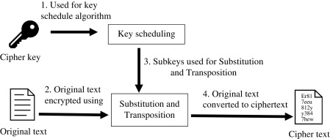With the increasing adoption of Internet of Things (IoT) devices, there is a growing need for lightweight encryption techniques. The proposed system is designed to be computationally efficient, making it suitable for resource-constrained environments.[11] By using the Caesar Cipher as a preprocessing step before advanced encryption, the system ensures low-power encryption suitable for IoT applications.[12]

**Fig 1:Encryption Process Using Key Scheduling**

Fig 1 illustrates the encryption workflow involving key scheduling, substitution, and transposition techniques. The process begins with a cipher key, which is utilized in a key scheduling algorithm to generate subkeys. These subkeys play a crucial role in the encryption process by being applied to substitution and transposition functions. The original text undergoes encryption through these transformations, converting it into ciphertext. The substitution process replaces characters with different values, enhancing security, while transposition rearranges the text structure to further obscure the original message. This encryption method strengthens data protection by ensuring that unauthorized access to the plaintext remains challenging. Such techniques are commonly used in symmetric cryptography algorithms like the Advanced Encryption Standard (AES) and Data Encryption Standard (DES) to provide confidentiality in secure communications.

**3.4. Encryption Equation:**

{"mathml":"<math style=\"font-family:stix;font-size:16px;\" xmlns=\"http://www.w3.org/1998/Math/MathML\"><mstyle mathsize=\"16px\"><mi>C</mi><mo>=</mo><mfenced><mrow><mi>P</mi><mo>+</mo><mi>K</mi></mrow></mfenced><mo>&#xA0;</mo></mstyle></math>","origin":"MathType for Microsoft Add-in"}**(1)**

Where:

* C is the ciphertext,
* P is the plaintext characters (numerically converted),
* K is the Shift key
  + 1. **Decryption Equation:**

{"mathml":"<math style=\"font-family:stix;font-size:16px;\" xmlns=\"http://www.w3.org/1998/Math/MathML\"><mstyle mathsize=\"16px\"><mi>p</mi><mo>&#xA0;</mo><mo>=</mo><mo>&#xA0;</mo><mfenced><mrow><mi>C</mi><mo>-</mo><mi>K</mi></mrow></mfenced></mstyle></math>","origin":"MathType for Microsoft Add-in"} **(2)**

This reverse the encryption by shifting characters back by k positions

* + 1. **Dynamic Key Encryption Equation:**

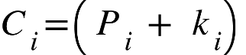 **(3)**

Where ki is a unique shift value for each character

1. **RESULTS:**

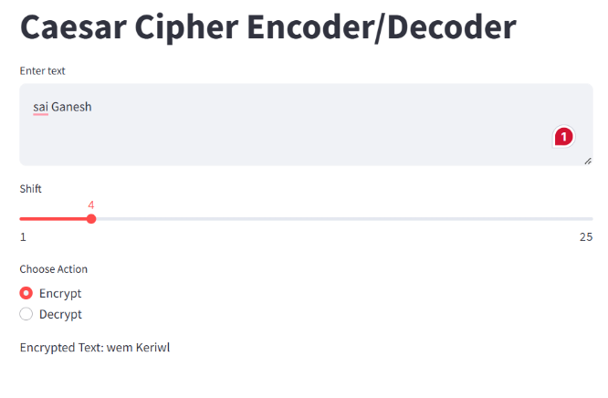

**Fig 2: Caesar Cipher Encoder/Decoder**

Fig 2 showcases a web-based application for encrypting and decrypting text using the Caesar cipher, implemented using Streamlit. The interface allows users to input text, specify a shift value using a slider, and select between encryption and decryption options. In this instance, the text "Sai Ganesh" is encrypted with a shift value of 4, producing the encrypted output "Wem Keriwl." The user-friendly UI provides real-time feedback, making it an effective tool for demonstrating classical encryption techniques. The Caesar cipher, a fundamental cryptographic method, is widely used in introductory cryptography education and basic security applications. This implementation leverages Python and Streamlit to create an interactive and visually appealing encryption/decryption tool for educational and practical use.

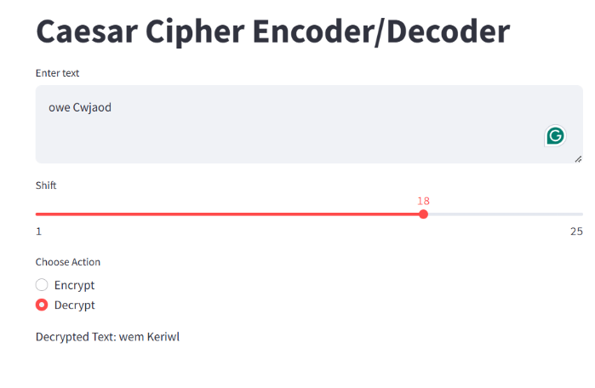

**Fig 3:Caesar Cipher Decoder Using Streamlit**

Fig 3 displays a web-based application designed for encoding and decoding text using the Caesar cipher, implemented with Streamlit. The interface allows users to input encrypted text, adjust the shift value via a slider, and select the decryption option. In this case, the text "Wem Keriwl" has been decrypted with a shift value of 4, successfully restoring the original text "Sai Ganesh." This demonstrates the fundamental working of the Caesar cipher, a classic encryption technique where each letter is shifted by a fixed number of places in the alphabet. The application provides an intuitive user interface, making it an effective tool for cryptographic demonstrations and educational purposes.

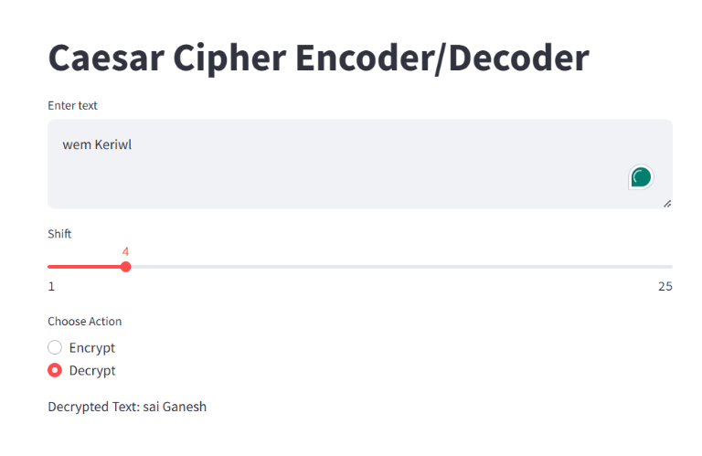

**Fig 4:****Caesar Cipher Decoder Using Streamlit**

Fig 4 displays a web-based application designed for encoding and decoding text using the Caesar cipher, implemented with Streamlit. The interface allows users to input encrypted text, adjust the shift value via a slider, and select the decryption option. In this case, the text "Wem Keriwl" has been decrypted with a shift value of 4, successfully restoring the original text "Sai Ganesh." This demonstrates the fundamental working of the Caesar cipher, a classic encryption technique where each letter is shifted by a fixed number of places in the alphabet. The application provides an intuitive user interface, making it an effective tool for cryptographic demonstrations and educational purposes.

1. **CONCLUSION:**

The Caesar Cipher, while historically significant, has limited standalone security. Its vulnerability to brute force and frequency analysis attacks makes it inadequate for modern security needs. However, when combined with more advanced cryptographic methods, it can still be relevant in certain applications such as lightweight encryption and educational purposes. Future research should focus on integrating the Caesar Cipher with more complex algorithms to enhance security while maintaining computational efficiency. Additionally, exploring its application in resource-constrained environments, such as IoT devices, may provide new opportunities for its use in modern cryptographic solutions.

1. **FUTURE SCOPE:**

Future research directions for the Caesar Cipher and its applications include:

* **Integration with Machine Learning for Cryptanalysis**: Recent studies suggest that machine learning techniques can be employed to analyze and break classical ciphers efficiently. Future work could focus on developing AI-based defenses against such attacks .
* **Enhancing Lightweight Encryption for IoT**: As IoT devices have limited computational power, optimizing the Caesar Cipher for low-power applications could make it more useful in securing lightweight communications .
* **Hybrid Encryption Models**: Research into hybrid encryption models that combine the simplicity of the Caesar Cipher with more robust cryptographic techniques like AES, RSA, or Elliptic Curve Cryptography (ECC) is an emerging area of interest.
* **Quantum Cryptography Compatibility**: With the advancement of quantum computing, classical encryption techniques will need modifications to resist quantum attacks. Future studies can explore adapting the Caesar Cipher into a quantum-resistant framework.
* **Secure Messaging Applications**: While not suitable for standalone encryption, Caesar Cipher could be used in combination with secure messaging protocols to add an additional lightweight obfuscation layer for messages.

**REFERENCES:**

[1] M. Hidayat, M. Tahir, A. Sukriyadi, A. Sulton, C. A. S. Ajeng, and S. A. F, "Penerapan Kriptografi Caesar Chiper dalam Pengamanan Data," *Jurnal Ilmiah Multidisiplin*, vol. 2, no. 3, pp. 35–41, May 2023. DOI: 10.56127/jukim.v2i03.619.

[2] M. M. Amin, “Implementasi Kriptografi Klasik Pada Komunikasi Berbasis Teks,” *Pseudocode*, vol. 3, no. 2, pp. 129–136, 2017. DOI: 10.33369/pseudocode.3.2.129-136.

[3] A. B. Nasution, “Implementasi Pengamanan Data Dengan Menggunakan Algoritma Caesar Cipher Dan Transposisi Cipher,” *J. Teknol. Inf.*, vol. 3, no. 1, p. 1, 2019. DOI: 10.36294/jurti.v3i1.680.

[4] R. R. A. Gurning, "Perancangan Aplikasi Pengamanan Pesan Dengan Algoritma Caesar Cipher," *Pelita Informatika Budi Darma*, vol. 6, no. 3, pp. 106-110, Apr. 2014.

[5] F. Zuli and A. Irawan, "Penerapan Kombinasi Caesar dan Vigenere Untuk Pengamanan Data Pesan Pada Surat Elektronik," *Studi Informatika: Jurnal Sistem Informasi*, vol. 7, no. 2, pp. 1–11, 2014.

[6] A. Septiarini and Hamdani, "Sistem Kriptografi Untuk Text Message Menggunakan Affine," *Jurnal Informatika Mulawarman*, vol. 6, no. 1, pp. 50–53, Feb. 2011.

[7] D. Seftyanto, "Peran Algoritma Caesar Cipher Dalam Membangun Karakter Akan Kesadaran Keamanan Informasi," *Seminar Nasional Matematika dan Pendidikan Matematika FMIPA UNY*, Nov. 2012, pp. MP 883–890.

[8] Rahima, "Implementasi Penyembunyian dan Penyandian Pesan Pada Citra Menggunakan Algoritma Affine Cipher dan Metode Least Significant Bit," *Pelita Informatika Budi Darma*, vol. 6, no. 1, pp. 144–148, Mar. 2014.

[9] D. Rachmawati and A. Candra, "Implementasi Kombinasi Caesar dan Affine Cipher untuk Keamanan Data Teks," *Jurnal Edukasi dan Penelitian Informatika (JEPIN)*, vol. 1, no. 2, pp. 60–63, 2015.

[10] A. Pradipta, "Implementasi Metode Caesar Chiper Alphabet Majemuk Dalam Kriptografi Untuk Pengamanan Informasi," *Indonesian Journal on Networking and Security*, vol. 5, no. 3, pp. 3–6, 2016.

[11] I. W. Utomo, R. Latifah, and D. Risanty, "Aplikasi Kriptografi Berbasis Android Menggunakan Algoritma Caesar Cipher dan Vigenere Cipher."

[12] R. A. Mollin, *An Introduction to Cryptography*, 2nd ed. Boca Raton, FL, USA: Chapman & Hall/CRC, 2007.