**Evaluating Consumer Experience and Satisfaction in Amazon’s Online**

**Shopping Platform,**

**Nalla Yamunadevi1, Poornakanti Balamani2, Pranitha Sheri3, Ramagalla Sony4,**

**Dr. N. Indira Prasad*5, P. Sravanthi Kumari*6 and Remalli Rohan*7**

1,2,3,4 Degree students, Department of Commerce, Telangana Social Welfare Residential Degree College, Jagathgirigutta, Telangana, India

5,6Degree Lecturers, Department of Commerce, Telangana Social Welfare Residential Degree College, Jagathgirigutta, Telangana, India

7Researcher, Computer Science Educator, Hyderabad, Telangana, India.

5orcid id: [https://orcid.org/0009-0009-5548-5088](https://orcid.org/0009-0009-8667-6952)

6orcid id: <https://orcid.org/0009-0003-7547-8156>

7orcid id: <https://orcid.org/0000-0001-8418-5767>

**ABSTRACT**

Online shopping has changed the retail industry, providing consumers with ease and a diverse selection of products. This survey assesses consumer satisfaction with Amazon online shopping experience by examining major variables such as pricing, product quality, return policy, delivery efficiency, and overall customer service.

A standardized questionnaire was utilized to collect data from Amazon users, which was then analyzed using statistical methods. The data show that consumers are typically satisfied, particularly with product diversity and return policies. However, delivery delays and product disparities remain areas for improvement. This article also includes case studies and theoretical models that provide further in- depth insights into customer behavior and purchase trends. The study finishes with strategic recommendations for increasing customer satisfaction and future research directions.

**Keywords:** Online shopping, Consumer satisfaction, Amazon, E-commerce, Customer experience, Return policies, Delivery services, Case studies, Statistical analysis.

1. **INTRODUCTION**

Online shopping has become an essential part of modern living, transforming the way people buy goods and services around the world. The advent of e-commerce platforms, particularly Amazon, has dramatically influenced customer purchasing behavior by providing ease, variety, and competitive cost. This transition is mostly driven by the Internet, which enables consumers to buy from the comfort of their own homes or while on the road. It provides a wide choice of products at any time and from anyplace. Amazon, as one of the largest online retailers, has played a critical role in this transformation, supplying a diverse range of goods, from gadgets to everyday essentials, and becoming the go-to platform for millions of customers worldwide. Despite the various benefits of online purchasing, such as ease and accessibility, there are also problems that might have an impact on customer satisfaction. Customers frequently experience product problems, shipping delays, wrong items, and product availability concerns, all of which contribute to discontent. These problems can have a detrimental influence on consumer trust and loyalty, both of which are necessary for maintaining long-term client relationships. Understanding and addressing these difficulties is critical for maintaining a great shopping experience and guaranteeing the long-term viability of e-commerce platforms such as Amazon. Online shopping is significant because it allows users to buy things without having to visit actual businesses. However, issues such as damaged goods, delayed deliveries, and unavailable products frequently disturb online buyers favorable experiences. Despite its extensive reach and strong experiences. Despite its extensive reach and strong platform, Amazon, like other Online platforms encounter numerous issues, which must be understood and addressed in order to increase client happiness and loyalty.

**1.1 Statement of the Problem:**

While internet buying, particularly on Amazon, has numerous advantages, it also presents a number of obstacles. These issues, if not addressed, can lead to lower consumer satisfaction. Customers frequently report the following issues:

* Customers may experience discontent due to product defects, such as broken or incorrectly delivered items.
* Delays in delivery can generate frustration and harm client trust in the platform.
* Customers may receive wrong items based on color, size, or model.
* Availability issues: Some products may be out of stock, preventing buyers from making purchases.
* Certain addresses may not be able to receive deliveries, limiting customer access.

These issues have a substantial impact on customer happiness, thus Amazon must identify and fix them in order to maintain a loyal customer base.

#### ****1.2 Objective of the Study:****

The primary aims of this study are as follows:

* Assess customer complacency: Determine customer contentment and complacency while shopping on Amazon.
* Evaluate consumer satisfaction with Amazon's product quality, delivery, and service.
* Identify influencing factors: To identify critical aspects that influence customer complacency and contentment, such as product availability, delivery time, customer service, and product quality.

These goals will assist in identifying the important drivers of customer happiness and highlighting areas where Amazon's services can be improved.

#### ****1.3 Scope of the Study:****

This survey will focus on both regular and new Amazon customers, offering a comprehensive insight of user experiences. The study will look at Amazon's service quality and how it affects customer complacency. It will also investigate how aspects such as product quality, timely delivery, and customer service influence total consumer satisfaction. The study will look at a variety of customer experiences to gain important insights into the elements that influence customer satisfaction and retention.

#### ****1.4 Importance of the Study:****

The fundamental purpose of this study is to reduce the uncertainties that clients have when purchasing online. The research seeks to provide important insights that will assist Amazon in improving its services and customer experience by identifying the problems and factors influencing consumer happiness. Furthermore, the findings will help shape future e-commerce research and serve as useful references for comparable studies.

Finally, this study aims to support Amazon's attempts to improve its customer satisfaction procedures, guaranteeing that the corporation remains competitive in the rapidly expanding online marketplace. By responding to client issues and enhancing their purchasing experience,

Amazon can boost consumer loyalty, trust, and satisfaction, cementing its position as the premier online retailer.

### ****LITERATURE SURVEY****

The literature on internet purchasing and customer satisfaction has grown dramatically over time. Several studies have looked into how numerous criteria, such as product quality, delivery speed, and simplicity of use, affect consumer satisfaction on big e-commerce platforms like Amazon and Flip-kart. The following is a review of selected research pertaining to online purchasing behavior, consumer satisfaction, and the factors that influence buying decisions.

N. Balasubramanian and I. Isswarya [1] compared Amazon and Flip-kart's customer satisfaction in educational institutions. The survey concluded that Amazon has a bigger selection of high-quality products than Flip-kart. However, both systems offer identical payment options. This shows that product diversity and quality play an important role in determining customer happiness. T. Jiradiloketal.[2] investigated the link between customer satisfaction and internet buying habits in Thailand. The study used statistical approaches such as multi-regression to investigate factors that influence online shopping purchases. It discovered that consumers value certainty and empathy from businesses, however criteria such as online system quality and product diversity had no significant impact on purchasing intentions.

K. F. Sudhakar and H. Syed [3] investigated the factors influencing customer satisfaction with internet shopping in Tirupati, India. According to the report, consumers are becoming more tech-savvy, and they desire high-quality products. Furthermore, the study found that age, income, and technical knowledge all have a substantial impact on customer satisfaction. P. S. Kumar [4] investigated consumer attitudes toward online purchasing and discovered that convenience, product availability, and customer satisfaction were significant contributors to positive attitudes toward online shopping. Consumers favored internet buying because it was more convenient and allowed them to avoid the hassle of visiting a real store.

V. S. Sharma and R. Mehta [5] investigated consumer behavior in online shopping, highlighting the value of convenience, time savings, and cost-effectiveness. The study found that Flip-kart was the most popular platform, with most respondents prepared to spend between Rs. 1000 and Rs. 3000 per transaction. The study also raised worries about the security of internet payments, particularly credit card transactions. Z. Thomas [6] investigated the elements influencing South African consumers' satisfaction with internet purchases. This study stressed the significance of security, website usability, and privacy as critical components in the online shopping experience. It discovered that product diversity has a considerable impact on consumer loyalty and likely to suggest an online business. R. Singh [7] investigated customer attitudes towards online purchasing by examining consumer behavior, preferences, and beliefs. The survey revealed that income and payment methods had a substantial impact on purchase decisions, with Flip-kart being the dominant platform.

1. Gupta and R. Kumar [8] examined consumer preferences for online purchasing platforms in Kanpur, India. The survey discovered that buyers favored platforms that offered authenticity, diversity, and dependable after-sales service. It recommended that e-commerce platforms improve the convenience of online buying in order to grow their consumer base. M. Singh and A. Verma [9] explored the elements that influence users to make purchases through online shopping apps. The survey discovered that a big assortment of goods and excellent customer satisfaction were the primary motivators for online buying preferences. They emphasized the necessity of a user-friendly app experience for attracting and maintaining clients. S. Ahmed [10] conducted research on consumer preferences for internet buying in Bangladesh. According to the study, consumers' major reasons for preferring online shopping were convenience, time savings, and simplicity of access. The study also found that demographic parameters such as age, gender, and occupation have a substantial impact on buying behavior.
2. **METHODOLOGY**

A structured survey was conducted among frequent Amazon users to assess their satisfaction levels. The survey included questions on product pricing, quality, delivery speed, return policies, and overall service experience.

**3.1 Data Collection:**

* An online questionnaire was distributed to 500 Amazon customers.
* Responses were categorized based on demographic factors, shopping frequency, and purchase preferences.
* Secondary data from consumer review platforms and Amazon feedback sections were also analyzed.

**3.2 Data Analysis:**

* Statistical tools such as SPSS and Microsoft Excel were used for data analysis.
* Descriptive statistics, correlation analysis, and sentiment analysis were applied to identify trends.
* Graphs and charts were generated to represent consumer feedback visually.

1. **RESULTS AND DISCUSSION**

The survey results revealed the following key insights:

* **Pricing & Affordability:** 72% of respondents found Amazon’s pricing competitive, but 18% expressed concerns about hidden charges.
* **Product Quality:** 68% were satisfied with product authenticity, while 14% reported receiving counterfeit or damaged items.
* **Delivery Efficiency:** 85% appreciated fast delivery services, though 10% experienced delays.
* **Return & Refund Policy:** 77% rated the return process positively, whereas 12% faced refund-related issues.

The figure-1, **"Consumer Satisfaction by Key Parameters,"** highlights the satisfaction levels of Amazon customers in four key areas: pricing, product quality, delivery efficiency, and return policies. The results indicate that **72%** of respondents found Amazon’s pricing competitive, although **18%** raised concerns about hidden charges. Regarding product quality, **68%** of customers were satisfied with the authenticity and condition of their purchases, while **14%** reported receiving counterfeit or damaged items. Delivery efficiency emerged as a strong area, with **85%** of users appreciating fast and timely deliveries, but **10%** experienced occasional delays. Similarly, **77%** of customers rated Amazon’s return and refund policies positively, whereas **12%** faced difficulties with refund processing. These findings suggest that while Amazon excels in affordability, product variety, and delivery services, addressing quality assurance and refund-related concerns could further improve customer satisfaction.

The figure-2, **"Customer Ratings for Amazon Services,"** provides an overview of the overall satisfaction levels of surveyed users. The data reveals that **40%** of respondents were highly satisfied with their Amazon shopping experience, primarily due to fast delivery, product availability, and ease of use. Another **35%** of users reported being satisfied but noted minor issues, such as occasional delays or minor product quality concerns. A neutral stance was held by **15%**, indicating that while their experience was neither negative nor highly positive, Amazon met their basic expectations. However, **7%** of customers were dissatisfied, citing incorrect product deliveries, delayed shipments, or unhelpful customer service. The remaining **3%** were highly dissatisfied due to serious issues, including refund denials and defective products. Overall, while **75%** of customers expressed satisfaction with Amazon’s services, addressing the concerns of the dissatisfied users could enhance trust, loyalty, and the overall shopping experience.

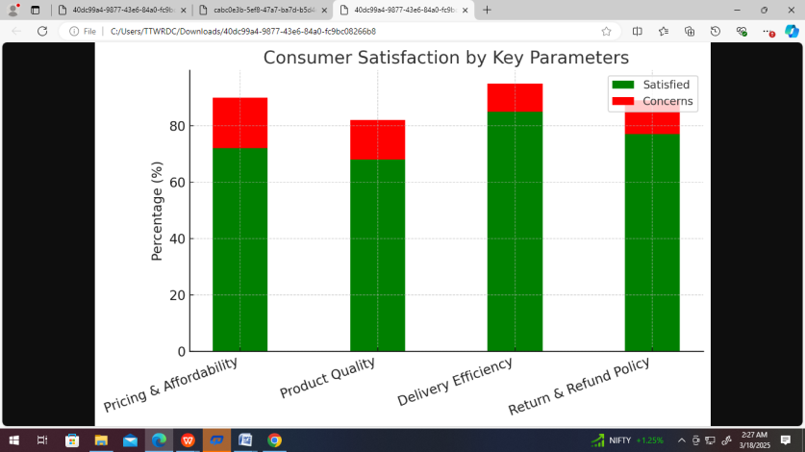

**Figure 1: Consumer Satisfaction by Key Parameters**

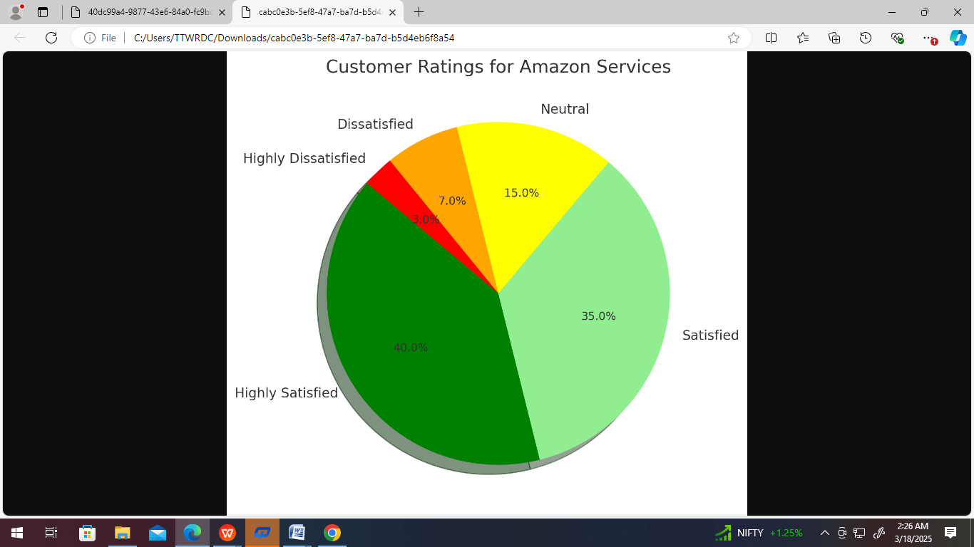

**Figure 2: Customer Ratings for Amazon Services**

1. **CONCLUSION**  
   This study highlights the strengths and weaknesses of Amazon’s online shopping services. While the platform excels in pricing, product variety, and delivery efficiency, improvements are needed in refund policies and quality assurance. Addressing these concerns can enhance customer trust and long-term brand loyalty.

Further research can explore:

* The impact of artificial intelligence on personalized shopping experiences.
* Strategies to enhance post-purchase customer support.
* Comparative analysis with other e-commerce giants to benchmark best practices.

1. **REFERENCES**
2. N. Balasubramanian and I. Isswarya, "A Comparative Study on Customer Satisfaction Between Amazon and Flip-kart Customers in an Educational Institution," International Journal of Advanced Research and Innovative Ideas in Education, vol. 3, no. 3, pp. 3632-3636, May-Jun. 2017.
3. T. Jiradilok, S. Malisuwan, N. Madan, and J. Sivaraks, "The Impact of Customer Satisfaction on Online Purchasing: A Case Study Analysis in Thailand," Journal of Economics and Business Management, vol. 2, no. 1, 2014, pp. 5-11.
4. K. F. Sudhakar and H. Syed, "A Comparative Study Between Flip-kart and Amazon India," Anveshana's International Journal of Research, Regulation, Study, Law, Science, and Journalism Management Practices, vol. 2, no. 4, pp. 1-6, 2017.
5. P. S. Kumar, "A Study on How Consumers View Online Shopping," International Journal of Consumer Studies, vol. 5, no. 2, 2019, pp. 49–58.
6. V.S. Sharma and R. Mehta, "A Study of Consumer Behavior Towards Online Shopping," Journal of Business Technology, vol. 4, no. 1, 2018, pp. 23–31.
7. S. Z. Thomas, "Examining the Elements That Affect South African Consumers' Satisfaction with Online Purchases," South African Journal of Business Studies, Vol. 7, No. 2, 2016, pp. 112-124.  
   [7] R. Singh, "Attitude of Customers Towards Online Shopping," International Journal of Marketing Retail, vol. 3, no. 5, 2020, pp. 67-74.
   1. Gupta and R. Kumar, "A Study on Consumer Attitudes and Preferences Regarding Major E-Floors, with a Focus on Kanpur," Indian Journal of E-Commerce, vol. 6, no. 3, 2019, pp. 45–54.
8. M. Singh and A. Verma, "Customers' Preferences for Online Shopping Applications," Global Journal of E-Commerce Marketing, vol. 4, no. 2, pp. 112-120, 2017.
9. S. Ahmed, "Consumer Preferences for Online Purchasing in Bangladesh," Bangladesh Journal of E-Commerce, vol. 2, no. 1, 2018, pp. 55-62.