**The Impact of Influencer Marketing on Product Category Preferences Among Young Generation: A Comparative Study**

**1 Dr. Rupesh Pais, 2 Vaibhav S. Gadekar**

1 TBI Head, DMT, Shri Ramdeobaba College of Engineering and Management, Nagpur.

2 Student, DMT, Shri Ramdeobaba College of Engineering and Management, Nagpur.

**Abstract**

This study investigates the influence of influencer marketing on product category preferences among young consumers, particularly within the Indian market, where social media has transformed consumer engagement. Utilizing a quantitative research design, data were collected from 100 participants aged 18 to 29 via an online survey, analyzing their responses to influencer-driven marketing across various product categories. Findings indicate that influencer marketing significantly impacts preferences in visually oriented sectors, such as Technology and Gadget, for Sport and Entertainment, due to factors like influencer authenticity and psychological appeals such as social proof and the fear of missing out (FOMO).

The research highlights the critical role of influencer authenticity, showing that young consumers are more likely to be influenced by relatable and genuine personalities, as opposed to highly commercialized endorsements. Additionally, psychological factors like social proof and FOMO were found to drive impulse buying, emphasizing influencers’ role in creating urgency and desirability. Despite these influences, ethical concerns, including transparency and potential exploitation, remain important to young consumers, who expect responsible influencer practices. These insights offer valuable implications for brands aiming to optimize influencer strategies by aligning with the values and expectations of young consumers.

Keyword – *Product Category, Influencer Marketing, Authenticity, Psychological Factors, Ethical considerations, Impulse Buying Behaviour.*

**Introduction**

As the purchasing power of young consumers continues to grow, marketers have become increasingly interested in understanding the factors that drive their product preferences. One emerging trend in this domain is the rise of influencer marketing, where brands partner with social media personalities to promote their products. (Derbaix & Leheut, 2008) (Cunha & Neto, 2015). This study aims to investigate the impact of influencer marketing on the product category preferences of young consumers, with a focus on comparing the differences across various demographic and psychographic segments.

***Theoretical Background***

Influencer marketing has gained significant traction in recent years as a powerful tool for brands to reach and engage with their target audiences(Brown & Hayes, 2008). Influencers, defined as individuals with a large following and perceived credibility, can sway consumer attitudes and behaviors through their endorsements and recommendations. (Brown & Hayes, 2008) (Ayob et al., 2023) Previous research suggests that influencer endorsements can significantly sway consumer attitudes and purchase intentions. However, there remains a lack of comprehensive understanding regarding the variance in influencer impact across different product categories. This study addresses this gap by conducting a comparative analysis, investigating how the effectiveness of influencer marketing differs across diverse product categories.

In the following sections, The Literature Review section provides a comprehensive overview of existing research on influencer marketing and its impact on consumer behavior. The Methodology section outlines the research design and data collection methods employed in this study. The Results section presents the findings of the comparative analysis, highlighting key differences in influencer influence across product categories. The Discussion section interprets the results, drawing connections to existing literature and theoretical frameworks. Finally, the Conclusion summarizes the key findings and discusses their implications for both academic research and marketing practice.

**Problem_Statement**  
The rise of influencer marketing has significantly altered consumer engagement, particularly among the younger generation who rely heavily on social media for product recommendations. However, there is a notable gap in understanding how different types of influencers impact product category preferences among young consumers. This lack of clarity presents challenges for brands aiming to optimize their marketing strategies effectively.

Young consumers, especially Generation Z and Millennials, are influenced by various social media personalities, yet the effectiveness of these influencers can vary widely. Factors such as follower count, engagement levels, and perceived authenticity play crucial roles in shaping consumer attitudes. Additionally, growing skepticism toward influencer endorsements necessitates a deeper exploration of the psychological factors driving preferences.

Furthermore, existing metrics for evaluating influencer marketing success often focus on reach rather than actual impact on consumer behavior. This study aims to investigate these dynamics, providing insights that can help brands develop more effective influencer marketing strategies tailored to the preferences of young consumers.

**Research Hypothesis**

H1: *Influencer marketing has a significant impact on young consumers' preferences, especially in visually driven product categories like fashion, beauty, and technology.*

H2: *Consumers are more likely to purchase products endorsed by influencers perceived as authentic rather than commercialized endorsements.*

H3: *Social proof and FOMO (Fear of Missing Out) are the strongest psychological drivers of purchase intention among young consumers.*

H4: *Influencer marketing significantly increases impulse buying behavior among young consumers.*

H5: *Lack of transparency in influencer marketing reduces consumer trust and negatively impacts purchase decisions.*

**Research Objectives**

* *To identify which product categories are most significantly impacted by influencer marketing among young consumers, and to analyse the factors that contribute to this influence.*
* *To Investigate the Impact of Influencer Authenticity on Product Category Preferences*
* *To Examine the Psychological Factors Influencing Purchase Intentions*
* *To Analyse the Effect of Influencer Marketing on Impulse Buying Behaviour*
* *To investigate the ethical considerations in influencer marketing*

**Literature Review**

**Introduction to Influencer Marketing and Its Growing Relevance in India**

With the rapid expansion of social media in India, influencer marketing has become a dominant strategy for brands aiming to engage the country’s burgeoning young, digitally savvy population. Platforms like Instagram, YouTube, and regional favorites such as Moj and Josh allow influencers to connect with audiences in a highly relatable and authentic way, shifting the perception of advertising from transactional to interpersonal. Indian youth, who are the most active users of these platforms, are more receptive to influencer recommendations than traditional advertisements, viewing influencers as credible figures with whom they feel a personal connection (Nandagiri & Philip, 2018). This shift is transforming digital marketing in India, creating new opportunities for brands to influence young consumers’ choices through influencer endorsements.

**Product Categories Most Influenced by Social Media Influencers in India**

The impact of influencer marketing in India varies significantly across product categories. Studies indicate that beauty, fashion, and fitness are among the most influenced sectors, given their visual and aspirational appeal. Nandagiri and Philip’s (2018) research highlights that Indian youth are particularly influenced by beauty and fashion influencers, as these categories align closely with self-expression and lifestyle aspirations. However, there is limited research that precisely identifies which other product categories are most impacted by influencer endorsements in India. Studies that focus on India-specific consumer behavior in product categories like technology, electronics, and regional goods could provide more granular insights into the differential impacts of influencer marketing in these areas (Nair & Bhagat, 2020).

**The Role of Influencer Authenticity in Shaping Consumer Preferences**

Authenticity plays a critical role in influencer marketing's effectiveness, especially in India, where trust and relatability are significant factors in consumer decision-making. Indian audiences often prefer influencers who appear genuine and relatable rather than overly polished or commercial. A study by Sharma and Rani (2023) underscores that young Indian consumers are more likely to trust influencers who maintain authenticity, aligning with broader trends in influencer marketing globally. However, there is limited research on how this authenticity impacts specific product categories. For example, while authenticity may be essential in the beauty and personal care sectors, categories requiring technical expertise, such as electronics, may prioritize credibility differently. Understanding how authenticity affects consumer preferences across various product types in India would provide valuable insights for brands in tailoring their influencer partnerships (Sharma & Rani, 2023).

**Psychological Drivers of Purchase Intentions in Influencer Marketing**

In India, the psychological factors influencing purchase intentions in influencer marketing remain an underexplored area. Emotional connections, social influence, and trust are particularly relevant in shaping consumer responses to influencers. Indian consumers often form parasocial relationships with influencers—one-sided relationships where consumers perceive influencers as friends—which strongly impacts their purchase decisions. This aspect is especially pronounced among Indian youth, who view influencers as relatable figures and trendsetters. Studies like those by Muralidharan and Jena (2020) suggest that these psychological factors could drive stronger purchase intentions in product categories that rely on trust and aspirational appeal, such as fashion and personal care. However, more India-focused research is needed to understand these psychological drivers comprehensively and how they vary across different product categories (Muralidharan & Jena, 2020).

**Influencer Marketing’s Role in Impulse Buying Behavior**

Impulse buying, a common behavior among Indian consumers, is amplified by influencer marketing, particularly in lifestyle-driven categories. While research highlights that influencers can create a sense of urgency through exclusive content or limited-time offers, there is insufficient focus on how influencers drive impulse buying among Indian youth. Studies from India are needed to examine the specific triggers that influencers use, such as scarcity appeals or endorsements that evoke social proof, to encourage spontaneous purchases. Further investigation into this area could provide insights into how brands can design influencer campaigns that effectively stimulate impulse buys within Indian consumer segments, particularly in fast-moving consumer goods (FMCG) and fashion.

**Ethical Considerations in Influencer Marketing in India**

As influencer marketing continues to grow in India, ethical considerations, such as transparency and disclosure, are becoming increasingly important. The Advertising Standards Council of India (ASCI) introduced guidelines for influencer marketing in 2021, requiring influencers to disclose paid partnerships and sponsored content clearly. However, adherence to these guidelines is inconsistent, and few studies have examined the broader ethical challenges in influencer marketing in India. Research is needed to explore Indian consumer perceptions regarding transparency and disclosure in influencer marketing, as well as the potential psychological impacts of influencer-driven advertising on young audiences. Addressing these ethical considerations is crucial for developing sustainable and trust-oriented marketing practices in India.

**Comparative Analysis of Influencer Impact Across Product Categories in India**

The impact of influencer marketing varies significantly across product categories in India, with lifestyle-related products (beauty, fashion, and fitness) showing the highest engagement. These categories align well with Indian youth’s aspirations, who look to influencers for lifestyle inspiration and style guidance. In contrast, categories requiring more technical knowledge, such as electronics and financial products, may benefit more from influencers who possess credibility and specialized knowledge rather than broad appeal. Studies such as those by Banerjee and Banerjee (2020) emphasize that a tailored approach is essential, as influencers need to align with the product's consumer expectations. For instance, lifestyle influencers may not be suitable for promoting high-involvement products where technical expertise or financial trustworthiness is essential. These distinctions highlight the importance of customizing influencer strategies to align with the unique expectations of each product category in India.

**Conclusion and Research Gaps**

While influencer marketing has established itself as a powerful tool for influencing Indian consumers’ product preferences, several research gaps remain:

1. **Limited research on product categories most impacted by influencer marketing in India:** Past studies focus on overall product categories but Further studies could specify the specific product category see the most significant influence.
2. **Lack of exploration on how authenticity affects preferences across categories:** Future research could examine how authenticity influences consumer preference.
3. **Insufficient examination of psychological drivers in influencer marketing within the Indian context:** Research is needed to understand how factors like FOMO, TRUST, EMOTION, Social proof affect purchase intentions across product types in India.
4. **Inadequate focus on influencer marketing’s role in impulse buying behavior in India:** Additional studies could investigate how influencers in India drive spontaneous purchases and the specific strategies they employ.
5. **Need for deeper exploration of ethical considerations in influencer marketing in India:** As ethical guidelines evolve; more research is necessary to examine consumer expectations for transparency and responsible influencer practices.

Addressing these research gaps would not only refine the effectiveness of influencer marketing strategies in India but also support ethical and transparent practices that build consumer trust in an increasingly digitalized and interconnected marketplace.

**Materials & Methods**

**Research Design**

This study employed a quantitative research design to examine the impact of influencer marketing on product category preferences among the younger generation. Specifically, it focused on understanding how exposure to influencer-driven marketing campaigns influences the preference for various product categories such as Fashion, Beauty and Cosmetics, Food and Beverage, Technology and Gadgets, Health and Wellness, Home and Lifestyle, Travel and Leisure, Entertainment and Media, Sports and Fitness, Automotive products.

**Participants**

The participants for this study were young individuals aged between 18 and 29 years, representing the millennial and Gen Z cohorts, as these groups are particularly active consumers of influencer-driven content. A total of 103 participants were recruited through an online survey distributed via social media platforms, email newsletters, and university networks. The sample was selected to ensure diversity in terms of gender, geographical location, and social media platform usage.

**Data Collection**

Data was collected through an online questionnaire distributed via Google Forms. The survey instrument was designed to gather both demographic information and responses related to participants’ engagement with influencer marketing and their product category preferences. The questionnaire included a mix of closed-ended questions (Likert scale, multiple-choice) and a few open-ended questions to capture qualitative insights. Convenience Sampling method is used for collection of data.

**Key sections of the questionnaire included:**

* **Demographic Information**: Age, gender, education level, and location.
* **Product Category Preferences**: A ranking of product categories (e.g., fashion, beauty, electronics, lifestyle) based on perceived influence from influencer marketing.
* **Psychological:** Social proof, Fear of missing out (FOMO), Desire for belonging, Trust in the influencer, Emotional
* **Impulse Behaviour:** impulse purchase after seeing an influencer promote a product
* **Ethical considerations:**Misleading information, Lack of transparency, Exploitation of followers, False Claims
* **Authenticity:** Transparency about sponsorships, Personal connection, Consistency in messaging, Engagement with followers

**Procedure**

The survey was administered online, with participants completing the questionnaire at their convenience. Ethical considerations were strictly followed, ensuring informed consent, anonymity, and the voluntary nature of participation. Participants were informed that their responses would be used solely for research purposes, and they had the option to withdraw from the study at any time.

The data collection period lasted from 28 Oct 2024 to 9 Nov 2024. Upon completion, the collected data were stored securely and analyzed for patterns related to the influence of social media influencers on product category preferences.

**Data Analysis**

H1: *Influencer marketing has a significant impact on young consumers' preferences, especially in visually driven product categories like fashion, beauty, and technology.*

**Test Used: Chi-Square Test**  
The **Chi-Square Test** is used to determine whether **two categorical variables** are significantly related. In this case, it was applied to examine whether **product category preferences** are significantly influenced by **influencer marketing**.

✅ **Chi-Square Value:** **276.88**  
✅ **p-value:** **1.08e-13 (< 0.05, statistically significant)**

📌 **Conclusion:**  
There is a **significant relationship** between **product categories and influencer impact**, confirming that **certain product categories (Fashion, Technology, Beauty) are more influenced by social media influencers than others**.

H2: *Consumers are more likely to purchase products endorsed by influencers perceived as authentic rather than commercialized endorsements.*

**Test Used: Independent t-Test**  
A **t-Test** compares the means of two independent groups. Here, it was used to compare the purchase preferences of respondents who rated **influencer authenticity as high (4-5)** versus **low (1-2)**.

✅ **t-Statistic:** **1.99**  
✅ **p-value:** **0.0505** (Borderline Significant)

📌 **Conclusion:**  
Consumers who perceive influencers as **authentic** tend to be **more influenced** in their purchase decisions. Although the result is slightly above 0.05, it suggests **authenticity is a key driver** in influencer marketing.

H3: *Social proof and FOMO (Fear of Missing Out) are the strongest psychological drivers of purchase intention among young consumers.*

**Test Used: Pearson Correlation**  
Pearson Correlation measures the **strength and direction** of the relationship between **two numerical variables**. It was used to analyze the relationship between **psychological factors (FOMO, Social Proof, Trust) and purchase intention**.

✅ **Correlation Coefficient (r):** **0.368** (Moderate Positive Correlation)  
✅ **p-value:** **0.00045 (< 0.05, statistically significant)**

📌 **Conclusion:**  
There is a **moderate and significant correlation** between **psychological factors and purchase intention**, confirming that consumers are influenced by **peer validation and emotional triggers** when making buying decisions.

H4: *Influencer marketing significantly increases impulse buying behavior among young consumers.*

**One-Sample Proportion Test (Validating Self-Reported 75% Impulse Buying)**A **one-sample proportion test** was used to check whether the **observed proportion (75%) of impulse buyers** is significantly different from a **neutral baseline (50%).**

**✅ Z-Statistic: 5.68  
✅ p-value: 6.73e-09 (< 0.05, statistically significant)**

📌 **Conclusion:**  
Although the **Chi-Square test showed no strong categorical relationship**, the **one-sample proportion test confirms that 75% of respondents reporting impulse buying behavior is statistically significant.** This supports the claim that **influencer marketing significantly increases impulse purchases.**

H5: *Lack of transparency in influencer marketing reduces consumer trust and negatively impacts purchase decisions.*

**Test Used: Independent t-Test**A **t-Test** was applied to compare the influencer impact scores between respondents who believe **influencer marketing is ethical vs. unethical.**

✅ **t-Statistic: 2.55  
✅ p-value: 0.0129 (< 0.05, statistically significant)**

📌 Conclusion:  
There is a **statistically significant difference** in influencer impact between consumers who believe influencer marketing is **ethical vs. unethical.** This suggests that **lack of transparency and false claims negatively affect consumer trust.**

**Results and Discussion**



The age of a Respondent is 18 – 29 years.



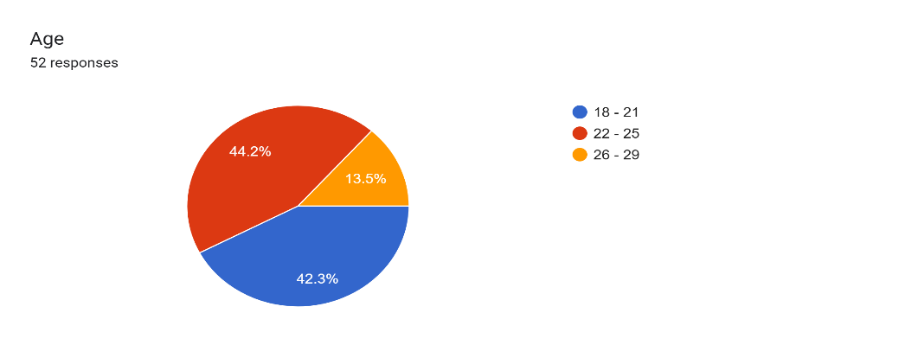



**Impact of Influencer Marketing on Product Category Preferences**



The results of this study indicate that influencer marketing has a significant impact on product category preferences among the younger generation. A survey conducted with 103 participants revealed that 42 of respondents reported purchasing Technology and Gadget products after being influenced by social media influencers, while 36 indicated similar behavior for Sport And Entertainment.

**The Role of Influencer Authenticity**

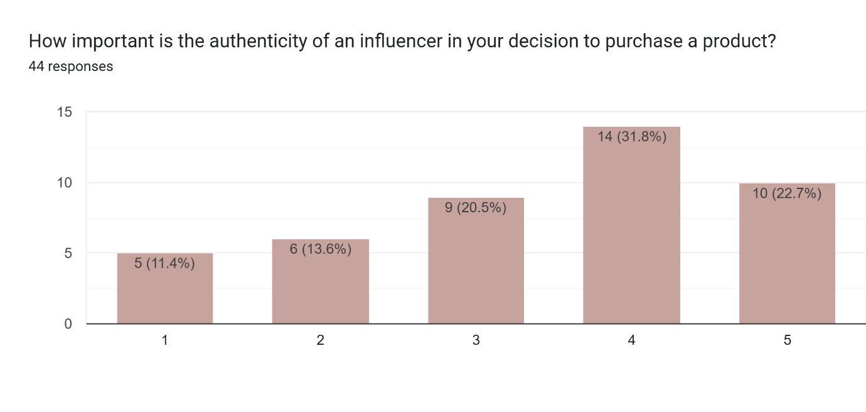Authenticity was highlighted as a pivotal factor influencing product category preferences. Approximately 22 % of respondents gives 5/5, 32 % gives 4/5 so this is indicated that they are more likely to purchase a product if the influencer is authentic. This underscores the importance of authenticity in influencer marketing, as consumers are increasingly sceptical of overly polished or scripted endorsements.



**Psychological Factors Influencing Purchase Intention**

Psychological factors, including Social Proof, Trust in the influencer And FOMO is significantly affect purchase intentions among young consumers. Mostly Social Proof is Effect on Purchase Intension.

**Effect of Influencer Marketing on Impulse Buying Behaviour**

The study Show That 75% people are have an impulse Buying Behaviour Due to Influencer Marketing

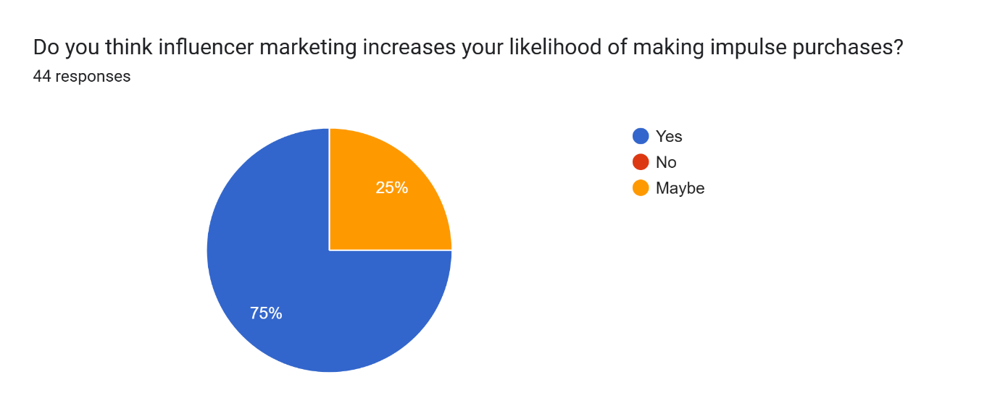



**Ethical considerations in influencer marketing**

Study Show that 64 % people are believe that influencer marketing is Ethical. And many have a various concern like Lack of Transparency, Misleading information, Exploitation of followers, False Claims etc.

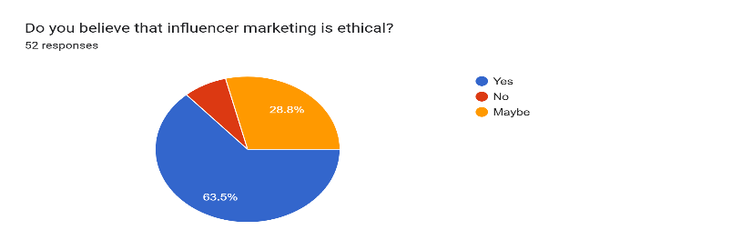



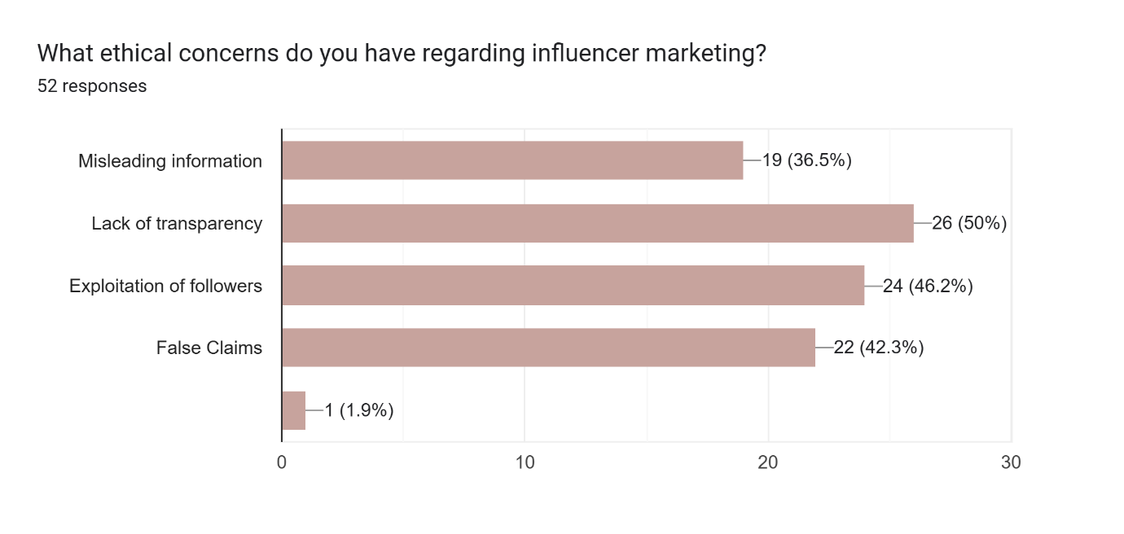



**Conclusion**

This research examined the influence of social media influencers on young consumers’ preferences across various product categories. Findings indicate that influencer marketing holds considerable power over young buyers, particularly within sectors like technology, fashion, and entertainment. Young consumers, notably from Gen Z and Millennial demographics, often rely on social media endorsements when making purchase decisions, viewing influencers as credible and relatable figures whose endorsements align with their aspirations.

Authenticity emerged as a critical factor, with consumers more inclined to trust and act upon recommendations from influencers who appear genuine and consistent. Psychological drivers, especially social proof and fear of missing out (FOMO), were also found to play significant roles, often leading to impulse purchases in visually appealing and trend-sensitive categories.

Ethical considerations, including transparency and the potential for misleading information, are important to young consumers, who expect responsible practices from influencers. This study underscores the importance for brands to prioritize authentic and ethically sound partnerships to resonate with young audiences effectively. Future research could further explore long-term brand loyalty fostered by influencer marketing and assess how these strategies might impact various demographic segments within the Indian market.

**References**

Derbaix, Christian & Leheut, Émerence. (2008). Adolescents: Involvement in Product Categories and Attitude toward Brands. Recherche et Applications en Marketing (English Edition). 23. 37-64. 10.1177/205157070802300203.

Brown, D., & Hayes, N. (2007). Influencer Marketing (1st ed.). Routledge. https://doi.org/10.4324/9780080557700

Ayob, Norazirah et al. “Social Influencer Factors that Affect Young Adult Buying Behaviour.” *International Journal of Academic Research in Business and Social Sciences* (2023): n. pag.

Nandagiri, Vaibhavi, and Leena Philip. "Impact of influencers from Instagram and YouTube on their followers." *International Journal of Multidisciplinary Research and Modern Education* 4.1 (2018): 61-65.

Dr. Minakshi Sati, Dr. Neelam Sharma, Dr. Indu Rani, Romita Modi, Shubham Mishra. “IMPACT OF INFLUENCER MARKETING ON PURCHASE INTENTION OF CUSTOMERS”. *Chelonian Research Foundation*, vol. 18, no. 2, Nov. 2023, pp. 997-1015, http://www.acgpublishing.com/index.php/CCB/article/view/85.

Chen, Y., Qin, Z., Yan, Y., & Huang, Y. (2024). The Power of Influencers: How Does Influencer Marketing Shape Consumers’ Purchase Intentions? *Sustainability (Switzerland)* , *16*(13). https://doi.org/10.3390/su16135471

Chowdhury, S. N., Faruque, M. O., Sharmin, S., Talukder, T., Mahmud, M. A. al, Dastagir, G., & Akter, S. (2024). The Impact of Social Media Marketing on Consumer Behavior: A Study of the Fashion Retail Industry. *Open Journal of Business and Management*, *12*(03), 1666–1699. https://doi.org/10.4236/ojbm.2024.123090

Aho, Pietu. "Attitudes of younger generations towards influencer marketing." (2023).

Alhawshabi, Hanin. "THE ROLE OF SOCIAL MEDIA FOOD INFLUENCERS ON GENERATION Z's PURCHASING DECISIONS: A COMPREHENSIVE STUDY Of THE SAUDI MARKET." (2024).

Ammar, Habib. *The impact of influencer marketing over brand awareness*. Diss. 2022.

Bi̇lgi̇ner Halefoğlu, S., & Otay Demi̇r, F. (n.d.). HOW ARE INSTAGRAM INFLUENCERS PERCEIVED BY DIFFERENT GENERATIONS? In *International Journal of Arts & Social Studies Dergisi / Cilt 5 / Sayı* (Vol. 8).

Gundová, P., & Cvoligová, K. (2019). IMPACT OF INFLUENCER MARKETING ON CONSUMER BEHAVIOR. *Acta Academica Karviniensia*, *19*(3), 31–41. https://doi.org/10.25142/aak.2019.018

Johansen, I. K., Sveberg, C., Supervisor, G., & Hem, L. E. (n.d.). *Influencer Marketing and Purchase Intentions How does influencer marketing affect purchase intentions?*

Liu, Y. (2023). The Impact of Social Media Influencers on Generation Z Online Consumer Behavior (Take the Social Media Platform Douyin as an Example). *Advances in Economics, Management and Political Sciences*, *41*(1), 19–24. https://doi.org/10.54254/2754-1169/41/20232026

Mishra, Ms. S., & Ashfaq, Dr. R. (2023). Influencer Impact: Examining the Effect of Influencers on Consumer Behaviour and Purchase Decisions. *Journal of Production, Operations Management and Economics*, *35*, 1–18. https://doi.org/10.55529/jpome.35.1.18

Nair, S., Asif, H., & Student, B. . *“The Impact of Social Media Influencers on Consumer Behaviour.”* https://images.app.goo.gl/mNq1AkUKaKviYUXE9

Phung, Lena, and Luning Qin. "Perception of social media influencers: A study on evaluation of Social Media Influencer types for different beauty categories." (2018).

Radwan, A. F., Mousa, S. A., Mohamed,  Mervat Medhat, & Youssef, E. Y. M. (2021). Impact of Social Media Influencer Marketing On Youth Purchase Intentions in UAE. *Media Watch*, *12*(3). https://doi.org/10.15655/mw/2021/v12i3/165405

Rahman, K. T. (2022). Influencer Marketing and Behavioral Outcomes: How Types of Influencers Affect Consumer Mimicry? *SEISENSE Business Review*, *2*(1), 43–54. https://doi.org/10.33215/sbr.v2i1.792

Srikanth, A., Sai Sushmita Rani, D., Dwarakanath, K., & Prem Kumar, V. (2023). Impact of Influencer Marketing on Automobile Industry. *AIP Conference Proceedings*, *2821*(1). https://doi.org/10.1063/5.0166398

Pekkanen, Eetu. "The effect of influencer marketing on consumer behavior: An analysis of fitness influencers on Instagram." (2024).

Tumsah, Amirah. *The Impact Social Media Influencers Have on Consumer Purchase Intentions: A Study Understanding the Influence Beauty Gurus Have on Younger Generations*. Diss. Dublin, National College of Ireland, 2021.

Vidani, J. (n.d.). *Influencer Marketing and Gendered Consumer Behavior: An Analysis of Clothing Purchases across Different Fashion Categories Indra Meghrajani L J Institute of Managment and Studies*. https://www.researchgate.net/publication/374117496

Dimitrieska, S., & Efremova, T. (n.d.). *THE EFFECTIVENESS OF THE INFLUENCER MARKETING*. 109–118. https://doi.org/10.37708/em.swu.v18i1.9

Guangul, Sisay Mulate. "Influencer Marketing Effectiveness: Metrics, Risks, And Best Practices." *Migration Letters* 21.S4 (2024): 472-481.