**How E-Commerce Empowers Artisans and Small Businesses**

Ankit Yadav

"Under the guidance of Dr. Anand Kumar Singh"

*Parul Institute of Engineering and Technology, Parul University, Limda, Vadodara, India*

**Abstract**

E-commerce has revolutionized the way artisans and small businesses connect with customers, turning the world into their marketplace. This paper explores how online platforms empower artisans by expanding their reach, lowering overhead costs, and helping them build strong, recognizable brands. While the benefits are significant, challenges such as digital literacy, market competition, and logistics hurdles can make it difficult for artisans to thrive online. To address these issues, this study highlights key strategies for success, including effective digital marketing, streamlined logistics management, and improved financial accessibility. Ultimately, e-commerce serves as a powerful catalyst for economic independence, sustainability, and creative entrepreneurship, offering small businesses the tools they need to grow and succeed in a competitive digital landscape.

**I. INTRODUCTION**

In today’s digital age, e-commerce has become an essential tool for small businesses and artisans, breaking down the geographical barriers of traditional brick-and-mortar stores. Online platforms enable sellers to reach a global audience, providing independent creators with the resources they need to market their handmade products effectively. This shift has made it easier for artisans to connect with buyers who appreciate craftsmanship and unique, high-quality goods.

The Home Mart project reflects this trend by offering a dedicated digital marketplace for home-based sellers. With a focus on simplicity and an intuitive shopping experience, the

platform helps artisans showcase their products, expand their customer base, and boost sales. The rise of digital platforms has transformed small businesses, eliminating the reliance on physical storefronts while opening new doors for marketing and brand growth. Through content marketing, customer reviews, and interactive shopping experiences, online businesses can build strong brand recognition and lasting customer relationships, driving long-term success.

**II. LITERATURE REVIEW**

**II.I Growth of E-Commerce**

E-commerce has experienced rapid growth, with platforms like Etsy, Shopify, and Amazon Handmade creating new opportunities for small businesses to succeed. By reducing overhead costs and diversifying income streams, online selling has become a game-changer for small-scale entrepreneurs. A great example of this shift is the Home Mart project, which offers sellers a user-friendly platform to manage inventory, process orders, and attract customers more effectively.

The increasing accessibility of e-commerce has encouraged more small businesses to go digital. Factors like easy-to-use selling platforms, advanced digital marketing techniques, and improved logistics networks have made it easier than ever for entrepreneurs to reach a wider audience and grow their businesses online.

**II.II Benefits for Artisans**

Artisans gain significant advantages from e-commerce, including greater visibility, direct access to consumers, and improved profit margins. Digital marketing tools like SEO and social media advertising make it easier for small businesses to establish and grow their online presence. The Home Mart platform enhances these opportunities by offering key benefits such as:

* Brand Autonomy: Artisans can build and maintain their unique brand identity without relying on third-party intermediaries.
* Customer Engagement: Direct communication through social media and other online channels helps strengthen relationships with buyers.
* Financial Inclusion: Secure digital payment options provide a safe and efficient way for artisans to manage transactions.

Home Mart further supports artisans by offering user-friendly features like advanced search functions, category-based product listings, and personalized seller pages. These tools help small businesses stand out in a competitive online market while making it easier for customers to discover and purchase their products.

**II.III Challenges in Adopting E-Commerce**

While e-commerce presents numerous opportunities for artisans, it also comes with challenges. Many small business owners struggle with technology, face stiff competition from mass-produced goods, and encounter logistical hurdles such as shipping and inventory management. The Home Mart project helps address these issues by providing an intuitive dashboard that simplifies transaction

management and customer interactions, making online selling more accessible.

One of the biggest obstacles for small businesses is navigating digital payment systems. Many artisans, especially those in developing regions, have limited access to digital banking and face difficulties with financial inclusion. Additionally, competing with larger, well-established e-commerce retailers can be daunting, making it harder for small businesses to gain visibility and attract customers. By offering user-friendly tools and resources, platforms like Home Mart empower artisans to overcome these challenges and build sustainable online businesses.

**III. METHODOLOGY**

This study takes a qualitative approach, exploring real-world examples of artisan businesses that have successfully embraced e-commerce. The research draws from industry reports, surveys, and academic studies to understand the impact of online platforms on small businesses. Additionally, insights from the Home Mart project are analyzed to showcase practical applications of digital tools in artisan entrepreneurship.

The methodology involves examining digital transaction data, conducting interviews with small business owners who have transitioned to e-commerce, and evaluating the effectiveness of various marketing and branding strategies used by successful online artisans. By combining these approaches, the study provides a comprehensive view of how e-commerce empowers small businesses and helps them thrive in a competitive digital marketplace.

**IV. FINDINGS AND DISCUSSION**

**IV.I Advantages of E-Commerce for Artisans**

* Flexibility and Convenience: Online stores operate 24/7, allowing businesses to make sales at any time without being limited by traditional store hours.
* Data-Driven Insights: E-commerce platforms provide analytics and customer insights, helping artisans understand buying trends and optimize their marketing strategies.
* Scalability: Small businesses can expand their product offerings and reach new markets without the high costs associated with physical expansion.
* Eco-Friendly Business Model: Digital storefronts reduce the need for physical resources like paper receipts and in-store energy consumption, promoting sustainability.
* Personalized Customer Experience: AI-driven recommendations, chatbots, and targeted marketing help create a tailored shopping experience for customers, boosting engagement and conversions.
* Faster Payment Processing: Digital transactions streamline payments, reducing delays and making it easier for businesses to manage cash flow.
* Access to Niche Markets: Artisans can target specific customer segments and cater to unique preferences, something that may not be feasible in traditional retail.

The Home Mart platform further enhances these benefits by offering advanced search features, category-based product organization, and personalized seller pages, helping artisans thrive in a digital-first economy.

**IV.II Key Challenges**

* Market Saturation: With countless online sellers, standing out and attracting customers can be difficult.
* Customer Trust: Building credibility and convincing buyers of product quality without a physical presence is a hurdle.
* Platform Dependency: Relying on third-party marketplaces means businesses must adapt to changing policies, fees, and algorithm updates.
* Content Creation Demands: Maintaining an engaging online presence requires constant product photography, descriptions, and social media updates.
* Tech Support Access: Many small business owners struggle with troubleshooting technical issues on e-commerce platforms.
* Return & Refund Complexity: Handling customer disputes, returns, and refunds can be challenging without a structured process.

The Home Mart initiative addresses these challenges by providing user-friendly tools, automated inventory tracking, secure payment systems, and order management features to help artisans navigate the digital marketplace successfully.

**IV.III Strategies for Success**

* **Engage in Live Selling:** Host live product demonstrations on social media to connect with customers in real time.
* **Offer Limited Editions:** Create exclusive, time-sensitive product drops to drive urgency and demand.
* **Build a Community:** Foster a loyal customer base through online groups, newsletters, and interactive content.
* **Utilize Micro-Influencers:** Partner with niche influencers who align with your brand to boost credibility and reach.
* **Provide Personalized Packaging:** Add handwritten notes or custom wrapping to enhance the customer experience.
* **Implement Loyalty Perks:** Reward repeat buyers with discounts, early access, or referral incentives.

Platforms like Home Mart support these efforts by simplifying product showcasing, order management, and customer engagement, helping artisans thrive in a competitive digital space.

**V. IMPLEMENTATION**

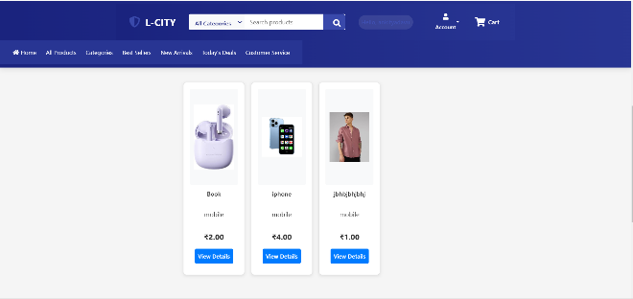

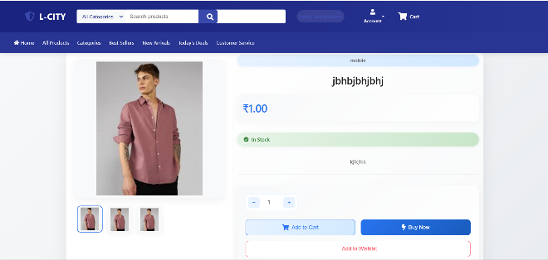

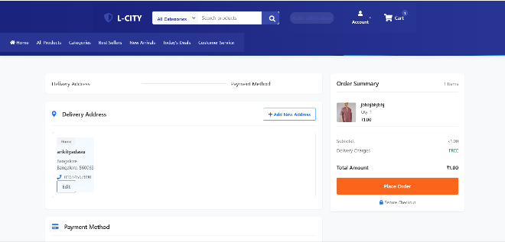

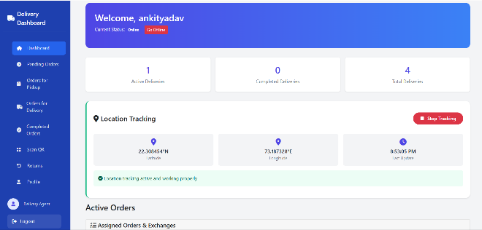



**VI. CASE STUDIES**

#### ****VI.I Case Study: Handwoven Textile Business****

A small weaving studio specializing in handwoven textiles transitioned from selling at local markets to launching an online store. By leveraging Pinterest and TikTok for visual storytelling, the brand attracted a global audience. Within 18 months, online orders surpassed in-person sales, and international shipping expanded the customer base significantly.

#### ****VI.II Case Study: Artisanal Skincare Brand****

An independent skincare brand, focused on natural and organic ingredients, used a combination of direct-to-consumer sales on its website and subscription boxes to increase brand visibility. Partnering with wellness bloggers and implementing email marketing campaigns led to a 70% boost in repeat customers within a year.

#### ****VI.III Case Study: Home Mart Success Story****

A collective of ceramic artists adopted the Home Mart platform to streamline their online presence. The platform’s search optimization tools and seamless checkout system helped them attract more customers. Within six months, their online engagement doubled, and average order value increased due to bundled product offerings and personalized recommendations.

#### ****VI.I Case Study: Handwoven Textile Business****

A small weaving studio specializing in handwoven textiles transitioned from selling at local markets to launching an online store. By leveraging Pinterest and TikTok for visual storytelling, the brand attracted a global audience. Within 18 months, online orders surpassed in-person sales, and international shipping expanded the customer base significantly.

#### ****VI.II Case Study: Artisanal Skincare Brand****

An independent skincare brand, focused on natural and organic ingredients, used a combination of direct-to-consumer sales on its website and subscription boxes to increase brand visibility. Partnering with wellness bloggers and implementing email marketing campaigns led to a 70% boost in repeat customers within a year.

#### ****VI.III Case Study: Home Mart Success Story****

A collective of ceramic artists adopted the Home Mart platform to streamline their online presence. The platform’s search optimization tools and seamless checkout system helped them attract more customers. Within six months, their online engagement doubled, and average order value increased due to bundled product offerings and personalized recommendations.

**VII. CONCLUSION**

E-commerce has revolutionized the way artisans and small businesses operate, offering them a global platform to showcase their craftsmanship and reach a broader audience. Digital marketplaces provide artisans with greater visibility, cost-effective selling opportunities, and direct customer engagement. The Home Mart platform exemplifies how a specialized e-commerce space can empower independent sellers with tools that simplify online transactions, enhance brand presence, and improve overall sales.

While challenges such as competition, logistics, and digital literacy persist, strategic marketing, personalized customer experiences, and technological adaptation can help artisans thrive in the online marketplace. Future advancements in AI-driven recommendations, automated inventory management, and blockchain-secured transactions could further transform the landscape of e-commerce for small businesses. Additionally, stronger policies on financial accessibility, cybersecurity, and sustainable packaging practices will play a crucial role in shaping a more inclusive and resilient digital economy for artisans.

### **VIII. REFERENCES**

* Anderson, P. (2022). The Rise of Digital Craft Markets: How Artisans are Thriving Online.
* Lewis, R. (2021). E-Commerce Strategies for Small Businesses: Overcoming Challenges in a Digital World.
* Patel, S. (2020). Building Brand Loyalty in Online Marketplaces: A Guide for Independent Sellers.