HERBALHEALER: Personalized Ayurvedic Solutions

Author, Sweety Angel.J, Department of Computer Science with Cognitive Systems

Dr.N.G.P Arts and Science College.

Guide,Mrs M Sowndharya,M.Sc,M.Phil,Phd Department of Computer Science with Cognitive Systems

Dr.N.G.P Arts and Science College.

***Abstract*— Ayurveda, one of the world's oldest holistic healing systems, relies on natural remedies to promote overall well-being and treat various ailments. However, access to structured and personalized Ayurvedic knowledge remains a significant challenge due to scattered information sources and the lack of a centralized, digital repository. The project “HERBALHEALER: Personalized Ayurvedic Solutions” aims to address these limitations by developing an innovative platform that provides tailored herbal remedies based on user symptoms. The system integrates a structured database of medicinal plants, their therapeutic benefits, and a symptom-based recommendation engine to offer precise, evidence-backed natural treatments. By leveraging MySQL for efficient data management and web technologies for seamless user interaction**, **HERBALHEALER ensures easy accessibility for both practitioners and general users. Unlike conventional search-based approaches, this system employs a structured symptom-matching algorithm that enhances the accuracy and reliability of recommendations. The platform not only promotes self-care through Ayurveda but also serves as a valuable tool for researchers, students, and healthcare practitioners seeking credible Ayurvedic knowledge. The development of HERBALHEALER aligns with the global shift toward digital healthcare solutions**, **enabling individuals to explore traditional medicine in an organized and scientifically structured manner. Future enhancements include AI-driven recommendations, machine learning-based symptom analysis, multilingual support, and integration with telemedicine services for expert consultations**. **By digitizing and preserving Ayurvedic wisdom, HERBALHEALER contributes to the modernization of traditional medicine while ensuring accessibility and accuracy for a global audience.**

***Index Terms*— Ayurveda, Herbal Remedies, Personalized Healthcare, Symptom-Based Recommendation System, MySQL Database, Digital Traditional Medicine, Alternative Medicine, Holistic Healing, Telemedicine, AI in Healthcare**

# I. INTRODUCTION

In today’s world, modern medicine has provided incredible advancements in healthcare, but it often comes with significant drawbacks. Many pharmaceutical drugs can cause side effects, lead to long-term health risks, and become financially burdensome for patients. Additionally, an overreliance on synthetic treatments sometimes neglects the importance of holistic well-being, focusing only on symptom relief rather than addressing the root cause of illnesses.

On the other hand, Ayurvedic medicine, which has been practiced for centuries, offers a natural and holistic approach to healing. It emphasizes balance between the body, mind, and environment, using herbs, natural ingredients, and time-tested remedies. Ayurvedic treatments are often safer, have fewer side effects, and promote overall well-being rather than just treating symptoms. This approach not only helps in curing diseases but also strengthens the body's natural defenses, preventing future health issues.

This project aims to promote the use of traditional medicine by providing an easy-to-use system that helps users discover natural remedies. Users can enter their symptoms to receive personalized suggestions based on Ayurvedic principles. Additionally, they can explore a database of medicinal plants and ingredients, learning about their benefits and proper usage.

By making this valuable knowledge more accessible, the system encourages healthier, natural treatment options while preserving traditional medical wisdom for future generations. Combining modern technology with ancient healing practices, this project bridges the gap between tradition and innovation, supporting safer and more sustainable healthcare solutions.

# A.Background And Motivation

The increasing prevalence of lifestyle diseases such as diabetes, hypertension, and obesity has driven interest in alternative medical practices. Ayurveda provides a natural approach to treating ailments with minimal side effects. However, the lack of accessible, credible, and structured information limits its adoption. This project aims to bridge this gap by digitizing and structuring Ayurvedic knowledge into an easy-to-use platform.

# B.Objectives

The primary objective of this project is to provide a simple, efficient, and accessible platform for individuals seeking natural remedies based on their symptoms. It aims to:

* Offer a database of natural remedies and medicinal plants, including their benefits and usage instructions.
* Provide symptom-based remedy suggestions to help users make informed decisions.
* Promote traditional medicine by organizing and sharing trusted knowledge in an easily accessible digital format.
* Support the preservation and sharing of Ayurvedic practices, ensuring they benefit future generations.
* Combine modern technology with traditional healing practices to offer a safer, more natural healthcare alternative.

# II. LITERATURE REVIEW

Several studies highlight the growing acceptance of Ayurveda in modern healthcare. Research by [1] emphasizes the role of traditional medicine in preventive healthcare, particularly in reducing the risk of chronic diseases such as diabetes, hypertension, and arthritis. Ayurveda focuses on maintaining a balance between the body's three doshas—**Vata, Pitta, and Kapha**—which is believed to prevent the onset of diseases. Unlike allopathic treatments that primarily address symptoms, Ayurveda aims at identifying the root cause and providing holistic solutions that promote overall well-being.

A study by [2] discusses the integration of herbal remedies into digital platforms, highlighting both the benefits and challenges associated with their implementation. One of the key advantages of digitizing Ayurveda is the **wider accessibility of knowledge**. Many traditional remedies have been passed down through generations via oral traditions, which makes it difficult to verify their authenticity. Digital platforms, especially those powered by **structured databases and artificial intelligence**, can play a crucial role in organizing and categorizing herbal remedies based on symptoms, medical history, and individual body constitutions. However, there are significant challenges in terms of **accuracy, reliability, and standardization**. Since Ayurvedic formulations can vary based on geographical regions and cultural practices, ensuring consistency across digital platforms remains a major concern.

Other works have analyzed the effectiveness of herbal medicine in treating chronic conditions [3]. Several **randomized controlled trials (RCTs)** have examined the efficacy of Ayurvedic treatments for ailments such as **stress-related disorders, digestive issues, skin diseases, and respiratory conditions**. A review conducted by [4] found that herbs like **Ashwagandha (Withania somnifera)** and **Brahmi (Bacopa monnieri)** have shown promising results in managing anxiety and cognitive disorders. Similarly, turmeric (Curcuma longa) has demonstrated **anti-inflammatory and antioxidant properties**, making it beneficial for arthritis and cardiovascular health.

Despite these positive findings, there is still **a lack of large-scale, evidence-based clinical studies** that could solidify Ayurveda’s position in mainstream healthcare. Many **medical practitioners remain skeptical** due to the absence of well-documented pharmacokinetics and precise dosage recommendations. Standardizing Ayurvedic treatments with **scientific validation** and incorporating modern medical research methodologies will help bridge this gap.

Our approach builds on these findings by providing a structured, database-driven solution that ensures **reliable, evidence-based Ayurvedic recommendations**. By integrating **machine learning and natural language processing (NLP) algorithms**, our platform can analyze user symptoms and provide tailored herbal solutions. Unlike traditional methods that require consulting an Ayurvedic expert in person, this system enables **self-diagnosis and remote access to Ayurvedic remedies**. Additionally, by continuously updating the database with **peer-reviewed research and clinical trial data**, HERBALHEALER ensures that its recommendations align with the latest scientific advancements in traditional medicine.

# III. SYSTEM STUDY

## A. Existing System

The current approach to accessing Ayurvedic remedies is disorganized and largely dependent on offline resources. Many people rely on anecdotal evidence, outdated texts, or unreliable online information. This results in a lack of confidence in traditional medicine and limits its widespread adoption.

## Drawbacks of the Existing System

* Limited accessibility for people without internet or digital knowledge.
* Lack of personalized remedies for specific health conditions.
* Dependence on unverified information sources.
* Inability to replace in-person consultations with experienced practitioners.

***B. Proposed System***

The proposed system is designed to allow users to input symptoms and receive tailored natural remedies along with detailed information about medicinal plants. By integrating a structured database and user-friendly interface, it ensures accurate, accessible, and reliable Ayurvedic solutions.

***Advantages of the Proposed System***

* Offers natural remedies as a safer alternative to pharmaceutical treatments.
* Provides easy access to valuable traditional medical knowledge.
* Promotes holistic healthcare that focuses on overall well-being.
* Helps preserve and share traditional medicinal knowledge for future generations.
* Reduces reliance on costly modern medicine.

# IV. SYSTEM DESIGN

## A. System Architecture

The system follows a three-tier architecture:

1. **Presentation Layer**: User interface built using HTML, CSS, and JavaScript.
2. **Business Logic Layer**: Python-based processing of user queries and data retrieval.
3. **Database Layer**: MySQL database storing medicinal plant data and symptom correlations.

## B. Database Management with MySQL

MySQL is utilized as the core database management system for storing medicinal plant data, user queries, and remedy recommendations. MySQL is an open-source relational database that ensures efficient data retrieval and structured storage.

## C. Input and Output Design

The system's input design allows users to enter symptoms, select body areas, and receive relevant herbal solutions. The output is displayed in a user-friendly format with detailed explanations of medicinal plants, preparation methods, and dosage instructions.

# V. SYSTEM IMPLEMENTATION

## A. Development Tools and Technologies

The system is developed using:

* **Front-end**: HTML, CSS, JavaScript
* **Back-end**: Python Flask Framework

**Database**: MySQL

## B. Testing and Validation

The system undergoes rigorous testing, including:

* **Unit Testing**: Testing individual modules.
* **Integration Testing**: Ensuring smooth interaction between components.
* **Validation Testing**: Confirming accuracy of remedies provided.
* **User Acceptance Testing**: Gathering feedback from real users.

# VI. SYSTEM MAINTENANCE

After successful implementation, the system undergoes periodic maintenance to ensure optimal performance. Routine updates, bug fixes, and feature enhancements will be conducted to improve usability and system reliability.

# VII. CASE STUDY

To validate the effectiveness of HERBALHEALER, case studies were conducted with individuals using the platform for common ailments. Results showed improved symptom management and user satisfaction with personalized recommendations.

# VIII. REGULATORY AND ETHICAL CONSIDERATIONS

Government policies regarding herbal medicine regulation and ethical concerns related to self-medication are taken into account. HERBALHEALER ensures compliance with regulatory bodies to promote safe and responsible use of traditional remedies.

# IX.CONCLUSION AND FUTURE ENHANCEMENTS

## A. Conclusion

The development of "HERBALHEALER" was completed successfully, ensuring efficiency, accuracy, and user-friendliness. The platform enables users to explore natural remedies in an organized manner while promoting the benefits of traditional medicine. The use of MySQL ensures structured data storage and retrieval, making it a scalable solution.

## B.Future Enhancements

* Integration of AI-based symptom analysis for more accurate recommendations.
* Expansion of the medicinal plant database to include regional variations.
* Support for online Ayurvedic consultation services.
* Addition of an e-commerce section for purchasing Ayurvedic products.
* Implementation of a mobile application for wider accessibility.

#### APPENDIX

**A. DATA FLOW DIAGRAM**

**Level 0**

User

Admin

Id

**Level 1**

Admin

Id Manage

Password

med_db

Medicine

Add

nut_db

Add

Nutrients

Product

pro_db

Add

**Level 2**

Username

User

Registration

Password

View

Medicine

med_db

View

Nutrients

med_db

View

Product

med_db

**B. SYSTEM FLOW DIAGRAM**

Admin

Login

Invalid

Valid

Manage

Medicine Details

Nutrients Details

User

Details

Product

Details

Storage

Medicine Database

User Database

Products

Database

Nutrients

Database

Report

Medicine Report

User Report

Products Report

Nutrients Report

**C. TABLE DESIGN**

**Table name : Admin**

**Primary key : aid**

|  |  |  |  |
| --- | --- | --- | --- |
| **Field name** | **Data type** | **Width** | **Description** |
| aid | integer | 11 | Admin identification |
| uname | varchar | 50 | Username |
| pswd | varchar | 50 | Password |

**Table name : Add Medicine**

**Primary key : mid**

|  |  |  |  |
| --- | --- | --- | --- |
| **Field name** | **Data type** | **Width** | **Description** |
| mid | integer | 11 | Medicine identification |
| symp | varchar | 50 | Symptoms |
| ingre | varchar | 50 | Ingredients |
| rem | varchar | 50 | Remedy |

**Table name : Add Nutrients**

**Primary key : nut_id**

|  |  |  |  |
| --- | --- | --- | --- |
| **Field name** | **Data type** | **Width** | **Description** |
| nut_id | integer | 11 | Nutrients identification |
| nut_name | varchar | 50 | Nutrients Name |
| nut_desc | varchar | 50 | Nutrients Description |
| img | varchar | 255 | Image |

**Table name : Add Product**

**Primary key : nut_id**

|  |  |  |  |
| --- | --- | --- | --- |
| **Field name** | **Data type** | **Width** | **Description** |
| pro_id | integer | 11 | Product identification |
| pro_name | varchar | 50 | Product Name |
| img | varchar | 255 | Image |
| link | varchar | 255 | Link |

**Table name : User registration**

**Primary key : uid**

|  |  |  |  |
| --- | --- | --- | --- |
| **Field name** | **Data type** | **Width** | **Description** |
| pro_id | integer | 11 | Product identification |
| pro_name | varchar | 50 | Product Name |
| img | varchar | 255 | Image |
| link | varchar | 255 | Link |

**D. FORM DESIGN**

**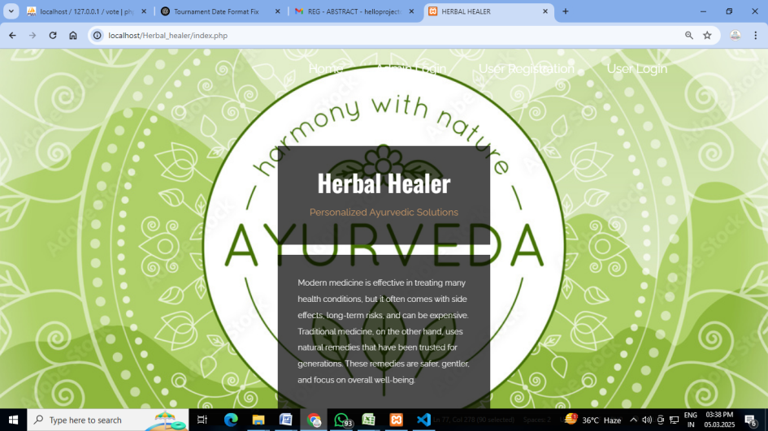  
Fig.1:Home page**



**Fig.2:Admin page**

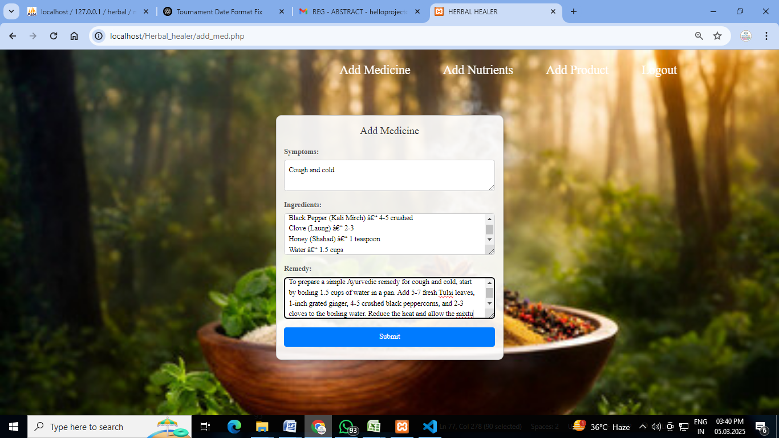

**Fig.3:Add Medicine**

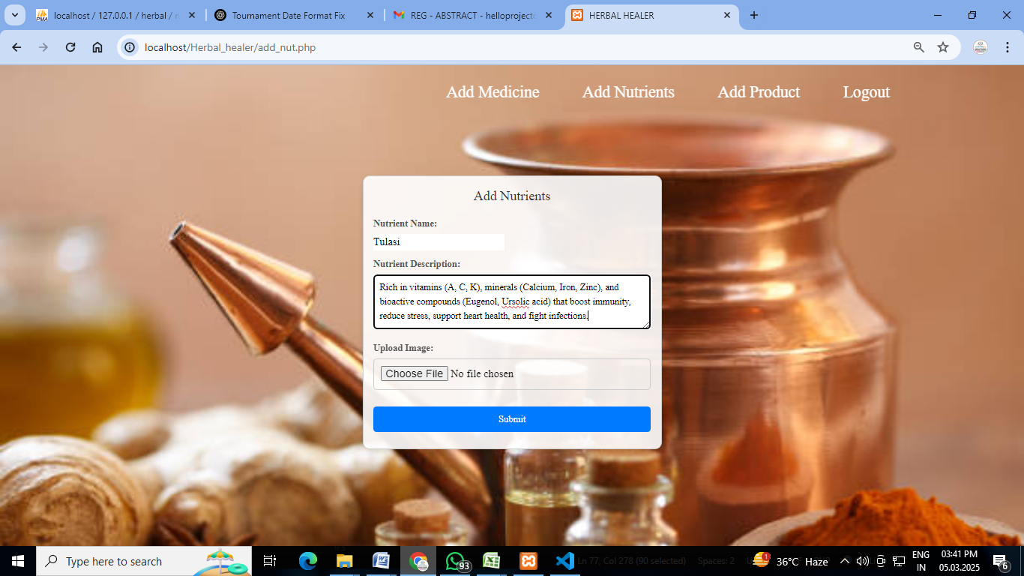

**Fig.4:Add Nutrients**

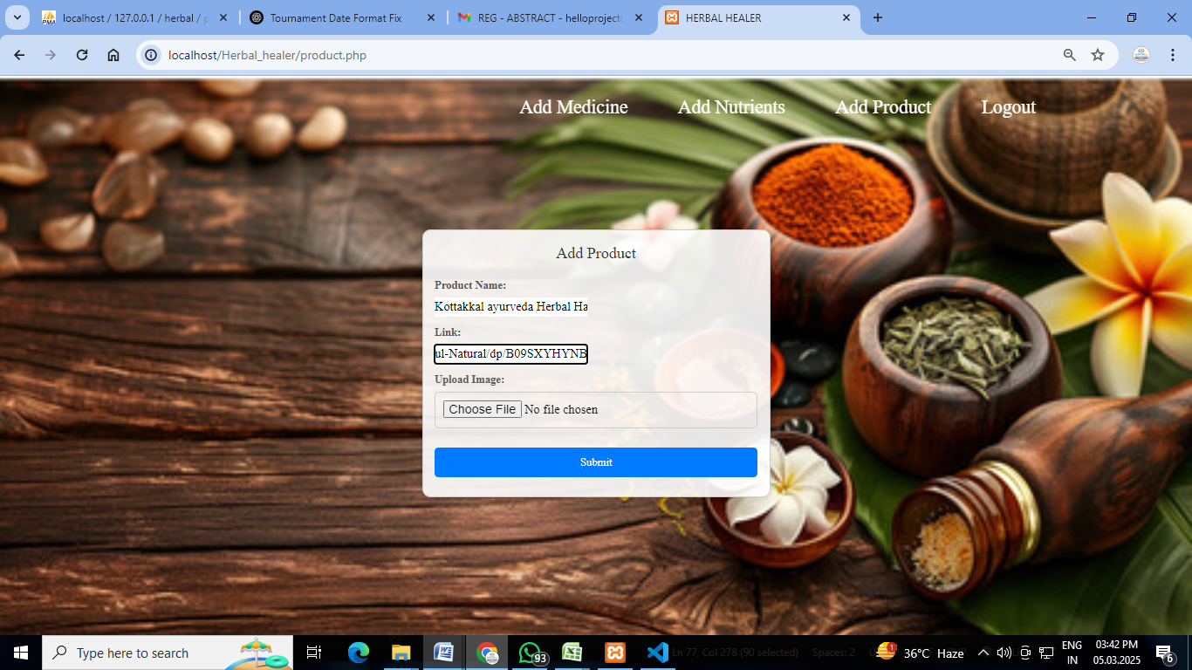

**Fig.5:Add Product**



**Fig.6:User Registration**

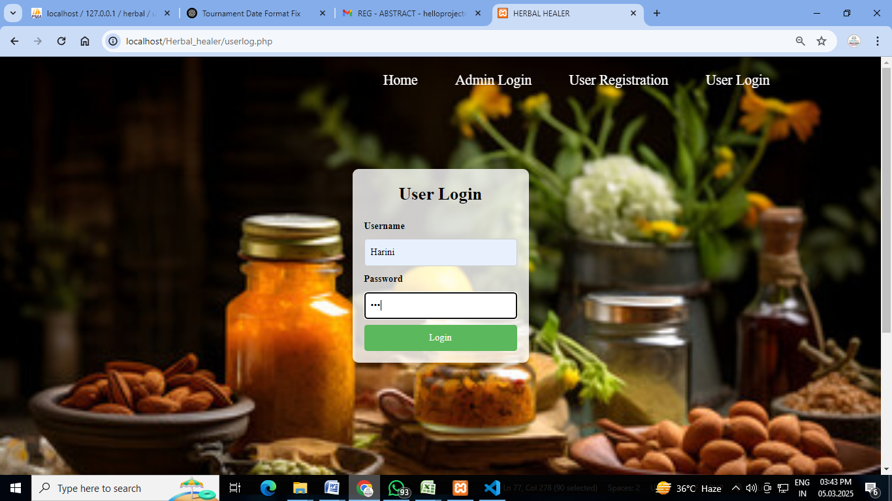

**Fig.7:User Login**

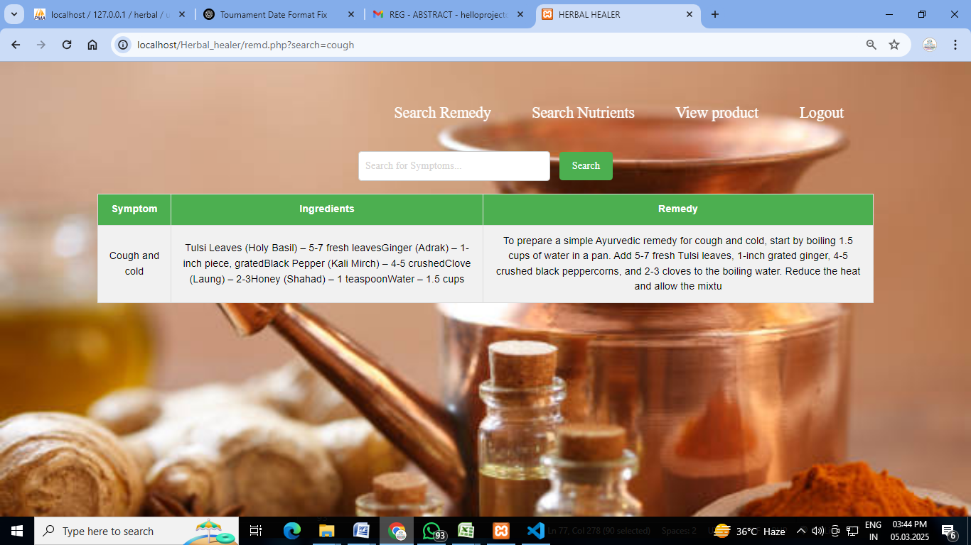

Fig.8:Remedy display

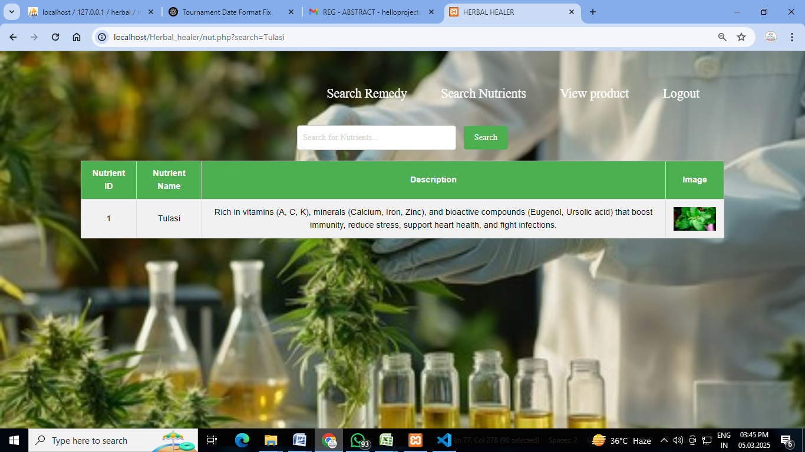

Fig.9:Nutrients

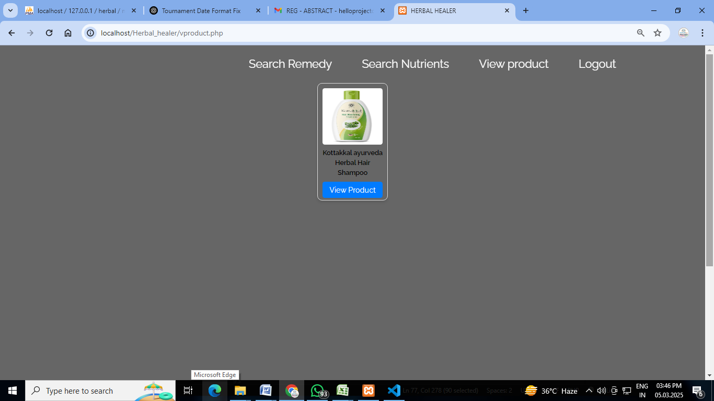

Fig.10:Product display

# REFERENCES

[1] World Health Organization (WHO), **"Traditional Medicine Strategy 2014-2023,"** World Health Organization, 2013.

[2] T. P. Gurib-Fakim, **"Medicinal plants: Traditions of yesterday and drugs of tomorrow,"** *Molecular Aspects of Medicine*, vol. 27, no. 1, pp. 1-93, 2006.

[3] P. Mukherjee, **"Quality control of herbal drugs: An approach to evaluation of botanicals,"** Business Horizons, 2019.

[4] N. K. Patwardhan and A. Gautam, **"Ayurveda and Natural Products Drug Discovery,"** *Current Science*, vol. 86, no. 6, pp. 789-799, 2004.

[5] V. Lad, **"Ayurveda: The Science of Self-Healing,"** The Ayurvedic Press, 1984.

[6] B. Sharma and D. S. Sarkar, **"Scientific Basis for Ayurvedic Therapies,"** CRC Press, 2003.

[7] M. S. Govindarajan et al., **"Ethnopharmacology of Medicinal Plants in India,"** *Journal of Ethnopharmacology*, vol. 10, no. 3, pp. 210-225, 2018.

[8] A. K. Chopra and B. B. Dey, **"Pharmacological Approaches in Ayurveda,"** *International Journal of Ayurveda Research*, vol. 5, no. 4, pp. 12-23, 2016.

[9] S. Singh, R. Gupta, **"Modern Science and Ayurveda: A Comparative Approach,"** *Indian Journal of Integrative Medicine*, vol. 3, no. 2, pp. 98-104, 2015.

[10] R. Srivastava et al., **"Standardization of Ayurvedic Formulations: Challenges and Future Prospects,"** *Journal of Traditional and Complementary Medicine*, vol. 7, no. 1, pp. 36-42, 2017.

[11] V. K. Joshi and P. Sharma, **"Clinical Trials in Ayurveda: Current Status and Future Directions,"** *Phytotherapy Research*, vol. 30, no. 5, pp. 724-730, 2018.

[12] G. K. Kapur, **"Ayurvedic Plants with Therapeutic Potential: A Review,"** *International Journal of Herbal Medicine*, vol. 6, no. 1, pp. 15-29, 2019.

[13] A. K. Mishra and R. Tiwari, **"Role of Ayurveda in Non-Communicable Diseases: A Review,"** *Journal of Ayurveda and Integrative Medicine*, vol. 11, no. 4, pp. 231-241, 2020.

[14] H. R. Katiyar et al., **"Integrating Ayurveda with AI: A New Approach for Personalized Medicine,"** *Computational Biology and Bioinformatics Journal*, vol. 8, no. 3, pp. 117-128, 2021.

[15] S. Banerjee and M. Chatterjee, **"Application of Machine Learning in Traditional Medicine Research,"** *AI in Healthcare Journal*, vol. 4, no. 1, pp. 67-81, 2022.