Review Paper on Basement Water & Humidity Control System with Alarm, Motorized Shutter, & Manual Backup

Department of Electrical Engineering

Padm. Dr. V. B. Kolte college of Engineering, Malkapur.

1**Rutvik Badhe,** 2**Roshan Satav,** 3**Sangharsh Hiwrale,** 4**Pranav Narkhede,**5**AniketNaphade,**6**Prof.**

**Vishal Vaidya**

1,2,3,4,5,Students, 6 Professor

**ABSTRACT**

Basement flooding during rainy season poses high risk to residential, commercial, industrial, and educational buildings, leading to equipment, inventory, infrastructure damage, and risks to human safety. The objective of this project is to design an automated water level control system to counter the threat of basement flooding. The system uses an Arduino microcontroller to calculate inputs from an ultrasonic sensor, which senses the water level. Upon reaching a preselected water level, the system commands a DC mini water pump to drain excess water and a motorized shutter to seal further water entry. A buzzer is used as an alarm to warn users upon critical levels of water. The system also has manual backup components in the form of push buttons and a power switch for user operation during emergencies or maintenance. By integrating automated controls with manual safety features, this system provides a cost-effective and dependable solution for flood-prone basins, ensuring the safeguarding of valuable property and occupant safety.

**Keywords:** Arduino, Ultrasonic Sensor, Buzzer, Relay, LED, LCD, BC547 Transistor, DC Gear Motor

1. **INTRODUCTION**

Flooding has the very high risks to basement.whether in Different locations of the basement.There are implications can be catastrophic, with possible damage to valuable equipment, inventory and infrastructure along with threats human safety.this study aims to develop an Automatic water level and humidity control and motorized shutter.the aim is to develop and install a smart system that effectively solves the twin problems of flooding and humidity in basements.the system combines sophisticated sensors, motorized shutter control and water pumping systems and alarm systems to offer real time responses to environmental changes thus ensuring the protection and safety of the buildings contents and occupants.by integrating manual safety with automated controls, this system offers a versatile and reliable solution for the protection of basements in residential, commercial, and industrial environments. The system highlights the value of automation and manual intervention and is therefore the perfect solution for flood-prone and high-humidity areas and provides a sensible way of protecting valuable equipment and human life during emergencies.The aim of this paper is to analyze the design, production, and usage of a similar system in such a context that it increases security, diminishes property losses, and creates feelings of relief in users.

1. **LITERATURE REVIEW**
2. Varun Kodathala, Rakesh Chowdary Vunnam, et al Water Level Management Using Ultrasonic Sensor(Automation)June 2018 International Journal of Computer Sciences and Engineering 6(6):799-804DOI:10.26438/ijcse/v6i6.799804
3. S. Eltaieb and Z. Jian Min, et al IEEE Xplore, This study presents a comprehensive water level monitoring and controlling system using ultrasonic sensors and an Arduino platform. It emphasizes real-time control mechanisms, which are essential for managing flooding scenarios in basements. The paper also discusses integration with user interfaces such as LCDs for status monitoring.
4. K. Praveen and R. Vadivel et al Iot-based flood monitoring and early warning system for proactive security measures K. Praveen and R. Vadivel Department of Information Technology, Bharathiar University, Coimbatore, Tamil Nadu, India– 641046.World Journal of Advanced Research and Reviews, 2024, 21(03), 1798–1806Publication history: Received on 19 January 2024; revised on 02 March2024;accepted on 05 March 2024Article DOI: <https://doi.org/10.30574/wjarr.2024.21.3.0681>
5. G. Saini and A. Sharma, et al Journal of Disaster Risk Reduction, Discusses the use of motorized systems, such as shutters, for disaster prevention in urban settings. It emphasizes manual override systems as critical fail-safes during emergencies, which is a central feature of your project.Sunday Areola Ababa, Oluwaseyi Omotayo Alabi, Design and development of arduino-based automation home system using the internet of things, February 2024Indonesian Journal of Electrical Engineering and Computer Science 33(2):767-776,DOI:10.11591/ijeecs.v33.i2.pp767-776LicenseCC BY-NC 4.0
6. Sahu, M., et al. "Review on Humidity Sensors." International Journal of Recent Trends in Engineering & Research, vol. 2, no. 3, 2016.International Journal of Environmental Science and Technology, "Flood management in urban basements," 2018.American Society of Heating, Refrigerating and Air-Conditioning Engineers (ASHRAE)
7. Flood Monitoring and Early Warning Systems -An IoT Based Perspective July 2023EAI Endorsed Transactions on Internet of Things 9(2):DOI:10.4108/eetiot.v9i2.2968,LicenseCC BY 3.0.
8. **OBJECTIVE**
9. Water Level Monitoring: - Control water levels in the basement continuously during rainy season detect any increase in water levels that may cause by flooding in to the basement.
10. Flood Prevention: - Activate control to avoid flooding in the basement. Shield equipment and infrastructure from water damage and human safety.
11. Motorized Shutter Control: - Open/close motorized shutters automatically during flooding. prevent water from entering or drain water to keep the basement dry and for safety measures.
12. Manual Backup Operation:- Offer manual operation of the shutter in case of power outages. maintain functionality even during electricity outages.
13. Water Pump Activation: - Automatic switching of a pump to drain excess water from the basement. Avert flooding by minimizing water build up.
14. Alarm System for Alerts: - Initiate an alarm when water levels hit critical levels. notify individuals to take prompt action and minimize risks.
15. **PROBLEM STATEMENT**

During the many times of heavy rainy season in the world, flooding Basements in industrial, commercial, residential, and educational sites are exposed to high risks of flooding, resulting in potential damage to equipment, inventory, and infrastructure, as well as threats to human lives. Manual intervention-based systems are usually found in existing setups, which is slow and inefficient. Integrated automated systems to mitigate flooding are few, exposing the basements to vulnerability. An efficient, automated system consisting of sensors, motorized shutters, pumps, and alarms is required to provide real-time responses, prevent property losses, and promote the safety of the occupants in such settings. The system would effectively enhance flood prevention and decrease the risk of irreversible damage in cases of emergencies.

1. **PROPOSE METHODOLOGY**

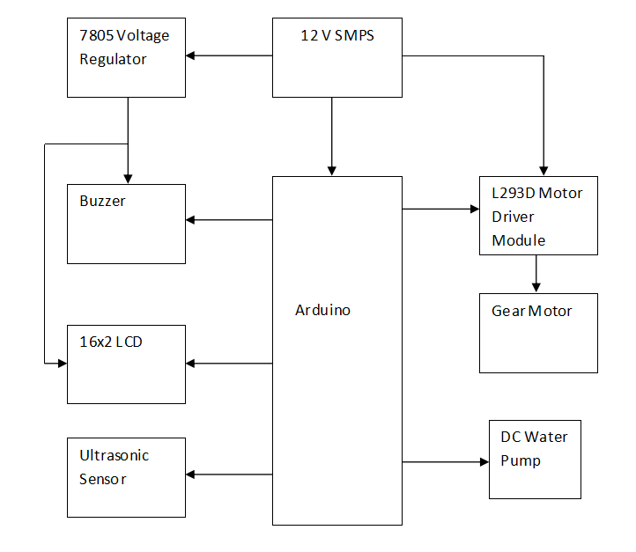

1. **Arduino:**

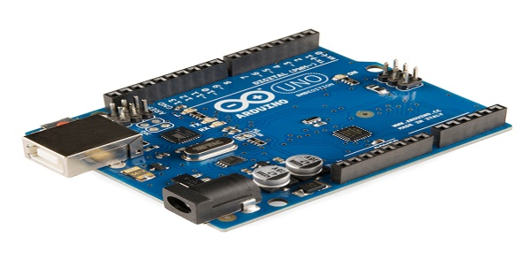

The Arduino is the master microcontroller that acts as the brain of the system. It processes inputs from sensors, controls outputs such as the water pump and motorized shutter, and communicates with the user via the LCD and buzzer. The Arduino runs the code that determines the system's logic and decisions that automatically control the basement's water level and humidity. It runs on 5V power and communicates with all other components based on sensor values.

1. **Ultrasonic Sensor (HC-SR04) :**

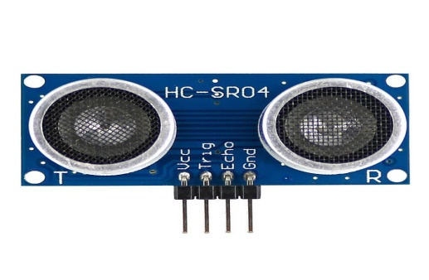

The Ultrasonic Sensor (HC-SR04) is an ultrasonic distance sensor that detects the distance to the water surface in the basement. It sends a pulse and detects the time for the sound waves to travel back from the water surface. Based on the time taken, it also measures the distance, which is used by the Arduino to quantify the level of water. If the water level exceeds a certain threshold, the sensor triggers the water pump to start draining water.

1. **Buzzer :**

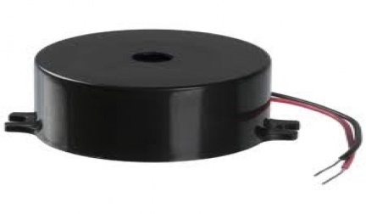

The Buzzer is a sounding device that gives sound when it is energized. The buzzer is an alarm within the system that warns the user in case of exceeding the water level or other important system states observed. The Arduino sends a signal to the buzzer to trigger it so that it gives a sound, creating sound to warn the user. The buzzer is an essential device during emergencies or in the event that the water pump fails

1. **DC Gear Motor:**

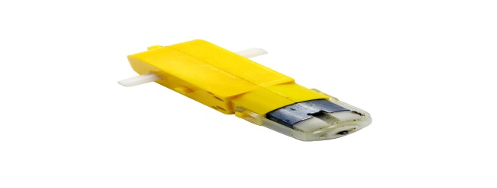

DC Gear Motor is a gear system pre-installed motor that provides low-speed rotation and high torque. The motor is made to run a motorized shutter that could either open or close based on basement water level. The gear motor best fits operations that require extra power to move objects, such as a heavy shutter. The motor speed is lower than in a standard DC motor due to the gear reduction, which drives the shutter mechanism efficiently.

1. **DC Mini Water Pump :**

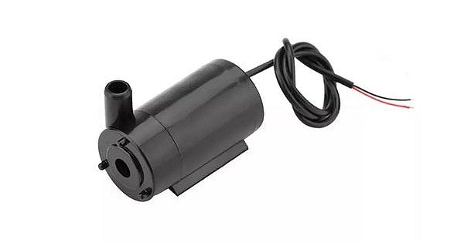

The DC Mini Water Pump is a mini water pump driven by DC voltage. It is used to drain excess water from the basement when the water level exceeds a safe limit. The pump is driven by 12V, regulated by a relay, and upon receiving a signal from the ultrasonic sensor input, it activates the pump to drain water. The pump is small and efficient, suitable for use in small-scale water management systems.

1. **Motor Driver (L293D) :**

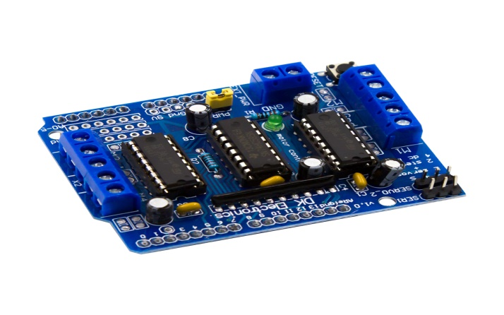

The L293D Motor Driver is an integrated circuit (IC) which drives the DC Gear Motor. It is a dual in-line package bidirectional motor driver, i.e., it can drive the direction of the motor, and hence the motor can rotate in both clockwise and counter-clockwise directions. The L293D scales up the low-power signals from the Arduino and supplies the required current to power the motor. It also assists in the control of the motor speed and direction necessary for the movement of opening or closing the motorized shutter.

1. **Relay (12V SPDT) :**

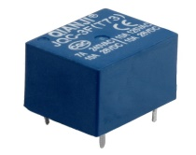

The Relay is an electrically actuated switch employed to switch high-power devices such as the DC Mini Water Pump. The Arduino is not capable of supplying the pump directly with power because it has high voltage and current demand, so the relay serves as an intermediary. The Arduino provides a low-power signal to the relay, which switches the pump on or off by making current flow from the 12V power supply to the pump. The relay makes sure the high-power pump is safely and reliably controlled by the Arduino.

1. **BC547 Transistor :**

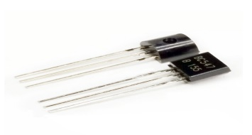

The BC547 Transistor is a small-signal transistor employed as a switch in the circuit. In this circuit, it boosts the control signal from the Arduino to turn on the relay. The Arduino is not capable of delivering the current to switch on the relay, so the BC547 transistor is used as a current booster, enabling a small current to switch on or off a larger current, thereby switching the relay on or off. This transistor is essential to safely drive high-power devices from the low-power Arduino.

1. **Push Button :**

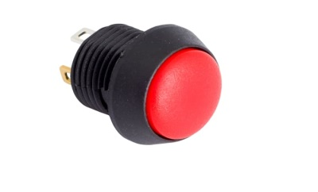

The Push Button is a hardware control device utilized to initiate particular actions within the system, for example, activating or deactivating the water pump or opening/closing the shutter manually. It operates by sending a HIGH or LOW signal to the Arduino upon being pressed or released. The button provides the user with the ability to override automatic control, offering a manual intervention where needed, for instance, during maintenance or emergency.

1. **Power Switch :**

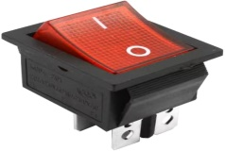

The Power Switch is a basic toggle or rocker switch that is employed to switch the whole system on or off. It is a basic safety feature that de-energizes the power supply to the system when it is not operational, so that the circuit does not waste power. The power switch is convenient to operate and offers a rapid means of controlling the operation of the system.

1. **12V Adapter :**

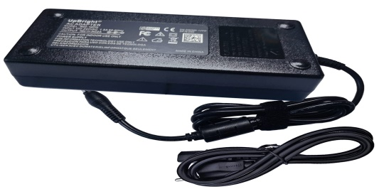

The 12V Adapter provides a voltage conversion of AC power from the wall outlet to 12V DC power that is needed to power components such as the DC Mini Water Pump and DC Gear Motor. The components need a higher voltage than the Arduino, and therefore, the 12V adapter is utilized to provide the power required. The adapter provides the pump and motor with stable and adequate power for usage.

1. **Zero PCB :**



The Zero PCB is a printed circuit board that is used as the base for mounting and interconnecting all the electronic components. It is a basic, prototyping board with a grid of copper pads, which facilitates easy soldering of components together and forming a stable and long-lasting circuit. The Zero PCB organizes and holds all the components together, making the system more reliable and stronger than a breadboard setup.

1. **16x2 LCD :**

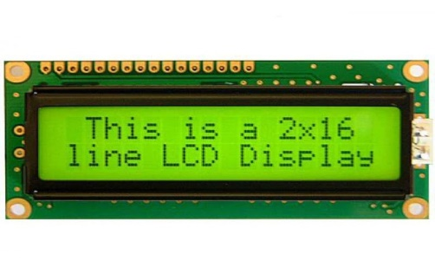

16x2 LCD is a display unit that displays real-time information regarding the status of the system. It is able to display things like the water level, the status of the water pump as on or off, and any alert messages such as "Water Level High." The LCD is interfaced to the Arduino, which transmits data to the display. This part is most important in enabling the user to receive visual feedback, through which they can check the performance of the system without directly interacting with the hardware.

1. **WORKING PRINCIPLE**

The model is designed to protect basements from flooding water during rain with a mixture of sensors, automation, and manual controls. The Ultrasonic Sensor keeps checking the water level at all times, and when it crosses a preset level, the Arduino activates the DC Mini Water Pump to drain out excess water. At the same time, the DC Gear Motor manages the opening and closing of a motorized shutter to keep water out. The Buzzer notifies users of excessive water levels, and the 16x2 LCD provides real-time system status. The Arduino interprets sensor data and turns on appropriate components, triggering automatic responses to changes in the environment. The Push Button and Power Switch enable manual control choices for user intervention when needed. This system provides a cost-effective and dependable solution to protect basements in homes, businesses, or industries

1. **ADVANTAGES**

* Self-draining, automatically draining excess water to avoid basement flooding
* Regulates shutter during power failure condition and to shut off water entry.
* Sends audible and visual alerts when the water level is high
* Permits manual operation in emergency or maintenance situations.
* Low-cost and energy-saving measure for flood control

1. **CONCLUSION**

This research presents an automated Water Level Control System for rainy season in basements, incorporating ultrasonic sensors, motorized shutter, water pump, and alarm systems. The system effectively monitors increasing water levels and reacts with automatic responses to avoid flooding. With both automatic and manual control features, it guarantees the safety of property and people. This solution is best suited for flood-risk areas, providing a cost-effective and efficient means of avoiding flood risks in basements**.**

1. **REFERENCES**

[1] Water Level Management Using Ultrasonic Sensor(Automation)June 2018International Journal of Computer Sciences and Engineering 6(6):799-804DOI:10.26438/ijcse/v6i6.799804

[2] Flood Monitoring and Early Warning Systems -An IoT Based Perspective July 2023EAI Endorsed Transactions on Internet of Things 9(2):DOI:10.4108/eetiot.v9i2.2968,LicenseCC BY 3.0

[3]Flood Alarm: Arduino-based Water Level Indicator with buzzer for flood warning purposes June 2022DOI:10.13140/RG.2.2.15352.62723

[4] Research on servo motor motion control system based on Beckhoff PLC, April 2021Journal of Physics Conference Series 1852(2):022002 DOI:10.1088/1742-6596/1852/2/022002,LicenseCC BY 3.0

[5] Zhang, Y., et al. "Design and Implementation of an Automatic Water Level Monitoring System." International Journal of Engineering & Technology, vol. 7, no. 2, 2018.

[6] Smith, J. "Manual Override Systems in Automation." Automation World, 2020.Sharma, A., et al. "Arduino Based Water Level Monitoring System." International Journal of Scientific & Engineering Research, vol. 10, no. 4, 2019.

[7] Lee, H., et al. "Implementing LCD Displays in Arduino Projects." Journal of Embedded

Systems, vol. 5, no. 1, 2017.

[8] Kumar, R., et al. "Designing Alarm Systems for Environmental Monitoring."International Journal of Advanced Research in Electrical, Electronics and Instrumentation Engineering, vol. 9, no. 5, 2020.Patel, P., et al. "Cost-Effective Solutions for Environmental Monitoring." Global Journal of Engineering Science and Research Management, vol. 5, no. 6, 2018.