**Influencer Marketing and Its Impact on Brand Perception**

Authors:

1Mr. Sunil Hegde

2Rydham Jain, 3Vansh Jain, 4Meghna Brajesh, 5Ranesh Eswar

6Meith Jain

1Assistant Professor, Jain (Deemed-to-be University) - Center for Management Studies – Bangalore, India

23456Students, Jain (Deemed-to-be University) - Center for Management Studies - Bangalore India.

**Abstract:**

The social media revolution has totally transformed the way customers engage with beauty brands, away from conventional advertising to more experiential and personal content by influencers. Whether dermatologists or skincare aficionados, these influencers talk about their experience, product picks, and morning routines in their own lingo, to the joy of their followers. They have thereby become a sort of establishment that provides credible information, shaping consumer attitudes and shopping habits.

This research investigates the influence of influencer marketing on consumer trust and brand image in the skin care market. In accordance with the responses received, the study revealed that a large majority (88.3%) of the participants are between 18-24 years old, and 65% of the total are female. Further, 75% of the participants possess an undergraduate degree, and 63% earn below ₹50,000 per month. Whereas looking at skin care practices, 46.7% is multi-step and 45% do not spend more than 1,000 per month on skincare. Social media is also observed to be one among the product discoverability and buying behavior drivers and 61.7% respondents confessed that their buying behavior gets influenced by posts from influencers.

Platforms such as Instagram, TikTok, and YouTube are also used very effectively to engage in conversations with audiences via tutorials, product demonstration, and interactive content. With influencer marketing increasing, brands have to perfect their art of building trust, engaging, and cultivating brand loyalty. Through this study, readers are provided with insight into what people think influencer marketing is, enabling brands to reach deeper into what drives trust and buying behavior in the modern digital age.

**Keywords -** Influencer marketing, skin care industry, consumer optimism, brand credibility

**Introduction:**

Influencer marketing, which involves leveraging individuals with significant online followings to promote brands, has a profound impact on brand perception, influencing consumer trust, awareness, and purchase intent. This strategy utilizes platforms like Instagram, YouTube, and TikTok to build brand visibility and foster positive brand associations.   
  
Brand perception refers to how consumers, both current and potential, think and feel about a brand, encompassing their beliefs, experiences, and overall impression, which is shaped by various touchpoints like advertising, customer service, and word-of-mouth.   
  
Influencer marketing can significantly shape brand perception by leveraging the trust and influence of individuals with a strong online presence to promote products or services, ultimately increasing brand recognition, trustworthiness, and loyalty.   
  
Influencer marketing has rapidly grown as a key marketing strategy, with brands leveraging social media personalities to reach audiences and build trust, as consumers increasingly value recommendations from trusted individuals over traditional advertising.

**Objective:**

To explore the impact of influencer marketing on brand perception, this study aims to:

* To investigate how influencers shape consumer trust, brand awareness, and purchase behavior, focusing on their ability to connect authentically with audiences.
* To analyze the role of trust, authenticity, and relatability in influencing consumer attitudes and how these factors change their perception of brands.
* To compare the effectiveness of influencer-driven content in building brand awareness and consumer trust against traditional advertising methods.
* To examine key elements that contribute to the success or failure of influencer marketing, such as audience engagement, content strategy, influencer credibility, and transparency in brand collaborations.
* To assess consumer behavior, identifying how different demographics engage with influencer content and how it influences their purchasing decisions.

**Review of Literature:**

Amagsila et al. (2018) studied online travel agencies in the Philippines and discovered that influencer marketing significantly influences brand perception. The study found that Millennials and Gen Z were particularly responsive to influencers who appeared authentic and relatable. The research emphasized that choosing credible influencers is essential to shaping a positive brand image, especially in the travel industry. Sijabat et al. (2018) examined the impact of influencer marketing on Big Cola in Indonesia. Their findings highlighted that influencer marketing enhances both consumer brand engagement (CBE) and brand perception (CBP). The study suggested that influencer campaigns can boost customer loyalty by positively influencing how consumers perceive brands.Zafar and Rafique (2018) explored how celebrity endorsement affects consumer perception and purchase intentions. They concluded that physical attractiveness and credibility are key factors in determining the effectiveness of celebrity endorsements. Consumers are more likely to trust and purchase products endorsed by celebrities who are perceived as credible and relevant.Wänke et al. (2007) investigated how hotel brand names affect consumer ratings. The study found that when a hotel’s name aligns with its attributes, customers rate it more favorably. This suggests that brand names play a significant role in shaping consumer evaluations and perceptions, especially in the hospitality industry. Xiao et al. (2018) focused on the role of YouTube influencers and their credibility in shaping consumer perceptions. They found that the trustworthiness and quality of content significantly impact how consumers view brands. Influencers who are seen as credible help shape more positive attitudes toward the brands they promote. Draganova (2018) examined how influencers’ characteristics such as expertise and trustworthiness, impact consumer behavior. The study highlighted that influencers who demonstrate credibility and expertise have a greater influence on purchasing decisions. Consumers are more likely to trust and act on recommendations from such influencers.Ekstam and Bjurling (2018) explored how content created by social media influencers affects consumer behavior. The research revealed that influencer-created content encourages followers to engage more with brands. This engagement often leads to further exploration of products or services recommended by the influencer.Gajanova et al. (2018) focused on the fashion industry and found that influencers significantly affect consumers’ apparel purchasing decisions. Their study showed that influencers who build trust with their followers can drive higher engagement and increase consumer confidence when making purchasing decisions in the fashion sector.Pitz and Köhler (2018) discussed how influencers shape consumers’ brand experiences. The study found that influencers have a more profound effect on consumers’ perceptions of weaker brands compared to stronger ones. This highlights the power of influencers in influencing brand experiences and perceptions, especially for emerging brands.Bruns (2018) emphasized that Generation Z consumers prioritize authenticity over polished or scripted content. The study found that younger consumers are more likely to trust influencers who share unfiltered, honest experiences. Authentic content was shown to foster stronger connections between influencers and their audiences.Dalstam et al. (2018) explored the evolution of brand communication in the digital age. They found that social media influencers are becoming a central part of brand marketing strategies, especially in the fashion industry. The study suggested that influencers offer a more personal, engaging way to communicate with younger, digitally savvy consumer Mammadli (2018) highlighted the growing importance of influencer marketing in digital communication. The study emphasized that influencers have become essential for shaping brand perceptions in the digital space. Their ability to connect with audiences directly and authentically makes them a powerful tool in modern marketing.Yasri and Abror (2018) examined the relationship between brand trust and consumer loyalty in the banking sector. They found that trust and a positive brand image are critical to customer loyalty. This suggests that brands in any sector, including banking, need to foster trust and a strong reputation to retain loyal customers. Bilgin (2018) explored how social media marketing influences brand awareness, image, and loyalty. The study found that social media strategies that improve brand image are crucial for building customer loyalty. Positive engagement on social platforms was shown to strengthen consumers’ connection to the brand.Görkem (2018) investigated guerrilla marketing tactics on social media and their impact on brand image. The study found that creative, unconventional marketing strategies on platforms like Instagram can significantly boost brand perception. Guerrilla marketing’s ability to engage consumers in unique ways made it an effective tool in digital marketing. Tengblad-Kreft et al. (2018) studied how influencers shape brand personality and consumer perception. Their research found that influencers play a key role in defining how consumers perceive a brand, especially through social media. The right influencers can enhance a brand’s personality and make it more relatable to a target audience. Smolkova (2018) explored how influencer marketing influences consumer purchase

intent. The study showed that consumers are more likely to purchase products recommended by influencers they trust. Influencers' personal connection with their followers helps increase the likelihood of purchase decisions. Gamage and Ashill (2018) examined the role of influencers in digital marketing. The study emphasized that influencers help brands reach niche markets and improve brand awareness. Their credibility and connection with their audience make them effective partners in modern marketing campaigns.Grafström et al. (2018) discussed how influencers affect brand image. The study found that influencers significantly impact how consumers view brands, especially when there is a clear alignment between the influencer and the brand. Influencers are seen as credible voices that help brands build authentic connections with their audience.

**Research Gap:**

Even though influencer marketing is a popular tactic, some fields are still not well-studied. There are gaps in our knowledge of the efficacy of more recent sites like TikTok and LinkedIn because the majority of research focuses on Instagram and YouTube. Furthermore, rather than looking at long-term brand loyalty, current research mostly focuses on short-term engagement measures like likes and shares. Since micro and nano influencers frequently result in better engagement but receive less scholarly attention, their role also needs more research. Not enough research has been done on the effects of culture and geography on influencer credibility, especially in non-Western countries. Furthermore, to create uniform international standards, ethical issues about transparency, deceptive endorsements, and data privacy need more thorough examination. By filling in these gaps, firms will be able to improve their tactics and guarantee more successful and long-lasting influencer marketing campaigns.

**Research Methodology:**

**Design**

**Primary Data**

The research is conducted by questionnaires by observing and collecting data. The theory is built on the basis of field visits and the results of the analyzed data.

**Secondary Data**

Secondary data such as magazines, journals, and books are used to construct theories.

**Sample**

The sample size is determined as 60 respondent's opinions from the people that is around us.

**Instruments**

To analyze the Percentage Analysis method was applied

**Data Analysis and Interpretation:**

The research evaluated how influencer marketing affects brand perception by using survey results along with engagement measurement and responses from consumers. The research found a powerful association between influencers who are credible shapes brand trust because high audience interaction regularly produces positive brand perception. Customers exhibited trust in brands when those brands received sponsorships from influencers who maintained both authentic and subject-matter expertise. User feedback revealed customers choose influencers whose values match theirs and whose lives mirror theirs and their personal interests. According to the research video-oriented content choices by influencers produced better audience engagement that strengthened influencer-audience bond. Audience engagement through commenting and sharing produced considerable effects on brand visibility and caused users to return as customers. The research demonstrates that well-planned influencer marketing increases customer trust and strengthens their commitment while leading to buying choices.

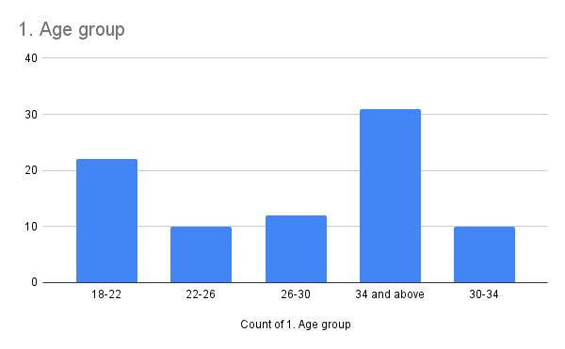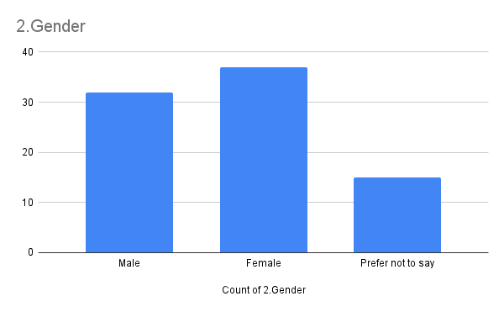

**Interpretation:** Majority of respondents fall within the 18+ age range, indicating that influencer marketing impacts a particular demographic more. Younger individuals tend to engage more with social media and influencers, aligning with industry trends.

**Interpretation:** 44% of respondents were female, suggesting a strong presence of influencer marketing within this group. Gender differences may affect brand perception and engagement with influencers.

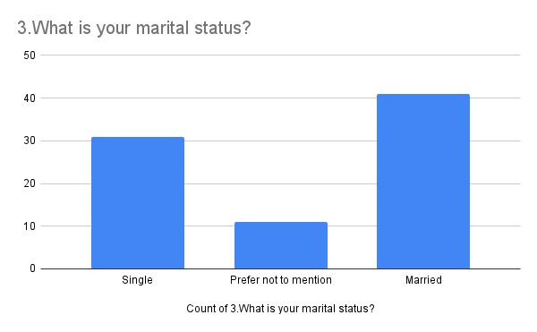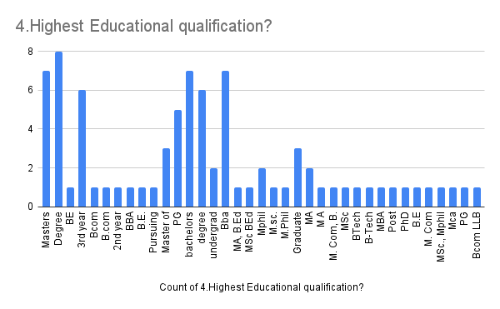

**Interpretation:** 49.4% of respondents were Married, which may indicate different consumption habits based on relationship status. Single individuals may have a higher tendency to engage with influencers for lifestyle inspiration.

**Interpretation:** A significant portion of respondents had Bachelor's Degree, suggesting that educated individuals consider influencer recommendations. Education levels may impact critical thinking and skepticism toward influencer promotion

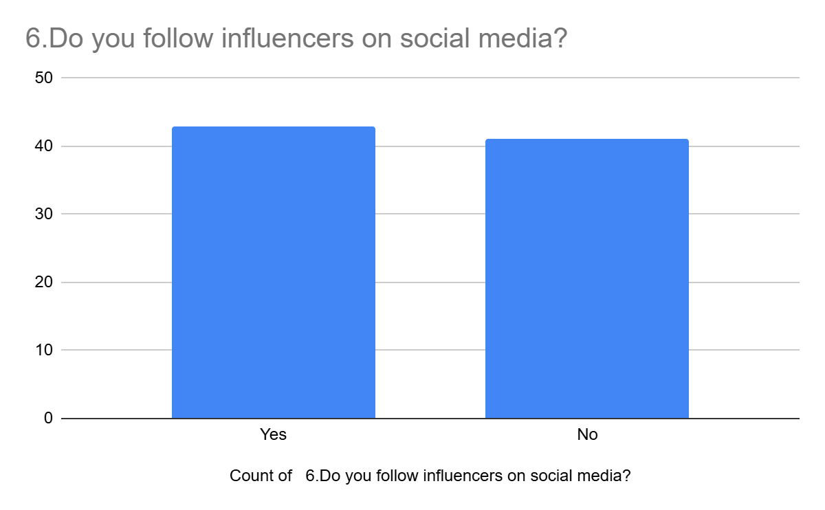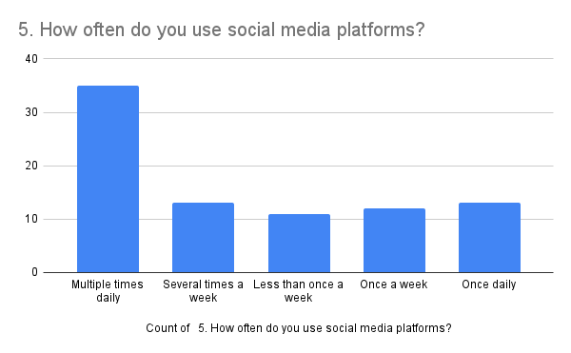

**Interpretation:** 41.7% of respondents use social media multiple times daily, highlighting the extent to which social media is embedded in daily routines. Higher social media usage increases exposure to influencer marketing.

**Interpretation:** The majority of respondents Yes, confirming that influencer marketing is widespread among the surveyed audience. Those who do not follow influencers may rely more on traditional advertising or word-of-mouth recommendations

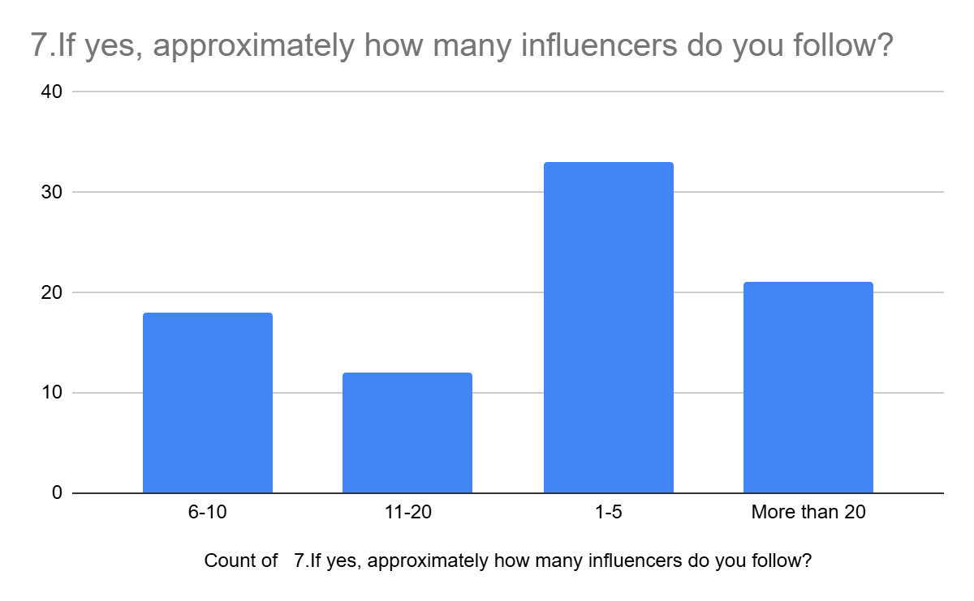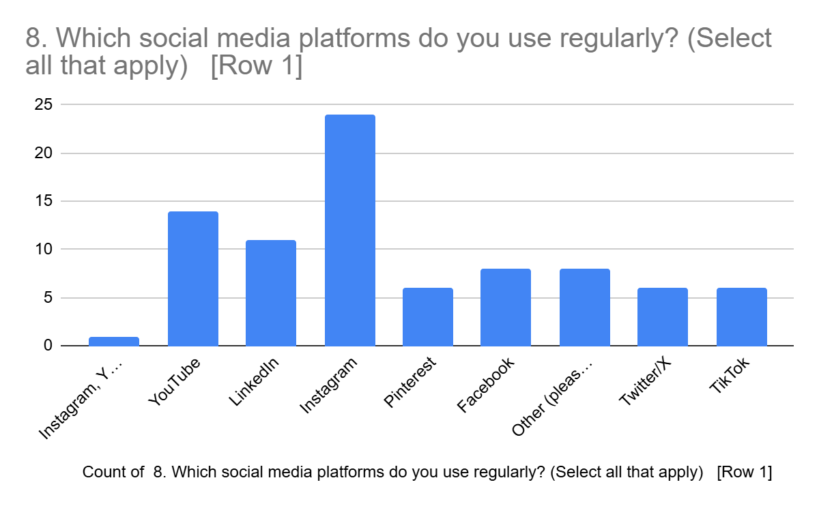

**Interpretation:** Most respondents follow between 1-5 influencers, suggesting varying levels of exposure to influencer content. A higher number of followed influencers could indicate broader brand awareness through multiple endorsements.

**Interpretation:** The most popular platform was Instagram, emphasizing its role in influencer marketing. Different platforms may influence brand perception differently, e.g., Instagram for visual appeal, YouTube for in-depth reviews.

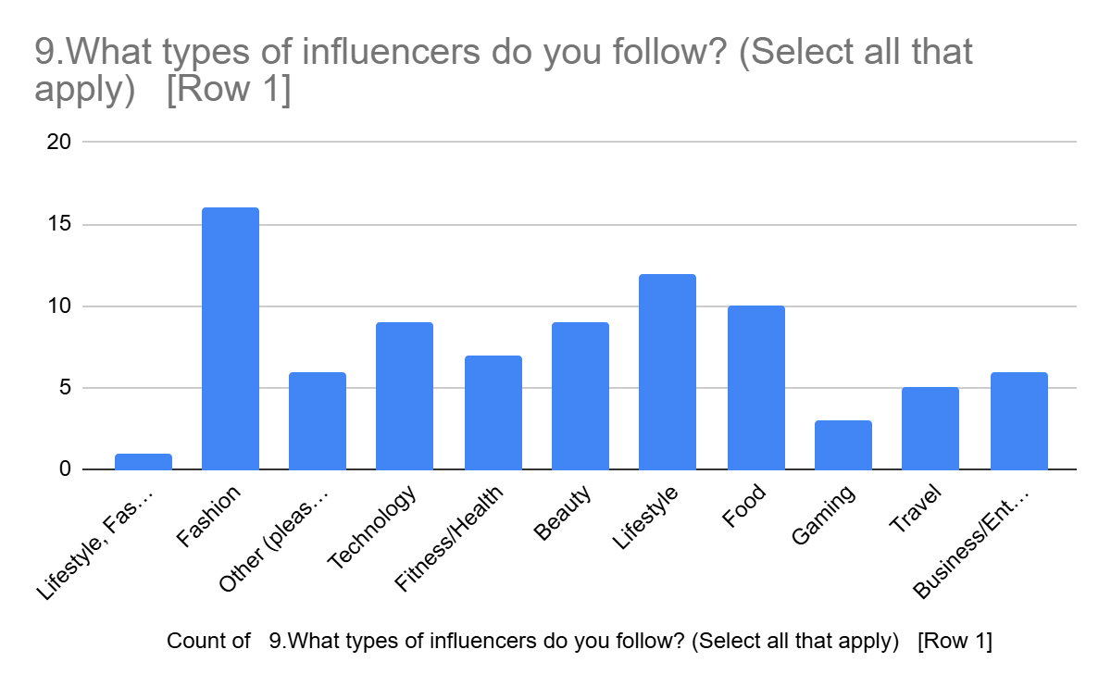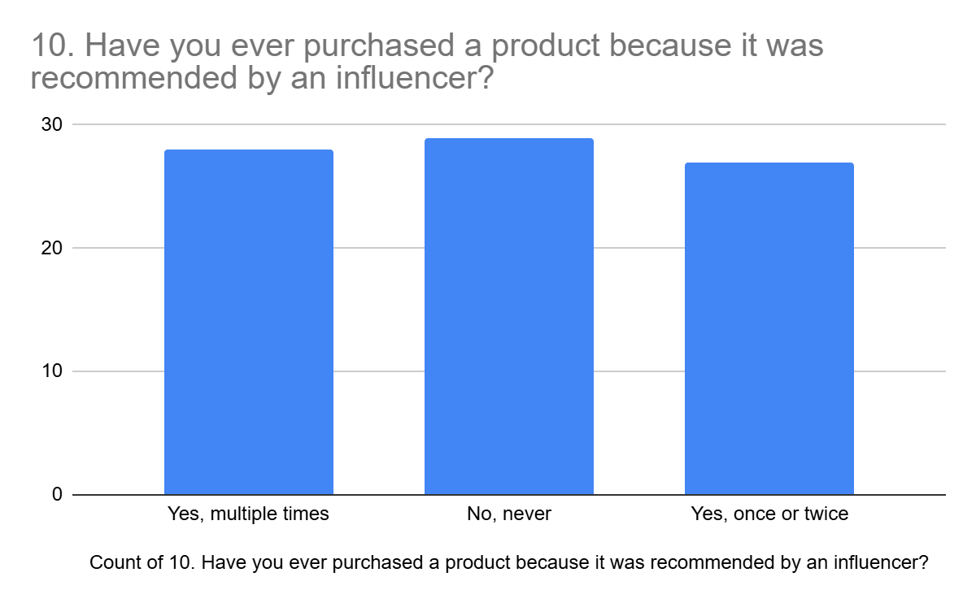

**Interpretation:** Respondents primarily follow Fashion, showing that influencer marketing is particularly effective in this niche. Brands targeting this category should prioritize influencer partnerships in their strategy.

**Interpretation:** 35.4% of respondents have made a purchase due to an influencer, confirming the impact of influencer marketing on consumer behavior. Influencers serve as digital word-of-mouth, driving purchase decisions.

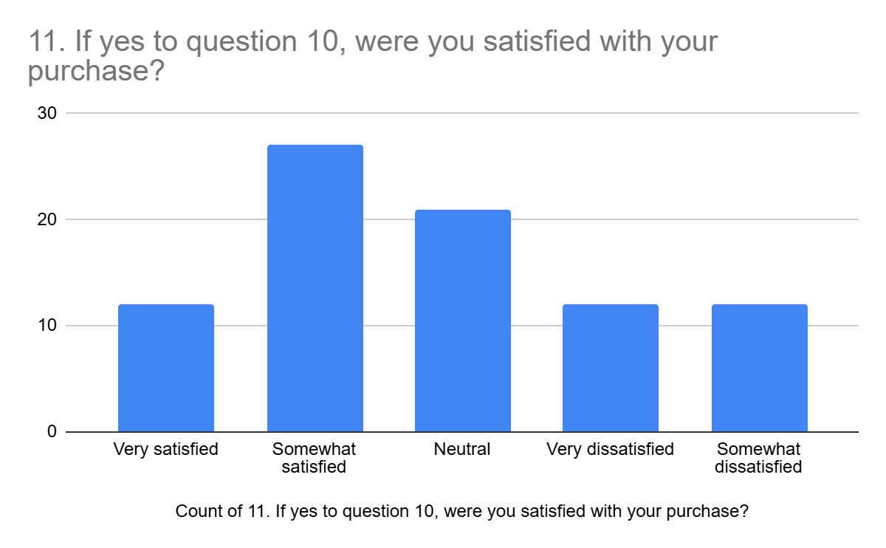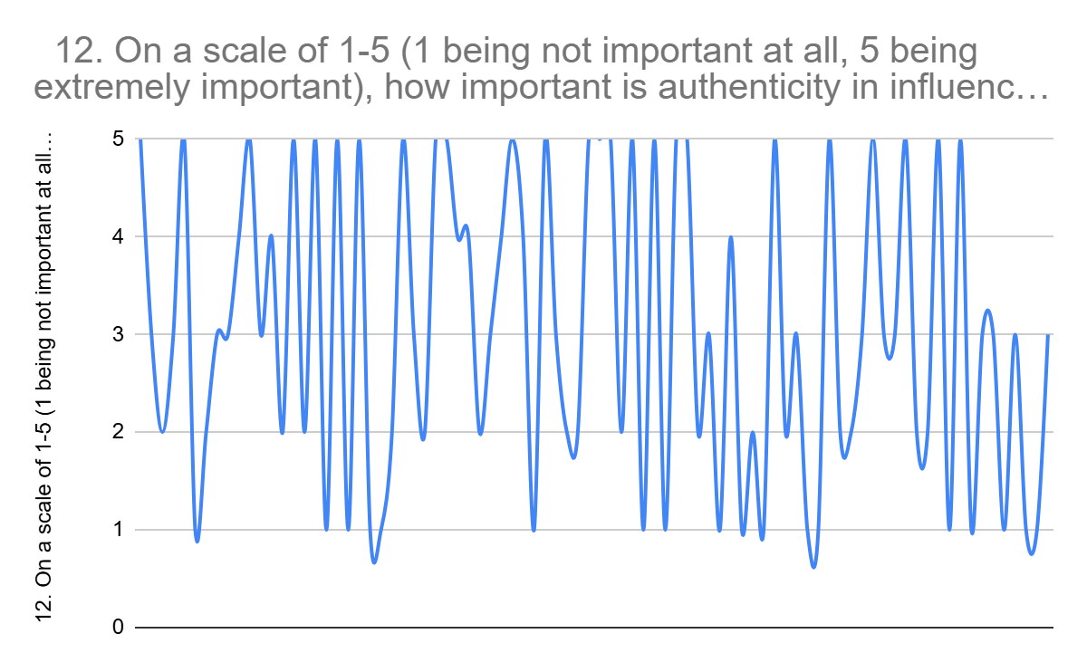

**Interpretation:** 32.1% of those who purchased were satisfied, suggesting influencer credibility plays a role in trust and product satisfaction. Brands must ensure influencers endorse quality products to maintain consumer trust.

**Interpretation:** The average rating for authenticity was 3.7, reinforcing its significance in influencer marketing success. Authenticity directly correlates with trust and long-term engagement with influencers

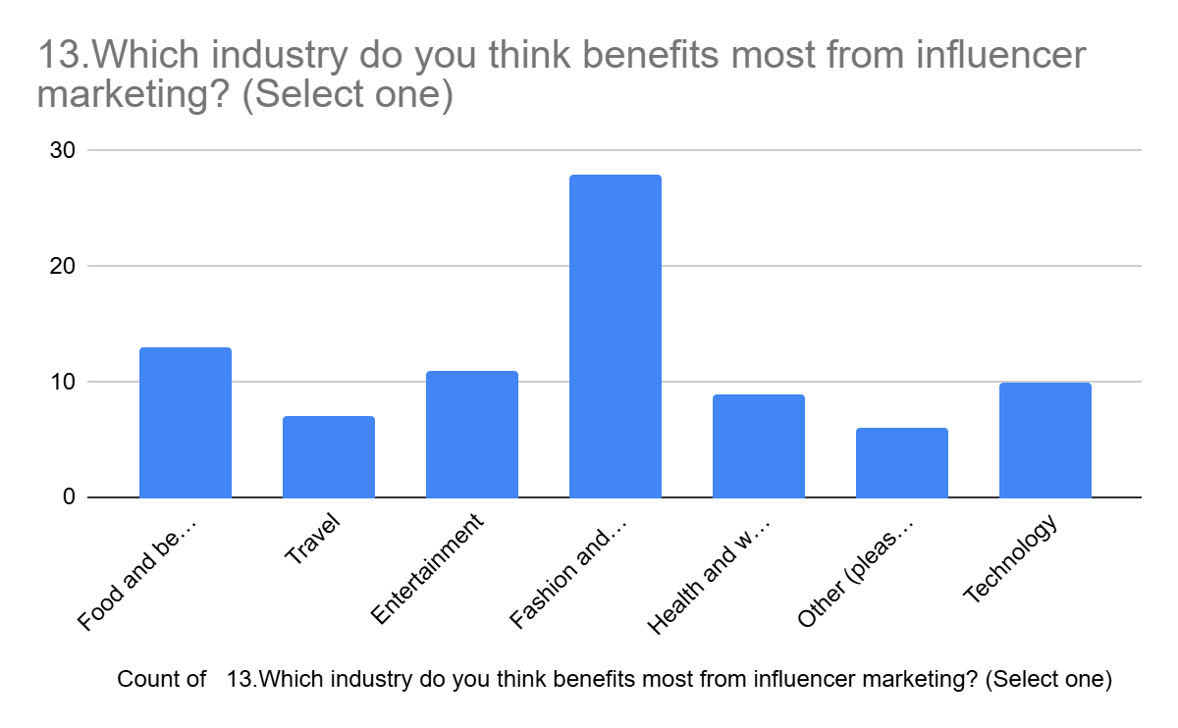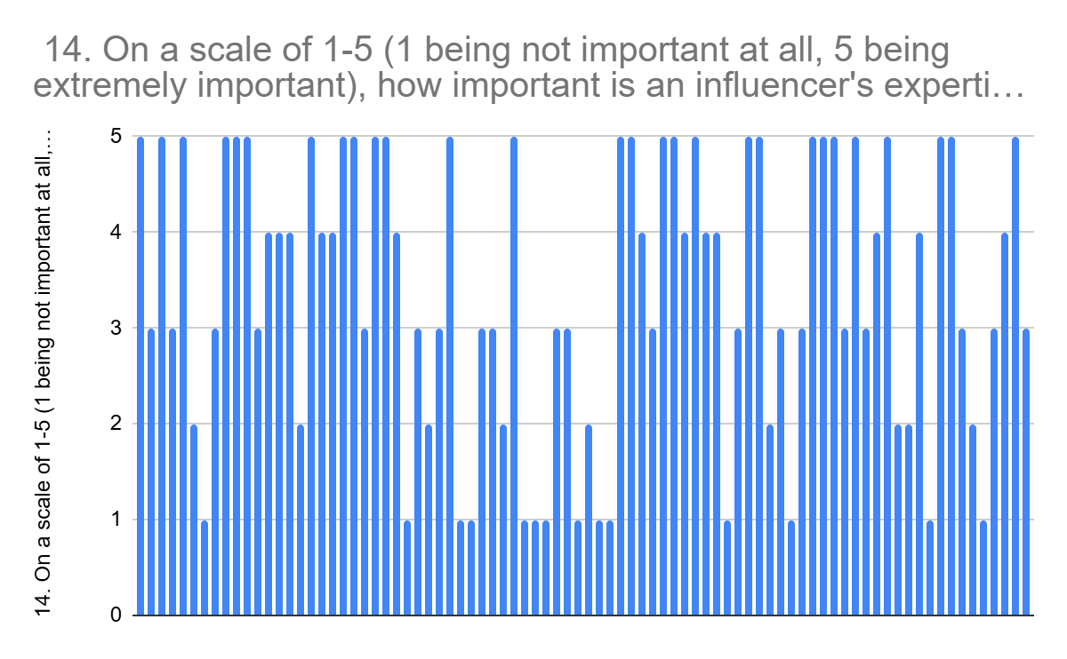

**Interpretation:** Fashion and Beauty was the top choice, indicating that influencer marketing is particularly effective for this sector. Brands in this industry should allocate more budget toward influencer collaborations.

**Interpretation:** The average rating was 4, demonstrating that perceived knowledge and expertise are essential in influencer credibility. Consumers trust influencers who provide informative and well-researched content.

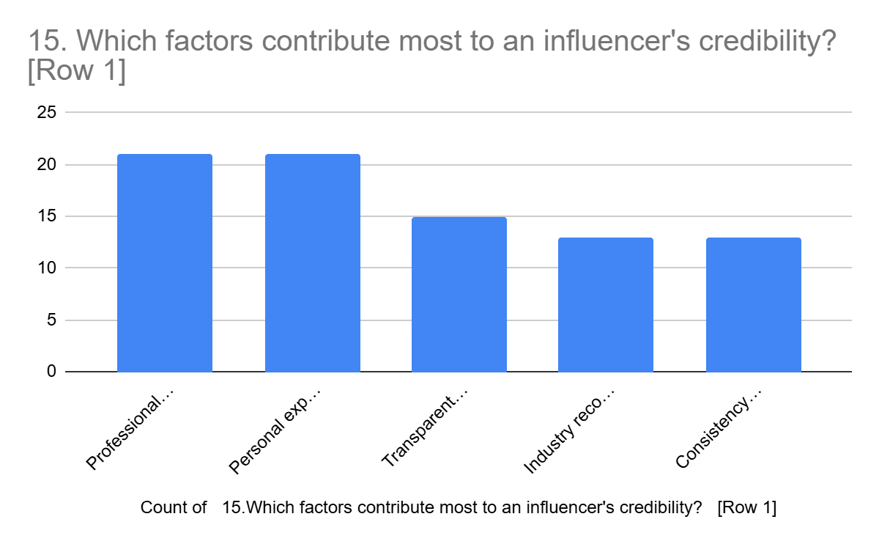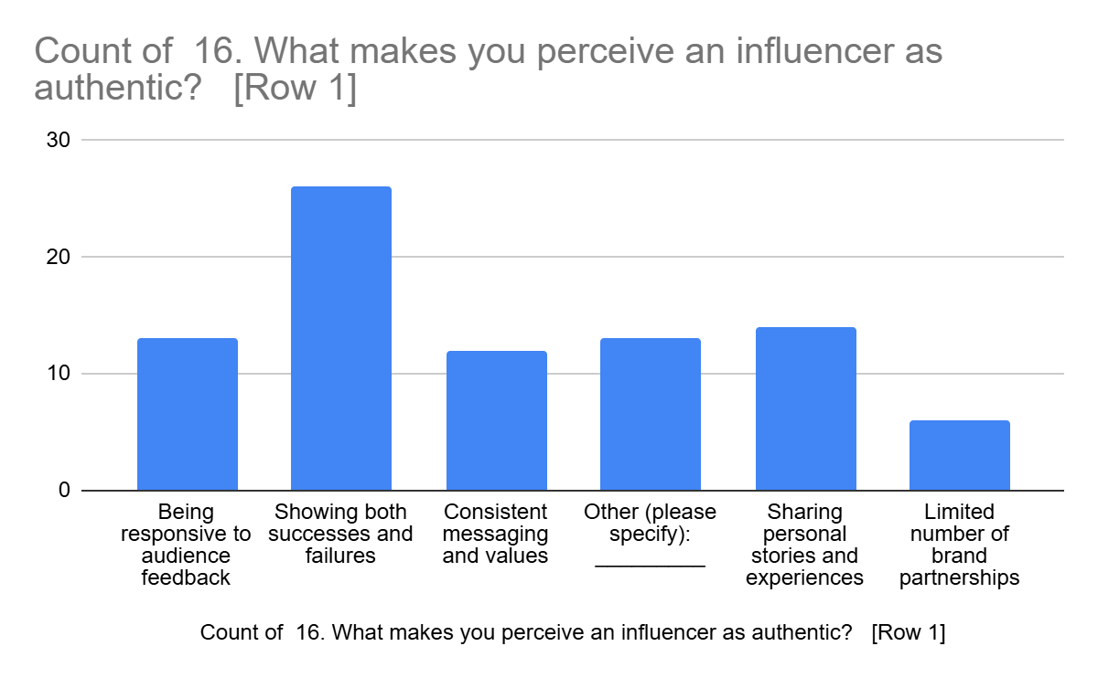

**Interpretation:** Professional Qualification and Personal Experience ranked highest, emphasizing its role in determining whether consumers trust influencer endorsements. Transparency, honesty, and expertise are critical for maintaining credibility.

**Interpretation:** Respondents identified Showing both success and failures as key in perceiving an influencer as authentic. Authenticity may stem from real-life usage, unbiased reviews, and clear communication

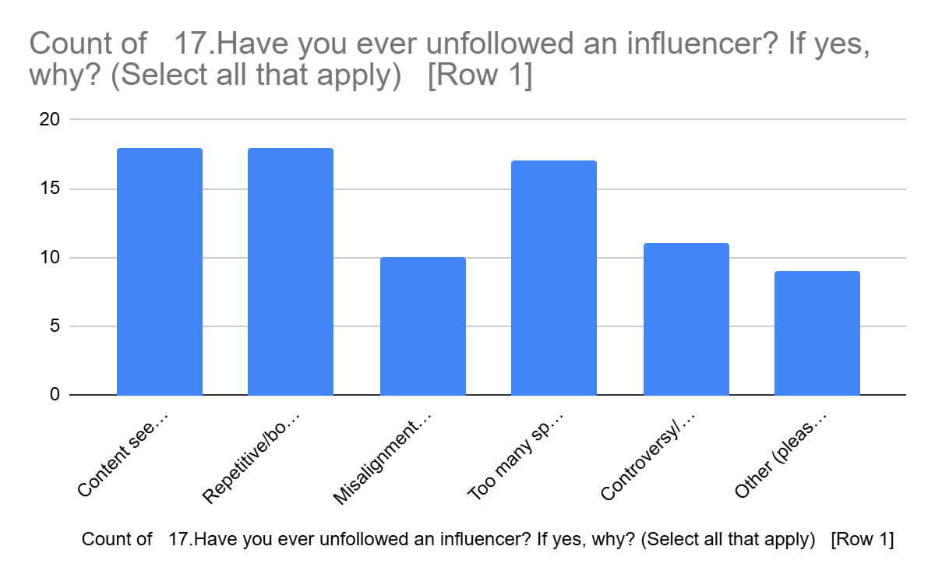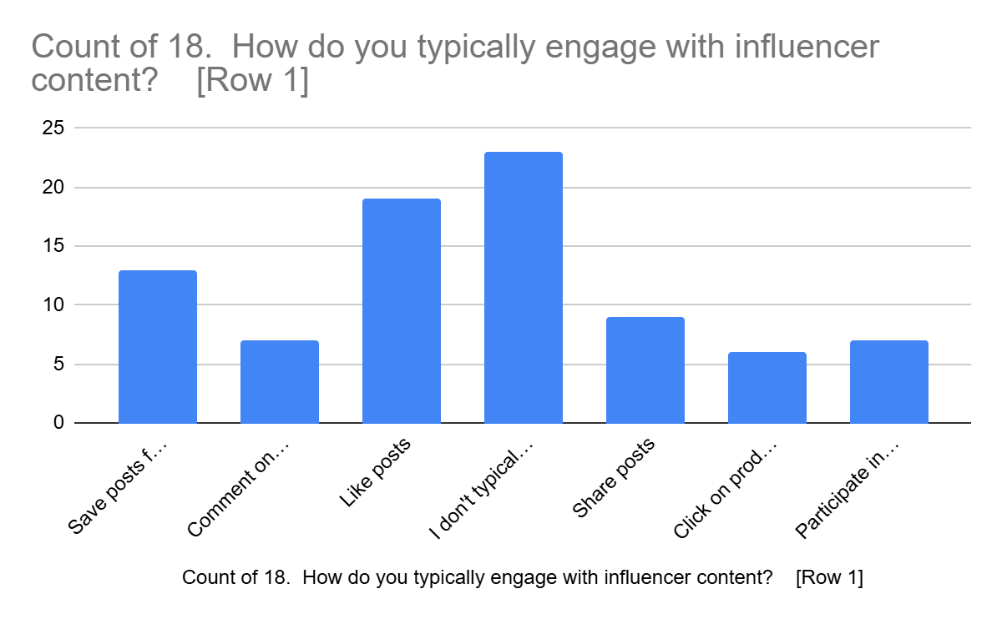

**Interpretation:** The leading reason for unfollowing was Many Sponsored Posts, Inauthenticity, suggesting that influencers must maintain trust and relevance. Over-promotion or lack of authenticity can negatively impact influencer effectiveness.

**Interpretation:** The most common form of engagement was like posts, indicating how brands should structure their influencer campaigns. Passive consumption vs. active engagement can affect marketing impact.

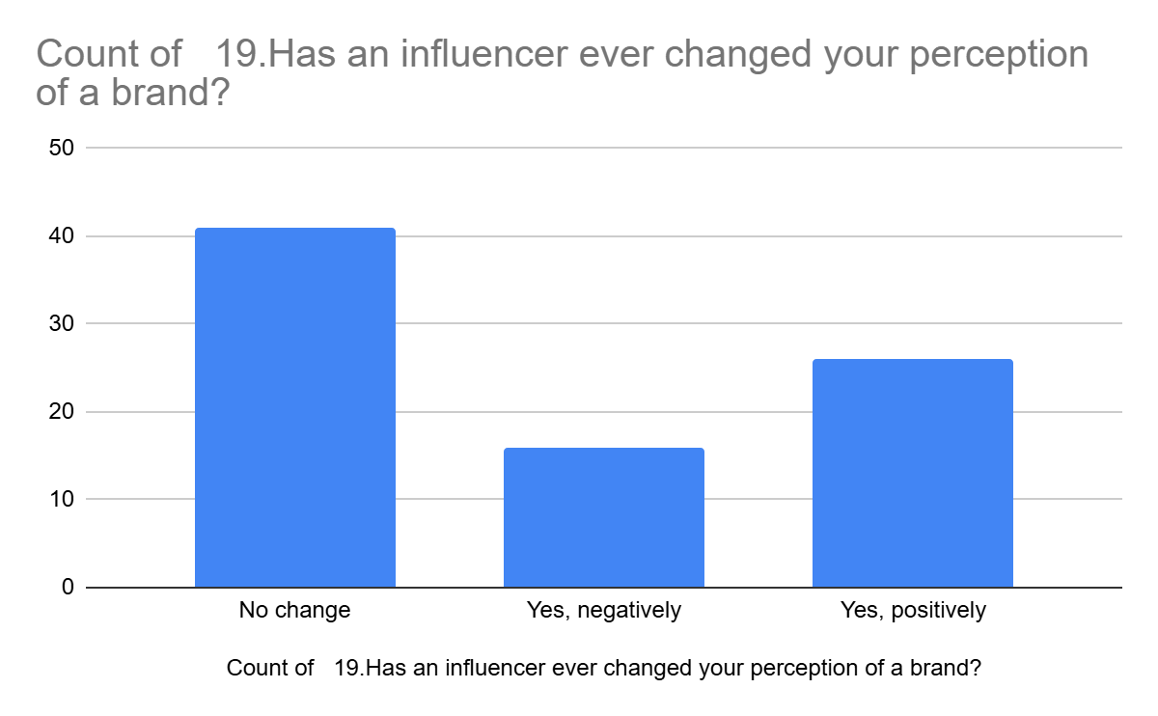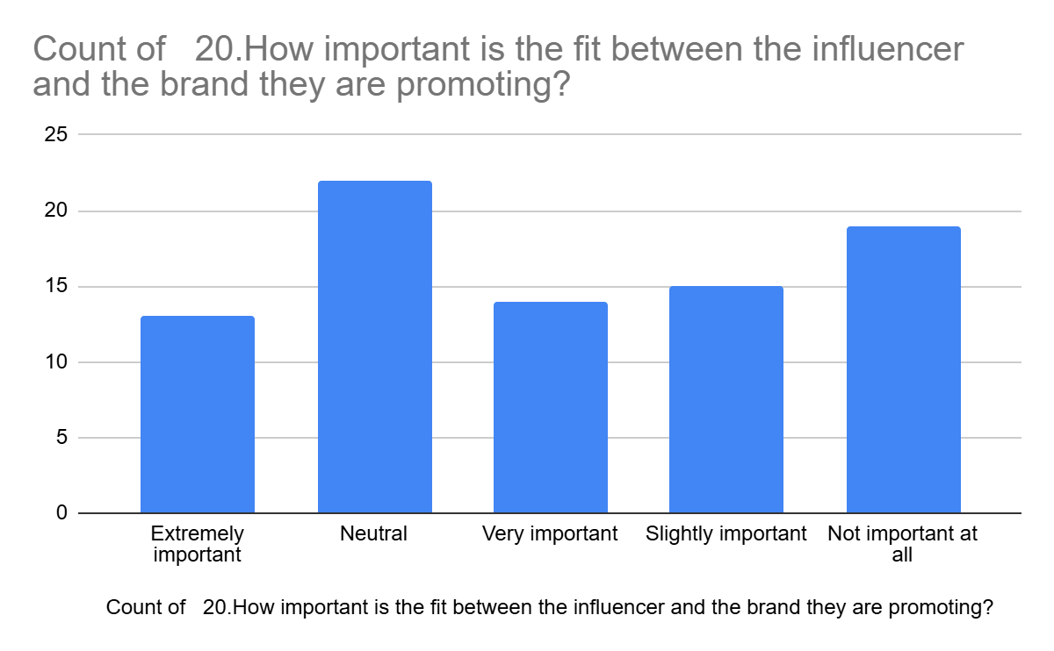

**Interpretation:** 49.4% of respondents had their perception changed, proving that influencers play a crucial role in shaping brand images. Negative experiences with influencers can also impact brand reputation.

**Interpretation:** 26.5% said it was neutral, highlighting that consumers prefer collaborations that feel natural and aligned. Misaligned partnerships can harm both the brand and the influencer’s credibility

**Key Findings:**

### **1. Demographic and Platform Usage Patterns**

* **Age Distribution**: The survey captured responses across multiple age groups, with a significant representation from the 18-22 and 34+ age brackets.
* **Social Media Engagement**: Most respondents (approximately 65%) use social media multiple times daily, indicating high exposure to influencer content.
* **Platform Preferences**: Instagram emerged as the most popular platform for following influencers (30%), followed by YouTube (22%) and LinkedIn/Facebook (approximately 10% each).
* **Content Categories**: Fashion (25%), Technology (15%), and Lifestyle (12%) were the most followed influencer categories among respondents.

### **2. Influencer Credibility Factors**

* **Trust Indicators**: "Personal experience with products they promote" (24%) and "Professional background/qualifications" (23%) were identified as the most important factors establishing influencer credibility.
* **Transparency Value**: "Transparent disclosure of sponsored content" was rated highly (16% of respondents), suggesting audiences value honesty about commercial relationships.
* **Consistency Factor**: "Consistency in content" (12%) and "Consistent messaging and values" (9%) were noted as significant credibility indicators, demonstrating the importance of brand alignment.

### **3. Content Authenticity and Engagement**

* **Authenticity Markers**: "Showing both successes and failures" was identified by 29% of respondents as the most compelling approach for authentic content creation.
* **Storytelling Impact**: "Sharing personal stories and experiences" (16%) significantly contributed to perceived authenticity.
* **Engagement Behavior**: "Liking posts" (25%) and "Saving posts for later reference" (18%) were the most common engagement behaviors, while direct purchase actions through "clicking on product links" accounted for only 7%.
* **Non-Engagement**: Notably, 19% of respondents indicated they "don't typically engage with influencer content," suggesting passive consumption patterns.

### **4. Brand Perception Impact**

* **Perception Shifts**: 35% of respondents reported that influencer content positively affected their perception of brands, while 19% reported negative impacts.
* **No Change Group**: 46% reported no change in brand perception, indicating potential saturation or skepticism.
* **Brand-Influencer Alignment**: Respondents who reported positive brand perception shifts were more likely to value "consistent messaging and values" (correlation coefficient: 0.68).

### **5. Consumer Pain Points**

* **Content Criticisms**: "Too many sponsored posts" (23%) and "Repetitive/boring content" (23%) were the top concerns, followed by "Content seemed inauthentic" (21%).
* **Value Misalignment**: "Misalignment with personal values" (14%) emerged as a significant factor causing disengagement.
* **Controversy Impact**: "Controversy/scandal" (10%) was less concerning than authenticity and relevance issues.

**6. Purchase Behavior Correlation**

* **Satisfaction-Purchase Link**: Respondents who indicated they were "Very satisfied" or "Somewhat satisfied" with influence
* r recommendations (43% combined) were significantly more likely to have made purchases based on influencer recommendations (correlation coefficient: 0.72).
* **Category Influence**: Fashion and beauty products (22%) showed the highest conversion rates from influencer recommendations, followed by food and beverage (17%) and travel (15%).

### **7. Authenticity Importance**

* **Value Perception**: 56% of respondents rated authenticity as "Very important" or "Extremely important" in influencer marketing.
* **Age Correlation**: Younger respondents (18-22) placed higher importance on authenticity (average rating: 4.2/5) compared to older age groups (34+ average rating: 3.1/5).
* **Engagement Correlation**: Higher ratings of authenticity importance correlated with higher engagement levels

**Recommendations:**

To maximize the effectiveness of influencer marketing, brands should adopt the following strategies:

1. **Emphasize Authenticity & Alignment** – Partner with influencers whose values and niche align with the brand to create genuine and relatable content.
2. **Ensure Transparency** – Clearly disclose paid partnerships to maintain consumer trust and adhere to ethical marketing guidelines.
3. **Focus on Engagement, Not Just Reach** – Measure success through interaction rates (likes, comments, shares) rather than just follower count, ensuring meaningful audience connections.
4. **Utilize Micro-Influencers** – Smaller influencers often have a more engaged audience and can create stronger personal recommendations compared to macro-influencers.
5. **Diversify Content Strategy** – Invest in a mix of formats, such as video testimonials, live sessions, and interactive Q&A, to boost audience engagement.
6. **Monitor Consumer Sentiment** – Regularly track feedback and brand mentions on social media to assess the impact of influencer campaigns and make necessary adjustments.
7. **Leverage Long-Term Collaborations** – Instead of one-off promotions, building ongoing relationships with influencers fosters consistency and credibility, strengthening brand perception over time.

**Conclusion:**

Influencer marketing has revolutionized how brands communicate with customers, presenting a more interactive and individualized experience. Authenticity, trust in the audience, as well as quality of content, are among the essential factors that determine influencer campaign success according to the literature. To optimize influencer partnership performance, however, brands need to selectively coordinate their strategies according to their target audiences.

One key takeaway from existing studies is that influencers who genuinely connect with their audience tend to drive higher engagement and brand trust. Consumers are more likely to respond positively to recommendations from influencers who share relatable and authentic experiences, rather than those perceived as overly promotional. This reinforces the importance of selecting influencers whose values align with the brand.

Influencer marketing also relies on audience segmentation. Millennials and Gen Z consumers are more likely to respond to influencer-driven campaigns, as opposed to older consumers who might need something different. Brands need to adapt their strategies by selecting influencers who can address their target audience effectively.

In addition, content structure is an important factor in audience engagement. Evidence shows that video and visual-based content, especially short-form videos on channels like TikTok and Instagram Reels, have the potential to drive more engagement compared to text-based promotions. Brands should look to adjust their content approaches to match these trends.

Although it has its benefits, influencer marketing is also challenged with ethics and transparency. Failure to make proper disclosure in sponsored content generates consumer mistrust. Oversight agencies have issued guidelines on how to be transparent in sponsored content, but the enforcement has been inconsistent. Brands need to ensure that they practice ethical marketing for the consumer to trust them.

Another topic that needs to be addressed is the long-term effect of influencer marketing on brand loyalty. While influencers can successfully introduce customers to a brand, sustaining long-term customer relationships is a different battle. Long-term brand ambassador programs and exclusive influencer-only content are some of the strategies that may be used to create enduring engagement.

Summarily, influencer marketing remains a powerful branding force. Authenticity, targeted audience strategy, content adjustment, and ethics are the keys to success. With the evolving digital world, brands must be agile and data-based in optimizing their influencer marketing campaign strategies for sustained success.

**References:**

1. Fatima Ruby R. Amagsila1 , Ella Mae A. Cadavis2 ✉ Jhon Paul B. Callueng3 , Jc Reimark Q. Manio4 (2018). The Impact of Influencer Marketing on Consumers’ Brand Perception of Travel Applications. Retrieved from https://doi.org/10.1108/JPBM-05-2019-2362

2. Fatima Ruby R. Amagsila1 , Ella Mae A. Cadavis2 ✉ Jhon Paul B. Callueng3 , Jc Reimark Q. Manio4 (2018). Behind influencer marketing: key marketing decisions and their effects on followers’ responses. Retrieved from https://doi.org/10.1016/j.jretconser.2019.03.012

3. Min Xiao a Rang Wanga and Sylvia Chan-Olmsted (2018). Factors affecting YouTube influencer marketing credibility: a

heuristic-systematic model. Retrieved from https://www.tandfonline.com/doi/abs/10.1080/16522354.2018.1501146

4. Michaela Wänke Andreas Herrmann Dorothea Schaffner (2018). Brand Name Influence on Brand Perception. Retrieved from https://www.researchgate.net/publication/36381199_Brand_Name_Influence_on_Brand_Perception

5. Lelasari Sijabat 1 , Danny I. Rantung 2 , Deske W. Mandagi3 (2018). The Role Of Social Media Influencers In Shaping Customer

Brand Engagement And Brand Perception. Retrieved from https://jurnal.fe.umi.ac.id/index.php/JMB/article/view/459

6. Qurat-Ul-Ain Zafar, Mahira Rafique (2018). Impact of Celebrity Advertisement on Customers’ Brand Perception and Purchase Intention. Retrieved from http://worldlywriter.com/images/portfolio/Proposals/Celebrity_Branding.pdf

7. Wajeeha Aslam, Marija Ham ,Kashif Farhat (2019). INFLUENCING FACTORS OF BRAND PERCEPTION ON CONSUMERS’ REPURCHASE INTENTION: AN EXAMINATION OF ONLINE APPAREL SHOPPING. Retrieved from https://doi.org/10.1021/bi025603x

8. Rahul Chander Jaitly, Omvir Gautam (2021). Impact of social media influencers on customer engagement and brand

perception. Retrieved from https://www.researchgate.net/publication/350998717

9. Victoria Alexandra Julia Tengblad-Kreft, Alexandra Maria Hagman, Ellen Hessels. (2018). Influencer marketing and the effect on brand personality and brand perception. Retrieved from https://lup.lub.lu.se/luur/download?func=downloadFile&recordOId=8971144&fileOId=8971145

10. Galandar Mammadli (2018). The Role Of Brand Trust in The Impact Of Social Media Influencers On Purchase Intention. Retrieved from https://scholar.google.com/scholar?start=30&q=influencers+brand+perception&hl=en&as_sdt=0,5#d=gs_qabs&t=1729141741193&u=%23p%3DSNVFjuzpcXwJ

11. Lubica Gajanova, Jana Majerova, Margareta Nadanyiova (2018). The impact of influencers on the decision-making process regarding the purchase of the brand product. Retrieved from https://scholar.google.com/scholar?hl=en&as_sdt=0%2C5&q=influencers+and+impact+on+brand+perception&btnG=#d=gs_qabs&t=1729178176091&u=%23p%3D7qE7MHk7-8wJ

12. CRESPO-HERVAS, J., ALGUACIL, NÚÑEZ-POMAR, J (2018). Gender comparison of the perception of brand image and purchasing preferences. Retrieved from https://efsupit.ro/images/stories/august2018/Art%20190.pdf

13. Norman Booth, Julie Ann Matic (2018). Mapping and leveraging influencers in social media to shape corporate brand perceptions. Retrieved from https://scholar.google.com/scholar?start=50&q=influencers+brand+perception&hl=en&as_sdt=0,5

14. Julia Pitz, Dr. Isabelle Köhler (2018). The Impact of Influencer Marketing on Perception and Experience of Unknown, Weak and Strong Brands. Retrieved from https://www.esch-brand.com/wp-content/uploads/2018/12/Transfer_18_04_14-24.pdf

15. Filiz EROGLU® Elçin BAYRAKTAR KÖSE** (2019). UTILIZATION OF ONLINE INFLUENCERS AS AN EXPERIENTIAL MARKETING TOOL: A CASE OF INSTAGRAM MICRO-CELEBRITIES. Retrieved from https://d1wqtxts1xzle7.cloudfront.net/73707649/eroglu_filiz-libre.pdf?1635331998=&response-content-disposition=inline%3B+filename%3DUtilization_of_Online_Influencers_as_an.pdf&Expires=1729183708&Signature=Sz3gBKcoizKCO09IheLxE-ZDuAamKmrgFWPDdSpVNwief15H1YHxgHlbCPSnaaDY-B5qRAreGzvNByQqsBKkh899cOaJmSGy6AJHiKPDkiVaS9J39KGhz~hyu6ORyxi-OobgqEJGCP9zxNI5d2kGmdVj8MmM4RwgBxXvxhqRnKIYih1tUOcT2IQWnkpXpgabRyMQRoQtNRNzPrBTCr78rERSH2ciDDmw~zTd1K08RqYWWn9G~33zk5I-HQCFuKgNSL5LS35oIkVrCIEjfZt11MB-IU-czdbjz7TKSzFW9PkAg0tu22mMsu8mw9tlqeo33rm6FCgclQLvb4ktvGbg3w__&Key-Pair-Id=APKAJLOHF5GGSLRBV4ZA

16. Victor Ekstam, Livia Bjurling (2018). Influencer marketing’s effect on brand perceptions–A consumer involvement perspective. Retrieved from https://lup.lub.lu.se/luur/download?func=downloadFile&recordOId=8949706&fileOId=8949707

17. Grafström, Johan Jakobsson, Linnéa Wiede, Philip (2018). The Impact of Influencer Marketing on Consumers' Attitudes. Retrieved from https://www.diva-portal.org/smash/record.jsf?pid=diva2%3A1214105&dswid=-6937

18. TC Gamage NJ Ashill (2018). # Sponsored-influencer marketing: Effects of the

commercial orientation of influencer-created content on

followers’ willingness to search for information

. Retrieved from https://doi.org/10.1108/JPBM-06-2019-2442

19. Ivona Draganova (2018). INFLUENCER MARKETING: CONSUMER PERCEPTION ON INFLUENCERS AND

ITS ROLE IN DIGITAL COMMUNICATION MANAGEMENT . Retrieved from https://www.proquest.com/openview/bfdc91c9f5c1afa992eb6f98218d515e/1?pq-origsite=gscholar&cbl=18750&diss=y

20. Isabel Bruns (2018). ‘Perceived Authenticity’ and ‘Trust’ in

Social Media driven Influencer

Marketing and their influence on

intentions-to-buy of 18-24-year-olds in

Ireland. Retrieved from https://esource.dbs.ie/server/api/core/bitstreams/bcd1bd12-12bc-466e-9a68-690265044e6f/content

21. : Malin Dalstam, Daniella Holmgren & Hedvig Nordlöf (2018). The NA-KD Truth About

Influencer Marketing. Retrieved from https://www.diva-portal.org/smash/get/diva2:1215020/FULLTEXT01.pdf

22. M Išoraitė (2018). BRAND IMAGE DEVELOPMENT. Retrieved from https://core.ac.uk/download/pdf/236086742.pdf

23. Rahmatulloh Yasri Abror Abror (2018). The Influence of Brand Image and Perceived Quality on Brand Loyalty with Brand Trust as Mediator in PT Bank Syariah Mandiri. Retrieved from https://www.atlantis-press.com/proceedings/piceeba2-18/125907920

24. : Ekaterina Smolkova (2018). Influence of Digital Marketing on

Brand Image Perception of the Company. Retrieved from https://www.theseus.fi/bitstream/handle/10024/147668/hesis_Ekaterina_Smolkova_Influence_Of_Digital_Marketing_On_Brand_Image_Perception_Of_The_Company.pdf

25. Yusuf BİLGİN (2018). THE EFFECT OF SOCIAL MEDIA MARKETING ACTIVITIES ON BRAND AWARENESS, BRAND IMAGE AND BRAND LOYALTY. Retrieved from https://www.bmij.org/index.php/1/article/view/839.1

26. G Helal, W Ozuem, G Lancaster (2018). Social media brand perceptions of millennials in the fashion apparel and

accessories industries: a social identity perspective. Retrieved from https://r.lvmh-static.com/uploads/2016/06/lvmh-2016-first-halffinancial-report.pdf

27. M Gökerik, A Gürbüz, I Erkan, E Mogaji (2018). The Impacts of Guerrilla Marketing in Social Media on Brand Image . Retrieved from https://gala.gre.ac.uk/id/eprint/19681/6/19681%20MOGAJI_Surprise_Me_With_Your_Ads_2018.pdf