**Smart Solar Grain Dryer System For Agriculture**

**Prof. Fatema Sarkar, Mr. OM Karande, Mr. Nikhil Kolambe, Mr. Varun Mourya, Mr. Akshay Dhote, Mr. Tushar Wadhe**

Department of Electrical Engineering

Padmshri Dr V B Kolte college of Engineering, Malkapur, Buldhana, 443101

**Abstract:**

Solar dryer is a very simple form of the sun energy dryer in which there are 2 boxes. All those vegetables that perish quickly or the ones whose prices are low if cleaned, washed, and cut properly, and spread across and sun-dried, then for 1 year at room temperature, these products remain preserved in a really good condition. This dryer is extremely small that is 1 by 1 foot in size and weighing 6 kg. This Model make help to farmers by using on their farm itself. For which there would be zero requirements of any additional moving components like photo voltage, panels, or batteries. In the topmost plastic layer, there is a particular technology that we have used such that the ultraviolet rays carried by the sunrays get blocked and hence do not reach the food products. Thus 70-80% of nutrition is retained in the product. In addition to that, I am going to connect this solar dryer to a smart phone using IoT. It enables us to desktop the tempe according to the vegetable's type

The project is intended develop smart solar dryer using Arduino for drying of agricultural products. The system uses solar energy as a primary source of energy, which makes the economic aspect viable as well as environmental-friendly. Drying is automated using an Arduino and given controlled optimum conditions for continuous drying. The temperature and humidity sensors monitor and control drying to ensure excellent drying quality of the products. This also implemented a fan, LED lights, and a relay module, which accompany the entire system for efficient and effective drying. All the research findings show that the smart solar dryer using Arduino proves to be an effective, efficient solution for drying agricultural products in high-standard dry forms with reduced labor and increased productivity. This is in comparison to the traditional methods of drying of many products.

**KEYWORDS – Solar Panel, Temperature Sensor, Drying Fruits and Vegetables.**

**INTRODUCTION**

India, predominantly, is considered a nation that is into agriculture to the extent of around seventy per cent, who go farmer owing to practice agriculture and live by it. Advancement in technology must also improve the workload of a farmer into a mechanized easy work. Agriculture can be termed as the backbone of Indian economy. Farming becomes quite an indispensable aspect in the overall improvement of efficiency and productivity in agriculture along with the ensured safe cultivation for the farmer. Drying is the process whereby moisture from grains of crops is eliminated after harvesting.

The application of an automatic grain dryer can take the crops from harvest any month of the year and keep them for a long time. When the grains are dried to the optimum moisture content, they get preserved for remarkably longer time than the grains that are not so dried. Farmers' burden and task will hence be reduced considerably, and they will get chances to utilize their time for other activities. The drying by automated method would dry within hours.

After harvesting, paddy always has around 25-30% moisture content. Drying is done to obtain about 14% of moisture if these are to be preserved/stored for longer periods. It reduces all harvesting losses, for example head shattering and cracked kernels. In this way dependency on weather condition is reduced when it comes to harvest and drying. Which in turn allow more time to a farmer for other activities postharvest. Common grain drying methods include the use of solar bubble dryer, Layer drying, Natural airflow drying at low temperature, and continuous airflow drying. Mechanical drying of agricultural products consumes energy during post-harvest technology. More preference is given to the solar-sourced energy to overcome the shortages of fossil fuels. A new solar convection dryer with natural convection was developed, which consists of a solar air heater and a drying chamber. It is impossible to dry the initial moisture content adequately by natural air flow drying because of the low temperature. It also requires electric power supply at each bin for dryer fan motors. This marks an increase in capital cost and also calls in for skilled and experienced labour.

The basic downfall with all these drying techniques is that these are very old conventional methods which take enormous space and time, are dependent on weather, have heavy initial costs, and are not affordable for medium- or small-scale farmers. To overcome the above problems, a new solar-powered automatic grain dryer is being developed.

**LITERATURE SURVEY**

Aditya Jain, Aftab Pasha**:** This paper presents the design and development of an automatic solar powered grain dryer used to remove the moisture content from grains, post harvesting. The drying is achieved by allowing the heat from heat chamber to flow on to the conveyor belt with the help of exhaust fans present in the heat chamber.

Grain drying system - Dr. Drick E. Mainer: This paper is described the different types of drying method used for drying grains also how much amount of heat is safe for grains.

Unlike the traditional methods of drying agricultural products, solar drying is much simpler, effective, and increasingly accepted as the best way recently. Countless research has been done across continents on solar dryers, and the results from various countries show that in fact, solar dryers provide quality drying with reduced labour load and energy consumption.

Singh and Tiwari (2007) personally create a natural convection solar dryer for grapes using solar collector drying chamber and controls the drying process using temperature and humidity sensors keeping in view results which indicate solar dryer is better in reduction of time required for drying and improvement of dried grapes quality as compared to those dried by sunlight. Use of microcontrollers like Arduino in designing solar dryers has been the recent trends. Arduino microcontrollers give cheap and simple platform for controlling and monitoring the entire drying process.

**PROBLEM STATEMENT**

In India, the farmers tend to face many problems regarding their crops from pre-harvesting to post-harvesting problem drying of grain. Another problem is drying the grain after harvesting and protecting the grains from insects and birds while preventing moisture from entering the grains again. Proper drying alone will save all the storage efforts, irrespective of how good storage systems are. Advancements have also made lots of changes to our day-to-day lives. It is measured with that attempt to progress further in their growing field, either through production or technological advancement.

Time has always been a severe issue, and time shortages have left many problems in life, every farmer. To reduce this time of the farmer in postharvest time is incorporated in the idea. The motor-controlled conveyer belts made out of netted material serve as the most excellent example of laying the grains comfortably, as well as the proper penetration of hot air into it. It uses an Arduino Uno Microcontroller for the smart controlling action that is needed to be implemented for the drying process. The grains will be sun-dried for a period of 10 to 15 days to harness the heat from sun rays. Based on the same principle, in this paper it use heating coil heat with the fan-generated heat required to dry grains as per specifications and standards, desired.

**SIGNIFICANCE OF PROJECT**

Storage is meant for protecting the dry grains with respect to insects, molds, rodents and birds, and blockage of moisture re-entry. But, even if the best storage is provided, losses will always occur due to improper drying. Technological advancement has brought a great deal of change in our entire day life, and we have been very thankful for it. The agricultural sector, likewise, grows up daily, employing growth either in productivity or technology. Time has always been the greatest enemy; without enough time, many problems will face every individual walking this planet.

It is, therefore, proposed to reduce the time spent by a farmer postharvest. A motor controlled conveyer belts made up of netted material is intended to lay the grains conveniently and also ensure easy penetration of hot air. It would make use of Arduino Uno Microcontroller for smart controlling action that will be needed to be put up for the drying process. The method of natural sun drying is to use the heat from the sun rays to dry the grains for 10-15 days, which becomes rather consuming and monotonous. By using the same concept, this paper used the heat generated from heating coil along with the exhaust fan, which thereby gives the heat required to dry the grains as per the specifications and standards which is desired to.

**COMPONENTS(TOOLS)**

**Solar Panel:**

By a solar panel is meant a device which works by turning the sunlight into electric energy from. Its essential parts are solar cells that are interconnected with quite a few other solar cells to form photovoltaic modules. It affects the absorption of photons from sunlight and transforms them to produce an electric energy value.

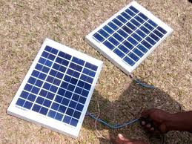

Fig.1. Solar Panel

**Battery:**

Batteries are the essential components of solar dryers, especially in off-the-grid, remote areas that have limited or no access to power grid connections. It is the storage container for energy harvested from solar panels on sunny days when the dryer is powered during low sunlight hours or at night.

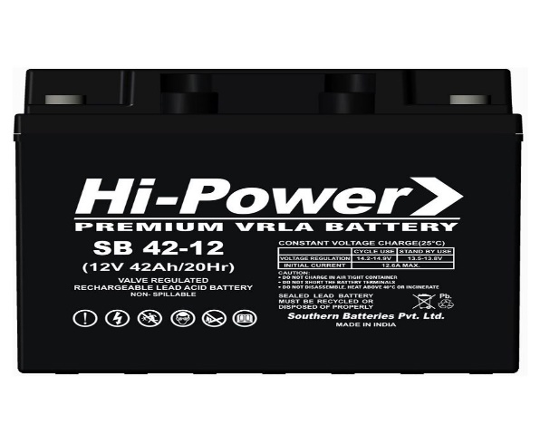

Fig.2. Battery

**Dryer Tunnel:**

A dryer tunnel is integrated as a significant part of a solar dryer. It is a part of an enclosed controlled environment where agricultural commodities are dried from the sun's rays. A dryer tunnel is typically a long and narrow structure designed to let air pass through the structure, hot airflow in, and out subsequently drying the products within. This tunnel is most made from lightweight, durable materials, for example, aluminum or plastic, which are both heat and weather resistant. With a dark-coloured material lining the interior like black plastic or painted metal absorbs sunlight, hence heating the air within.

**Inverter Kit:**

Inverter kits are essential components in power electronics, converting direct current (DC) from sources like batteries or solar panels into alternating current (AC), which is used by most household appliances.

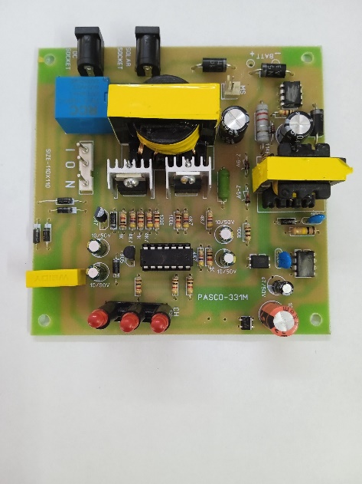

Fig.3. Inverter

**VI Digital Display:**

A digital voltage and ampere display is an electronic measuring device used to monitor the voltage and current in electrical circuits. It is widely used in power supplies, battery monitoring, and industrial automation to provide real-time data about electrical parameters. These displays are available as standalone panel meters or integrated into multimeters and power monitoring systems.

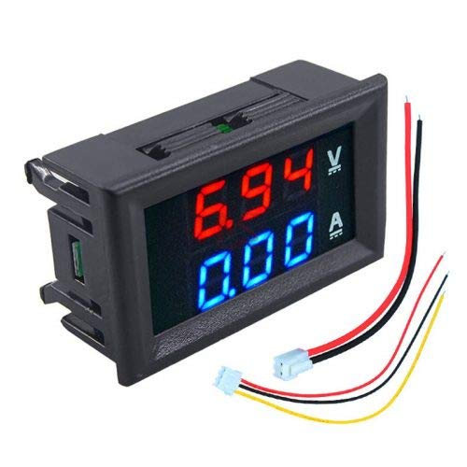

Fig.4. VI Digital Display

**Relay Module:**

Relay modules are electronic devices used in solar dryers to operate current to different devices. It functions like an on/off switch activated by an electrical signal. Typical relay module comprises a coil, a switch, and a set of contacts. When any electrical signal is sent to the coil, an electro-magnetic field induces and it pulls the switch nearer to the contacts, thus closing the circuit and allowing current to pass. When the signal is removed, the switch goes back to its original position again to open the circuit and stop the current from passing through.

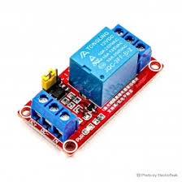

Fig.5. Relay Module

**Arduino:**

Arduino is open source electronics made easy; hardware easy to use and software easy to use. It consists of microcontroller board and development environment used for many different kinds of electronic projects including solar dryers.

The usual configuration of the Arduino board is that it has input/output (I/O) pins that can be used to integrate with sensors, relays, and displays in the solar dryer system. The functionality is often to be programmed within the Arduino IDE, a software-based simple and user-friendly interface for writing codes into the board.

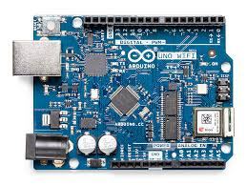

Fig.6. Arduino

**RESULT**

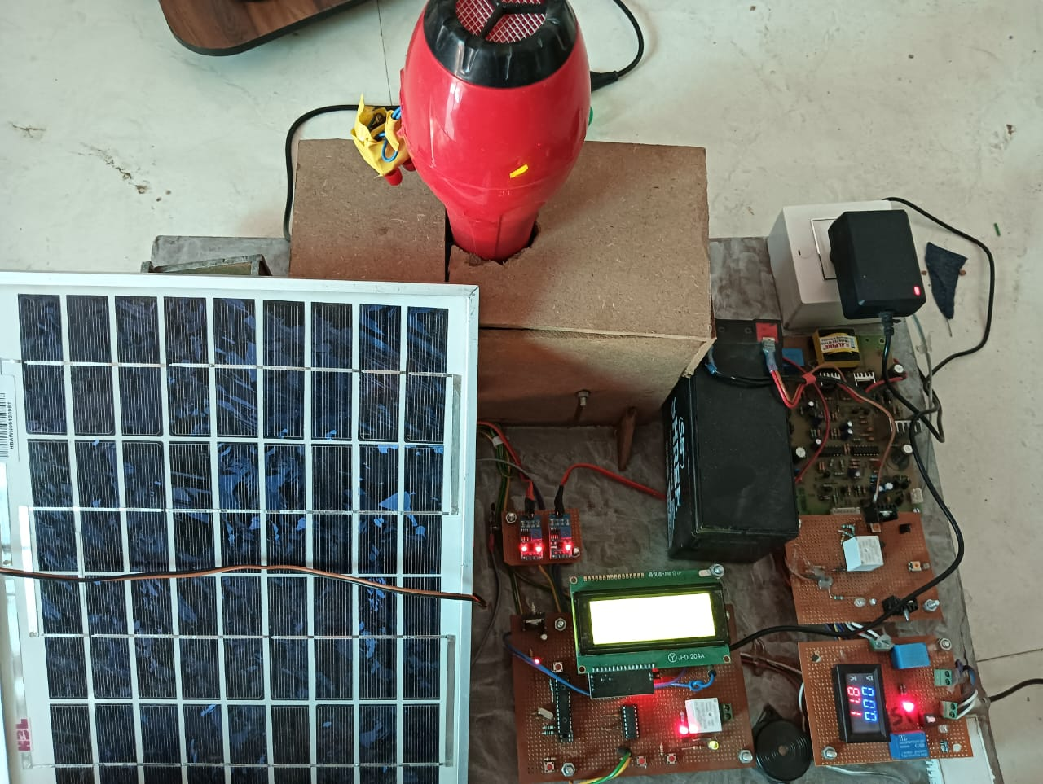

Fig.7. Result

**CONCLUSION**

The proposed project demonstrates how the grains after harvesting can dry, without hassle and without time delay. The model gave a fairly good idea of how one can go ahead in bigger scale implementation with the same vision and prospectus. It can further show that apart from saving time for the farmers, it can also demonstrate how the technologically advanced controlling action where everything about the grain is measured and controlled could just give the true effective result. proposed system is portable and handy to use Does not need any skill on the working as everything just work automatically. This system is most suited for small and medium-scale farmers who cannot afford to use technologically advanced expensive dryers.

No more is the work of the farmer as he does not need to spread the grains all across huge landfills to dry under the sun. This system completes the drying in a matter of a few hours; temperature in Bangalore is considered. Going with the current temperature of Bangalore, the output of the solar panel is good as it can touch up to 10V, using boost converter at the output has reached the voltage up to 30V DC with about 1amp current.

**FUTURE SCOPE**

Being an experimental portable prototype model, this can be scaled into a more mega commercial project keeping the same aspects in mind to prove the project effective to the world in general. A particular site allocated for a cluster of such village systems within this larger project, where all farmers can come to one place and dry their grains effectively.

A moisture sensor-a very basic one Arduino compatible soil moisture sensor; numerous grain Moisture meters are out there in the market but are costly and therefore not preferred; Moisture meters can be possible to use in the future. An improved heating chamber could be made by using comparatively larger capacity DC fans as heating coils to dry the grains faster at times.

**REFERENCES**

1. Pallavi S., Jayashree D. Mallapur, Kirankumar Y. Bendigeri “Remote Sensing and Controlling of Greenhouse Agriculture Parameters based on IoT” 2017 International Conference on Big Data, IoT and Data Science (BID) Vishwakarma Institute of Technology, Pune, Dec 20-22, 2017.
2. Development of smart sensors for the supervision of a solar dryer: agro-products dehydration application” Laboratorio de Tecnología de Sensores, Centro Nacional de Investigaciones Metalúrgicas, Consejo Superior de Investigaciones Científicas, Av. Gregorio del Amo 8, 28040 Madrid (Spain).”
3. F. Kaci Department of Agricultural Engineering Agricultural Mechanization Laboratory ENSA “Realization of an indirect solar dryer with a plan sensor for fruits and vegetables”
4. J.C Cheftel, « Introduction à la biochimie et à la technologie des aliments », 1976, Ed Lavoisier Vol II.
5. R.Bakyalakshmi Nisha, S.Madhumitha Electrical and Electronics Engineering Bannari Amman Institute of Technology Sathyamangalam, India “Solar Food Processor” 2010 International Conference on Chemistry and Chemical Engineering (ICCCE 2010)
6. Y. Baradey1 , M. N. A. Hawlader2 , A. F. Ismail3 , M. Hrairi4 , M. I. Rapi5 1,2,3Department of Mechanical Engineering, Faculty of Engineering, International Islamic University Malaysia, Jalan Gombak, 53100, Kuala Lumpur, Malaysia “Solar Drying of Fruits and Vegetables”.
7. Seelan, S.K., Laguette, S., Casady, G.M. and Seielstad, G.A., 2003. Remote sensing applications for precision agriculture: A learning community approach. Remote Sensing of Environment, 88(1-2), pp.157-169.
8. Chandra, D.G. and Malaya, D.B., 2011, April. Role of e-agriculture in rural development in Indian context. In 2011 International Conference on Emerging Trends in Networks and Computer Communications (ETNCC) (pp.320-323). IEEE. Parkes, D.H., Shivers Inc, 1986. Grain dryer system. U.S. Patent 4,599,809.
9. Tilman, D., Cassman, K.G., Matson, P.A., Naylor, R. and Polasky, S., 2002.Agricultural sustainability and intensive production practices. Nature, 418(6898), p.671.
10. Snaper, A.A., 2003. Method and apparatus for drying harvested crops prior to storage. U.S. Patent 6,536,133.
11. Suleiman, R.A., Rosentrater, K.A. and Bern, C.J., 2013. Effects of deterioration parameters on storage of maize: a review. Journal of Natural Sciences Research, 3(9), p.147.
12. Ahmad, I., Akhtar, M.J., Zahir, Z.A. and Jamil, A., 2012. Effect of cadmium on seed germination and seedling growth of four wheat (Triticum aestivum L.) cultivars. Pak. J. Bot, 44(5), pp.1569-1574.
13. Datta, D., 1981. Principles and practices of rice production. Int. Rice Res. Inst.
14. Kiaya V 2014,Post harvest losses and stratergies to reduce them.Technical paper on Post harvest losses.Action contre La Faim(ACF)
15. Sistler F,1987.Robotics and intelligent machines in agriculture IEEE Journal on Robotics and Automation, 3(1),pp.3-6
16. Sur, H.S., Prihar, S.S. and Jalota, S.K., 1980. Effect of rice-wheat and maize-wheat rotations on water transmission and wheat root development in a sandy loam of the Punjab, India. Soil and Tillage Research, 1, pp.361-371.