**IoT-** **Based Storage System for Managing Volatile Medical Resources in Healthcare Facilities**

# Harshad Asabe1, Rohan Asabe2, Onkar Lengare3, Sonali Godase4

1,2,3 UG Students, Electronics and Telecommunication Engineering, SKN Sinhgad College of Engineering, Korti. Pandharpur, India

4Assistant Professor, Electronics and Telecommunication Engineering, SKN Sinhgad College of Engineering, Korti. Pandharpur, India

***Abstract*— *In modern healthcare facilities, the efficient management of volatile resources such as medications, chemicals, and sensitive medical supplies is crucial for ensuring patient safety and operational efficiency. To tackle this issue, we propose an IoT-based intelligent storage system specifically designed for managing volatile resources in healthcare environments. This solution integrates advanced technologies including load cells for real-time weight measurement, RFID for secure identification and tracking of resources, and color sensors for automated inventory management. By leveraging these technologies, the system provides accurate monitoring of resource quantities, enhances security through RFID-based access control, and enables proactive inventory management to prevent stock out of critical supplies. Through a user-friendly interface accessible via web or mobile devices, hospital staff can remotely monitor resource levels, receive alerts for low stock and track resource usage patterns for informed decision-making. Moreover, the system facilitates seamless integration with existing hospital information systems for centralized data management and reporting. This solution aims to remain at the forefront of innovation, driving continuous improvement in resource management. The data-driven insights provided by the system enable more informed procurement decisions, optimizing inventory levels and minimizing excess stock. The implementation of this IoT-driven smart storage solution offers significant benefits, including improved patient safety, reduced operational costs, enhanced regulatory compliance, and streamlined inventory management processes.***

***Keywords— Inventory Management, Internet of Things (IoT), Cloud Service, Multiplexer***

1. **INTRODUCTION**

Certain drugs and medicines are volatile in nature, requiring precise environmental controls and secure storage to maintain their efficacy and prevent degradation. Mismanagement of these resources can lead to serious consequences, including theft, wastage, or shortages that may compromise patient care. The proposed system, "IoT-Driven Smart Storage Solutions for Managing Volatile Resources in Hospitals," is designed to address these challenges comprehensively by integrating modern IoT technologies with robust management protocols. The system ensures that only authorized personnel can access stored medical resources by assigning unique identification codes (IDs) to all staff members. This ID-based authentication validates every access request, ensuring security and accountability. Advanced sensors embedded in the storage units continuously monitor critical parameters such as temperature, humidity, and inventory levels. The data gathered is transmitted to a cloud-based storage system for real-time visualization and analysis. This setup allows hospital administrators to track the consumption of medical supplies by individual users, providing a detailed usage record that helps prevent theft, misuse, and overuse. A core component of this system is the ESP-32 microcontroller, known for its versatility and efficiency in IoT applications. It processes data from sensors and facilitates seamless communication between the hardware and the online data storage platform. After resources are dispensed, the system automatically updates the stock levels,

providing real-time insights into inventory status. In cases where the stock of a particular drug falls below a predefined threshold, the system generates automated alerts, notifying relevant personnel to initiate timely restocking. This feature ensures uninterrupted availability of critical medical supplies, thereby supporting continuous patient care. Beyond inventory management, the system incorporates advanced analytics to forecast demand based on historical usage patterns and real-time data. This predictive capability enables hospitals to optimize procurement schedules, reduce unnecessary stockpiling, and minimize waste due to expired or unused drugs. Furthermore, the IoT-enabled design supports remote monitoring, allowing administrators to oversee storage conditions and inventory from any location, thereby enhancing operational flexibility.

**II. LITERATURE REVIEW**

**IoT-Driven Automation and Solution for Medical Drug Storage: Intelligent Pharmacy System [1]** Ensuring a consistent and reliable supply of these vital [1] resources is crucial for saving lives in critical situations. Unfortunately, issues such as theft, expiration, and misplacement often occur in drug stores. To address these challenges and safeguard patients' lives, a Drug and Medicine Monitoring Model is proposed. This model utilizes RFID and IoT technologies to continuously monitor the availability, quality, location, and security of medicines and drugs in the store.

**IoT-Based Inventory Management [2]:** A proposed model addresses the issue of theft in pharmacies by implementing a system for continuous monitoring to efficiently manage pharmacy resources. The solution incorporates technologies such as TCP, HTTP, and RFID, with a Raspberry Pi serving as the central monitoring unit. Furthermore, the model is designed to comply with all applicable government laws and regulations.

**Load Cell Based Gas Monitoring System [3]:** Gases are crucial for daily life but poses risks such as gas explosions. To enhance safety, [3]an automatic gas booking system is proposed, ensuring convenience even when owners are busy. Additionally, continuous weight measurement of Gas cylinders using load cells aids in monitoring gas levels, further promoting safety and efficiency.

**Drug Storage and Dispensing System [4]:** The study presented in [4] explores the design of medicine management and dispensing systems, highlighting key challenges and solutions. It provides valuable insights into the hardware components of control systems and their analysis, which can be instrumental in developing effective solutions for medicine management. The research underscores the critical importance of precise tracking and dispensing to minimize medication errors and enhance patient safety

**III. Methodology**

Amplifier

Circuit

Load

Cells

Microcontroller

Multiplexer

Circuit

Microcontroller

Figure 1: Figure explaining methodology

As shown in Figure 1, the process begins with measuring the weight of volatile resources using a load cell. A load cell functions by converting force into an electrical signal, which is then enhanced by an amplifier circuit. While load cells are ideal for determining the weight of volatile substances in containers, other mechanical actuators can be substituted depending on specific application needs. The signals generated by load cells are typically very small and may not be directly interpretable by the microcontroller. To address this, an amplifier is used to strengthen the input signals. These amplified signals are then sent to a multiplexer, which processes multiple input signals and forwards the desired one to the output. The processed output from the multiplexer is transmitted to the microcontroller, where it is logged into an online database via a cloud connection. By analysing this recorded data, it becomes possible to track the consumption patterns of the resources. Subsequent processes are managed by other components within the IoT architecture. The IoT architecture serves as the core functional module, enabling the microcontroller to connect to the internet and transfer data to the cloud-based database. Depending on the chosen cloud service or platform, additional elements such as PHP scripts or SQL queries may be incorporated to facilitate data handling and storage. This system also supports the detection of potential leaks, as discrepancies between the current recorded quantity and the historical data stored online can indicate issues.

**IV. System Block Diagram**

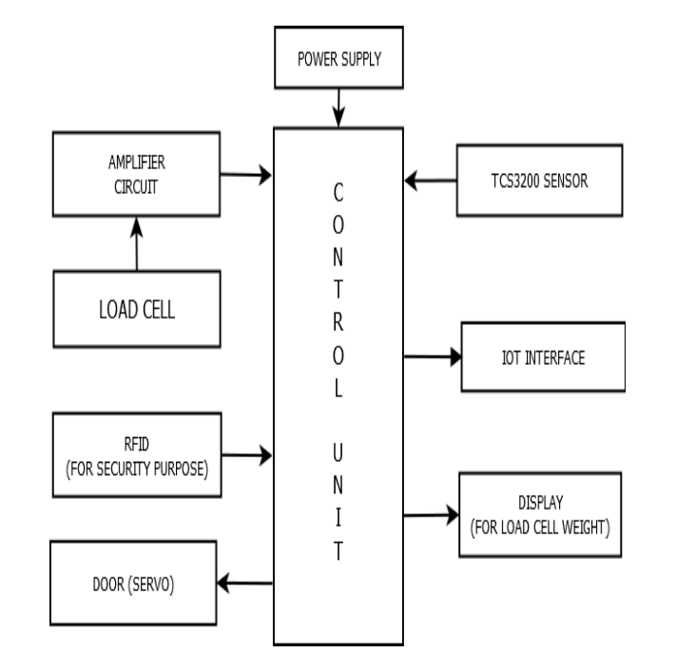

Figure 2 Block diagram of implemented work

Power Supply is the source of electrical power for the entire system. Control Unit serves as the central processing unit of the system, coordinating and managing the various components. Load Cell measures the weight of items in the inventory. Its output is sent to the amplifier circuit. Amplifier Circuit amplifies the signal from the load cell and sends it to the control unit for processing. TCS3200 color Sensor is used for identifying and counting inventory items based on their color. Its output is sent to the control unit. RFID (Radio Frequency Identification) is used for security purposes of inventory. The output is then sent to the control unit for processing. Servo Motor controls the movement of the inventory door. It receives instructions from the control unit, likely triggered by RFID scans for access control. Display is used to visually represent information to the user. In this case, it displays the weight measured by the load cell. The display receives its data from the control unit. IoT Interface connects the system to the internet, allowing data to be sent to and from a cloud interface. It likely sends data collected from the various sensors and components to the cloud for storage and analysis. Additionally, it can receive instructions from the cloud interface, allowing for remote monitoring and

control of the inventory system. Overall, this system integrates various sensors and components to provide comprehensive inventory management, including weight measurement, color identification, security via RFID, and remote monitoring through IoT connectivity

V. **Flow Chart**

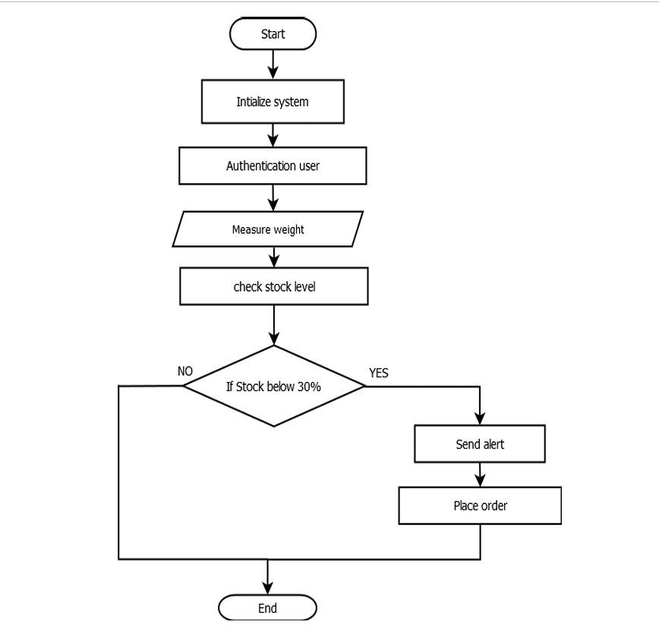

Fig 3 Flow chart of implemented work

**VI. Results and Discussion**

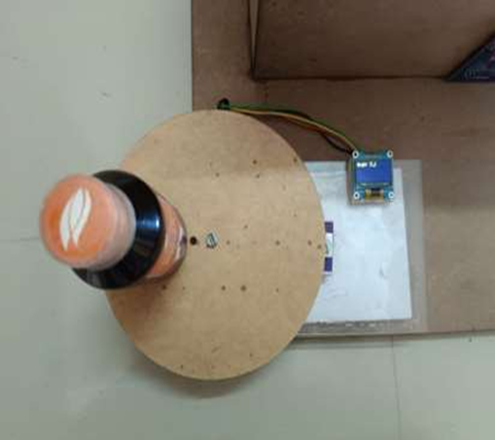

Fig 7.1 Weight Measurement of Medicines

As shown in above Fig 7.1 the weight of volatile container is measured by load cell and displayed on OLED.

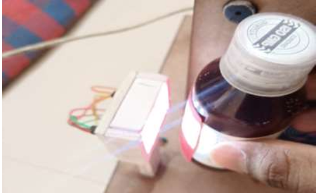

Fig 7.2 Counting of Medicines

As shown in Fig 7.2 The volatile container are counted and categorized by using TCS3200 sensor.

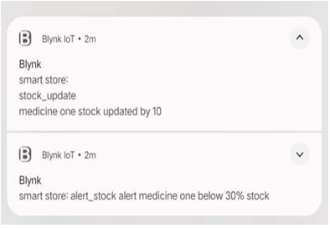

Fig 7.3 Notifications: The notifications are given through email

As shown in Fig7.3 By using Blynk App we can send the notifications of stock updated, alert notification on mail.

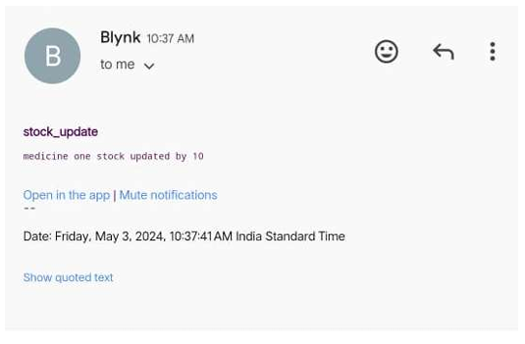

Fig 7.4 Stock Update Notification

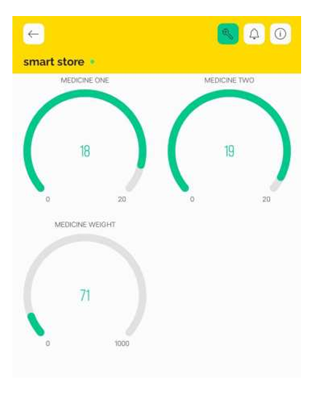

Fig 7.5 Blynk output: Stock availability of medicines and Weight of Volatile Resource

**VI.** **VOLATILE RESOURCES**

Hospitals commonly store various volatile resources, many of which require careful handling and monitoring due to their flammable nature and associated risks. Proper management of these substances is critical and is primarily the responsibility of the hospital staff. The table below highlights some of these volatile compounds along with their respective uses:

|  |  |
| --- | --- |
| **Volatile compounds** | **Uses** |
| HFC134a | Refrigerant |
| Amyl nitrite | Cyanide antidote |
| Oxygen | ICU |
| Isopropyl nitrite | Poppers |
| Tetrachloroethane | Cleaning solvent |
| Chloroform, trichloromethane | Anesthetic |
| Diethyl ether (DME), Methyl Ether | Anesthetic |
| Nitrous oxide | Analgesic |

Table 1: volatile resources in the hospital

**VII. Merits**

**Efficiency:** By automating processes such as weight measurement, colour identification, and inventory tracking, the system increases operational efficiency. Tasks that would otherwise require manual effort are performed swiftly and accurately by the integrated sensors and components.

**Accuracy**: The use of precise sensors like load cells for weight measurement and TCS3200 colour sensors for colour identification ensures accurate data collection. This accuracy improves inventory management, reduces errors, and enhances decision-making processes.

**Real-time Monitoring**: With IoT connectivity, the system enables real-time monitoring of inventory status. This allows stakeholders to access up-to-date information about inventory levels, weight, and security status from anywhere with internet access, facilitating better decision-making and inventory control.

**Security:** The incorporation of RFID technology enhances security by providing a reliable means of access control. RFID tags can prevent theft or unauthorized access.

**Scalability:** The system’s modular design facilitates seamless expansion. New sensors or components can be added as required to support increasing inventory needs or enhance system capabilities. This flexibility ensures the system can evolve to meet changing demands over time.

**Data Analysis:** The system generates valuable data about inventory levels, trends, and usage patterns. This data can be analysed to identify optimization opportunities, forecast demand, or detect anomalies. Such insights empower organizations to make data-driven decisions and streamline operations.

**Remote Management:** With IoT connectivity, the system can be remotely managed and monitored. This feature is particularly beneficial for multi-location businesses or organizations with distributed inventory. Remote management capabilities improve flexibility and responsiveness to operational need.

**VIII**. **CONCLUSION**

"IoT based Smart Storage Solutions for Managing Volatile Resources in Hospitals" improves how hospitals manage important supplies by keeping an eye on them in real-time and keeping detailed records. It makes monitoring hospital resources easier by giving a complete view of what's available. With easy-to-access records, hospitals can easily keep track of how much they're using and improve how they manage their inventory. By using this new system, hospitals can watch and manage their inventory very carefully. The system uses IoT technology to keep watching for any problems with storage or resource levels and warns staff if there's an issue. This careful approach helps hospitals keep their important supplies in good condition and available when needed. Plus, the system helps hospitals make smarter decisions based on data, so they can use their resources more effectively and waste less. All these improvements make hospitals run better and take better care of patients by making sure they have what they need, when they need it.

**IX. Future Scope**

Explore advanced security measures such as biometric authentication or block chain technology to ensure the integrity and security of volatile resources. Continuously improve the user interface and user experience of the app to make it more intuitive and user-friendly for hospital staff interacting with the storage solution. Explore integration with telemedicine platforms to facilitate remote consultation and collaboration among healthcare professionals regarding inventory management and resource allocation.

**REFERENCE**

1. M.A.Jacobs,R.Breeuwer,M.F.Kemmereand J.T.F.Keurentjes,”Contact less liquid detection in a partially filled tube by resonance ”.Journal of sound and vibration, vol.191, no. 5,pp.755-780,1996.
2. K. Gupta, N. Rakesh, N. Faujdar, M. Kumari, P. Kinger, and R. Matam, “IOT Based Automation and Solution for Medical Drug Storage: Smart Drug Store,” in 2018 8th International Conference on Cloud Computing, Data Science & Engineering (Confluence), Noida, Jan. 2018, pp. 497– 502. doi: 10.1109/CONFLUENCE.2018.8443023..
3. Adami, A.M.; Pavel, M.; Hayes, T.L.; Singer, C.M., "Detection of Movement in Bed Using Unobtrusive Load Cell Sensors," in Information Technology in Biomedicine, IEEE Transactions on , vol.14, no.2, pp.481-490, March 2010
4. K. Thanaboonkong and J. Suthakorn, “A study and development on robotic drug storaging and dispensing system in drug logistics for a midsized hospital,” in 2014 IEEE International Conference on Robotics and Biomimetics (ROBIO 2014), Bali, Indonesia, Dec. 2014, pp. 2116–2120.doi: 10.1109/ROBIO.2014.7090649
5. Naik, C., Pandit, S., Gokhale, S., & Kulkarni, M. (2021). IoT Driven Smart Storage Solutions for Managing Volatile Resources in Hospitals. International Journal of Engineering Research & Technology (IJERT), 10(09).
6. Godase, M., Singh, C., & Tanpure, A. (2023). IoT-Based Storage Management System. In Internet of Things (IoT): Key Digital Trends Shaping the Future (pp. 89–101). Springer, Singapore.
7. Chaudhari, D. A., & Umamaheswari, E. (2024). Technology-Enabled Medical IoT System for Drug Management. International Journal of Communication Networks and Information Security (IJCNIS), 16(1), 19–31.
8. Mitkari, S., Raut, V., Solase, O., & Shaikh, S. (2021). Edge Computing Based Storage Monitoring System Using IoT. 2nd International Conference on IoT Based Control Networks and Intelligent Systems (ICICNIS 2021).
9. Kumar, P. P. (2024). IoT-Driven Predictive Maintenance in Healthcare Facilities Using Machine Learning. International Journal of Sustainable Development in Computer Science Engineering, 10(10).
10. Javaid, M., Haleem, A., Vaishya, R., Bahl, S., Suman, R., & Vaish, A. (2020). Industry 4.0 technologies and their applications in fighting COVID-19
11. Abdellatif, A. A., Samara, L., Mohamed, A., Erbad, A., Chiasserini, C. F., Guizani, M., O'Connor, M. D., & Laughton, J. (2020). I-Health: Leveraging Edge Computing and Blockchain for Epidemic Management. arXiv preprint arXiv:2012.14294
12. Godase, V., & Godase, J. (2024). Diet Prediction and Feature Importance of Gut Microbiome using Machine Learning. Evolution in Electrical and Electronic Engineering, 5(2), 214-219.https://publisher.uthm.edu.my/periodicals/index.php/eeee/article/view/16120
13. Sharma, R., Gupta, A., & Kumar, V. (2022). A smart storage and monitoring system for hospitals using IoT. IEEE Access, 10, 134567-134579.Kumar, N., & Raj, S. (2021). Cloud-based IoT framework for efficient medical supply chain management. Journal of Medical Systems, 45(8), 1-12.
14. Ali, F., Bashir, M., & Ahmad, K. (2023). IoT-driven inventory control for pharmaceutical storage. Computers in Biology and Medicine, 159, 106764.
15. Khan, R., Riaz, Z., & Mehmood, A. (2022). Machine learning in IoT-based healthcare storage systems. Neural Computing and Applications, 34, 4121-4138.
16. Das, S., & Ghosh, P. (2023). Temperature-sensitive medicine storage using IoT. Sensors and Actuators B: Chemical, 380, 133112.
17. Vaibhav Godase, Vijaya Dhope, Amruta Chavan, Namrata Hadmode, "SMART PLANT MONITORING

SYSTEM", International Journal of Creative Research Thoughts (IJCRT), ISSN:2320-2882, Volume.12, Issue

5, pp.b844-b849, May 2024, Available at :http://www.ijcrt.org/papers/IJCRT2405203.pdf

1. Vaibhav Godase, Vijaya Dhope, Amruta Chavan, Namrata Hadmode, "SMART PLANT MONITORING

SYSTEM", International Journal of Creative Research Thoughts (IJCRT), ISSN:2320-2882, Volume.12, Issue

5, pp.b844-b849, May 2024, Available at :http://www.ijcrt.org/papers/IJCRT2405203.pdf

1. Vaibhav Godase. (2024). SMART PLANT MONITORING SYSTEM. In International Journal of Creative

Research Thoughts (Vol. 12, Number 5, pp. b844–b849). Zenodo. https://doi.org/10.5281/zenodo.11213525

1. Vaibhav Godase, Akash Lawande, Kishor Mane, Kunal Davad and Prof. Siddheshwar Gangonda . "Pipeline

Survey Robot." International Journal for Scientific Research and Development 12.3 (2024): 141-144.

1. Vaibhav Godase, Yogesh Jadhav, Kakade Vishal, Virendra Metkari and Prof. Siddheshwar Gangonda . "IOT

Based Greenhouse Monitoring And Controlling System." International Journal for Scientific Research and Development 12.3 (2024): 138-140.

1. Godase, Vaibhav, Amol Jagadale, and SKNSCOE, Korti, Solapur University-413304, India. “Three Element

Control Using PLC, PID & SCADA Interface.” Journal-article. IJSRD - International Journal for Scientific Research & Development. Vol. 7, 2019. https://www.ijsrd.com.

1. Godase, Vaibhav, Prashant Pawar, Sanket Nagane, and Sarita Kumbhar. “Automatic Railway Horn System Using Node MCU.” Journal of Control & Instrumentation 1 (2024): 11–19. https://journals.stmjournals.com/joci.
2. Godase, V., Mulani, A., SKN Sinhgad College of Engineering, Pandharpur, Godase, V., Mulani, A., Ghodak,

R., Birajadar, G., Takale, S., SKN Sinhgad College of Engineering, Pandharpur, & Kolte, M. (2024). A

MapReduce and Kalman Filter based Secure IIoT Environment in Hadoop. In SKN Sinhgad College of Engineering, Pandharpur [Journal-article]. https://www.researchgate.net/publication/383941977