**A study on working women issues in the IT sector with special reference to Bangalore**

Shankar Prasad, Harshita Gupta, Sunay Doshi, Dhristi Jain, Sujal Bhandari, Mehek Jain S

Shankar Prasad

Assistant Professor

CMS Jain (Deemed to be University)

Bangalore

Email: [shankarprasad@cms.ac.in](mailto:shankarprasad@cms.ac.in)

Phone: 9900723328

**A study on working women issues in the IT sector with special reference to Bangalore**

INTRODUCTION

India's economy has undergone a revolution and the labour force structure has been redefined as a result of the Information Technology (IT) sector's explosive growth in recent decades. This has created a plethora of opportunities, especially for women. Often praised for its meritocratic culture, the IT sector has been essential in promoting diversity and giving women the confidence to defy gender norms and make meaningful contributions to the economy. Bangalore, which is sometimes referred to as India's Silicon Valley, stands out among the cities that have led this change. Bangalore, the nation's centre for information technology, has drawn highly qualified workers, with a sizable proportion of its workforce being female. The obstacles that women in the IT industry, especially those in Bangalore, still encounter are numerous and complex, even with the advancements made in their integration into the workforce. Because it provides women with chances for both financial independence and job progress, the business is frequently seen as a shining example of gender equality. Beneath this exterior, though, are hidden problems including work-life equilibrium, discrimination at work, inequality in compensation, few prospects for advancement into leadership roles, and the enduring influence of gender stereotypes. The current study intends to investigate these concerns in detail and look at the several aspects that impact working women in the IT industry, specifically concerning Bangalore. Bangalore's transition in the 1990s—when globalisation and liberalisation made it easier for multinational corporations (MNCs) to set up shop in India—is partly responsible for the city's rise to prominence as India's IT centre. A sizable, highly skilled, and English-speaking labour pool, together with the city's strong infrastructure and somewhat cheap operating expenses, all contributed to its expansion. Bangalore has become a centre for innovation, technology, and business outsourcing during the past few decades thanks to the establishment of large operations by multinational corporations like IBM, Microsoft, Google, and Infosys as well as smaller players like Wipro. This success story would not be possible without the tremendous contributions made by women in the fields of software development, project management, quality assurance, data analytics, and other vital professions. Bangalore's IT sector has seen a continuous increase in female engagement as more women enrol in STEM (science, technology, engineering, and mathematics) programs. Though more women are joining the workforce, there are still issues with retention, advancement, and the general experience of women in the field, which this study aims to solve. Women's incorporation into Bangalore's IT workforce is a major indicator of India's changing socioeconomic structure as well as a reflection of larger global trends. Economic growth depends on the participation of women in the workforce, and sectors with higher proportions of female employees typically exhibit superior financial performance, innovation, and productivity. In terms of inclusivity and diversity, Bangalore's IT sector thus acts as a model for other industries, both inside and outside of India. Nonetheless, there are still significant obstacles that women in this field must overcome. Women are less likely than men to be retained in the IT business, even in spite of advancements in gender inclusion. Obstacles to professional advancement are common for women, such as the "glass ceiling" phenomenon, which makes it challenging for them to move up to leadership roles. This is made worse by problems like the gender pay gap, which frequently results in women being paid less for equivalent jobs and responsibilities than males. Moreover, as women are frequently expected to balance both professional and home responsibilities, societal and cultural expectations—particularly in the Indian context—have an impact on how women view the workplace. This research seeks to explore the particular challenges encountered by women in the IT industry in Bangalore. By grasping these obstacles, we can more effectively guide policymakers, corporate executives, and human resource professionals on strategies to enhance working conditions for women and advance gender equality within the sector. A research study examining the challenges faced by female employees in the IT industry, particularly in Bangalore, would likely highlight the specific obstacles encountered by women in this field. These challenges may include inequalities in promotion opportunities, difficulties in maintaining a work-life balance due to extensive working hours, insufficient maternity leave provisions, issues related to sexual harassment, and societal expectations concerning family duties—issues that are intensified by Bangalore's status as a leading IT centre characterized by a rigorous work environment. The exploration of women's roles in IT highlights several important aspects, starting with the representation of women in various positions (entry-level, mid-level, and leadership), while also considering their age demographics and family circumstances to pinpoint patterns in career advancement. Work-life balance factors are analysed, particularly the impact of extended working hours, the availability of flexible work options, and how demanding project deadlines affect personal life, especially for women managing childcare. The research also investigates perspectives on parental leave policies, assessing their utilization by women and whether they adequately meet their needs. Additionally, the study examines gender bias and discrimination, looking into stereotypes present in hiring practices, promotion opportunities, and salary discussions, as well as assessing reports of sexual harassment and the efficacy of reporting structures in IT companies. Qualitative interviews are conducted to gain deeper understanding of women's encounters with micro aggressions and implicit biases in the workplace. In terms of career progression, the study evaluates the presence of mentorship initiatives and leadership training specifically designed for women, alongside the general accessibility and awareness of career growth opportunities within various IT companies. Factors that contribute to women's decisions to exit the IT industry are also considered. Finally, the research analyses sociocultural influences, such as societal norms regarding women's familial roles, how these affect their career goals, and the role of community support systems or initiatives geared towards empowering women in the IT field. Collectively, these factors provide a thorough overview of the hurdles and prospects women face in navigating and progressing within the IT sphere. The CFA Institute report indicates that the IT industry boasts the highest proportion of women in its workforce, with 30% female participation, positioning it as a leader in gender diversity in comparison to other fields. Following closely is the financial services sector, which recorded a female participation rate of 22.4% for the 2021-22 fiscal year. This examination, based on the voluntary Business Responsibility and Sustainability Reporting (BRSR) disclosures from 134 companies, provides insights into the representation of women across various sectors. As the biggest employer of white-collar professionals in the nation, the IT sector's relatively high level of female representation stands out and reflects the industry’s commitment to gender inclusion. In contrast, this level of representation does not extend to other fields such as FMCG (Fast-Moving Consumer Goods) and industrial sectors, which report substantially lower female participation rates of 5.5% and 4.3%, respectively. These statistics highlight the disparities in gender representation among industries, emphasizing the need for targeted initiatives and policies to promote diversity and inclusion. The report stresses the necessity of promoting gender diversity, especially in sectors where female representation is lower, suggesting that deliberate efforts are essential to bridge this gap. Possible enhancements could involve adopting more inclusive hiring practices, creating leadership opportunities, and providing support for work-life balance to draw in and retain more women in sectors where they are currently less represented. This analysis not only captures the present state of gender diversity in the workforce but also advocates for ongoing attention to improving gender equity across all sectors to achieve a more balanced and inclusive professional landscape. The technology sector in India has made considerable progress in enhancing gender diversity, incorporating over a million women into its workforce in the last ten years. This expansion reflects the dedicated initiatives of industry leaders, educational institutions, and government programs aimed at promoting inclusivity. In the 2012-13 period, women comprised 30% of the IT workforce, with around 900,000 women among a total of 3 million employees. Over time, this figure has doubled, with more than 2 million women currently employed, representing 36% of the overall workforce of 5.3 million. Various elements have contributed to this rise in female representation. IT companies have adopted forward-thinking policies designed to attract and retain more women, prioritizing the creation of an inclusive work atmosphere. The increase in the number of colleges offering computer science degrees has also been crucial, as more women opt for education and careers in technology. Furthermore, the presence of women in leadership positions has served as inspiration for aspiring females in the tech field, further bolstering their involvement in the industry. In addition, numerous state governments have implemented measures to assist women in the workforce, such as permitting night shift work, which was once limited. These actions, along with industry-wide commitments to advancing gender equality, have fostered an environment where women can prosper in the tech sector. Consequently, there has been a notable shift in gender representation within India's IT industry, which continues to develop as more women assume influential positions and drive the sector's growth and innovation. However, this progress needs to be consistently supported through ongoing efforts in education, corporate practices, and government backing to ensure that women's representation in the tech sector not only increases but also leads to equitable opportunities for leadership and career progress. The Indian IT sector has seen remarkable growth over the past few decades, turning cities like Bangalore into international centers of technological innovation and business activities. Frequently referred to as the "Silicon Valley of India," Bangalore is home to a diverse range of tech companies, start-ups, and multinational organizations, making it a highly desirable location for IT professionals. Women have increasingly made their mark in this workforce. Over time, there has been a clear increase in the number of women pursuing careers in engineering, computer science, and information technology. This development signifies a notable shift in the gender dynamics of an industry that was historically male-dominated. Nonetheless, women in IT still encounter many challenges that impact their advancement and contributions to the field. In India, societal norms and expectations often impose extra pressures on women, who are anticipated to manage both their professional careers and household duties. These cultural expectations are especially pronounced in the IT industry, where demanding work schedules and strict deadlines add more pressure. This study intends to highlight the specific challenges that working women face in Bangalore's IT sector, reflecting broader gender issues within the global technology landscape.

REVIEW OF LITERATURE: -

1. IT Industry and Women’s Agency: Explorations in Bangalore and Delhi, India

GOVIND KELKAR, GIRIJA SHRESTHA and VEENA N.

Kelkar, G., Shrestha, G., & N, V. (2002). IT industry and women’s agency: Explorations in Bangalore and Delhi, India. *Gender, Technology and Development*, *6*(1), 63-84.

The text examines four key aspects of women's involvement in the IT sector: the inclusion of women, the challenge of domestic responsibilities, mobility and flexibility, and the glass ceiling. The significant presence of women in the IT field has challenged the traditional family structure, where men are seen as the primary earners and women as caretakers. A new understanding of women as financial contributors has developed, leading to an increase in their negotiating power within the household. The construction and exercise of women's autonomy and agency vary based on how work, power dynamics, hierarchy, and resources are distributed within the home. In many households in Bangalore and Delhi, it was observed that domestic chores remain predominantly regarded as the responsibility of women. However, numerous women in the industry have found ways to shift this burden by hiring others to handle housework. While acknowledging the realities of the glass ceiling and gender discrimination in the IT sector, it was noted that several women have successfully navigated these obstacles to attain leadership roles

1. A Study on the Interplay between the Constructs of Quality of Work life: With Special Reference to IT Professionals in Bangalore City

M. Swapna & S. Gomathi

Swapna, M., & Gomathi, S. (2013). A study on the interplay between the constructs of quality of work life: With special reference to IT professionals in Bangalore City. *Asian Social Science*, *9*(9), 107.

In this research, the connection between gender, age, and work experience with Quality of Work Life (QWL) was explored. Additionally, correlations were examined to determine the impact of these factors on QWL. A significant portion of IT staff (approximately 75%) reported having a moderate level of QWL. There is a need for intervention in the identified areas of concern. It is suggested that the findings of this study serve as a foundation and as a reference point for evaluating improvements in QWL after changes are made. It was proposed that a work environment that promotes psychological well-being is one where individual needs are met and where employees perceive their quality of work life as important and satisfactory. Thus, the focus was directed towards aspects viewed as potential issues, and specific recommendations were provided.

1. Impact of Demographic Variables on Work-Life Balance of Women Employees (with special reference to Bangalore City)

Kumari K Thriveni , Devi V Rama

Thriveni, K. K., & Rama Devi, V. (2012). Impact of demographic variables on work-life balance of women employees (with special reference to Bangalore City).

The analysis indicates that there is a notable connection between demographic factors and the work-life balance of female employees. Understanding how demographic factors relate to employees' work-life balance is crucial for developing effective policies to tackle these issues. Initiatives aimed at promoting work-life balance, which aid employees in managing their professional and personal lives, are essential for numerous employers in today’s working environment.

1. Women in BPO Sector in India: A Study of Individual Aspirations and Environmental Challenges

Dipa Dube, Indrajit Dube, Bhagwan R. Gawali1 & Subechhya Haldar1

Dube, D., Dube, I., Gawali, B., & Haldar, S. (2012). Women in BPO sector in India: A study of individual aspirations and environmental challenges. *Asian Social Science Journal*, *8*(7).

The research has shed light on the position of female employees in the BPO sector across the nation. In comparison, it has shown that Kolkata, West Bengal, falls significantly behind Bangalore, Karnataka, concerning employee pay, benefits, and workplace facilities. Transportation emerges as a significant issue for Kolkata workers, particularly those on night shifts. There is a general need to enhance security measures in both Kolkata and Bangalore. Both cities have similarly pointed out the lack of mechanisms for addressing grievances related to discrimination and harassment within organizations. While some BPOs have made noteworthy progress toward creating a gender-inclusive work environment, many others that are rapidly emerging across the states still have a long way to go. A more proactive stance from the Government, along with a cooperative and concerned approach from organizations, could certainly assist in eliminating these challenges.

1. Labour Activism and Women in the Unorganised Sector: Garment Export Industry in Bangalore

Supriya Roy Chowdhury

RoyChowdhury, S. (2005). Labour activism and women in the unorganised sector: garment export industry in Bangalore. *Economic and Political Weekly*, 2250-2255.

The self-employed, without a doubt, play a significant role in the informal economy. It’s important to note, however, that in the evolving economic landscape, the relationship between capital and labor is not confined solely to the traditionally defined formal sector—specifically, large factories where numerous male workers engage in assembly line jobs and are inclined towards unionization. The key trend in a globalized economy has actually been to reshape this workforce, both within factories and beyond, into a more irregular format, supported by temporary contracts instead of steady employment, as well as through outsourcing, put out systems, and ancillarisation. The substantial employment of women in the garment industry exemplifies these trends. Consequently, rather than relying on highly paid, unionized male workers in developed nations, capital has shifted some of its operations to employ underpaid, non-unionized female workers in developing countries. The relationship between capital and labor, along with the evident exploitation involved, is quite apparent in these situations and is not obscured.

STATEMENT OF PROBLEM

The IT industry in Bangalore, often referred to as India's Silicon Valley, has experienced notable growth and development over the years. While this sector has created numerous opportunities for professionals, it is essential to recognize the challenges and issues faced by women working in this industry. This study aims to explore these concerns, emphasizing their distinct experiences and viewpoints.

*Key Problem Statements *

1. *Gender-based Discrimination and Harassment: * Despite progress toward workplace equality, incidents of gender-based discrimination and harassment remain prevalent in the IT sector in Bangalore. This includes disparities in pay, restricted opportunities for career advancement, instances of sexual harassment, and discriminatory practices during recruitment and promotions. Gaining insight into how frequent and impactful these behaviours are being vital for effectively addressing them

2. *Work-Life Balance Challenges: * The high demands of the IT industry, combined with societal expectations and personal obligations, often create work-life balance issues for women. Extended working hours, rigid work schedules, and the pressure to thrive both professionally and personally can lead to stress, burnout, and challenges in maintaining a healthy lifestyle.

3 *Underrepresentation in Leadership Roles: * Even with the rising number of women in the IT sector, they are still underrepresented in leadership roles. This gap can be linked to factors such as gender bias, insufficient mentorship opportunities, and systemic hurdles that restrict women's advancement to senior positions. Analysing the causes of this underrepresentation is essential for fostering gender equality in the industry.

4. * Safety Issues: * The concern for safety, especially for women who work later shifts or need to travel at night, continues to be a major issue in Bangalore. Safety anxieties influence women’s decisions to pursue jobs requiring travel or night hours, which can restrict career advancement and reinforce preconceived notions about women's fit for certain positions

Data Collection

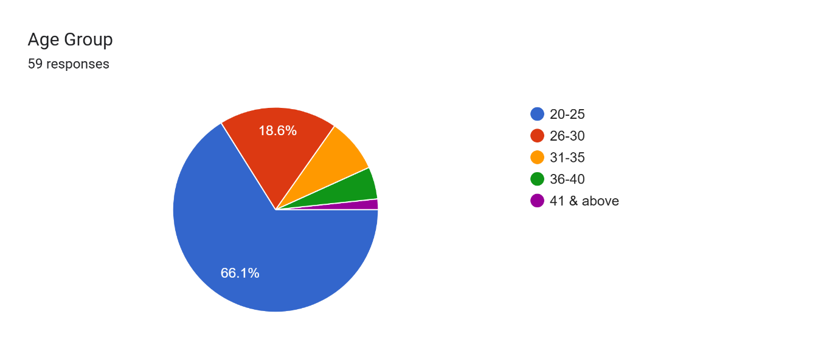

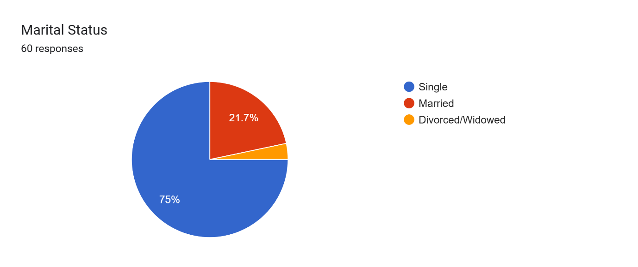

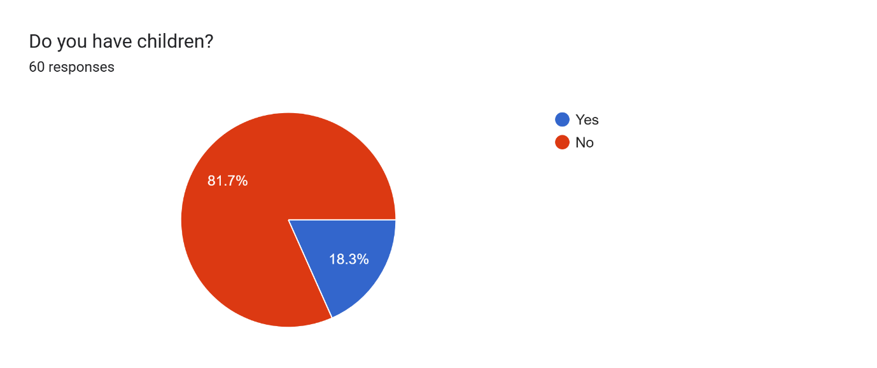

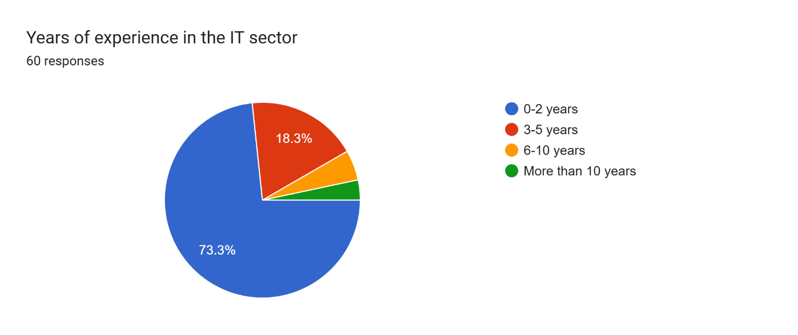

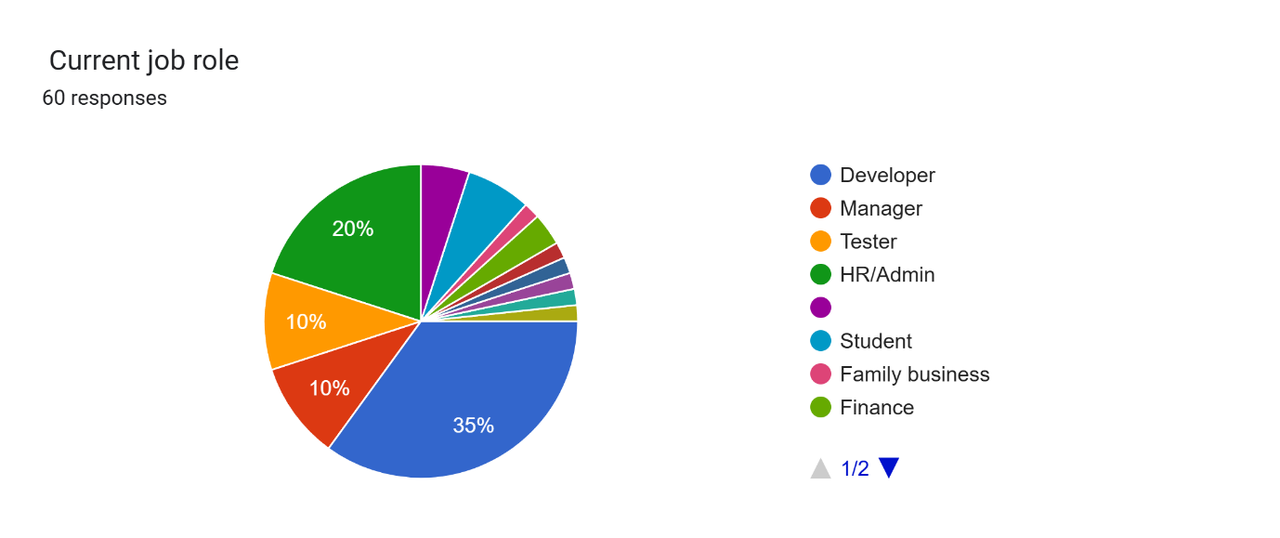

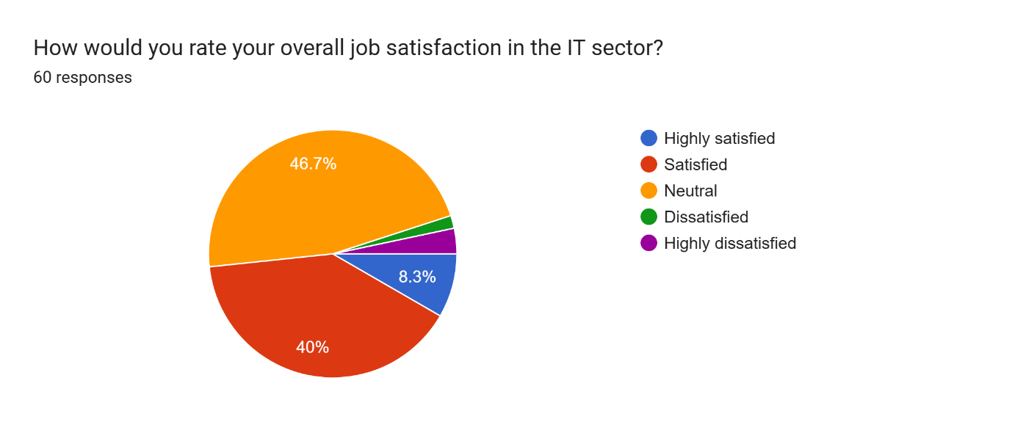

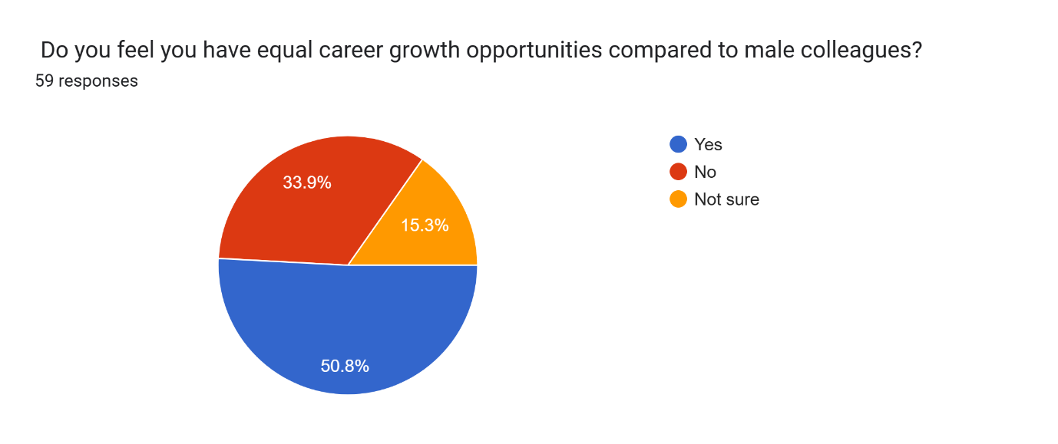

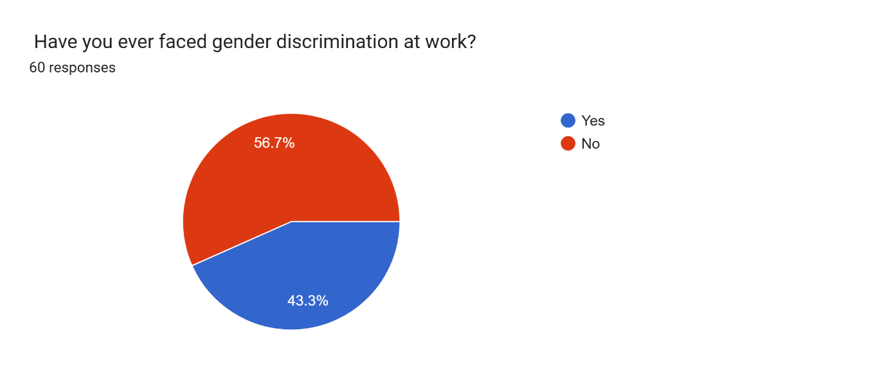

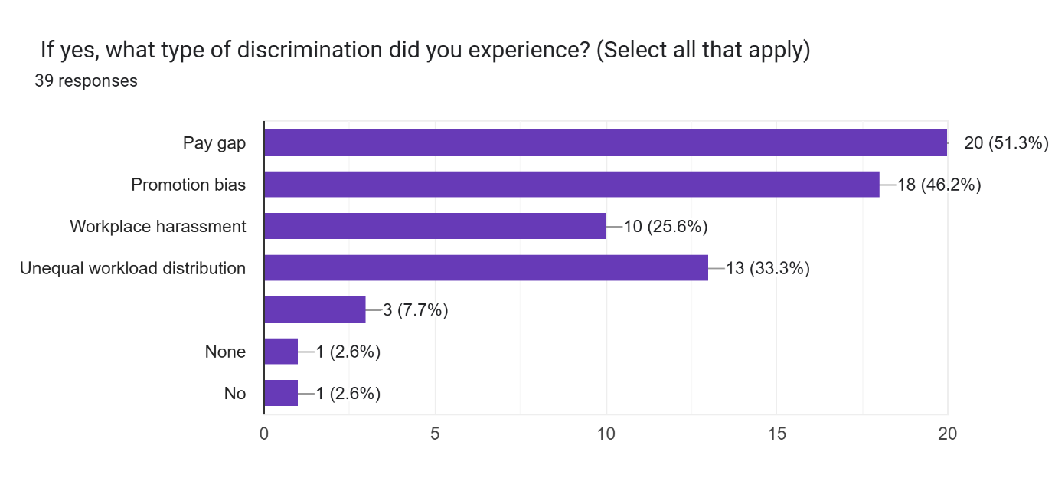

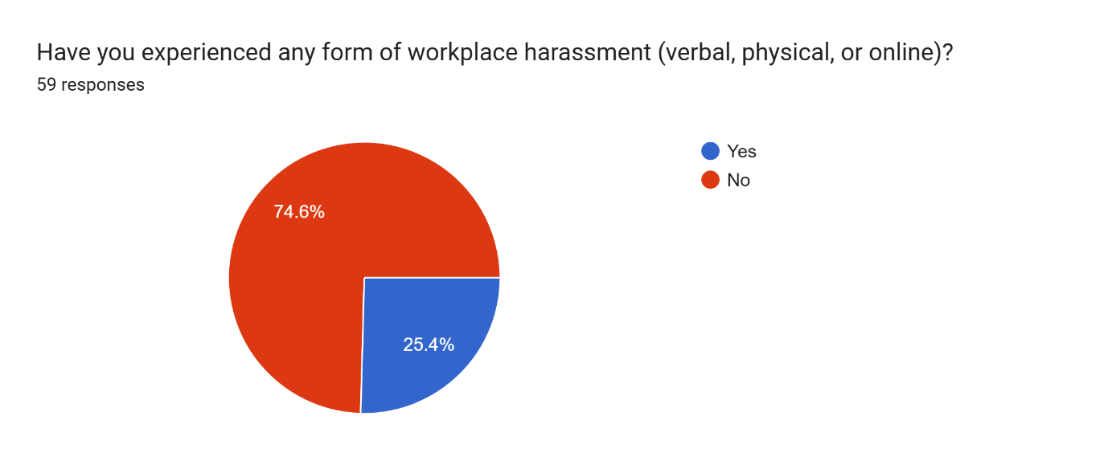

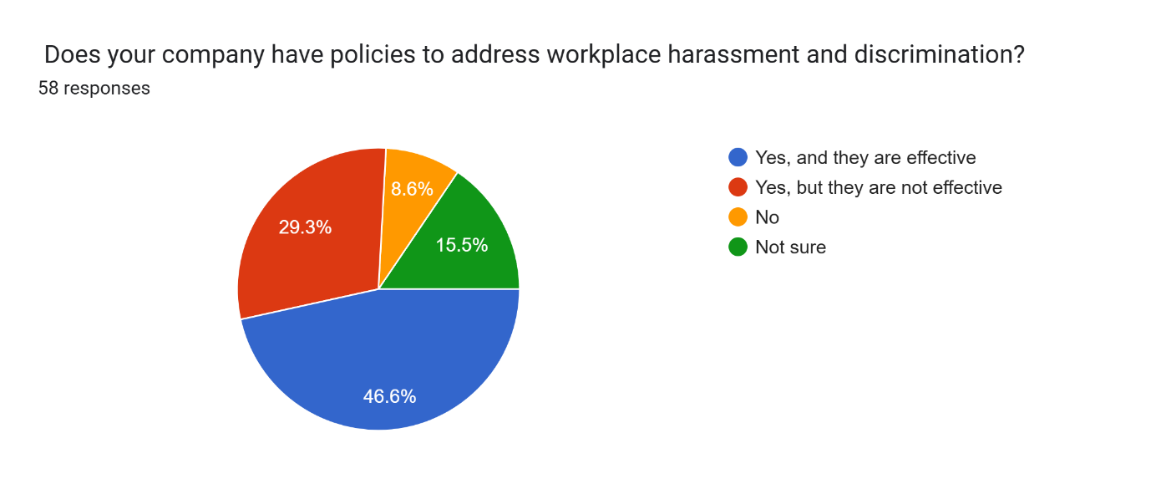

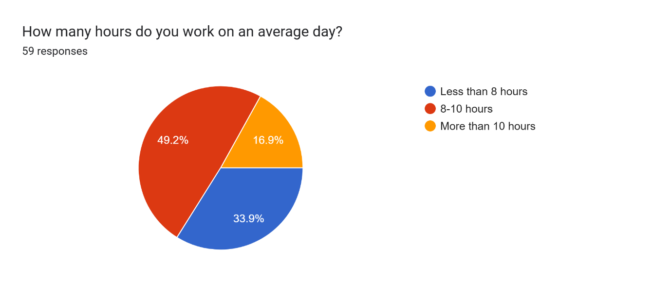

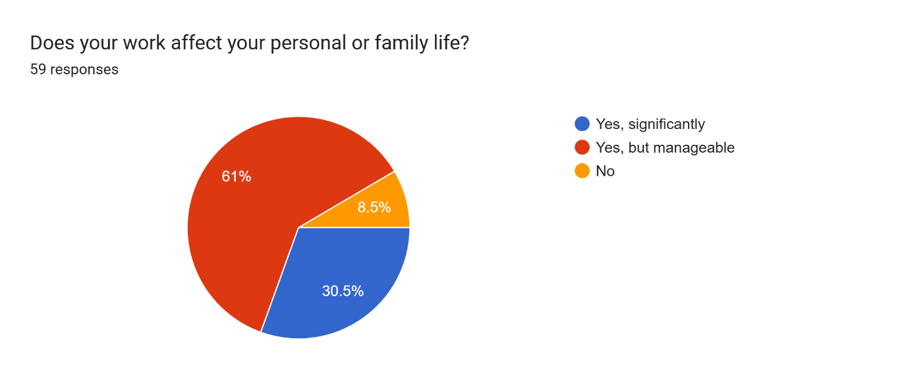

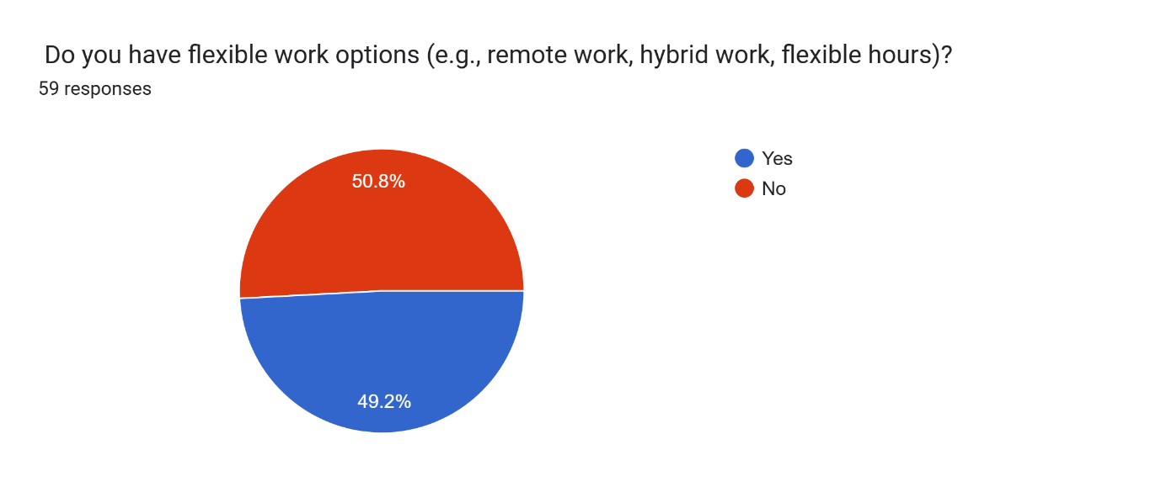

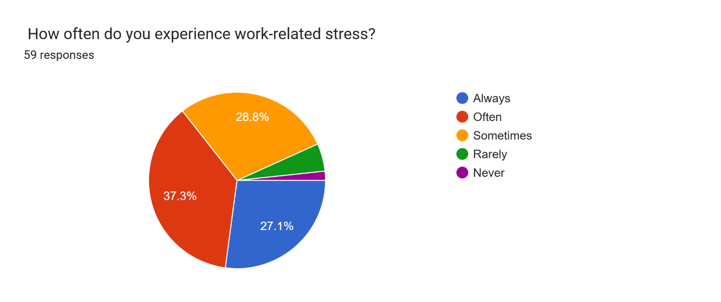

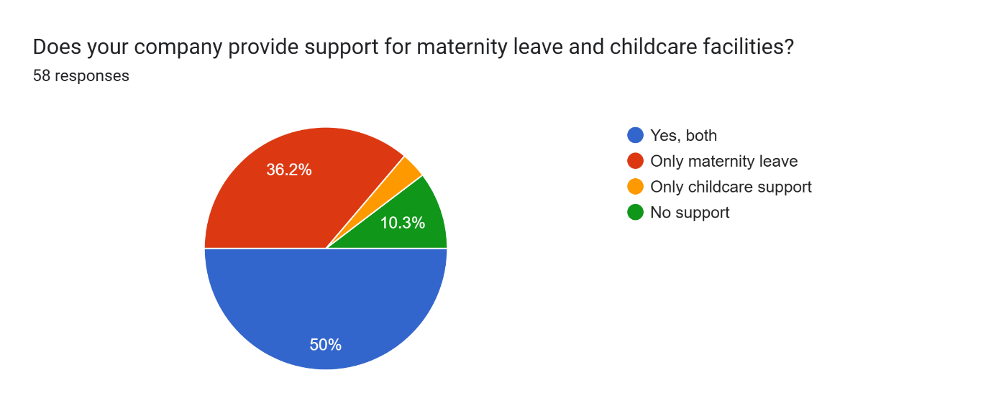

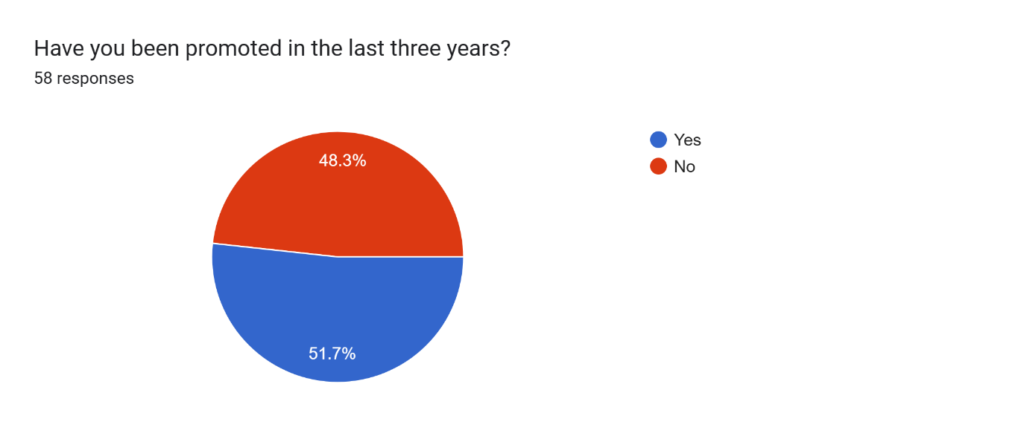

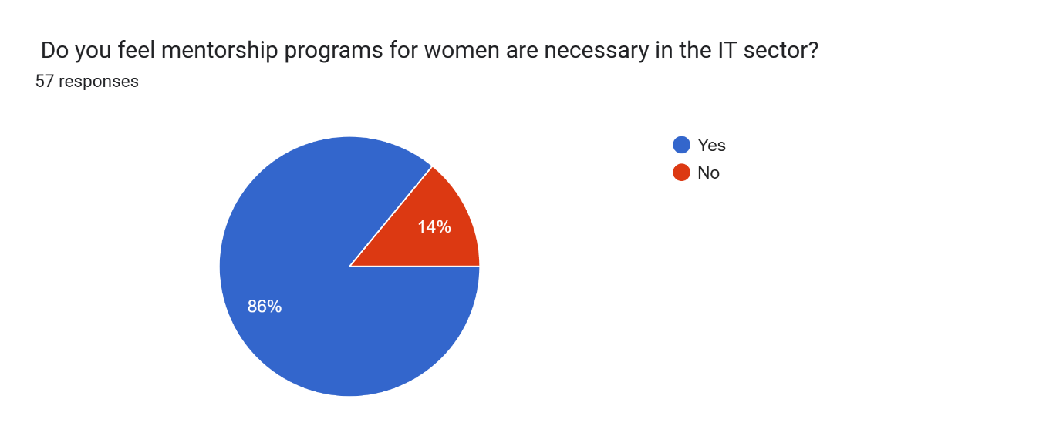

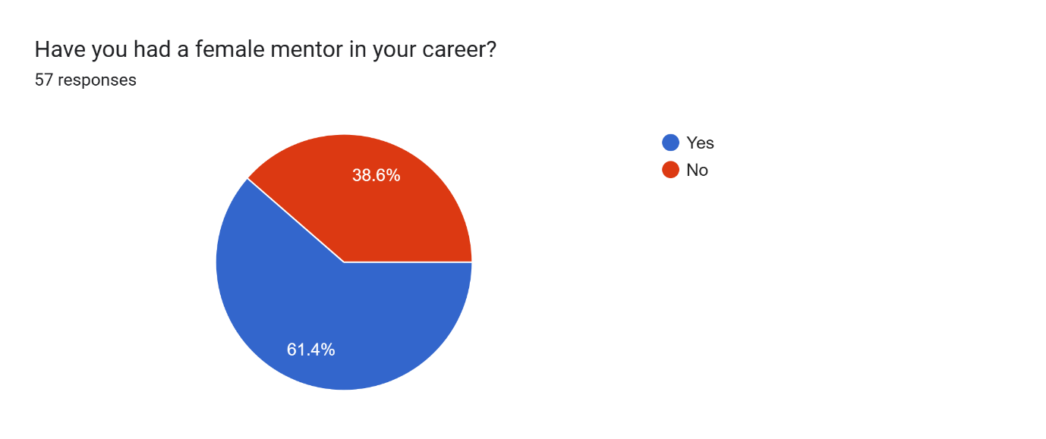

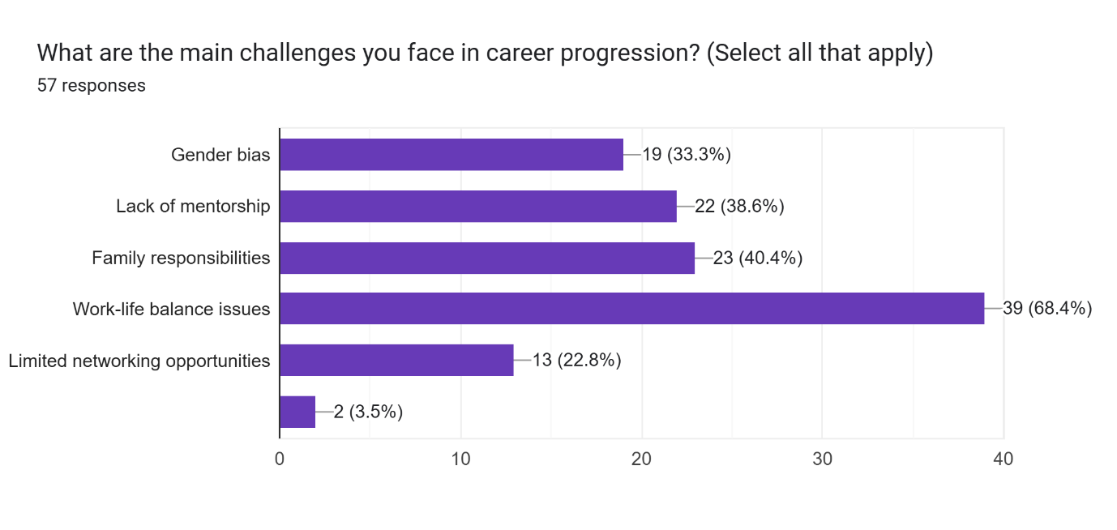

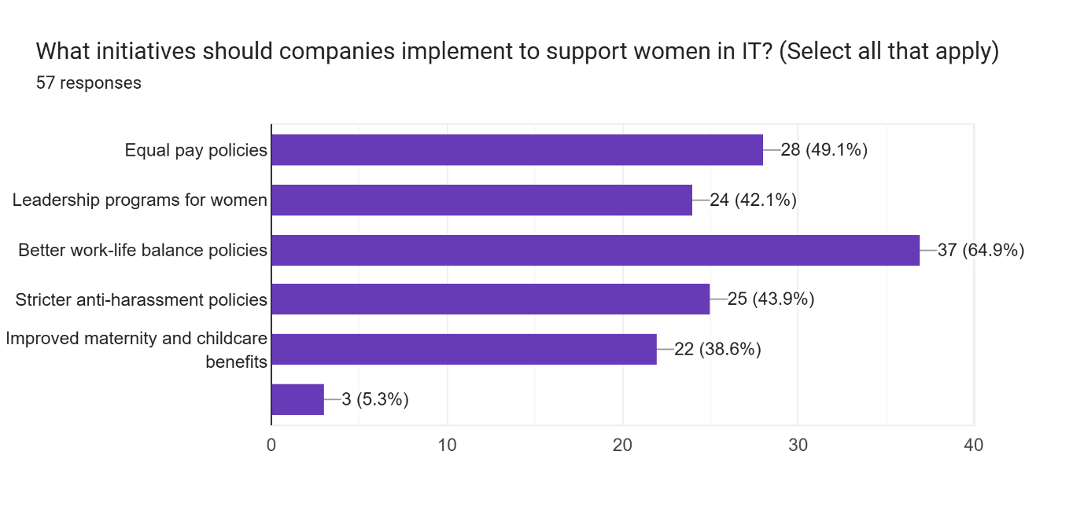

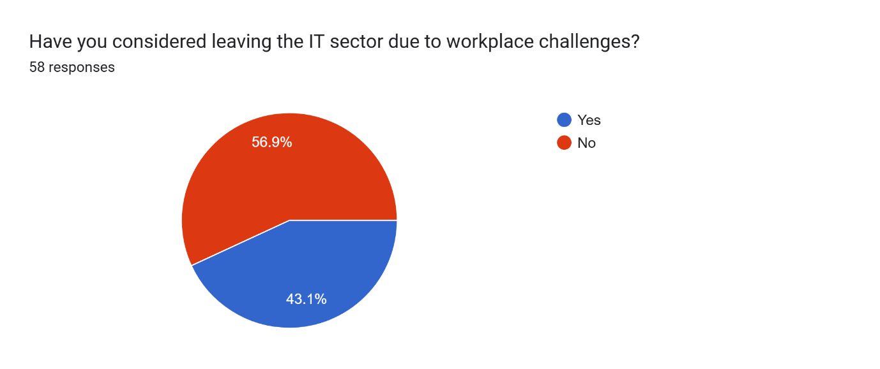

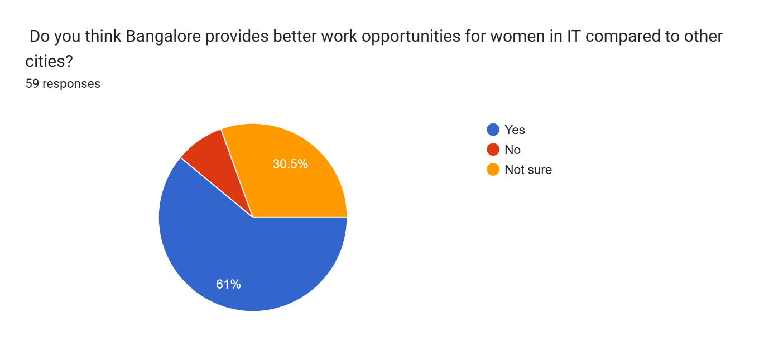

Suggestions for Enhancement:

Organizations within Bangalore's IT industry are urged to adopt more inclusive recruitment practices, foster gender-neutral workplace environments, and implement mentorship initiatives aimed at supporting and advancing female employees.

Government initiatives can significantly contribute to achieving gender wage equality, enhancing safety protocols for women, and cultivating a more inclusive atmosphere within the technology sector.

Citations:

National Association of Software and Service Companies (NASSCOM), India Skills Report 2020.

McKinsey Report (2019): "Women in the Workplace" study.

PayScale, India Pay Gap Report 2020.

Boston Consulting Group (BCG) Report (2018): "The Gender Gap in Tech".

YouGov India Survey (2018): Women's Safety in Bangalore.

Addressing these matters is essential for the advancement of women in the IT field and the overall prosperity of Bangalore as a significant contributor to the global IT arena.