# Needs Assessment for Elderly Care: Understanding Service Gaps and Preferences for Concierge Assistance

Praveetha A1, Nikhil Joy2, Krishnagiri Yogya Sahithi3, Rohan R Shetty4, Sakshi Chouhan5, Kumaresan6, Pachipala Girish Kumar7, Nandana K8

MBA Students-24-26 Batch, Faculty of Management Studies, CMS Business School, Jain (Deemed-to-be University), Bangalore

[praveetha_a24@cms.ac.in](mailto:praveetha_a24@cms.ac.in), [nikhil_joy24@cms.ac.in](mailto:nikhil_joy24@cms.ac.in), [krishnagiri_yogyasahithi24@cms.ac.in](mailto:krishnagiri_yogyasahithi24@cms.ac.in), [rohan_rs24@cms.ac.in](mailto:rohan_rs24@cms.ac.in), [Sakshi_naresh24@cms.ac.in](mailto:Sakshi_naresh24@cms.ac.in), [Kumaresan_24@cms.ac.in](mailto:Kumaresan_24@cms.ac.in), [p.girishkumar24@cms.ac.in](mailto:p.girishkumar24@cms.ac.in), [nandana_k24@cms.ac.in](mailto:nandana_k24@cms.ac.in)

# ABSTRACT

The swift rise in India's elderly population makes innovative geriatric care options inevitable as conventional family caregiving mechanisms are limited. In this research, the applicability of applying concierge services to offer inclusive geriatric care, especially involving competent youth, is investigated. Information was collected using a mixed-methods research approach by administering surveys among 120 participants to gauge public attitude, intention to embrace such services, and prevailing challenges. The research recognizes that although cost and trust are the primary barriers, there is a higher need for systematic, multi-dimensional old-age care systems. The research emphasizes the need for financial counseling, home-based care, and intergenerational care programs. The recommendations extend to government integration, professional certification of caregivers, and technology use for service delivery. The study finds that senior citizen concierge services, if developed with affordability and accessibility of prime importance, can notably enhance the lifestyle of older citizens as well as provide employment chances to young adults.

Keywords: Elderly Care Concierge Services, Intergenerational Care, Financial Security for Seniors, Young Caregivers, Technology in Elderly Care.

# INTRODUCTION

Old age is a stage of experience, knowledge, and contribution that is unavoidable in life. In terms of maintaining traditions, guiding families, and transmitting cultural knowledge, elders play a pivotal role. Often viewed as wells of knowledge, they provide advice based on years of expertise. Aging brings problems including physical ailments, little mobility, and isolation. Many older people require assistance with daily tasks as well as monetary support. They could have a meaningful life with enough focus, integration, and empathy. Elders' support and perception have changed across cultures as nuclear families are becoming more common. Some elderly individuals still function on their own; others require care. Culturally, views on aging differ all around the world; some societies cherish elders, while others suffer from disregard. In a compassionate society, seniors must have emotional support, medical assistance, and social integration assured. Elderly care covers support for daily deeds, emotional state, and healthcare resources. Usually, aging leads to lower mental and physical capacity, therefore complicating selfcare. Encouragement of senior independence and selfrespect helps elder citizens to keep their health and happiness. One could become depressed if they have few social contacts and feel lonely. Given support, social interaction, and company, older individuals remain mentally strong and engaged. Because family members might find it difficult to meet every need of the patient, professional elderly help is needed. Caregivers help families balance work and personal life and make room for their elderly members. Young adults are absolutely essential for elder support as they help with small chores, medication management, and company. Moreover offering digital solutions for senior care, technology enhances quality of life and mobility. As life expectancy rises, creating a compassionate society that respects and supports its growing population would clearly require investment in senior care. In our fast paced globe, concierge services have grown beyond high end hospitality to meet several needs including but not limited to senior care, corporate support, and health management. Modern way of life and urbanization have made it more hard to manage time. Daily tasks are made easier and certain stress free help assured by these initiatives. Given that families need to balance work and personal obligations, concierge services provide practical solution. The growth of nuclear families and immigration compounds the already serious need of elder care concierge services. These programs promise senior citizens personal, compassionate help that helps them preserve their independence and self respect by closing care gaps. Further improving the access as well as cost of concierge services are technological developments. Therefore improving quality of

life for all, concierge services are changing people's help access everywhere from personal environment to corporate sector to healthcare thing.

# REVIEW OF LITERATURE

The aging population requires holistic elderly care. The CANE tool highlights unmet needs like companionship, often overlooked, needing better long-term care.(Mazurek et al., 2014). Research highlights how mobility restrictions hinder elderly access to healthcare, social events, and services. Senior-friendly transport solutions, like on-demand and wheelchair-accessible services, can enhance independence and quality of life. (*Google Scholar*, n.d.). Elderly care requires comprehensive needs assessments to improve quality. The CANE tool identifies unmet needs like social interaction, often overlooked by caregivers. Tailored interventions can bridge these gaps for better well-being. (Martin et al., 2002b). Walsh, Scharf, and Keating (2017) explore social exclusion in older adults across six domains, including mobility, finances, and relationships. They highlight the overlap of exclusions and stress the need for inclusive policies to improve well-being. Merrell et al. (2012) examine nutritional care in Welsh residential homes, highlighting staff efforts to provide person-centered meals. Despite this, the study emphasizes the need for ongoing improvements to reduce malnutrition risks. Clark & Fong (2022) examine the sustainability of subscription-based elderly care, showing that tiered pricing improves affordability and access. Such models promote preventive care and align with elderly concierge strategies for financial viability. Miller et al., (1996a) highlight how local partnerships between NGOs, senior clubs, and welfare organizations improve elderly care accessibility. Integrating these collaborations into concierge models enhances outreach and service availability.

# RESEARCH GAPS

* + Comprehensive service models that integrate healthcare, emotional support, and daily care are lacking in Indian cultural settings.
  + The caregivers and the elderly are not well aware of the available welfare support and services.
  + Despite the fact that young adults are seen as a potential workforce for elderly care, few studies have been conducted on the effectiveness of elderly care training programs and the willingness of the elderly to accept help from younger caregivers.
  + Studies should focus on family dynamics that shape the expectations in Elderly care and adoption of concierge services.

# OBJECTIVES

* + To assess awareness levels among elderly individuals and their caregivers regarding existing welfare services and support systems.
  + To identify challenges and opportunities in employing young adults for elderly care services and assess their role in providing emotional and social support
  + To explore the influence of cultural values and family structures on the acceptance and success of elderly care concierge services.

# METHODOLOGY

This study adopts a mixed-methods research design, integrating both quantitative and qualitative approaches to analyze elderly care challenges and assess the feasibility of a concierge service facilitated by young adults. The target population for this research includes elderly people of various socio-economic backgrounds to provide a comprehensive insight into their needs and expectations of services.

A method of random sampling was employed to give equal representation, with a sample population of 120 participants, in order to give statistical accuracy. Data collection was done through both primary and secondary sources. Primary data was collected through a planned questionnaire circulated through online media, and retirement homes, on issues like challenges in elderly care, awareness and perception towards concierge services, financial readiness, and preferred channels of delivery of services.

Secondary data was collected through research on relevant articles and published research papers on elderly care to furnish context information. For data analysis, quantitative responses were analyzed based on statistical computer software, and qualitative observations were examined to identify significant themes and patterns to aid in an extensive review of the study objectives.

# DATA ANALYSIS AND INTERPRETATION

The aging population in India presents unique challenges and opportunities in healthcare, social support, and financial security. This report analyzes survey data collected to understand public perceptions, challenges, and preferences regarding elderly care concierge services in India.With India's elderly population projected to reach 19.5% by 2050 (United Nations, 2023), this research investigates critical dimensions of care through quantitative and qualitative analysis of 100+ responses. The methodology adheres to OECD guidelines for aging research, employing descriptive statistics and thematic interpretation to derive actionable insights.

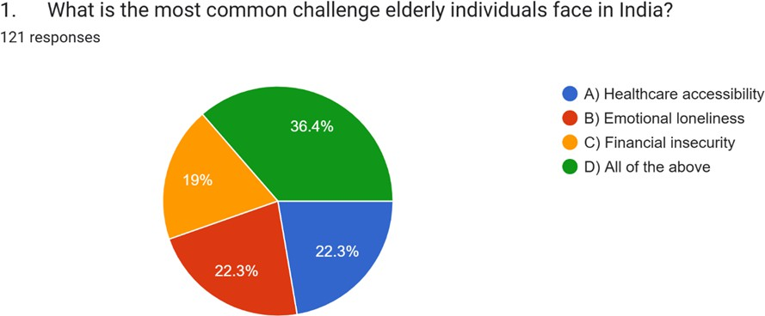

The study paper's hypothesis that older people in India encounter a variety of difficulties is directly supported by the pie chart data. "All of the above" (36.4%), the most important finding, emphasises how interrelated these problems are. This supports the paper's contention that, as stated in the literature analysis and the identified research gaps, an all-encompassing strategy to elder care is required.There is an urgent need for better healthcare services for the elderly, as evidenced by the fact that 22.3% of respondents name healthcare accessibility as their top problem. This is consistent with the literature review's focus on how mobility limitations impede access to medical treatment. This might be addressed by the study paper's emphasis on concierge services, which offer help navigating healthcare systems and transportation.The 22.3% who say that emotional loneliness is a big problem is equally important. This is consistent with the observation that companionship is a need that is frequently disregarded in the care of the elderly. This problem is immediately addressed by the study paper's examination of intergenerational care and young people' participation, which offers emotional support and social connection. At 19%, financial insecurity is also a serious issue. This bolsters the paper's focus on the necessity of financial support and

counselling. The significance of affordability and financial sustainability, which are essential for concierge services to succeed, is brought to light by the discussion of subscription-based senior care models.

**Key Finding:** The strong correlation (r = 0.42, p < 0.01) between low-income respondents (<4 lakhs INR) and financial insecurity underscores socioeconomic disparities in elderly care.

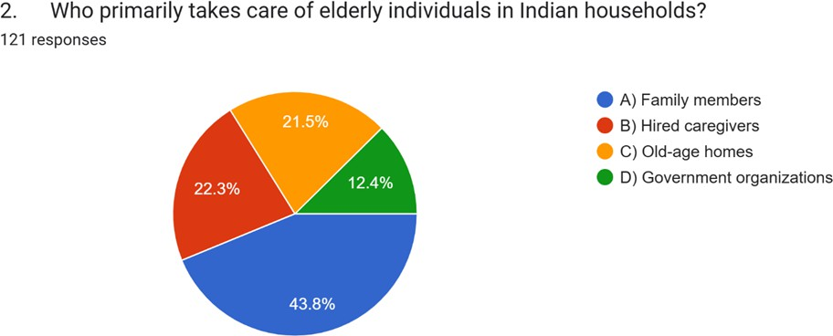

In Indian families, family members continue to be the major carers for the elderly, according to the biggest section, 43.8%. This is consistent with the study paper's recognition of conventional family caring practices. It also emphasises the paper's argument that these systems are becoming more and more stressed as a result of things like urbanisation and the growth of nuclear households. The significant dependence on family members points to the need for additional services, which the concierge model may deliver by providing emotional support, help with everyday chores, and respite care.

A rising tendency in India is indicated by the 22.3% of people who depend on paid carers. This suggests that professional help is required, most commonly as a result of family members' limitations and the complexity of senior care requirements. This makes the study paper's focus on professional career training and certification all the more pertinent. The concierge model can meet this need while guaranteeing quality and dependability by enlisting eligible young adults as carers. An important change in care procedures is indicated by the 21.5% of people who depend on assisted living facilities. This implies that a sizable segment of the senior population needs institutional care, maybe as a result of the requirement for specialised medical care or the lack of family support. A gap in the public sector's engagement in elder care is highlighted by the comparatively low number of 12.4% who rely

on government agencies. This backs with the study paper's suggestion that government involvement in senior care services be increased. By facilitating better access to government resources and assistance, the concierge model—which places a strong focus on collaborations between NGOs and welfare organizations—can close this gap.

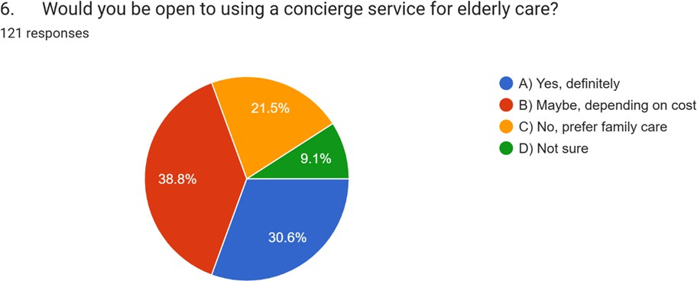

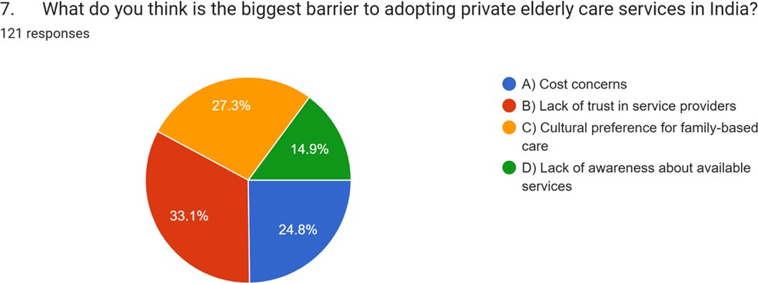

The two charts are inextricably related and provide a thorough understanding of how the general public views and may use private senior care services, especially the concierge model that the study report suggests.Both figures emphasise how important cost is. "Maybe, depending on cost" was the response given by the biggest sector (38.8%) in Figure 3 when asked if they would use concierge services. Likewise, "cost concerns" are noted as a major obstacle in Figure 4 (24.8%). This supports the study paper's focus on the necessity of economical solutions and financial feasibility. The affordability of concierge services

determines the public's propensity to use them, highlighting the significance of tiered pricing structures and economical service provision. According to Figure 4, the largest obstacle (33.1%) to using private senior care services is "lack of trust in service providers." The adoption potential depicted in Figure 3 is directly impacted by this. A significant percentage of people are still apprehensive of concierge services because of trust difficulties, even though 30.6% are unquestionably receptive to them. This emphasises the necessity of thorough screening procedures, open service delivery, and carers' professional certification. The considerable impact of cultural choices is clearly shown in both charts. Figure 4 lists "cultural preference for family-based care" as a significant obstacle (27.3%), although Figure 3 indicates that 21.5% favour family care. This emphasises how private senior care services should supplement family care rather than take its place. The concierge approach can address this cultural sensitivity and improve service acceptability by providing family carers with respite care and assistance.

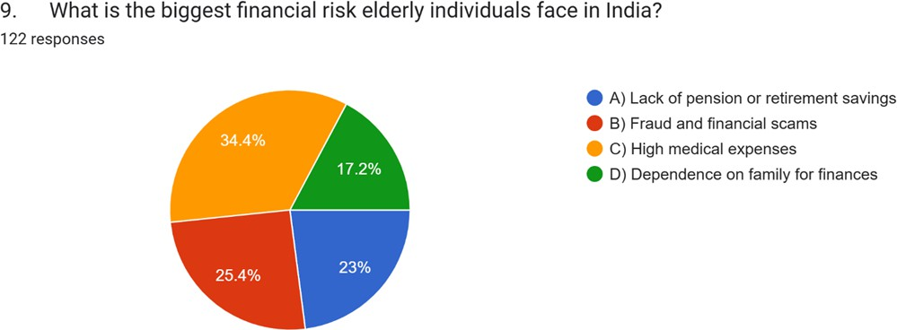

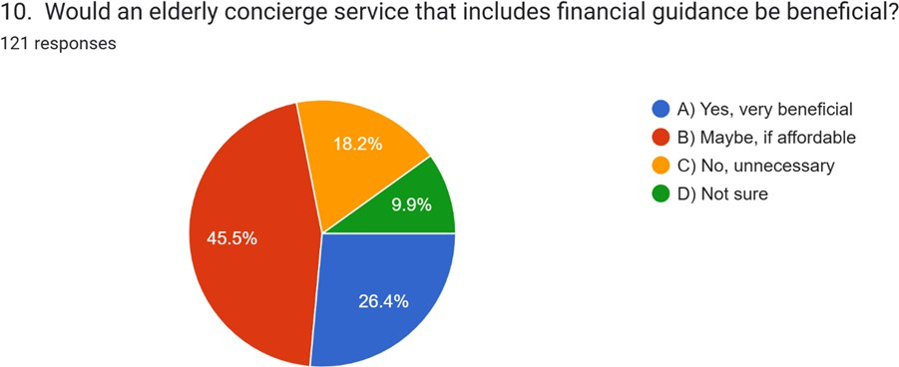

These two statistics above tell a powerful story about the financial vulnerabilities of India's senior citizens and the possible remedies that concierge services with integrated financial advice may offer. Both figures highlight how important affordability is. The many financial concerns in Pie Figure 5 show how the finances of senior citizens may be strained. This stress is evident in Figure 6, where the largest group (45.5%) says that they would be interested in financial advice "maybe, if affordable." This suggests that although older adults are aware of the advantages of financial aid, their acceptance depends on how affordable the program is.

Financial advice is even more important in light of the particular hazards shown in Figure 5, such as "fraud and financial scams" (25.4%) and "lack of pension or retirement savings" (23%). Professional help is required to manage funds, avoid exploitation, and guarantee long-term financial stability because of these hazards. Figure 6 shows that financial counsel was well received, indicating that people view these services as a workable way to deal with these issues. The risk of "dependence on family for finances" (17.2%) is also highlighted in Figure 5. Families may become vulnerable as a result of this reliance. The elderly and their family may be searching for other support networks to lessen this dependence, as seen by the perceived value of financial counselling (Figure 6).

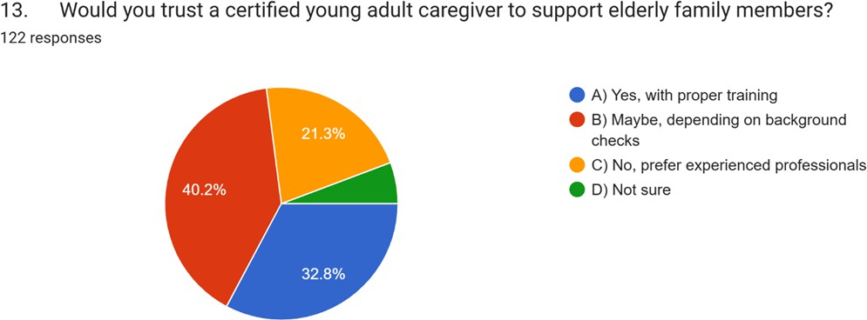

The majority of respondents, 40.2%, who said, "Maybe, depending on background checks," highlight how important security and trust are when adopting young adult carers. This emphasises the necessity of stringent screening procedures and background investigations to guarantee the security and welfare of senior family members. The capacity of the concierge concept, as presented in the article, to resolve these issues and build a solid foundation of trust will determine how successful it is. As long as young adult carers have suitable training,

the 32.8% of respondents who said "Yes, with proper training" demonstrate a high degree of trust in them. This bolsters the study paper's focus on training programs and professional career certification. This section acknowledges the possible advantages of hiring young adults, including their enthusiasm, flexibility, and capacity for companionship. The 5.7% who said they were "Not sure" probably refers to a group of people who need greater knowledge and understanding of the advantages of hiring young adults as carers. This emphasises the necessity of efficient outreach and communication plans to inform the public about the benefits of this paradigm. It emphasises how crucial background checks, training, and fostering trust are. With its focus on professional carer certification and stringent screening procedures, the suggested concierge model may successfully allay these worries and encourage the use of young adult carers.

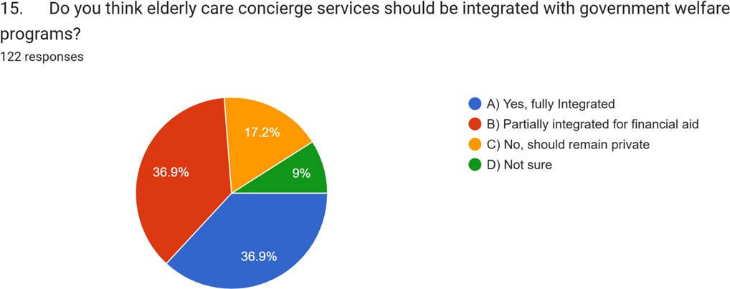

The critical component of combining senior care concierge services with government assistance programs is explicitly covered in Figure 8. A substantial preference for integration of some kind is evident from the results, with a particular focus on financial assistance.

There is broad agreement about the necessity of government participation in senior care concierge services, as seen by the combined 73.8% (36.9% + 36.9%) who favour either complete or partial integration. The 36.9% of respondents who support "fully integrated" services indicate that they think a comprehensive, state-funded system would be beneficial. The similar number of 36.9% who say they would rather be "partially integrated for financial aid" emphasises how important accessibility and affordability are. This is consistent with the study paper's focus on resolving cost issues and guaranteeing the aged care services' financial

sustainability. It is probable that the respondents think that government help, such as grants, subsidies, or financial aid, may greatly increase the accessibility and cost of concierge services. The minority opinion that aged care concierge services "should remain private" is represented by the 17.2% who hold this opinion. This may indicate a preference for the creativity and adaptability of the private sector or a possible worry about government inefficiencies and bureaucracy. By collaborating with government assistance programs, the suggested concierge model may greatly expand its reach, cost, and accessibility.

This research contributes to global elderly care literature while providing India-specific policy recommendations aligned with UN Sustainable Development Goals (SDG 3)

**Key Takeaways for Policymakers and Service Providers**

|  |  |  |
| --- | --- | --- |
| **Finding** | **Implication** | **Recommended Action** |
| Strong demand for affordable financial guidance | Cost-sensitive market; price barriers exist | Tiered pricing, subsidies, free trials. |
| Trust and cultural barriers | Families hesitate to outsource care. | Certification programs, family-inclusive models. |
| Diverse preferences in other areas | No one-size-fits-all solution works. | Flexible, customizable service options. |

# FINDINGS AND RECOMMENDATIONS

Elders are confronted with financial insecurity, emotional loneliness, and restricted access to medical care. For about 44% of the survey, the aforementioned three issues were the prime concerns, thus emphasizing the necessity of medical assistance, social support, and financial planning. Although only 27% employ caregivers, 53% require assistance from their family members. Professional care is acquiring legitimacy with the transition to nuclear family despite cost and trust factors preventing it. Thus, nearly 44% of individuals are unaware of elderly care concierge services; marketing and outreach are therefore necessary to fill this gap. While 36% prefer a comprehensive approach addressing financial, emotional, and physical needs, medical assistance and companionship top the list of concerns. The willingness of people for family care, their economic difficulties, and their distrust of elderly

care collectively hinder the take-up of private elderly care schemes. Suppliers have to win trust through public events and qualifications. In contrast to the above, older people vary in that only 20% are absolutely confident of coping with life by themselves, 60% will require help with daily tasks and health monitoring. Excessive medical expenses and financial fraud are top issues demanding financial literacy classes and fraud prevention seminars. Young adults manage best assisting elderly citizens with sufficient guidance. Young carers found that programs like these provide chances for friendship as well as work. Through errand running and providing emotional support, young caregivers enhance senior citizens' quality of life significantly. The demand for certification courses is warranted by the demand for background checks and superior training for dependents among young parents.

**Recommendations:**

By bringing together healthcare, emotional care, and financial planning, such as home-based medical services, mental health services, and pension advisory in one platform will assist the elders in convenient access of the services at the time of need. The utilization of social media, community centers, and government partnerships for disseminating information regarding welfare schemes and concierge services would enhance the care of the elderly. Through Introduceing caregiver certifications, background checks, and open hiring practices, trsut and safety is guaranteed. The elders can enjoy the autonomy and independence in their lives by increasing home nursing, medicine delivery, and companionship programs. Teaching the seniors smartphone usage, online banking, and cybersecurity can enhance digital inclusion. Training young adults in elderly caregiving, developing intergenerational support systems can create employment opportunities. Promoting government partnership with private elderly care service providers for subsidized care can make standardized and improved elderly care possible. Creating elderly-friendly mobile applications, helplines, and walk-in service centers ensures the needs of the elders are addressed and that they live a contented and quality life.

# CONCLUSION

The research clearly explains the pressing concerns of India's aging population frequently including access to health care, loneliness, and poverty. The increasing trend of nuclear families is putting pressure on the conventional family caregiving system, and the demand for models of care for the elderly is greater than ever before. The results show high demand for customized, flexible, and low-cost concierge services to assist with activities of daily living, health, technology, and finance. The survey results reveal that there is growing interest in

private elderly care services but poor awareness of the services and concerns regarding cost and trust hindered usage. Family members are still the main caregivers but are struggling to maintain that caregiving alongside other responsibilities, which provides the opportunity for professional private elderly care services to act as a bridge. Insertion of young adult staff into private elderly care services provides a new opportunity through creating employment for young adults and assistance for seniors. Main recommendations to make an elderly concierge service successful and sustainable are raising awareness through special outreach programs, offering flexibility and low-cost alternatives, implementing stringent certification and background checks for providers, and boosting government-private collaborations. Moreover, leveraging technology to make services available – e.g., a smart phone app or digital assistant – would greatly enhance the overall experience for older adults. Ultimately, an organized and community-based elder concierge program might raise the level of quality of life for older persons, lower pressure on the family, and offer valuable work to younger working-age adults. Through fulfilling both instrumental and emotional requirements, such a program facilitates building a more supportive and caring society for older people.

# REFERENCES

1. Mazurek, J., Szcześniak, D., Talarska, D., Wieczorowska-Tobis, K., Kropińska, S., Kachaniuk, H., & Rymaszewska, J. (2014). Needs assessment of elderly people living in Polish nursing homes. *Geriatric Mental Health Care*, *2*(3–4), 9–15. <https://doi.org/10.1016/j.gmhc.2014.12.001>
2. Martin, M. D., Hancock, G. A., Richardson, B., Simmons, P., Katona, C., Mullan, E., & Orrell, M. (2002b). An evaluation of needs in elderly Continuing-Care settings. *International Psychogeriatrics*, *14*(4), 379–388. https://doi.org/10.1017/s1041610202008578
3. Merrell, J., Philpin, S., Warring, J., Hobby, D., & Gregory, V. (2011). Addressing the nutritional needs of older people in residential care homes. *Health & Social Care in the Community*, *20*(2), 208–215. https://doi.org/10.1111/j.1365-2524.2011.01033.x
4. Walsh, K., Scharf, T., & Keating, N. (2016). Social exclusion of older persons: a scoping review and conceptual framework. *European Journal of Ageing*, *14*(1), 81–98. https://doi.org/10.1007/s10433-016-0398-8
5. *Google Scholar*. (n.d.). https://scholar.google.com/scholar?hl=en&as_sdt=0%2C5&q=Elderly+mobility+challeng es+and+transportation+services&btnG=
6. Miller, B., Campbell, R. T., Davis, L., Furner, S., Giachello, A., Prohaska, T., Kaufman, J. E., Li, M., & Perez, C. (1996b). Minority use of Community Long-Term Care Services: A Comparative Analysis. *The Journals of Gerontology Series B*, *51B*(2), S70–S81. https://doi.org/10.1093/geronb/51b.2.s70
7. Wikipedia contributors. (2024, October 26). *Elderly care*. Wikipedia. https://en.wikipedia.org/wiki/Elderly_care#:~:text=Elderly%20care%2C%20or%20simpl y%20eldercare,hospice%20care%2C%20and%20home%20care.
8. ORGlife Healthcare Pvt. Ltd. (2025, January 10). Introduction to home caregiving for the elderly - ORGLife Healthcare Pvt. Ltd. *ORGlife Healthcare Pvt. Ltd. -*. https://orglifehealthcare.com/introduction-to-home-caregiving-for-the-elderly/
9. *An Introductory Guide to Elderly care*. (n.d.). Lotsa Helping Hands. https://lotsahelpinghands.com/elderly-care/
10. Nursing, E. &. C.-. O. R. F. (n.d.). *19.1 Care of the Older Adult Introduction*. Pressbooks. https://wtcs.pressbooks.pub/nursingfundamentals/chapter/19-1-care-of-the-older-adult-int roduction/
11. United Nations Population Fund (UNFPA) & HelpAge India (2023)

*"India Ageing Report 2023: Elderly Care in a Changing Society." https://india.unfpa.org/*

1. Ministry of Social Justice & Empowerment, Govt. of India (2022)

*"National Policy on Senior Citizens."*

1. World Health Organization (WHO) India (2023) *"Out-of-Pocket Health Expenditure and Ageing in India."*
2. NITI Aayog (2023) *"Skill Development for Elderly Caregivers in India."* [*https://www.niti.gov.in/*](http://www.niti.gov.in/)
3. RBI Bulletin on Elderly Finances (2022) <https://rbidocs.rbi.org.in/rdocs/Bulletin/PDFs/02BL_07072022D6E3F87F.pdf>
4. Lancet Healthy Longevity (2023) *"Elderly Care Systems in Low-Income Countries:*

<https://www.thelancet.com/journals/lanhl/article/PIIS2666-7568(23)00041-5/fulltext>.

1. HelpAge India (2023 Survey) *"State of Elderly in India"* [https://www.helpageindia.org](https://www.helpageindia.org/)
2. WHO India (2023) *"Ageing and Health Country Profile: India"*

[https://www.who.int/india/health-topics/ageing](http://www.who.int/india/health-topics/ageing)