**Connect Energy IoT Smart Meter**

**F. Mathew Gibson1, Dr. Senthil Kumar R2,**

1Student, B sc CSCS, Dr N.G.P Arts and Science, Coimbatore, Tamilnadu, India

2Proffesor, B sc CSCS ,Dr N.G.P Arts and Science, Coimbatore, Tamilnadu, India

**ABSTRACT**

The "Connect Energy IoT Smart Meter" project presents an intelligent energy metering system integrating Xinje PLC, multi-functional energy meters, CT coils, HMI, relays, SMPS, and MCB for real-time monitoring, control, and analysis of electrical consumption. By leveraging Internet of Things (IoT) technology, the system enables remote energy management through cloud connectivity, allowing users to monitor usage and control electrical loads via mobile or web applications.

The Xinje PLC serves as the system’s core, processing data from energy meters and CT coils to compute key electrical parameters, including voltage, current, power consumption, energy, and power factor. This data is displayed on an HMI for local monitoring and transmitted to the cloud for remote access and historical analysis. The system features threshold-based alerts and relay-controlled mechanisms to optimize energy consumption and prevent overuse.

To ensure reliability, the system integrates fault protection using MCBs, mitigating overloads and short circuits. This smart energy management solution enhances efficiency, reduces wastage, and empowers users with greater control over their electricity consumption. By integrating IoT with energy monitoring, the project contributes to the development of smart grids and sustainable energy practices, promoting a more efficient and intelligent energy management framework

.**Keywords:** Smart Energy Meter, IOT Based Meter, Smart Meter

1. **INTRODUCTION**

The rising global demand for efficient energy management has driven the need for intelligent monitoring systems that enhance control and optimization of electricity usage. The **"Connect Energy IoT Smart Meter"** project presents an advanced solution that integrates **Xinje PLC, multi-functional energy meters, CT coils, HMI, relays, SMPS, and MCBs** to enable real-time energy monitoring and management. By incorporating **Internet of Things (IoT) technology**, the system allows users to remotely track and regulate energy consumption through cloud-based platforms accessible via mobile and web applications.

At the heart of this system, the **Xinje PLC** gathers and processes data from energy meters and CT coils, calculating key electrical parameters such as **voltage, current, power consumption, energy usage, and power factor**. This information is presented on an **HMI for local monitoring** and simultaneously transmitted to the **cloud for remote access and historical analysis**. The system also includes **threshold-based alerts and relay-controlled mechanisms** to enhance power efficiency, prevent excessive usage, and optimize energy distribution.

To ensure **safety and reliability**, the system is equipped with **fault protection through MCBs**, effectively preventing overloads and short circuits. This smart energy metering approach not only improves energy efficiency and reduces wastage but also supports the transition toward **smart grids and sustainable energy practices**. By merging IoT with intelligent energy monitoring, this project contributes to the advancement of **smart energy systems**, promoting more efficient and responsible electricity consumption.

1. **METHODOLOGY**

The development of the **Connect Energy IoT Smart Meter** follows a systematic approach to ensure precise energy monitoring and remote management. The methodology involves **hardware integration, data collection, processing, cloud communication, and control mechanisms** to achieve efficient energy tracking and automation.

**2.1 Hardware Setup**

The system consists of **Xinje PLC, multi-functional energy meters, CT coils, HMI, relays, SMPS, and MCBs**, all interconnected to monitor electrical parameters such as **voltage, current, power, energy consumption, and power factor**. The **PLC** functions as the main controller, receiving data from the energy meters and CT coils

**2.2 Cloud Communication and IoT Integration**

For remote monitoring, the **PLC transmits processed data to a cloud-based server** using communication protocols such as **MQTT** or **HTTP**. Users can access this information through a **web or mobile application**, enabling real-time tracking of energy consumption. Additionally, the system supports historical data analysis for identifying patterns and optimizing energy usage

1. **MODELING AND ANALYSIS**

Fluid and Material which are used is presented in this section. Table and Fluid should be in prescribed format.

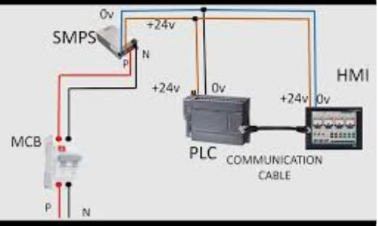

**Figure1:**Structure of Communication

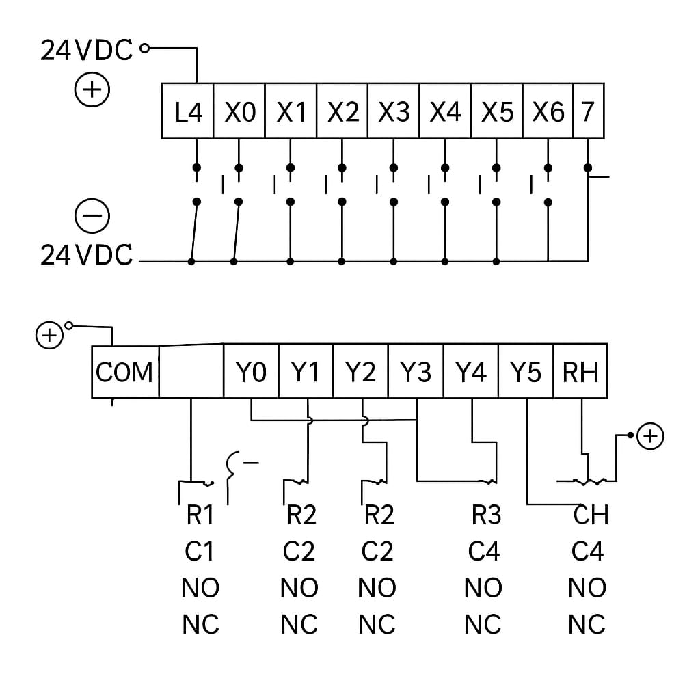

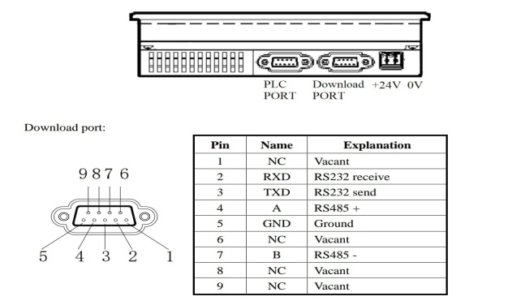

**Figure2:PLC Input Output Structure Figure3: HMI Output Ports**

1. **RESULTS AND DISCUSSION**

The implementation of the "Connect Energy IoT Smart Meter" system yielded significant improvements in energy monitoring, control, and efficiency. The integration of Xinje PLC, multi-functional energy meters, CT coils, HMI, relays, SMPS, and MCBs successfully facilitated real-time data acquisition and processing. The system demonstrated seamless cloud connectivity, enabling remote monitoring and control via mobile and web applications.

1. **CONCLUSION**

The "Connect Energy IoT Smart Meter" project introduces a modern and efficient approach to energy management, utilizing advanced IoT technologies and intelligent metering solutions. At the heart of the system is the Xinje PLC, which processes data from energy meters and CT coils to calculate key electrical parameters such as voltage, current, power usage, energy, and power factor. This data is displayed on a local HMI for immediate monitoring and is also transmitted to the cloud, enabling remote access and long-term analysis of energy consumption patterns.

Incorporating mechanisms for fault protection, including MCBs, the system ensures reliability and safety by preventing overloads and short circuits. The inclusion of threshold-based alerts and relay-controlled features provides users with the ability to optimize energy use and prevent overconsumption. With its cloud-based connectivity, the system enables users to manage their electrical loads remotely via mobile or web applications, offering greater control over their energy consumption.

This solution plays a key role in the broader vision of smart grids by integrating IoT with energy monitoring. It offers an innovative way to reduce energy wastage, improve efficiency, and promote sustainable practices. The project highlights the potential for future smart energy management systems that are not only more efficient but also contribute to a more sustainable and intelligent energy ecosystem

1. **REFERENCES**

[1] Sasanenikita N, "IOT-based energy meter billing and monitoring system," the International Research Journal of Advanced Engineering and Science, (2017).

[2] Pandit S, "Smart energy meter using Internet of things (IoT)," VJER Vishwakarma Journal of Engineering Research, Vol.1, No.2, (2017).

[3] Maitra S, "Embedded Energy Meter-A New concept to measure the energy consumed by a consumer and to pay the bill," Power system technology and IEEE Power India conference, (2008).

[4] Depuru SSSR, Wang L & Devabhaktuni V, "Electricity theft: Overview, issues, prevention and a smart meter based approach to control theft," Energy Policy, Vol.39, No.2, (2011), pp.1007–1015.

[5] Giri Prasad S, “IOT based energy meter,” International Journal of Recent Trends in Engineering & Research (IJRTER), (2017). D. V. Lindberg and H. K. H. Lee, "Optimization under constraints by applying an asymmetric entropy measure," J. Comput. Graph. Statist., vol. 24, no. 2, pp. 379–393, Jun. 2015, doi: 10.1080/10618600.2014.901225. International Journal for Research in Applied Science & Engineering Technology (IJRASET) ISSN: 2321-9653; IC Value: 45.98; SJ Impact Factor: 7.538 Volume 12 Issue IV Apr 2024- Available at www.ijraset.com 3089 ©IJRASET: All Rights are Reserved | SJ Impact Factor 7.538 | ISRA Journal Impact Factor 7.894 |

[6] Landi, C.; Dipt. Di Ing. dell''Inf., Seconda Univ. di Napoli, Aversa, Italy; Merola, P.; Ianniello, G, "ARM-based energy management system using smart meter and Web server," IEEE Instrumentation and Measurement Technology Conference Binjiang, pp. 1 – 5, May 2011.

[7] Garrab, A.; Bouallegue, A.; Ben Abdallah, “A new AMR approach for energy saving in Smart Grids using Smart Meter and partial Power Line Communication,” IEEE First International Conference on Renewable Energies and Vehicular Technology (REVET), pp. 263 – 269, march 2012

[8] Darshan Iyer N, Dr. KA Radhakrishnan Rao, “IoT Based Energy Meter Reading, Theft Detection & disconnection using PLC modem and Power optimization,” IRJET, (2015)

[9] (2017 Jan. 31) ACS712 [Online] Available: <https://www.sparkfun.com/datasheets/BreakoutBoards/0712.pdf>

[10] Hazenberg W, Huisman M. Meta Products: Building the Internet of Things. Amsterdam, NL: BIS Publishers; 2011.

[11] Luigi Atzori, Antonio Iera,and Giacomo Morabito. The Internet of Things: A survey. Computer Networks, 54(15):2787–2805, 2010.

[12] L. Srivastava, Pervasive, ambient, ubiquitous: the magic of radio, in European Commission Conference "From RFID to the Internet of Things" Bruxelles, Belgium, March 2006.

[13] I. Vázquez, Social Devices: Semantic Technology for the Internet of Things, Week@ESI, Zamudio, Spain, June 2009.

[14] H. Sundmaeker, P. Guillemin, P. Friess, S. Woelfflé, Vision and challenges for realizing the Internet of Things, Cluster of European Research Projects on the Internet of Things - CERP IoT, 2010.

[15] W. Yaïci, K. Krishnamurthy, E. Entchev, and M. Longo, “Recent advances in Internet of Things (IoT) infrastructures for building energy systems: a review,” Sensors, vol. 21, no. 6, Mar. 2021, doi: 10.3390/S21062152.

[16] S. Somantri, I. Yustiana, and A. Nugraha, "Electrical consumption monitoring and controlling system based on IoT and mobile application," in Proceeding of International Conference on ICT for Smart Society (ICISS), Indonesia, November 2020, pp. 1–5, doi: 10.1109/iciss50791.2020.9307556.

[17] V. S. M et al., “Internet of Things based smart energy meter with fault detection feature using MQTT protocol," in Proceedings of the 8th International Conference on Advanced Computing and Communication Systems (ICACCS), India, March 2022, pp. 1592–1596, doi: 10.1109/ICACCS54159.2022.9785026.

[18] M. O. Agyeman, Z. Al-Waisi, and I. Hoxha, "Design and implementation of an IoT-based energy monitoring system for managing smart homes," in Proceeding of the Fourth International Conference on Fog and Mobile Edge Computing (FMEC), Italy, June 2019, pp. 253–258, doi: 10.1109/FMEC.2019.8795363.

[19] S. Khalid, M. Sarfraz, V. Singh, Aafreen, and A. Allahloh, “A novel model for IoT-based meter using ATmega328P microcontroller and google cloud store,” in Lecture Notes in Mechanical Engineering, Singapore, Springer, 2021, pp. 639–648, doi: 10.1007/978-981-15- 5463-6_57.

[20] Y. Maulana, R. Darmawan, L. Kamelia, E. Mulyana, M. R. Effendi, and M. I. Pamungkas, “The development of the home electrical power consumption system prototype in real-time,” in Proceeding of the 7th International Conference on Wireless and Telematics (ICWT), Indonesia, August 2021, pp. 1–5, doi: 10.1109/ICWT52862.2021.9678420.

[21] A. Othman and N. H. Zakaria, "Energy meter based wireless monitoring s