Formulation and Evaluation of Momordica charantia in Anti-aging Serum
Munmun Bhattacharya², Princy Tirkey², Prerna Dhiwar², Suchita Wamankar¹
¹Rungta Institute of Pharmaceutical Sciences and , Kohka - Kurud , Bhilai, 490024, Chattishgarh India
²Rungta Institute of Pharmaceutical Sciences and Research, Kohka - Kurud , Bhilai, 490024, Chattishgarh, India

Corresponding author
Munmun Bhattacharya
Student
Rungta Institute of Pharmaceutical Sciences and Research, Kohka - Kurud , Bhilai, 490024, Chattishgarh, India
Email id- mbhattacharya697@gmail.com
Contact no-+91- 7974411700

ABSTRACT
With the growing demand for natural and effective skincare solutions, the present study focuses on the formulation and evaluation of an anti-aging serum incorporating Momordica charantia extract is rich in antioxidants and bioactive compounds that help combat signs of aging by reducing oxidative stress and enhancing collagen production. The synergistic combination of these natural extracts aims to improve skin hydration, reduce wrinkles, and promote an even skin tone. The formulated serum was assessed for its physicochemical properties, spreadability, pH stability, and skin compatibility. The evaluation also included an analysis of its anti-wrinkle, moisturizing, and mild sun-protective effects. The results indicated that the serum provided significant improvements in skin texture, elasticity, and overall appearance. This study highlights the potential of Its based formulations as a sustainable and effective alternative to conventional anti-aging products. Further research will focus on optimizing the formulation.

KEY WORDS
Anti-aging serum ,Momordica charantia, Collagen production, Skin hydration, Wrinkle reduction ,Even skin tone ,Physicochemical properties ,Spreadability ,pH stability , Skin compatibility , Anti-wrinkle effect ,Moisturizing effect Sun protection ,Skin texture ,Elasticity ,Sustainable skincare , Natural formulation , Clinical trials.

INTRODUCTION
Aging is a natural process that leads to a decline in skin elasticity, hydration, and collagen production, resulting in fine lines, wrinkles, and other visible signs. As concerns over the side effects and long-term safety of synthetic skincare products grow, the demand for natural alternatives has increased. This study aims to develop an anti-aging serum using Momordica charantia (bitter melon) extract, which boasts antioxidant and skin-rejuvenating properties.The proposed serum formulation combines Momordica charantia extract with Aloe Vera gel, starch, glycerine, Vitamin E oil, lavender oil, and tea tree oil. This blend provides deep hydration, soothes the skin, neutralizes free radicals, promotes collagen synthesis, and prevents skin infections. The active compounds in Momordica charantia extract work synergistically to reduce oxidative stress, prevent collagen breakdown, and enhance skin elasticity.Natural extracts like Momordica charantia can be unstable and have limited bioavailability. To address this challenge, Vitamin E oil and glycerine serve as stabilizers, while the starch-based formulation ensures controlled release of active ingredients for prolonged effectiveness.[1,2,3]

Several herbal ingredients have demonstrated significant anti-aging benefits. Turmeric, green tea, ginseng, rosehip oil, Gotu kola, licorice root, and ashwagandha have been shown to combat skin aging by reducing oxidative stress, boosting collagen synthesis, improving skin hydration, and enhancing skin elasticity.Developing an anti-aging serum using Momordica charantia offers several advantages. Its natural composition makes it a safer alternative to synthetic products, which can cause side effects. Bitter melon has been shown to have collagen-boosting effects, improving skin elasticity and firmness. The growing demand for innovative and natural skincare solutions drives the need for this product.This Momordica charantia-based serum aims to provide a natural, safe, and effective anti-aging solution, enhancing skin elasticity, reducing wrinkles, and ensuring deep hydration. By incorporating other potent herbs, this serum can offer a holistic approach to combating skin aging naturally.

MATERIAL AND METHODS
Preparation of Momordica charantia extract
Momordica charantia leaves were collected form garden of Rungta Institute of Pharmaceutical Sciences and Research. And specimens were authenticated at Govt V.Y.T.PG College, Durg . Preparing raw juice of fresh fruit of immature, crushed and cut Momordica charantia, to which water is added intermittently filter the raw juice to obtain filtered juice .[14,15]

Determination of Total Antioxidant Capacity
The antioxidant activity of Mormodica charantia was evaluated using the hydrogen peroxide scavenging assay. This method measures the ability of the extract to neutralize hydrogen peroxide, a common oxidizing agent. In addition to this assay, the phosphomolybdenum method was employed to assess the total antioxidant capacity of the aqueous and ethanolic extracts. The latter method involves the reduction of molybdenum (VI) to molybdenum (V) by the extract, resulting in the formation of a green phosphate-molybdenum (V) complex under acidic conditions. The antioxidant capacity was expressed as gram equivalents of ascorbic acid per milliliter of extract. The combination of these two assays provided a comprehensive understanding of the antioxidant properties of Mormodica charantia.[10, 12,11]

Serum formulation
The formulation for the anti-aging serum is given in Table 1. Starch is first dispersed in glycerin to create a uniform mixture with slight thickening properties. This dispersion is then combined with Mormodica charantia extract, known for its antioxidant and skin-rejuvenating effects. Aloe vera gel is added to enhance hydration and provide soothing benefits. To this mixture, essential oils such as tea tree oil and lavender oil are incorporated to offer antibacterial properties and promote skin relaxation. Vitamin E oil is blended in to protect against oxidative damage and improve skin elasticity. A controlled amount of salicylic acid is then introduced to aid in exfoliation and unclogging pores. The final formulation is continuously mixed to ensure uniformity, resulting in a serum that nourishes, hydrates, and revitalizes the skin.[8,6,7]

Table no 1: Anti-Aging Serum Formulation with Momordica charantia
S.N | Ingredients | Category | Quantity
1 | Aloe Vera Gel | Base / Carrier | 50g
2 | Glycerin | Humectant | 5g
3 | Momordica charantia Extract | Api | 10g
4 | Salicylic acid | Exfoliant | 1g
5 | Vitamin E oil | Antioxidant /moisturizer | 2g
6 | Starch | Thickening agent | 2g
7 | Lavender oil | Soothing agent | 0.5g
8 | Tea Tree oil | Preservatives | 0.5 g
9 | Distilled water | Diluent | 100 gn

EVALUATION
Organoleptic evaluation: Assessing its color, odor, and texture. The appearance of the cream was evaluated based on its color and smoothness.

Test for microbial growth in formulated Serum: Additionally the serum was subjected to microbial growth testing to ensure its safety and stability. The test involved inoculating the serum onto agar media using the streak plate method, followed by incubation at 37°C for 24 hours. The plates were then examined for microbial growth, with the results compared to a control sample without the serum. This assessment enabled the evaluation of the serum antimicrobial properties and its potential to support skin health.

Homogeneity: Examine each for uniform texture, consistent And smoothness. A homogeneous serum will have even distribution of with no lumps, Irregularities, or variations across sections.

pH of serum: The pH of a serum formulation is a crucial factor influencing its stability, efficacy, and compatibility with the skin. Human skin typically has a slightly acidic pH, ranging between 4.5 and 6.5, which helps maintain the skin barrier and prevent microbial infections. A well-balanced serum should align with this range to ensure optimal absorption and avoid skin irritation. Extreme pH levels can lead to adverse effects such as dryness, redness, or increased sensitivity.

Spreadability Studies: Spreadability is an important parameter in evaluating the application performance of a serum. It determines how easily and uniformly the serum spreads on the skin, affecting user experience and product efficiency. Spreadability is usually assessed using a glass slide method, where a fixed amount of serum is placed between two slides, and the diameter of the spread is measured. A well-formulated serum should exhibit smooth and even spreadability, ensuring adequate skin coverage and enhanced bioavailability of active ingredients.
Spreadability = M×L×T
M = weight tied to the upper slide
L =length of glass slide
T =time taken in seconds.

After-Feel Analysis: The after-feel of a serum refers to the tactile sensation left on the skin after application. It is an essential aspect of user satisfaction and influences consumer preference. Factors such as viscosity, absorption rate, and formulation components determine whether the serum feels greasy, sticky, smooth, or lightweight. A well-formulated serum should provide a comfortable and non-greasy after-feel while ensuring adequate hydration and nourishment.

Irritancy Test: The irritancy test assesses the potential of a serum to cause skin irritation or adverse reactions. This evaluation is crucial, especially for products designed for sensitive skin. Common methods include patch testing on human volunteers or in vitro tests using reconstructed human epidermis models. Parameters such as redness, itching, or burning sensation are monitored over a specific period. A serum with minimal to no irritation ensures better skin tolerance and safer long-term use.

Table no 2: Evaluations parameters
S.N | Evaluation parameters | Result | Images
1 | Organoleptic property | Colour: light green  Odour : slight  Taste:characteristics | 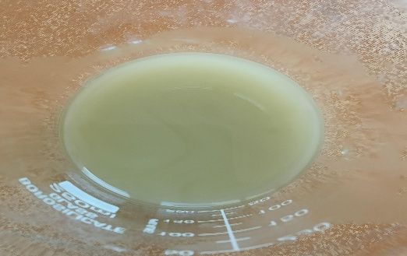
2 | Antimicrobial test | E.coli, S.aureus, Salmonella: No Characteristic  colonies | 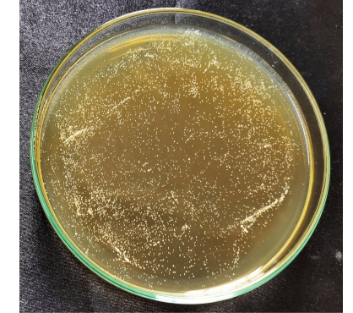
3 | Homogeneity | Homogeneous | 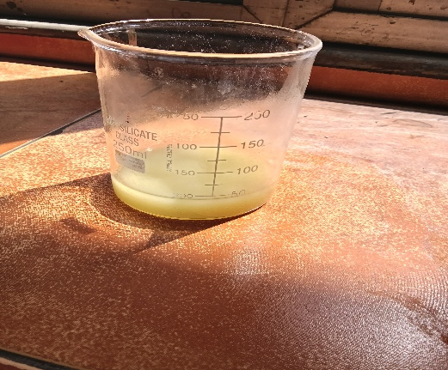
4 | Antioxidant Capacity | High antioxidant capacity | 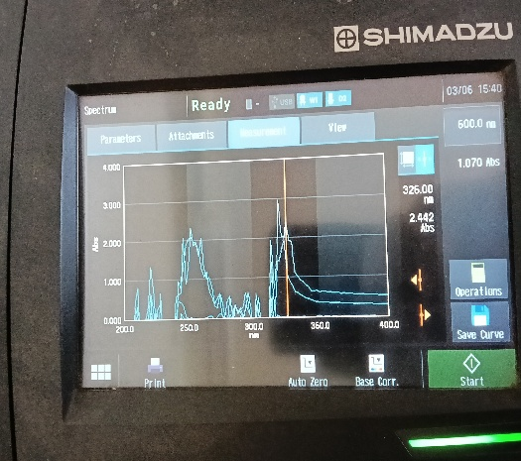
5 | pH | 4.5 pH | 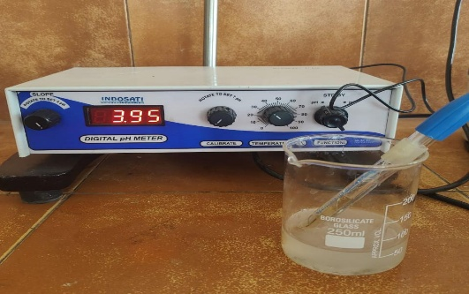
6 | Spreadability studies | Smooth, uniform spreadable | 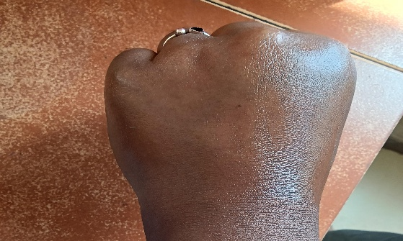
7 | After feel analysis | spreadability, rapid absorption, non-greasy after-feel, and enhanced skin hydration without tackiness
8 | Irritancy test | no signs of skin irritation, redness, or allergic reactions | 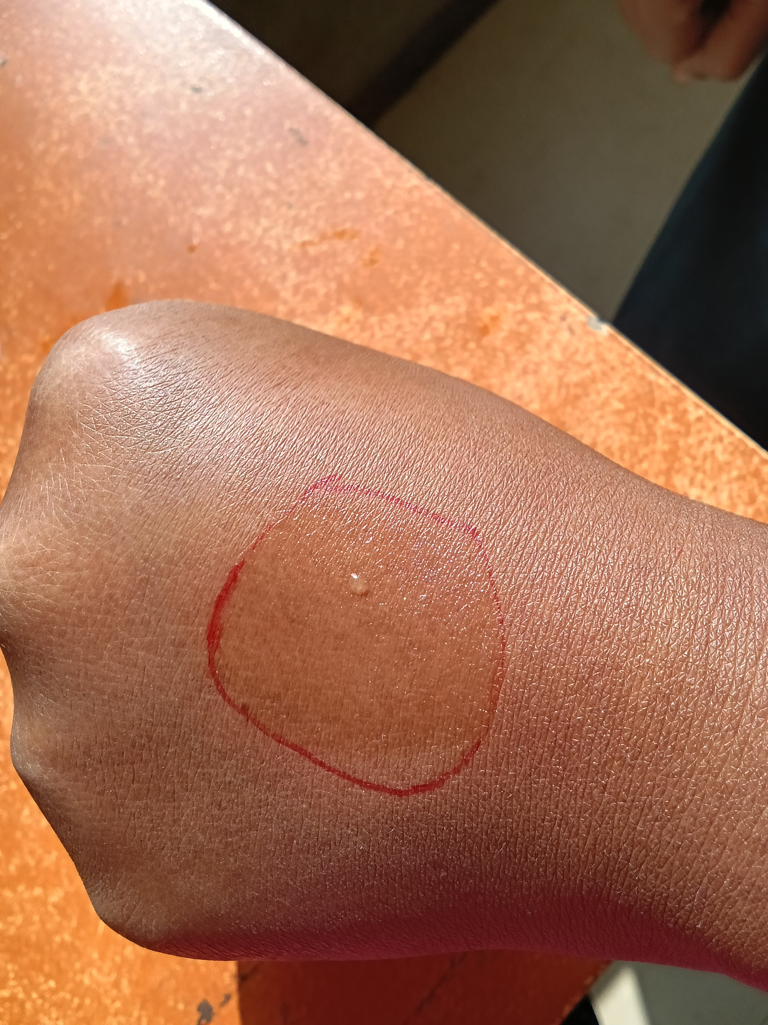

RESULT AND DISCUSSION
A Momordica charantia anti-aging serum was formulated using natural ingredients to enhance its cosmetic and medicinal benefits. The serum exhibited excellent solubility and formed a homogeneous solution, ensuring even distribution of active compounds. The pH value was within the skin-friendly range, minimizing irritation risks and making it suitable for regular use. The formulation was screened for its anti-aging efficacy and showed promising results due to the presence of bioactive compounds such as flavonoids, alkaloids, and antioxidants. These components contributed to significant skin rejuvenation, reducing wrinkles and improving skin elasticity. Additionally, the serum demonstrated effective moisturizing and brightening properties, helping to maintain skin hydration and promote an even skin tone. The synergistic combination of Momordica charantia with other natural extracts enhanced its overall cosmetic potential, making it a beneficial addition to skincare routines. Further studies will focus on optimizing the formulation and evaluating long-term effects through clinical assessments.

CONCLUSION
The formulation of the Momordica charantia anti-aging serum utilizes the potent antioxidant, anti-inflammatory, and skin-rejuvenating properties of Momordica charantia extract to combat signs of aging effectively. This extract, enriched with bioactive compounds, enhances collagen synthesis, reduces wrinkles, and promotes youthful skin. A stable base ensures smooth application, quick absorption, and non-greasy texture, making it suitable for daily use. Physico-chemical evaluations, including homogeneity, spreadability, and pH stability, confirmed the serum’s skin compatibility, while microbial testing demonstrated its protective properties against environmental aggressors. The formulation’s long-lasting effects and ability to enhance skin texture make it a promising natural anti-aging solution, offering both efficacy and user satisfaction.

REFERENCE
- P.P. Bhushan and L.B. Sachin, “Polyphenols: A Remedy for Skin Wrinkles” in Polyphenols in Human Health and Disease, R.W. Ronald, R.P. Victor, and Z. Sherma. Eds., Academic Press-Elsevier, CA.pp. 861–869 (2014).
- L.T. Vuong, A.A. Franke, J.L. Cluster, and P.S. Murphy, Momordica cochinchinensis Spreng. (gac) fruit carotenoids re-evaluated, J. Food Comp. Anal., 19, 664–668 (2006).
- J. Kubola and S. Siriamornpun, Phytochemicals and antioxidant activity of different fruit fractions (peel, pulp, aril and seed) of Thai gac (Mormordica cochinchinensis Spreng), Food Chem., 127, 1138–1145 (2011).
- L.T Vuong, Under-utilized beta-carotene-rich crops of Vietnam, Food Nutr. Bull., 21(2), 173–181 (2000).
- C. Hoang, P. Thi, P.J. Osorio, and W. Yves, Stability of carotenoid extracts of Gac (Momordica cochi-nchinensis) towards cooxidation—Protective effect of lycopene on Beta-carotene, Food Res. Int., 44, 2252–2257 (2011).
- P.M. Nguyen, Investigation the different ratios of carrier material to protect carotenoids in gac (Momordica cochinchinensis Spreng) powder in drying process, Int. J. Multidiscip. Res. Dev., 1(2), 71–76 (2014).
- J. Kubola, N. Meeso, and S. Siriamornpun, Lycopene and beta carotene concentration in aril oil of gac (Momordica cochinchinensis Spreng) as infl uenced by aril-drying process and solvents extraction, Food Res. Int., 50, 664–669 (2013).
- P. Klungsupya, J. Saenkhum, T. Muangman, U. Rerk-Am, S. Laovitthayanggoon, and W. Leelamanit, Non-cytotoxic property and DNA protective activity against H2O2 and UVC of Thai gac fruit extracts in human TK6 cells, JAPS, 02(04), 4–8 (2012).
- P. Klungsupya, W. Tiatragoon, T. Muangman, J. Eiamwat, S. Laovitthayanggoon, J. Thongdo-A, and S. Trangwacharakul, Investigation on phytochemical, antioxidant and cytotoxic properties of Momordica cochinchinensis (gac) fruit extracted by supercritical fl uid carbon dioxide (SCF-CO2) method, Thai J. Pharm. Sci., 38, 29–32 (2013).
- H.C. Mai, V. Truong, B. Haut, and F. Debaste, Impact of limited drying on mormordica cochinchinensis Spreng. aril carotenoids content and antioxidant activity, J. Food Eng., 118, 358–364 (2013).
- NCES Kaur IP, Kapila M, Agrawal R. Role of novel delivery systems In developing topical antioxidants as therapeutics to Combat photo aging, 6, 2007, 271-288.
- Watson, Ogden S, Cotterell LF, Bowden JJ, Bastrilles JY, Long SP, Griffiths CE.A cosmetic ‘anti-ageing’ product Improves photo aged skin, a doubleblind, randomized Controlled trial British. J Dermatol, 161, 2009, 419–426.
- S. Saraf, C.D. Kaur, Phytoconstituents as photoprotective Novel cosmetic formulations, Pharmacogn. Rev., 4(7), 2010,1-11.
- Hema Sharma Datta and Rangesh Paramesh, Trends in Aging and skin care: Ayurvedic concepts, Journal of Ayurveda and Integrative Medicine, 1(2), 2010, 110-113.
- Geesin JC, Darr D, Kaufmann R, Murad S and Pinnel SR,Ascorbic acid especially increases type I and type III Procollagen messenger RNA levels in human skin fibroblast. J. Invest. Dermatol., 90(4), 1998, 420-44

