**UPGRADING DEVELOPMENTS IN CONCRETE BY SWITCHING M35 SOLID CEMENT WITH GARLIC HUSK ASH (GHA) AND FLY CINDER (FC)**

**Shaik Imran 1, Vanam Sameer Kumar 2**

1PG Student, Civil Engineering, Dr.K.V.Subba Reddy Institute of Technology, Kurnool, Andhra Pradesh, India

2Assistant Professor, Civil Engineering, Dr.K.V.Subba Reddy Institute of Technology, Kurnool, Andhra Pradesh, India

**ABSTRACT**

In present age of mankind, the key industry needed to each household is development division which holds third place among 13 economic divisions inside the planet. The true drawback of this split: one is pollution & secondly is Scarcity of materials. Within the show scenario, the globe is venturing towards the underutilized considerations in design to shuffle the defilement by using the intermediate elements rather than cement, sand & totals owing to its starving.

In this paper of examine talks about the progression of mechanical attributes in concrete. Both Garlic Husk Ash (GHA) and Fly Cinder (FC) may substitute cement in concrete. Often considered a waste item, this substance may give a superior alternative to Portland cement, lessen the environmental effect of concrete, and aid enhances building qualities such as strength, durability, and performance. Fly cinder may be a by-product of coal combustion in warm control plants. It is recuperated as a fine, fine substance from the vent gasses and has both pozzolanic and cementitious capabilities. Garlic peel ash is created by burning the peels of garlic, which are generally thrown as garbage. The resultant ash making it possible as pozzolanic material. The GHA & FC both are replaced in place of cement by maintaining FC as constant with 10% and GHA with increasingly follows from 0%, 3%, 6%, 9%, 12% & 15% in M35 Solid.

Moreover, the comparison is held between the conventional Solid & Solid with proxy blends like 0%GHA+0%FC, 3%GHA+10%FC, 6%GHA+10%FC, 9%GHA+10%FC, 12%GHA+10%FC & 15%GHA+10%FC

**Keywords:** Cement, Garlic Husk Ash (GHA), Fly Cinder (FC), & M35 Solid

1. **INTRODUCTION**

Cement, aggregates such as sand, gravel or stone, and water make up the cement. Despite being the most frequently used construction material in the world, concrete is getting more and more difficult to procure. There are a variety of concerns affecting these raw resources.

The first restriction is the Sand restriction. There has been an exponential growth in mining and usage of sand owing to its rising demand, notably in building. As a consequence, local shortages have emerged. The usage of sand has also been found to impact the environment, such as by shifting river channels or harming other ecosystems.

The second task is the Environmental task. The manufacturing of cement is an energy intensive process that leads to substantial greenhouse gas emissions which eventually adds to global warming. Also, there are locations which have no significant limestone reserves, therefore producing cement looks unfeasible.

The third concern is the Pressure on Domestic Supply. Rock and sand which are fundamental source in the manufacture of cement are already in depletion stages in different places since the mining of such raw materials might over time leads to pollution of the environment as well as deplete the existing supplies.

**A DEEPER LOOK INTO THE PROXIES UTILIZED IN CONCRETE HISTORY:**

* Contemporary building increasingly employs cement substitutes such as fly ash, slag, silica fume, and natural pozzolans to reduce the environmental impact of cement production. The justification for integrating these alternatives encompasses:
* Mitigating Carbon Emissions: Cement manufacture substantially contributes to CO2 emissions; hence, employing these alternatives aids in reducing the overall carbon footprint of concrete.
* Resource Conservation: The integration of industrial by-products and natural materials in these cement alternatives contributes to the preservation of natural resources and promotes recycling initiatives.
* Improving Durability: Specific alternatives can augment the long-term durability and performance of concrete, rendering constructions more resilient to environmental difficulties such as corrosion.
* Cost-Effectiveness: In certain circumstances, the use of these alternatives may prove more economical, since they can present a reduced price point relative to traditional cement.
* Advancing Sustainability: These materials enable a transition to more sustainable construction practices, according to green building standards and improving overall environmental accountability.
* In summary, cement alternatives are essential for enhancing sustainability, reducing carbon emissions, and augmenting the performance and durability of concrete in contemporary building.

**WHAT IS GARLIC HUSK ASH (GHA)?**

Garlic husk ash is the byproduct obtained by incinerating the outer layers or husks of garlic cloves. Typically considered trash, garlic husks can be exposed to high-temperature burning to generate ash. This ash includes a range of minerals, including calcium, potassium, magnesium, and silica, which are freed during the burning process. Recently, the use of garlic husk ash in building and agriculture has attracted attention as a sustainable resource..

**MAKE-UP OF GARLIC HUSK ASH:**

* Garlic husk ash (GHA) acts as an excellent additional element in cement, improving many critical components:
* Silica (SiO2): GHA is rich in silica, which reacts with calcium hydroxide in cement to generate calcium silicate hydrate (C-S-H), hence boosting the strength and endurance of the cement.
* Calcium Oxide (CaO): The ash may also include calcium oxide, which plays a function in the setting and hardening processes of cement.
* Alumina (Al2O3): The alumina present might impact the production of tricalcium aluminate (C3A), consequently altering the chemical characteristics of the cement and its resistance to sulfate attack.
* Potassium Oxide (K2O) and Magnesium Oxide (MgO): These oxides can effect the workability, setting time, and long-term strength of the cement.

**EMPLOYMENTS OF GARLIC HUSK ASH:**

* Partial Cement Substitution: GHA acts as a substitute for a part of traditional cement in concrete, resulting to economic savings and a lower environmental imprint while supporting sustainability.
* Improved Durability: GHA boosts the concrete's capacity to tolerate chemical aggressors, including sulfate and chloride, hence enhancing its lifetime and durability.

**BENEFITS OF GARLIC HUSK ASH:**

* Enhanced Workability: Incorporating GHA into concrete mixes can enhance their workability, permitting simpler handling and shaping.
* Sustainable Concrete Solutions: The incorporation of GHA in concrete formulations leads to a decreased carbon footprint by lowering the reliance on traditional cement manufacture, which is notorious for its high energy consumption.

**WHAT IS FLY CINDER (FC)?**

Fly ash, sometimes known as fly cinder, is a fine, powdery by-product created by the burning of coal or other carbonaceous materials in power production facilities. The specific properties and content of fly ash are controlled by the kind of fuel consumed and the combustion circumstances. It is frequently exploited in the construction sector, notably as a supplemental cementitious material in concrete, where it contributes to enhanced strength, durability, and sustainability by lessening the reliance on Portland cement.

**COMPOSITION OF FC:**

FC principally comprises:

* Silica (SiO2): This is the main ingredient found in fly ash, which interacts with calcium hydroxide in cement to create calcium silicate hydrate (C-S-H), enhancing both strength and durability.
* Alumina (Al2O3): This element plays a key role in forming calcium aluminates, which affect various cement characteristics, including how quickly it sets and its ability to withstand sulfate attacks.
* Iron Oxide (Fe2O3): Although a minor player, it impacts the color and performance of cement, especially its resistance to elevated temperatures.
* Calcium Oxide (CaO): Found in lesser quantities, it aids in the setting process and contributes to the development of strength in the cement.
* Magnesium Oxide (MgO): Present in small amounts, it can affect the workability and setting time of the mixture..

**ADVANTAGES & USES OF FLY CINDER:**

* Better Strength
* Greater Durability
* Lower Heat of Hydration
* Improved Workability
* Eco-Friendly Benefits
* Supplementary Cement Material: Fly ash is used as a partial alternative for cement in concrete to boost performance and sustainability.
* Great-Performance Concrete: It is incorporated in combinations for concrete constructions that demand great strength and durability, such bridges and highways.
* Precast Concrete: It is employed in creating precast concrete components such as panels, beams, and blocks for construction.
* Concrete for huge Pours: Its usage helps lower heat output, making it perfect for huge concrete pours, as in dams and enormous foundations.

**MANUFACTURING PROCESS OF GARLIC HUSK INTO ASH:**

* The process of converting garlic husks into ash comprises many critical steps:
* 1. Collection and Drying: First, garlic husks are harvested and dried to get rid of any moisture.
* 2. Burning: Next, the dried husks are burnt in a furnace or kiln at extremely high temperatures, ranging from 500°C to 800°C, to transform the organic material into ash.
* 3. Cooling: Once the burning is done, the ash is allowed to cool down to room temperature.
* 4. Sieving/Grinding (Optional): The cooled ash can be sieved or ground if a uniform particle size is desired.
* 5. Storage: Finally, the garlic husk ash is preserved in dry, sealed containers for subsequent use.

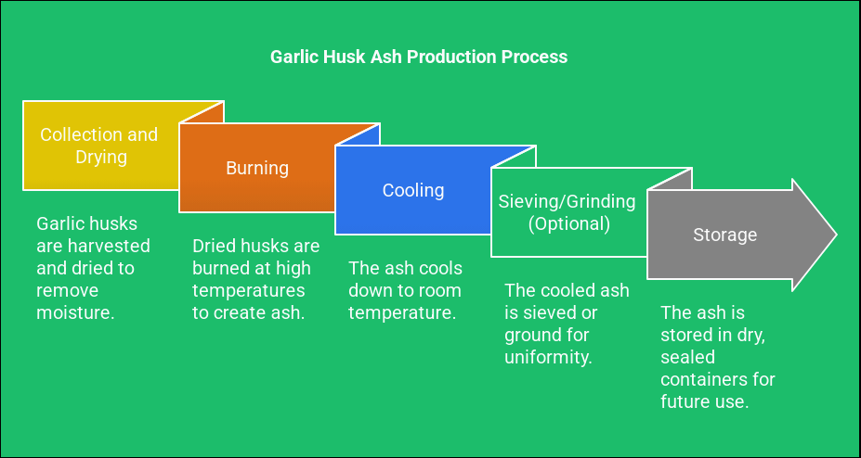

**Figure 1:** Steps involved in making Garlic Husk Ash (GHA)

1. **METHODOLOGY**

* The Methodology summarizes the replacements for cement mentioned in this paper:
* It studies the application of Fly Ash (FC) at a constant ratio of 10% with Garlic Husk Ash (GHA) in different levels from 3% to 15% for M35 Grade.
* The compressive strength of cubes of 150 x 150 x 150 mm is measured.
* The tensile strength of cylinders with a diameter of 150 mm and a height of 300 mm is investigated.
* The bending strength properties of beams sized 500 x 100 x 100 mm are also investigated.

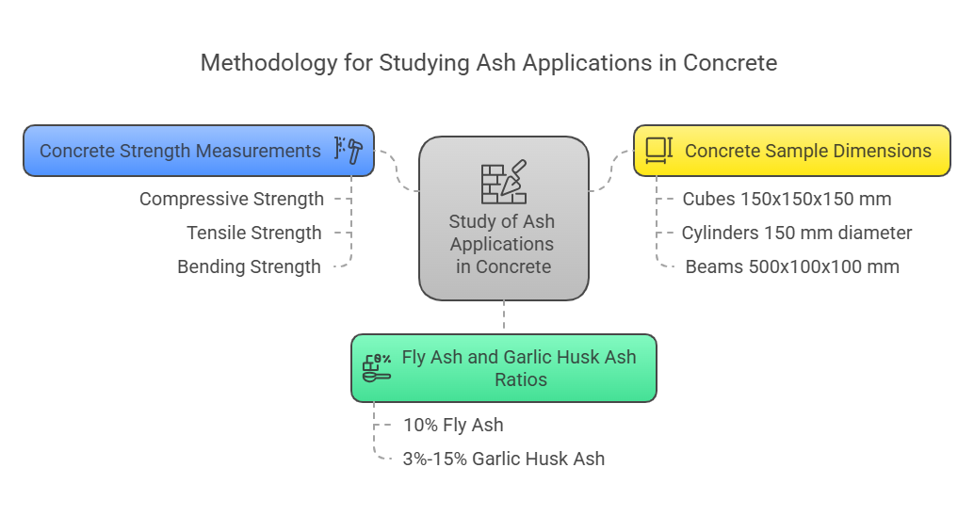

**Figure 2:** Steps involved in methodology of with respect to proxies.

1. **MATERIALS USED**

**Cement:**

It has a cement-like structure that develops a strong link with the stone when it comes into touch with water. The chemical components of the cement stay in the finished product, strengthening its positive characteristics and helping it integrate well with the cement. The kind of cement used is AMBUJA Cement, especially Ordinary Portland Cement (OPC 43 Review).

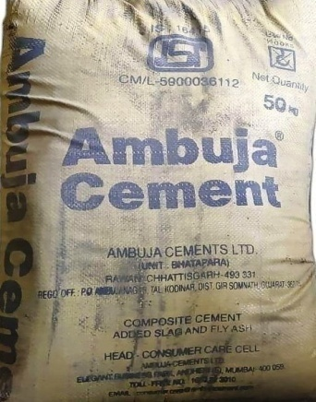

**Figure 3:** Type of Cement

**Fine Aggregate:**

Fine aggregates, which particles are measuring as tiny as 4.75 mm, play a key role in the building sector. Comprising 77% calcium oxide, these aggregates are crucial for filling the spaces between bigger aggregates, boosting the dimensional stability of concrete mixes. The sand employed in this method is acquired locally and corresponds to the standards for zone I. Additionally, it has passed extensive laboratory testing by sieve analysis, following the requirements defined in IS 383: 1970.

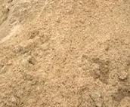

**Figure 4:** Fine Aggregate

**Coarse Aggregate:**

Quarrying yields rough aggregates, which consist of irregularly shaped fragments in various sizes essential for construction projects. The market offers a diverse range of these sizes, including those exceeding 40mm, along with 20mm and 10mm options. Incorporating these aggregates significantly enhances the strength of concrete. Generally, a single size is utilized, specifically 20mm, adhering to the IS 383-1970 standard.

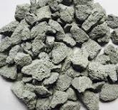

**Figure 5:** Coarse Aggregate

**Water:**

Water plays a crucial role in the chemical reactions involving cement, making it indispensable for concrete. During the production process, tap water is utilized for both mixing and curing. The pH level of the water is recorded at 6.8.

**Garlic Husk Ash (GHA):**

Garlic husk ash is the powdery residue left after burning the outer skins of garlic cloves. This ash is mostly composed of inorganic minerals such as silica, calcium, potassium, magnesium, and certain trace elements. This ash is produced by incinerating the dry husks at high temperatures. Because of its mineral content and potential eco-friendliness, it is beneficial for tasks such as soil fertilization, cement production, and water treatment..

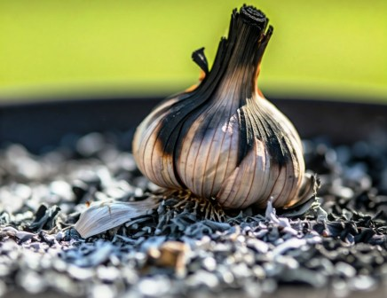

**Figure 6:** Garlic Husk Ash (GHA)

**Fly Cinder (FC):**

Fly cinder, commonly referred to as fly ash, is a by-product formed when coal is burnt in power plants. It’s a fine, powdery particle that is caught from the smoke created during the coal combustion process.

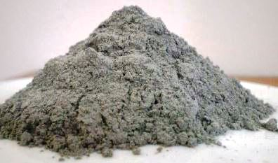

**Figure 7:** Fly Cinder (FC)

**Table No 1.** Physical properties of Garlic Husk Ash (GHA):

|  |  |  |
| --- | --- | --- |
| **S.No** | **Physical Property** | **Garlic Husk Ash (GHA)** |
| 1 | Size of Particle | Fine, typically below 100 microns |
| 2 | Color | light gray to white |
| 3 | Density | Low bulk density 1.5 - 2.0 g/cm³ |
| 4 | Water absorption | 5.8% |
| 5 | Specific Gravity | 2.53 |

**Table No 2.** Physical properties of Fly Cinder (FC)

|  |  |  |
| --- | --- | --- |
| **S.No** | **Physical Property** | **Fly Cinder (FC)** |
| 1 | Size of Particle | Typically, finer than 45 microns (usually around 30–50 microns) |
| 2 | Color | light gray to black |
| 3 | Density | 856 Kg/m³ |
| 4 | Water absorption | 2.56 % |
| 5 | Specific Gravity | 2.62 |

1. **LITERATURE REVIEW**

The exploration of Fly Cinder (FC) and Garlic Husk Ash (GHA) in the realm of cement and concrete has captured significant interest, owing to their remarkable ability to improve mechanical properties, durability, and sustainability within construction materials. These two substances function as supplementary cementitious materials (SCMs), offering a viable alternative to a portion of Portland cement, thus minimizing environmental repercussions while simultaneously enhancing the performance of concrete.

**Charles Berrymana Jingyi Zhu et.al; (2004)** : Class C fly ash in concrete had the greatest 7-day compressive strength at around 35% fly ash to cement ratio, whereas Class F fly ash had its maximum compressive strength at about 25% fly ash to cement ratio. The minimum compressive strength that concrete must meet for Class I, II, and III RCP is 27.6 MPa, as stated in ASTM C 76(02). The 7-day compressive strength of concrete cylinders containing Class C fly ash is 27.6 MPa or higher up to a fly ash concentration of 65% or higher. The compressive strength after 7 days of Class F fly ash remains at or above 27.6 MPa up to a fly ash concentration of about 45%. These numbers provide the ballpark for what has to be set to guarantee the concrete pipe sections have enough structural integrity and minimum compressive strength right after the forms are removed. <https://doi.org/10.1016/j.cemconres.2004.06.040>

**V.Sameer Kumar et.al;(2023)** The workability of the control specimen of SCC, as well as the SCC that included Alccofine and Fly Ash, was found to be within the limitations allowed by the Indian Code, according to the findings of a battery of tests. This verifies the mix design of the SCC. It seems that the addition of Alccofine and Fly Ash improves the workability of the SCC, since this tendency was also seen in other evaluation techniques. Using a compression testing equipment, we measured the concrete's average compressive strength at7,14, and 28 days. According to the results, as compared to regular concrete, the average compressive strength is much higher, reaching its peak at a 25% Alccofine replacement level. Additionally, the average split tensile strength was also tested at 7, 14, and 28 days, with the maximum value reported at a combination of 20% Fly Ash, 20% Alccofine, and 1% superplasticizer. Similarly, the average flexural strength at these intervals was measured, with the highest value again observed at the same mix proportions of 20% Fly Ash, 20% Alccofine, and 1% superplasticizer. <https://www.ijrar.org/papers/IJRAR23B1720.pdf>

**Jagdish Virupakshi Patil (2017)** It may be seen that in fly ash concrete, the total quantity of cementitious material is larger, while the content of Ordinary Portland Cement (OPC) is lower. Additionally, the number of fine particles is lowered, whilst the coarse aggregate content stays constant. Furthermore, there is a reduction in water utilisation, resulting to a drop in density owing to the lower density of fly ash in contrast to cement. <https://www.irjet.net/IRJET-V4I11204.pdf>

1. **MIX DESIGN & SLUMP VALUE**

**Table No 3.** Slump Cone values

|  |  |
| --- | --- |
| **Mix % Replacement** | **Slump value in mm** |
| 0%GHA + 0%FC | 95 |
| 3%GHA + 10%FC | 98 |
| 6%GHA + 10%FC | 101 |
| 9%GHA + 10%FC | 103 |
| 12%GHA + 10%FC | 91 |
| 15%GHA + 10%FC | 86 |

**Graph No 1:** Slump Cone values

**Table no 4:** Mix proportion of M35

|  |  |
| --- | --- |
| Grade | **M35** |
| Proportion | **1:1.67:2.15** |
| W/C ratio | **0.41** |
| Cement | **436.22** |
| Fine Aggregate | **731.13** |
| Coarse Aggregate | **939.72** |
| Water | **196** |

1. **TEST RESULTS**

**Table no 5** Test results of Compressive Strength at 7 days, 14 days & 28 days:

|  |  |  |  |
| --- | --- | --- | --- |
| **Mix % Replacement** | **7 days in Mpa** | **14 days in Mpa** | **28 days in Mpa** |
| 0%GHA + 0%FC | 25.32 | 34.83 | 41.57 |
| 3%GHA + 10%FC | 25.93 | 35.57 | 42.29 |
| 6%GHA + 10%FC | 26.51 | 36.19 | 42.92 |
| 9%GHA + 10%FC | 27.17 | 36.27 | 43.55 |
| 12%GHA + 10%FC | 22.44 | 30.29 | 38.41 |
| 15%GHA + 10%FC | 20.16 | 28.62 | 35.51 |

**Graph No 2:** Contrast values of Compressive strength for 7 days, 14 days & 28 days

**Table no 6** Test results of Split Tensile Strength at 7 days, 14 days & 28 days:

|  |  |  |  |
| --- | --- | --- | --- |
| **Mix % Replacement** | **7 days in Mpa** | **14 days in Mpa** | **28 days in Mpa** |
| 0%GHA + 0%FC | 1.52 | 2.48 | 3.11 |
| 3%GHA + 10%FC | 1.98 | 2.97 | 3.63 |
| 6%GHA + 10%FC | 2.49 | 3.45 | 4.07 |
| 9%GHA + 10%FC | 2.96 | 3.89 | 4.59 |
| 12%GHA + 10%FC | 1.46 | 2.25 | 2.79 |
| 15%GHA + 10%FC | 1.02 | 1.58 | 2.35 |

**Graph No 3:** Contrast values of Split Tensile strength for 7 days, 14 days & 28 days

**Table no 7** Test results of Flexural Strength at 7 days, 14 days & 28 days:

|  |  |  |  |
| --- | --- | --- | --- |
| **Mix % Replacement** | **7 days in Mpa** | **14 days in Mpa** | **28 days in Mpa** |
| 0%GHA + 0%FC | 5.19 | 6.14 | 7.08 |
| 3%GHA + 10%FC | 5.58 | 6.51 | 7.53 |
| 6%GHA + 10%FC | 6.08 | 7.07 | 7.98 |
| 9%GHA + 10%FC | 6.55 | 7.51 | 8.41 |
| 12%GHA + 10%FC | 4.72 | 5.61 | 6.58 |
| 15%GHA + 10%FC | 3.93 | 4.95 | 5.91 |

**Graph No 4:** Contrast values of Flexural strength for 7 days, 14 days & 28 days

1. **CONCLUSION**

Based on the foregoing considerations and developments, this essay can be concluded by concentrating on the following points:

* The result clearly shows that the substitution of FC & GHA both are replaced in place of cement by maintaining FC as constant with 10% and GHA with ascending follows from 0%, 3%, 6%, 9%, 12% & 15% in M35 Solid.
* Based on results as considered the compressive quality, ductile quality & flexural quality attained maximum strength at percentage of replacing 9%GHA+10%FC.
* The maximum Compressive strength quality gained for 28 days is 43.55 MPa.
* The maximum Tensile strength quality gained for 28 days is 4.59 MPa.
* The maximum Compressive strength quality gained for 28 days is 8.41 MPa.
* It can be referred as green concrete due to the replacement of agro based waste GHA.

1. **REFERENCES**
2. Berryman, C., Zhu, J., Jensen, W., & Tadros, M. (2004). High-percentage replacement of cement with fly ash for reinforced concrete pipe. Cement and Concrete Research, 35(6), 1088–1091. https://doi.org/10.1016/j.cemconres.2004.06.040
3. Sameer Kumar, V., Ahmed Vali, D., Venkata Prakash, M., & Chand Basha, S. (2023). Study on workability and strength of M30 grade SCC by partial replacement of cement with fly ash and alccofine. In Department of Civil Engineering & Dr K.V.Subba Reddy Institute of Technology, Kurnool, India, International Journal of Research and Analytical Reviews (Vol. 10, Issue 2, pp. 1–2) [Journal-article]. https://www.ijrar.org/papers/IJRAR23B1720.pdf
4. Olatoyan, O. J., Kareem, M. A., Adebanjo, A. U., Olawale, S., & Alao, K. T. (2023). Potential use of biomass ash as a sustainable alternative for fly ash in concrete production: A review. Hybrid Advances, 4, 100076. https://doi.org/10.1016/j.hybadv.2023.100076
5. Chakraborty, J., & Banerjee, S. (2016). Replacement of cement by fly ash in concrete. International Journal of Civil Engineering, 3(8), 58–60. http://dx.doi.org/10.14445/23488352/IJCE-V3I8P110
6. Rao, B. K., Reddy, M. a. K., & Rao, A. V. (2021b). Effect of flyash as cement replacement material and pore filling material in concrete. Materials Today Proceedings, 52, 1775–1780. https://doi.org/10.1016/j.matpr.2021.11.444
7. Ridha, S., & Yerikania, U. (2014). Geopolymer cement slurries with enhanced mechanical and physical properties for oilwell cementing. 7th Brunei International Conference on Engineering and Technology 2018 (BICET 2018). https://doi.org/10.1049/cp.2014.1095
8. Alterary, S. S., & Marei, N. H. (2021). Fly ash properties, characterization, and applications: A review. Journal of King Saud University - Science, 33(6), 101536. https://doi.org/10.1016/j.jksus.2021.101536