**THE IDEA OF CUMULATIVE QUANTITIES AND THE BULLWHIP EFFECT IN EXTENDED SUPPLY CHAINS**

Abishak A1,Dr.Kandavel R2,

1MBA Student, School of Arts, Humanities and Management, Jeppiaar University, Chennai, India.

2Associate Professor, School of Arts, Humanities and Management, Jeppiaar University, Chennai, India.

1***abishak7708@gmail.com***,

2***[krkandavel@gmail.com](mailto:krkandavel@gmail.com)***,

**ABSTRACT**

One of the most talked-about issues in recent years is the bullwhip effect, which frequently arises in extended supply chains. The term "bullwhip" refers to a supply chain's growing demand fluctuation (amplitude). During the demand change, this logistic phenomenon is seen at the partner interfaces. Numerous scholars attribute the bullwhip effect to information distortion and the independent determination of dependent demand. This study examines if the bullwhip effect can be addressed or even avoided using the concept of cumulative quantities.

First, the idea of order calculation and cumulative amounts are described. Then, in order to calculate the lead time between the previous cumulative curves of dependent demand, a common production and material flow structure of the expanded supply chain is defined. A straightforward example using a constant Master Production Program illustrates the findings on a chart. The effects on the cumulative curves of dependent demand and order calculation are then described when the constant Master Production Program is converted to a sporadic one. After that, certain unique elements that affect cumulative curves and order computation in extended supply chains are examined, such as increased demand. At least some conclusions are drawn and a resume is provided.

**Keywords:** bullwhip effect, expanding supply chains, prior cumulative curves, and the idea of cumulative quantities

##### Introduction

When demand order unpredictability increases as it moves up the supply chain, it's known as the bullwhip effect. Significant inefficiencies can result from skewed information moving from one end of a supply chain to the other (s. Lee Hau et al. 1997, p. 93). The bullwhip effect was identified for consumer goods, when market demand is unpredictable, anonymous, and subject to large fluctuations in user demand. Thus, the field of distribution logistics was the primary subject of numerous studies and publications (cf. Arnold et al. 2008, p. 29 ff., Cachon, 2007, Hongchun, 2011, Lee Hau et al. 1997a, Warburton, 2004).

More and more original equipment manufacturers (OEMs) are now producing to client order (BTO) rather than to stock (BTS). Therefore, rather than the distribution chain, the supply chain and procurement logistics are becoming more and more significant. This primarily pertains to businesses that produce intricate technological goods with numerous components and a broad variety of variations. As a result of the globalization of the economy, multinational corporations establish manufacturing facilities across all continents and expand their networks of suppliers, which in turn causes the suppliers to expand their networks. As a result, there is a steady increase in the number of material flow interfaces and cooperating enterprises, and "the problem of demand order variables in enterprise-wide value- added systems" (s. Göpfert, 2013, p. 29) can arise. "The bullwhip effect seems to have an easy fix. The current practice of autonomous production and stock planning on available resources and capacities in the supply chain must be replaced with a global perspective, and all collaborating enterprises in the chain must have direct access to the end-user demand information. (s. above page 30). In order to meet the aforementioned postulation, this study explores whether the idea of cumulative quantities (CQ) is appropriate for overcoming or avoiding the bullwhip effect as much as possible.

##### The concept of cumulative quantities

###### The calculation of cumulative curves

Compute the 'cumulative curves' (CC) for the finished products that are kept in the Master Production Plan (MPP) to begin the idea of cumulative quantity (CQ). The singular values for final products in a timeline's time units produce the cumulative curve. By summing all of the earlier values up to the time-unit that was obtained, the cumulative quantity for a time-unit in the timeline is determined. A roughly increasing curve is the end outcome (s. Heinemeyer, 1992, S. 163 ff.). A 'production calendar' must be used to normalize the timeline's time units, transferring the data from the Gregorian calendar into an equally spaced calculation calendar. This implies that all calendar days with work reductions or shortages must be correspondingly "cut," and all calendar days without working hours are eliminated or designated as "free days." This is necessary to provide an accurate supply chain lead-time estimation (see below). The timeline's many time units, such as shifts, hours, and so on, are also subject to this normalization.

**Utilizing the control loop theory and cumulative curves, order calculation**

The control loop theory is the foundation for determining order amounts in the CQ concept. The cumulative actual quantity and each specific cumulative goal quantity in a time unit are compared. A control mechanism, which is the software used to calculate requirements and demands, decides the production or delivery order based on the target-actual deviation. An order is created at the level of the measured deviation if the cumulative actual value is less than the cumulative goal value. Stated differently, an order is only initiated when the cumulative goal curve surpasses the actual cumulative curve (s. fig. 1). No order is created if the actual cumulative value is higher than the desired value.

A time-oriented algorithm or similar logistic control mechanism can be utilized to regulate a certain lot size as well. When lot size is taken into consideration, the order quantity typically surpasses the desired amount. This 'event' only occurs during the relevant time unit since the subsequent order is only generated when the cumulative order quantity is less than the next cumulative target amount. In the short term, this causes some variability and volatility, but it cannot cause a bullwhip effect over time.It should be noted that in order to establish the target-actual deviation and compute new orders for the future, the newly calculated orders are also utilized to create the cumulative in the future (s. Chap. 2.3).

Generally speaking, the degree of order variability and fluctuation is determined by the timeline's granularity, the quantity needed, and the lot size for production or transportation. These aspects will not be discussed in depth here because they clearly have no significant impact on the basic method of calculation.

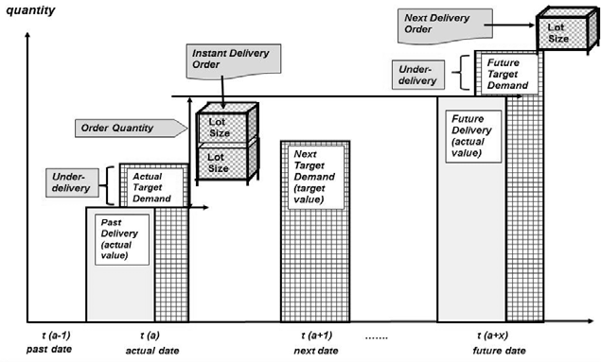Fig. 1: Calculation of delivery orders (simple example)

The automatic adjustment of over- and under-delivery or over- and under-production, regardless of the causes of the discrepancies, is part of the control loop principle. This covers later modifications to the product documentation, customer order definition, and MPP. The subsequent requirement demand calculation run also includes error cleanup. Mistakes, shortcomings, and deficiencies in the processes and documentation, such as incomplete BOM data, incorrect product order description, late or erroneous data gathering, mounting of a bogus component, or improper termination of technical changes, might be examples of these errors. These incidental circumstances cause a change in the cumulative target or actual curve, yet they are unpredictable and outside of standard processes and procedures. These retroactive adjustments and corrections are clearly intended and must be considered in the control loop principle for precisely calculating requirements and demands. They cause "certain" variations in the cumulative target curve, particularly for the current or subsequent order.

Preceding cumulative curves in supply chains Calculating the necessary demand for each component (single parts, assemblies, units, and raw parts) begins with the cumulative target curve for final product orders in the MPP. Determining a consistent production and material flow structure (PMF-structure) for the whole supply chain is necessary for the dependent demand calculation. An ideal Boolean interval algebra can be used to describe an orientated material flow, where a particular length or piece of the supply chain is mapped by an interval within (cf. Herlyn, 2012, p. 131 ff.). Any type of manufacturing, transportation, stock space, or other necessity can be represented by an interval. An interval's 'counting point' (CP) always marks its start, while the CP of the subsequent interval delineates its conclusion. No gaps or overlaps exist between the next two periods, allowing the PMF-structure to map the whole supply chain in a clear and consistent manner. Every interval can be further subdivided into sub intervals, and so on, with no overlap or deficiencies in these sub intervals.

The assembly mounting interval (Int-AM) and the unit assembly section (Int-UA) come next, where "unit" is another term for a primary assembly that is necessary for the finished product. The final product assembly (Int-FA) is represented by the final section. There are two subsections for manufacturing activities and transportation activities inside each of these primary intervals. For a more precise computation, they could be separated into further subsections, although this is not very relevant to our goal.

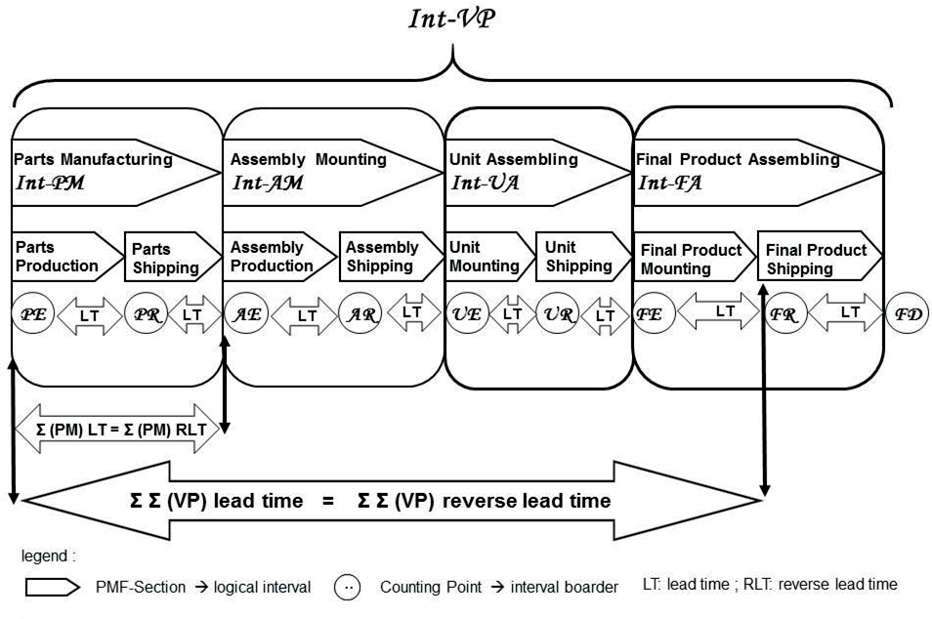Fig. 2: Production & Material Flow Structure and (Reverse) Lead Time

The requirement demand calculation begins "at the right" and moves in the opposite direction to the material flow. The upper boundary of the PMF-Structure is represented by the cumulative goal curve of final product assembly, or CP "Final Product Ready" (FR). The computation then proceeds backwards from one CP to the CP that comes before it, ending at the counting point "Part Entry" (PE), which stands for the PMF-structure's lower boundary. A pull-system-oriented technique is supported by the required demand, which is calculated step-by-step rearward to the physical material flow. When it comes to the varying demand of all components, the cumulative curve of final goods is the dominating curve and the superior border for the previous cumulative curves.

Particularly suitable for continuous production and material flow, the computation of previous cumulative curves is a straightforward shift by lead time (LT) (cf. Wiendahl, 1997, p. 33 ff.). Every PMF-section has its own unique LT definition. For backwards calculations, the LT from one CP to the next is known as the Reverse Lead Time (RLT). It is possible to add up the individual LTs of previous intervals so that the total LT for a component is equal to the sum of the LTs for all relevant intervals. The single LTs of all PMF-sections that a single part travels through must be summed in order to determine, for example, the total RLT for that part from "Parts Entry" (PE) to the conclusion of final product assembly (FR).The more precisely the LT is established and the more exact the requirement calculation's outcome, the more thoroughly the PMF-structure is explained and the more precisely the PMF-sections are defined.

A typical progression and shape of multiple previous cumulative target curves based on an MPP with constant output of 50 items per day are depicted in the chart below (s. fig. 3). At the conclusion of the cumulative curve for 850 final products, the counting point (FR) has been reached, and 300 final products have been cumulatively generated 'today'. The "earliest" target demand in time is represented by the cumulative curve at the counting point "Parts Entry" (PE), and the "latest" target demand is represented by the curve for the counting point "Final Products Ready" (FR). The cumulative curves for the other counting points, such as "Parts Ready" (PR), "Assembly Ready" (AR), "Unit Ready" (UR), and "Final Product Entry" (FE), are displayed between these "corridors." The cumulative curve for finished items is moved along the timeline in our case because we assume a continuous material flow without lot sizes. Due to the delivery lot size, only the final cumulative curve for "Parts Entry" contains a few minor kinks. When the required target demand is less than the actual demand, the curve is exceeded at the time-unit. In this instance, the delivery order is generated using a lot size of 40 items. The effect of lot size only lasts for a limited period of time and does not result in a sustained increase in supply chain demand.It should be noted that the order computation must be modified in the event of a large lot size that eventually surpasses the cumulative curve. A'special treatment' is required for limitations if the lot size is very large or the demand is very low. This implies that it must be made sure that, over time, particularly when demand is running low, the actual order curve does not surpass the target curve.

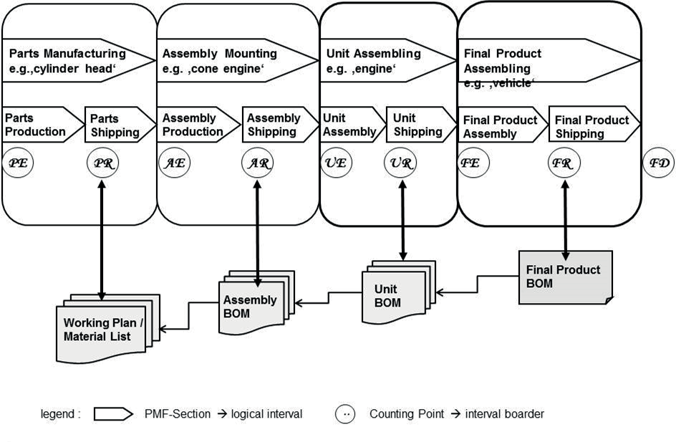

Fig. 3: Cumulative curves for a constant Master Production Program

The LT must be applied to every PMF-object that passes the relevant PMF-interval since it is an attribute for a PMF-interval and not for a PMF-object. All relevant PMF-objects can receive instantaneous notifications of any changes made to the LT during a given interval (or subinterval). Therefore, there is no need for further data entry for every single PMF-object in the master data. This effective technique is particularly crucial for a complicated product with several components and variations.

**Changes in the Master Production Program**

The cumulative curves of the final product and the cumulative curves that came before it are affected differently by two different kinds of MPP alterations. While the cumulative quantity at the conclusion of the time window stays the same, the first type just modifies the distribution of final goods in the MPP within a specific time window. Such a shift is frequently seen in businesses that use BTO-Production, where several activities optimize or modify the final product's sequence. Limiting a time window is done just for better demonstration and is neither a requirement nor a restriction for the procedure.A more or less irregular distribution of the end products replaces the MPP's consistent distribution in the following example (s. fig. 4). This indicates that a greater quantity of finished goods were manufactured on some days while none or very few were produced on others. You can see that the cumulative quantities of two or three cumulative curves are similar on the same days in the consequence. The explanation is that none of the goods in question are in this PMF-section because the lead time is lower than the days without production.Due to the significant increase in final production of 200 pieces in two days (450 650), you can observe a significant boost in output in the middle of the timeline (860). The lead time of the previous PMF-sections causes a few more minor adjustments.  Although this hypothetical situation can be handled independently, it is included here to help clarify the process. The described transformation of the MPP's end product distribution from a constant to a sporadic can actually occur, and vice versa. Final products with numerous variations and wildly disparate customer orders, where an assembly line balance is required, are a good way to illustrate this.

The second type alters not only the distribution of finished goods or the mix of product variations, but also the overall quantity of finished goods at the conclusion of the specified time frame. As a result, the MPP has been significantly and temporarily altered. If the MPP is overflowing with fictive client orders and there are insufficient real customer orders, those changes will be evident.

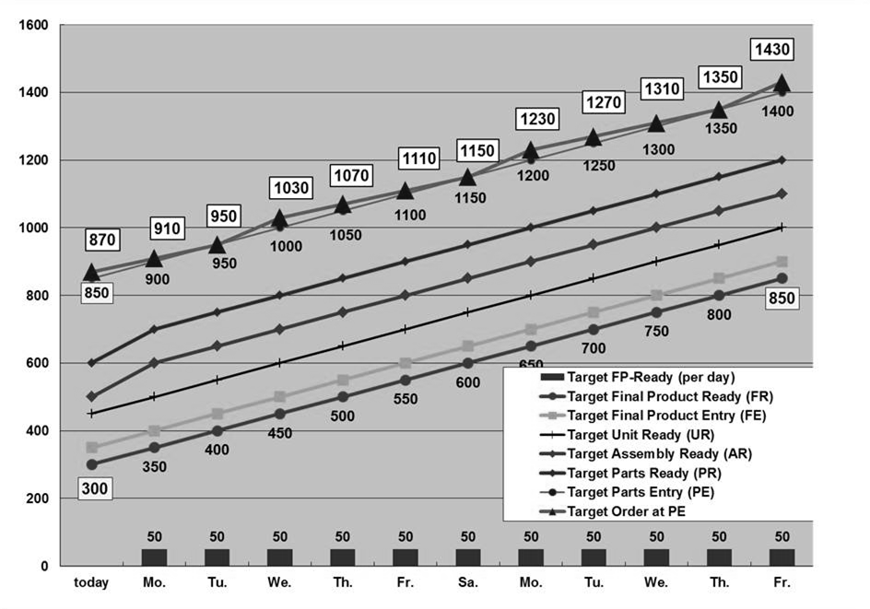

Fig. 4: Cumulative Curves for a 'sporadic' distribution of final product

The fake orders will be replaced as soon as actual customer orders are received. To deal with this kind of transition, certain BTO manufacturers have a unique system in place (s. Herlyn, 2012, p. 202 f.). Since the CQ idea still functions in the same way, no more examples are provided here. Naturally, a steady product distribution in the MPP can shift to a sporadic one, and vice versa. This is frequently seen in assembly-line balancing when there are several options for items and a wide range of customer requests. Thus, the order calculation and cumulative curve findings are also the opposite.

**The impact of BOM data and product structure on the computation of dependent demand**

A Bill of Materials (BOM), which documents the product structure and the relationships between the components, is required for the computation of cumulative demand. To break down the finished product into its constituent parts, this BOM data are required. This is a prerequisite for translating the higher demand for the finished product to the higher demand for its constituent parts. The product structure can be referred to at the PMF-structure's counting points and must correspond with the PMF-structure. Four BOMs are needed in our situation because there are Counting Points that indicate the conclusion of manufacturing operations (s. fig. 5).

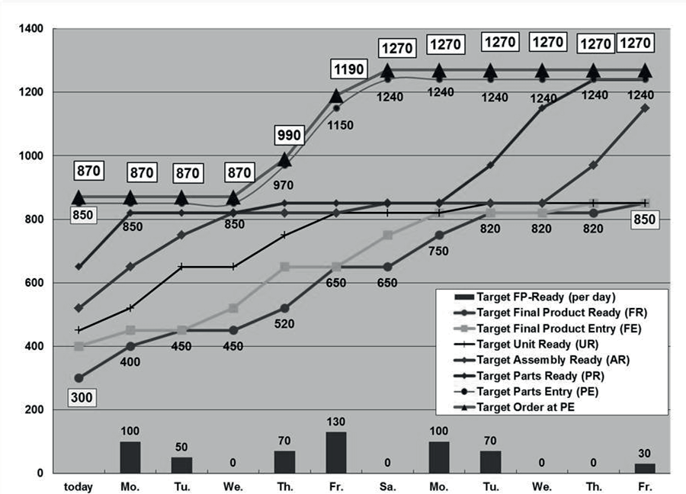The quantity is multiplied by the "usage factor" in the BOM if a component is utilized more than once at a certain usage point.

Fig. 5: Product Structure with linkage to the PMF-Structure

The cumulative curve maintains its distinctive shape despite being proportionately increased. A common cumulative curve is created at the relevant counting point if a component has multiple usage points in the same observed PMF-section. These parts are frequently'standard parts', such as washers, plugs, bolts, screws, etc. The common cumulative curve is a combination of several quite distinct curves because they are typically components that do not belong to a particular product version. It would take a lot of work to trace back every curve in this instance.

However, neither of these situations warrants a bullwhip effect. Furthermore, some elements are unable to pinpoint precisely, such as mounting with selective requirement, mounting alternative components, or creating parts with stochastic outcomes. To correct the curves in this situation, the relevant cumulative curves must be computed as a bundle. No more research should be done on this.

**Splitting and merging of material flow**

In addition to the demand calculation that has been explained, the form and height of the previous cumulative curves are altered by the division of material flow and demand (for example, several suppliers or manufacturers) and the combination of material flow and demand (for example, distinct product variants). The cumulative curve must be separated into its several pieces if the PMF splits, and as a result, the demand is split. A rule outlining the precise guidelines for "splitting" is required for this. This regulation may take the form of an order quotation or another delivery and production switch. Consequently, there are roughly peaks and lows in the order quantities at specific points in the timeline.

The height of the lot size and the gradient of the cumulative curve determine this. In any event, this is merely an intrinsic process in the concept of CQ and not a cause for a bullwhip effect.

A delivery quotation (splitting) of '70:30' percent is displayed with the actual delivery orders for suppliers A and B in the following charts. The shipping order lot size for each is 40 pieces. Since the order-line for the constant MPP (s. fig. 6) is displayed in chart 6, it is likewise extremely constant. There are only two orders of 80 goods because the lot size is little less than the daily demand.

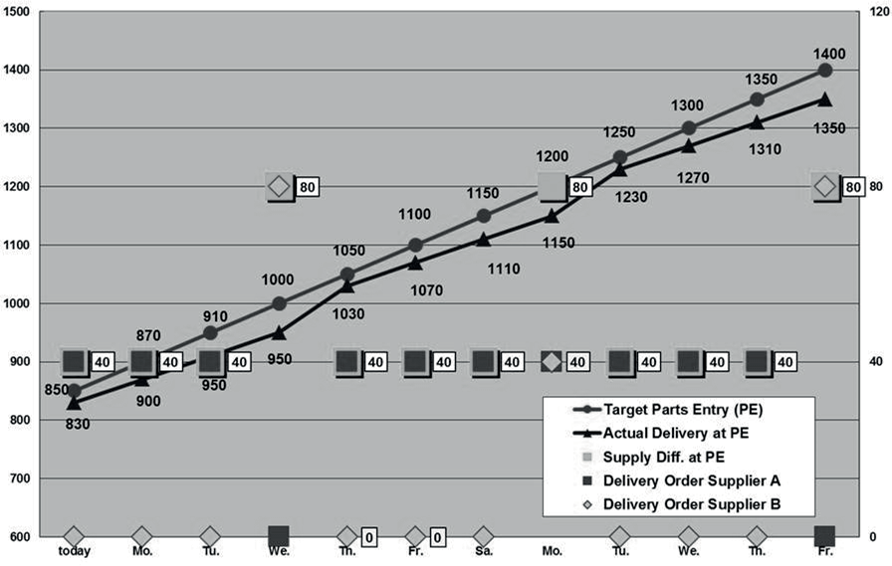

Fig. 6: Delivery order splitting for the constant MPP (cf. fig. 3)

##### Additional demand to final products demand

Additional demand sources for final product components are a significant factor that affects the cumulative curve's height and shape. The spare parts, industrial partners, or other affiliated businesses of a group are the primary source of the additional demand. Multiple customers inside a business provide an additional demand. For internal tasks, such as prototyping in the design department or trying out industrial equipment and manufacturing tools in the production department, they require components. The production of flawed and inadequate components results in an increased demand.Additionally, parts were destroyed in the course of manufacturing, shipping, or both. In any case, the intended demand from the finished product must be increased by all other demands. The cumulative goal quantity will rise as a result of the additional demand, which is included in the cumulative target curve. There won't be a bullwhip impact because the CQ principle is still operating in the same way.  
  
It must be noted that it is quite challenging to identify the cause of a tangible actual order when there are multiple additional demand sources for a component. The cumulative curves for the various demand sources must be separated in order to assess this. The demand for components that deviate from the MPP and the increased demand are not inherently systematic. Therefore, there is no bullwhip effect, but the previous cumulative curve is altered in a careless manner that may result in an unforeseen order change.

##### Short resume and conclusion

Multinational corporations have global production and procurement networks as a result of the globalization of the international economy. As a result, the number of interfaces and cooperating businesses is increasing gradually, and the enlarged supply chain exhibits the bullwhip effect. More and more OEMs are now building their products to order rather than to stock. In this case, the enlarged supply chain requires a strong idea for calculating requirements and demands.

A fairly straightforward and reliable technique for determining dependent demand requirements in an extended supply chain is the idea of CQ. This idea incorporates the bullwhip effect-avoidance control loop paradigm. The cumulative target curve for the MPP's final products is calculated first. After then, a common PMF-structure is used to calculate the dependant demand of the components step-by-step backward. The outcomes are cumulative curves for each supply chain Counting Point that is pertinent. This idea is particularly suitable for transportation and continuous flow production when there is a constant high demand. This idea can incorporate certain effects from both inside and outside the business, primarily the increased need for components.

All cooperating partners in the expanded supply chain must apply this concept in order to put it into operation. They must define and employ a consistent PMF-structure with common counting points as a key starting point. Every partner must communicate their goals and their values to their companions. This involves using a common communication platform and gathering real data at the right moment. Since the PMF-sections and the counting points are only material flow items and not legal items, it makes no difference whether the interfaces between the cooperating partners are inside or outside of a group. Thus, the idea of cumulative quantities can satisfy the aforementioned postulation.

**References**

1. Handbuch Logistik, 3. Aufl., Berlin, 2008; Arnold, D. et al. (Hrsg.
2. In Search of the Bullwhip Effect, Cachon, G. et al., 2007, pp. 457–479 in Manufacturing & Service Operations Management, Vol. 9, No. 4.
3. Quantifying the Bullwhip Effect in a Simple Supply Chain: The Effect of Forecasting, Lead Times, and Information was published in 2000 by Chen F., Drezner Zvi, Ryan J. K., and Simchi-Levi D. in Management Science, INFORMS, Vol. 46, No. 3, March 2000, pp. 436–443.
4. Ingrid Göpfert, "Logistik-Leadership Concept and Supply Chain Management," 3rd ed., München
5. The Bullwhip Effect in Supply Chains by Lee Hau L, Padmanabhan V, and Whang Seungijn, in: Sloan Management Review, Volume 38, Issue 3, pp. 93-102, Spring (1997)
6. Lee Hau L, Padmanabhan V., Whang Seungijn, 1997(a), Information Distortion in a Supply Chain: The Bullwhip Effect, in: Management Science; Apr 1997; 43, 4; pg. 546
7. Hongchun Wang, Baizhou He, 2011, Research on the Reducing Measures of Bullwhip Effect, in: International Conference on Software and Computer Applications, IPCSIT vol.9. wpg.
8. Heinemeyer, W., 1992, Die Planung und Steuerung von logistischen Prozessen mit Fortschrittszahlen, in: Adam D. (Hrsg.), Flexible Fertigungssysteme, S. 161-188, München
9. Herlyn, W., 2012, PPS im Automobilbau - Produktionsprogrammplanung und -steuerung von Fahrzeugen und Aggregaten, München
10. Warbuton, G., 2004, An Analytical Investigation of the Bullwhip Effect, in: PRODUCTION AND OPERATIONS MANAGEMENT (POMS), Vol. 13, No. 2, pp. 150–160,Summer
11. Wiendahl H.-P., 1997, Fertigungsregelung - Logistische Beherrschung von Fertigungsabläufen auf Basis des Trichtermodells, München