**A STUDY ON HOW LEGAL COMPLIANCE AFFECTS EMPLOYEE AND ORGANIZATIONAL PERFORMANCE**

Remisha R1,Mrs Keerthi S2,

1MBA Student, School of Arts, Humanities and Management, Jeppiaar University, Chennai, India.

2Assistant Professor, School of Arts, Humanities and Management, Jeppiaar University, Chennai, India.

1***remisharemi04@gmail.com***,

2***K.g.s.keerthi@gmail.com***,

**ABSTRACT**

This study looks at how legal compliance affects organizational and employee performance. The primary objective is to understand how adherence to the law affects organizational efficacy, financial stability, and market reputation in addition to employee satisfaction, productivity, and retention. Legal compliance is thought to be essential for risk management, improving operational processes, and creating a positive work atmosphere. The report indicates that businesses with strong compliance systems usually witness increases in worker satisfaction and productivity. While addressing the challenges businesses face in maintaining compliance, such as regulatory complexity and associated costs, it also emphasizes the long-term benefits of legal adherence for organizational success and employee well-being.

**Keywords**: Employee performance, organizational performance, and legal compliance

**INTRODUCTION**

In today's business world, an organization's capacity to operate effectively and sustainably depends on its adherence to the law. Legal compliance is the process of ensuring that a company conforms with all relevant laws, regulations, and guidelines that govern its industry and business processes. These may consist of guidelines for financial reporting, labor laws, environmental regulations, and corporate governance. By promoting an ethical and transparent environment, companies that prioritize legal compliance not only reduce their risk of fines but also position themselves for long-term success.Beyond only avoiding fines and legal issues, legal compliance has a big impact on how well workers and businesses operate.Increasing operational efficiency, reducing risks, and enhancing reputation via compliance can help businesses achieve better financial results and a stronger position in the market. In a similar vein, workers at compliant companies report feeling safer, happier, and more trusted, which could increase productivity and retention.  
  
Although most people agree that following the law is important, little is known about the specific effects on employee behavior and organizational success. This study aims to explore these effects in greater detail by examining the ways in which regulatory compliance affects several facets of employee experiences and business operations.It also covers the challenges businesses face in staying in compliance, such as evolving regulations and continuous costs, and how these challenges can be resolved to fully benefit from abiding by the law.

**DEFINITION**

**Legal Compliance:** Legal compliance is adherence to the laws, regulations, and guidelines that govern an organization's operations. It comprises ensuring that the company's operations adhere to the legal standards set by regulatory bodies, governing bodies, and industry-specific guidelines.   
Legal compliance encompasses a number of topics, including corporate governance practices, tax regulations, labor laws, and environmental requirements.  
**Organizational Performance:** Often measured by elements such as financial success, customer happiness, employee productivity, and operational effectiveness, "organizational performance" refers to how well a business achieves its goals and objectives.

**Employee Performance:** The effectiveness and productivity of a worker in completing tasks, achieving goals, and contributing to the overall success of the business is known as employee performance. Among the elements that influence it are motivation, skills, and job satisfaction.

**OBJECTIVES**

1. To evaluate how employee performance and organizational efficiency are affected by legal compliance.
2. To assess how employee performance is impacted by legal compliance.
3. To determine the best ways to improve performance while adhering to the law.

**REVIEW OF LITERATURE**  
Legal compliance has a significant impact on personnel and organizational performance. By lowering risks, boosting operational efficiency, and improving the organization's reputation, it enhances performance. Observance of labor, health, and safety laws fosters employees' motivation, health, and job satisfaction, all of which improve engagement and output. Proactive compliance strategies and external regulatory demands promote accountability and a responsible business culture. Furthermore, following the law strengthens governance institutions and encourages moral decision-making, both of which improve employee morale in general. However, barriers like potential over regulation and the high costs of compliance can hinder innovation and flexibility, especially for SMEs. Despite these challenges, when legal compliance is managed well, it leads to long-term corporate success.  
  
A Novel Approach to Legal and Business Difficulties: Compliance Management  
Benedek, Petra (2012) Because of the global economic crisis, which has increased awareness of risk management and prevention, organizations are searching for efficient solutions to comply with complicated legal requirements. Identification and prevention of corporate crimes, harm reduction, prevention of recurrence, and improvement of control and business processes are the objectives of compliance management. Management is responsible for detecting and preventing corporate crimes, minimizing damage, preventing their recurrence, and improving control and business processes. regulations concerning businesses, the environment, labor and wage regulations, data security, health and safety issues, equal employment opportunity, antitrust issues, and competitiveness are just a few of the areas it covers. Compliance management can be seen as part of the shift from regulatory law enforcement to self-regulation, which can be quicker, more flexible, and more effective than governmental regulation.  
  
Human Resource Professionals and Legal Compliance: A Reasoned Action Approach   
In 2020, Shayna and David Frawlev   
This literature study examines legal compliance and HR professionals' compliance behavior using the Reasoned Action Approach.It discusses how important compliance is to companies and how HR specialists can support adherence. The review examines attitudes, subjective norms, perceived behavioral control, and the challenges faced by HR professionals, such as company culture, resource constraints, and regulatory complexity. Techniques for improving compliance include training, policy development, and monitoring. The review is completed with case studies and empirical data.

**RESEARCH METHODOLOGY:**

This study's research methodology employs a quantitative approach with a descriptive design to investigate how legal compliance affects organizational and personnel performance. A structured questionnaire made with Google Forms will be used to collect primary data, and books, journals, prior dissertations, and the internet will be the sources of secondary data.

Simple random sampling was used to choose the 60 Halol responders that make up the sample size. Organizational and employee performance are the dependent factors, whereas legal compliance is the independent variable, according to the study. The use of closed-ended questions that might not fully capture the range of replies, the study's dependence on self-reported data, which could be skewed, and its online distribution strategy, which might leave out people without access to digital devices, are some of its drawbacks. Reaching all of the chosen participants may also be hampered by time constraints, and the impact of legal compliance may be harder to isolate due to other variables like management techniques and economic conditions. Finally, the findings may be impacted by the ways that managers and employees perceive and comprehend legal compliance.

**DATA ANALYSIS AND INTERPRETATION**

* Employees of the responders participated in safety training sessions.

|  |  |  |
| --- | --- | --- |
| **Response** | **frequency** | **Percentage** |
| Monthly | 57 | 95 |
| Quarterly | 1 | 2 |
| Annually | 2 | 3 |
| Total | 60 | 100 |

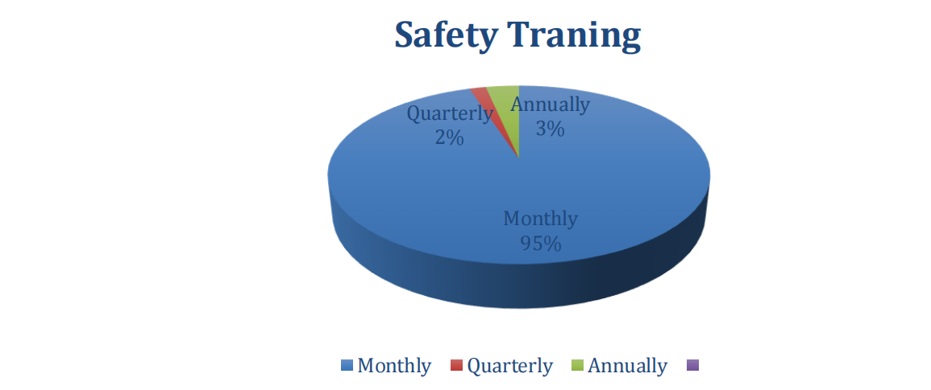

It is evident from the above table that 95% of respondents (N=57) say that safety training sessions are held monthly, 2% (N=1) say that they are held quarterly, and 3% (N=2) say that they are held annually. The majority of respondents think that their organization holds monthly safety training sessions, it can be inferred.

* Please provide any other information you may have about how legal compliance affects organizational and worker performance at work.

|  |  |  |
| --- | --- | --- |
| **Particular** | **frequency** | **percentage** |
| Very useful | 14 | 23 |
| Good | 9 | 15 |
| Very important | 6 | 10 |
| Legal compliance improve performance | 5 | 8 |
| Enhance productivity | 6 | 10 |
| Boosts accountability & efficiency | 4 | 7 |
| Safety & fairness for employees | 4 | 7 |
| Fosters trust & avoids penalties | 4 | 7 |
| Clear policies & roles | 5 | 8 |
| Improve employee morale | 3 | 2 |
| Total | 60 | 100 |

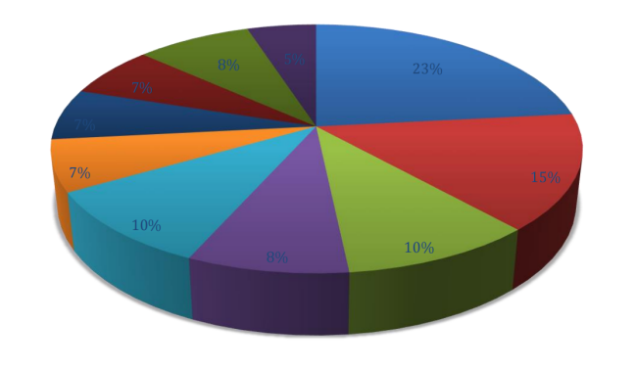

According to the above table, 23% (N=14) of respondents think that following the law is very helpful, 15% (N=9) think it is good, and 10% (N=6) think it is very important. 8% (N=5) concur that performance is improved by legal compliance, 10% (N=6) believe it increases production, and 7% (N=4) Have faith in Boots' efficiency and accountability. 7% (N=4) believe it ensures worker safety and equity. 8% (N=5) appreciate it for providing clear policies & roles, 5% (N=3) think it improves staff morale, and 7% (N=4) agree that it fosters trust and prevents fines. It can be inferred that the majority of respondents recognize the beneficial effects of legal compliance on employee and organizational performance.

**MAJOR FINDINGS**

Most of the study's respondents are men between the ages of 25 and 50, and the majority of them work in manufacturing and large enterprises with more than 250 people. Smaller groups occupy executive, human resources, and managerial jobs, but their primary roles are Associates/Workers. The majority of responders have been employed by their companies for three to six years. Regarding legal compliance, a sizable portion of respondents attest to the fact that training is offered and are quite knowledgeable with the legal obligations in their company. They regularly take legal compliance into account in their day-to-day work because they believe it is crucial to the success of the firm. The majority of respondents think that following the law has a beneficial effect on workplace safety, employee productivity, and organizational performance, which in turn creates a happier workplace and higher employee morale.Numerous people also state that compliance-related procedures, like transparent safety guidelines and equitable treatment, have enhanced productivity at work. The majority of respondents express satisfaction with their company's adherence to labor regulations and health initiatives, including wellness initiatives and ESIC benefits. Overall, the response from the respondents shows that following the law not only increases output and lowers conflict but also promotes a stable and effective workplace by avoiding fines and legal problems.

**SUGGESTIONS:**

Using language that is accessible, straightforward, and free of jargon is crucial for improving compliance standards and making sure that everyone in the company can comprehend them. Continuous, role-specific training should be offered, emphasizing the value of compliance through scenario-based learning that draws on real-world experiences. Frequent internal audits can provide helpful criticism and assess policy compliance. Employees should learn how compliance relates to their individual responsibilities through training programs, and interactive e-learning modules can increase participation. New hires should receive thorough compliance training during onboarding, and staff members should be informed of any changes to internal or legal policies. Frequent audits guarantee that the company complies with legal requirements and offer input for ongoing development.Long-term growth, stability, and market position are facilitated by consistent legal compliance, which communicates ethics, accountability, and credibility to partners, investors, employees, and customers.

**CONCLUSION**

The significant impact that legal compliance has on worker and organizational performance is highlighted in the study's conclusion. In addition to avoiding penalties and protecting an organization's reputation, abiding by the law fosters a productive workplace. Setting compliance as a top priority improves an organization's efficiency and lowers risks like litigation, fines, and penalties. Long-term success depends on strengthening stakeholder trust, enhancing financial performance, and fortifying consumer relationships. From the perspective of the employee, a legally compliant workplace encourages increased involvement, better morale, and increased job satisfaction. Employee loyalty and dedication increase when they observe their employer abiding by labor rules, safety requirements, and moral standards.

By building confidence between management and employees and creating a sense of security, this reduces turnover and promotes a stable workforce. Nonetheless, noncompliance can have detrimental impacts on companies and workers, raising staff attrition, depressing morale, and exposing them to penalties, legal issues, and damage to their brand. Additionally, confusion can impair team cohesiveness and organizational effectiveness. Organizations must prioritize legal compliance by establishing clear policies, providing ongoing training, and designating compliance officers. A culture of compliance, demonstrated by leadership, and routine procedure reviews are essential. The results of the study show that legal compliance significantly affects both employee performance and company success.Ultimately, it assists companies in reducing risks, fostering a positive work environment, and raising employee happiness.

**REFERENCES:-**

1. Compliance Management: A Novel Approach to Legal and Business Challenges, Petra Benedek, 2012.
2. In 2010, Schumm, D., Leymann, F., Kokash, N., Elgammal, A., Turetken, O., and H., V.D. Reusable units of compliant procedures for business process compliance. Pages 325-337 of the Proceedings of the 10th International Conference on Current Trends in Web Engineering, ICWE'10, Heidelberg, Germany. Springer-Verlag
3. Bakker, A. B., Albrecht, S. L., and Leiter, M. P. (2011). significant questions regarding participation at work. 20(1), 4-28, European Journal of Work and Organizational Psychology.
4. Lepine, J. A., Crawford, E. R., and Rich, B. L. (2010). the reasons behind job engagement and how it affects job performance. The Academy of Management Journal
5. Governatori, G. and Rotolo, A. (2008). An algorithm for business process compliance. Proceedings of the 2008 Conference on Legal Knowledge and Information Systems, Amsterdam, the Netherlands, pages 186–191 of JURIX 2008: The Twenty-First Annual Conference. iOS Pr ess.
6. Arnaud (2006). Two new theories and measures of an ethical workplace culture are the psychological process model (PPM), Orlando, and the ethical climate index (ECI).
7. Business research techniques, 4th edition, 2009, Sekaran Uma, Rania & Co., copyright.
8. Dhanpat Rai & Co., 2005, Human Resource Management by T.N. Chakra, 7th Edition, copyright.
9. New Age International Publishers, Second Edition, Research Methodology, C.R. Kothari.