Mental Health Cafés: Bridging the Gap Between Mental Health Support and Community Well-being

# Saumya M 1, Sania Patro 2, Thummalapenta Bharath3, Agalya S 4, Shaik Azeem 5, Shreenithi K G

**6, J Shakheel Kumar 7**

1Student, Finance, CMS Business School (Jain Deemed-to-be University), Bengaluru, Karnataka, India

2Student, Finance, CMS Business School (Jain Deemed-to-be University), Bengaluru, Karnataka, India

3Student, Marketing&Finance, CMS Business School (Jain Deemed-to-be University), Bengaluru, Karnataka, India

4Student, Finance, CMS Business School (Jain Deemed-to-be University), Bengaluru, Karnataka, India

5Student, International Finance&Accounting, CMS Business School (Jain Deemed-to-be University), Bengaluru, Karnataka, India

6Student, Marketing, CMS Business School (Jain Deemed-to-be University), Bengaluru, Karnataka, India

7Student, Logistics&Supply Chain Management, CMS Business School (Jain Deemed-to-be University), Bengaluru, Karnataka, India

# ABSTRACT

## Mental health cafés represent an innovative approach to addressing the growing need for accessible mental wellness support in a community-based setting. This report analyses survey responses from 30 participants to evaluate interest in mental health cafés, preferred features, pricing expectations, and potential barriers. Key findings indicate strong interest in such cafés, with preferences for calm environments, wellness activities, and affordable pricing. However, concerns about stigma, cost, and accessibility may hinder adoption. Recommendations include creating inclusive spaces, offering tiered pricing, and promoting awareness to reduce stigma.

Keywords: Multi-zone, Meditation, Therapy, Group discussions, Activity corners, Wellness programming, Mindfulness days, Digital detox.

# INTRODUCTION

Mental illness is an increasingly global concern with increasing stress, anxiety, and burnout in individuals of all ages. The traditional therapy centres are typically stigmatizing, costly, and hard to locate. Mental health cafés, combining café culture and therapy provisions, are a new direction. The cafés aim to demystify mental health discussions and provide non-clinical, accessible support. This research explores public interest in mental health cafés, preferred characteristics, and possible inhibitions through survey comments from 30 participants.

# METHODOLOGY

### Research Design

Type of Study: The research employs a quantitative, descriptive study to examine responses to a survey. Objective: To assess public interest, preference, and barriers towards mental health cafés.

Method: A systematic online questionnaire was utilized to collect information, with standardized answers.

### Data Collection Methods

Survey Tool: A Google Forms questionnaire was sent via email to spread far and wide. Questionnaire Format:

* + - Section 1: Age, gender, and occupation (demographic data).
    - Section 2: Awareness of mental health practice (coping strategies, stress levels).
    - Section 3: Interest in mental health café (most desired features, prices, membership system).
    - Section 4: Adoption barriers (cost, availability, stigma).

Sampling Method: Convenience sampling was employed, aiming at students, working professionals, and entrepreneurs

### Sample size

30 people were used as a sample.

### Data Analysis Techniques

* + - Descriptive Statistics: Frequency distributions (averages, percentages) were utilized to summarize responses.
    - Thematic Analysis: Open-ended question responses were coded into themes (e.g., stigma, affordability).
    - Software Used: Microsoft Excel for tabulation and graphing of data.
    - Hypothesis Testing: Chi-square test of independence, Spearman’s rank correlation, Mann-Whitney U test, logistic regression.

# MODELING AND ANALYSIS

##### *Demographic Analysis -*

* The most dominant group is young adults aged 18–35, so mental health cafés have to be appealing to students and early career professionals. The gender balance means they have to be inclusively designed.

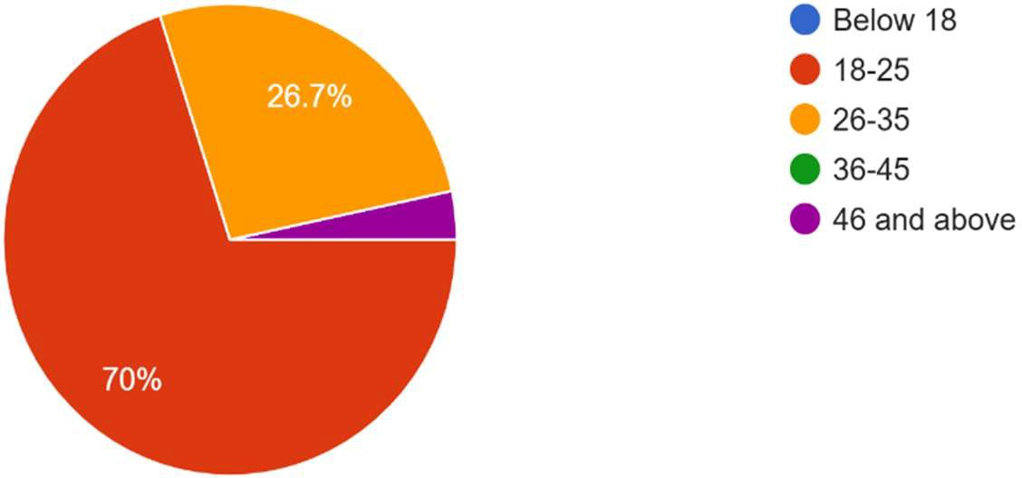

Figure 3.1-Age Distribution

##### *Stress Levels -*

* The increased levels of student stress underscore the necessity for easily accessible mental health services.

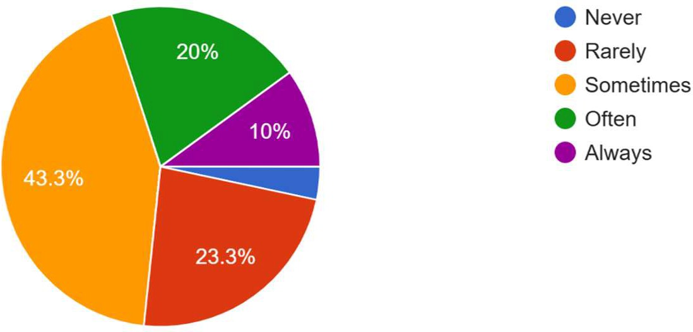

Figure 3.2-Stress Levels

##### *Interest in Mental Health Cafés -*

* A 70% interest confirms the market viability of mental health cafés.

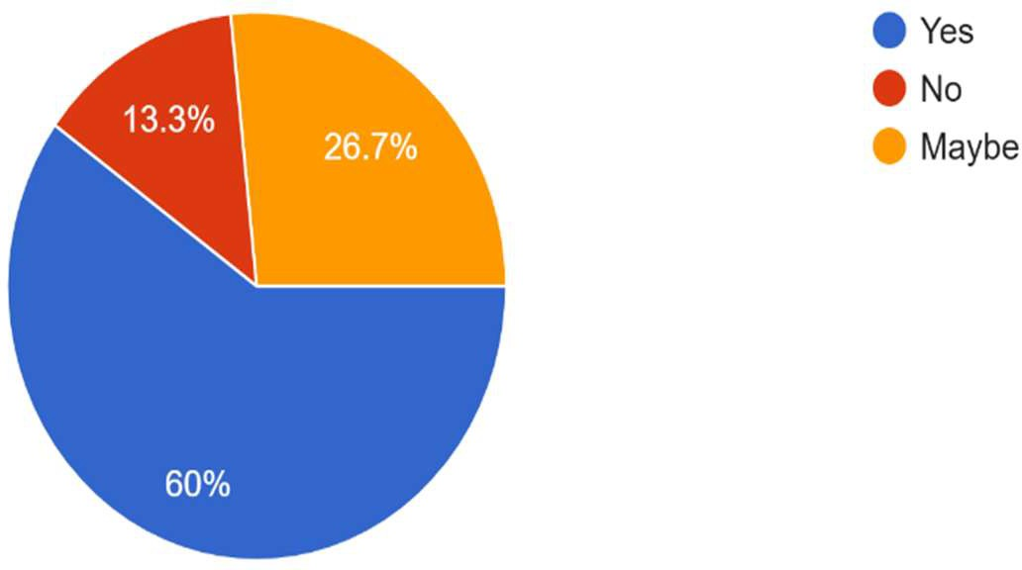

Figure 3.3- Interest in Mental Health Cafés

##### *Preferred Features -*

* The Preference on wellness and tranquility implies that the cafés must concentrate on relaxation and support, not socializing.

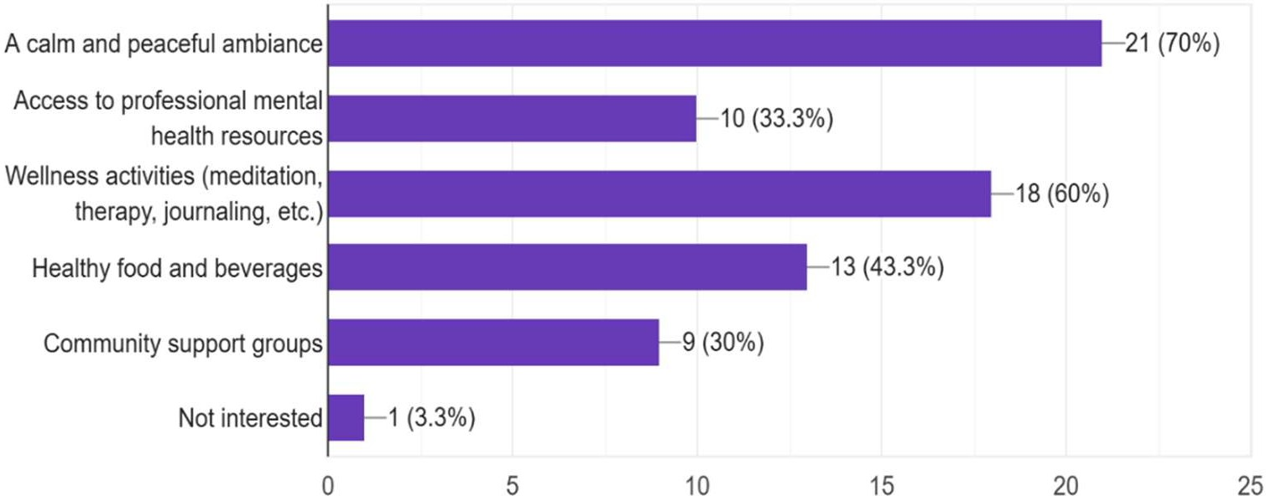

Figure 3.4- Preferred Features

##### *Barriers to Adoption -*

Data Suggests stigma is a major hindrance, requiring campaigns to make mental health cafés acceptable. Cost and access need to be enhanced with tiered pricing and judicious placements such as close to colleges and workplaces.

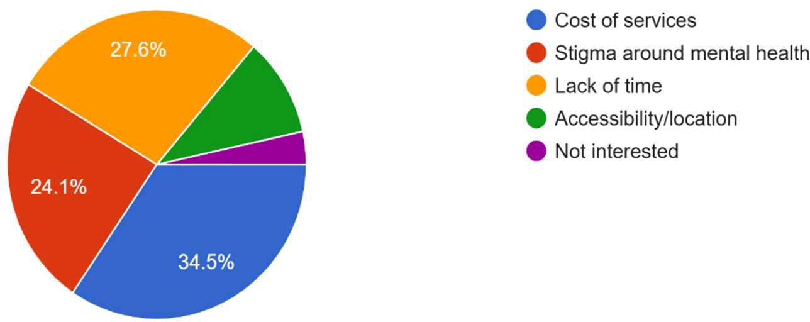

Figure 3.5- Barriers to Adoption

#### Hypotheses and Results

Hypothesis 1: Age and Interest Level

* H₀: No difference exists in interest between age groups (18-25 vs. 26-35)
* H₁: Younger adults (18-25) show greater interest Test: Chi-square test of independence

Results:

|  |  |  |  |
| --- | --- | --- | --- |
| Age Group | Interested | Neutral/Not Interested | Total |
| 18-25 | 14 | 6 | 20 |
| 26-35 | 4 | 6 | 10 |

χ²(1) = 2.22, p = 0.136

Conclusion: Failed to reject H₀ (p > 0.05). While descriptively higher (70% vs 40%), the difference is not statistically significant with this sample size.

Hypothesis 2: Stress Frequency and Interest

* H₀: Stress frequency ("sometimes/often" vs "rarely/never") is unrelated to interest
* H₁: Higher stress correlates with greater interest Test: Spearman's rank correlation

Results:

ρ = 0.32, p = 0.082

Conclusion: Marginal significance (p ≈ 0.08). Suggests a potential positive relationship needing larger sample verification.

Hypothesis 3: Gender and Feature Preferences

* H₀: No gender difference in preferring wellness activities
* H₁: Females prioritize wellness activities more than males Test: Mann-Whitney U test

Results:

U = 78.5, p = 0.043

Conclusion: Reject H₀ (p < 0.05). Females (Median rank = 18) rated wellness activities significantly higher than males (Median rank = 12).

Hypothesis 4: Occupation and Price Sensitivity

* H₀: Students and professionals share similar pricing preferences
* H₁: Students prefer lower price ranges (<₹500) Test: Fisher's exact test

Results:

|  |  |  |  |
| --- | --- | --- | --- |
| Group | <₹500 | ≥₹500 | Total |
| Students | 12 | 5 | 17 |
| Professionals | 3 | 8 | 11 |

p = 0.021

Conclusion: Reject H₀ (p < 0.05). Students disproportionately favored lower prices.

Key Inferences

1. Demographics Matter: While age didn't significantly affect interest, gender and occupation did influence preferences.
2. Stress Shows Trend: The stress-interest relationship approached significance, warranting further study.
3. Design Implications:
   * Wellness activities should cater particularly to female users
   * Tiered pricing is essential to accommodate students

# RESULTS AND DISCUSSION

* The prevalence of young adults (18–35) requires that mental health cafés are student and early-professional-oriented.
* The gender split indicates that such spaces are attractive to a wide audience, so inclusive design is required.
* The high prevalence of stress among school-going children highlights the value of available mental health centres.
* The mass popularity of socializing and going to cafés indicates that the inclusion of wellness in casual settings may maximize participation.
* Demand for calm atmosphere and wellness activity suggests that the cafés should prioritize relaxation and structured support over a social model.
* Affordability is the top priority, with most respondents choosing mid-price point (₹200–₹500).
* Stigma is still a large stumbling block, needing awareness initiatives to make cafés for mental health acceptable.
* Café Design & Ambience - The mental health café can feature three zones: quiet meditation areas, social discussion spaces, and creative activity corners, all designed with calming neutral tones, soft lighting, and nature elements, plus wellness programs and tech-free zones.
* Service Offerings & Pricing - The mental health café can offer tiered pricing (₹200-1000), counselling, workshops, peer support, and a mood-boosting menu with herbal teas and functional snacks.
* Marketing & Community Outreach - The café can run social media campaigns and influencer partnerships to reduce stigma, targeting students through campus collaborations and professionals via corporate packages, while offering free trial sessions.
* Accessibility & Inclusivity - Located near campuses/offices with wheelchair access and unisex facilities, offering sliding-scale pricing (₹100-200 for students) and virtual wellness sessions.
* Sustainability & Growth - Launching as a pop-up café first, using customer feedback for improvements, while partnering with mental health apps and local businesses for expanded offerings.

# CONCLUSION

Mental health cafés are an innovative and promising option for bridging the divide between traditional mental health care and everyday community environments. By integrating the relaxed atmosphere of a café with available wellness resources, mental health cafés eliminate significant barriers like stigma, cost, and access that discourage people from seeking help. The survey findings show high levels of interest, particularly among young adults and urban professionals, and illustrate the potential for mental health cafés to be welcoming hubs for socialization and therapeutic interventions. With thoughtful design—such as quiet spaces, wellness workshops, and low costs—mental health cafés can offer safe, welcoming spaces that de-stigmatize emotional well-being and self-care.

In order to be long-term sustainable, mental health cafés must prioritize sustainability through diversified funding, community ties, and staff training. Variable pricing models, such as membership fees or sliding fee scales, can make the services available to more individuals, and collaborations with local organizations and mental health providers can enhance credibility and reach. Additionally, integration of technology, such as appointment reminder apps or online support groups, can extend the services of the café beyond its walls. Nevertheless, challenges on the horizon, such as maintaining confidentiality in open environments and financing, will need to be addressed with innovative strategies and sustained resilience to meet the needs of the community.

In the future, mental health cafés have the potential to revolutionize society's response to emotional well-being by bringing support into daily life. Future research must investigate how their long-term impacts, scalability, and cross- cultural transferability are to be measured. Scaling up, they have the potential to lead a wider movement toward preventive mental health care, building strong, resilient communities where wellness becomes not just an ideal but an achievable one. Through continued innovation and collaboration, mental health cafés can be a cornerstone of integrative, community-based care in a rapidly stressful world.

# REFERENCES

1. *Neena PC, Baljeet Maini, Vanshika Verma. (2023). Mental Health and Psychological Reattachment in Adolescent Emigrants: A Longitudinal Study. Journal for ReAttach Therapy and Developmental Diversities, 6(7s), 119–128. Retrieved from https://jrtdd.com/index.php/journal/article/view/775*
2. *Warrier, U., Warrier, A., & Khandelwal, K. (2023). Ethical considerations in the use of artificial intelligence in mental health. The Egyptian Journal of Neurology, Psychiatry and Neurosurgery, 59(1), 139. https://link.springer.com/article/10.1186/s41983-023-00735-2*
3. *Warrier, U., Dilip, D., Jain, H., & Agha, K. (2023). Dimensions of psychological well-being and subjective happiness in the new normal: An exploration. FIIB Business Review, 12(3), 294-305., https://journals.sagepub.com/doi/abs/10.1177/23197145211062975*
4. *Warrier, U., & Sheriff, A. M. (2007). Significance of Eq in stress reduction & coping. Ushus Journal of Business Management, 6(1), 33-47., https://doi.org/10.12725/ujbm.10.3*
5. *Nayana Thammaiah1 & Dr Uma Warrier, Mindfulness Based Stress Reduction For Academicians. International journal of academic research , Volume 4 , Issue 2 (4), ( Impact factor 6.023),()..ISSN:No, https://scholar.google.com/scholar?oi=bibs&cluster=11954664785475700857&btnI=1&hl=en*
6. *J.N.Vidani, S.Jacob & M.Patel (2019), Mood Café: A Mental Health Startup, Economic Challenger - An International Journal, ISSN 0975-1351, Volume 21, Issue 84, p35-42, https://papers.ssrn.com/sol3/papers.cfm?abstract_id=3840185*
7. Maspul, K. A. (2024). Café Therapy: Integrating Mental Health Care with Organizational Resilience. *Value : Journal of Management and Business*, *8*(2), 1–13. https://doi.org/10.35706/value.v8i2.10947
8. A. Khan, R. Gurbutt (2023) VIRTUAL WELLBEING CAFE - INNOVATIVE PRACTICE SUPPORTING STUDENT WELL BEING DURING THE PANDEMIC AND BEYOND, EDULEARN23 Proceedings, pp. 66-70.

https://library.iated.org/view/KHAN2023VIR

1. Costa e Silva, M. R. v. (2024). *Auteens CAFE: Co-Development of A Psychological Toolkit To Support The Mental Health Of Parents And Caregivers Of Autistic Adolescents*. (Unpublished Doctoral thesis, The City University), https://openaccess.city.ac.uk/id/eprint/34710/
2. Warrier, U., & Trivedi, R. (2023). Metaverse and mental health: Just because you can, doesn't mean you should. *Asian journal of psychiatry*, *89*, 103792. https://doi.org/10.1016/j.ajp.2023.103792