**THE LASTING IMPACT OF COVID-19 ON STUDENTS: EDUCATIONAL, MENTAL HEALTH, AND SOCIAL CONSEQUENCES**

**Sahana Reddy1, Ritu Purvey2, S Trisha3, Ravish Chauhan4, Supreet Ganachari5, Sai Shanmukhanath Tumuluru 6, Dr. Vedantam Seetha Ram7**

**MBA students123456, Assistant professor Finance7**

Faculty Of Management Studies, CMS Business School, Jain (deemed to be university)

[Sahana19304@gmail.com](mailto:Sahana19304@gmail.com), [ritupurvey12@gmail.com](mailto:ritupurvey12@gmail.com), [trishakumarr@gmail.com](mailto:trishakumarr@gmail.com),

[ravishc8859@gmail.com](mailto:ravishc8859@gmail.com), [supreetg2000@gmail.com](mailto:supreetg2000@gmail.com), [tumuluru2001@gmail.com](mailto:tumuluru2001@gmail.com)

**ABSTRACT**

The international COVID-19 pandemic has transformed the education system radically, affecting students at all levels in ways much beyond the initial health crisis. With the m2ass closure of schools, the abrupt shift to online education, and extended social distancing, students have been confronted with special challenges that have programmed their academic performance, mental health, and social development. The goal of this study is to examine the long-term effect of the pandemic on students, particularly attention to academic motivation—a core dimension of student success.

In spite of the statistical result, the practice implications of the results are enormous. The pandemic unveiled entrenched flaws in education systems, especially in maintaining student motivation and engagement during crises. These challenges are especially true for underprivileged students, many of whom had little access to technology, a quiet place to study, or emotional support throughout the pandemic.

The wider implications of this loss of motivation will be long-lasting. Lower academic motivation can result in lower grades, knowledge deficits, and less interest in learning. Additionally, the interconnectedness of motivation and mental health indicates that demotivation is not merely an academic problem but rather an indicator of the emotional welfare of students in the pandemic.

To counteract these impacts, schools and policymakers need to invest in recovery efforts like individualized academic support, counseling on the accessible scale, and student confidence and relationship restoration programs.

**KEYWORDS:**

COVID-19, student motivation, academic performance, mental well-being, education, effects of the pandemic, distance learning, learning recovery.

**INTRODUCTION**

The COVID-19 pandemic was one of the most disruptive events in global history in recent times, touching every corner of life, including education. When schools and universities shut their gates to slow down the virus, millions of students were left to switch to new learning platforms, without the proper resources and support. The abrupt transition to online learning revealed underlying inequalities, affecting disproportionately low-income students, rural students, and students with disabilities. Many of them suffered serious learning setbacks, particularly in subjects that involve hands-on teaching or peer-to-peer interaction.

Outside of academics, the pandemic had a significant effect on the mental health of students. The uncertainty. Loneliness, and added screen time led to heightened anxiety, depression, and stress levels. Limited availability of mental health services, coupled with the need to maintain schoolwork in new learning environments, left many emotionally struggling. Younger students, in particular, experienced development setbacks due to the absence of routine social interactions.

With the progress of the world, there is a need to evaluate the long-term effects of COVID-19 on students and take measures to counter its ill effects. The following paper will discuss the education, mental health, and social impacts of the pandemic, focusing on the requirement of targeted interventions to recover and flourish in the post-pandemic period.

**OBJECTIVES**

1. To analyse the long-term educational impact of COVID-19 on students, including learning loss and academic disparities.
2. To examine the mental health effects of the pandemic on students, such as increased anxiety, stress, and isolation.
3. To explore the social consequences of reduced peer interaction and limited extracurricular engagement.
4. To identify strategies and recommendations for supporting students’ academic recovery and well-being post-pandemic.

**RESEARCH METHODOLOGY**

**Research Design**

This research has a quantitative survey-based research design to analyze the long-term impacts of COVID-19 on students’ education, mental well-being, and social life. A survey-based research design facilitates the gathering of primary data from students directly, enabling measurable findings into their lives. As the research depends on primary data only, data will be collected through structured questionnaires in surveys.

The survey uses multiple-choice and Likert-scale questions to capture the effect of COVID-19 on students.

**LITERATURE REVIEW**

1. **COVID-19 and its impact on education, social life and mental health of students: A survey. *Children and youth services review*, *121*, 105866.**The outbreak of COVID-19 affected the lives of all sections of society as people were asked to self-quarantine in their homes to prevent the spread of the virus. The lockdown had serious implications on mental health, resulting in psychological problems including frustration, stress, and depression. In order to explore the impacts of this pandemic on the lives of students, we conducted a survey of a total of 1182 individuals of different age groups from various educational institutes in Delhi - National Capital Region (NCR), India.
2. **Akat, M., & Karataş, K. (2020).** Pandemics have been seen in many periods throughout history. Pandemics are diseases that cause millions of people to die and have great negative effects on the psychological health of society. It also disrupted the students ' educational process. Pandemics such as Middle East Respiratory Syndrome (MERS), severe acute respiratory syndrome (SARS) and Spanish flu which have appeared in the past and threatened the health of people, have also led to negative consequences in people's psychology.
3. **Son, C., Hegde, S., Smith, A., Wang, X., & Sasangohar, F. (2020).** The COVID-19 pandemic has brought into focus the mental health of various affected populations. It is known that the prevalence of epidemics accentuates or creates new stressors including fear and worry for oneself or loved ones, constraints on physical movement and social activities due to quarantine, and sudden and radical lifestyle changes.
4. **Giusti, L., Mammarella, S., Salza, A., Del Vecchio, S., Ussorio, D., Casacchia, M., & Roncone, R. (2021).** On March 11, 2020, the World Health Organization listed the coronavirus pandemic as a Public Health Emergency of International Concern [[1](https://link.springer.com/article/10.1186/s40359-021-00649-9#ref-CR1)]. Since Italy’s COVID-19 lockdown, a range of containment measures have been urgently adopted (i.e., the closure of all schools, universities and workplaces and home confinement) to contain the spread of the infection, locking down the whole country and prohibiting people from assembling.
5. **Lee, J. (2020).** The coronavirus disease 2019 (COVID-19) pandemic—and the social distancing measures that many countries have implemented—have caused disruptions to daily routines. As of April 8, 2020, schools have been suspended nationwide in 188 countries, according to [UNESCO](https://en.unesco.org/covid19/educationresponse). Over 90% of enrolled learners (1·5 billion young people) worldwide are now out of education. The UNESCO Director-General Audrey Azoulay warned that “the global scale and speed of the current educational disruption is unparalleled”.
6. **Kumar, A., & Nayar, K. R. (2021).** The global community is concerned about Coronavirus disease 2019 (COVID-19) and its long-term consequences. It is going to impact various spheres of life such as the economy, industries, global market, agriculture, human health, health care, etc. At present, the focus of States and the World bodies such as the World Health Organization (WHO) is on controlling and mitigating the impact of this pandemic by identifying, testing, treating infected people, developing drugs, vaccines and treatment protocols.
7. **Shah, K., Mann, S., Singh, R., Bangar, R., & Kulkarni, R. (2020).** The coronavirus disease 2019 (COVID-19) outbreak was first reported in Wuhan, China, and was later reported to have spread throughout the world to create a global pandemic. As of August 18th, 2020, the coronavirus had spread to more than 216 countries with at least 21,756,357 confirmed cases, resulting in 771,635 deaths globally. Several countries declared this pandemic as a national emergency, forcing millions of people to go into lockdown. This unexpected imposed social isolation has caused enormous disruption of daily routines for the global community, especially children.
8. **Ihm, L., Zhang, H., Van Vijfeijken, A., & Waugh, M. G. (2021).** The Covid-19 pandemic caused by the novel Sars-CoV-2 coronavirus, has resulted in millions of deaths and disruption to daily life across the globe. University students have been additionally affected by a sudden move to online learning, the closure of campuses and dramatic societal changes that have upended their experiences of higher education. Here we focus on the physical and mental health consequences of the pandemic for this population sector during 2020, and the interdependencies of these impacts.
9. **De Figueiredo, C. S., Sandre, P. C., Portugal, L. C. L., Mázala-de-Oliveira, T., da Silva Chagas, L., Raony, Í., ... & Bomfim, P. O. S. (2021).** The world has been changing at a dizzying speed since [Severe Acute Respiratory Syndrome Coronavirus 2](https://www.sciencedirect.com/topics/medicine-and-dentistry/severe-acute-respiratory-syndrome-coronavirus-2) (SARS-CoV-2), the virus that causes [coronavirus](https://www.sciencedirect.com/topics/medicine-and-dentistry/coronavirinae) disease 2019 (COVID-19), promoted a drastic and sudden change in the way we organize ourselves as social [human beings](https://www.sciencedirect.com/topics/biochemistry-genetics-and-molecular-biology/human). In March 2020, WHO declared that COVID-19 reached a pandemic status, putting the planet in a state of maximum alert and grew to dimensions that still cannot be measured today ([World Health Organization (WHO), 2020a](https://www.sciencedirect.com/science/article/pii/S0278584620304875#bb0515)).
10. **Radwan, E., Radwan, A., & Radwan, W. (2020).** The coronavirus disease 2019 (COVID-19) pandemic and the social distancing procedures that many countries have implemented have caused disruptions to daily activities. The first preventive procedures taken by responsible authorities are the closing of schools. In spite of these preventive procedures may be considered critical to contain the rapid outbreak of COVID-19, they will undoubtedly have short- and long-term consequences for the mental health of school students.
11. **Cielo, F., Ulberg, R., & Di Giacomo, D. (2021).** The coronavirus disease (COVID-19) outbreak has affected not only physical health but also mental health and psychological wellbeing. This narrative review aimed to map the literature on the psychological impact on the young generation of the COVID-19 pandemic, social restrictions, and extraordinary measures to curb the spread of coronavirus.
12. **Idris, F., Zulkipli, I. N., Abdul-Mumin, K. H., Ahmad, S. R., Mitha, S., Rahman, H. A., ... & Naing, L. (2021).** In keeping with nation-wide efforts to contain the spread of COVID-19, Universiti Brunei Darussalam (UBD) transformed fully its pedagogical delivery to online mode, where we investigated teaching and learning experiences, physical and mental health of undergraduate students and lecturers during the COVID-19 pandemic.
13. **Grubic, N., Badovinac, S., & Johri, A. M. (2020).** With the global development of the coronavirus disease (COVID-19) outbreak, the psychological issues which accompany this pandemic have rapidly compounded its public health burden ([Torales et al., 2020](https://journals.sagepub.com/doi/full/10.1177/0020764020925108#bibr3-0020764020925108)). Emerging research assessing the mental health implications of COVID-19 has identified a heightened prevalence of moderate-to-severe self-reported depressive and anxious symptomatology among the general public ([Wang et al., 2020](https://journals.sagepub.com/doi/full/10.1177/0020764020925108#bibr4-0020764020925108)), reflecting the widespread effects of uncertainty and health-related fears.
14. **Thakur, A. (2020).** The global impact of 2019 novel coronavirus disease (COVID-19) is unprecedented and has left countries grappling with uncertainties. Various public health measures all over the world have been implemented to reduce associated illness severity and mortality. Countries are now coming out of lockdown with cautious optimism after successfully flattening the curve with measures such as social distancing, quarantine, and closure of public places including schools.
15. **Meherali, S., Punjani, N., Louie-Poon, S., Abdul Rahim, K., Das, J. K., Salam, R. A., & Lassi, Z. S. (2021).** The COVID‑19 pandemic and associated public health measures have disrupted the lives of people around the world. It is already evident that the direct and indirect psychological and social effects of the COVID‑19 pandemic are insidious and affect the mental health of young children and adolescents now and will in the future. The aim and objectives of this knowledge-synthesis study were to identify the impact of the pandemic on children’s and adolescent’s mental health and to evaluate the effectiveness of different interventions employed during previous and the current pandemic to promote children’s and adolescents’ mental health.

**DATA ANALYSIS AND INTERPRETATION**

1) How has the pandemic affected your motivation to study and complete assignments?

|  |  |  |
| --- | --- | --- |
| **OPTION** | **RESPONSES** | **PERCENTAGE** |
| Increased motivation | 14 | 20.9% |
| No change | 20 | 29.9% |
| Decreased motivation | 33 | 49.3% |

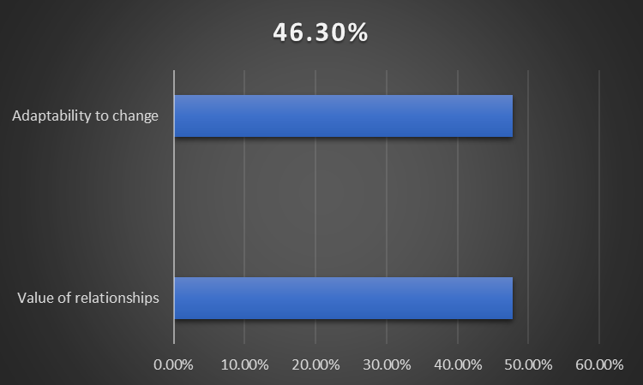

The statistics show the pandemic had a massive influence on the motivation of the students. Almost half of them (49.3%) indicated that they experienced a drop in motivation, indicating that issues like distance learning, isolation, and high levels of stress contributed. Around 29.9% had no change, which means that their study habits were unaffected by the situation. Just 20.9% noticed an improvement in motivation, perhaps because they had extra time for academic concentration. In general, the pandemic resulted in a significantly negative effect on students' motivation to do work.

2) What challenges did you face during online learning compared to in-person classes? (Select all that apply)

|  |  |  |
| --- | --- | --- |
| **OPTION** | **RESPONSES** | **PERCENTAGE** |
| Technical issues | 26 | 38.8% |
| Lack of motivation | 23 | 34.3% |
| Difficulty understanding material | 26 | 38.8% |
| Distractions at home | 32 | 47.8% |
| None of the above | 3 | 4.5% |

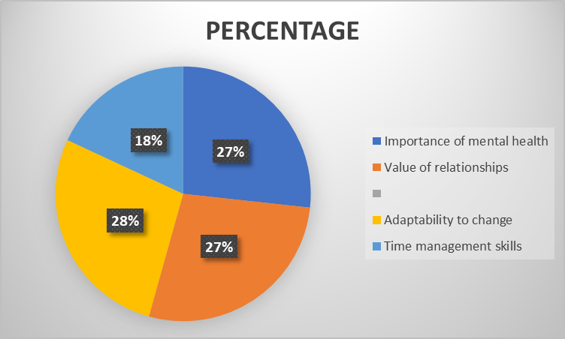

The statistics indicate that the greatest challenge for online learning was being distracted at home (47.8%), which made it more difficult for students to concentrate. Difficulty with technology and not understanding the material were also common challenges, each encountered by 38.8%. Lack of motivation was also prevalent, reported by 34.3%. Few students (4.5%) reported no challenges. This implies that online learning presented several challenges, with distractions and technological problems as the most pervasive.

**HYPOTHESIS**

To analyse the long-term educational impact of COVID-19 on students, including learning loss and academic disparities.

* **Null Hypothesis (H₀):** The proportion of students who experienced decreased motivation is **less than or equal to 50%**.
* **Alternative Hypothesis (H₁):** The proportion of students who experienced decreased motivation is **greater than 50%**.

This is a **one-tailed proportion test**.

From the data:

* Total number of responses = 14 + 20 + 33 = **67**
* Number of students with decreased motivation = **33**

So, sample proportion p^=33/67≈0.4925

significance level (commonly used is **α = 0.05**).

**Z-test for proportion=** **−0.123**

For a **one-tailed test** at α = 0.05, the **critical z-value** is **-1.645** (since we are testing if it's significantly *greater*, but we got a *negative* z).

Because **z = -0.123 > -1.645**, and also the **p-value is much greater than 0.05**, we **fail to reject the null hypothesis**.

There is not enough statistical evidence to conclude that a majority of students experienced decreased motivation due to the pandemic.

**FINDINGS AND RECOMMENDATIONS**

**FINDINGS**

1. **Impact on Motivation and Academic Performance**

* Almost half (49.3%) of the students reported reduced motivation to study and finish assignments.
* 29.9% reported no impact, and just 20.9% reported increased motivation.
* Many students could have found it difficult to keep up with academic performance, with many likely experiencing a drop.

1. **Challenges of Online Learning**

* The most prevalent challenges were distractions at home (47.8%), technical problems (38.8%), and trouble understanding material (38.8%).
* Lack of motivation was the biggest obstacle (34.3%), indicating that students found it difficult to remain motivated.
* 4.5% said they had no issues, which means the majority of students had problems adjusting to online learning.

1. **Mental Health Impact**

* The pandemic consolidated relationships for some but tested them for others, indicating mixed impacts on social relationships.
* Most students indicated reduced social interactions with fellow students.
* Mental health was impacted, with a significant percentage experiencing negative changes.

1. **Lessons Learned**

* Most students acknowledged the significance of mental health (46.3%), the value of relationships (47.8%), and the ability to adapt to change (47.8%) as the major takeaways.
* Time management was enhanced by 31.3%, but still, a large majority might need assistance in the above sea.

**RECOMMENDATIONS**

1. **Motivation and Academic Support**

Adopt academic mentorship schemes to deliver customized guidance and support. Provide interactive study techniques (group discussion, gamified studies) to engage students better. Offer time management workshops to assist students with effective study practices.

1. **Enhancing Online Learning Experiences**

Provide enhanced technical support to students who have connectivity and hardware issues. Established organized learning timelines to minimize distraction and keep students on track. Promote study groups among peers to enhance knowledge of subject matter and motivation.

1. **Mental Health and Well-being**

Increase mental health resources such as counselling sessions, stress management workshops, and mindfulness initiatives. Normalize conversations regarding mental health awareness in order to install students to approach help-seeking when necessary. Encourage physical exercise as stress relief.

1. **Social and emotional Support**

Plan social activities (in-person and online) to aid students in reconnecting and re- cultivating relations. Create an empathetic school/university setting in which students are at ease talking about their problems.

1. **Offering Required Recovery Support**

Institutions and schools should provide funding support to those students facing financial hardship due to the pandemic. Establish academically designed catch-up opportunities for students who lost ground throughout remote learning. Promote community involvement opportunities whereby students get to assist others in peer mentorship and community volunteering.

**CONCLUSION**

The COVID-19 pandemic has had a lasting effect on students, influencing their motivation, academic performance, mental health, and social interactions. Responses to the survey reveal that many students reported a drop in motivation and academic performance, with most of them finding it difficult to adjust to remote learning because of technical problems, distractions, and challenges in comprehending material. Mental health issues were the most significant issue, with many students reporting greater stress and anxiety, both during remote learning and when they returned to in-person classes. Although some received professional or informal help, others did not use resources available to them even though they knew they needed assistance. Exercise, mindfulness, and social connections were the main coping strategies that helped them manage stress. Mitigating the long-term impact of COVID-19 for students must be a multi-pronged response that prioritizes academic assistance, mental health services, and social reintegration initiatives.

**REFERENCES**

1) COVID-19 and its impact on education, social life and mental health of students: A survey. *Children and youth services review*, *121*, 105866.

2)Psychological effects of COVID-19 pandemic on society and its reflections on education. *Electronic Turkish Studies*, *15*(4).

3) Effects of COVID-19 on college students’ mental health in the United States: Interview survey study. *Journal of medical internet research*, *22*(9), e21279.

4)Predictors of academic performance during the covid-19 outbreak: impact of distance education on mental health, social cognition and memory abilities in an Italian university student sample. *BMC psychology*, *9*, 1-17.

5) Mental health effects of school closures during COVID-19. *The lancet child & adolescent health*, *4*(6), 421.

6) COVID 19 and its mental health consequences. *Journal of Mental Health*, *30*(1), 1-2

7)Impact of COVID-19 on the mental health of children and adolescents. *Cureus*, *12*(8).

8) Impacts of the Covid‐19 pandemic on the health of university students. *The International Journal of Health Planning and Management*, *36*(3), 618-627.

9)COVID-19 pandemic impact on children and adolescents' mental health: Biological, environmental, and social factors. *Progress in Neuro-Psychopharmacology and Biological Psychiatry*, *106*, 110171.

10)The mental health of school students and the COVID-19 pandemic. *Aquademia*, *4*(2), ep20020.

11)Psychological impact of the COVID-19 outbreak on mental health outcomes among youth: A rapid narrative review. *International Journal of Environmental Research and Public Health*, *18*(11), 6067.

12)Academic experiences, physical and mental health impact of COVID-19 pandemic on students and lecturers in health care education. *BMC medical education*, *21*, 1-13.

13) Student mental health in the midst of the COVID-19 pandemic: A call for further research and immediate solutions. *International Journal of Social Psychiatry*, *66*(5), 517-518

14)Mental health in high school students at the time of COVID-19: A student’s perspective. *Journal of the American Academy of Child and Adolescent Psychiatry*, *59*(12), 1309.

15) Mental health of children and adolescents amidst COVID-19 and past pandemics: a rapid systematic review. *International journal of environmental research and public health*, *18*(7), 3432.