**Scalable Data Processing for Social Media Analysis with Sentiment Analysis**

**Deepakragavan J1, Guruprasath V2, Manuneethi S3, Bhuvanadurai M4, Dr.R. Arunkumar5**

1,2,3,4Final Year B.E. C.S.E.(DS)Students, 5Associate Professor

Department of Computer Science and Engineering, Annamalai University, Chidambaram

[cf012deepakragavan@gmail.com](mailto:cf012deepakragavan@gmail.com), [guruvk1187@gmail.com](mailto:guruvk1187@gmail.com), [manuneethi07@gmail.com](mailto:manuneethi07@gmail.com), [bhuvanaduraim2023@gmail.com](mailto:bhuvanaduraim2023@gmail.com), [arunkumar_an@yahoo.com](mailto:arunkumar_an@yahoo.com)

**ABSTRACT**

This project, “Scalable Data Processing for Social Media Analysis with sentiment analysis,” focuses on building an efficient framework to handle and analyze vast amounts of social media data for sentiment insights. The pipeline begins with data collection via APIs (e.g., Twitter, Reddit). The data is stored in scalable systems such as MongoDB, DynamoDB, or cloud storage solutions like Amazon S3 and HDFS. Preprocessing tasks like text cleaning, tokenization, and normalization are performed using Python libraries such as NLTK and SpaCy. Sentiment analysis is implemented through rule-based approaches (e.g., VADER), machine learning models, or deep learning techniques using BERT. The framework supports large-scale data processing through batch and stream processing, utilizing tools like Apache Spark, Flink, and Kafka. Finally, sentiment trends and insights are visualized using Tableau, Power BI, or Python libraries like Matplotlib. This scalable approach ensures real-time sentiment analysis for diverse applications across industries.

**Keywords:** Scalable data processing, social media analysis, sentiment analysis, real-time data pipeline, Apache Kafka, Apache Spark, MongoDB, Twitter API, machine learning, natural language processing (NLP), sentiment classification, data visualization, big data analytics, and predictive analytics.

**INTRODUCTION**

In today’s digital era, social media platforms have become a significant source of Information and public sentiment, with billions of users sharing their opinions, experiences, and Emotions daily. Harnessing this wealth of data offers valuable insights into societal trends, Consumer preferences, and emerging topics. However, analyzing such massive and continuously Growing data in real-time poses substantial challenges due to its scale, diversity, and velocity.

This Project, titled “Scalable Data Processing for Social Media Analysis,” aims to address these Challenges by developing an efficient and robust framework capable of processing and analyzing Vast amounts of social media data for sentiment insights.

The proposed framework encompasses several key components designed to handle the endto-end process of social media analysis. Data collection is the initial step, performed using APIs Provided by platforms such as Twitter and Reddit or web scraping tools like BeautifulSoup for Extracting data from diverse sources. To accommodate the sheer volume of data, scalable storage Solutions such as MongoDB, DynamoDB, Amazon S3, or Hadoop Distributed File System (HDFS) are employed, ensuring efficient and reliable data management.

Preprocessing is a crucial stage that involves preparing raw data for analysis. This includes Tasks like text cleaning, tokenization, and normalization, which are carried out using advanced Python libraries such as Natural Language Toolkit (NLTK) and SpaCy.

Once the data is Preprocessed, sentiment analysis is implemented using a combination of rule-based approaches, Like more advanced machine Learning including(Logistic Regression, Naiye bayes, Random Forest)

Support large-scale data analysis, the framework integrates batch and stream processing Techniques using industry-standard tools like Apache Spark, Apache Flink, and Apache Kafka.

This ensures the ability to handle both historical and real-time data efficiently. Finally, the insights Derived from the sentiment analysis are visualized through interactive and intuitive dashboards Created with tools like Tableau, Power BI, or Python libraries such as Matplotlib and Seaborn, Providing actionable insights for diverse applications across industries.

This project’s scalable and flexible design ensures it is well-suited to various use cases, Including market research, brand monitoring, crisis management, and public opinion tracking. By Combining advanced data processing techniques with state-of-the-art sentiment analysis methods, This framework bridges the gap between raw social media data and meaningful, actionable insights, Making it a valuable tool in today’s data-driven decision-making landscape.

**METHODOLOGY**

The methodology for sentiment analysis begins with collecting Twitter data to gather historical datasets for analysis. Social media platforms, particularly Twitter, provide a rich source of user-generated content, which is crucial for understanding public sentiment. By extracting and storing a large volume of tweets, the system ensures that a diverse set of opinions is available for analysis, allowing for more accurate sentiment classification.

Once the data is collected, it undergoes data preprocessing to improve its quality and remove any unnecessary elements. This involves cleaning and normalizing the text by eliminating stopwords, punctuation, special characters, and noise. Techniques such as tokenization, lemmatization, and stemming are applied using Natural Language Processing (NLP) tools like NLTK and SpaCy. These preprocessing steps enhance the structure of the text data, ensuring that only relevant and meaningful information is used for further analysis.

Efficiently handle large-scale or real-time data, scalable data processing methods are implemented. Batch processing frameworks such as Apache Spark are employed to process massive datasets efficiently. These frameworks help in distributing computational workloads, making it possible to analyze sentiment trends over time. Real-time processing capabilities also allow the system to capture and respond to live sentiment shifts, making the analysis more dynamic and insightful.

For structured data management, scalable storage solutions are used. NoSQL databases like MongoDB provide flexibility in storing semi-structured and unstructured textual data, making them ideal for handling social media content. These databases allow for fast retrieval and efficient querying, supporting the real-time nature of sentiment analysis.

The core of the sentiment analysis process involves applying machine learning models to classify textual data into different sentiment categories. Various supervised learning algorithms such as logistic regression, Naïve Bayes, and random forest tree are used to enhance classification accuracy. These models learn from labeled datasets and improve over time, ensuring better prediction performance in identifying positive, negative, or neutral sentiments.

Finally, the analyzed data is presented in a visual format to provide meaningful insights. Python visualization libraries such as Matplotlib and Seaborn are used to generate sentiment trend reports, interactive graphs, and word clouds. These visualizations help in identifying patterns, sentiment shifts, and public opinions over time, making the findings more accessible and actionable for businesses, policymakers, and researchers.

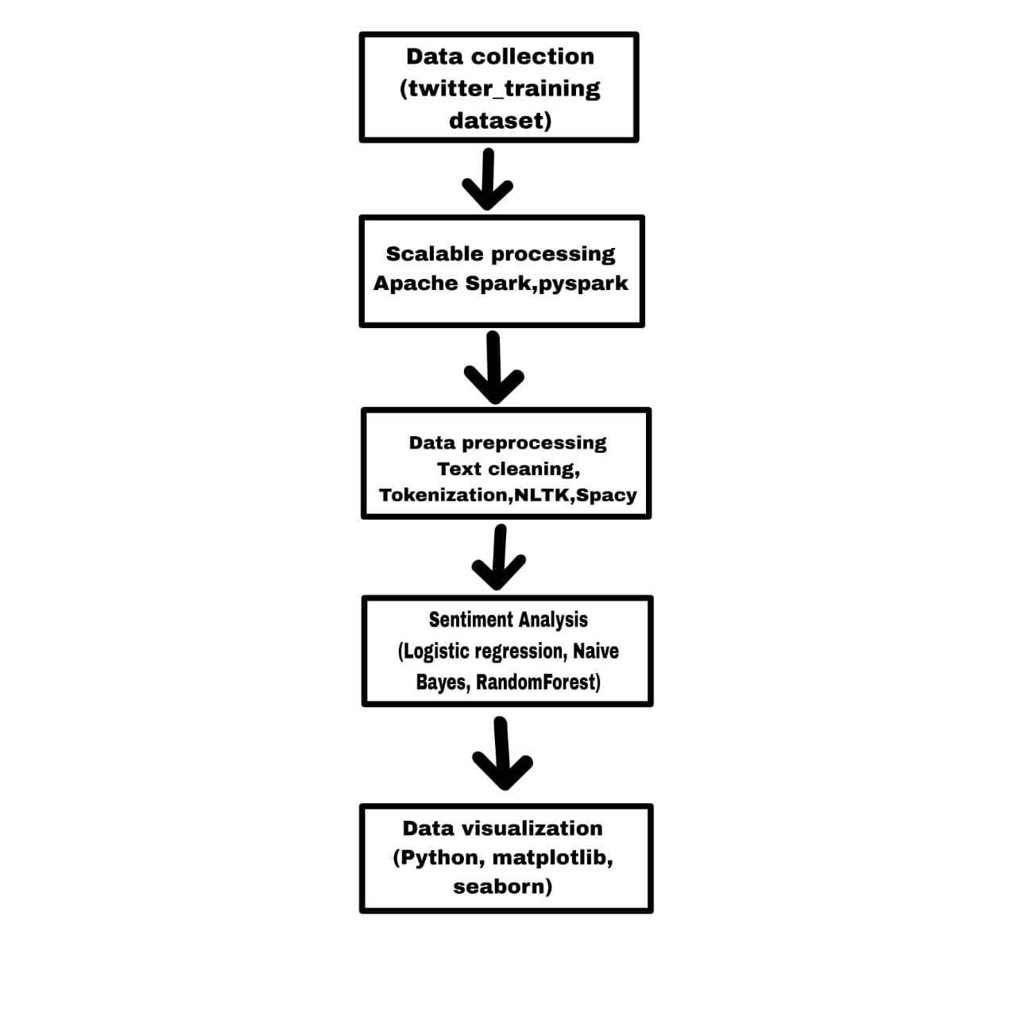**Figure 1:** BLOCK DIAGRAM OF PROPOSED **METHODOLOGY**

**Modules Description**

The Module Description of this sentiment analysis project is structured into six key components, each playing a crucial role in ensuring the accuracy and efficiency of sentiment classification.

The first module, Data Collection, involves retrieving historical data from Twitter to build a comprehensive dataset for sentiment analysis. HTTP requests and JSON parsing techniques are employed to extract structured data from Twitter, ensuring that relevant textual content is gathered in an organized format. These techniques enable seamless data retrieval, allowing efficient access to social media discussions for further analysis.

The Scalable Data Processing module, the system processes large volumes of data efficiently using batch processing techniques. Apache Spark, a distributed computing framework, is utilized to handle massive datasets in parallel, optimizing performance and minimizing computational delays. The batch processing approach ensures that historical data is processed effectively before being passed to later stages of the analysis.

The Data Preprocessing module focuses on refining the collected textual data before analysis. Several preprocessing techniques are applied, including text cleaning, tokenization, stemming, and lemmatization. Stopwords, punctuation, and special characters are removed to eliminate noise from the dataset. Tokenization is then performed to break sentences into individual words, followed by stemming and lemmatization, which reduce words to their root forms. These processes are executed using NLP tools like SpaCy and NLTK. To further enhance text normalization, Porter Stemmer and WordNet Lemmatizer algorithms are applied. Additionally, Regular Expressions (RegEx) help clean the dataset by removing unwanted symbols and patterns.

The Sentiment Analysis module, machine learning-based classification techniques are implemented. Feature extraction methods like TF-IDF (Term Frequency-Inverse Document Frequency) and Word2Vec are used to transform textual data into numerical representations suitable for model training.

Various machine learning models:

Logistic Regression:

**1. Sigmoid Function (Logistic Function)**

This maps predictions to probabilities:

​

* predicted probability (between 0 and 1)
* parameter vector (weights)
* input feature vector

Logistic regression is used for **binary classification**. It outputs a **probability score** between 0 and 1. It's widely used in **sentiment analysis**, **spam detection**, **medical diagnosis**, etc.

Naïve Bayes:

**Bayes Theorem**

Naive Bayes is based on Bayes’ Theorem with a strong (naive) assumption that features are independent**.**



* P(y∣X): Posterior probability of class “y” given data “X”
* P(X∣y): Likelihood of data “X” given class “y”
* P(y): Prior probability of class “y”
* P(X): Evidence (probability of data)

Classifies text as **positive**, **negative**, or **neutral**. Works well with **bag-of-words** models and **TF-IDF** features. Efficient for large datasets.

Random Forest:

Random Forest is an ensemble learning method that combines multiple decision trees to improve classification or regression accuracy.

Prediction Formula:

* h1(x),h2(x),….hn(x) be predictions from K decisions trees.
* Each hk(x) outputs a class label

mode: the class that appears most frequently among all tree predictions.  
Handles high-dimensional text data well. Reduces overfitting compared to individual decision trees. Provides feature importance scores (which words/phrases matter most).

The final module, Data Visualization, ensures that sentiment trends are effectively represented in an interpretable format. Static visualization techniques using Matplotlib and Seaborn allow for the graphical representation of sentiment distributions and patterns. Additionally, time-series analysis algorithms are used to track sentiment fluctuations over time, providing valuable insights into how public opinions evolve. These visualizations help businesses and researchers make data-driven decisions by identifying key sentiment trends from social media discussions.

The **dataset** used in this project focuses on sentiment analysis of tweets, classifying them into different sentiment categories. It plays a crucial role in training machine learning models to predict sentiments accurately. The dataset consists of various attributes, including tweet ID, tweet content, category information, and sentiment status. It is primarily structured in a tabular format, allowing for easy processing and analysis. The dataset is sourced from Kaggle and contains 74,681 tweets, which are distributed across different sentiment classes, enabling comprehensive training and validation of models.

Each entry in the dataset represents a tweet, where columns provide information about the topic, sentiment label, and textual content. The key attributes include an ID that uniquely identifies each tweet, an information category that categorizes the tweet (such as politics, entertainment, sports, or health), a status column that contains the sentiment label (such as positive, negative, or neutral), and a comment section that holds the actual tweet text. These structured fields help in efficiently organizing and analyzing the data for sentiment classification.

Before training a machine learning model, the dataset undergoes preprocessing to enhance its quality and effectiveness. Preprocessing steps include converting text to lowercase for uniformity, removing special characters, links, and unnecessary symbols, eliminating stopwords to focus on meaningful words, and applying tokenization to break sentences into individual words. Additionally, techniques such as stemming and lemmatization are used to reduce words to their base forms, improving the accuracy of sentiment classification.

The dataset distribution plays a critical role in ensuring balanced sentiment representation. The tweets are categorized into positive, negative, and neutral sentiments, and an analysis of their distribution helps in understanding any imbalances in the data. Visualization techniques such as bar charts and word clouds can be applied to explore common words in different sentiment categories. These visual insights assist in refining data handling strategies and model training approaches.

Handling challenges within the dataset is crucial for achieving high sentiment classification accuracy. Issues such as imbalanced data, noisy text, and short tweet lengths are addressed using advanced techniques like Synthetic Minority Oversampling Technique (SMOTE), pretrained embeddings (such as Word2Vec and BERT), and noise filtering methods. By effectively managing these challenges, the dataset becomes more reliable for real-world sentiment analysis applications.

This dataset is highly valuable for a wide range of applications, including social media monitoring, brand sentiment analysis, and political opinion mining. Organizations and researchers use such datasets to track public sentiment, gain customer insights, and understand trends in user opinions. Future improvements in the dataset can include expanding the dataset size, incorporating additional sentiment categories, and leveraging context-aware deep learning models for more accurate classification. Advanced techniques such as transformer-based models and attention mechanisms can further enhance the detection of complex sentiments, including sarcasm and nuanced opinions.

**MODELING AND ANALYSIS**

**System Architecture**

The System Architecture of the sentiment analysis system is designed to handle real-time and historical data efficiently, ensuring seamless processing, storage, analysis, and visualization. It consists of six primary components, each contributing to the overall functionality of the system.

The first component, Data Collection, is responsible for retrieving real-time tweets from Twitter. Twitter data extraction enables continuous monitoring of user opinions on various topics. By leveraging streaming data retrieval, the system ensures that sentiment analysis is conducted on fresh, relevant information, making it highly responsive to changing trends.

Once the data is collected, it is processed through the Streaming Data Processing component. Apache Kafka, a distributed event-streaming platform, is used to ingest data continuously. Kafka ensures low-latency data transfer, allowing real-time sentiment analysis by buffering and transmitting high-speed tweet streams to subsequent processing units.

Handling historical data, the system incorporates Batch Processing using Apache Spark. This component processes large volumes of previously collected tweets, enabling comprehensive sentiment analysis over extended time periods. The batch processing framework ensures that the system can handle massive datasets efficiently by distributing computational tasks across multiple nodes, improving scalability and speed.

The Storage component plays a crucial role in managing structured and unstructured data. MongoDB, a NoSQL database, is chosen for its ability to store flexible, schema-less tweet data efficiently. The database supports real-time data retrieval and querying, ensuring that both recent and historical sentiment information remains easily accessible for analysis.

The core of the system is the Sentiment Analysis module, where machine learning models classify sentiments into categories such as positive, negative, and neutral. Various classification algorithms, including Naïve Bayes, Logistic Regression, and Random Forest, process the extracted features from the textual data. For enhanced accuracy, deep learning models like BERT and Hugging Face Transformers are employed, capturing contextual and linguistic nuances within tweets.

Finally, the Visualization component provides meaningful insights through interactive dashboards and graphical representations. Real-time sentiment dashboards are generated using Matplotlib, Seaborn, and other visualization libraries, allowing users to track sentiment trends over time. The system also integrates time-series analysis techniques to monitor fluctuations in public opinion dynamically.

This system architecture ensures an efficient and scalable pipeline for sentiment analysis, enabling real-time monitoring, historical data processing, and comprehensive sentiment classification, ultimately providing valuable insights for businesses, policymakers, and researchers.

**Figure 2: flow chart**

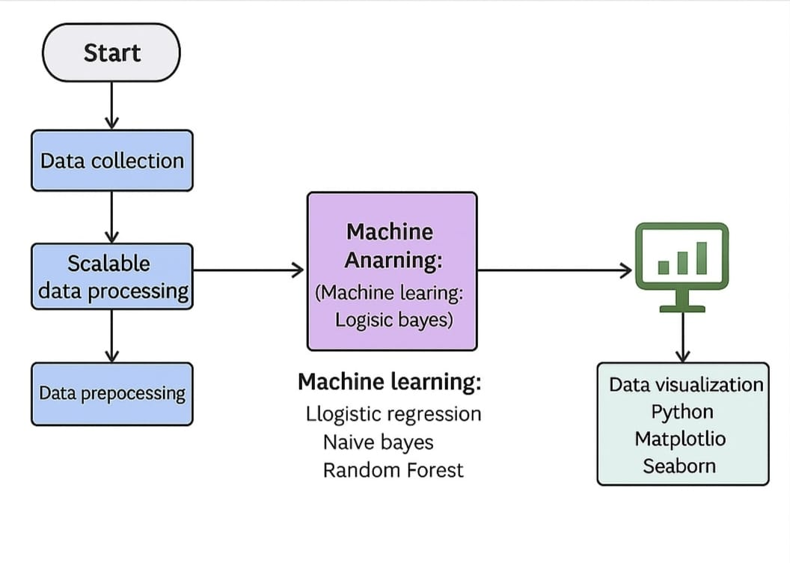

The Modeling and Analysis phase plays a crucial role in transforming raw text data into meaningful insights through various feature extraction techniques, machine learning models, and deep learning approaches. This project utilizes a Kaggle dataset, which consists of key attributes, including an ID, representing a unique identifier for each tweet, the country, specifying the geographic location of the tweet, the label, indicating the sentiment category (Positive, Negative, or Neutral), and the text, containing the actual tweet message. The dataset includes multiple sentiment expressions from users discussing various topics, making it an ideal source for sentiment classification tasks.

Extract relevant information from textual data, feature extraction techniques such as TF-IDF (Term Frequency-Inverse Document Frequency) and Word2Vec embeddings are employed. TF-IDF helps assign importance scores to words based on their occurrence in individual tweets relative to the entire dataset, ensuring that common words do not dominate the sentiment classification. Word2Vec, on the other hand, captures semantic relationships between words, allowing the system to understand contextual meanings and associations within text data.

Sentiment classification, multiple machine learning models are implemented to improve prediction accuracy. Naïve Bayes Classifier, a probability-based model, is widely used for text classification tasks due to its efficiency and ability to handle high-dimensional data. Logistic Regression is applied for binary classification tasks, distinguishing between positive and negative sentiments, while Random Forest, an ensemble learning technique, aggregates multiple decision trees to enhance classification performance and reduce overfitting.

Further enhance accuracy, deep learning techniques such as BERT (Bidirectional Encoder Representations from Transformers) are incorporated into the model. Unlike traditional machine learning approaches, BERT processes text bidirectionally, enabling it to capture deeper linguistic and contextual nuances in sentiment expressions. Additionally, Hugging Face Transformers are fine-tuned using the Kaggle dataset, ensuring that sentiment analysis remains highly accurate across diverse textual inputs.

The effectiveness of the sentiment classification models is assessed using performance evaluation metrics, including accuracy, precision, recall, and F1-score. Cross-validation techniques are applied to ensure that the models generalize well across different subsets of data. Furthermore, hyperparameter tuning is conducted using Grid Search and Random Search, optimizing parameters such as learning rates, batch sizes, and regularization factors to improve model efficiency.

After model implementation, error analysis is performed to identify misclassified tweets and refine the sentiment detection process. Confusion matrices and classification reports provide valuable insights into model behavior, highlighting common misclassification patterns and allowing further fine-tuning of decision boundaries.

By leveraging a structured modeling and analysis framework, this project successfully processes and classifies sentiment data from the Kaggle dataset, ensuring accurate sentiment prediction and real-time trend identification across various social media discussions.

**RESULTS AND DISCUSSION**

**Comparison result:**

|  |  |  |  |  |
| --- | --- | --- | --- | --- |
| **Algorithm** | **Accuracy** | **Precision** | **Recall** | **F1-Score** |
| **Logistic Regression** | **0.67** | **0.67** | **0.68** | **0.67** |
| **Naïve Bayes** | **0.71** | **0.71** | **0.81** | **0.76** |
| **Random Forest** | **0.91** | **0.90** | **0.91** | **0.91** |

|  |  |  |  |  |
| --- | --- | --- | --- | --- |
|  |  |  |  |  |
|  |  |  |  |  |
|  |  |  |  |  |

Logistic Regression achieved moderate performance with balanced precision and recall, suitable for baseline sentiment classification. Naïve Bayes performed well with higher recall, effectively capturing more positive/negative sentiments.Random Forest delivered the highest accuracy and overall metrics, making it the most effective model for sentiment analysis in this task.

**Figure 3: Run spark container & describe dataset**

|  |
| --- |
|  |
|  |
|  |

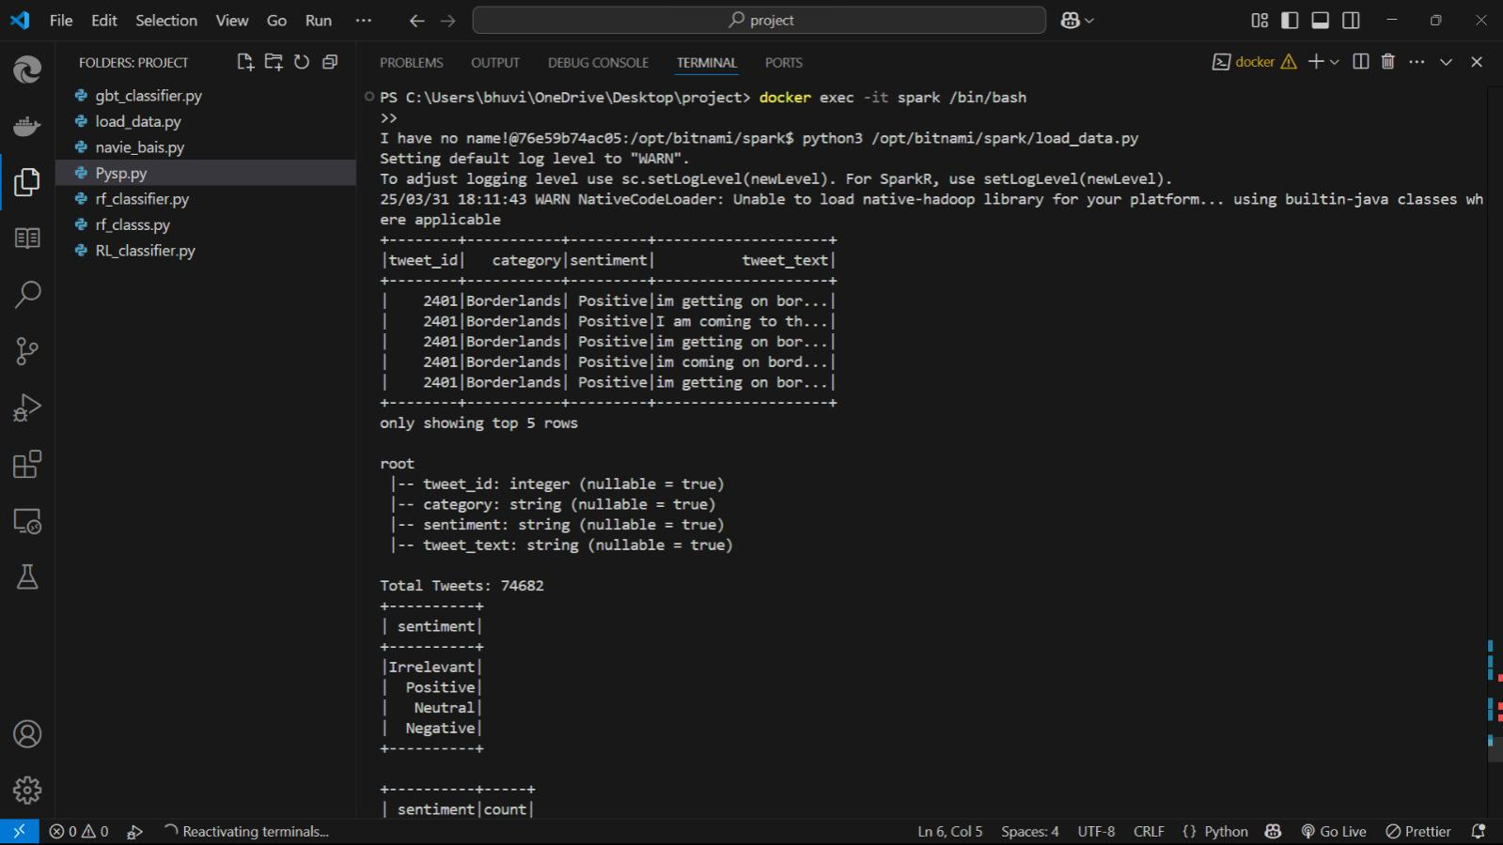

I used PySpark inside a Docker container to load and describe the Twitter sentiment dataset, showcasing sample rows, schema structure, and sentiment distribution.

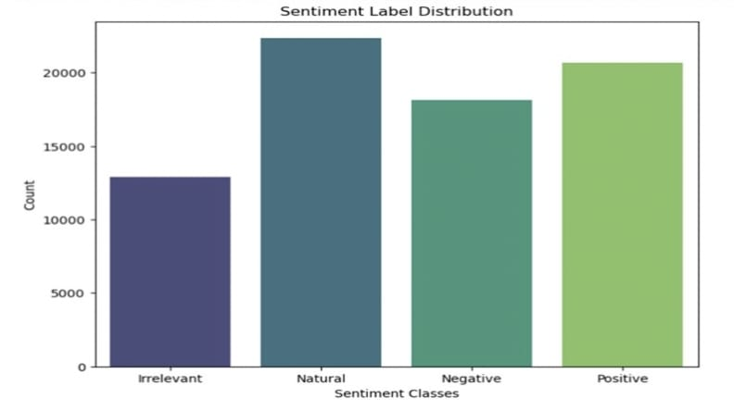**Figure 4: Results and analysis-1**

The bar chart visualizes the distribution of sentiment classes, showing that 'Neutral' tweets are the most frequent, followed by 'Positive', 'Negative', and 'Irrelevant'.

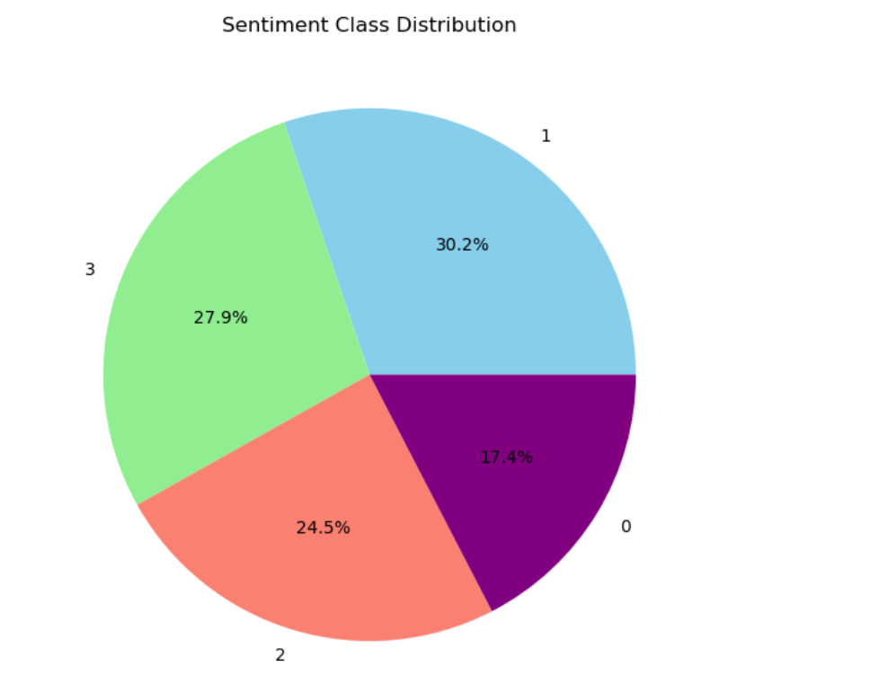**Figure 5 : Result and analysis-2**

The pie chart illustrates sentiment class distribution, showing that class 1 (likely Neutral) is the most common at 30.2%, followed by class 3, class 2, and class 0.

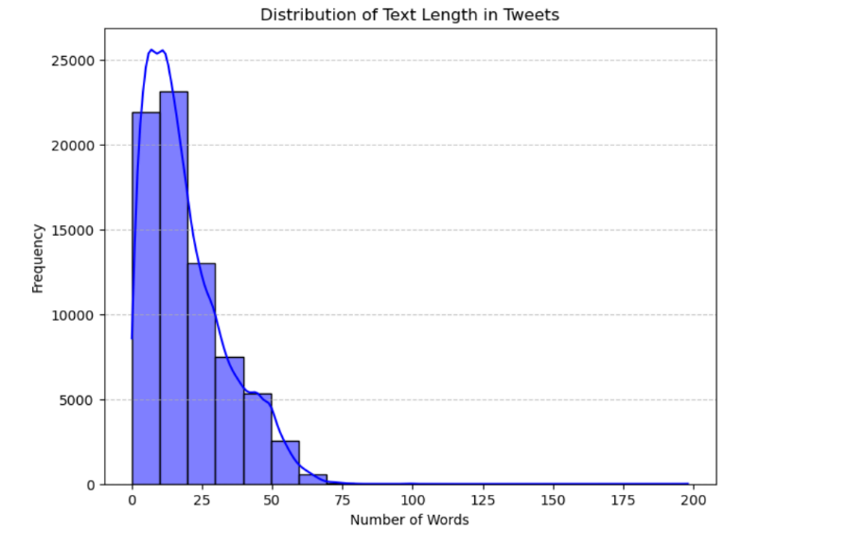**Figure 6: Result and analysis-3**

The histogram shows that most tweets contain between 5 and 25 words, with tweet lengths following a right-skewed distribution.

**CONCLUSION**

The sentiment analysis results provide valuable insights into how different brands are perceived on social media platforms. The distribution of tweets across sentiment categories—**Positive, Negative, Neutral, and Irrelevant**—highlights key trends in **customer engagement**, **public opinion**, and **brand reputation management**. The presence of a high proportion of positive sentiments indicates strong brand loyalty, while negative sentiments point to areas needing improvement.

Through exploratory data analysis (EDA), we observed that most tweets are **short and concise**, making them ideal for fast processing using **distributed frameworks like PySpark**. Visualization of sentiment labels and text lengths helped confirm the dataset’s balance and relevance for training machine learning models.

Furthermore, applying classification algorithms like **Logistic Regression**, **Naïve Bayes**, and **Random Forest** enabled us to compare model performance and select the most effective approach for sentiment classification—**Random Forest achieving the highest accuracy and F1-score**.

This sentiment analysis pipeline provides a solid foundation for **real-time monitoring**, **trend detection**, and **strategic brand decision-making** in a data-driven marketing environment.

**REFERENCES**

[1]: Damian Konrad Kowalczyk & Jan Larsen. “Scalable Privacy-Compliant Virality Prediction on Twitter ” Journal Name: arXiv.org, <http://arxiv.org/abs/1812.06034v2>

[2]: Dunka, VinayKumar. “Data Engineering for Scalable Big Data Processing: Techniques for Data Ingestion, Transformation, and Real-Time Analytics.” Journal of Artificial Intelligence Research and Applications, vol. 3, no. 2, Scientific Research Center, London, Jul-Dec 2023.

[3]: Mitta, Nischay Reddy. “Data Engineering in Cloud Environments: Techniques for Scalable Data Integration, Management, and Security.” Journal of Artificial Intelligence Research and Applications, Vol. 3, no. 2, 2023, pp. 939–972. Scientific Research Center, London.

[4]: Allayla, Mohamed A., et al. “A Big Data Analytics System for Predicting Suicidal Ideation in Real-Time Based on Social Media Streaming Data.” 2024, University of Mosul, Iraq; Yildiz Technical University, Turkey; University of Southern Denmark, Denmark.

[5]: Yadav, Harsh. “Scalable ETL Pipelines for Aggregating and Manipulating IoT Data for Customer Analytics and Machine Learning.” Peer Reviewed Journal, vol. 6, no. 6, 2024, pp. 1-30.

[6]: Mendhe, Chetan Harichandra, et al. “A Scalable Platform to Collect, Store, Visualize, and Analyze Big Data in Real Time.” IEEE Transactions on Computational Social Systems, June 2020, Doi:10.1109/TCSS.2020.2995497.

[7]: Sebei, Hiba, Mohamed Ali Hadj Taieb, and Mohamed Ben Aouicha. “Review of Social Media Analytics Process and Big Data Pipeline.” Social Network Analysis and Mining, vol. 8, no. 30, 2018, Springer, <https://doi.org/10.1007/s13278-018-0507-0>.

[8]: Bohlouli, Mahdi, et al. Knowledge Discovery from Social Media Using Big Data Provided Sentiment Analysis (SoMABiT). Institute of Knowledge Based Systems, Department of Electrical Engineering and Computer Science, University of Siegen, 2020.

[9]: Dasgupta, Subhasis, et al. “Ingesting High-Velocity Streaming Graphs from Social Media Sources.” arXiv preprint arXiv:1905.08337, 20 May 2019,

[10]: Ballal, Sunita Rajesh, and Paresh Jain. “An Advanced Framework for Collecting and Preprocessing Social Media Data to Enhance Business Decision-Making.” African Journal of Biological Sciences, vol. 6, no. 10, 2024, pp. 5134–5143

[11]: Martínez-Castaño, R., Pichel, J. C., & Losada, D. E. (2020). A big data platform for real-time analysis of Signs of depression in social media. International Journal of Environmental Research and Public Health, 17(13), 4752. <https://doi.org/10.3390/ijerph17134752>

[12]: More, J., & Lingam, C. (2016). A Scalable Data Mining Model for Social Media Influencer Identification. Communications in Computer and Information Science. DOI: 10.1007/978-981-10-3433-6_75.

[13]: Zheng, X., Dasgupta, S., Kumar, A., & Gupta, A. (2022). AWESOME: Empowering Scalable Data Science on Social Media Data with an Optimized Tri-Store Data System. University of California, San Diego.

[14]: Patel, J. (2019). An Effective and Scalable Data Modeling for Enterprise Big Data Platform. IEEE International Conference on Big Data (Big Data), 2691-2697.

[15]: Zhang, Pengcheng, Fang Xiong, Jerry Gao, and Jimin Wang. “Data Quality in Big Data Processing: Issues, Solutions and Open Problems.” IEEE, 2017.