PLASTIC CYCLE PASSENGERS FOOT PATH

Prof. Jagtap Pradnya N*1, Thakare Aniket S*2, Nagare Kalpesh P*3, Shaikh Asif D*4, Pagar Om N*5

1, Lecturer, Department of Civil Engineering, Santosh N Darade Polytechnic, Babhulgaon, Yeola, Maharashtra,

India.

2,3,4,5,Students, Department of Civil Engineering, Santosh N Darade Polytechnic, Babhulgaon, Yeola, Maharashtra,

India.

# ABSTRACT

The plastic wastes could be used in road construction and the field tests withstood the stress and proved that plastic wastes used after proper processing as an additive would enhance the life of the roads and also solve environmental problems. Plastic use in road construction is not new. It is already in use as PVC or HDPE pipe mat crossings built by cabling together PVC (polyvinyl chloride) or HDPE (high-density poly-ethylene) pipes to form plastic mats. Waste plastic is ground and made into powder; 3 to 4 % plastic is mixed with the bitumen. The durability of the roads laid out with shredded plastic waste is much more compared with roads with asphalt with the ordinary mix. The use of the innovative technology not only strengthened the road construction but also increased the road life as well as will help to improve the environment and also creating a source of income.

***Keywords: -*** plastic wastes, PVC pipe, HDPE pipe, plastic waste.

# INTRODUCTION

With increasing urbanization and vehicular movement, efficient traffic management and security enforcement have The Plastic Footpath concepts consist of a prefabricated, modular and hollow road structure based on (recycled) plastics. The prefabricated production the light weight and the modular design of the plastic Road make construction and maintenance faster, simpler and more efficient compared to traditional road structures. Imagine that constructing a road would take days instead of months. That road would last three times as long. That maintenance and traffic disruptions are things of the past. And that cable and piping problems are solved overnight.

The plastic wastes could be used in road construction and the field tests withstood the stress and proved that plastic wastes used after proper processing as an additive would enhance the life of the roads and also solve environmental problems. Plastic use in road construction is not new. It is already in use as PVC or HDPE pipe mat crossings built by cabling together PVC (polyvinyl chloride) or HDPE (high-density poly-ethylene) pipes to form plastic mats. Waste plastic is ground and made into powder; 3 to 4 % plastic is mixed with the bitumen. The durability of the roads laid out with shredded plastic waste is much more compared with roads with asphalt with the ordinary mix. The use of the innovative technology not only strengthened the road construction but also increased the road life as well as will help to improve the environment and also creating a source of income.

1. **OBJECTIVIES**

Road is the primary need for a nation development. It’s just using the waste plastic in the road so that you can’t disposed it anywhere else. The main objective of road made of plastic waste is to reduce the plastic from environment and enhance the communication in rural or urban areas.

1. To emphasize the reduce use of plastic and the beneficial management of plastic waste.
2. Efficient transformation of plastic into energy and fuel.
3. Making our environment an eco-friendly zone.
4. Modify the design of recycling machines
5. **LITURATURE SURVEY**

As new innovations go Plastic Footpath actually has numerous advantages when compared to conventional roads, both in terms of construction and maintenance. The idea for the concept was conceived by Anne Koudstaal and Simon Jorritsma of KWS Infra in the Netherlands, who claim that PlasticFoothpath which consists of 100% recycled material, is the ideal sustainable alternative to conventional road structures and opens the door for a number of new innovations such as power generation, quieter road surfaces, heated roads and modular construction.

At the moment KWS Infra are working hard on the business case for the Plastic Road and are researching the best way to produce the Plastic Road. As soon as the idea is proved to be feasible, they will arrange a pilot. The City of Rotterdam has already offered a pilot location to test the Plastic Road.

1. **RESEARCH GAP**

Despite growing global interest in sustainable infrastructure and waste recycling, the application of recycled plastic in constructing cycle passages and footpaths remains underexplored. While some pilot projects have demonstrated the potential of using plastic waste as a construction material, there is a significant lack of comprehensive research addressing the long-term performance, durability, and environmental implications of such structures. Current studies are limited in scale and often fail to evaluate the mechanical strength, weather resistance, and maintenance requirements of plastic-based footpaths under real-world conditions. Moreover, the potential leaching of microplastics and harmful additives from recycled plastic over time raises environmental and health concerns that have not been thoroughly examined. There is also a notable absence of standardized construction guidelines, material composition standards, and quality control measures, which restricts wider implementation. Furthermore, the economic and social feasibility, including public acceptance and cost-benefit analysis, is rarely addressed in existing literature. Urban planners and policymakers lack integrated strategies for incorporating plastic pathways into broader smart city or sustainable development frameworks. These gaps highlight the need for interdisciplinary and region-specific research to assess the technical viability, environmental safety, and social impact of plastic cycle passages and footpaths.

1. **METHODOLOGY AND MATRIAL USED**

* **INTRODUCTION**

The objective of the current research is to analyze practices followed by plastic recovery and recycling units in, India. Disposal of waste plastic is a major problem Plastic is everywhere in today’s lifestyle and its disposal is a great problem. It is no biodegradable and it mainly consists of low-density polyethylene. Burning of these waste plastic bags causes environmental pollution. To find its utility in bituminous mixes for road construction, Laboratory performance studies were conducted on bituminous mixes. Improvement in properties of bituminous mix .

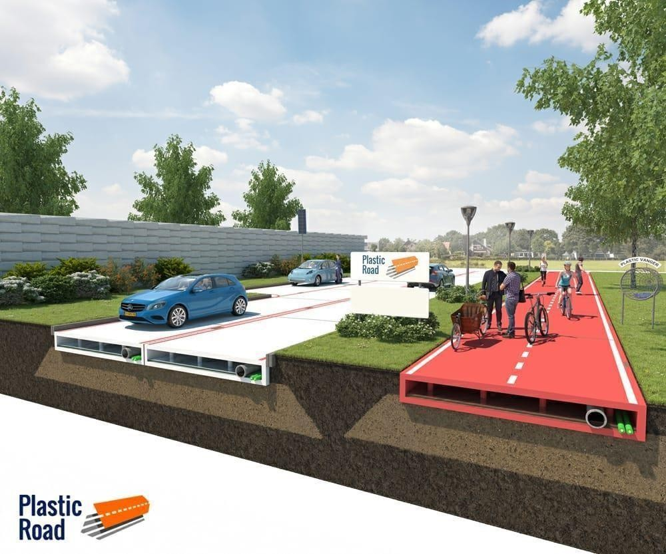

### PLASTIC INDUSTRY AND GENERATION OF PLASTIC WASTE IN INDIA

A boom in the consumption of plastic is experienced with the economic liberalization since 1991. Plastic consumption in India has more than doubled from 0.85 million tonnes during 199091 to 1.79 million tons during 1995-96. Various resins of plastic Polyethylene tetra phthalate

(PET, PETE), Density polyethylene (HDPE), Vinyl (Poly vinyl chloride or PVC), Lowdensitypolyethylene (LDPE), and Polypropylene (PP) .Accor ding to central pollution scontrol board India generate 56 lakh tonnes of plastic waste annually. As per the CPCB report in 2014-15,

51.4 million tonnes of solid waste were generated in the country, of which 91 percent was collected, and 27 per cent was treated and remaining 73 per cent disposed of at dump.

|  |  |  |  |  |  |  |
| --- | --- | --- | --- | --- | --- | --- |
| **Region** | **PVC** | **HDPE** | **LD/LLD/**  **H/M** | **PP** | **Other** | **Total** |
| **West** | **60** | **113** | **78** | **65** | **12** | **328** |
| **North** | **135** | **45** | **38** | **35** | **14** | **267** |
| **South** | **53** | **41** | **30** | **29** | **09** | **162** |
| **East** | **34** | **29** | **04** | **20** | **04** | **91** |

**Table 1: Reprocessing in Recycling Industry: Region wise and Polymer wise in kTA** Source: Nanavaty, 1997.

### PROPERTIES

1. In the proposed model by Volkerwessels, plastic roads can have hollow space built in to allow ease of wiring, connecting pipes, etc.
2. Heating and power generation can be incorporated into plastic roads. Heating can prevent roads from freezing; it can also help evaporate water from the surface.
3. Since plastics come with various chemical and physical properties, roads can be engineered to meet specific requirements (e.g. weather and wear resistance)
4. Plastic roads can be made into interlocking pieces that can be quickly assembled or disassembled. This makes on-site construction much faster and convenient.
5. **DESIGNING AND MANIFACTURING**

## Hollow design

The Plastic Road has a hollow space that can be used to (temporarily) store water, thus preventing flooding during extreme precipitation. The hollow space can also be used for the transit of cables and pipes, thus preventing excavation damages. And there are numerous other conceivable applications, including the installation of sensors or the electric charging of vehicles.

## Prefabricated and modular

The Plastic Road concept consists of a prefabricated, modular and hollow road structure based on (recycled) plastics. The prefabricated production, the light weight and the modular design of the Plastic Road make construction and maintenance.

## Sustainable

The PlasticRoad is a completely circular product that is based on recycled plastics. It has a significantly smaller carbon footprint than traditional road structures thanks to the longer lifespan and the reduction of transport movements involved in its construction.

## Collaboration

KWS, a Royal Volker Weasels company, waving and Total are working on the development of the plastic Road. Three companies, each contributing its own expertise and experience to the development of this innovative concept.

# TESTING

1. **IMPACT TESTING BY IZOD AND CHARPY TEST**

## Test the Impact Strength of Plastic with Charpy Test

**What is Charpy Impact Test?**

**Charpy Impact Tester** is a lab testing machine which is designed for the calculation of the resistance of impact to metals and plastics. The testing device works on principle working of the pendulum. The Charpy impact test can be performed with the help of high-quality of Charpy Impact Tester. The test comprises of vertical impact on the horizontally clamped sample, **Charpy test** is performed. On the other hand, when the horizontal impact is made on the vertically clamped sample, the test is known as **Izod Impact**. Both the tests can be performed easily with one testing device i.e. [**Izod/Charpy Impact Tester**](https://www.prestogroup.com/products/izod-charpy-impact-tester)but with different sample placement fixtures.

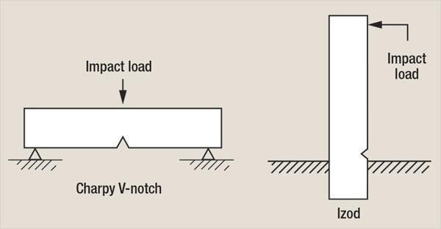

## How are Izod/Charpy Impact Testers designed?

The impact testers are designed in accordance with the international standard test method **ASTM D-256, D883; D618; D1928; D1204; D1248 & E691**. This indicates that the machine offers precise and accurate test results. The testing device is designed with high-quality and userfriendly features that help to operate the device easily. It is the best testing device which is used to evaluate the impact resistance strength of the material that is kept for testing and impacted by a specific amount of load. It is a highly precise, reliable and accurate testing machine which is used for assessment and is mandatory for polymer and plastic industries.

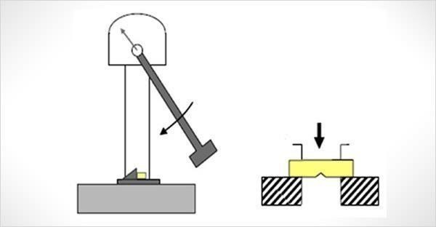

Presto assembles and supplies a wide range of [**Plastic**](https://www.prestogroup.com/categories/plastic-testing-instruments)[**testing Instruments**.](https://www.prestogroup.com/categories/plastic-testing-instruments) Out of the available range of testing machines, one of the widely used testing devices to test the impact tolerance / resistance strength of plastic is charpy impact test.

* **COST ESTIMATION**

The Cost of Waste Plastics: **Rs.7 / Kg.**

The Cost of Processing: **Rs.5 / Kg.**

The Total cost of Waste Plastics: **Rs.12 / Kg**.

* Optimum percentage of plastic in the blend as per the test results is around 8% (% Wt. of bitumen)
* Generally roads in India are constructed in basic width of 3.0 m, 3.75 m. and 4.0 m
* Consider 1 Km length road of width 3.75 m. it uses bitumen approx. **21300 Kg.** For new work and **11925 Kg**.

For Up-gradation:-

The Cost of Bitumen: **Rs.8400 / Drum (200 Kg.)** The Cost of Bitumen: **Rs.42 / Kg.**

1. Cost of New Road / Km including BBM, Carpet, and Seal Coat: Rs. 18, 95,000/-10 → Bitumen required for work (approx.): 21,300 Kg. / Km o

Cost of bitumen in new work**: Rs.8, 95,000 / Km.**

* + Waste plastic, co-processed with bitumen for PMB (8% by Wt.): **Rs.1, 704 / Kg**.
  + Cost of waste plastic used: **Rs.20, 450 / Kg.**
  + Cost of Bitumen saved (1704Kg. equivalent to plastic used): Rs.71550 oTotal savings per Km.: **Rs. 51,100** oCost of Road (Up gradation)/km including Carpet and Seal Coat**: Rs. 10, 80,000** oBitumen required for work (approx.): **11925 Kg. / KM**.
  + Cost of bitumen in repairs (Up gradation) per Km.: **Rs. 5, 01,000/-** oWaste plastic, co processed with bitumen for PMB (8% by Wt.): **954 Kg.** oCost of waste plastic used: Rs. 11450 oCost of Bitumen saved (954Kg. equivalent to plastic used): **Rs.40, 050**
  + Total savings per Km.: **Rs.28, 600** oOptimum amount of waste plastic used in dry process: 10% (by Wt. of aggregates) oThe Amount of aggregates used in road construction (1 Km length x 3.75 m width): 3750

sqm x 12.5 Kg per sqm (Avg.) = **46875 Kg.** oTherefore Amount of waste plastic used in the road (10% by Wt.): **4687.5 Kg**

1. Total Amount of waste plastic used in road construction using both the processes together (i.e. Combination of wet process & dry process):1704 + 4687.5 = **6391.5 Kg**
2. Total Cost of waste plastic used in road using mix process: **Rs.76,700**
3. Extra cost for construction of road (Cost of waste plastic used in road construction – Total savings using modified bitumen): 76,700 – 51,100 = **Rs.25, 600 / Km**

|  |  |  |
| --- | --- | --- |
| **% of plastic coating over aggregate** | **Compressive strength (MPa)** | **Bending strength (MPa)** |
| 10% | 250 | 325 |
| 20% | 270 | 335 |
| 30% | 290 | 350 |
| 40% | 320 | 390 |

According to the findings as the percentage of Plastic Coating over Aggregate increases the corresponding Compressive and Bending Strength increases.

1. **CONCLUSION**

I would like to express my sincere gratitude to all those who contributed to the successful completion of this study on *Plastic Cycle Passengers Footpath*. First and foremost, I am deeply thankful to my guide/supervisor, [Name], for their invaluable guidance, continuous support, and constructive feedback throughout the research process. I extend my appreciation to the faculty members and staff of [Department/Institution Name] for providing the necessary resources and a supportive academic environment.

I also wish to acknowledge the insights and cooperation provided by local authorities, environmental experts, and municipal engineers, whose practical knowledge greatly enriched this study. Special thanks go to my peers and friends for their encouragement and assistance during various stages of the research. Lastly, I am grateful to my family for their unwavering support and motivation, which inspired me to pursue this topic with dedication and passion.

1. **ACKNOWLEDGMENT**

This research has been made possible through the generous support and assistance of numerous individuals, and we would like to extend our heartfelt appreciation to all of them.Above all, we dedicate this achievement to God Almighty, whose wisdom, strength, serenity, and good health enabled us to successfully complete this study. We sincerely thank our families for their unwavering encouragement, which played a crucial role in the successful completion of this research. We are profoundly grateful to Snatosh N Darade polytechnic Babhulgaon (423401) , the Department of Civil Engineering, and the Head of the Department, along with the esteemed faculty members, for their continuous guidance, insightful supervision, and for equipping us with essential knowledge and resources throughout this study. Their invaluable support has been instrumental in bringing this endeavor to fruition. Our deepest gratitude extends to our mentor, Prof.Jagtap P.N, for generously sharing his expertise, wisdom, and mentorship, which greatly enriched our work. We also wish to acknowledge, along with everyone who has willingly contributed their skills and assistance towards this research. This project would not have been possible without the collective efforts and contributions of all those mentioned.

1. **REFERENCES**
   1. Netherlands Company introduces plastic roads that are more durable climate friendly than asphalt. Think progress. Retrieved 2015 - 11 – 16
   2. ["Say Hello to the Latest Technology in Civil Engineering: Plastic Road](http://www.industrytap.com/say-hello-latest-technology-civil-engineering-plasticroad/32735) [-](http://www.industrytap.com/say-hello-latest-technology-civil-engineering-plasticroad/32735) [Industry](http://www.industrytap.com/say-hello-latest-technology-civil-engineering-plasticroad/32735) [Tap".](http://www.industrytap.com/say-hello-latest-technology-civil-engineering-plasticroad/32735) Industry tap. Retrieved 2015-11-16.
   3. [EnviroNews Archives](http://isebindia.com/01_04/03-10-2.html) [-](http://isebindia.com/01_04/03-10-2.html) [Plastics Recycling and the Need for BioPolymers".](http://isebindia.com/01_04/03-10-2.html) Isebindia.com. Retrieved 2015- 10-20.
   4. ["What Happens to All That Plastic?".](http://blogs.ei.columbia.edu/2012/01/31/what-happens-to-all-that-plastic/) Retrieved 2015-11-16.
   5. [USE OF PLASTIC WASTE IN ROAD CONSTRUCTION.ppt".](https://docs.google.com/file/d/0B_NO7PnJhCFTdTB3MVMtVE9WY2s/edit?pli=1&usp=embed_facebook) Google Docs.

Retrieved 2015-10-21. These. Co. Exist. Retrieved 2015-10-21.

* 1. [A road full of bottlenecks: Dutch cycle path is made of plastic waste".](https://www.theguardian.com/environment/2018/sep/13/a-road-full-of-bottlenecks-dutch-cycle-path-is-made-of-plastic-waste) Retrieved 201809- 22*.*
  2. [VolkerWessels introduces the Plastic Road](http://en.volkerwessels.com/en/news/detail/volkerwessels-introduces-the-plasticroad) [-](http://en.volkerwessels.com/en/news/detail/volkerwessels-introduces-the-plasticroad) [VolkerWessels".](http://en.volkerwessels.com/en/news/detail/volkerwessels-introduces-the-plasticroad)
  3. ["Guidelines for the use of Plastic Waste in Rural Roads Construction".](http://pmgsy.nic.in/circulars/GPW.htm) Retrieved 201511- 16.