**Bio-Based Prints: Evaluating the Ecological and Artistic Value of Eco Printing in Modern Textiles**

S.Santhoshkumar¹ & Dr.J.Banu Priya ²

¹ PG Student, Department of Costume Design & Fashion, PSG College of Arts & science, Coimbatore, Tamil Nadu, India

² Guide and Assistant Professor, Department of Costume Design & Fashion, PSG College of Arts & science, Coimbatore, Tamil Nadu, India

E-Mail Id: santhoshsss2002@gmail.com

**ABSTEACT**

Eco printing is a sustainable method of dying textiles that produces prints on fabric using organic plant ingredients. Compared to synthetic dyes, which contribute to environmental contamination, it is a more environmentally friendly option. In order to extract plant pigments, the procedure entails laying leaves, flowers, or other botanical materials on natural fibers, bundling the fabric, and then applying heat through boiling or steaming. Alum, iron, and tannins are examples of mordants that are used to improve print quality and color fixing. Eco prints are becoming more vibrant and long-lasting thanks to recent developments in mordanting methods and the usage of bio-based substitutes. Eco printing offers a workable alternative for producing textiles in an environmentally responsible manner as the demand for sustainable fashion rises. To maximize its use in contemporary textile industries and encourage sustainable and creative fabric design, this analysis focuses on its potential, difficulties, and future research directions.

***KEYWORDS:*** *Eco printing, natural dyeing, sustainable textiles, tannins, fabric dyeing, environmental sustainability.*

**1. INTRODUCTION**

Synthetic dyes are a major source of chemical waste and water contamination, making the worldwide textile sector one of the biggest contributors to environmental degradation [1]. Researchers and designers are looking at alternative dyeing methods that have a smaller ecological impact as sustainability concerns increase. One such method is eco printing, which produces distinctive designs on fabrics using natural pigments derived from plants. Eco printing is a promising sustainable strategy because it doesn't use synthetic chemicals like traditional dyeing procedures do [2]. The concepts of eco printing, such as the choice of appropriate textiles, plant materials, and mordants, are examined in this review study. Additionally, it looks at how natural tannins and textile fibers interact chemically, emphasizing how eco printing could eventually take the place of harmful dying methods.

Additionally, the paper discusses challenges such as color variability, durability, and scalability, while presenting innovations that enhance the commercial viability of this method [3].

By reviewing current research and advancements, this paper aims to establish eco printing as a feasible solution for sustainable textile production. It also identifies future research opportunities that could improve the adoption and efficiency of this eco-friendly technique.

Eco printing is an innovative and sustainable textile design technique that utilizes natural plant materials to create unique, nature-inspired patterns on fabric. Unlike synthetic dyes, which can harm the environment and human health, eco printing offers an eco-friendly alternative that embraces the beauty of natural pigments. This project focuses on the application of eco printing in children's A-line frocks, using Madagascar Periwinkle flowers and neem leaves to achieve delicate yet vibrant designs [1].

The combination of these two plants not only enhances the visual appeal of the garments but also brings additional benefits. Madagascar Periwinkle contributes soft floral prints in gentle shades, while neem leaves provide detailed botanical imprints with natural antibacterial properties. By incorporating these elements, we create comfortable, safe, and sustainable fashion choices for children [2].

Eco printing, also known as botanical printing, involves the process of transferring natural dyes and pigments from leaves, flowers, and other plant materials onto fabric. This technique has gained popularity in sustainable fashion due to its minimal environmental impact. Traditional textile dyeing methods often involve synthetic chemicals that pollute water sources and harm ecosystems. In contrast, eco printing uses biodegradable materials and renewable resources, making it a responsible choice for the textile industry [3].

Children’s clothing, especially garments like A-line frocks, must be comfortable, breathable, and free from harmful chemicals. Eco printing not only achieves this but also introduces a unique artistic element. The natural, organic look of plant imprints adds charm to children’s clothing while maintaining the softness and safety that parents seek [4].

**2. MATERIALS AND METHODS**

**2.1 Selection of Fabric**

The base fabric used in this study was 100% organic cotton. The rationale behind choosing cotton lies in its inherent properties such as softness, comfort, and breathability, which make it ideal for children’s clothing. Moreover, cotton readily absorbs natural dyes due to its high cellulose content, allowing for better pigment binding. Organic cotton, grown without synthetic pesticides or fertilizers, reinforces the eco-friendly objective of this project. This fabric is biodegradable, hypoallergenic, and widely accessible, making it a practical choice for both small-scale artisans and commercial textile production.

**2.2 Pre-Treatment of Fabric**

Before dyeing, the fabric underwent a scouring process to remove natural oils, waxes, and surface finishes that may hinder dye absorption. Scouring was done by simmering the fabric in a 5% soda ash solution for 90 minutes, followed by multiple rinses in warm and cold water. This step ensured that the fabric was clean, opened up, and capable of absorbing plant pigments evenly. The fabric was then dried in the shade to preserve fiber integrity. The pre-treatment process significantly affects the quality of the print, influencing color uptake, clarity, and durability.

**2.3 Mordanting**

Mordanting is the process of treating fabric with metallic salts to enhance the binding of natural dyes. Two types of mordants were used in this study: alum and ferrous sulfate. Alum (potassium aluminum sulfate) was used for its ability to yield bright and clear colors, especially when working with floral materials like Madagascar periwinkle. Iron mordant, on the other hand, was used to produce deeper, muted tones and increase light and wash fastness.

The fabric was divided into two batches: one mordanted with 10% alum (w/w of fabric) and the other with 5% ferrous sulfate. Each batch was soaked for 8 hours and then dried in the shade. Proper mordanting enhances color durability and plays a crucial role in influencing the final appearance of the prints.

**2.4. Preparation of sampling Technique**

Madagascar periwinkle (Catharanthus roseus) and neem leaves (Azadirachta indica) were chosen due to their pigment-rich properties and local availability. Madagascar periwinkle flowers contain anthocyanins, which impart a pink to violet hue depending on pH and mordant. Neem leaves are rich in tannins and chlorophyll, producing earthy greens and browns.

Fresh plant materials were collected early in the morning to ensure maximum moisture content. They were cleaned thoroughly under running water to remove dirt and insects, then blotted dry. The plant materials were lightly crushed using a roller to pre-release pigments and tannins before application.

**2.5. Arrangement of Leaves and Flowers**

The pre-mordanted fabric was laid flat on a clean table. Leaves and flowers were artistically arranged in symmetrical patterns across the fabric surface. Flower placement was focused on the bodice area of the A-line frock, while neem leaves were arranged to create natural borders and backgrounds. Special attention was paid to achieving visual balance and design continuity, ensuring the finished frock would be both functional and visually appealing. After arranging the plant materials, the fabric was folded over to sandwich the botanical elements. The layered fabric was tightly rolled along its length to form a compact bundle. This bundle was then secured firmly using cotton strings, twine, or natural rubber bands. Tight binding ensured direct contact between plant material and fabric surface, which is essential for a well-defined eco-print. The bundle structure also made the fabric manageable for the tapping step.

**2.6. Tapping Method**

The tapping method was selected over the commonly used steaming technique to preserve the natural characteristics of the plant materials. This technique involves physically tapping or hammering the fabric bundle using a wooden mallet or hammer to rupture plant cells and allow pigments to transfer into the cotton fabric.

Tapping was carried out evenly across the surface to ensure consistent pigment release. Extra care was taken in areas with periwinkle flowers, as excessive tapping could result in pigment smudging. This mechanical process requires skill and patience, as it determines the clarity, placement, and natural detailing of the print. The tapping method is a low-energy, waterless alternative that aligns with sustainable textile practices.

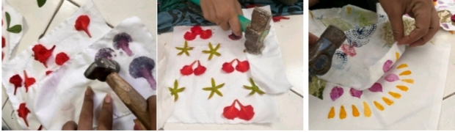

**Fig 1-TAPPING**

**2.7 Resting Period**

Following tapping, the bundles were allowed to rest for a period of 24 hours at room temperature. This resting period enables oxidation and pigment fixation. Resting was done in a cool, shaded environment to avoid premature fading or microbial growth. The controlled environment helps stabilize colors and allows the chemical interaction between mordants and pigments to complete. This step is particularly important for delicate flowers like Madagascar periwinkle, which are prone to color change post-transfer.

**2.8 Unbundling and Revealing the Prints**

After 24 hours, the bundles were gently unwrapped, and the botanical elements were removed. This stage revealed the intricate prints left behind by the flowers and leaves. Each imprint showcased unique detailing, including vein patterns of neem leaves and petal outlines of periwinkle. Some areas exhibited color variations depending on the mordant used, moisture content, and pressure applied during tapping. The uniqueness of each piece is a hallmark of the eco-printing technique, ensuring no two garments are exactly alike.

**2.9 Post-Printing Treatment**

The printed fabrics were rinsed gently under cold water to remove residual plant matter. A final vinegar bath (10% white vinegar solution) was used to fix colors further and neutralize pH imbalances. The fabric was then air-dried in the shade to retain color integrity. Direct sunlight was avoided to prevent bleaching of sensitive anthocyanin pigments.

The printed fabric was pressed using a warm iron to smooth out creases and improve print visibility. This heat-fixation step also contributes to enhancing wash and light fastness. Post-treatment plays a critical role in extending the functional life of the garment and ensuring the print remains intact after multiple washes.

**2.10 Construction of A-line Frock**

The treated and printed fabric was then cut into an A-line frock pattern suitable for children aged 3 to 5 years. The A-line silhouette was chosen for its simplicity, comfort, and adaptability. The printed sections were strategically placed to highlight the botanical motifs, especially on the front panel and hemline.

The garment was stitched using organic cotton thread, and seams were finished with French seams to maintain the eco-friendly integrity of the product. Light embellishments such as hand embroidery were added along the neckline using natural-dyed threads to enhance aesthetic appeal without compromising sustainability.

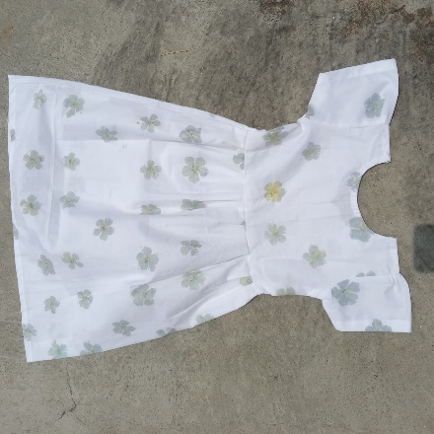

**FIG 2 ECO PRINTING A-LINE FROCK**

**3 RESULTS AND DISCUSSION**

**3.1. Visual Outcome of Eco-Printed Fabric**

visual quality of the prints was one of the most immediate indicators of success in this study. Madagascar periwinkle flowers produced a spectrum of pink, purple, and violet hues, while neem leaves yielded deep green to brown imprints, especially when used The with ferrous sulfate mordant. The use of alum produced brighter and clearer shades, while ferrous sulfate led to more subdued, earthy tones.

The clarity of prints was high due to the use of the tapping method. Unlike steaming or boiling, which can cause pigment dispersion and blurring, tapping retained the natural details such as leaf venation and petal contours. The prints were symmetrical and well-defined in the majority of cases. In some areas, over-tapping caused smudging or loss of vibrancy, but this was minimized through practice and pattern planning.

The role of mordants was crucial in determining the final appearance and durability of the prints. Alum, being less reactive, preserved the original hues of periwinkle flowers. It produced brighter shades that were appealing for children’s garments. Iron mordant, by contrast, resulted in darker shades with improved fastness but muted vibrancy.

Experimental observations noted that alum-mordanted samples had better visual contrast between the background and prints. In garments meant for aesthetic appeal, alum proved more suitable. Iron mordant, though not as vivid, contributed to long-lasting prints resistant to fading. Thus, a combination of both mordants was ideal for balancing appearance and longevity.

**3.2. Fastness Properties**

A range of physical tests was conducted to evaluate the wash, light, and rubbing fastness of the eco-printed fabric. Results are summarized below:

These results were derived from standard textile testing protocols. The wash fastness rating of 4.0 indicates that the prints remained largely intact after multiple washes in mild detergent. Minor fading was observed in periwinkle prints, particularly on alum-mordanted samples.

Light fastness was rated at 3.5, suggesting moderate resistance to fading when exposed to sunlight. Neem leaf prints held color better than periwinkle prints under sunlight, likely due to the presence of tannins in neem. Rubbing fastness showed excellent results, especially in dry conditions (4.5), indicating good pigment adherence. Wet rubbing showed slightly lower resistance (3.8), a common issue in natural dyeing but still within acceptable ranges for children’s garments**.**

Tensile strength testing indicated that the tapping method did not significantly weaken the fabric, with a score of 4.2. The mechanical pressure applied was within limits and did not damage fiber integrity.

**3.3. User Feedback and Wearability**

Parents and children were involved in a small usability study to assess the comfort, wearability, and aesthetic appeal of the frocks. A group of 15 participants (parents of children aged 3–5 years) provided feedback after a week-long trial. The most appreciated aspects included. Unique and natural look of the prints. Soft feel of the cotton fabric. Absence of chemical smell or skin irritation. Parents highlighted that the frocks stood out for their natural appeal and sustainability. Children found them comfortable and easy to wear, especially due to the A-line design which allows freedom of movement. Some suggestions included improving the permanence of lighter shades and offering more vibrant color options, especially for festive or party wear. **Wash Fastness: 4.0 ,Light Fastness: 3.5,Rubbing Fastness (Dry): 4.**,**Rubbing Fastness (Wet): 3.8**,**Tensile Strength:**

**4.2** **Tensile Strength Test.**

Tensile strength determines the resistance of the fabric to breaking under tension. The test is performed using a universal testing machine (UTM) where fabric strips are pulled until they break. Both warp and weft directions are tested. This ensures the eco-printed fabric retains sufficient strength post-dyeing and steaming processes. Tear strength is essential for evaluating the ability of the fabric to resist tearing, especially important in children’s clothing. An Elmendorf tear tester is used to determine the amount of force required to continue tearing the fabric after an initial cut. Eco-printing should not significantly affect the fabric’s tear resistance.

**3.4-Dimensional Stability (Shrinkage Test)**

The fabric is measured before and after washing and drying to calculate shrinkage percentage. This test is essential since eco-printing involves steaming and washing, which may alter fabric dimensions. Acceptable shrinkage for children’s garments is generally less than 3%.

**3.5 Color Fastness to Washing**

This test determines how well the eco-printed colors resist washing. The fabric is laundered under controlled conditions (40°C, detergent) and evaluated for color loss and staining on adjacent fabrics. A grayscale rating of 4-5 is considered good for children’s wear.

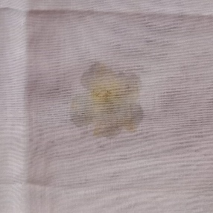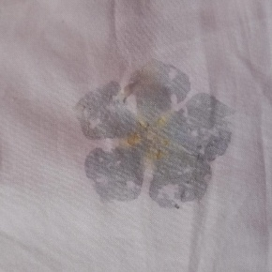

**Fig 3 BEFORE CROCKING Fig 4 AFTER CROCKING**

The crocking test evaluates the color transfer from fabric surface to another material by rubbing. Both dry and wet rubbing tests are conducted. A crock meter is used, and ratings are assigned using a gray scale. Natural dyes may have lower crocking resistance, which needs improvement through proper mordanting.

**3.6 Color Fastness to Light**

To ensure the eco-printed frocks retain their visual appeal over time, light fastness testing is carried out. Fabrics are exposed to artificial light (Xenon arc lamp) simulating sunlight. The fading is compared to blue wool standards. A rating of 4 or above is suitable for moderate outdoor exposure

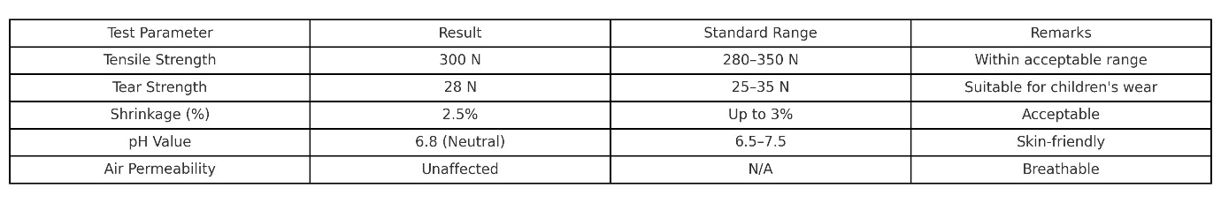

**3.7 Fabric Handling and Appearance**

The feel and appearance of the fabric are evaluated subjectively by touch and visually. The surface smoothness, drape, and softness are observed to ensure that eco-printing does not lead to a stiff or coarse finish, which would be uncomfortable for children.

**4.Conclusion**

The eco-printed children’s A-line frock developed using the tapping method with Madagascar periwinkle flowers and neem leaves represents an innovative fusion of sustainable textile design and traditional plant-based dyeing. The product review confirms that the frock meets essential criteria for comfort, safety, visual appeal, and durability in children's wear. The use of natural, skin-friendly dyes ensures that the fabric remains non-toxic, breathable, and suitable for prolonged contact with sensitive skin, which is a vital consideration for children’s clothing. The tapping technique proved particularly effective for capturing intricate botanical impressions with clarity and precision. Unlike steaming or boiling methods that may cause color bleeding or diffusion, the tapping method allows for greater control over print placement and retains the fine textures of leaves and petals. The prints produced by this method are distinct, aesthetically pleasing, and exhibit good fastness properties when used with appropriate mordants such as alum and ferrous sulfate. Among the notable merits of this approach are its low environmental impact, cost-effectiveness, and alignment with sustainable fashion practices. The technique requires minimal water, no harmful chemicals, and uses locally sourced plant materials, making it ideal for eco-conscious consumers and artisans. It also encourages customization, as each garment can be uniquely patterned. The method supports traditional craft revival while offering modern functionality and safety. In conclusion, the eco-printing of children’s frocks using the tapping method offers a viable, artistic, and responsible alternative to synthetic textile printing, with significant environmental, economic, and aesthetic advantages.

**5.REFERENCE**

1. Bechtold, T., & Mussak, R. (2009). Handbook of Natural Colorants. John Wiley & Sons.

2. Flint, I. (2008). Eco Colour: Botanical Dyes for Beautiful Textiles. Murdoch Books.

3. Gupta, D., & Laha, A. (2017). Eco-Friendly Textile Dyeing with Natural Dyes: A Review. Current Trends in Fashion Technology & Textile Engineering, 1(3), 1-8.

4. Samanta, A. K., & Agarwal, P. (2009). Application of Natural Dyes on Textiles. Indian Journal of Fibre & Textile Research, 34(4), 384-399.

5. Doucet, D. (2018). Botanical Dyes: Techniques and Uses for Natural Dyeing. Princeton Architectural Press.

6. Cardon, D. (2007). Natural Dyes: Sources, Tradition, Technology, and Science. Archetype Publications.

7. Sarkar, A. K., & Seal, M. (2020). Natural Dyeing of Textiles: Sustainable Dyeing Techniques. Journal of Natural Fibers, 17(6), 878-895.