## Authentify Focuses on Identifying and Removing Fake Product Reviews

Dr. Dhivya. K1 , Mr. SELVAGANESH J2

1Assistant Professor, Department of Commerce CA, Dr. N.G.P Arts and Science College, Coimbatore -641048, Tamil Nadu, India

III B.COM CA -Student, Department of Commerce CA, Dr. N.G.P Arts and Science College, Coimbatore -641048, Tamil Nadu, India

# ABSTRACT

The proliferation of fake product reviews poses a significant threat to the credibility of e-commerce platforms. This paper introduces Authenticate, an innovative web application designed to identify and remove fake product reviews effectively. Leveraging automation techniques, Authenticate analyzes patterns, user behavior, and review inconsistencies to detect fraudulent activities with high accuracy. The application is built using PHP for robust server-side scripting, while MySQL ensures efficient database management and secure data handling. Key features include real-time review monitoring, advanced data analytics, and strong database security protocols to protect sensitive information. Authenticate not only enhances the authenticity of online reviews but also fosters trust among consumers and businesses in the competitive e-commerce landscape.

## Keywords

Web Application, Automation, PHP, MySQL, Database Security.

# INTRODUCTION

In the rapidly evolving world of e-commerce, product reviews play a pivotal role in influencing consumer purchasing decisions. However, the rise of fake product reviews has undermined the reliability of online platforms, leading to skewed perceptions, unfair competitive advantages, and potential financial losses for businesses. These deceptive practices often involve fabricated positive reviews to boost product visibility or negative ones to harm competitors, creating a challenging environment for both consumers and sellers.

To address this growing concern, Authenticate emerges as a cutting-edge web application specifically designed to identify and remove fake product reviews. By leveraging advanced automation techniques, Authenticate can efficiently analyze large volumes of data, detect suspicious patterns, and distinguish authentic reviews from fraudulent ones. Built with PHP and supported by a robust MySQL database, the application ensures secure data management while maintaining high performance. Additionally, its strong database security measures safeguard sensitive information, reinforcing user trust.

# OBJECTIVES

* + Create a system to identify and remove fake product reviews.
  + Improve customer trust by ensuring only genuine reviews are displayed.
  + Prevent manipulation of product ratings by detecting fraudulent activities.

1. **LITERATURE REVIEW**

### **1. Luca (2016): Economic Impact of Online Reviews**

Luca (2016) demonstrated that online reviews have a direct influence on consumer decisions and business outcomes. His research showed that a one-star increase in Yelp ratings can lead to a 5–9% rise in restaurant revenue. This economic impact has created incentives for businesses to generate fake reviews to manipulate consumer perception, contributing to the growing prevalence of deceptive content on review platforms.

2. Jindal and Liu (2008): Categorization of Opinion Spam

Jindal and Liu (2008) were among the first to classify fake reviews into specific types, such as duplicate reviews, promotional content, and opinion spam. Their work laid the groundwork for identifying structural patterns in fake reviews, helping distinguish between genuinely poor reviews and intentionally misleading ones. They highlighted that many fake reviews are crafted to either unfairly boost or harm product reputations.

3. Mukherjee et al. (2013): Behavioral and Group Spam Analysis

Mukherjee et al. (2013) extended the study of review spam by introducing the concept of group spamming—coordinated efforts by multiple users to manipulate review systems. They analyzed behavioral patterns like review frequency, timing bursts, and overly biased ratings. Their work revealed how spammers evolve tactics over time, making detection increasingly challenging for platforms relying on static rules.

4. Ott et al. (2011): Linguistic Cues in Fake Reviews

Ott et al. (2011) focused on the linguistic characteristics of deceptive reviews. Using machine learning and text analysis, they identified patterns such as exaggerated sentiment, generic phrasing, and emotional tone often found in fake reviews. Their study showed that while humans struggle to detect deception, machine learning algorithms can outperform human judgment in identifying fake content.

5. Akoglu et al. (2013): Network-Based Detection Methods

Akoglu et al. (2013) introduced graph and network-based models to detect fraud in online systems. They examined relationships between reviewers, products, and timelines to spot suspicious activity clusters. Their model effectively identified fraudulent behaviors that textual and behavioral methods alone might miss, making it a strong complement to existing spam detection frameworks.

# 

# EXISTING SYSTEM

## Description of the Existing System

The current review systems used by e-commerce platforms, online service providers allow users to submit reviews and ratings . These reviews help potential customers make informed decisions. However, most existing systems lack proper security measures to prevent fake system leading to the manipulation of ratings and misleading information for consumers.

## Weakness of the Existing System

* 1. Fake Reviews & Review Manipulation
     + Many businesses hire fake reviewers or use bots to post multiple positive reviews for their products or services.
     + Competitors post negative fake reviews to lower the ratings of rival products.
     + Some users review bomb products, flooding them with fake negative reviews for personal or political reasons.
  2. Weak IP Tracking System
     + Most existing systems track public IP addresses to detect duplicate reviews.
     + However, public IPs can be easily masked using VPNs, proxies, or dynamic IP addresses, making it easy for users to bypass detection.

# DEVELOPED SYSTEM

## A. Description of the Developed System

**Customer Module**

The **Customer Module** allows customers to register, submit product reviews, and view other user reviews while ensuring authenticity. The system authenticates users, detects fake reviews, and removes fraudulent content to maintain review credibility.

## Key Features:

1. **Customer Registration & Login** – Secure authentication via email/password.
2. **Profile Management** – Customers can update their details and view their submitted reviews.
3. **Review Submission** – Customers can post reviews on products.

## Fake Review Detection

**2. Admin Module**

The **Admin Module** allows administrators to manage user reviews, detect fake reviews, and take action on flagged content. Admins can monitor the system, approve or remove reviews, and ensure that only genuine product reviews remain visible.

* Admin Login
* Manage Reviews
* Fake Review Detection
* User Management
* Review Flagging
* Reports&Logs
* Notifications

USE CASE DIAGRAM:

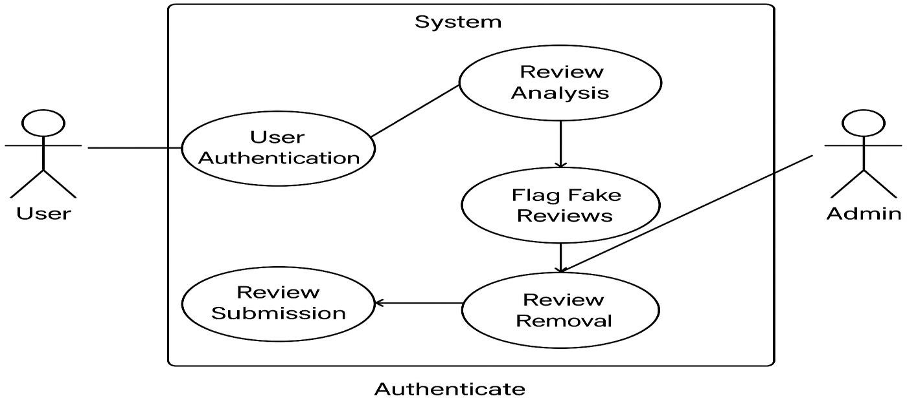

# RESULTS AND DISCUSSION

LOGIN MODULE

The **Login Module** securely authenticates users in the **Fake Product Review Detection System** using hashed passwords and session management. **Admins** review flagged content, while **customers** submit and track reviews. Built with **PHP, MySQL, and HTML/CSS**, it ensures a safe and efficient login process..



USER REGISTERATION MODULE

The User Registration Module allows customers and admins to create accounts securely by providing a username, email, password (hashed for security), and role selectio. The system validates inputs and stores user details in a MySQL database.



# DATABASE DESIGN

The system uses MySQL as the database management system. The key tables include:

**Table: Admin**

|  |  |  |  |
| --- | --- | --- | --- |
| **Column Name** | **Data Type** | **Constraints** | **Description** |
| id | INT (11) | PRIMARY KEY, AUTO_INCREMENT | Unique Admin ID |
| username | VARCHAR (50) | UNIQUE, NOT NULL | Admin username |
| password | VARCHAR (255) | NOT NULL | Hashed password |
| created_at | TIMESTAMP | DEFAULT CURRENT_TIMESTAMP | Admin account creation time |

**Table: Customer**

|  |  |  |  |
| --- | --- | --- | --- |
| **Column Name** | **Data Type** | **Constraints** | **Description** |
| id | INT (11) | PRIMARY KEY, AUTO_INCREMENT | Unique User ID |
| username | VARCHAR (50) | UNIQUE, NOT NULL | User's chosen name |
| email | VARCHAR (100) | UNIQUE, NOT NULL | User's email |
| password | VARCHAR (255) | NOT NULL | Hashed password |
| created_at | TIMESTAMP | DEFAULT CURRENT_TIMESTAMP | User registration timestamp |

# XI. RESULTS:

1. Ensure that all features function correctly.
2. Identify and fix errors before deployment.
3. Verify the system’s security against fake reviews.
4. Improve the user experience and system efficiency.
5. Confirm that the system meets business and functional requirements.

# X. CONCLUSION

The Fake Review Detection System has a promising future with AI integration, enhanced security, and scalability across different platforms. By implementing advanced verification mechanisms, real-time analytics, and blockchain technology, the system can significantly improve review authenticity and consumer trust in e-commerce and online marketplaces. The future of this system lies in its ability to adapt to emerging threats, automate detection, and provide actionable insights to businesses and users alike.

# REFERENCES

1. Luca, M. (2016). Fake It Till You Make It: Reputation, Competition, and Yelp Review Fraud. Harvard Business School.
2. Ott, M., Choi, Y., Cardie, C., & Hancock, J. (2011). Finding Deceptive Opinion Spam by Any Stretch of the Imagination. Association for Computational Linguistics.
3. Mukherjee, A., Venkataraman, V., Liu, B., & Glance, N. (2013). Fake Review Detection: Classification and Analysis of Review Spammers. ACM International Conference on Web Search and Data Mining.
4. Jindal, N., & Liu, B. (2008). Opinion Spam and Analysis. Proceedings of the International Conference on Web Search and Data Mining (WSDM).