**THE PATENTSACT,2024**

**COMPLETE**

**SPECIFICATION**

**SECTION**

**TITLE**

**HOSPITAL MANAGEMENT SYSTEM**

**APPLICANT**

Mrs.N.G.Dharaniya

**INVENTORS**

Mrs. N.G.Dharaniya,

Nandhakumar.S, Navaneeth Kumar.S , Nesly Jeniston.M , Rithish .R

Department of Information Technology,

Sri Shakthi Institute of Engineering & Technology, Coimbatore.

**ABSTRACT**

A hospital management system (HMS) is a software solution designed to manage the day-to-day operations of a hospital. It helps streamline key processes such as patient registration, appointment scheduling, medical record management, billing, and professional communication. The system improves efficiency by providing real-time patient information and enabling healthcare providers to make informed decisions faster.By automating services such as hospital infrastructure (beds, equipment, personnel) and financial management, HMS reduces operational workload and ensures smooth hospital operations and enhances patient care by medical records making them easily accessible to doctors and nurses.With secure access controls and data protection features, the system ensures sensitive patient information is protected. Overall, the clinical management system aims to improve clinical efficiency, reduce errors and deliver better services to patients and healthcare.

**FIELD OF THE INVENTION**

The present invention relates to healthcare technology, primarily through the development and use of medical chatbots (MedBots).A.I. MedBots are designed to improve patient care, facilitate medical consultations, aid in diagnosis, improve patient engagement, and streamline healthcare They are particularly useful for consumer medicine telecommuting, patient education, triage of symptoms, appointment scheduling, and follow-up care. Provides better communication This initiative is intended to help improve the quality of digital health solutions, reduce healthcare costs, and enhance the quality of healthcare.

**BACKGROUND OF THE INVENTION**

Hospitals and healthcare facilities have traditionally relied on paper-based and manual systems to manage patient records, appointments, billing, and other administrative tasks These processes are often time-consuming, error-prone, was ineffective, especially as hospitals grew and actually managed hospital operations of the The need for a system was evident.

A **Hospital Management System (HMS)** has been developed to streamline and automate patient registration, scheduling, billing, inventory, and medical record storage By moving these services to a digital platform, HMS reduces manpower errors, speeding up processes and facilitating inventory control at the clinic

Technological advances have made today’s **HMS** solutions sophisticated, providing features such as real-time data access, electronic health records (EHRs), and patient monitoring, driving care and operational efficiencies effective but many healthcare facilities, especially small. face challenges due to complexity or lack of proper training

The goal of this initiative is to provide a simple, cost-effective and flexible hospital management system that helps hospitals improve efficiency, reduce errors and provide better patient care, regardless of size or their property

**DETAILED DESCRIPTION OF THE INVENTION**

The Hospital Management System with Chatbot is a complicated digital answer designed to streamline the operations of healthcare facilities, beautify the patient revel in, and improve administrative efficiency. It integrates key functionalities together with affected person control, which enables the registration, tracking, and control of patient statistics, and appointment scheduling, allowing sufferers to e book, modify, or cancel appointments with ease. The device additionally handles clinical information control, enabling medical doctors to hold and access digital fitness information, lab results, and remedy histories in actual time, improving the accuracy and continuity of care. Additionally, the billing device automates invoicing, insurance claims, and charge processing, making financial transactions extra efficient. The personnel control component handles scheduling, attendance, payroll, and function-based get right of entry to, making sure that the proper employees are to be had whilst wanted and that sensitive records is covered. Incorporating a chatbot in addition elevates the device via providing 24/7 assistance to sufferers, healthcare vendors, and visitors. This clever assistant can cope with primary obligations such as booking appointments, answering health-associated questions, supplying symptom triage, and guiding users via hospital services. The chatbot additionally acts as an interactive medical resource, providing academic content on conditions, treatments, and medicines. For health facility group of workers, the chatbot offers updates on affected person information, group of workers schedules, and other administrative tasks. It can also be used to test aid availability, alert group

of workers to urgent needs, and provide actual-time verbal exchange, reducing delays and enhancing usual health facility performance. Furthermore, the gadget is equipped with functions like telemedicine integration, allowing far flung consultations between sufferers and docs, which is specially useful for sufferers in faraway places or those unable to go to the health center. Clinical Decision Support Systems (CDSS) constructed into the platform assist healthcare vendors by using suggesting diagnostic and treatment pointers based totally on patient facts. The patient remarks system permits hospitals to accumulate actual-time input on affected person reports, making sure continuous development in care best. The device additionally supports multi-language talents, making healthcare more reachable to numerous patient populations. Integration with wearable fitness gadgets permits continuous tracking of patient vitals, while discharge planning capabilities make certain sufferers acquire right comply with-up commands after leaving the health center. Additionally, the emergency control machine provides actual-time indicators for critical conditions, making sure that team of workers can respond promptly to emergencies. Technically, the system uses advanced tools such as Natural Language Processing (NLP) for chatbots to understand and answer patient questions in natural language It also uses machine learning algorithms for predictive analytics, helping hospitals to show patient flow, improve resource allocation and improve business processes Cloud -based infrastructure Ensures system scalability as the hospital growth, making it more flexible and reliable in terms of data storage and access. Blockchain technology can also be combined to provide improved data security, ensuring patient records remain tamper-proof and compliant with health data regulations such as HIPAA or GDPR. Despite the obvious benefits, the system also presents challenges. User training may be required, especially among clinicians unfamiliar with new technologies. Additionally, integrating systems into existing hospital management software can present challenges, requiring customization and seamless data transfer Although chatbots offer many advantages, it is important to you see its limitations in providing medical advice Finally there, Data security remains a major concern, when the system deals with sensitive health information, which needs to be created ban fi the violation or misuse of the law. Overall, the Hospital Operations System with Chatbot represents a major advance in digital healthcare, integrating automation, AI, and cloud-based technologies to create more efficient healthcare, it observes patients, and is safe Empowering With careful planning and implementation, these programs can transform clinical management and patient care, and provide it is an essential tool for modern healthcare organizationsOverall, the Hospital Operations System with Chatbot represents a major advance in digital healthcare, integrating automation, AI, and cloud-based technologies to create more efficient healthcare, it observes patients, and with safety Provides Power With careful planning and implementation, these programs can transform clinical management and patient care, and provide it is an essential healthcareorganizations.

**DIAGRAM:**

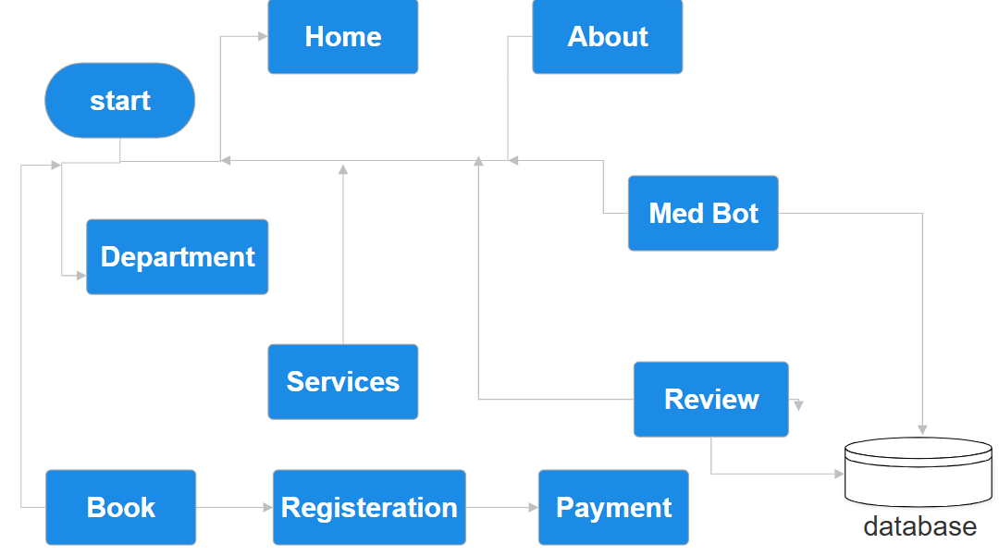

**HOSPITAL MANAGEMENT SYSTEM**

**ABSTRACT**

A hospital management system (HMS) is a software solution designed to manage the day-to-day operations of a hospital. It helps streamline key processes such as patient registration, appointment scheduling, medical record management, billing, and professional communication. The system improves efficiency by providing real-time patient information and enabling healthcare providers to make informed decisions faster.By automating services such as hospital infrastructure (beds, equipment, personnel) and financial management, HMS reduces operational workload and ensures smooth hospital operations and enhances patient care by medical records making them easily accessible to doctors and nurses.With secure access controls and data protection features, the system ensures sensitive patient information is protected. Overall, the clinical management system aims to improve clinical efficiency, reduce errors and deliver better services to patients and healthcare professional.

**CLAIMS:**

1. 24/7 Availability: Med bots can help patients or staff around the clock, answer questions, guide patients through various procedures, and provide basic on-demand information, improving clinical performance.
2. Emergency support: Patients can receive real-time answers to questions, whether about their symptoms, treatment options, or clinical services. This makes satisfaction very satisfying.
3. Reduced wait times: Through automation and intake systems, Med Bot can reduce the time patients spend in line, resulting in a more efficient process.
4. Medical Advisory: Med Bot can provide real-time clinical decision support by analyzing patients’ symptoms, history, and test results to confirm a possible diagnosis or flag a trend.
5. Data Protection: Systems with built-in security measures can help protect patient records and sensitive information.