Shubhkari Electricals

|  |  |  |  |
| --- | --- | --- | --- |
| Maithili Jadhav | Pooja More | Soham Suryawanshi | C.S.Mogare, |
| **Department of Information Technology** | **Department of Information Technology** | **Department of Information Technology** | **Project Guide** |
| **MET Institute of Technology,** | **MET Institute of Technology,** | **MET Institute of Technology,** | **MET Institute of Technology,** |
| **Polytechnic, Bhujbal Knowledge City,** | **Polytechnic, Bhujbal Knowledge City,** | **Polytechnic ,Bhujbal Knowledge City** | **Polytechnic ,Bhujbal Knowledge City** |
| **Nashik-422003** | **Nashik-422003** | **Nashik-422003** | **Nashik-422003** |
| [maithilij59@gmail.com](mailto:maithilij59@gmail.com) | [poojamorepm2003@gmail.com](mailto:poojamorepm2003@gmail.com) | [sohamsuryawanshi04@gmail.com](mailto:sohamsuryawanshi04@gmail.com) | [chetanm_iot@bkc.met.edu](mailto:chetanm_iot@bkc.met.edu) |

# Abstract

Shubhkari Electricals is a customer-centric web-based platform designed to streamline electrical service inquiries and customer support. The project integrates MySQL for efficient database management, ensuring seamless communication between customers and the support team. This research paper explores the user criteria and training program associated with Shubhkari Electricals, outlining its technological framework, methodologies, and impact on service-based industries.

The study highlights the role of digital transformation in enhancing customer engagement, operational efficiency, and service quality. The integration of structured data storage and dynamic customer request management is examined in relation to user experience and business performance. Additionally, this research delves into the comparative advantages of Shubhkari Electricals over traditional customer service models, emphasizing improvements in response time, service tracking, and overall customer satisfaction.The findings also discuss the significance of database-driven service management, automation, and the potential role of AI-driven solutions in customer support. By assessing the efficiency of the implemented design and technologies, this research provides valuable insights into how modern web-based platforms can optimize customer interactions in service- based industries.

# Keywords

Electrical services, client-based project, service management system, local host deployment, scalability, web technology, service tracking, AI integration, predictive maintenance, customer support automation, cloud-based solutions, database-driven interaction.

# Introduction

### Background

The increasing reliance on digital solutions in service industries. Need for streamlined customer service in electrical work. Role of web-based platforms in addressing service inquiries efficiently.Challenges faced by traditional customer service models, including delayed responses, unstructured data management, and inefficiencies in tracking service requests.The necessity of a user-friendly interface for both customers and service providers to facilitate smooth interactions.

### Literature Survey

Existing digital solutions for service industries.Comparative analysis of customer support platforms.Technological advancements in database management and customer interaction.

**Introduction and Objective**

## Purpose of Shubhkari Electricals

A dedicated platform for handling electrical service inquiries and customer interactions. Addressing common customer pain points such as unavailability of technicians, delayed responses, and lack of transparency in service tracking. Providing an accessible, web-based solution to facilitate direct communication between customers and service providers.

## Objectives

Enhancing customer engagement through real-time communication and status updates. Optimizing inquiry management with structured data storage and automated service request processing. Ensuring seamless service request handling through a user-friendly interface that allows for easy service tracking and response time monitoring. Implementing a feedback system for continuous improvement of customer service quality.

### Scope

Application Areas:

Applicability to residential and commercial electrical service inquiries. Adaptability for different types of electrical services, including installation, maintenance, and troubleshooting.

Scalability and Expansion:

Potential scalability to other service-based industries such as plumbing, HVAC repair, and home appliance servicing. Integration possibilities with emerging technologies like AI chatbots and predictive maintenance tools to anticipate service needs. Development of multilingual support for broader accessibility across diverse customer demographics.

# System Architecture Diagram

**Purpose**: Provides an overview of how different components interact within the system

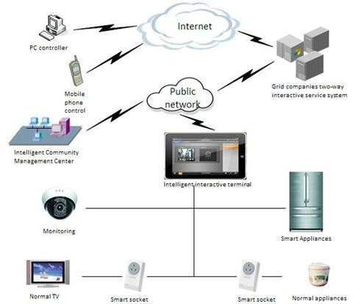

# Design, Technologies, and Methodologies

### Technologies Used:

**Database Management:**

MySQL provides robust database connectivity, ensuring structured storage of customer inquiries and service requests. Secure authentication and authorization mechanisms protect user data.

### Front-End Development:

The platform is developed using HTML, CSS, and JavaScript to create a responsive and interactive user interface. A user-friendly design ensures accessible navigation and efficient search functionalities.

### Back-End Development:

PHP powers the backend, enabling seamless communication between the database and front-end. RESTful APIs are implemented to support interoperability with third-party applications.

**Hosting & Deployment:**

Cloud-based hosting ensures accessibility, scalability, and security. The use of content delivery networks (CDNs) enhances platform performance and speed.

### Methodology Followed

Agile development approach for iterative improvements, allowing for continuous testing and feedback incorporation. User-centered design for enhanced usability. Security measures implemented for data protection. Performance testing and stress testing to evaluate system robustness and scalability.

### Software and Apps Used for Data Analysis

MySQL database queries for customer request analysis. Python for data visualization and performance monitoring

# Flow Diagram

**Purpose**: Illustrates the step-by-step process of user interaction with the platform.

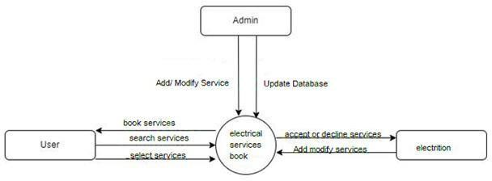

# Results and Discussion

### Data as a Result/Findings:-

The implementation of web-based inquiry forms has significantly improved customer engagement and streamlined communication for electrical service needs. Faster response times ensure timely issue resolution, enhancing overall service efficiency. Additionally, structured data management allows for better tracking and organization of service requests, optimizing operational workflow.

### Explanation of Data/Findings:-

Analyzing user inquiries provides valuable insights into common service demands and customer preferences. Database integration has facilitated workflow optimization by enabling quick and structured access to service requests, reducing response times, and improving overall efficiency. The evaluation of customer interaction patterns indicates increased engagement and a better user experience, demonstrating the impact of digital solutions in modern service industries.

### Discussion:-

Comparing Shubhkari Electricals’ digital platform to traditional inquiry methods reveals advantages such as enhanced accessibility, quicker responses, and improved data organization. The efficiency of database integration is evident in reduced processing time and streamlined service tracking. However, challenges such as initial user adaptation, data security concerns, and system scalability were encountered, necessitating continuous refinements for optimal performance.

# Deployment Diagram

**Purpose:** Illustrates the physical deployment of the system components.

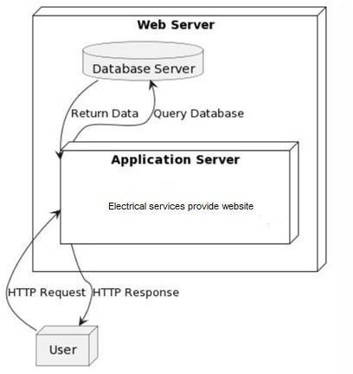

# Conclusion

### Objective Reviewed

Evaluation of how well Shubhkari Electricals met its intended objectives of improving customer service efficiency and engagement. Assessment of user satisfaction through feedback collection and service performance metrics.

### Reviewed Key Findings

Positive impact of digital platforms on customer service management, leading to increased transparency and customer trust.Importance of database-driven interaction for service-based businesses, allowing for structured and efficient service request handling.

### Recommendations for Future

Integration of AI-based chat support to improve customer interaction and provide instant responses to common queries. Development of a mobile application for enhanced accessibility. Implementation of advanced data analytics for predictive maintenance services. Continuous security upgrades to ensure data privacy and protection against cyber threats.

**Output of the website:-**

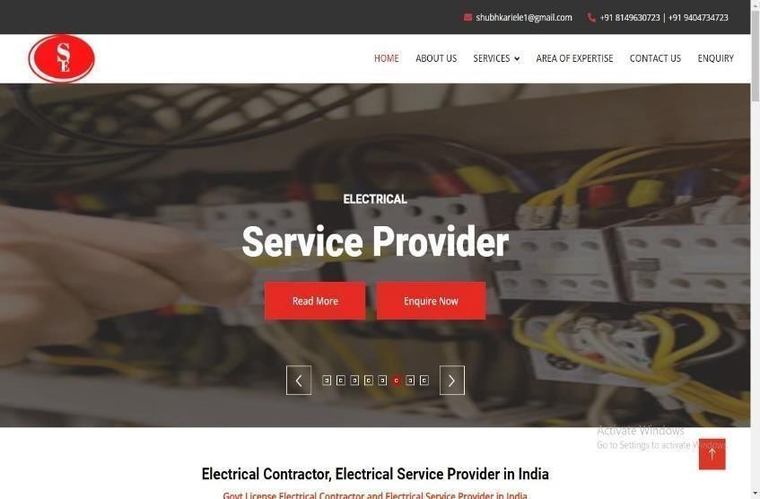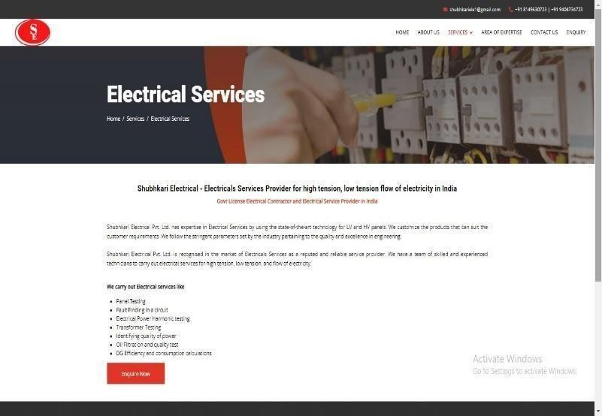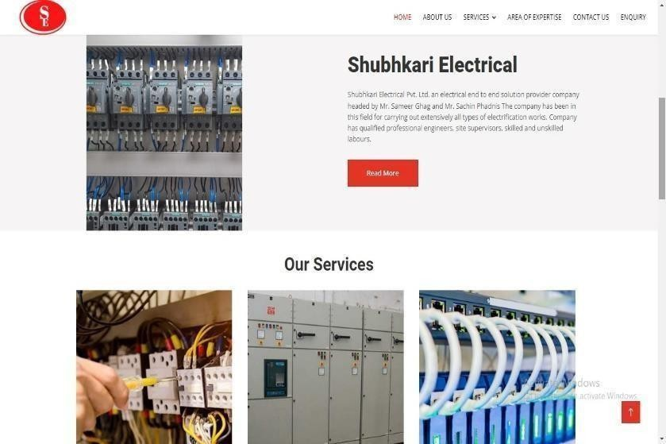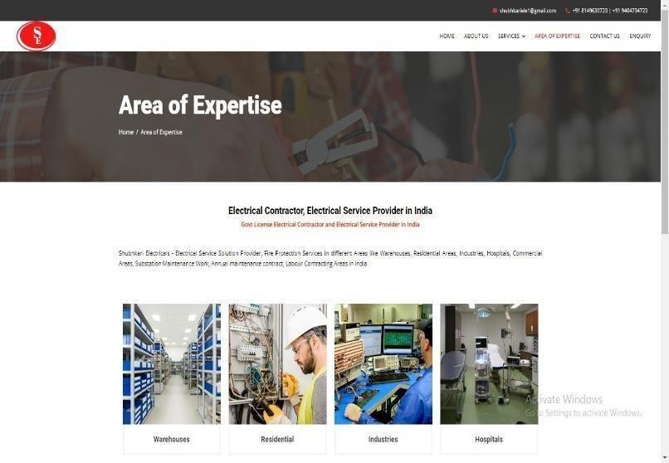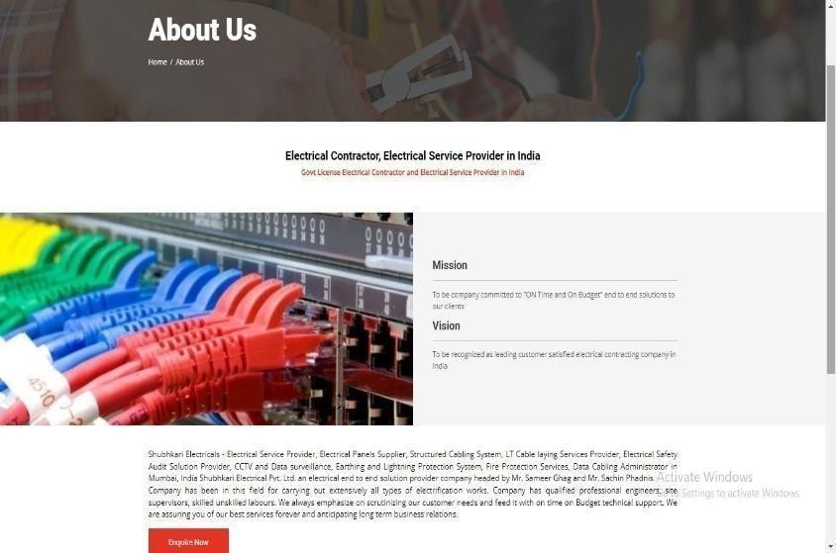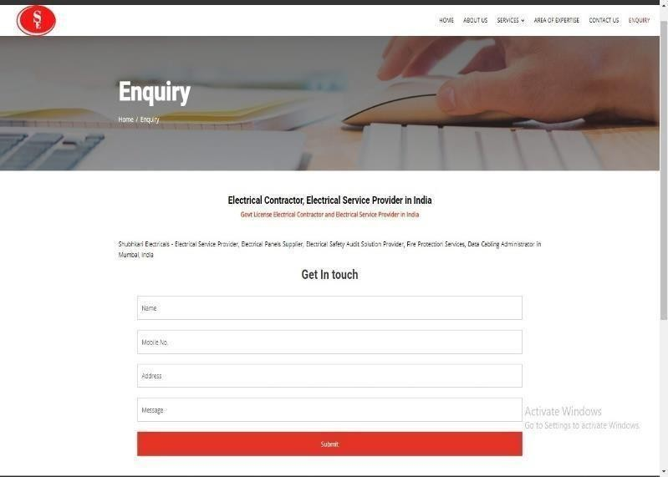

**Admin Panel:-**

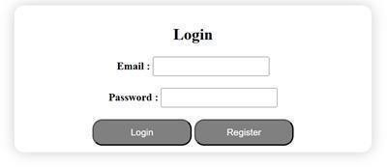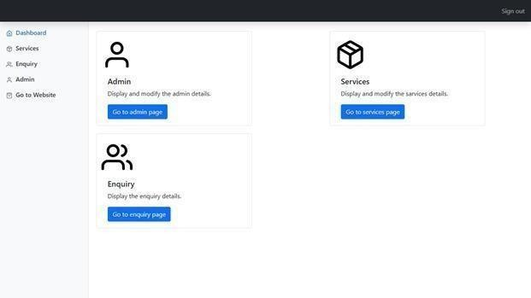

# References

* **Advances in Electromagnetics Empowered by Artificial Intelligence and Deep Learning** *Authors*:Douglas H. Werner, Sawyer D. Campbell *ISBN*:978-1-119-66296-9

*Publication Year*: 2023

* + Nanoantennas and Plasmonics: Modelling, Design and Fabrication

*Authors*: Douglas H. Werner, Zhi Hao Jiang

*ISBN*:978-1-78561-837-6

*Publication Year*: 2020

* + Electromagnetic Vortices: Wave Phenomena and Engineering Applications

*Authors*: Zhi Hao Jiang, Douglas H. Werner

*ISBN*: 978-1-119-66296-9

*Publication Year*: 2021

* **Integration of Renewable Sources of Energy** *Authors*: Felix A. Farret, Marcelo Godoy Simões *ISBN*:978-1-119-07839-5

*Publication Year*: 2017