ARIA: An Intelligent Voice-Enabled Virtual Assistant for Desktop Automation and Conversation

Aniket Supe1, Amey Waikar 2, Aditya Tripathi 3,

Shudhodhan Bokefode1 and Kishor sakure.2

1Asst. Professor, Computer Engineering Department,

Terna Engineering College, Nerul, Navi Mumbai.

2Assistant Professor, Computer Engineering Department,

Terna Engineering College,Nerul, Navi Mumbai

**ABSTRACT**

**To increase desktop productivity through natural language interaction, this research paper, Aria, introduces a Virtual Virtual Personal Assistant (VPA), built in Python. Application controls (memo blocks, calculators, etc.), webbrows, language typing, e-mail, weather invocations, and natural conversations with DialOgpt conversation models are just some of the many tasks that ARIA can do. To interpret, create creation, and automate tasks on the user's computer, the assistant uses a variety of Python libraries, such as Speech_Recognition, Pyttsx3, Pyautogui, and Trans. Easy to adjustable modular architecture allows users to improve their skills according to their special needs.  
Integration of language-based automation into smartphones and intelligent devices has been passed considerably thanks to the efforts of established virtual assistants providing Google Assistant, Siri, Siri, Alexa, Alexa and Cortana. The system and its capabilities rely primarily on a cloud-based ecosystem. Similarly, several open source initiatives, such as desktop-based Jarvis Clones and Mycroft AI, aim to introduce AI assistants to HR computers, but often only limited offline capabilities, are born on a specific platform and require conversational skills.  
Aria overcomes these limitations by providing a fully adjustable and conscious desktop assistant through privacy. Data security and user control are guaranteed by offline and online operations, support for customer-specific commands, and independence from local task cloud storage. These are open source libraries, allowing developers and researchers to change or extend functionality at will. Aria is a convenient and clever way to improve interactions between humans and computers in everyday arithmetic environments. Thanks to the integration of conversation AI, you can respond directly to commands and have contextual conversations.**

**Keywords:**Virtual Personal Assistant (VPA), Speech Recognition, Natural Language Processing (NLP), Text-to-Speech (TTS), Python, Artificial Intelligence (AI), Voice Automation, Desktop Assistant, Offline Functionality, Conversational AI.

# **INTRODUCTION**

The demand for smart, hands-free computing has grown exponentially during the present era of digital transformation. Virtual personal assistants (VPAs) have become an integral part of day-to-day life because of extensive use of artificial intelligence (AI), natural language processing (NLP), and speech recognition technologies. These artificial intelligence (AI)-based systems are able to understand human language, execute commands, and perform a range of tasks, from responding to questions and sending reminders to controlling smart devices and providing real-time data. VPAs are evolving from simple voice responders to proactive, intelligent assistants that can assist with personal and professional tasks as human-computer interaction (HCI) becomes more conversational and intuitive.

This revolution has been driven by commercial assistants like Google Assistant, Apple's Siri, Amazon's Alexa, and Microsoft's Cortana, which offer voice-enabled services primarily for mobile and smart home contexts. These assistants have some disadvantages, however, especially relating to integration with traditional desktop platforms, even though they are widely employed. Many of these platforms lack extensive levels of customization, are closed-source, and require ongoing internet connectivity. In addition, their application in offline or sensitive settings is constrained by problems with cloud-based voice processing, user data privacy, and dependence on proprietary APIs.

This paper introduces ARIA, an open-source Python virtual personal assistant designed specifically for desktop PCs, as a remedy to these limitations. Employing a combination of speech recognition, text-to-speech (TTS) engines, GUI automation tools, and AI-based conversational models, ARIA can understand and execute voice commands. The assistant can perform a variety of tasks, such as launching apps, typing out content dictated to them, web browsing, fetching weather forecasts, managing emails, and answering general questions naturally. Unlike existing commercial solutions, ARIA's architecture is extensible and modular, enabling both online and offline functionality while maintaining strict user privacy. The approach of implementation, fusion of various Python libraries, chat flow with the DialoGPT model, and practical uses of ARIA in real desktop environments are all explored in this research.

# **RELATED WORK**

One of the largest fields of AI research has been the development of Virtual Personal Assistants (VPAs) to improve automation, accessibility, and the natural interaction between humans and machines. Several key contributions, each covering a different dimension of assistant capabilities, have formed the basis of voice-based systems.

Aditya Sinha et al. [1] gave a virtual assistant specifically designed to cater to the differently abled, utilizing speech recognition and offline Java-based software such as Sphinx-4 and MaryTTS. Their approach prioritized accessibility without conversational intelligence or desktop-level integration.  
Ankit Pandey and his group [2] suggested a smart voice assistant with AI that could handle calendars, notes, and emails. Yet, the assistant was mostly online and had limited desktop customizability.  
Bibek Behera [3] presented "Chappie," an AIML-driven chatbot that was meant for basic task management and customer service conversations. Though useful for rule-based questions, it did not have deep learning or natural language understanding for contextual conversation.  
Abhay Dekate et al. [4] created a voice assistant with Raspberry Pi and Python to control applications and read news automatically. The project was proof of local control feasibility but had performance limitations and no advanced AI integration. Deepak Shende et al.  
[5] developed a light Python voice assistant that was able to perform simple tasks like opening Notepad and retrieving jokes. In spite of its simplicity and effectiveness, the assistant was not very scalable and lacked web API integration.  
Deny Nancy and her team [6] built a voice assistant for college websites that allowed students to access specific portals using voice commands. Although practical in academic contexts, it lacked conversational flow and dynamic learning.  
Vadaboyina Appalaraju et al. [7] suggested an intelligent desktop assistant based on Python that could perform web searches, open files, and retrieve weather updates. Their assistant was effective in scripted situations but lacked a learning model or conversation engine. Dr. Kshama V. Kulhalli et al.

Isha S. Dubey et al. [9] designed an assistive voice system for visually impaired users using Raspberry Pi, helping them perform basic system tasks. However, its functionality was narrowly focused on accessibility rather than general-purpose use.

Lastly, Emad S. Othman [10] proposed a voice-controlled assistant using Raspberry Pi with Python and speech APIs, focusing on basic home automation tasks. The system required constant cloud interaction and lacked offline fallback modes.

From these studies, it is evident that many assistants were either limited by their dependence on predefined commands, lacked advanced dialogue handling, or were constrained by platform specificity and internet reliance. In contrast, the proposed assistant, ARIA, addresses these gaps by integrating both offline and online capabilities, incorporating natural conversation via DialoGPT, and offering a customizable, modular structure for advanced desktop automation. This makes ARIA a versatile and intelligent solution capable of adapting to diverse user needs.

# **THE PROPOSED SYSTEM**

The system proposed here, ARIA (AI-based Responsive Intelligent Assistant), is a Python desktop virtual assistant that incorporates voice recognition, speech synthesis, web automation, and conversational AI to deliver an uninterrupted user experience. ARIA differs from other assistants in that it is modular and highly customizable, making it capable of executing system-level commands and natural dialogue with the user. The system can function both offline and online, giving it flexibility in settings where internet connectivity is poor or nonexistent.  
ARIA's architecture is built to obtain the user's voice input, translate that voice into text through speech recognition, and process the command to identify the right action. Based on the input, ARIA may execute an action (e.g., launch an application or search the web) or create a conversational answer through the use of the DialoGPT model. The text answer is then translated into speech and provided back to the user through the use of a text-to-speech engine.  
  
The system employs a centralized control loop that continuously listens for user inputs. Every input goes through a decision module that directs the input to particular functional blocks, which are:  
• Application Control Module  
• Web Search Module  
• Email and Messaging Module  
• Voice Typing Interface  
• Conversational Engine (DialoGPT)  
• API Integration (e.g., Weather, Wikipedia, WolframAlpha)  
  
This modular organization not only promotes maintainability but also facilitates scalability by enabling features to be incorporated with little effort.

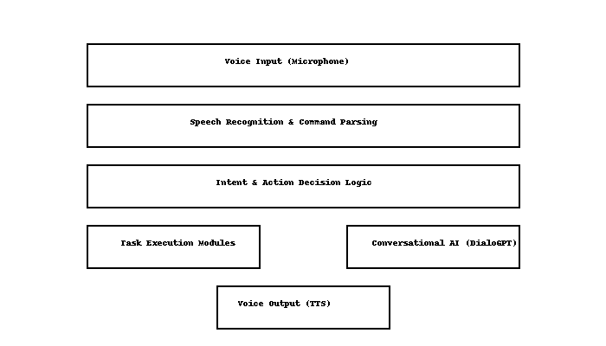

Fig. 1. Proposed System

The architecture of the envisioned Virtual Personal Assistant system, ARIA, is to facilitate modular, scalable, and intelligent interaction using voice commands. The process starts with voice input, where the user utters something into a microphone. The audio input is recorded in real-time and processed via the speech_recognition library, which translates the speech into respective text. After spoken command transcription, it is forwarded to the command parsing and intent recognition module, which breaks down the intent of the request by examining keywords and sentence structure. This is the central decision-making engine and decides whether the user request can be executed as a task, the retrieval of information, or a conversational reply.  
According to this analysis, the system directs the input to one of two main modules. If the input is a direct command (e.g., "open calculator" or "search for climate change"), it is sent to the task execution modules. These modules employ tools like os, pyautogui, and webbrowser to carry out system-level tasks, such as opening applications, automating keystrokes, surfing the web, or working with APIs like Wikipedia and OpenWeatherMap. Conversely, if the input is open-ended or conversational (e.g., "how are you today?"), the text is analyzed using the conversational engine fueled by the DialoGPT model of Hugging Face's Transformers library. The model creates contextually suitable, coherent responses, which gives the interaction a more human touch.  
Lastly, regardless of whether the output is a task confirmation or a chat response, it is spoken aloud through the text-to-speech (TTS) engine, provided through the pyttsx3 library. The generated speech is then played back to the user via speakers, producing a full-duplex, voice-based experience. The whole system runs in an ongoing listening loop and can run in both online and offline modes, which makes ARIA intelligent and responsive as well as privacy-aware and adaptable. This architecture allows for seamless interoperability between speech processing, AI-driven reasoning, and system-level task execution, which yields a capable and intuitive virtual assistant.

1. **METHODOLOGY**

The process of creating ARIA, a voice-enabled desktop-based personal assistant, is a systematic process that incorporates multiple Python libraries, third-party APIs, and AI models. The process of development is based on modular design principles, allowing for flexibility, ease of debugging, and extensibility for new features. The system architecture consists of speech-to-text, command interpretation, decision logic, task execution, conversational modeling, and text-to-speech feedback. This section describes the process and logical sequence of operations performed by ARIA, from user voice input to output in spoken response.  
  
First, the system starts by loading necessary libraries and models such as Pyttsx3 for text-to-speech (TTS), SpeechRecognition for capturing input, and DialoGPT from Hugging Face for conversational functionality. Upon triggering the assistant, it starts by continuously listening to audio input through an attached microphone. After audio is detected, it is processed through the speech recognition component where Google Speech API is often used to translate the audio signal into text.  
  
This transformed text is parsed by the command parser, which determines the command type—whether it is a request to launch an application, search, dictate, or chat. If the command corresponds to a pre-defined action, it is passed on to the respective function in the Task Execution Module that utilizes libraries like `os`, `pyautogui`, and `webbrowser` to interact with the system or the internet. If a match is not found or if the input is chat-like, it is then passed through the DialoGPT model to produce an intelligent, context-sensitive response. The response generated (either from task confirmation or the chatbot) is then presented to the user through the TTS engine, thereby concluding the

Interaction cycle.

.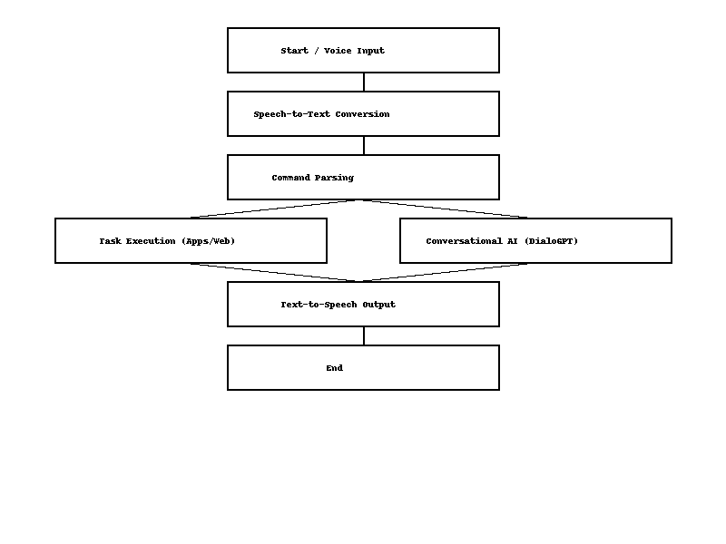

Fig. 2. Workflow of ARIA Virtual Assistant

The figure shows the workflow of the suggested Virtual Personal Assistant (ARIA) beginning with user voice input. The input is processed by Speech-to-Text Conversion, converting spoken words into text using a speech recognition engine. The text is then parsed in the Command Parsing phase, which identifies whether the request is task-oriented or conversational. From this analysis, the system proceeds along one of two paths: Task Execution, where it takes system or web-based action, or Conversational AI, where it employs models such as DialoGPT to produce responses. Either path ends with output being forwarded to the Text-to-Speech module, which voices the response to the user. The process ends at the End stage, finishing the interaction. This efficient flow allows ARIA to flip between executing tasks and participating in natural conversation.

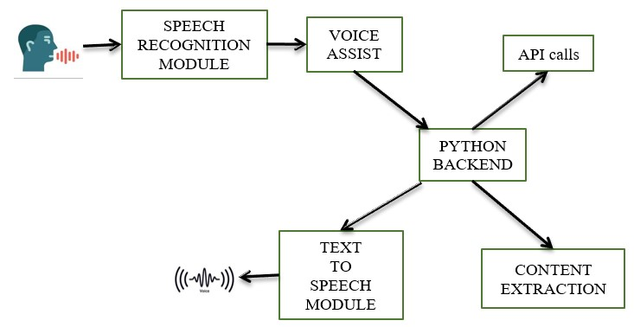

Fig. 3. System Architecture

# This is a representation of the Virtual Personal Assistant (ARIA) system's internal structure. It starts at the Speech Recognition Module, which records the voice of the user and interprets it as text. The voice is processed from text data by the Voice Assist component, aiding in determining the intent of the command. The Python Backend serves as the central core of the system, orchestrating tasks as per the analyzed input. It makes API calls to extract external information like weather or news and performs Content Extraction from results or web resources. When the concerned action has been done or data extracted, the Text-to-Speech Module translates the output text back to speech, thus enabling the assistant to make its response inaudible to the user. Both efficiency and scalability in handling the user commands as well as serving responses are enabled by this module-based mechanism.

# **ENHANCE MODEL INTEGRATION**

Our Virtual Personal Assistant's (ARIA) Enhanced Model Integration is a major breakthrough towards making human-computer interaction more natural, smart, and responsive. At the core of this integration lies the application of large-scale conversational AI models like OpenAI's GPT or Google Dialogflow, which allow the assistant to comprehend complex questions, preserve conversational context, and provide human-like responses. Such models enable ARIA to shift beyond keyword recognition and embrace a more sophisticated realization of user intent, emotion, and behavior, increasing the overall user experience exponentially.

To enable this sophisticated processing, ARIA is designed with a modular backend framework that allows effortless integration of disparate components like speech recognition, natural language processing, API interaction, and text-to-speech synthesis. Each module can be independently updated or swapped out, making it flexible and scalable. The Python backend processes data transfer and decision-making and decides whether the task is to be processed locally—such as launching an application—or remotely using cloud APIs, such as weather data or answers to general knowledge questions from services like Wikipedia.

Another vital feature of the improved integration is the ability of ARIA to give personalized and secure responses. Context-awareness is utilized by the system to intelligently answer follow-up questions, keeping conversations consistent. Voice biometrics and token-based authentication are also incorporated to protect sensitive operations like sending messages or accessing personal information. Text-to-speech responses are returned via sophisticated models such as Google Wavenet, to provide clarity, emotional tone, and even multilingual support when required. This multi-layered and interconnected architecture guarantees ARIA not only to be a command executor, but also a clever, conversational friend that can learn and adapt to personal user preferences over time.

1. **CONCLUSION AND FUTURE SCOPE**

The creation of ARIA, a Virtual Personal Assistant, reflects the merging of several state-of-the-art technologies into one user-friendly, glitch-free interface for users to easily communicate with their devices in more natural and convenient ways. By taking advantage of speech recognition, natural language processing (NLP), conversational AI, and text-to-speech (TTS) synthesis, ARIA fills the chasm between human intention and machine action. The assistant can perform all sorts of tasks like launching applications, web browsing, sending messages and emails, retrieving weather information, and even having sensible conversations—all through mere voice commands.

The design is centered not just on functional usefulness but also on enhancing user experience through contextual knowledge, fault tolerance, and customized replies. The modular nature of ARIA enables each part—ranging from speech-to-text to task processing—to be upgraded or replaced separately. This guarantees flexibility, future integration with intelligent models, and possible extension to diverse platforms, such as mobile phones, IoT devices, and smart homes. Also, the fact that Python is used as the backend ensures good compatibility with libraries and APIs, allowing for quick development and integration of new features.

In the future, the scope of ARIA is immense. With the ever-growing advancements in artificial intelligence and deep learning, ARIA can be developed to provide real-time language translation, emotion detection, and proactive task recommendations based on user behavior and usage patterns. Integration with machine learning algorithms might enable it to learn from user interactions and enhance itself over time. In addition, broadening ARIA's functionality to function in low-resource environments, or merging it with wearable technology and AR/VR ecosystems, would redefine user interactions with technology in everyday life. Security and privacy features like end-to-end encryption and user-specific voice biometrics will also be vital in the future vision. Overall, ARIA has immense potential as a personal assistant that can develop into a highly intelligent, secure, and invaluable digital companion.

1. **References**
2. Aditya Sinha, Gargi Garg, Gourav Rajwani, Shimona Tayal. “Intelligent Personal Assistant.” International Journal of Informative & Futuristic Research, Vol. 4, Issue 8, April 2017.
3. Ankit Pandey, Vaibhav Vashist, Prateek Tiwari, Sunil Sikka, Priyanka Makkar. “Smart Voice-based Virtual Personal Assistants with Artificial Intelligence.” Artificial Computational Research Society, Vol. 1, Issue 3, June 2020.
4. Bibek Behera. “Chappie - A Semi-automatic Intelligent Chatbot.” IEEE Conference, 2021.
5. Abhay Dekate, Chaitanya Kulkarni, Rohan Killedar. “Study of Voice Controlled Personal Assistant Device.” IJCTT – Volume 42 Number 1 – December 2016.
6. Deepak Shende, Ria Umahiya, Monika Raghorte, Aishwarya Bhisikar, Anup Bhange. “AI Based Voice Assistant Using Python.” Journal of Emerging Technologies and Innovative Research (JETIR), Vol. 6, Issue 2, February 2019.
7. Deny Nancy, Sumithra Praveen, Anushria Sai, M. Ganga, R. S. Abisree. “Voice Assistant Application for a College Website.” International Journal of Recent Technology and Engineering (IJRTE), Vol. 7, Issue 6S5, April 2019.
8. Vadaboyina Appalaraju, K Saikumar, V Rajesh, P Sabitha, K Ravi Kiran. “Design and Development of Intelligent Voice Personal Assistant using Python.” 3rd International Conference on Advances in Computing, Communication Control and Networking (ICACCCN), 2021.
9. Dr. Kshama V. Kulhalli, Dr. Kotrappa Sirbi, Mr. Abhijit J. Patankar. “Personal Assistant with Voice Recognition Intelligence.” International Journal of Engineering Research and Technology (IJERT), Vol. 10, No. 1, 2017.
10. Isha S. Dubey, Jyotsna S. Verma, Arundhati Mehendale. “An Assistive System for Visually Impaired Using Raspberry Pi.” IJERT, Vol. 8, Issue 5, May 2019.
11. Emad S. Othman. “Voice Controlled Personal Assistant Using Raspberry Pi.” International Journal of Scientific and Engineering Research, Vol. 8, Issue 11, November 2017